Alison Haddon
2246314
Design Craft
ADAD4018
Julia Lockheart.

Task 1: Manifesto Writing = 529
Task 2: Observational Writing = 502
Task 3: Practice-Based Writing = 477
Total= 1,508

Manifesto Writing

1. Creative individuals perceive design as simple and beautiful.

2. Creators see forms and patterns in countless ways. They tell stories over time and deliver valuable insights into our past, future, and the social contexts in which they worked.

3. Creating inferior art is better than not creating art at all; your imagination knows no boundaries.

4. Clay is a fascinating material; shaping a soft piece of clay and transforming it with heat is incredibly exciting.

5. William Morris was at the forefront of design.

6. Stay humble, learn from others, and embrace criticism.

7. Dirty the paper and see what your mind creates.

8. Making good notes will help your future self.
Objects like ceramics, stained glass, jewelry, wallpaper, and fabrics from bygone eras carry stories with them. They offer a glimpse into the past, illustrating how people lived, worked, and expressed themselves through art and design. Each piece stands for the culture and values of the time in which created, as noted in "Popular Culture" (1981).

Historic objects such as door latches or ornate items like pocket watches provide us with a window into the past. The craftsmanship and skill of the artisans who created them, along with the materials and techniques used in their production, contribute to the narrative these items embody.

When we examine artifacts from the past, we can discern how they reflect the society in which they made. Clothing from different periods highlight fashion trends, social status, and cultural influences of the time. Similarly, ceramics and jewelry can reveal the artistic styles and traditions prevalent during specific eras.

While mass-produced items may offer convenience, they often lack the character and history that handmade or vintage pieces own. The uniqueness and individuality found in handmade items enhance their ability to tell a compelling story. Furthermore, many contemporary designers draw inspiration from the past and strive to create pieces that are both timeless and meaningful ( Buckley,2000)

William Morris, (1834-1896) A Victorian artist and designer, was renowned for his focus on creating beautiful and functional objects inspired by nature and traditional craftsmanship. His work, which encompassed textiles, wallpaper, and furniture, reflected his belief in the significance of art and beauty in daily life. Morris’s designs stay popular today, more than a century after his death, showing the enduring appeal of objects that have a story to share (Fiell,2017)

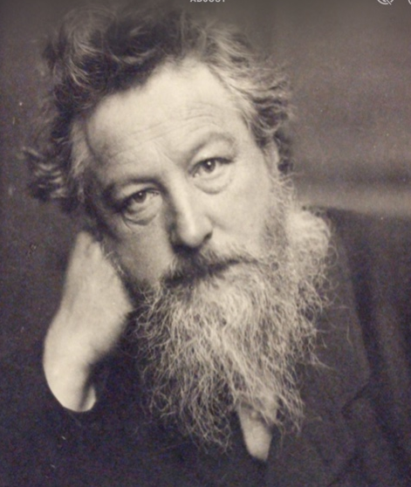
Fredrick Hollyer. (1884). portrait William Morris London; V&A.

At 16, Morris proved his loyalty to the craft principle by refusing to enter the Great Exhibition in London, which celebrated machine-age designs. Morris often quoted, "Have nothing in your houses that you do not know to be useful or believe to be beautiful."
(fiell,2017, p.167) “A Life of Art Illustrated”


Shannon Tofts. (2019). Imbrication.Edinburgh: National Museum of Scotland.

Ceramicist Frances Priest creates objects inspired by history, keeping the past alive while being still relevant to the present. By incorporating historical references into their work, they pay homage to past traditions and techniques while infusing their unique perspective. Through their creations, they invite us to appreciate the beauty and significance of objects that tell a story (Priest,2019)

Bibliography
Buckley, C. *Potters and Paintresses: Women Designers in the Pottery Industry, 1870-1955*. The Women's Press Ltd; 2000.

Fiell, C., & Fiell, P. *William Morris 1834-1896: A Life of Art Illustrated*. Taschen America LLC; 2017.

Freestone, I. *Pottery in the Making: World Ceramics Traditions*. Published for the Trustees of the British Museum by British Museum Press; 1997.

Taylor, L. *The Ceramics Bible: Revised Edition*. Chronicles Books; 2022.

Frances Priest. (2019). Artist Maker. [Online]. Frances Priest artist-designer-maker. Last Updated: Unknown. Available at: www.francespridstceramics.com [Accessed 22 November 2024].

List of figures

Fredrick Hollyer. (1884). portrait William Morris London; V&A.
Shannon Tofts. (2019). Imbrication.Edinburgh: National Museum of Scotland.

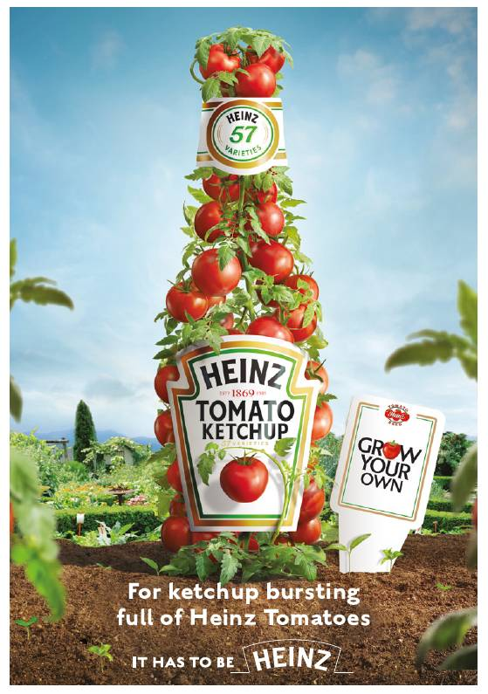
Semiotics
Most adverts give various meanings and visual impacts to the readers. You can interpret the meanings articulated from the advert.
Semiotic analysis helps to reinforce images and texts to a particular product.
The signs and symbols act as indirect communicators to the consumers. These signs and symbols serve the purpose of the target audience. Advertisements manipulate the feeling and behaviour of the consumer.
Advertising like this focuses on signs, symbols, connotations, and demotion meanings.
Using this approach highlights the signifier and signified and how the symbols of the advertisements affect the reader's perception.
Exploring the connotative and denotative meanings of advertisements and focusing on the theories of Ferdinand de Saussure and Roland Barthes's arbitrariness in the product's image.
We all interpret in numerous ways. Individuals may perceive the signs and symbols differently based on their experiences and cultural backgrounds. By using semiotics in advertising, marketers can reinforce the image and message of their product in a way that resonates with their target audience (Hill&Wang,2012, p.274)

The signs and symbols used in advertisements serve as indirect communicators, guiding the audience towards a desired response.
These signs can shape the audience's understanding of the product and influence their purchasing decisions.
I explore my chosen advert using a semiotic approach. Examining the signifier and signified.
Exploring how the symbols and imagery can affect the audience's belief.
Ferdinand De Saussure (1857-1913) and Roland Barthes's (1915-1980) theory aims to shed light on the importance of semiotics in advertising and how it can create compelling and impactful advertisements (Hill&Wang,2012, p.274)

What the advert signifies
Beautiful pale blue sky, showing us that the tomatoes have grown in a beautiful climate.
Green Lush foliage donates that growing conditions are perfect.
Soft fluffy quality earth donates the plants have grown in top-quality soil.
Bottles holding fresh red juicy tomatoes all still attached to the vine donated quality fresh and only the best tomatoes in every bottle of Heinz ketchup (1876). The white crisp label implies that the company has been around for many years, and the writing is classic which leads you to believe that the quality is the best. The label also has the dates of the company showing the viewer how long the company has been running, making every bottle have the same quality of tomatoes.

Pale clouds in the background suggest a bright and sunny day, perfect for growing tomatoes. The overall signified message is that Heinz ketchup (1876) was from the freshest and highest quality tomatoes, grown in the most ideal conditions and processed with care to keep their natural flavour and nutrients. The signified message also conveys a sense of tradition and reliability, as Heinz has been a trusted brand for generations.

In conclusion, by analysing the signifiers and signified of the image of blue sky, green leafy foliage, brown earth, red tomatoes, white label, and pale clouds, we can see that the overall message communicated is one of quality, freshness, tradition, and reliability. The image evokes feelings of health, natural goodness, and trust in the product, making it an effective and appealing marketing tool.

Bibliography
Kraft. (2015). It has to be Heinz. (photography). United States: Kraft Heinz.
Alexandros Ph.Lagopoulos and Karin Boklund-Lagopoulos. (2021). Theory and methodology of semiotics. 10th ed. Athens Greece: De Gruyter Mouton. p.357.
Roland Barthes. (2012). Mythologies. 3rd ed. New York city: Hill & Wang. p.274.

Task three
Practice based writing.

The wallpaper “The Strawberry Thief.” conceived by William Morris in (1883) is a beautiful depiction of nature, showcasing a Sparrow amongst the brambles enjoying a ripe strawberry. The paper is made from recycled paper and has a slightly rough texture. The designs were screen printed to give a 3D effect. The paper was designed and printed in Merton Abbey, Sussex, England and features heritage colours in muted pinks, clay reds, ochre yellows, olive greens, and earthy browns.

During the time of the wallpaper's design, tragic events were going on in the United Kingdom such as the deaths of 183 children in Victoria Hall in Sunderland and the sinking of the SS Daphne in Glasgow. These events symbolise chaos and confusion, which is stark contrast to the calming and subtle nature of Morris's wallpaper

The word "chaos" is often associated with complete confusion and disorder. It can also refer to a person being in a state of wildness and complete lack of restraint. The chaos theory, discovered by Edward N Lorenz, explains how chaotic behaviour exists in natural systems such as weather, fluid dynamics, and irregular heartbeats.

Imogen Cunningham. (1998). Edward N Lorenz. [Photograph]. Seattle: Institute of Technology.

Lorenz was an American Mathematician and meteorologist. He was
known for discovering the principles of the chaos theory and the butterfly effect. ( Brittania.com)
When linking the word "chaos" to the wallpaper, it can create a different effect. The serene scene of the Sparrow and strawberry could be viewed chaotically, with bright unruly colours and a different interpretation of the scene. However, it is important to keep the beauty and elegance of the wallpaper separate from the chaos theory.
In conclusion, the wallpaper "The Strawberry Thief" is a timeless piece of art that captures the beauty of nature. While chaos may exist in the world around us, it is vital to appreciate the tranquillity and harmony that art such as Morris's wallpaper brings. The juxtaposition of chaos and serenity can create interesting contrasts, but ultimately, the two should exist separately for their unique qualities.
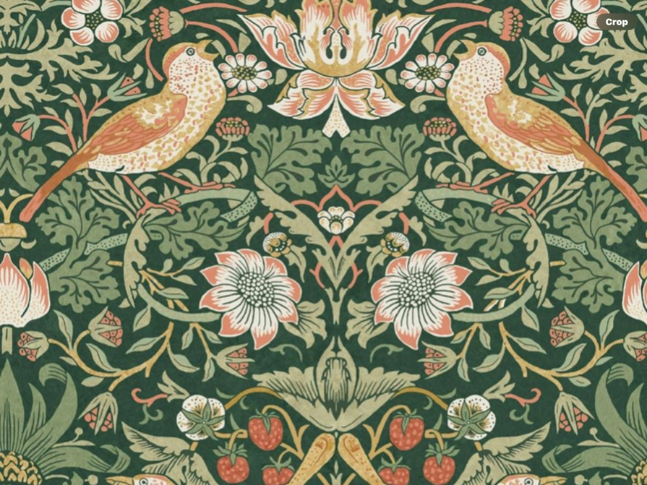
(William Morris. (1883). The strawberry thief. London: V & A.)

Bibliographyphy

Fiell,C ., & Fiell, P. William Morris 1834 – 1896: a life of Art Illustrated. Taschen America LLC; 2017.

Edward N Lorenz. (1995). The essence of chaos. Washington: Taylor and Frances. p.227.

List of figures
(William Morris. (1883). The strawberry thief. London: V & A.)
Imogen Cunningham. (1998). Edward N Lorenz. [Photograph]. Seattle: Institute of Technology.

