The tomb of Irukaptah (also known as Khenu, or the tomb of the butchers), is located at Saqqara near the pyramid of Unas, is an ancient Egyptian tomb dating from the 5th Dynasty (2500-2350 BCE) to the first intermediate period (2181-2055 BCE) (Taylor, 2001, pp. 11). Irukaptah offers a unique and rich insight into the material world evoking experience beyond ‘verbal, conceptual and consciousness’ (Schiffer, 2009, pp. 677-679). Through the tombs architecture, decoration, and material culture it contextualises and describes Irukaptah’s and ancient Egyptian relations with both the living and the dead. Furthermore, the presence of the unprecedented fourteen statues, detailed wall art, inscriptions, and labyrinthine structure carved into a limestone cliff, are suggestive of a transcendental, cosmic nature to death and the afterlife in ancient Egypt (Benderitter, 2005). This transitional nature of death is particularly relevant as Baines & Lacovara note; the mortuary process was essential in displaying wealth, status, and cultural values (of the ancient Egyptians) (Baines & Lacovara, 2002, pp.26). The ancient Egyptian mortuary process is a multi-faceted performance in which structures, religion, spirituality, and the physical body (and non-physical body) amalgamate with material culture to solidify an identity post-mortem, in this case forming the identity of; Irukaptah, the tomb of the butcher.
The architectural layout of Irukaptah is part of a greater collective of eleven burials located along the southern causeway, leading in the direction of the Pyramid of Unas. Notably, this southern direction (and the orientation) was part of a planned design in which it located towards the southerly direction of the Nile (Raven, 2005, pp.40). The Nile has been long recognised by ancient Egyptians as transitional and lifegiving source, in which it acted as a ‘ancient highway’ transporting craftsmen and trade goods (Vitali, 2016, pp. 1). The Nile also possess spiritual and greater connotations above the meta-physical world. It is, therefore, of importance when addressing after-life and death as it embodied the power of the God of the Dead, Osiris. Osiris was said to control the floods, and the purification of a dead king’s body within the sacramental Nile, by absorbing (imbibing) or travelling along the Nile, the deceased ‘might partake of the god’s immortality’ (Della, 1992, pp. 183) helping them and their non-physical journey to the afterlife. Thus, the physical orientation of Irukaptahs tomb is the first step in guiding and transitioning the physical and non-physical aspects of the individual(s) through to the afterlife.
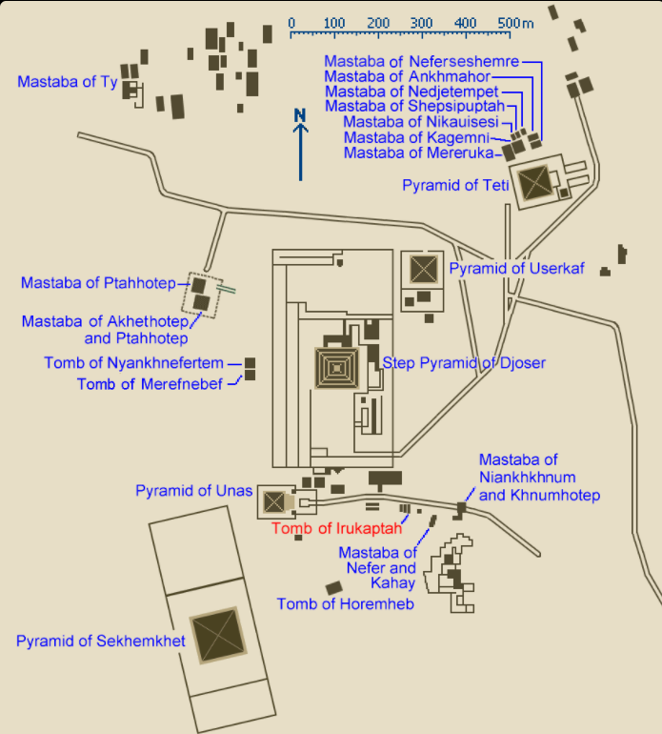
Fig. 1 (Mariais & Benderitter, 2005) (Above). Displays the location of Irukaptah’s tomb in relation to other tombs and the Pyramid of Unas.
Irukaptah was not of royal blood, instead he was in the employ of a butcher’s shop, who provided a direct service to the sovereign. His tomb placement was likely to solidify his bond with the King and protect his transition into the afterlife. Baines & Lacaovara surmises the placement of non-royal tombs in-situ to pyramids as ‘proclaiming both its indestructability and survival of human social hierarchies into the next world’ (Baines & Lacovara, 2020, pp. 26). Taylor further identifies tombs as ‘evolving into complex architectural structures, in which burial came to involve rituals and application of magical texts and images’ (Taylor, 2001, pp. 15). Ultimately, this non-royal burial marked a unique social phenomenon to the ancient Egyptians (Maskell, 2001, pp. 27), in which Osiris became the shepherd of the dead to the afterlife and not the sovereign (Benderitter, 2005). Perhaps revealing a change in attitudes amongst the non-royal individuals who wanted a greater chance of successfully reaching the afterlife (Ucko, 1969, pp.268). Additionally, it works as a social performance (Gallou & Georgiadis, 2009, pp. 384-385) for the living to keep the dead as ‘participants’ (Maskell, 2001, pp.29) in society.
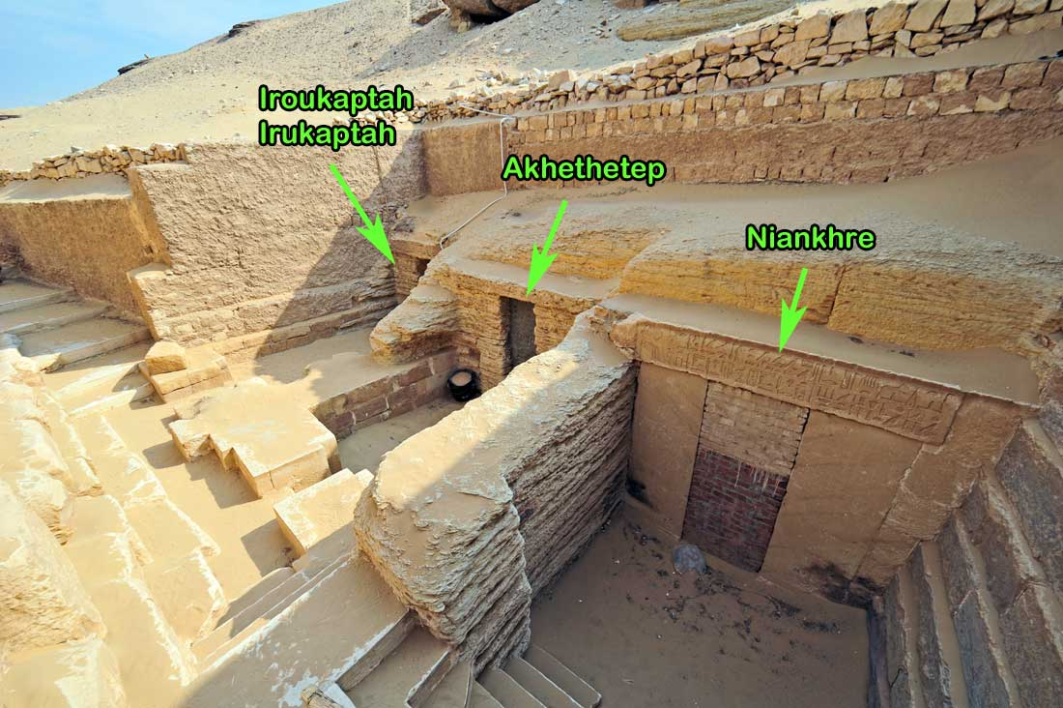

Fig. 2 (Mariais & Benderitter, 2005) (Above). The courtyard leading to Irukptah’s Tomb faces towards the north and is decorated externally by well-finished limestone blocks, the passage highlighted orientates into the south wall, proceeding into the chapel. These tombs were set up to house both the physical aspects of the deceased, but also the separate meta-physical aspects, involving the Ba (personality of the deceased), Ka (Life force) and the Akh (immortality of the deceased) (Lloynes, 2015, pp. 1). These different aspects of the ‘spirit’ each had specific material and immaterial requirements to sustain them. In which the Ka, would remain close to the body to imbibe sustenance, while the Ba and Akh could travel and leave the body (Taylor, 2001, pp. 19). The tomb and its materiality acts as a locale of comfort, shelter, and nourishment for the Ka, which as Snape explains mirrors the world of the living, allowing comfort and protection in death and the after world (Snape, 2011, pp.37).
Leading down into the Chapel, and into its long chamber, reveals unfinished masonry, rough and chisel marked walls and a myriad w decoration. Indicative of perhaps; a rushed burial or lack of (relative) importance to the greater social collective of ancient Egyptian society. However, despite this seeming lack of opulence in the tomb, there is fourteen statues carved directly into the chapel’s walls, with varying levels of finish, preservation, and vibrant colouration. These statues, acted as transcendental mortuary conduits, in which varying aspects of the deceased could be sustained and cult performances carried out to venerate the deceased. The materiality of the statues enabled the individual(s) to be ‘represented and receive a share of the offerings made to the gods’ (Taylor, 2001, pp.20), perpetuating their Ka, while also making sure the identity was remembered. Statues due to this spiritual inheritance, acted as a ‘bridge between terrestrial and divine realms’ (Hartwig, 2015, pp. 193), allowing Irukaptah, his family and possibly his fellow butchers greater success in capturing and preserving their identities when they meet Osiris.

Irukaptah’s fourteen statues would have enacted a sensory performance upon those who visit, they possess exceptional colouration, and quantity while guiding the living further into the tomb. Perhaps the material decoration the statues possess was a method of Irukaptah distinguishing himself to other ‘elite’ burials in the area, as prosperity in the afterlife was founded on ‘corporeal perfection’ in the world of the living (Maskell, 2001, pp.29). Making sure that despite his status of Butcher of the palace, his name and title would be remembered. The remembrance of a name and title is of particular importance as ‘defacement of the name of the deceased was seen as a negation of a person’s existence and his opportunity of attaining the afterlife’ (Maskell, 2001, pp. 30). Irukaptah’s title is that of ‘the one who makes libation, the butcher of the meal of the palace’ (Benderitter, 2005), which creates a further sense of ‘self’ for the deceased that even in death his titles and royal appointment will possess value in the afterlife. The written word possessed unique qualities to the ancient Egyptians for ‘word was itself was magic’ (Snape, 2011, pp. 44) having the power to construct reality by defining it, allowing the further protection of identity, and solidification of cultural status for Irukaptah to successfully transition to the afterlife.
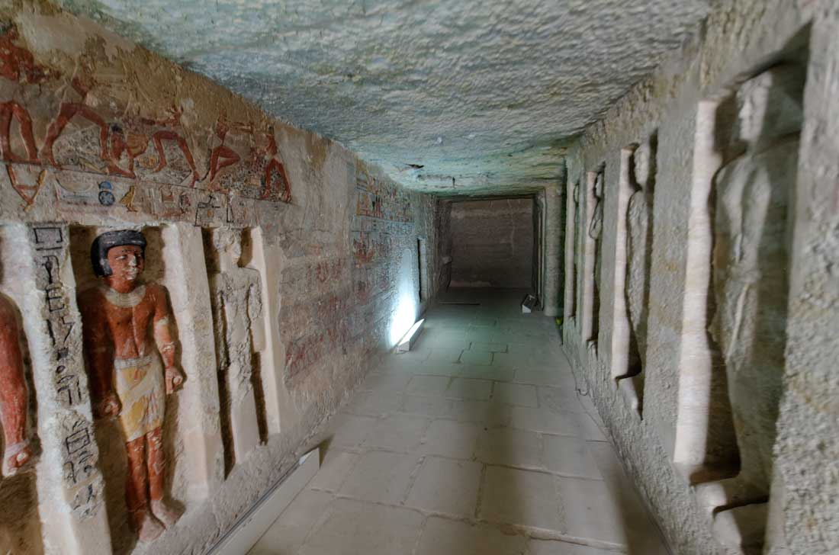
Fig 3. (Mariais & Benderitter, 2005) (Above) Illustrates the inner entrance of the chapel, lined with statues and decorations, yet still bears the marks of raw craftsmanship in unison with artisanal detail on the statues, suggesting an unfinished, yet ambitious design and desire to get to the afterlife. Joanne Fletcher (2018) highlights in her archaeological tour of Irukaptah tomb, that these powerful broad-shouldered statues (Morgan, 2011, pp. 6) greet the living directly out of the walls as they enter the tomb, offering a powerful physical and spiritual manifestation of Irukaptah, creating an eternal vessel for his Ka, capturing a ‘perfect’ (ideal) rendition of his physicality while maintaining a watchful guise on those who would bring offerings or dare to plunder his tomb. This physicality of the statues displays Irukaptah in his ‘splendour and finery’ (Fletcher, 2018), of which his attire is of seemingly high quality and design. Suggesting that this striking materiality would transition with him and was important in the journey to the afterlife. Due to this importance, it could be suggested these statues contain agency, evidenced through the continuing affect to ‘emotions, thoughts and memories amongst the living’ (Chesson, 2007, pp. 109).
The eternal body is a primary ideology throughout ancient Egyptian culture and is reflected both in the architectural layout of tombs, and the material culture present in Irukaptah. The statues act to mirror the sacramental nature of the body housing it’s Ba. Texts and incantations present throughout the narrow and orientated hallways function to guide the Ka and Akh of the deceased, while also ‘expressing social composition’ to the living through artistic materiality (Lemos, 2018, pp. 25) and further contextualising the life of Irukaptah.
Interestingly, the materiality varies in its abundance, with much unfinished or damaged by time and contemporary looting. Despite this, many of the decorations and art that cover the walls of the tomb are bountiful with renditions of the life of Irukaptah, his family, offerings, life as a butcher, and his cyclical journey to the afterlife (Fletcher, 2018). This materiality in artistry encapsulates beliefs, ideologies, symbology, and requirements that allow Irukaptah to start his next journey into the afterlife.
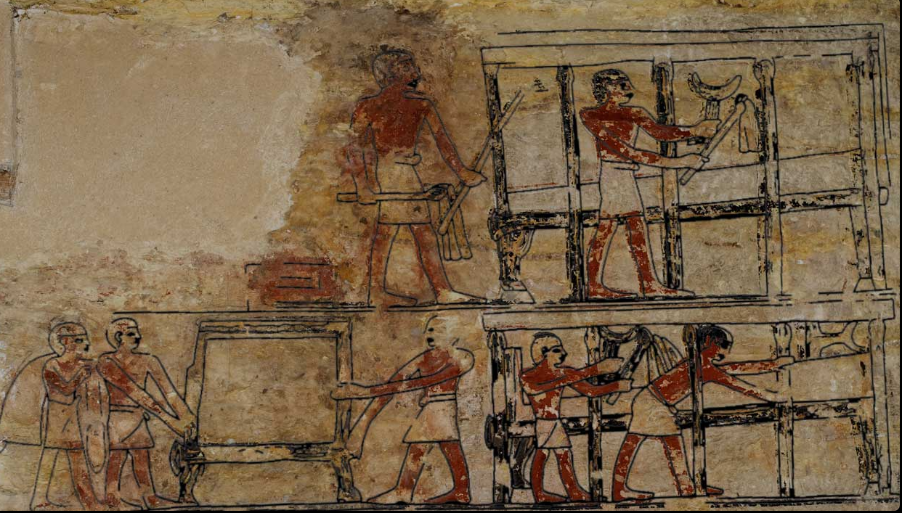
Fig. 4 (Above) (Mariais & Benderitter, 2005). This wall art displays the household servants making the beds of Irukaptah and his family, even bringing a small head pillow for comfort. These comforts, reveal that even in the afterlife Irukaptah and his family will be cared for, comfortable and still perpetuating in social, (Snape, 2011, pp.45) and cultural exchanges (Fletcher, 2018) in the world of the living. Furthermore, this concept of renewal, protection and comforting the non-physical body is recurrent throughout the tomb’s materiality. This materiality further suggests of a life prepared for death, in which death was not final, but instead was part of the transitional process in which records of one’s life, deeds and non-physical and physical identities must be recognised. Additionally, Taylor elucidates this process into a primary three categories of which tombs (and their materiality) had to appease ‘the gods, the living and the transfigured dead’ (Taylor, 2001, pp.15).
Fig 6. (Below) (Mariais & Benderitter, 2005). Irukaptah sits upon a chair designed in likeness to a bull’s leg, holding a lotus flower by the stem. While placed on tables in front of him is various offerings, of bread, fruits, and wines, these imperishable model materials provide to the deceased a physical sustenance for the afterlife. This representation of Irukaptah is rich in symbology perhaps most notable is the Lotus flower as it was seen by ancient Egyptians as a ‘transmutational plant, - related to moments of creation’ (Haddad, 2021 pp. 4). Moreover, the act of Irukptah holding the Lotus, is to signify physical and non-physical immortality, the ability to be resurrected and perhaps even a boast of power over death. Once again, perhaps to influence his chances of successfully transitioning into the afterlife by recognising the mythological connotations of which becoming immortal involved Ra and Osiris, these dualistic gods became representations ‘for achieving survival over death’ (Haddad, 2021 pp. 31).
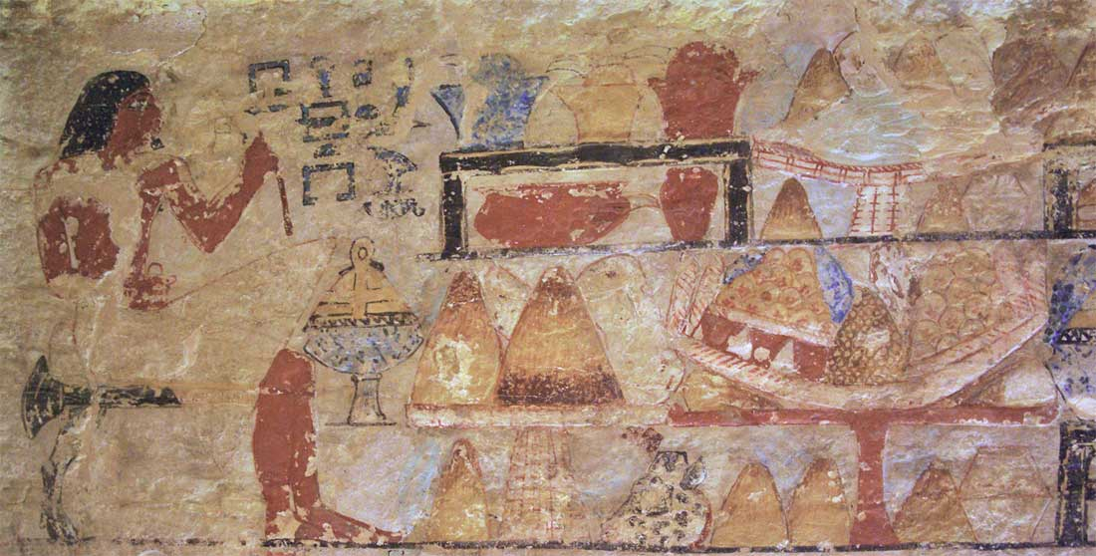
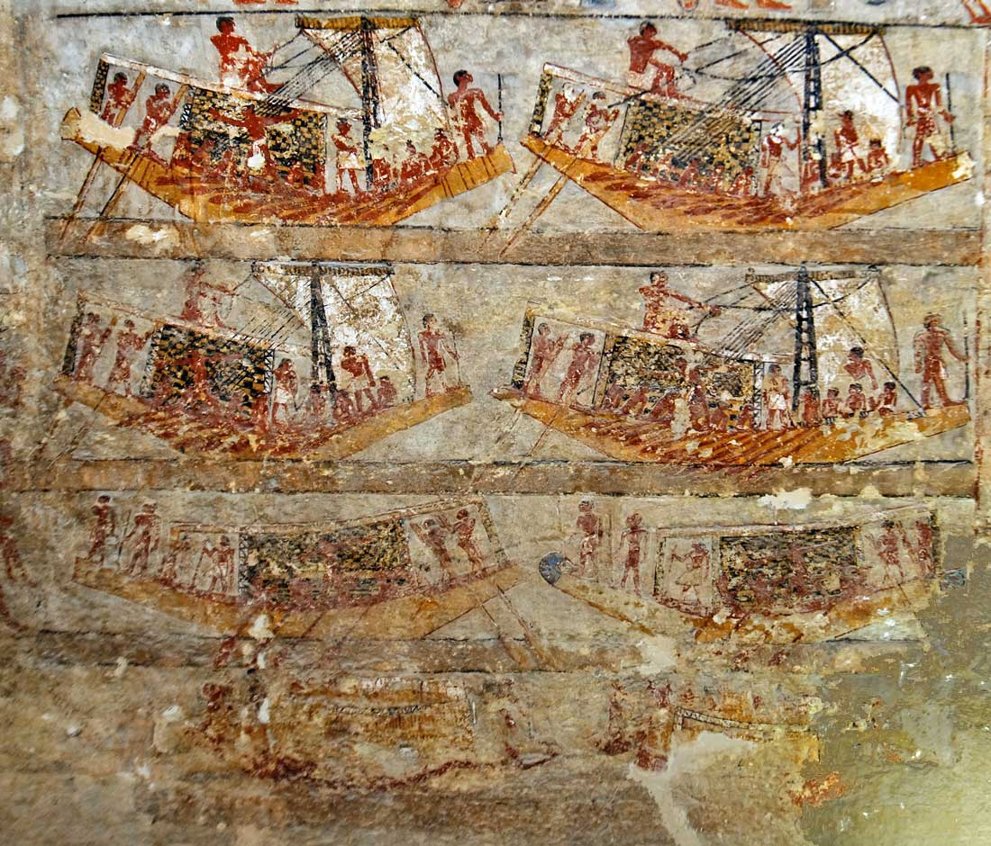
Fig 6. (Above) (Mariais & Benderitter, 2005). Boats and representations of them have become common place at many Egyptian burial sites. The Nile geographically ran all the way across much of their world, so boats were a common feature of life. Irukaptah appears to take a central seat in these illustrations, perhaps purveying his perceived importance and the voyages and trading he participated in his life. Possessing a dual meaning is that also ‘dying was likened to the arrival of a boat at its harbour- the end of one journey but the beginning of another’ (Taylor, 2001, pp.13). These boats symbolised the Nile’s ever-present influence and the movement of death as the body travelled to the afterlife (Davis, 2020), this model materiality would have been a valuable addition to ease Irukaptah’s journey to the afterlife. For if he has his own boat, it may have influenced Ra’s decision to ‘raise him up into the sky upon his boat if deemed righteous’ (Haddad, 2021 pp. 31).
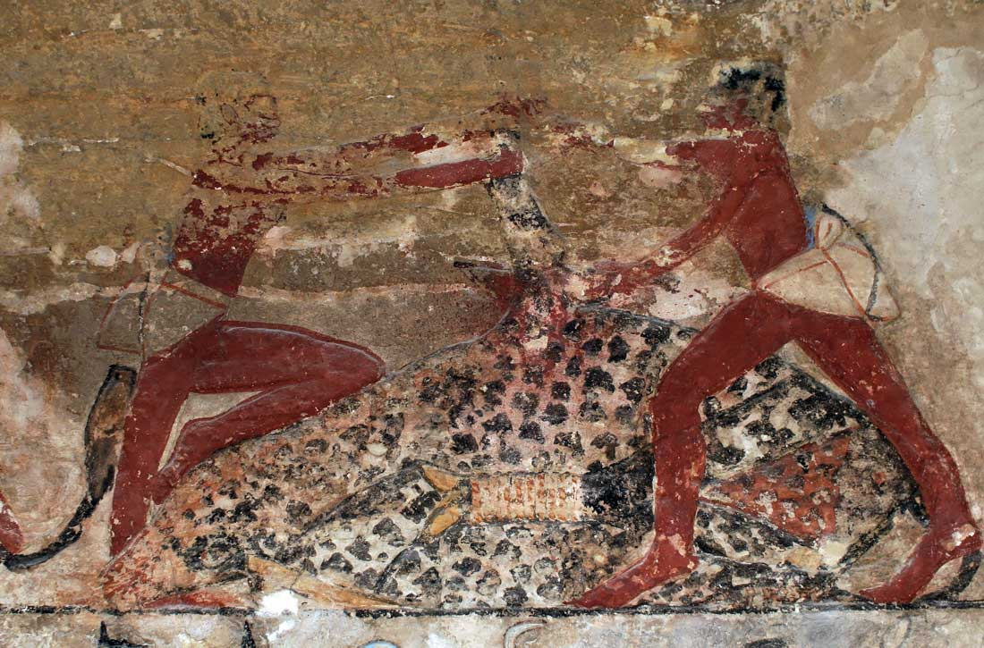
Fig 7. (Above) (Mariais & Benderitter, 2005). This tomb art represents a detailed portrayal of Irukaptah’s butcher’s processes, in which two individuals engage in the slaughter of oxen. This was done to distinguish Irukaptah’s identity, his royal libations, and to display (and perhaps retain) his knowledge and skill into the afterlife. To be judged by Osiris who would weigh the character and content of the deceased life, it was ideal to include as much material and detail as one could afford.
The culmination of Irukaptah’s tomb’s materiality, architecture and structure reveals much about Egyptian perspectives and beliefs on mortality, death, and the afterlife. Primarily the transitional attributes of the spirit, of each requires varying aspects of care and ritual to allow the deceased’s immortal form to be consolidated. Irukaptah was entombed with a great wealth yet still unfinished material throughout his tomb, it depicts his powerfully built statue form which would hold his Ka, while it enriched itself on offerings. With complimentary wall art, offering an insight into both the life and the idealized form of Irukaptah. This art was designed to comfort and ease the spirit of the dead, while not denying them from the world of the living in which death and the deceased created a socio-material performance that intertwined with the world of the living. Irukaptah’s tomb contains materiality in the pursuit of immortality after death, in which the written word could sustain his identity and protect Irukaptah from destruction. Comfort, continuation, and descriptive material culture allowed for the persona of Irukaptah to retain value and relevance to the living. While the symbolic (and contextual) nature of this tomb art and royal association maintained his position in the divine cosmos and his relationship to Osiris and Ra (Taylor, 2001, pp.27). Irukaptah could now independently of his sovereign, design his own image of immortality, which as a 5th Dynasty non-elite was unprecedented.

References:
Baines, J. Lacovara, P. (2002), Burial and the Dead in Ancient Egyptian Society, Journal of Social Archaeology, Vol. 2, No. 5, pp. 5-36, Published by: SAGE, Url: https://www.researchgate.net/publication/249631679_Burial_and_the_Dead_in_Ancient_Egyptian_Society, Accessed online: 19/09/21
Benderitter, T. (2005), Osirisnet: Tombs of Ancient Egypt, Irukaptah: The tomb of Irukaptah at Saqqara, Article, published by: Osirisnet, Url: https://osirisnet.net/mastabas/iroukaptah/e_iroukaptah_01.htm, Accessed online: 17/09/21
Chesson, M.S. (2007), Remembering and Forgetting in Early Bronze Age Mortuary Practices and the South-eastern Dead Sea Plain Jordan, No. 3, pp. 109 – 139,Published by: Oriental Institute of the University of Chicago, Url: https://oi.uchicago.edu/sites/oi.uchicago.edu/files/uploads/shared/docs/ois3.pdf, Accessed Online: 29/11/20
Cooney. J.D. (1952), Three Egyptian Families of the Old Kingdom, Brooklyn Museum Bulletin, Vol 13, No 3, pp. 1-18, Published by: Brooklyn Museum, Url: https://www-jstor-org.ezproxy.uwtsd.ac.uk/stable/26458644?seq=1#metadata_info_tab_contents, Accessed online: 20/09/21
Davis, W. (2020), Boats models and the afterlife in Ancient Egypt, [Article], pp. 1-1, Published by: University of Reading, url: https://collections.reading.ac.uk/wp-content/uploads/sites/7/2020/06/Model_boats_Ure_UoR.pdf
Delia, D. (1992), The Refreshing Water of Osiris, Journal of the American Research Center in Egypt, Vol. 92, pp. 181-190, Published by: American Research Center in Egypt, Url: https://www-jstor-org.ezproxy.uwtsd.ac.uk/stable/40000492?seq=3#metadata_info_tab_contents, Accessed online: 22/09/21
Fischer, H.G. (1975), An Elusive Shape within the Fisted Hands of Egyptian Statues, The Metropolitan Museum of Art, Vol. 10, pp. 9-21, Published by: Metropolitan Museum Journal, Url: https://www.metmuseum.org/art/metpublications/elusive_shape_within_fisted_hands_of_egyptian_statues_the_metropolitan_museum_journal_v_10_1975, Accessed online: 25/09/21
Fletcher, J. Timeline- World History Documentaries, (2018), The Real Origins Of Ancient Egypt | Immortal Egypt | Timeline, [Online Video], Published by: Youtube, Url: https://www.youtube.com/watch?v=Wo6OO992ywI&t=1011s, Accessed online: 25/09/21
Gallou, C. & Georgiadis, M. (2009), The Mycenaean cult of the dead and athletic contest in honour of the ancestors, pp. 383-393 Published by: Oxford Books, url: https://canvas.brown.edu/courses/1023508/files/58926520/download?download_frd=1, accessed online: 07/12/20
Haddad, C.G. (2021), The Lily of the Nile: A work on the ritualistic use of an ancient flower of immortality, Uppsala Universitet, pp. 1-39, Published by: Uppsala Universitet, url: http://www.diva-portal.org/smash/get/diva2:1560422/FULLTEXT01.pdf, Accessed online: 26/09/21
Harrington, N. (2012), Living with the Dead: Ancestor Worship and Mortuary Ritual in Ancient Egypt, Studies in Funerary Archaeology, Vol. 6, pp. 1-208, Published by: Oxbow Books, Url: https://www-jstor-org.ezproxy.uwtsd.ac.uk/stable/j.ctvh1ds21, Accessed online: 23/09/21
Hassan, H.A. (2017) Egypt and controlling the Nile: From mythologies to real politics, Egypt and the Nile River: How to Enhance Cooperation in the Nile Basin, Vol. 1, pp. 1-8, Published by: Pambazuka News, Url: https://www.researchgate.net/publication/321419899_Egypt_and_controlling_the_Nile_From_mythologies_to_real_politics_Published_on_Pambazuka_News_httpswwwpambazukaorg, Accessed online: 22/09/21
Lemos, R. (2018) Perspectives on Materiality in ancient Egypt – agency, cultural reproduction, and change, Access Archaeology, Materiality and Cultural reproduction in non-elite cemeteries, pp. 24-34, Published by: Archaeopress, Url: https://www.archaeopress.com/ArchaeopressShop/Public/download.asp?id=%7BD8605B9B-BA5C-4938-AB2E-9ADAF03872D7%7D, Accessed online: 23/09/21
Loynes, R. (2015), Prepared for Eternity: A study of human embalming techniques in ancient Egypt using computerised tomography scans of mummies, Archaeopress Egyptology, Vol. 9, pp. 1-251, Published by: Archaeopress, url: https://www-jstor-org.ezproxy.uwtsd.ac.uk/stable/j.ctv177tj77, Accessed online: 18/09/21
Meskell, L. (2001), The Egyptian Ways of Death, Archaeological Papers of the American Anthropological Association, Vol, 10, No. 1, pp. 27-40, Published by: American Anthropological Association, url: https://www.researchgate.net/publication/229832548_The_Egyptian_Ways_of_Death, Accessed online: 20/09/21
Morgan, L. (2011), Enlivening the Body: Colour and Stone Statues in Old Kingdom Egypt, Notes in the history of Art: Approaches to Painted Sculpture, Vol. 30, No. 3, pp. 4-11, Published by: University of Chicago Press, Url: https://www-jstor-org.ezproxy.uwtsd.ac.uk/stable/23208555?seq=3#metadata_info_tab_contents, Accessed online: 26/09/21
Raven, M.J. (2005), Egyptian Concepts on the Orientation of the Human Body, The Journal of Egyptian Archaeology, Vol. 91, pp. 37-55, Published by: Sage Publications, Url: https://www-jstor-org.ezproxy.uwtsd.ac.uk/stable/3822392?seq=1#metadata_info_tab_contents, Accessed online: 21/09/21
Schiffer, M.B. (2009) Reviewed Work: Material Cultures, Material Minds: The Impact of Things on Human Thought, Society and Evolution by Nicole Boivin, technology and Culture, Vol. 50, No. 3, pp. 677-679, Published by: The Johns Hopkins University Press and the Society for the History of Technology, Url: https://www-jstor-org.ezproxy.uwtsd.ac.uk/stable/40345740?seq=2#metadata_info_tab_contents, Accessed online: 22/10/20
Snape, S. (2011), Ancient Egyptian Tombs: The culture of life and death, Vol. 1, pp. 1-303, Published by: Wiley-Blackwell, Url: https://www.wiley.com/en-gb/Ancient+Egyptian+Tombs%3A+The+Culture+of+Life+and+Death-p-9781444393736, Accessed online: 20/09/21
Taylor, J.H. (2001), Death and the Afterlife in Ancient Egypt, pp. 1 – 278, Vol. 1, Published by: British Museum Press, url: https://trove.nla.gov.au/work/32757930/version/39979938?keyword=Death%20and%20the%20Afterlife%20in%20Ancient%20Egypt, accessed online: 18/09/21
Vitali, A. (2016), Setting Sail for the After Life, Cooper Hewitt, Article, pp. 1-3, Published by: Cooper Hewitt, url: https://www.cooperhewitt.org/2016/06/07/setting-sail-for-the-afterlife/, Accessed online: 22/09/21

Figures:
1-7: Benderitter, T. Mariais, C. (2005), Osirisnet: Tombs of Ancient Egypt, Irukaptah: The tomb of Irukaptah at Saqqara, Article, Published by: Osirisnet, Url: https://osirisnet.net/mastabas/iroukaptah/e_iroukaptah_01.htm, Accessed online: 17/09/21

