
8/8/2026
Software Solution for Business
Module Code: (ACCA4026_LON)
Lecturer: Kwame Assa-Agyei
Muhammad Saqib Khan

Contents
Introduction 1
Task 1. e-Commerce Website builders/software solutions 1
1.1 Wix 1
1.2 Google Site 2
Task 2. Mind-map of contemporary software applications 3
2.1 Describe mind mapping and explain the benefits of using mind mapping 3
2.2 Create a mind map of contemporary software applications 5
Task 3. Office Applications 5
3.1 Four office software solutions for business operations 5
Ms Word 5
Ms Excel 7
Ms PowerPoint 8
Ms Access 9
3.2 Test any two features 10
Mail Merge 10
IF Statement 13
Task 4. Communication and Collaboration applications 14
4.1 One contemporary Communication and one Online Collaboration 14
Gmail 14
Zoom 15
4.2 Test one feature of a freely available Communication (1) and one feature of a Collaboration (1) application 16
Gmail 17
Zoom 19
Conclusion 21
References 23

Introduction
Technology is a key element in the modern business landscape, allowing businesses to carry out their day-to-day activities successfully and efficiently. Different sorts of software programs used by businesses to connect with their customers and employes, manage information, analyse data, produce papers, provide presentations and support online business operations. The right software may allow an organization to increase productivity, communication, collaboration and decision making.
This paper looks at a number of current software programs utilised in company operations. First, it talks about Wix and Google Sites as tools for creating websites. It explains how companies may utilise these tools to construct a web presence and describes their primary features and uses. The paper also looks at mind mapping and how this may help with ideation, planning, organization, problem solving and cooperation inside a firm.
The paper also examines communication and collaboration apps like Gmail and Zoom, evaluating their advantages and disadvantages for corporate applications. Finally, it covers four major Microsoft office products including Microsoft Word, Microsoft PowerPoint, Microsoft Excel and Microsoft Access. The major features, commercial uses, advantages and limits are addressed to show how each application might help various parts of the company operations.
The objective of this report is to demonstrate how a range of software solutions can assist organisations to communicate, collaborate, organise information, analyse data and improve productivity and to consider the limitations that organisations need to be aware of when choosing and using these technologies.

Task 1. e-Commerce Website builders/software solutions

1.1 Wix
Wix is a cloud-based website builder with a simple drag-and-drop interface that allows even beginners to construct sophisticated websites. It provides over 900 templates that may be customized to fit various businesses, such as retail, restaurants, and professional services. Wix comes with builtin ecommerce technologies including secure online payments, shopping carts, inventory management, shipping choices, and marketing tools like email campaigns and SEO.One of Wix's most significant features is its flexibility. Users may create webpages without coding and add additional features via the Wix App Market.It also offers mobile optimization, which ensures that webpages perform properly on smartphones and tablets.
Once a template has been chosen, it cannot be modified without rebuilding the site. Some sophisticated features are only available with premium subscription options, thereby increasing prices for small organizations. One of the primary benefits of Wix for businesses is its e-commerce capabilities. The platform allows businesses to set up an online store, showcase items, receive online payments, and handle orders.
Another advantage of Wix is that websites may be made to run on both desktop and mobile platforms. This is significant since people are increasingly accessing company websites via smartphones and tablets. Wix also offers hosting and security services, which reduces the amount of technical expertise necessary by the business owner.
However, Wix does have certain limits. Although anyone may begin creating a website for free, companies often require a premium membership to use professional e-commerce capabilities and remove Wix branding. Overall, Wix is ideal for small and medium-sized enterprises looking for an easy platform to create and manage an online store. [1]

1.2 Google Site
Google Sites is a website-building application developed by Google that allows users to construct simple websites without the need for programming or web development expertise. It has an easy-to-use editing interface where users can add text, photos, buttons, and other elements. Websites may be browsed on computers, tablets, and smartphones. Integration with other Google products is a key aspect of Google Sites. Users may add material to a website using Google Drive, Docs, Sheets, Slides, Forms, Maps, and Calendar. This might be beneficial for businesses since information generated using many Google applications can be organized and shared via a single central webpage.
Google Sites also offers collaboration, which means that several employees can be granted authorization to edit and update a site. As a result, it might be beneficial for internal corporate websites, team projects, training materials, and information exchange within organizations. Google Sites is easy to use and comes as part of Google's services, making it a viable alternative for people and businesses. However, unlike Wix, its design and commercial options are more limited. Most notably, Google Sites is not a standalone e-commerce solution. It does not provide the same built-in online-store functionality as Wix, such as product inventory management, shopping carts, and integrated e-commerce checkout.
As a result, Google Sites is better suited to developing simple informative or internal company websites rather than a full-fledged online store. A firm that needs extensive e-commerce capabilities would typically require extra services or a separate e-commerce platform. [2]

Task 2. Mind-map of contemporary software applications

2.1 Describe mind mapping and explain the benefits of using mind mapping
Mind mapping is a visual approach for organizing and presenting information in a clear and systematic manner. A mind map often starts with a core topic or idea in the centre, and branches stretch outward to indicate related thoughts, tasks, or information. Each branch can then be broken into smaller sub-branches to offer further information. Mind maps can feature keywords, colours, symbols, images, and linkages to help people absorb complicated material. According to Buzan and Buzan (2010), mind mapping can assist organize thoughts by displaying the links between various kinds of information.
Mind maps may be developed in modern enterprises with software tools such as Mind Meister, XMind, and Miro. Employees can use digital mind-mapping apps to easily develop, modify, organize, and exchange ideas. They are especially effective for brainstorming, project planning, meetings, issue solving, and creating corporate strategy.
One significant advantage of mind mapping is greater organization. Employees can divide a major job or difficulty into smaller portions, making information more manageable. For example, while designing a marketing campaign, a firm may construct different branches for the budget, target clients, advertising, social media, and deadlines. Another advantage is improved communication and teamwork. A mind map gives employees a visual picture of a topic, allowing team members to see how different ideas and actions are related. Online mind-mapping software may also allow several employees to contribute ideas and make modifications, promoting cooperation, even when employees are working away.
Mind mapping can also aid in creativity and brainstorming. During a company discussion, employees can swiftly capture various thoughts without having to type lengthy paragraphs. New concepts can then be linked to existing branches and organized into appropriate categories. Davies (2011) shows that mind mapping can help learners produce and correlate ideas, but its success is dependent on how it is employed.
Mind maps can also help people make decisions and solve problems. Before making a choice, managers can graphically organize potential solutions, benefits, drawbacks, and critical aspects. This can make complex business challenges easier to investigate. Overall, mind mapping is a beneficial approach for organizations since it allows employees to organize information, develop ideas, interact with colleagues, and plan operations. Digital mind-mapping software improves the ease with which mind maps may be edited, stored, and shared. However, mind maps should be used in conjunction with other business tools since extremely detailed information may be best displayed in papers, spreadsheets, or databases. [3]

2.2 Create a mind map of contemporary software applications

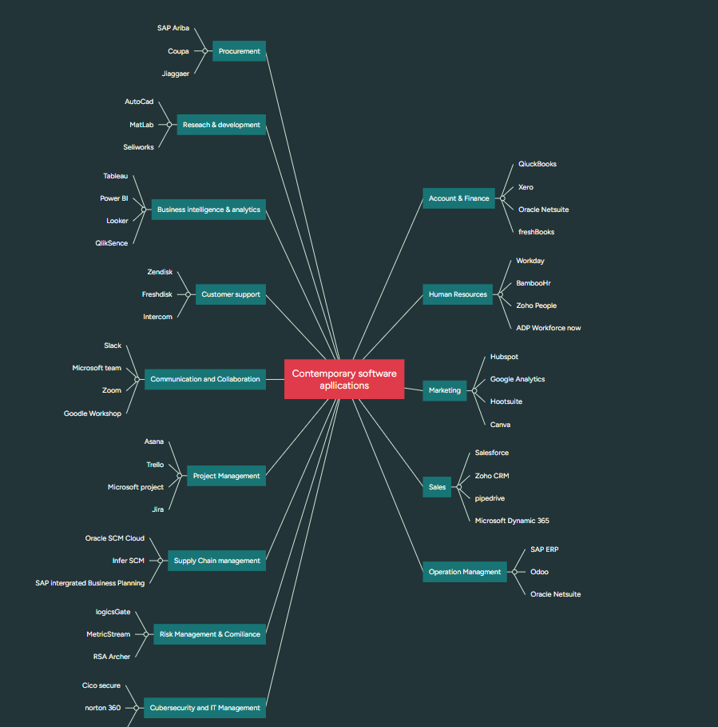

Task 3. Office Applications

3.1 Four office software solutions for business operations

Ms Word
Microsoft Word is a word processing software tool created by Microsoft. It is widely used by organizations to produce, edit, format, and distribute professional documents. Businesses may use Word to create letters, reports, contracts, meeting agendas, policies, invoices, newsletters, and other written materials.

Major Features
Microsoft Word has several essential tools for business operations. It provides formatting features that let you adjust fonts, headers, colours, margins, and page layouts. Businesses can also utilize templates to generate professional papers with standard formatting.
Mail Merge is another significant function that enables organizations to produce personalized documents for many consumers or employees. For example, a corporation may send the identical message to 200 consumers while automatically altering their names and addresses. Word also has spell and grammar checkers, tables, pictures, headers and footers, page numbering, Track Changes, and comments. Track Changes is useful when several employees need to examine and change the same document.
Benefits
One big advantage of Microsoft Word is that it allows organizations to create professional documents rapidly. Templates can save employees time by eliminating the need to produce papers from scratch. Word also increases teamwork by allowing employees to evaluate papers, provide comments, and suggest modifications. Documents kept online may be shared with coworkers, allowing employees to collaborate from several places. Another advantage is consistency. Businesses may maintain a professional business image by using the same templates, fonts, logos, and layouts in all their publications.
Limitations
One issue is that several services require a Microsoft 365 membership, which incurs additional costs for enterprises. Formatting may also vary when documents are opened in various apps. Word is also not appropriate for many commercial activities. For example, complex computations are best accomplished in Excel, yet vast volumes of organized customer information may be better maintained using database software such as Access.
Business Uses
- Business letters and reports
- Contracts and policies
- Meeting agendas and minutes
- Invoices
- CVs and job descriptions
- Newsletters and promotional materials [3]

Ms Excel
Businesses may use Microsoft PowerPoint, a presentation program, to convey information using slides. Text, images, charts, tables, diagrams, videos, music, and animations can all be used in a presentation. Meetings, conferences, training sessions, sales presentations, and company pitches all often utilize PowerPoint.
Major Feature
The variety of templates and themes available in PowerPoint is one of its key advantages. These let companies to produce polished presentations using standardized fonts, colours, and layouts. Multimedia material, including images, movies, and audio, is also supported by PowerPoint. Complicated business information may be presented in a more visual and intelligible manner with the use of charts and SmartArt. Presenter View, speaker notes, animations, and transitions are additional capabilities. Additionally, companies may work together on presentations, enabling many staff members to participate to the same project.
Benefits
Because PowerPoint allows organizations to integrate written information with visual features, it may make information easier to grasp. For instance, a manager may use a chart to demonstrate whether sales have risen or dropped rather than a lengthy list of sales numbers. Additionally, it can add interest to presentations. Diagrams, movies, and pictures may keep viewers interested. Because businesses may design templates with their logo, chosen fonts, and colours, PowerPoint is particularly helpful for keeping consistent corporate identity.
Limitation
One drawback is that overly detailed slides might render presentations useless. A presentation with a lot of text may be hard to read. Overuse of visual effects, animations, and transitions can potentially divert viewers. Additionally, presenters risk becoming overly reliant on their slides rather than interacting organically with the audience. A Microsoft 365 membership might be necessary for some functions.
Business Uses:
PowerPoint is used for:
- Business meetings and staff training
- Presentations for sales
- Proposals for marketing
- Presentations of projects
- Financial outcomes
- Meetings [4]

Ms PowerPoint
Microsoft PowerPoint is a presentation program made by Microsoft. It is a tool for creating presentations via a sequence of slides. These slides may include text, photographs, charts, tables, videos, music, diagrams and animations. PowerPoint is a regularly used tool in enterprises for meetings, staff training, sales presentations, project proposals, marketing presentations and conferences.

PowerPoint offers a variety of templates, themes and layouts to assist users produce professional-looking presentations. For businesses, slides may also be branded with a corporate logo, colours and other branding. One valuable feature is Presenter see, which lets presenters to see their notes as they present (Microsoft, 2026).

Benefits of Microsoft PowerPoint
- User friendly: PowerPoint offers templates and easy editing tools that enable users to make excellent presentations without requiring sophisticated technical abilities.
- Visual communication: Users may add charts, photos, graphs and films which can make hard business information simpler to grasp.
- Consistent colours, logos, fonts and designs enable businesses to maintain their professional brand image.
- Collaboration friendly: Employees may work on presentations together and provide input, which is handy for working on team projects.
- Training: Businesses may use PowerPoint to produce training presentations for new and current employees.
- Data presentation: Charts and graphs may be used to graphically display information such as sales, expenses and company performance.
- Multimedia features: Videos, music, animations and transitions may make your presentations more interesting.
Limitation of Microsoft PowerPoint
- Too much info: Putting too much text or facts on slides might make a presentation difficult to grasp.
- Effects overuse: Too many animations, transitions and visual effects might distract the viewer from the important material.
- Technical problems: Problems with computers, projectors, internet connections or incompatible files may hinder presentations.
- Subscription costs: PowerPoint and other features may need a Microsoft 365 subscription for business use.
- Dependence on the presenter: A presenter who is not well prepared may just read out material on the slides, which might make the presentation less interesting.
- effort-consuming: Creating a good presentation with the right visuals, animations and formatting may take a lot of effort. [5]

Ms Access
Microsoft Access is a database management program created by Microsoft. It lets companies to produce, store, organise and manage enormous volumes of structured information. Whereas Excel is mostly spreadsheets, Access is a relational database . This means information may be stored in different tables and linked by relationships . Businesses may use Access to handle customer information, employe records, stock, goods, suppliers and orders. The fundamental elements of a database are tables, queries, forms and reports (Microsoft, 2026). Advantages of Microsoft Access Access organises company data: Businesses may retain a vast quantity of information in Access, arranged in distinct tables. Reduces data redundancy: Relationships between tables might eliminate the requirement of entering the same information repeatedly. Queries allow businesses to swiftly search, filter, and retrieve specified information. For example, a manager may want to retrieve all the orders a client placed in each month. Forms:
Forms provide employes a better structured, simpler approach to input information into a database.
- Reports: Managers may run reports from stored information to examine, print and analyse vital company data.
- Improved efficiency: information can be found and retrieved more rapidly than manually going thru vast volumes of records.
- Integration: Access may combine data from other Microsoft programs and other data sources. Constraints of Microsoft Access
- Requires database knowledge: For the novice, access might be harder since users need to grasp tables, relationships, primary keys and queries.
- Training may be required: Employes may need training to be able to efficiently construct and maintain complicated databases. Not good for extremely big databases: Access is not a good option for large businesses with enterprise size databases and numerous simultaneous users. Design mistakes If the tables and relationships are not properly designed, the database can include redundant, missing or wrong information.
- Platform limitations: The software is mainly available as a desktop program for Windows, which may be less accessible for businesses that use other operating systems. Cost: Access is available under certain Microsoft 365 subscriptions and plans, therefore organisations may need to pay to access it. [6]

3.2 Test any two features

Mail Merge

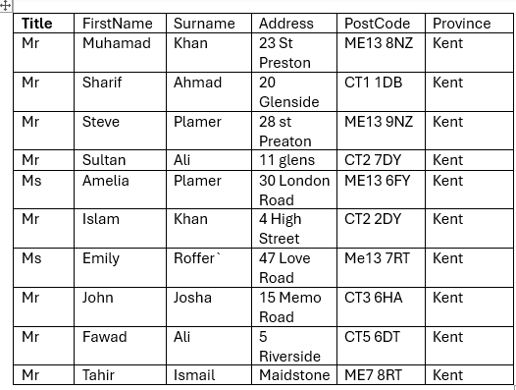

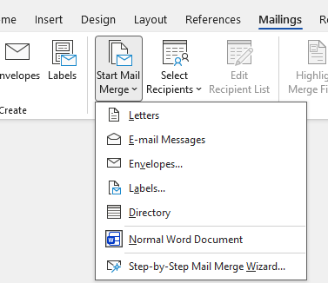
Selecting mail

In this selection I done the select the Mail Merge and selected the letter.

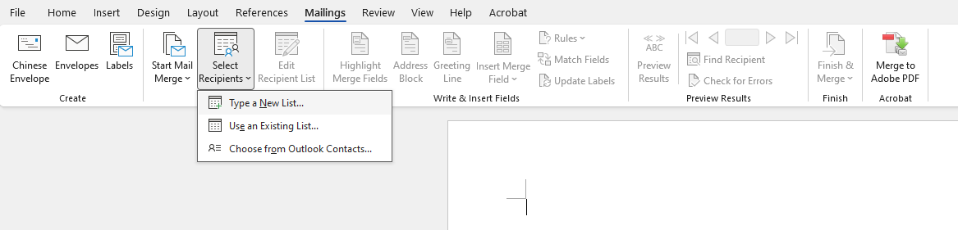

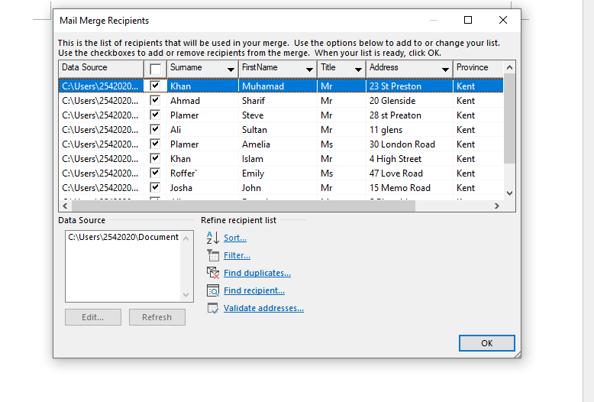

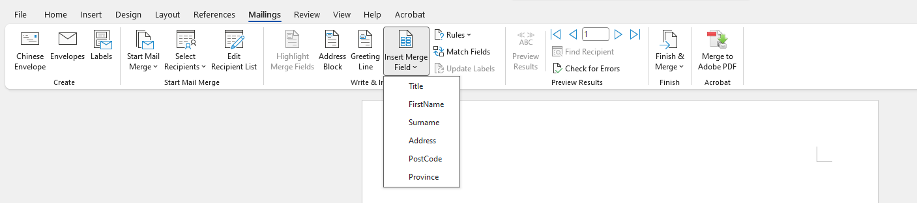

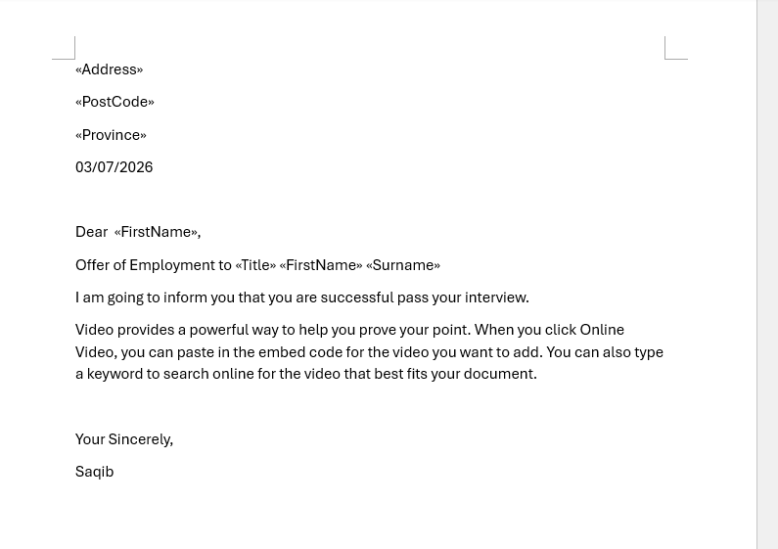

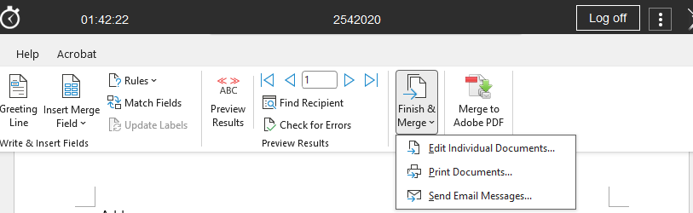

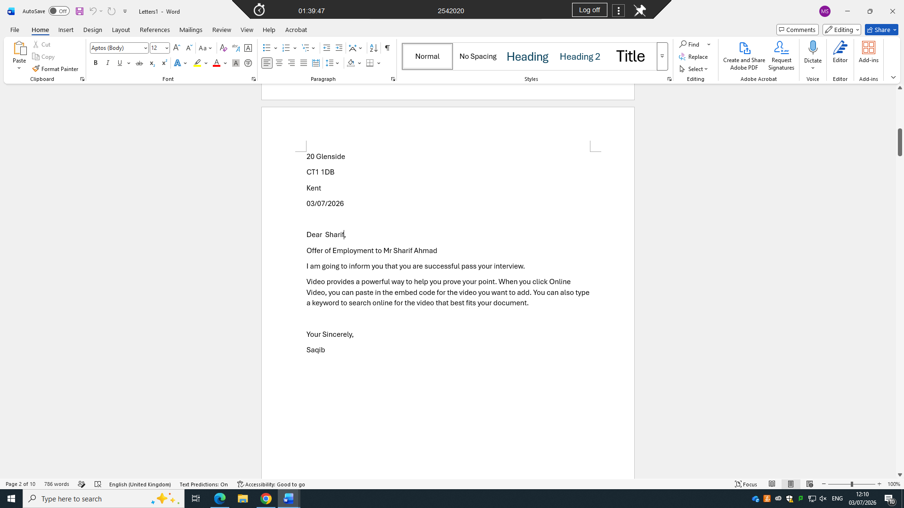

IF Statement



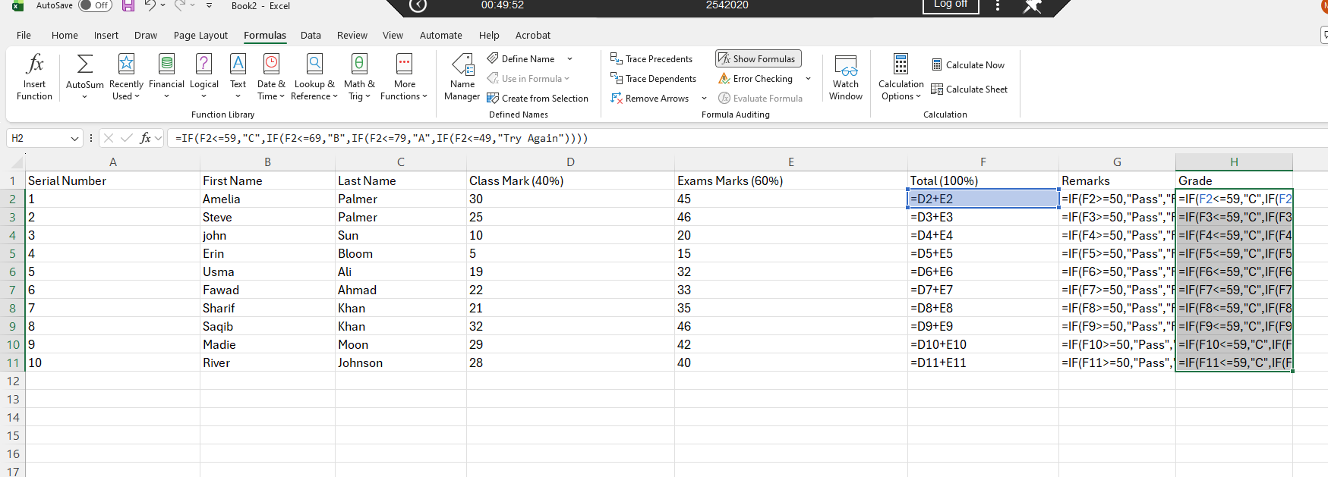

Task 4. Communication and Collaboration applications

4.1 One contemporary Communication and one Online Collaboration

Gmail
Gamil is a free webmail service created by google on April 1, 2004, lunched as a private, invitation only for beta test. February 7,2007 it was open for all public allow to create account to anyone without invitation. In July 7,2009 it was officially left the beta version and become the full product.
Gmail can operate anywhere due to its webmail service interface and user friendly.
Benefits
Gmail provides helpful features that made user super easy to do their job like Snooze, undo sends, and schedule send along with written style, writing suggestion and suggested replies. Gamil can also create a reuseable template for frequently massages and show availability in calendar for the meeting.
- Effortless correspondence: Gmail enables enterprises to swiftly send and receive emails, facilitating contact with staff, clients, and vendors.
- Extensive storage capability: Users are provided with cloud-based storage, enabling them to retain a substantial volume of emails and files.
- Google Workspace integration: Gmail collaborates with many Google products like Google Drive, Calendar, Meet, and Docs. This may enhance cooperation and efficiency within an organization. Gmail offers spam filtration and security mechanisms aimed at safeguarding users from undesirable or possibly dangerous communications. Access via many devices: Employees can use Gmail on PCs, cell phones, and tablets, facilitating distant and adaptable work arrangements. Gmail offers search capabilities, labels, filters, and categories that assist employees in systematically organising and retrieving messages. Utilising Google Workspace, companies may use Gmail with a personalised corporate email address derived from their own domain. [7]

Zoom
Advantages of Zoom Zoom is a platform for video conferencing and communication that enterprises may use for virtual meetings, online training, webinars, and interactions between staff and clientRemote interaction: A primary advantage of Zoom is that employes may engage in face-to-face conversation without needing to occupy the same physical space.
This is especially advantageous for enterprises with remote or hybrid employes. Diminished operational expenses: Zoom may decrease the need for personnel to travel for meetings. This may assist enterprises in reducing costs associated with transportation, lodging, and other travel-related expenditures. Screen sharing: Team members can display their screens in meetings to showcase documents, spreadsheets, presentations, and more data. This is beneficial for exhibitions, instruction, and cooperative endeavours. Meeting documentation: Based on the configuration and strategy, meetings may be documented for further consultation. A company could record a training session for employes to revisit subsequently. Collaboration: Tools like chat, screen sharing, whiteboards, and breakout rooms may promote employe engagement and teamwork in virtual meetings. Accessibility: Zoom is available on PCs, tablets, and smartphones, enabling employes to join meetings from many places. Zoom provides features tailored for extensive meetings and webinars, beneficial for corporate presentations, training sessions, and events. [8]
Limitation of Zoom
- Internet reliance: Zoom needs a stable internet connection for optimal performance. Subpar internet connectivity may lead to video freezing, audio lag, or disconnection of participants.
- Subscription expenses: While Zoom offers a free alternative, enterprises could need paying subscriptions to use enhanced functionalities and meet their needs.
- Time constraints: Complimentary Zoom meetings may be subject to duration limitations based on the meeting type and existing plan stipulations. This may pose challenges during extended business discussions.
- Security and privacy: Organisations must properly set up meetings and accounts to safeguard sensitive information. Utilise features like meeting passwords, waiting rooms, and access restrictions where suitable.
- Technical challenges: Staff may encounter issues with microphones, cameras, speakers, or software, potentially disrupting meetings.
- Diminished personal engagement: Virtual meetings may lack the same degree of personal contact as in-person communication, especially for activities where physical presence and casual dialogue are essential. Prolonged video meetings might lead to tiredness, diminishing employees' focus and involvement. [8]

4.2 Test one feature of a freely available Communication (1) and one feature of a Collaboration (1) application

Gmail
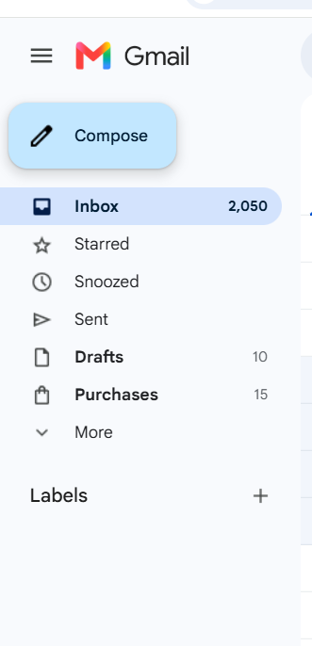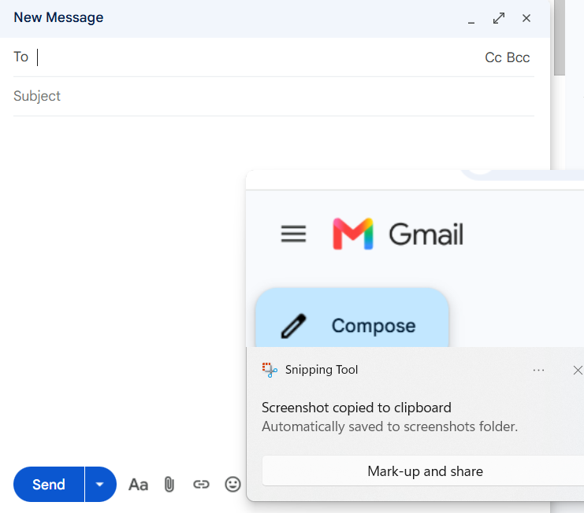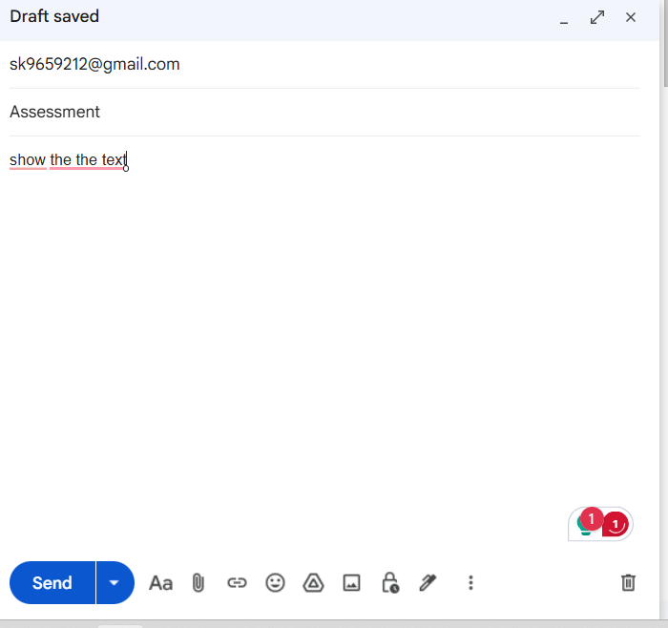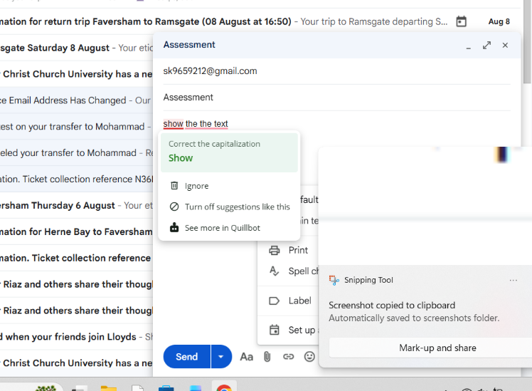
Compose the email click here to open the text page
Body of the mail
Subject of the mail
Sender whos you want to send email
Click here to send

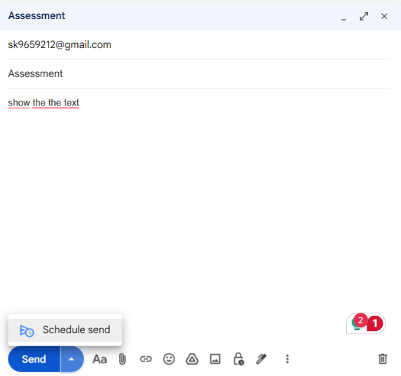
Schedule the mail

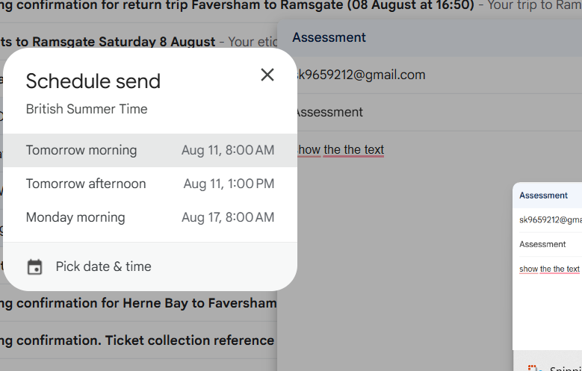
Select time for schedules mails

Zoom
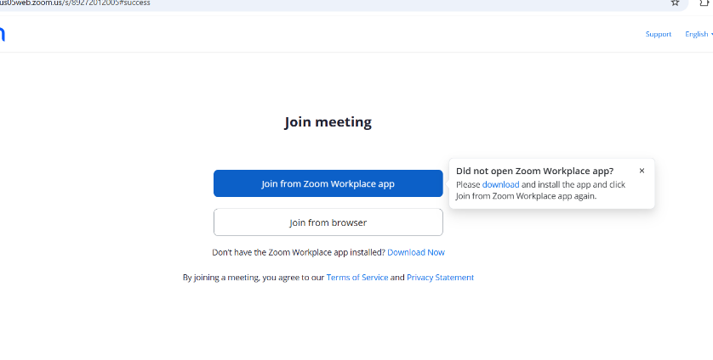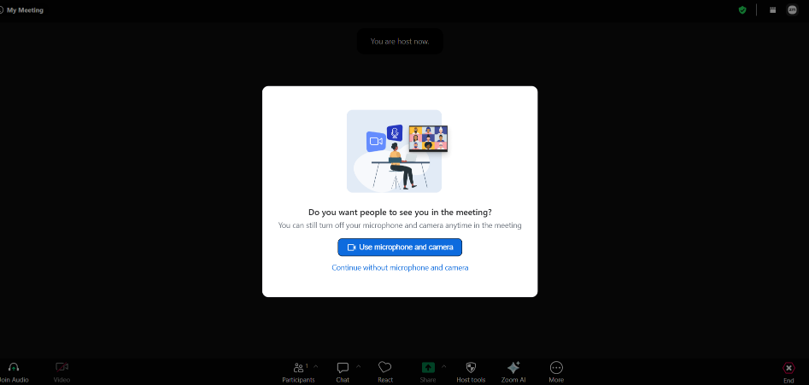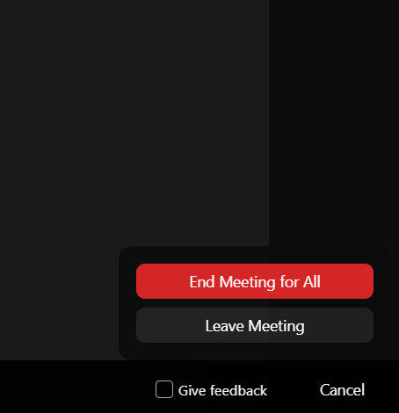
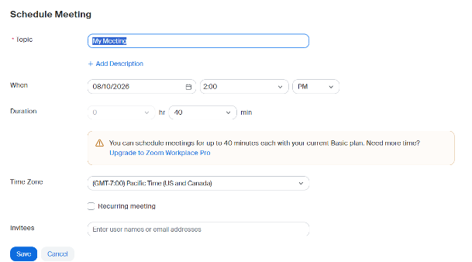

Conclusion
To conclude, modern software programs play a significant role in assisting firms to run efficiently and successfully. This study has discussed certain software solutions that help with various aspects of company operations. Both Wix and Google Sites provide the ability to build websites and an online presence, but Wix offers more complex tools if you need e-commerce capabilities for your company.
Mind mapping may help organisations plan, brainstorm, solve problems and organise ideas. Communication apps such as Gmail and Zoom enable employees, customers and other stakeholders to interact and cooperate from multiple places.
The survey also looked at Microsoft Word, PowerPoint, Excel and Access. Word is for professional business papers, PowerPoint is for visual presentations, Excel is for computations and data analysis for organisations, and Access is for tools for storing and managing structured information via databases.
Every software program has its own perks and limits and so, companies should choose the software according to their needs, budget available and talents of their employees. Appropriate software may assist organisations in increasing efficiency, improving communication, organising information, supporting decision-making and providing better services to clients in general.

References

[1] | W. site, “eCommerce Website Builder,” 2006. [Online]. Available: https://www.wix.com/ecommerce/website.
[2] | google, “Google Sites: Website Creator and Hosting,” 2026. [Online]. Available: https://workspace.google.com/products/sites/.
[3] | T. Buzan and B. Buzan, The Mind Map Book: Unlock Your Creativity, Boost Your Memory, Change Your Life, BBC Active, 2010.
[4] | Microsoft, “Word help & learning,” 2026. [Online]. Available: https://support.microsoft.com/en-us/word.
[5] | Microsoft, “Excel help & learning,” 2026. [Online]. Available: https://support.microsoft.com/en-us/excel.
[6] | Microsoft, “PowerPoint help & learning,” 2026. [Online]. Available: https://support.microsoft.com/en-us/powerpoint.
[7] | MIcrosoft, “Access help & learning,” 2026. [Online]. Available: https://support.microsoft.com/en-us/access.
[8] | Google, “Gmail: Private and secure email,” 2026. [Online]. Available: https://www.google.com/gmail/about/.
[9] | Zoom Communications, Inc., “Zoom Workplace,” 2026. [Online]. Available: https://www.zoom.com/en/products/collaboration-tools/.

