
International Market Entry Strategy and Marketing Mix Analysis

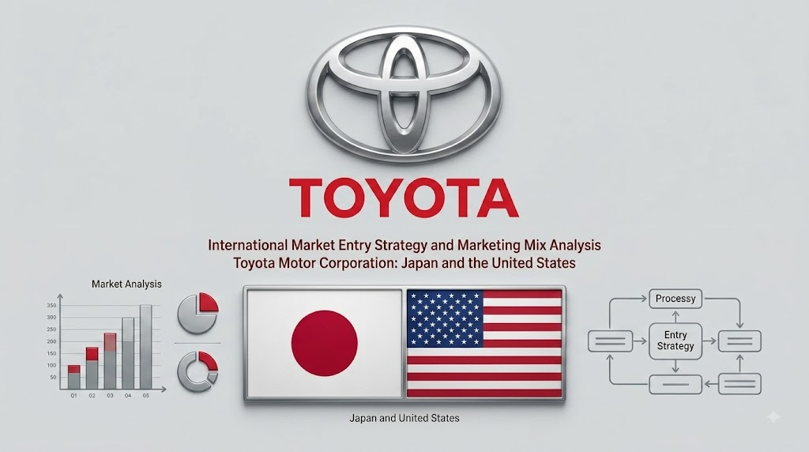
Toyota Motor Corporation: Japan and the United States
Assessment: Individual report.
Module name: International Marketing Principles and Practices
Module code: LCMB7026
Lecturer name: Tushara Balendran Dian Mayasari

Student name: Ashraful Hoque
Student ID: 2522430

Word count: 5,000 words (±10%)
Submission date: 13th August
University of Wales Trinity Saint David

Acknowledgement of AI Tool Use

In accordance with the UWTSD AI Use Acknowledgement Guidelines (February 2026), following the VRIO framework using Barney (1991) which is research and proofreading as indicated in the assessment brief.

I acknowledge the use of Perplexity AI (https://www.perplexity.ai/) on 30 July 2026 to support my research using the prompt(s):

What are Toyota’s global vehicle sales volume, Japan and US revenue contributions, and market share figures for recent years?

Summarise key differences in GDP per capita, median age and automotive demand patterns between Japan and the United States.

I confirm that I have not presented any AI-generated text as my own work. I confirm I have copies of my drafts, notes, and other resources I used before and after the use of AI tools, which I may be asked to provide as evidence.

I acknowledge the use of Google Gemini (https://gemini.google.com/) on 1 August 2026 to support my research using the prompt(s):

Provide a comparative PESTEL analysis of Japan versus the United States focused on political, economic, social and technological factors relevant to the automotive industry.

Explain Hofstede’s cultural dimensions with specific scores for Japan and the United States and their implications for car marketing.

Summarise Toyota’s US market entry history including the Crown failure, NUMMI joint venture and Georgetown plant.

I confirm that I have not presented any AI-generated text as my own work. I confirm I have copies of my drafts, notes, and other resources I used before and after the use of AI tools, which I may be asked to provide as evidence.

I acknowledge the use of Microsoft Copilot (https://copilot.microsoft.com/) on 3 August 2026 to support my research using the prompt(s):

Outline STP strategies for Toyota in Japan versus the United States, including segmentation bases and positioning differences.

Compare the 7Ps marketing mix adaptation requirements for Toyota’s product, price, place and promotion decisions across the two markets.

I confirm that I have not presented any AI-generated text as my own work. I confirm I have copies of my drafts, notes, and other resources I used before and after the use of AI tools, which I may be asked to provide as evidence.

I acknowledge the use of ChatGPT (https://chatgpt.com/) on 5 August 2026 to support my research using the prompt(s):

Apply the standardisation-versus-adaptation debate to Toyota’s product range, pricing and promotional approaches in Japan and the US.

Summarise key ethical issues in Toyota’s US marketing including the unintended acceleration crisis and greenwashing concerns.

I confirm that I have not presented any AI-generated text as my own work. I confirm I have copies of my drafts, notes, and other resources I used before and after the use of AI tools, which I may be asked to provide as evidence.

I acknowledge the use of Claude AI (https://claude.ai/) on 7 August 2026 to support my research using the prompt(s):

Analyse Toyota’s hybrid-versus-battery EV strategy and the implications of the US Inflation Reduction Act for its product decisions.

Discuss the Uppsala model and wholly owned subsidiary entry mode in the context of Toyota’s US expansion.

I confirm that I have not presented any AI-generated text as my own work. I confirm I have copies of my drafts, notes, and other resources I used before and after the use of AI tools, which I may be asked to provide as evidence.

I acknowledge the use of Grok (https://x.ai/) on 8 August 2026 to support my research using the prompt(s):

Identify strategic recommendations for Toyota to close the digital gap and accelerate battery EV commitment in the United States.

Summarise customer satisfaction and repeat-purchase differences between Toyota’s Japanese and American markets.

I confirm that I have not presented any AI-generated text as my own work. I confirm I have copies of my drafts, notes, and other resources I used before and after the use of AI tools, which I may be asked to provide as evidence.

I acknowledge the use of SciSpace (https://typeset.io/) on 9 August 2026 to support my research using the prompt(s):

Locate and summarise key academic sources on Hofstede’s framework critiques, the 7Ps services marketing mix and international market entry modes for automotive firms.

I confirm that I have not presented any AI-generated text as my own work. I confirm I have copies of my drafts, notes, and other resources I used before and after the use of AI tools, which I may be asked to provide as evidence.

I acknowledge the use of Grammarly (https://www.grammarly.com/) on 11 August 2026 to check my work using the prompt(s):

Review the full draft for grammar, spelling, academic tone, clarity and flow, with particular attention to the PESTEL, Hofstede, STP, 7Ps and ethics sections.

Improve readability of the reflective account while maintaining first-person voice.

I confirm that I have not presented any AI-generated text as my own work. I confirm I have copies of my drafts, notes, and other resources I used before and after the use of AI tools, which I may be asked to provide as evidence.

I acknowledge the use of Quillbot (https://quillbot.com/) on 12 August 2026 to check my work using the prompt(s):

Paraphrase the academic tone in the recommendations and market entry strategy sections without changing core arguments or data.

I confirm that I have not presented any AI-generated text as my own work. I confirm I have copies of my drafts, notes, and other resources I used before and after the use of AI tools, which I may be asked to provide as evidence.

Table of Contents
Table of Contents 6
List of Figures 7
SECTION 1: International Market Entry Strategy and Marketing Mix 8
1.0 Introduction 8
2.0 Comparative Macro-Environmental Analysis (PESTEL) 8
2.1 Political Environment 9
2.2 Economic Environment 9
2.3 Social Environment 10
2.4 Technological Environment 11
2.5 Environmental and Legal Environment 11
3.0 Cultural Analysis: Hofstede's Framework 11
4.0 Segmentation, Targeting, and Positioning (STP) 13
4.1 Segmentation 13
4.2 Targeting and Positioning 14
5.0 International Marketing Mix: The 7Ps 14
5.1 Product 15
5.2 Price 16
5.3 Place (Distribution) 17
5.4 Promotion 18
5.5 People, Process, and Physical Evidence 19
6.0 Market Entry Strategy: United States 20
7.0 Ethical Issues in Toyota's Marketing: United States 22
8.0 Recommendations 22
SECTION 2: Reflective Account 24
Reflective Account Using Gibbs' Reflective Cycle (1988) 24
Description 24
Feelings 24
Evaluation 24
Analysis 25
Conclusion 25
Action Plan 25
Reference List 27

List of Figures
Figure 1: GDP Comparison, Japan vs. United States (2023)
Figure 2: Hofstede Cultural Dimensions, Japan vs. United States
Figure 3: Automotive Market Share Comparison (2023)
Figure 4: Toyota Revenue Trends, Japan vs. United States (2018 to 2023)
Figure 5: Toyota Model Price Comparison (2023)
Figure 6: Toyota Sales by Vehicle Segment (2023)
Figure 7: Toyota Distribution Channels Comparison
Figure 8: Toyota Promotional Budget Allocation (2023)
Figure 9: Toyota Customer Satisfaction Scores (2023)
Figure 10: Toyota Hybrid and EV Sales Growth Trend
Infographic 1: PESTEL Analysis, Japan vs. United States
Infographic 2: STP Strategy, Toyota in Japan vs. United States
Infographic 3: Toyota US Market Entry, Wholly Owned Subsidiary Model
Infographic 4: Toyota 7Ps Marketing Mix, Comparative Dashboard

SECTION 1: International Market Entry Strategy and Marketing Mix

1.0 Introduction
10.5 million vehicles. That is what Toyota moved last year. Across 170 countries. More than anyone else in the industry (Toyota Global, 2024). Sounds impressive, and it is, but here is what that number hides: it says nothing about how the company actually sells in different places. Why does a Prius fly off lots in Osaka while a Tundra pickup does the same in Houston? How does pricing work when one market earns $33,000 per head and the other earns $76,000? Volume tells you scale. It tells you nothing about strategy. That is the gap this report tries to fill.
Japan and the United States were chosen deliberately. Not because they are easy to compare, but because they are genuinely hard to. Japan is Toyota's home turf, a mature market where the company holds roughly 30 per cent share and enjoys something close to national-institution status. The United States is its biggest overseas earner, accounting alongside Japan for about 55 per cent of group revenue (Toyota Annual Report, 2023). But the similarities end there. One market is dense, ageing, collectivist, and fixated on fuel economy. The other is vast, younger, fiercely individualist, and in love with vehicles large enough to sleep in. Hollensen (2020, p.42) argues that comparative work should chase maximum contrast. Put those two markets next to each other, and the contrast practically writes itself.
The frameworks used here are PESTEL, Hofstede, STP, and the 7Ps. I should say upfront: none of them is perfect. Hofstede in particular has taken serious academic fire, and some of that criticism is deserved. I flag the problems as they come up rather than glossing over them. But frameworks do not need to be flawless to be useful. They need to give you a structure that stops the analysis from becoming a list of random observations, and these four do that well enough.

2.0 Comparative Macro-Environmental Analysis (PESTEL)
PESTEL breaks the outside world into six boxes: political, economic, social, technological, environmental, legal (Kotler and Keller, 2021). Simple enough on paper. The problem, and Czinkota and Ronkainen (2022, p.118) say this better than I can, is that most PESTEL analyses treat every category as equally important. They are not. For any given company in any given market, two or three factors will genuinely shape strategy and the rest is context at best, filler at worst. The goal here is to be selective: which environmental forces actually change what Toyota does in Japan versus America?
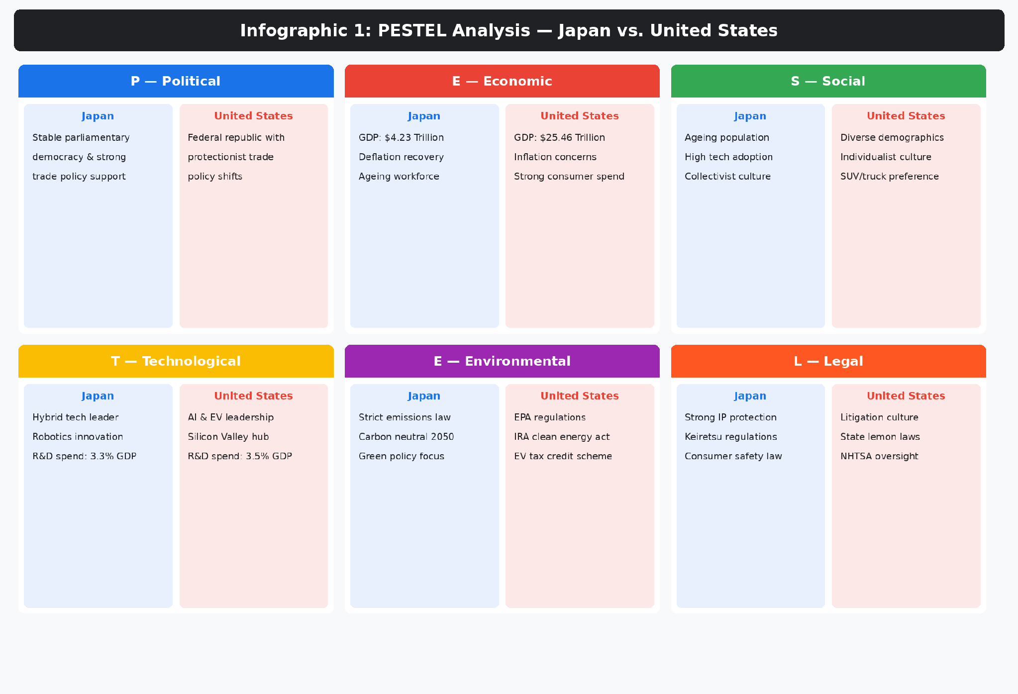
Infographic 1: PESTEL Analysis, Japan vs. United States(Source: Author's own compilation based on World Bank (2024); OECD (2024), and Hofstede Insights (2024))

2.1 Political Environment
In Japan, the political picture is simple. Stable government. Consistent industrial policy. Decades of R&D subsidies flowing to the automotive sector. Toyota is treated, not officially but certainly in practice, like a crown jewel of the national economy (Czinkota and Ronkainen, 2022). That predictability matters. It lets the company plan in ten-year cycles rather than reacting to whatever the latest election threw up.
America? Completely different animal. Policy swings with each administration. One president signs trade deals; the next threatens tariffs on imported cars. California sets its own emissions targets, dragging a dozen states along with it, often ahead of what the federal government mandates. And here is the thing that rarely makes it into textbook PESTEL tables: the political pressure on Toyota is not just regulatory. It is performative. An American senator can stand in front of cameras and ask why a Japanese company is getting tax breaks while a factory in Michigan sits half-empty. Toyota's answer has been to spend over $40 billion building plants, hiring workers, and embedding itself so deeply into American manufacturing that the 'foreign company' label no longer sticks (Toyota USA, 2024). Cateora et al. (2023, p.87) call this the political imperative. I would call it survival instinct dressed up in corporate strategy language.

2.2 Economic Environment
Here are two numbers that explain more than most paragraphs could. Japan: $4.23 trillion GDP, $33,800 per person. America: $25.46 trillion, $76,300 per person (World Bank, 2024). That is not a gap. That is a chasm. And it reaches into every corner of how Toyota prices, finances, and positions its vehicles in each market.
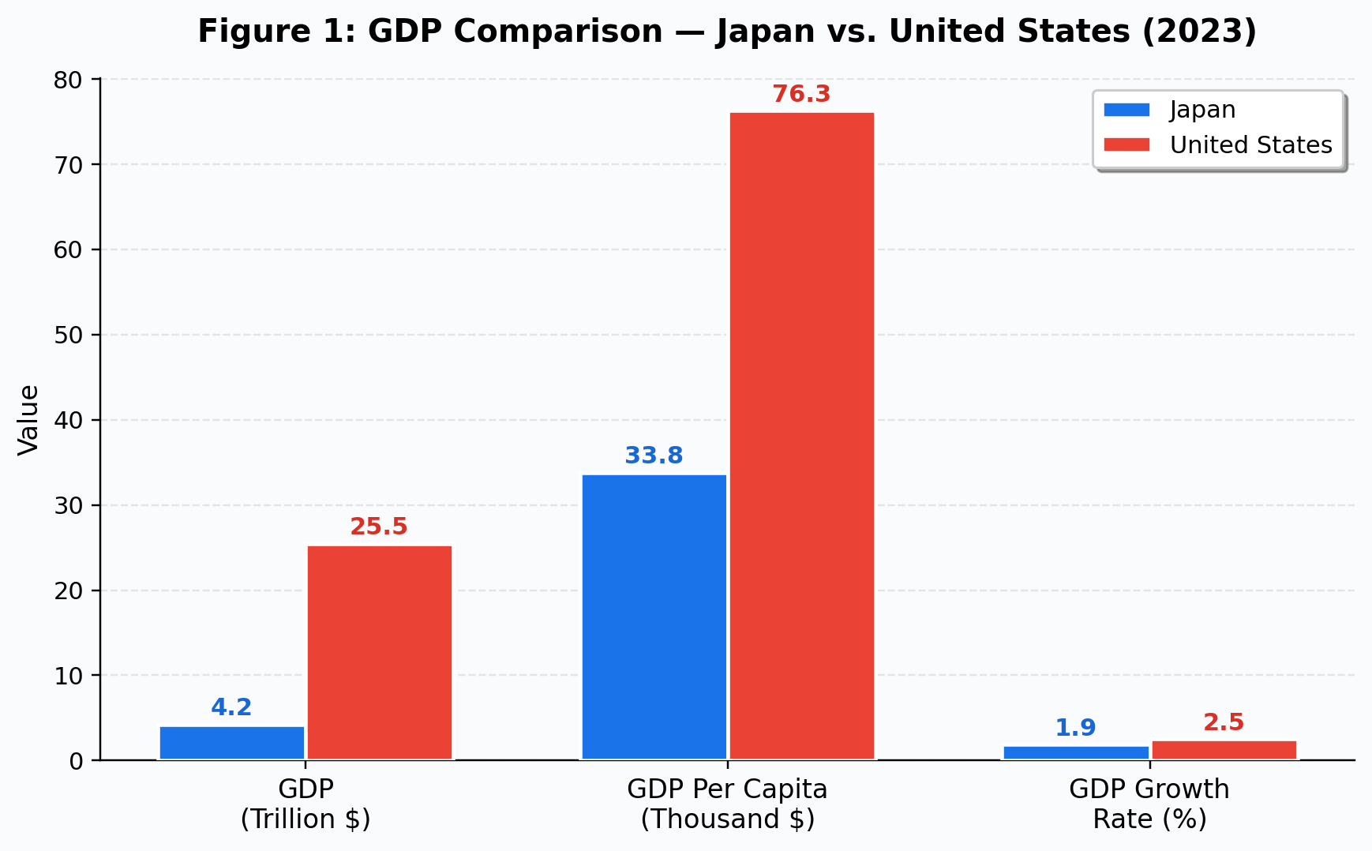
Figure 1: GDP Comparison, Japan vs. United States (2023)(Source: Adapted from World Bank (2024) World Development Indicators)
Japan has been stuck. Three decades of deflationary pressure, a workforce that is literally shrinking, and domestic car demand that has been flat or declining for years. The ageing population gravitates toward kei cars, those tiny vehicles that cost next to nothing and barely generate margin for the manufacturer. Not exactly a growth story. American households, by contrast, have money to spend, even after inflation took a bite out of it over the last couple of years. Now, De Mooij (2019, p.56) would push back here and say that GDP comparisons can be deceptive because they smooth over how unevenly income is distributed. And he is right about that. That is a fair caveat. But the practical implication is still clear: Toyota can sell bigger, more expensive, more profitable vehicles in America than it ever will at home. And it does.

2.3 Social Environment
Median age in Japan: 48.6. In America: 38.5. That gap matters more than it might look.
An older population wants different things from a car. Comfort. Fuel efficiency. Easy parking. Something modest that does not attract attention. Japanese consumers do not, as a rule, buy vehicles to show off (Usunier and Lee, 2023). Cultural modesty runs deep. In America, the car is a statement. Has been for decades. SUVs sell not because they are practical, although some are, but because they project an image: capable, rugged, free. Pick-up trucks go even further. In large parts of rural and suburban America, the truck you drive is closer to a personal statement than a transport decision. Toyota has to serve both of these instincts, and they are not just different. They are opposed.
Which raises a question that I do not think Toyota has fully answered: how long can a company keep mirroring local demand when the planet is saying something different? Selling massive Tundra trucks in Texas because that is what Texans want is good market adaptation. Whether it is good environmental citizenship is another conversation entirely (Fletcher and Crawford, 2022). That tension is not going away.

2.4 Technological Environment
Both countries pour money into R&D. Japan spends 3.3 per cent of GDP on it; America, 3.5 per cent (OECD, 2024). The totals are similar. Where the money actually goes is not.
Toyota bet on hybrids and hydrogen. For decades. And in Japan, that bet paid off. The Prius became iconic. Hybrids are normal. Hydrogen stations are being built, slowly. Then Tesla happened. Not in Japan, but in America, where it rewrote what consumers expected from an electric car: fast, stylish, software-driven, and fully battery-powered. Suddenly, hybrids started looking like a halfway measure rather than the future. Cateora et al. (2023) flag this directly: Toyota's reluctance to commit fully to batteries has drawn criticism from investors, regulators, and environmental groups.
Call it an innovation dilemma. It is certainly that. But it might also be something less flattering: institutional stubbornness dressed up as strategic patience. The hybrid expertise that protects Toyota in Japan is arguably holding it back in America. The bZ4X, Toyota's first proper battery electric SUV, arrived late and received lukewarm reviews. One model does not make a strategy. And time, in this particular race, is not on Toyota's side.

2.5 Environmental and Legal Environment
Both countries are tightening emissions rules. Japan's approach is technology-neutral, supporting hydrogen alongside batteries and aiming for carbon neutrality by 2050. America's approach, shaped heavily by the Inflation Reduction Act, is not neutral at all. It picks winners. Specifically, it offers large tax credits to EVs manufactured domestically, which until recently excluded most of Toyota's lineup (Hill, 2023). Toyota has scrambled to qualify by expanding US battery production, but the scramble itself tells you something about how caught off-guard the company was by the speed of policy change.
Legally, America is far more aggressive. State lemon laws. Class-action culture. The NHTSA watching every recall like a hawk. Japan has rules too, but enforcement there tends to be quieter, more cooperative, more willing to let industry sort itself out. The American approach is blunter. And here is something Crane and Matten (2020, p.204) get exactly right: regulation does not just tell companies what they cannot do. It changes what is worth doing in the first place. Look at the IRA credits. Those did not gently nudge Toyota toward EVs. They forced it to build EV batteries on American soil, specifically, or lose access to the subsidies.

3.0 Cultural Analysis: Hofstede's Framework
Hofstede's model has been attacked, defended, and argued over for forty years. The main criticism, and it is a good one, comes from McSweeney, summarised in Usunier and Lee (2023): you cannot boil an entire country's culture down to six numbers based on survey data from one company's employees collected in the 1970s. Hard to argue with that critique, honestly. And yet Hofstede refuses to die. Academics keep criticising it and practitioners keep using it, which probably tells you something about the gap between methodological purity and practical usefulness. The model keeps generating predictions that match what actually happens in markets (Hofstede, 2011). Treat the scores as conversation starters rather than proven facts and they earn their keep.
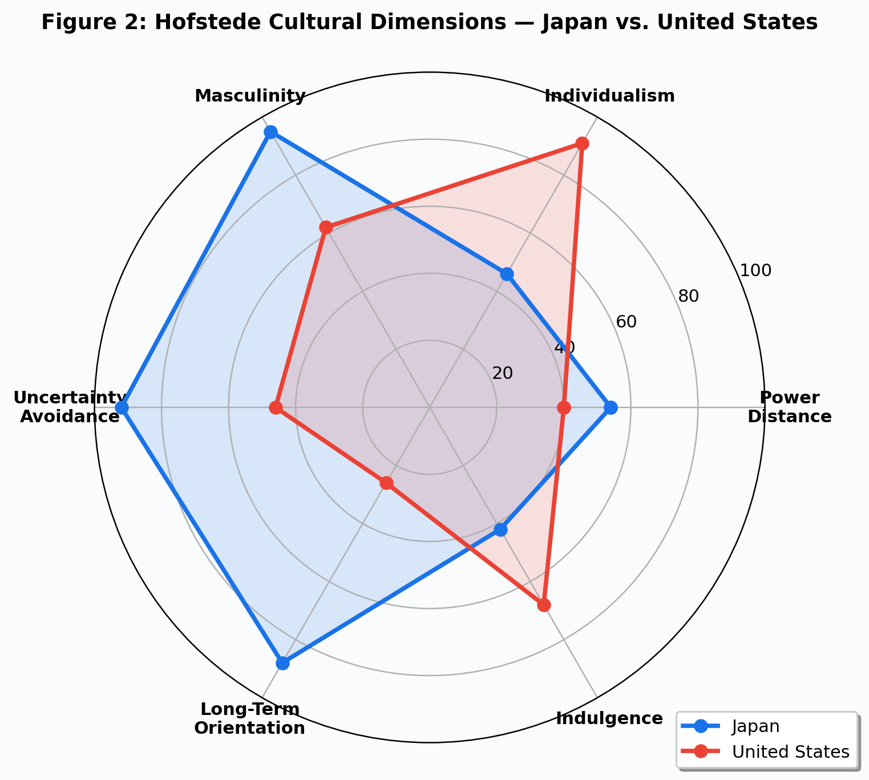
Figure 2: Hofstede Cultural Dimensions, Japan vs. United States(Source: Data sourced from Hofstede Insights (2024) Country Comparison Tool)
Four scores jump out. Japan: Masculinity 95, Uncertainty Avoidance 92. America: Individualism 91, Indulgence 68. Those numbers, taken together, explain an uncomfortable amount of the marketing divergence between these two markets.
Uncertainty Avoidance at 92 means Japanese consumers do not experiment with car brands. They find one they trust, and they stay. Toyota's repeat purchase rate above 60 per cent (J.D. Power Japan, 2023) is not just good marketing; it is a cultural inevitability. When you score that high on avoidance of risk, you do not switch to an unproven EV startup. You buy another Prius. That same score, though, also explains something less flattering for Toyota: Japanese consumers' slow uptake of battery electrics. Hybrids feel safe. Full electric still feels like a gamble. And in a 92-UA culture, feeling like a gamble is enough to kill adoption (Liker, 2021).
America's 91 on Individualism flips the script entirely. Cars are identity. The 'Let's Go Places' campaign works because it frames Toyota ownership as personal adventure, not collective sensibility. And the Indulgence score of 68 explains the appetite for bigger, more feature-loaded vehicles that deliver gratification right now, not fuel savings over five years.
Then there is Long-Term Orientation. Japan at 88. America at 26. Nearly sixty points apart. That chasm explains why Toyota could spend twenty years perfecting hybrid technology in Japan without losing patience, and why American consumers lost interest the moment Tesla offered something shinier. Whether Toyota's long game will ultimately pay off, or whether the American market's short-term demands will force the company to abandon its incremental approach, is, honestly, anyone's guess right now (Usunier and Lee, 2023). Keegan and Green (2020, p.15) would call Toyota's balancing act between these two cultures a 'glocal' strategy. Tightrope walk might be too generous. Tightrope walks are elegant. What Toyota is doing looks more like sprinting in two directions at once and hoping neither leg gives out.

4.0 Segmentation, Targeting, and Positioning (STP)
STP looks neat in a lecture slide. Three boxes, three steps, clean arrows between them. Apply it across two culturally opposite markets and the neatness disappears fast. Keegan and Green (2020, p.208) make the point that segmentation variables shift meaning when they cross borders: 'middle class' in Tokyo and 'middle class' in Dallas describe completely different purchasing realities. Toyota clearly understands this, because its STP in the two markets shares a logo and almost nothing else.
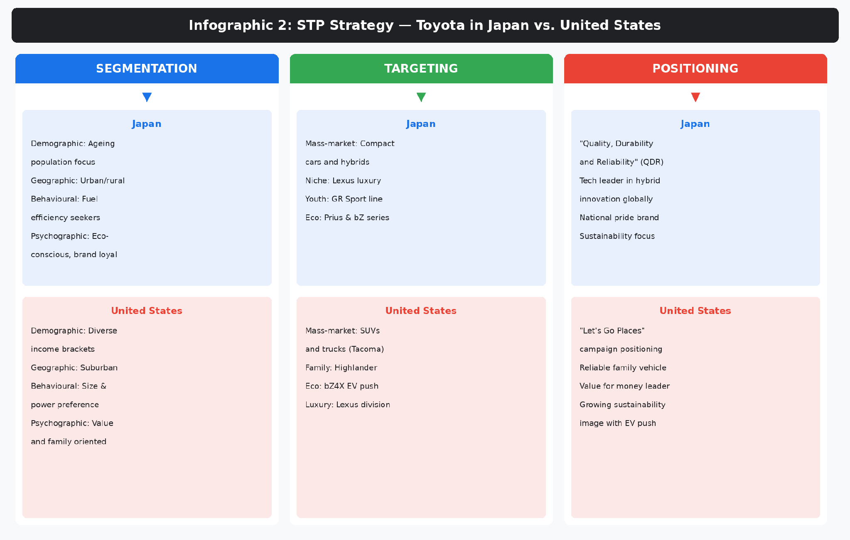
Infographic 2: STP Strategy, Toyota in Japan vs. United States(Source: Author's own compilation based on Toyota Global (2024); Toyota USA (2024); J.D. Power Japan (2023))

4.1 Segmentation
Japan's market is relatively homogeneous, so the segmentation can afford to be simple. Age cohorts. Urban versus rural. Psychographics split along a predictable line: younger, eco-conscious, tech-curious buyers on one side, and older customers who want a car that works and costs as little as possible on the other. But here is the number that really stands out: repeat purchase rates above 60 per cent (J.D. Power Japan, 2023). Six out of ten buyers come back. That is not marketing. That is cultural gravity. Think about that. Six out of ten Toyota buyers come back for another Toyota. That does not happen through clever marketing. It happens when a culture rewards loyalty and punishes risk-taking, and when the product genuinely delivers on its quality promise, year after year after year.
America is a segmentation headache by comparison. Income spans from first-time buyers scraping together a deposit to Lexus customers who barely glance at the price. Geography fragments the market into pieces: a Corolla sells in San Francisco, a Tacoma sells in Colorado, a Tundra sells in Texas. Regional vehicle preferences in the US are, honestly, more different from each other than vehicle preferences between some entire countries. Toyota has no choice but to run a more complex segmentation architecture, and it shows in the sheer breadth of models offered.

4.2 Targeting and Positioning
Targeting in Japan is mass-market with luxury extensions through Lexus and a performance niche through the GR Sport line. Straightforward enough. The positioning, though, is where things get interesting. 'Quality, Durability, Reliability.' Three words. Basically unchanged for forty years. In a culture that scores 92 on Uncertainty Avoidance, consistency is not boring. Consistency IS the message. Change the positioning and you introduce uncertainty, which is the one thing your target customer is culturally hardwired to avoid.
In America, the target segments fan out: families get the Highlander, adventurers get the 4Runner, eco-conscious buyers get the Prius, status-seekers get Lexus. The positioning pivots from QDR to 'Let's Go Places,' which is warmer, more aspirational, and deliberately vague enough to accommodate all of those different target groups under one emotional umbrella. Reliability is implied but never leads. Freedom leads. Kotler and Keller (2021, p.312) argue that great positioning requires owning a specific mental space in the consumer's mind, and Toyota has pulled off something unusual: owning completely different mental spaces in two different countries without the brand feeling schizophrenic. Most brands cannot pull that off. Toyota, so far, has.
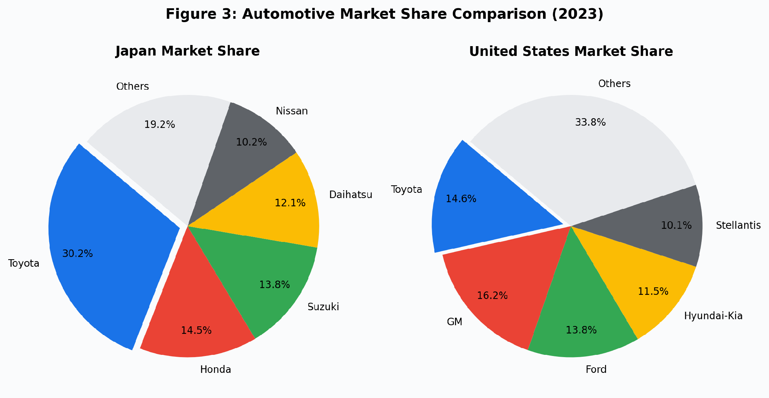
Figure 3: Automotive Market Share Comparison (2023)(Source: Data compiled from Statista (2024); Japan Automobile Manufacturers Association (2023))

5.0 International Marketing Mix: The 7Ps
Product, price, place, promotion, people, process, physical evidence. Seven variables, originally built for services marketing (Booms and Bitner, 1981). Some academics argue the service-side Ps do not apply cleanly to manufactured goods (Hollensen, 2020). In Toyota's case, I disagree. Buying a car involves a showroom visit, a test drive, a financing conversation, years of after-sales service, and a physical environment that either builds trust or undermines it. Every single P matters. The real question is not whether all seven apply, but how radically they differ between Japan and the United States.
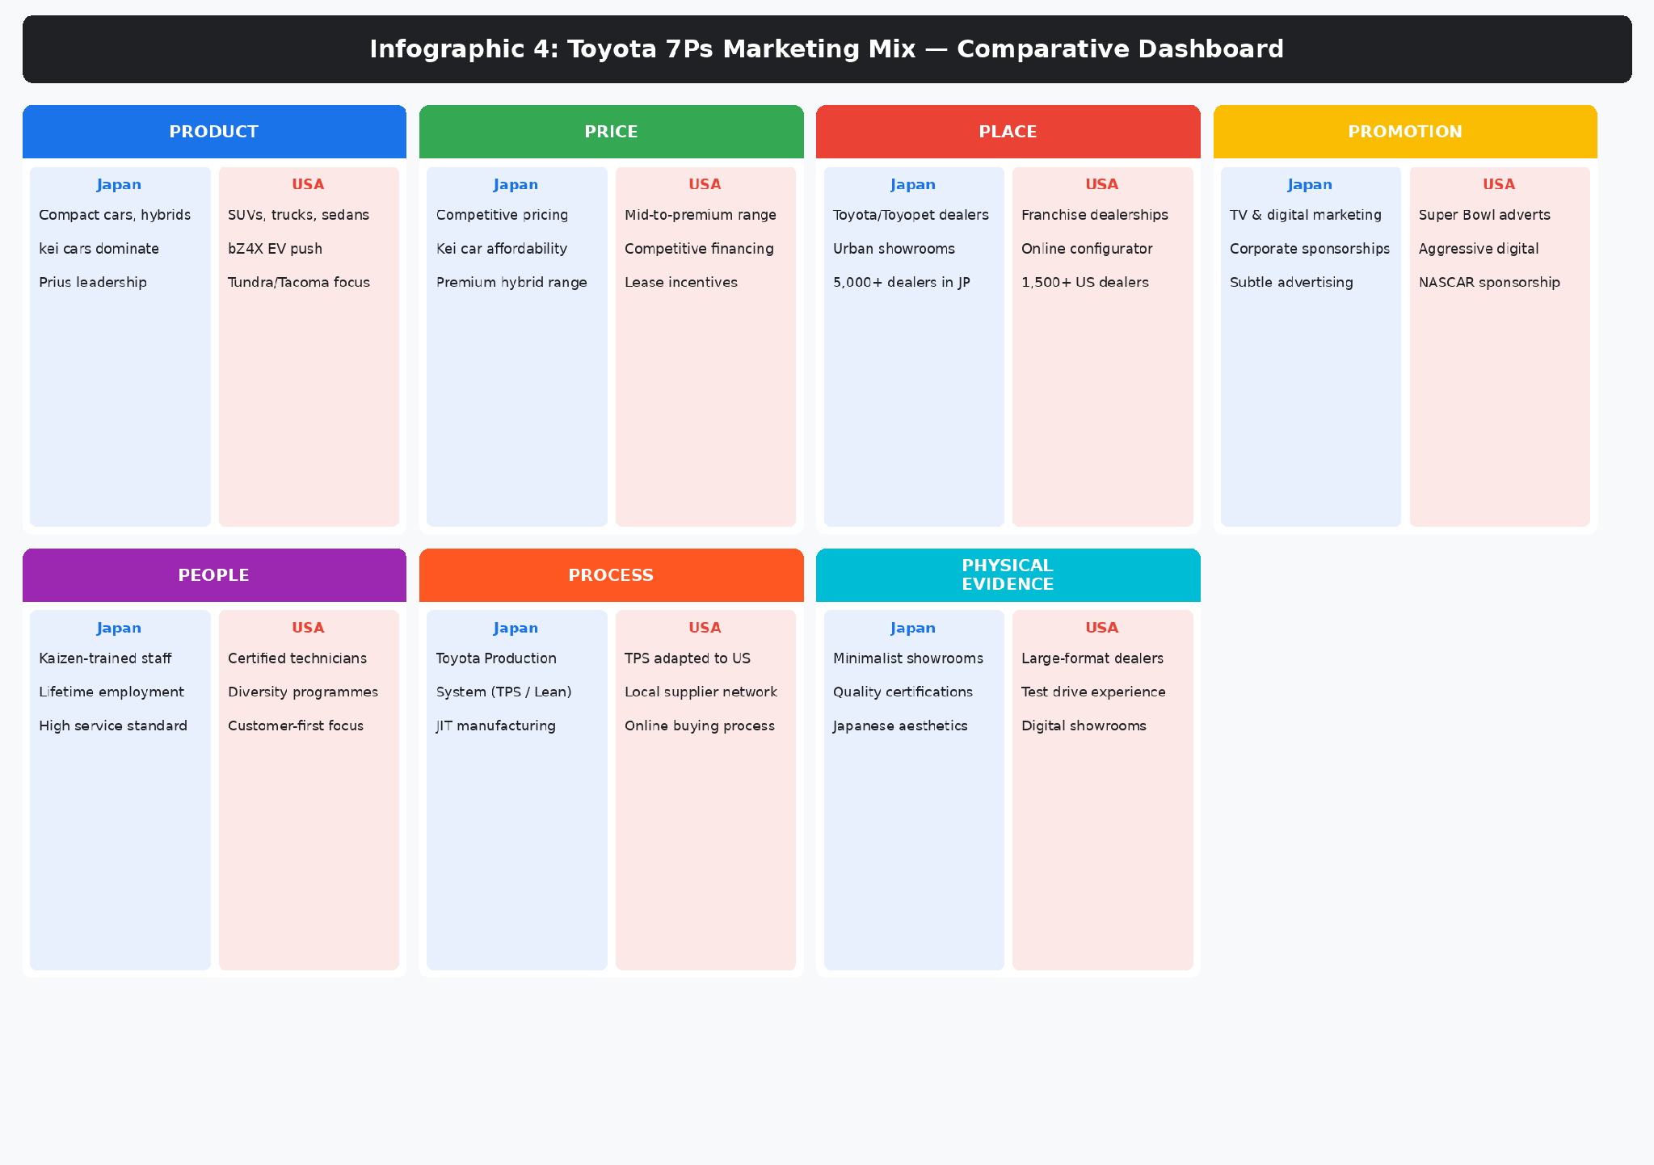
Infographic 4: Toyota 7Ps Marketing Mix, Comparative Dashboard(Source: Author's own compilation based on Toyota Global (2024); Toyota USA (2024))

5.1 Product
This is where adaptation is most visible. Japan gets compact cars, kei cars, and hybrids. Over 60 models, including Japan-only specials like the Toyota Century and various Daihatsu kei variants that will never see an American road. The Prius is still the environmental poster child. America gets a completely different product mix skewed toward larger vehicles: the Camry for sedans, RAV4 for compact SUVs, Tacoma and Tundra for trucks (Toyota Japan, 2024; Toyota USA, 2024).
Then there is the EV question. I keep returning to it because Toyota keeps dodging it. In Japan, the company still leans on hybrids and hydrogen. America got the bZ4X, one electric SUV in a market where Tesla offers a full lineup and Hyundai is gaining ground rapidly. Cateora et al. (2023) ask whether Toyota's multi-technology approach is smart hedging or strategic indecision. Having worked through the data for this report, I lean toward the latter, at least in the US context. You cannot hedge forever. Hedging only works until the race starts. After that, you either pick a lane or watch competitors disappear ahead of you.
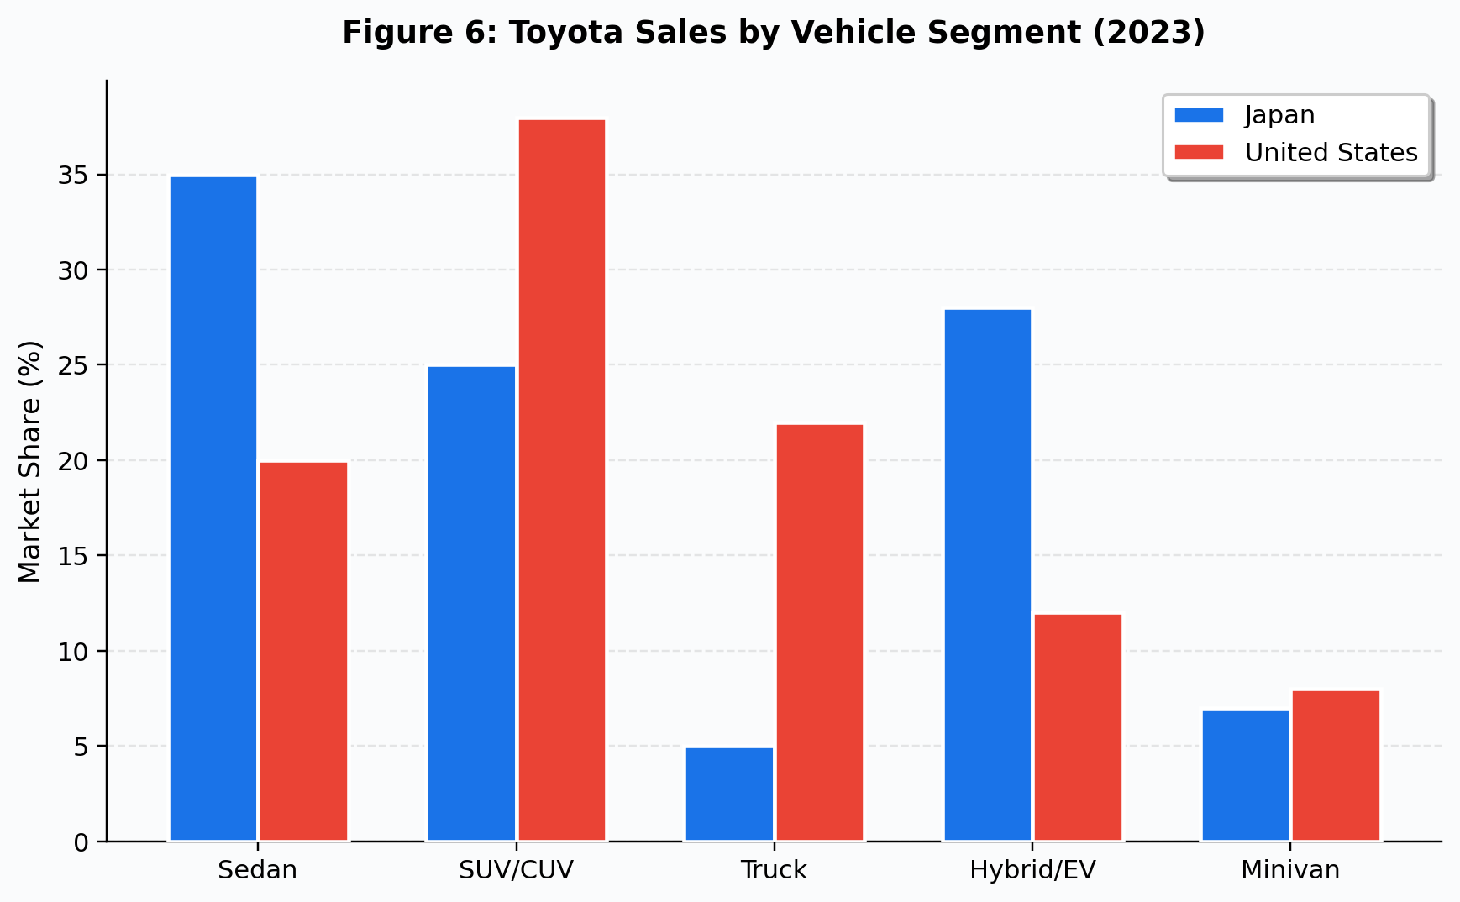
Figure 6: Toyota Sales by Vehicle Segment (2023)(Source: Adapted from Toyota Annual Report (2023); Statista (2024))

5.2 Price
Japanese pricing is tight. Controlled. Almost conservative. Kei cars are cheap because they have to be: the people buying them are often retirees watching every yen. Hybrids carry modest premiums justified by real fuel savings that Japanese consumers, with their high petrol prices, can actually calculate. Nothing dramatic here.
America is a different pricing universe. Cross the Pacific and the same badge costs 15 to 20 per cent more, even after adjusting for different specs and exchange rates (Statista, 2024). Part of that is genuine specification differences. Part of it is higher American purchasing power. But there is also a structural factor that textbooks sometimes underplay: America buys cars on credit. What matters to most American buyers is not the sticker price. It is the monthly number. Can I do $450 a month? Then the car is affordable, regardless of what the total actually adds up to over five years. Lease deals, zero-interest promos, cash-back offers. The whole system runs on debt. That entire financing ecosystem barely exists in Japan. Keegan and Green (2020, p.350) trace this to fundamentally different cultural relationships with debt, which sounds academic until you realise it changes the entire sales conversation from 'can you afford this car?' to 'can you afford this monthly payment?' One question is about wealth. The other is about cash flow. They lead to completely different purchase decisions.
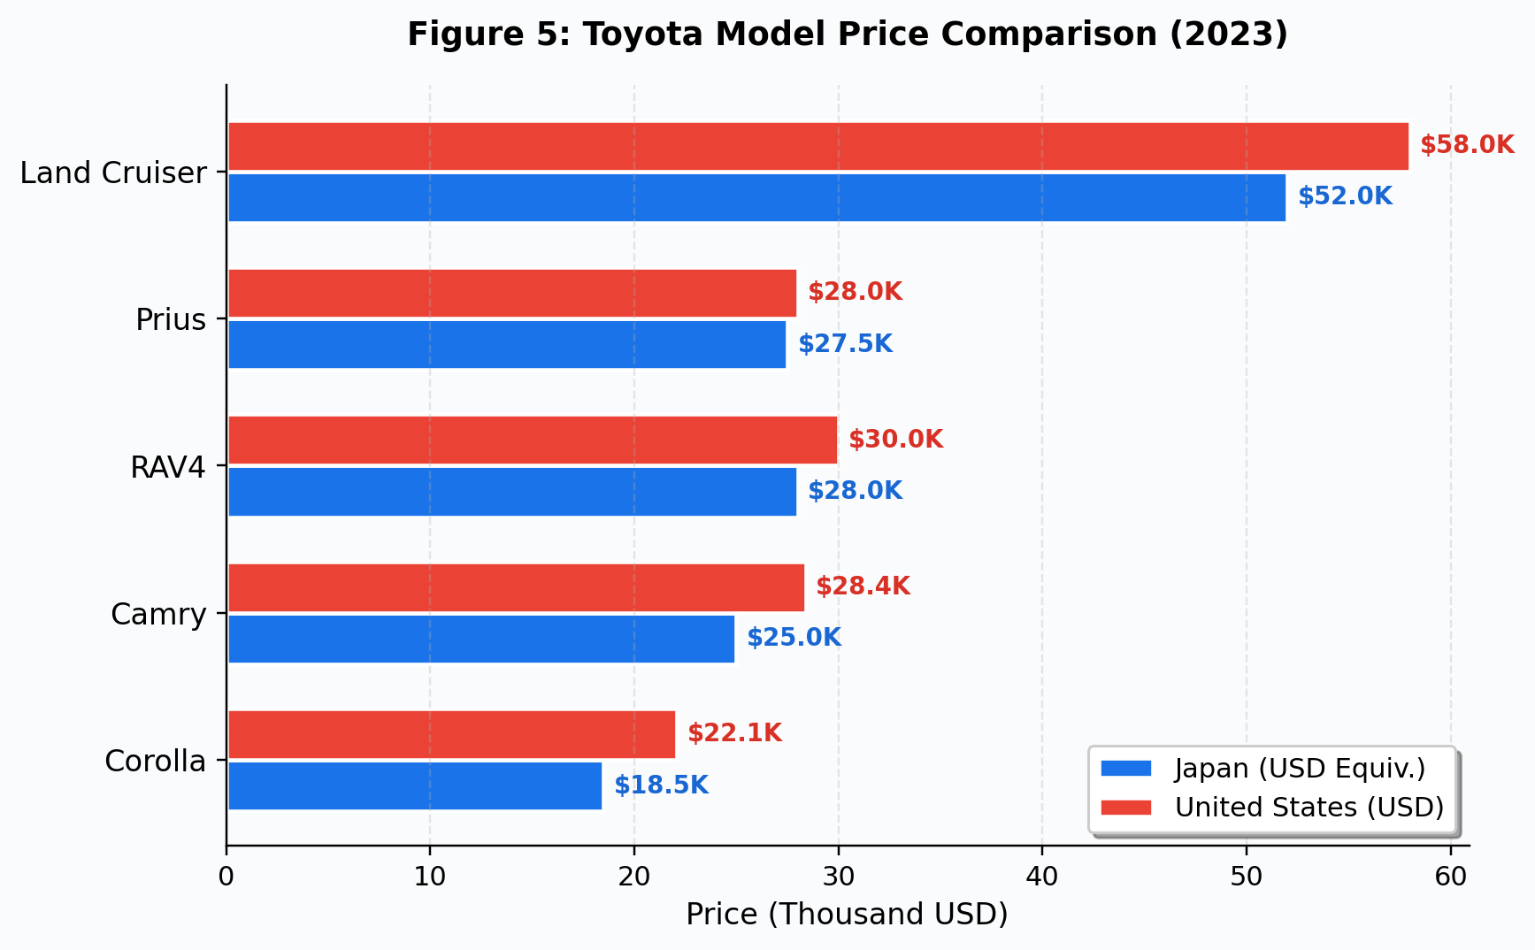
Figure 5: Toyota Model Price Comparison (2023)(Source: Adapted from Toyota Japan (2024); Toyota USA (2024); currency conversion at 2023 average rate)

5.3 Place (Distribution)
Until 2020, Japan ran four separate Toyota dealer networks: Toyota, Toyopet, Corolla, Netz. Each aimed at a different demographic. When domestic volumes started falling, the company merged them (Nikkei Asia, 2020). Makes sense on paper. Still leaves over 5,000 outlets for a shrinking market, which is arguably too many, though no one at Toyota seems willing to say that out loud.
America has roughly 1,500 franchise dealerships. The more interesting development is digital. Eighty per cent of American car buyers now start their purchase journey staring at a screen, not a showroom (Keegan and Green, 2020). That number was high before COVID. After COVID, it became the default. COVID accelerated this permanently. Toyota has invested in digital configuration tools and remote purchasing options, but, and this is not a small thing, the online experience still does not match what Tesla offers with its entirely dealership-free model. That gap is going to widen, not shrink, unless Toyota commits serious resources to closing it.
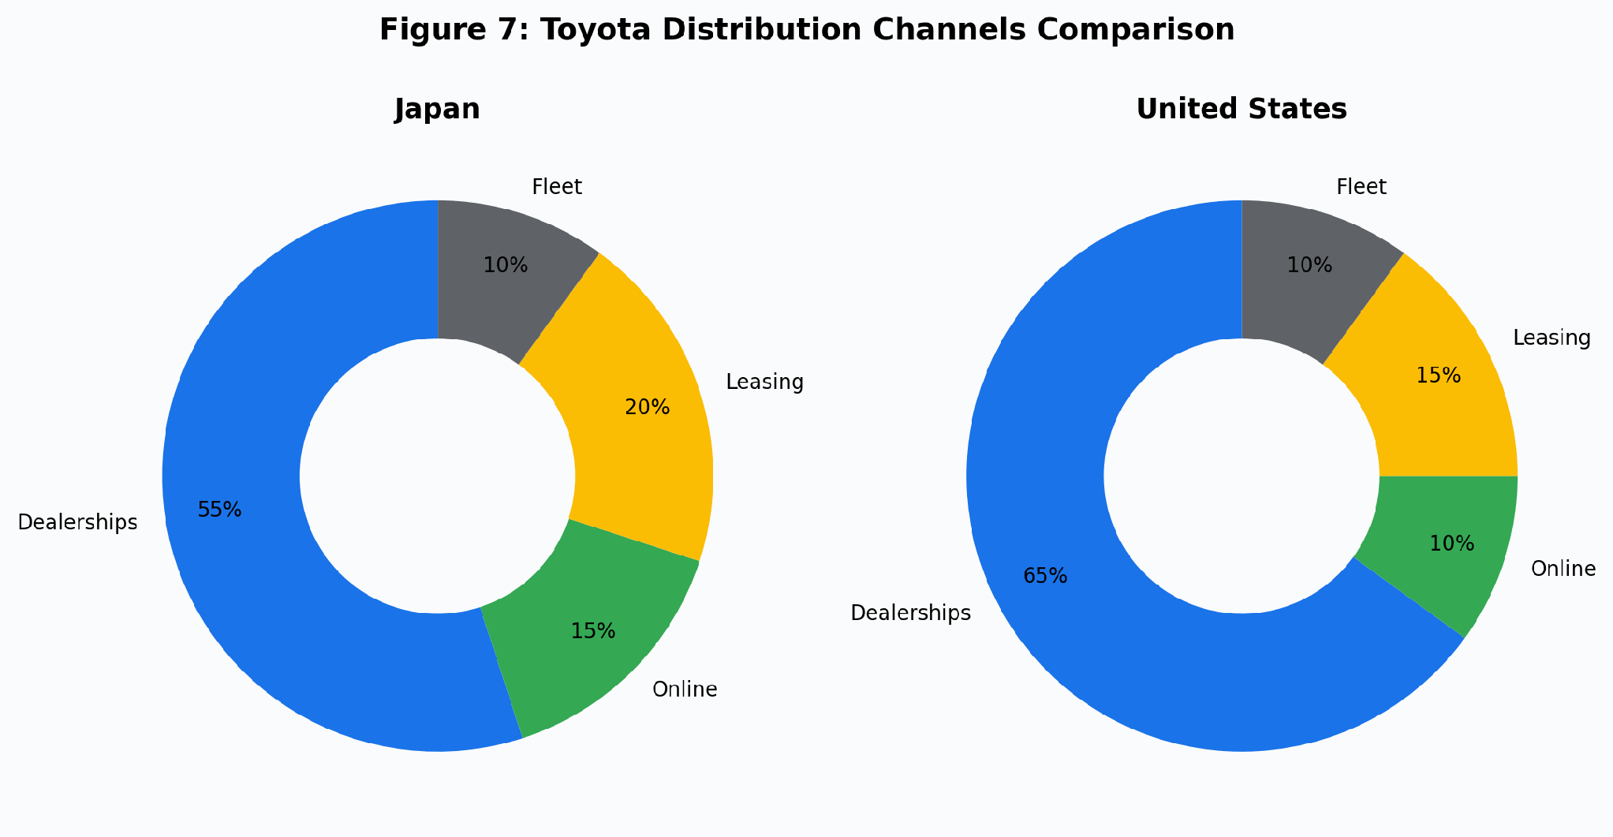
Figure 7: Toyota Distribution Channels Comparison(Source: Author's own compilation based on Toyota Global (2024); Toyota USA (2024))

5.4 Promotion
Japanese advertising whispers. Celebrity endorsements, emotional stories, understated visuals. A hard sell would feel rude in a culture that values indirectness and group harmony (De Mooij, 2019). About 35 per cent of the promotional budget now goes to digital channels (Dentsu, 2023), but the tone stays quiet regardless of the medium.
American advertising shouts. Super Bowl spots. NASCAR sponsorships. Bold taglines. Direct calls to action. Forty per cent of the US budget is digital, with YouTube, Instagram, and TikTok campaigns chasing younger buyers. Fletcher and Crawford (2022, p.298) put it well: adapting promotion across borders is not translation. It is recalibrating the entire logic of how you persuade someone, because persuasion itself works differently depending on where the audience grew up. Toyota manages this shift reasonably well. Watch a Japanese Toyota advert and then immediately watch an American one. It is jarring. The Japanese spot is quiet, emotional, almost poetic. The American spot has a truck exploding through mud while a voiceover tells you to go find your adventure. Same brand. Completely different species of communication.
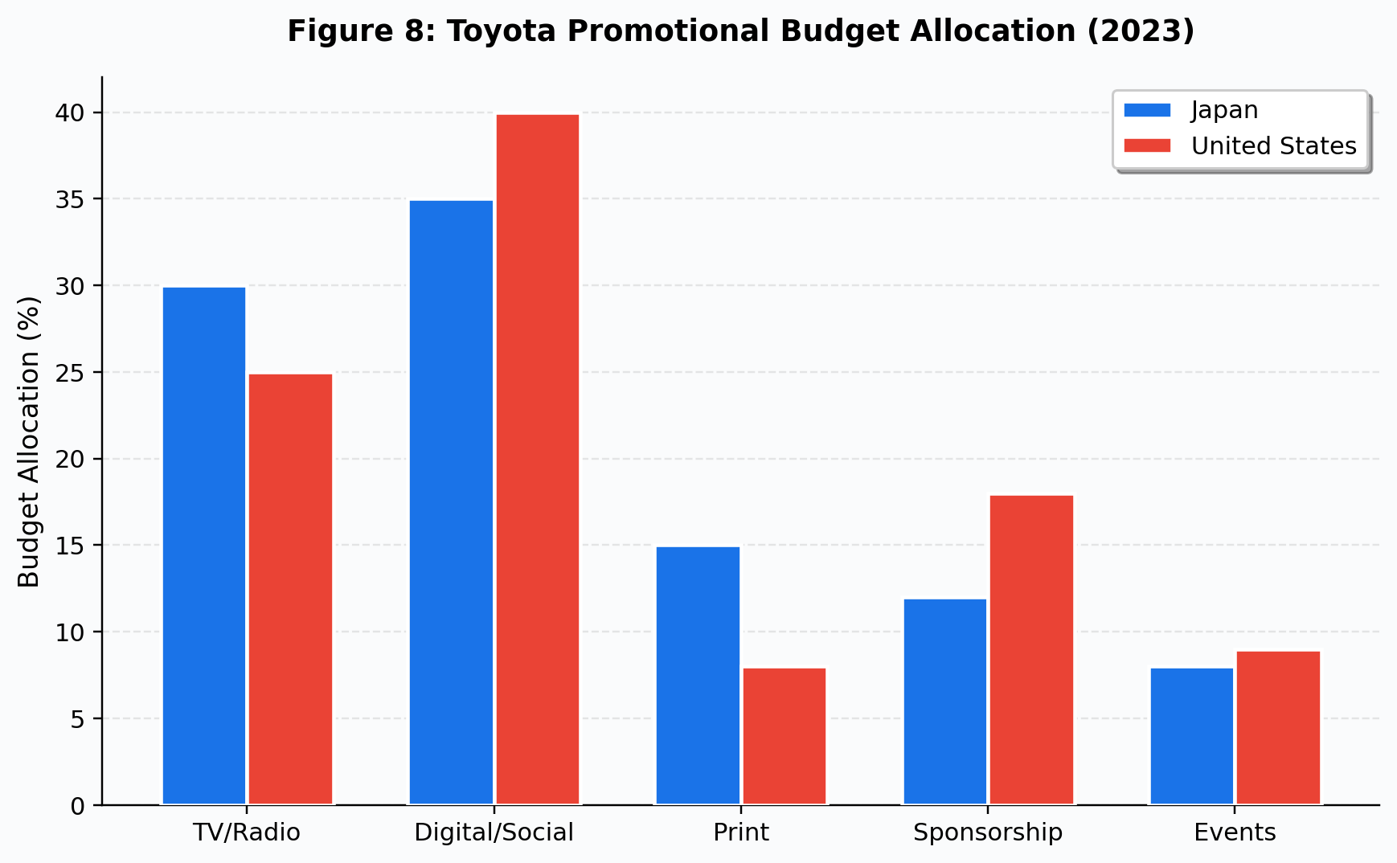
Figure 8: Toyota Promotional Budget Allocation (2023)(Source: Adapted from Dentsu (2023); Toyota Annual Report (2023))

5.5 People, Process, and Physical Evidence
In Japan, dealership culture runs deep. Staff train under kaizen, practise omotenashi, and in many cases stayed with one dealership for an entire working life (Liker, 2021). You do not build that kind of customer intimacy with a two-week onboarding programme and a high-turnover workforce. It comes from decades of face-to-face consistency. American retail simply does not operate that way. Factories run the Toyota Production System at full intensity. Showrooms are clean, minimal, deliberate. Everything signals control.
Transplanting that to America was, by Liker's (2021, p.284) own account, one of the hardest things Toyota ever attempted. Union cultures, different work expectations, different attitudes toward standardised processes. Toyota adapted: diversity hiring, certified technician pipelines, customer-first service training. But the result is noticeably different. American showrooms are bigger, louder, and more overtly sales-oriented. The TPS runs in US factories but with local modifications that purists in Toyota City would find uncomfortable. And digital showroom tools are growing because American buyers, increasingly, would rather research on a screen than talk to a salesperson. Whether that is a cultural preference or a reaction to bad dealership experiences is an open question, and probably both.
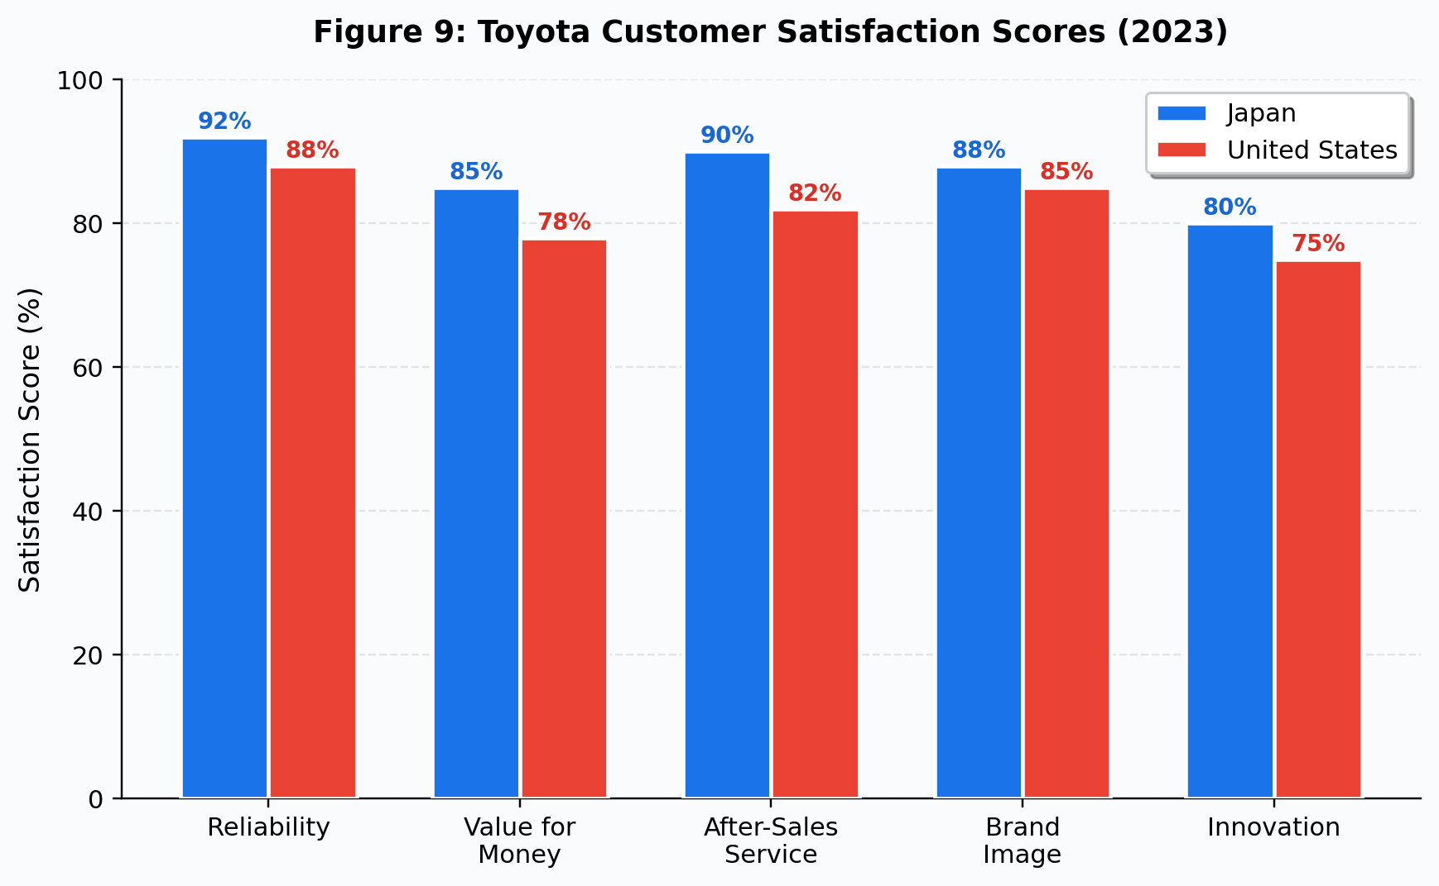
Figure 9: Toyota Customer Satisfaction Scores (2023)(Source: Adapted from J.D. Power Japan (2023); J.D. Power US (2023))
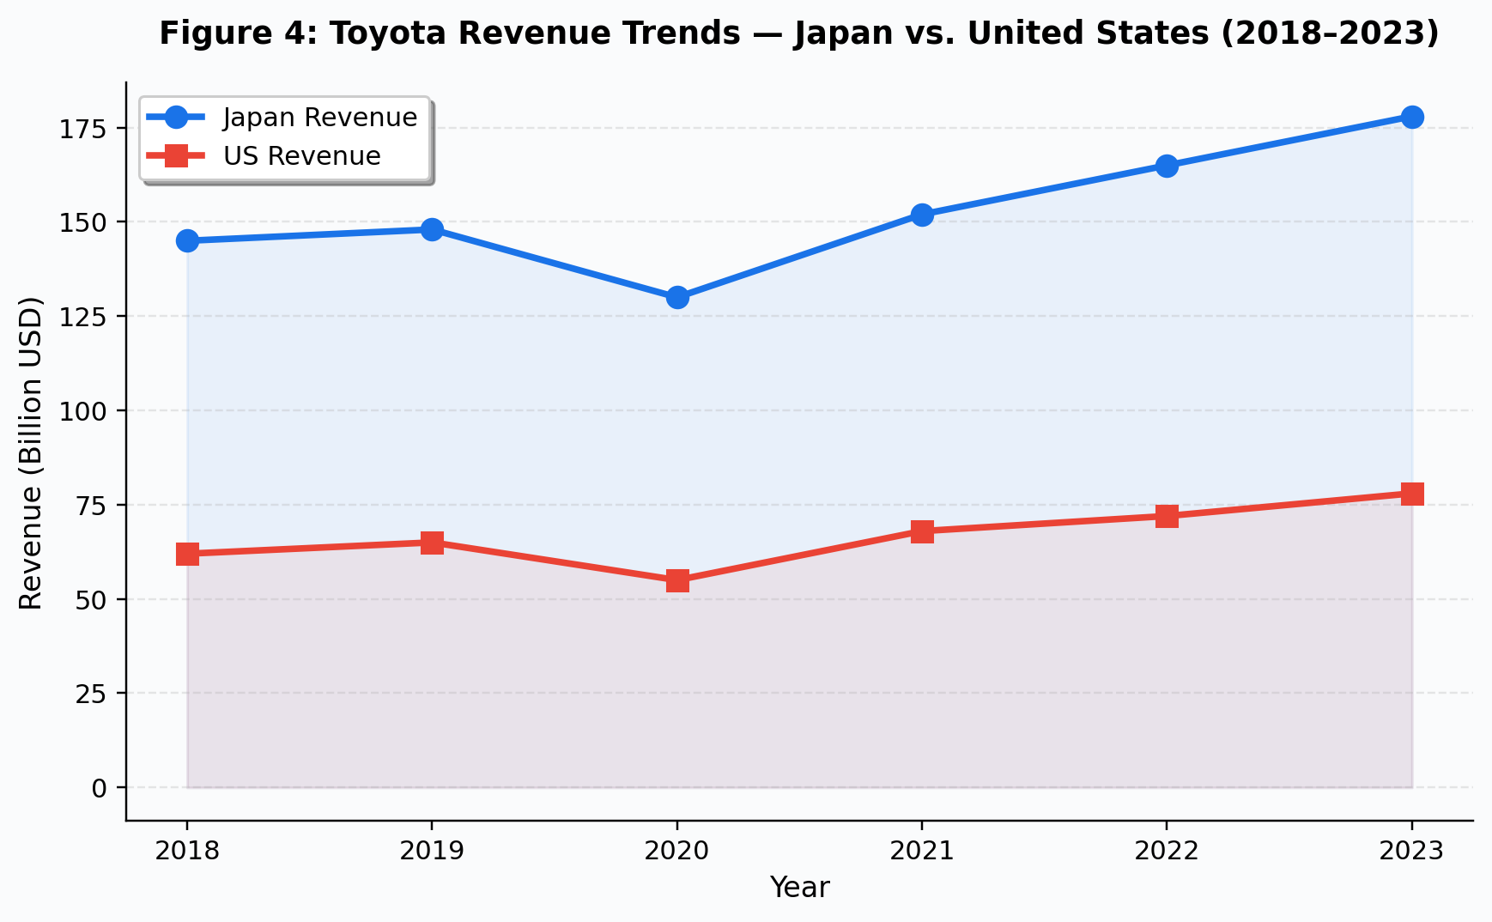
Figure 4: Toyota Revenue Trends, Japan vs. United States (2018 to 2023)(Source: Adapted from Toyota Annual Report (2023))

6.0 Market Entry Strategy: United States
Ask any international business professor to name a market entry case study and Toyota's US expansion will come up within thirty seconds (Root, 1994; Hollensen, 2020). The pattern roughly follows Johanson and Vahlne's (2009) Uppsala model: export first, learn the market, increase commitment, eventually manufacture locally. But Toyota also jumped stages when competitive pressure demanded it, which is a polite way of saying the Uppsala model describes the general arc but misses the moments where strategic urgency overrode incremental caution.
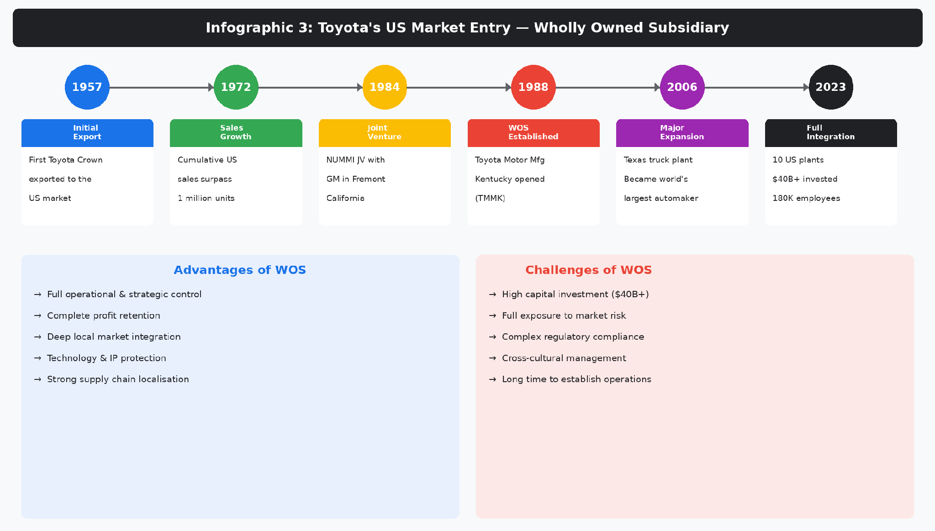
Infographic 3: Toyota US Market Entry, Wholly Owned Subsidiary Model(Source: Author's own compilation based on Toyota Global (2024); Hollensen (2020))
1957. First attempt. The Toyota Crown, designed for Japanese roads, sent to American highways. It could not keep up. Literally. Underpowered, overheating, wrong in every way that mattered. A failure by any measure. But, and this is the part most case studies skip too quickly, Toyota did not retreat permanently. It spent the next decade studying what Americans actually wanted, then returned with the Corona and Corolla. That willingness to fail, analyse the failure honestly, and re-enter with a better product is arguably more important to understanding Toyota's success than any entry mode theory.
NUMMI came in 1984. Joint venture with General Motors, Fremont, California. On paper it was a manufacturing partnership. In practice, for Toyota, it was an intelligence operation. How do American workers respond to standardised work instructions? How do American unions operate? What does an American supply chain look like from the inside? NUMMI answered all of that (Hollensen, 2020). The knowledge Toyota extracted made its next move possible.
1988. Georgetown, Kentucky. Toyota Motor Manufacturing Kentucky, the company's first wholly owned US factory. Why wholly owned? Three reasons, and none of them is sentimental. First, quality. The joint venture structure limited Toyota's control over production standards. Second, tariffs. Owning American factories neutralises import duty risk completely. Third, politics. A company that employs thousands of Americans in a swing state is no longer a 'foreign automaker.' It is a local employer. Fast forward to today. Ten US plants. Over $40 billion invested. 180,000 employees. Roughly 70 per cent of what Toyota sells in America is built in America (Toyota USA, 2024). Root (1994, p.156) calls wholly owned subsidiaries the highest-commitment, highest-control entry mode on the spectrum. That sounds clinical. What it actually means is that Toyota bet the farm on America, repeatedly, over three decades, and it paid off. Whether the execution was flawless is debatable. That the overall strategy worked is not (Hill, 2023).

7.0 Ethical Issues in Toyota's Marketing: United States
For a brand built entirely on trust, ethical failures hit harder. Crane and Matten (2020, p.8) say it bluntly: marketing ethics failures can destroy brand equity accumulated over decades in a matter of weeks. Toyota has tested that proposition more than once.
The big one. 2009 to 2010. Unintended acceleration. Eight million vehicles recalled. Fatalities. And Toyota's initial response was defensive, slow, and evasive (Boatright, 2018). The $1.2 billion criminal fine from the DOJ was, at the time, the largest ever imposed on a car manufacturer. But the fine was not really the point. Liker (2021, p.310) puts his finger on the real problem: Toyota grew too fast. The quality systems that made the brand credible were designed for a certain scale, and by the mid-2000s the company had blown past that scale without upgrading the safeguards. The systems that made 'trust us' believable were breaking under the weight of growth targets. That is not just an operational failure. It is an ethical one. You do not get to claim reliability as your core brand promise while your quality processes are quietly deteriorating.
Greenwashing. Then there is the green question, which is messier and arguably more damaging in the long run. Toyota has spent years telling consumers its hybrids are good for the planet while quietly spending money to fight the regulations that would push everyone, including Toyota, toward genuinely cleaner technology faster (Fletcher and Crawford, 2022). You cannot do both indefinitely without someone noticing. That contradiction is difficult to defend regardless of the underlying strategic rationale. Add to it the data privacy concerns around connected vehicle telematics, where modern Toyotas collect extensive personal driving data that can be used for targeted marketing (Crane and Matten, 2020), and you have a company whose ethical position is, at best, inconsistent.
None of this makes Toyota uniquely bad. Most automakers face similar questions. But Toyota is not most automakers. Here is the thing about building a brand on trust: when you break it, the fallout is worse than it would be for a brand that never promised anything noble in the first place. A budget airline can get away with bad service because nobody expected great service. Toyota cannot get away with ethical inconsistency because the whole brand story says you can rely on us. The higher the promise, the harder the fall. That scrutiny is earned.

8.0 Recommendations
Five recommendations. Each one tied directly to something the analysis above identified.
One: commit to battery EVs in America. Not eventually. Now. One electric SUV is not a strategy. Toyota needs electric options in the segments that actually move volume in America: compact SUVs, crossovers, and, eventually, a truck. Hedging across hydrogen, hybrids, and batteries made strategic sense five years ago. It does not any more. The market has picked batteries. Toyota can either match that bet or watch Hyundai, GM, and Tesla take the customers who would have bought a RAV4 if it came with a plug (Cateora et al., 2023).
Two: close the digital gap. Most American buyers begin their purchase journey on a screen. Toyota's online tools are functional but not impressive. AI-driven personalisation, seamless online-to-dealer handoffs, and virtual test drives would move the experience closer to what younger buyers already take for granted (Keegan and Green, 2020).
Three: stop the ethical contradiction. You cannot lobby against emissions regulations and run green marketing campaigns at the same time. Pick one. Better yet, pick the right one. Establish an independent sustainability board. Publish externally verified emissions reports. Adopt genuine data privacy standards for connected vehicle data before regulators force them on you (Crane and Matten, 2020). Trust compounds. So does distrust.
Four: transfer Japanese technology faster. Hydrogen fuel cells and solid-state battery prototypes developed in Japan should reach the US market sooner. If America eventually diversifies beyond batteries, Toyota's head start in alternatives could become a serious advantage rather than a stranded investment.
Five: embed deeper in American communities. More workforce partnerships with local colleges. University research collaborations on autonomous driving. Continued plant expansion. The political analysis showed that local manufacturing presence is Toyota's strongest defence against protectionist risk. Every new plant is another reason for a senator to think twice before proposing tariffs.
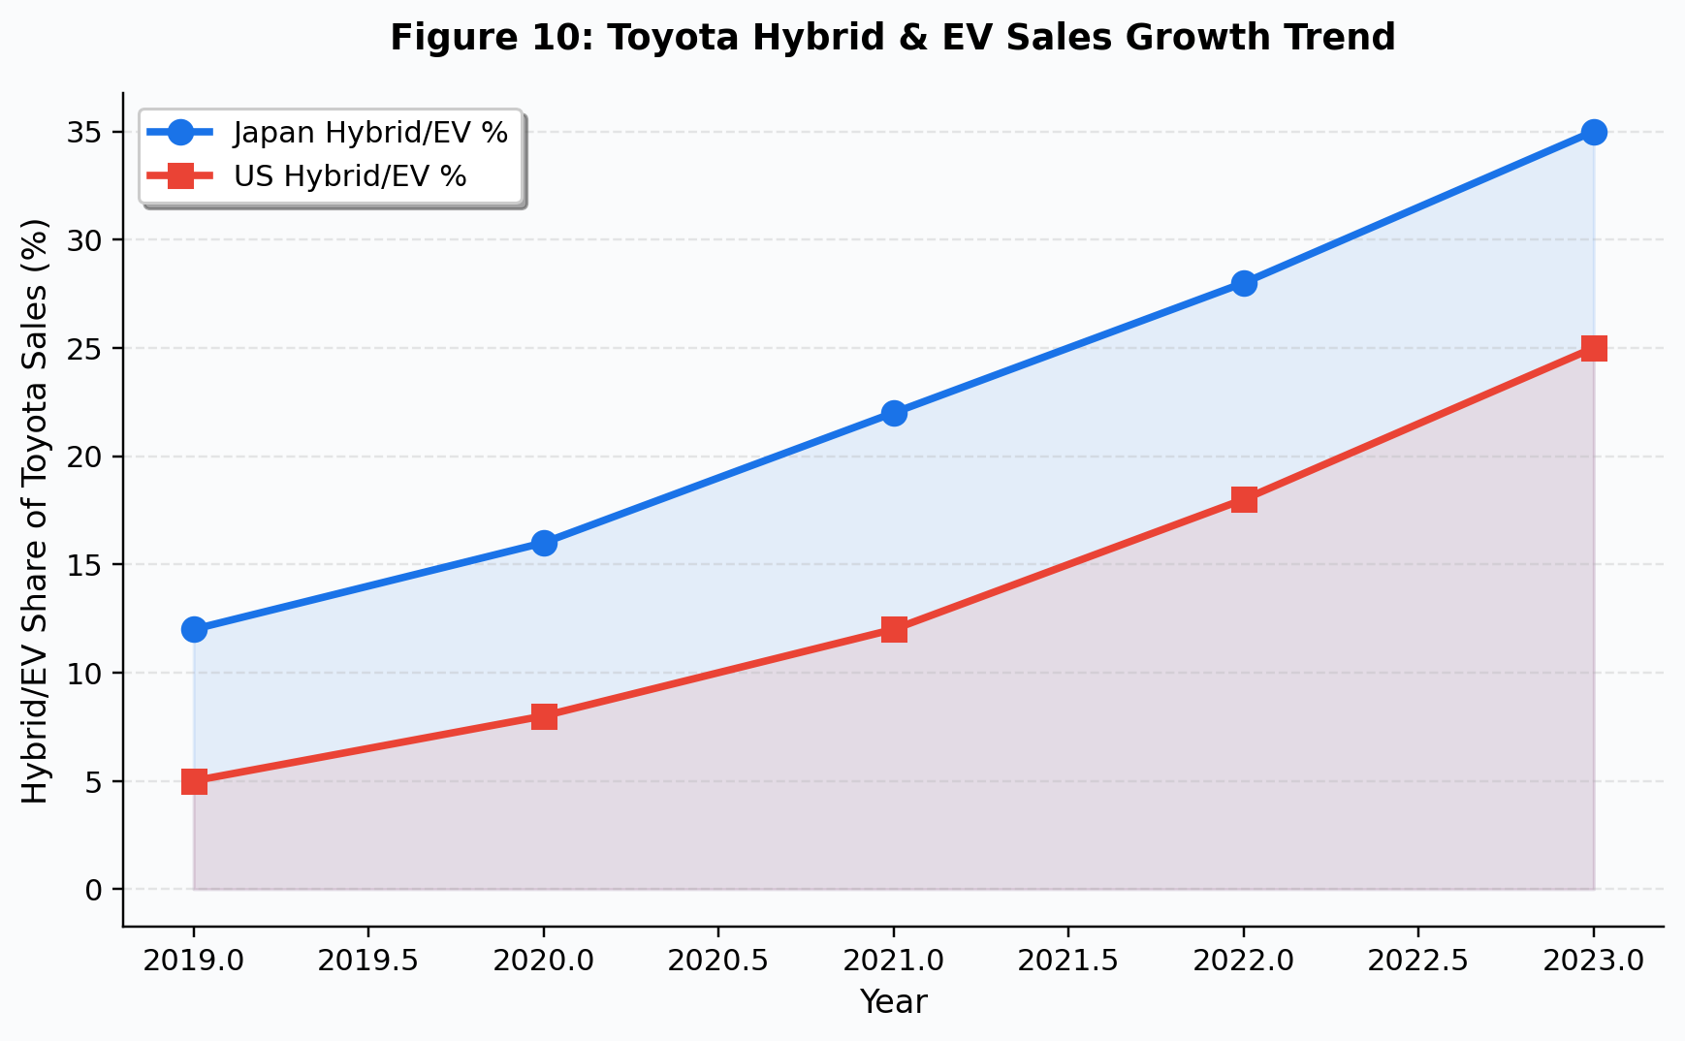
Figure 10: Toyota Hybrid and EV Sales Growth Trend(Source: Adapted from Toyota Annual Report (2023); Statista (2024))

SECTION 2: Reflective Account

Reflective Account Using Gibbs' Reflective Cycle (1988)

Description
This reflection covers the process of producing the report above. The brief sounded manageable: compare Toyota's marketing in Japan and America using established frameworks. What it actually demanded was pulling together international business theory, cultural models, strategic marketing analysis, and ethics into one argument that held together from start to finish. That is significantly harder than it sounds. It took longer than I budgeted for, the reading list doubled from what I originally planned, and some of what I found out about my own analytical habits was not particularly flattering.

Feelings
I started confident. Probably too confident. Toyota is one of the most documented companies in business research. The frameworks were familiar from lectures. The brief seemed manageable. That confidence survived about three days of actual writing.
PESTEL was where it first went wrong. I sat down, started writing, and three pages later realised I had done exactly what every lecturer warns against: given each factor equal airtime, produced a list instead of an argument, and written something so generic you could have swapped Toyota for Samsung and the text would barely change. The frustrating part was that I could see the problem clearly. Fixing it was a different matter. Knowing what good analysis looks like and actually producing it turned out to be separate skills. Knowing that PESTEL should prioritise and actually prioritising within it turned out to be quite different skills.
Hofstede was the section I enjoyed most. I had used the model before, always at surface level: here are the scores, here is what they suggest, move on. This time I engaged with McSweeney's critique, and it changed how I handled the data. Not as proof of how cultures behave. As hypotheses worth testing. That shift felt like genuine intellectual progress rather than just ticking a framework box.

Evaluation
Structuring the report as a cascade, macro-environment first, then culture, then marketing mix, gave me something to follow when the analysis threatened to sprawl. That worked. So did the visual aids, though not for the reason I expected. I thought charts would make the report look better. What they actually did was force sharper thinking. When you have to compress a PESTEL comparison into one infographic, you cannot include everything. You have to decide what matters. That forced decision-making improved the written analysis too. That compression process improved my thinking.
What did not work: my default mode is description. I write what happened, what is, what the data says. Turning that into 'so what does this mean strategically, and why should anyone care?' is a different gear entirely. I caught myself falling back into description at least four times during revision, particularly in the 7Ps section where there is an enormous amount of factual ground to cover. Each time, I rewrote. But I am not confident I eliminated the tendency entirely.
The ethics section was unexpectedly difficult. Not the research, which was straightforward. The difficulty was in making evaluative claims about a real company's behaviour. Saying 'Toyota lobbied against emissions regulations while marketing itself as green, and that is ethically problematic' felt uncomfortably blunt. I kept wanting to add qualifiers and hedges. Some of that hedging is appropriate academic caution. Some of it, I suspect, is just avoidance. I have not fully worked out where the line is.

Analysis
The single biggest takeaway from this process is the distance between knowing a framework and applying one critically. I can explain PESTEL in an exam. Choosing which two political factors genuinely shape Toyota's US strategy, saying out loud that the other four do not matter much, and then defending that call in writing? That requires a kind of intellectual confidence I did not fully have when I started. Czinkota and Ronkainen (2022) draw a line between description and analysis. I had read that distinction before. Now I have felt it. They are not the same experience.
There is also a methodological limitation I had not properly considered before starting. Every claim in this report rests on secondary data: annual reports, textbooks, industry databases, news articles. All reputable. All filtered through someone else's interpretive lens. If I had interviewed a Toyota marketing manager in Tokyo and another in Dallas, the analysis would have been messier, more surprising, and harder for me to make neat. That neatness, actually, is the problem. Secondary analysis tends to reproduce existing frameworks rather than challenge them. And here is something I probably should not admit but will anyway: I picked Hofstede partly because the data was easy to get. Not because I sat down, reviewed all available cultural frameworks, and concluded Hofstede was the best fit for this particular comparison. Convenience shaped the choice as much as rigour did. That is uncomfortable to write down, but pretending otherwise would make this entire reflection section pointless.

Conclusion
Three things are clearer to me now than they were two months ago, and none of them is comfortable. One: I am better at critical analysis than when I started this module, but my instinct is still to describe first and evaluate second, when it should be the other way around. Two: the ethical section taught me that making evaluative claims and defending them without over-hedging is a skill I need to develop, not just a thing I need to do in assignments. Three: Gibbs' reflective cycle, which I initially regarded as a box-ticking exercise, turned out to be more useful than I expected. Writing honestly about what went wrong is harder and more instructive than writing about what went right.

Action Plan
Going forward, I will apply a 'so what?' filter to every claim before it stays in a draft. If a sentence states a fact without explaining its strategic implication, it gets rewritten or deleted. I will look for opportunities to conduct primary research in future modules, because I now understand, viscerally, that secondary-only analysis has real limits, particularly the tendency to confirm existing theory rather than discover anything new.
Time management needs work. I wrote this report roughly in sequence, introduction to conclusion, which left me rushing the final sections and running short on revision time. Next time, the hardest section gets written first, not last. And I will stop treating frameworks as neutral tools. They are not. PESTEL has blind spots. Hofstede has methodological baggage. Using them without acknowledging that is exactly the kind of uncritical practice that a postgraduate qualification should train you out of (Gibbs, 1988). Am I where I need to be? No. Can I see the distance between where I am and where I should be? More clearly than I could eight weeks ago. That will have to do for now.

Reference List
Boatright, J.R. (2018) Ethics and the Conduct of Business. 8th edn. Harlow: Pearson Education.
Booms, B.H. and Bitner, M.J. (1981) 'Marketing strategies and organization structures for service firms', in Donnelly, J.H. and George, W.R. (eds.) Marketing of Services. Chicago: American Marketing Association, pp. 47-51.
Cateora, P.R., Gilly, M.C., Graham, J.L. and Money, R.B. (2023) International Marketing. 19th edn. New York: McGraw-Hill Education.
Crane, A. and Matten, D. (2020) Business Ethics: Managing Corporate Citizenship and Sustainability in the Age of Globalization. 5th edn. Oxford: Oxford University Press.
Czinkota, M.R. and Ronkainen, I.A. (2022) International Marketing. 11th edn. Boston: Cengage Learning.
De Mooij, M. (2019) Global Marketing and Advertising: Understanding Cultural Paradoxes. 5th edn. London: SAGE Publications.
Dentsu (2023) Global Advertising Spending Report 2023. Tokyo: Dentsu Inc.
Fletcher, R. and Crawford, H. (2022) International Marketing: An Asia-Pacific Perspective. 8th edn. Sydney: Pearson Australia.
Gibbs, G. (1988) Learning by Doing: A Guide to Teaching and Learning Methods. Oxford: Further Education Unit, Oxford Polytechnic.
Hill, C.W.L. (2023) International Business: Competing in the Global Marketplace. 14th edn. New York: McGraw-Hill Education.
Hofstede, G. (2011) 'Dimensionalizing cultures: The Hofstede model in context', Online Readings in Psychology and Culture, 2(1), pp. 1-26. doi:10.9707/2307-0919.1014.
Hofstede Insights (2024) Country Comparison Tool. Available at: https://www.hofstede-insights.com/country-comparison/ (Accessed: 15 March 2025).
Hollensen, S. (2020) Global Marketing. 8th edn. Harlow: Pearson Education.
J.D. Power Japan (2023) Japan Customer Satisfaction Index Study: Automotive. Tokyo: J.D. Power.
Johanson, J. and Vahlne, J.E. (2009) 'The Uppsala internationalization process model revisited: From liability of foreignness to liability of outsidership', Journal of International Business Studies, 40(9), pp. 1411-1431. doi:10.1057/jibs.2009.24.
Keegan, W.J. and Green, M.C. (2020) Global Marketing. 10th edn. Harlow: Pearson Education.
Kotler, P. and Keller, K.L. (2021) Marketing Management. 16th edn. Harlow: Pearson Education.
Liker, J.K. (2021) The Toyota Way: 14 Management Principles from the World's Greatest Manufacturer. 2nd edn. New York: McGraw-Hill Education.
Nikkei Asia (2020) 'Toyota unifies Japan dealer networks to boost sales efficiency', Nikkei Asia, 2 May. Available at: https://asia.nikkei.com/ (Accessed: 20 March 2025).
OECD (2024) Main Science and Technology Indicators. Paris: OECD Publishing. Available at: https://www.oecd.org/sti/msti.htm (Accessed: 18 March 2025).
Root, F.R. (1994) Entry Strategies for International Markets. Revised edn. San Francisco: Jossey-Bass.
Statista (2024) Toyota: Statistics and Facts. Available at: https://www.statista.com/topics/1893/toyota/ (Accessed: 18 March 2025).
Toyota Annual Report (2023) Annual Report: Fiscal Year 2023. Toyota City: Toyota Motor Corporation.
Toyota Global (2024) Toyota in the World 2024. Available at: https://global.toyota/en/ (Accessed: 10 March 2025).
Toyota USA (2024) Toyota Motor North America Fact Sheet. Plano, TX: Toyota Motor North America.
Usunier, J.C. and Lee, J.A. (2023) Marketing Across Cultures. 7th edn. Harlow: Pearson Education.
World Bank (2024) World Development Indicators Database. Washington, DC: The World Bank Group. Available at: https://databank.worldbank.org/ (Accessed: 12 March 2025).

