

Name: Oksana Lazdovska
Student ID: 2511190
Module Code: LCHS4003
Module: Introduction to Health and Social Care
Lecturer: Farah Islam

Submitted on: Turnitin

n
engrained
TABLE OF CONTENTS
TASK 1: HEALTHCARE SERVICE POSTER –UK AMBULANCE SERVICES....................3
REFERENCE LIST......................................................................................................................4
TASK 2: SOCIAL CARE ESSEY...............................................................................................5
Introduction...............................................................................................................5
Historical Context and Origins...............................................................................5
Modern Functioning and Critical Evaluation.....................................................5-6
Significance to Service Users................................................................................6
Conclusion................................................................................................................6
REFERENCE LIST...................................................................................................................7

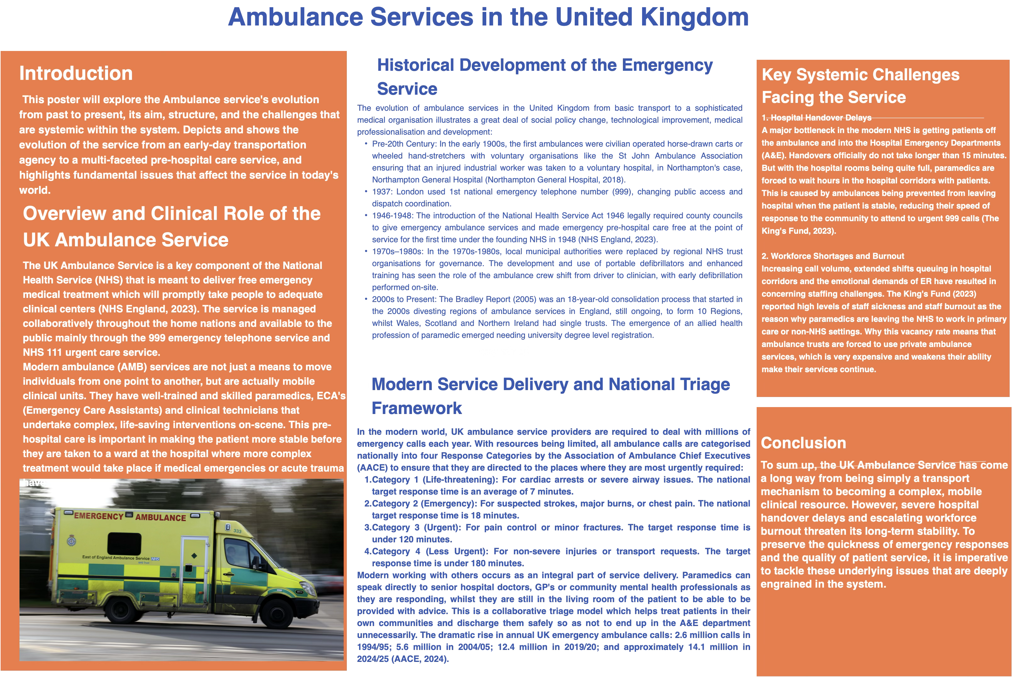

REFERENCE LIST
Association of Ambulance Chief Executives (AACE) (2024) State of the Sector: UK Ambulance Services Operational Review. London: AACE. Available at: https://aace.org.uk/wp-content/uploads/2024/03/Ambulance24-vision-final.pdf
NHS England (2023) Major plan to recover urgent and emergency care services. London: NHS England. Available at: https://www.england.nhs.uk/2023/01/major-plan-to-recover-urgent-and-emergency-care-services/
Northampton General Hospital (2018) The History of the Ambulance Service. Northampton: NGH NHS Trust. Available at: https://www.northamptongeneral.nhs.uk/About/OurHistory/History-of-Ambulance.pdf
The King’s Fund (2023) Ambulance Response Times: What is Happening? London: The King’s Fund. Available at: https://www.england.nhs.uk/long-read/delivery-plan-for-recovery-urgent-and-emergency-care-progress-update-and-next-steps/

TASK 2: SOCIAL CARE ESSAY
Chosen Service: Community Mental Health Services
Introduction
Community mental health services (CMHS) is both a dramatic shift from institutional confinement to local, recovery-oriented care. This essay explores the transition from the Victorian asylum to community care, examines the relationship model used by services in the present and the challenges this brings and outlines the benefits this has for the quality of life, autonomy and dignity of service users.

Historical Context and Origins
In the past, in the United Kingdom, support for mental health was characterised by isolation and institutionalisation. The county asylum system was the dominant one during the Victorian era, regulated under the Lunacy Act 1890, which was designed to keep people suffering with severe mental illnesses out of the public eye and provided either custodial or ‘out of sight’ care without much opportunity for social integration (Scull 2021).
A mass change of ideas began in the middle of the twentieth century. However, the Mental Health Act 1959 established a precedent that psychiatric services should be provided, when possible, outside of the walls of the asylum facility, at the community level. Deinstitutionalisation, famously backed by Health Minister Enoch Powell's 1961 Water Tower speech, was the start of the grandiose system of the large psychiatric institutions closing down. Until the enactment of the National Health Service and Community Care Act 1990, however, the legislation to create community-based support was not sufficiently established. The legislation saw the funding and responsibility for longterm care transferred from a centralised NHS hospital to the local authority's social services department, effectively ‘giving birth' to a new type of community mental health system that was multi-agency in nature (National Archives, 1990).

Modern Functioning and Critical Evaluation
The principle of collaboration and multidisciplinary working is prominent in the functioning of the CMHS today with the focus on Community Mental Health Teams (CMHTs). These teams have members from psychiatric nursing, social work, occupational therapy, psychology and Psychiatry and are designed to provide holistic localised care (NHS England, 2019). The Care Programme Approach (CPA), which was previously held in very rigid ways, has been replaced by a localised approach, organised around Primary Care Networks (PCNs) and voluntary sector organisations (NHS England, 2019).
This present model is analysed critically and is shown as a system of deep contrasts. On the other hand, modern CMHS is able to make effective use of inter-agency working to provide more specialist interventions including crisis resolution, early help for the first sign of psychosis, and employment support. However, systemic barriers blight the service. Austerity-driven cuts to local authority funding over the last decade, and an acute lack of qualified psychiatric professionals, has led to a ‘postcode lottery’ across the care quality.
There has been a severe regional imbalance in care quality over the last decade, known as the ‘postcode lottery’ (The King's Fund, 2020), caused by cuts in funding for local authorities and a lack of qualified psychiatric professionals. The King's Fund (2020) reported that many people with moderate to severe diseases end up in a hole neither considered too unwell or too vulnerable to access basic primary care therapies, nor perceived as becoming an imminent risk to meet the workload criteria of under-resourced CMHTs until they fall ill in an extreme and dangerous manner.

Significance to Service Users
Whilst facing these problems, the value of CMHS in improving their service users' quality of life is huge. CMHS places the needs of the service user first, which promotes their autonomy and dignity, value, relationships, employment and living within with communities (Mind, 2023). The modern community system focuses on a recovery approach rather than a clinical ‘cure'. Such a strategy looks at each person's strengths and personal goals, challenging the historical socially negative connotations of psychiatric labels (Mind, 2023).

Conclusion
To sum up, community mental health services have successfully been used as a historical clinical isolation to shift towards the current philosophy of community integration and collaborative care. Despite ongoing problems with funding and structural blocks that constrict access and unnecessarily pressure staff, the service is an essential to realise and preserve the human rights, independence and quality of life of those living with severe mental illness.

REFERENCE LIST
Mind (2023) Health and social care rights. Available at: https://www.mind.org.uk/information-support/legal-rights/health-and-social-care-rights/eligibility-for-social-care/
National Archives (1990) National Health Service and Community Care Act 1990. London: HMSO. Available at: https://www.legislation.gov.uk/ukpga/1990/19/contents (Accessed: 12 May 2026).
NHS England (2019) The NHS Long Term Plan. London: NHS England. Available at: https://www.england.nhs.uk/2019/01/long-term-plan/
Scull, A., 2021. " Community Care": Historical Perspective on Deinstitutionalisation. Perspectives in Biology and Medicine, 64(1), pp.70-81.
The King’s Fund (2020) Mental Health Services in England: Integration, Funding, and Challenges. London: The King’s Fund. Available at: https://www.kingsfund.org.uk/insight-and-analysis/long-reads/mental-health-360
Tom, B., 2020. Community-based mental health care in Britain. Consortium psychiatricum, 1(2), pp.14-20.

