11/20/2025
University of Wales Trinity Saint David
London campus
E-Portfolio Link: https://25149756.wixsite.com/my-site-3
Module Name: Learning In the Digital Era
Module Code: ACCA 4025

Student Name: Kaled Mensur
Student ID: 2514975
Group: 2

Lecturer’s Name: Koushik Modak

LDE Assignment 1
E-Portfolio
Table of Contents
Introduction 2
Main Body 2
Task 1: Essential Academic and Employment Skills for the future career Path 2
Task 1 (a): Report on Essential Academic and Employment Skills 2
Task 1 (b): Evaluation of Task 1 (a) based on Similarity report 2
Task 2: Collaborative Mind Map and Individual Poster 2
Mind Map (Collaborative) 2
Poster (Individual) 2
Task 3: Virtual Collaboration and RefWorks 2
Report on Virtual Collaboration 2
Step-by-step process of using RefWorks with visuals 2
Task 4: E-Portfolio Creation and Evaluation 2
Task 4 (a): E-Portfolio Creation 2
Task 4 (b): Illustrative Review of E-Portfolio tool Selection 2
Conclusion 2
References 2
Task 1 References: 2
Task 3 References: 2

Task 1: Essential Academic and Employment Skills for the future career Path
Academic and professional skills are essential for success in both education and the workplace. The ability to communicate, think critically, use information literacy, and manage time are key academic skills [1]. Strong communication—both written and verbal—supports effective assignment completion, class participation, and collaboration.
Students who use critical thinking can assess evidence, analyse issues, and come up with logical answers. Students who possess information literacy can recognize reliable sources, analyse data, and ethically use information [2]. Maintaining productivity, meeting deadlines, and balancing workloads are all made possible by time management.
Employment skills such as teamwork, adaptability, digital literacy, and professionalism are equally important. Teamwork prepares individuals to
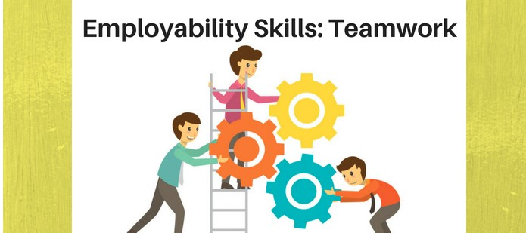
Figure: Employability skills.

work collaboratively in diverse environments, while adaptability enables them to adjust to changing technologies and workplace expectations [3].
As businesses depend on software tools, communication platforms, and data systems, digital literacy has become crucial for modern jobs. Professionalism, which includes accountability, dependability, and moral conduct, promotes trust at work and long-term job development.
Career choice and planning are directly supported by these academic and employment skills. Career paths aligned with individual strengths, including communication skills, analytical thinking, and digital competency, can be identified by understanding personal strengths.
Gaining proficiency in these areas also boosts self-esteem, enhances employability, and expands employment options in a variety of industries [4].
Ultimately, the combination of academic education and workplace skills equips individuals to make informed career decisions and succeed in a competitive job market.

Task 1 (b): Evaluation of Task 1 (a) based on Similarity report
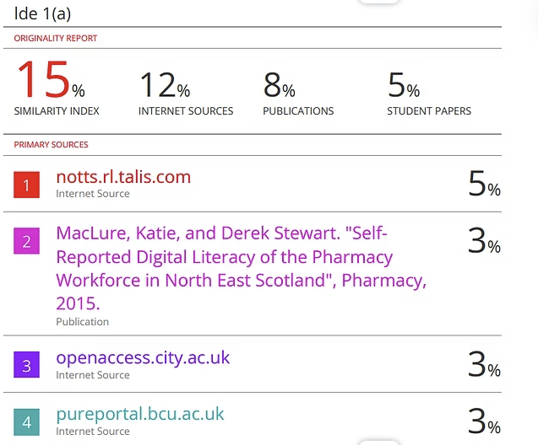

My Turnitin report shows 15 % of similar contain, which is quiet low. From this report I can say that , my writing skill are authentic .Most similarities came from academic heading and form reference, which is quiet acceptable. From this I can score myself more than 65%.Next time I will try to do more paraphrasing properly and I will use RefWorks tool, which going to help me to proper citation and reduce my plagiarism percentage.

Task 2: Collaborative Mind Map and Individual Poster

Mind Map (Collaborative)
Link: https://mm.tt/map/3845138122?t=p2sHkWYE8N
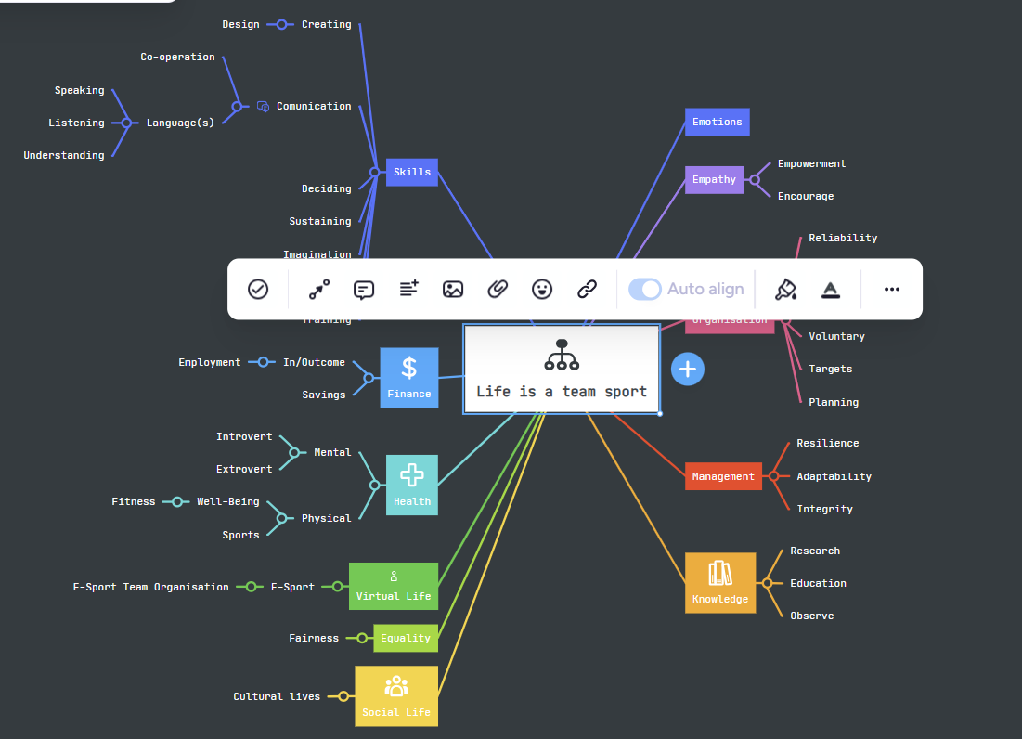

Poster (Individual):

Link: https://www.canva.com/design/DAG5PzwkKe8/_QVTuF0slvpiF-rDLF0o6Q/edit?utm_content=DAG5PzwkKe8&utm_campaign=designshare&utm_medium=link2&utm_source=sharebutton
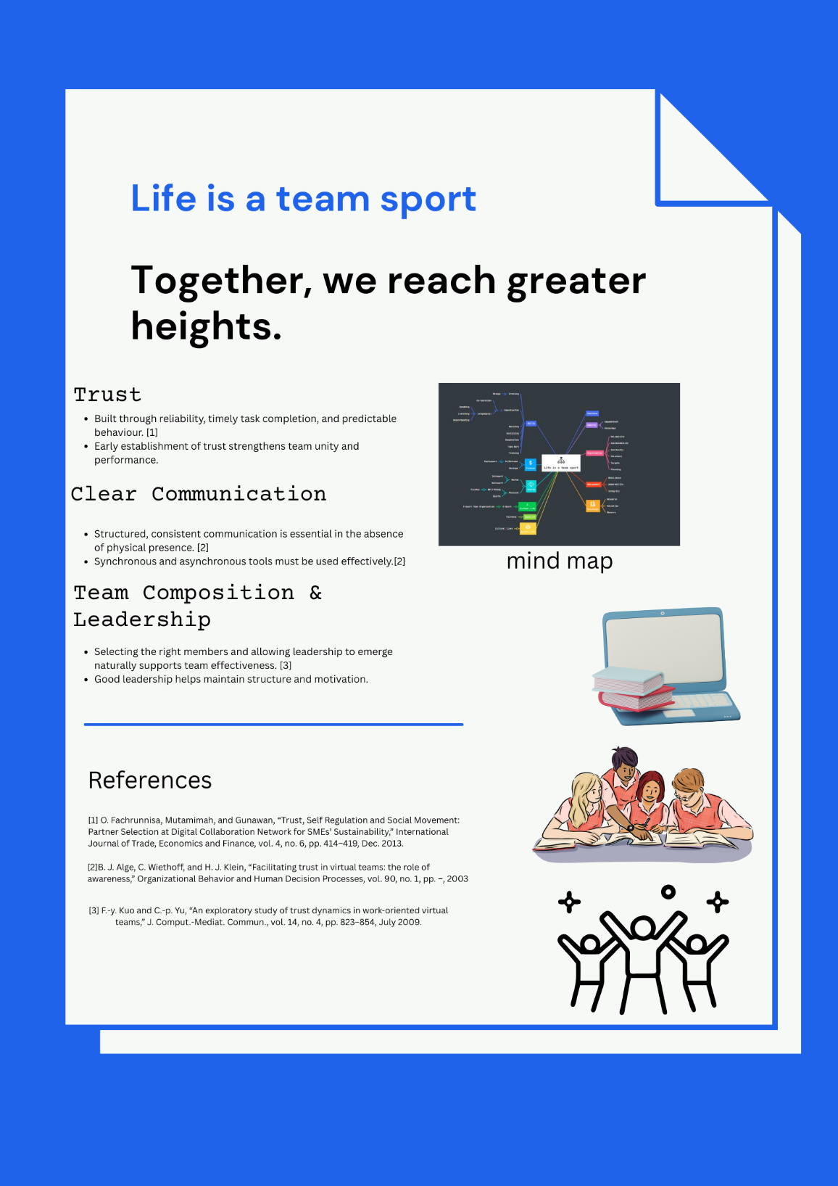

Task 3: Virtual Collaboration and RefWorks

Report on Virtual Collaboration:
Establishing a virtual team for productive co-operation involves paying close attention to the technology infrastructure, communication structure, team composition, and trust. Traditional methods of unity and trust need to be reconsidered in virtual environments because team members are often spread out in time and location and must rely on digital tools[1]
A crucial element in virtual team formation is trust. Without physical presence, trust is primarily built on the reliability of task delivery and past behavior[2].Study shows, members rapidly develop calculus-based trust (assessing costs/benefits) and knowledge-based trust (predicting behaviors), which then influence communication quality and team unity [3].Building this trust early is essential for upholding group effectiveness throughout the lifecycle of the virtual team.
The structure of the task is equally important. It is important for team members to have well-defined tasks and clear interdependencies in order to encourage accountability and clarity. When the structure is clear-cut, members feel more responsible for their part, and this encourages regular communication, which in the near future builds trust.
Awareness of each other’s activities helps maintain unity; research shows that awareness mechanisms (status updates, dashboards) moderate the effect of task structure on trust .
Technology and socio-technical environments are also important dimensions. Virtual teams depend on synchronous (video calls, chat) and document email-type asynchronous channels. However, tool limitations, time zone differences, and platform usability can inhibit collaboration.
Although some "radical co-location" can be electronically replicated through shared synchronous venues, technology issues and unequal access still exist, according to empirical research from online hackathons[4].
Finally, team roles and leadership emerge dynamically. The success of a virtual team depends on combining the dynamics of interpersonal relationships (trust, awareness), structural clarity (task design), and technology. Virtual teams can be productive, cohesive, and resilient even when physically separated by the way members are selected, trust is cultivated, and tools are leveraged.

Step-by-step process of using RefWorks with visuals:
down the below I have attached all the step I followed:
Step 1. First I had to open an account in RefWorks with my university credential. then I log in to RefWorks.
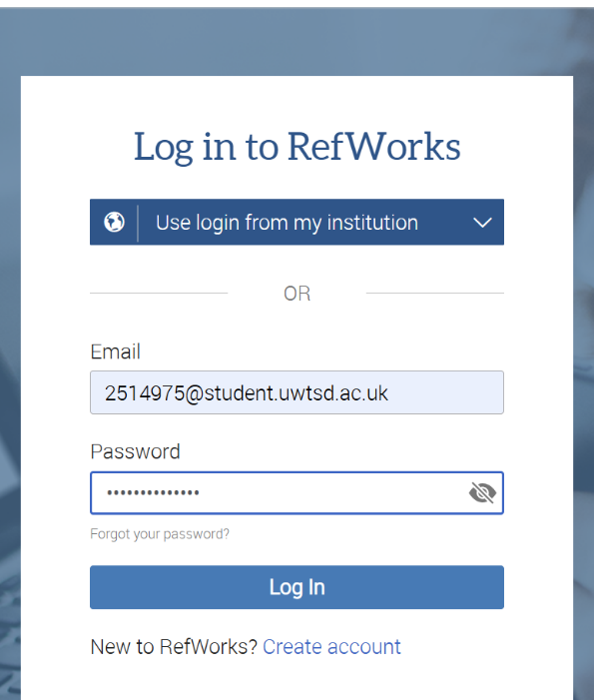

Create a folder Task3
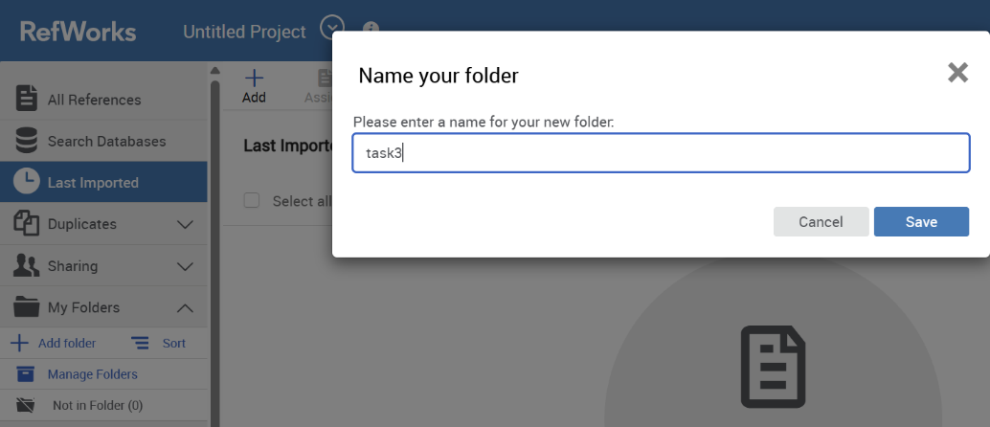

Search on google forming a team,

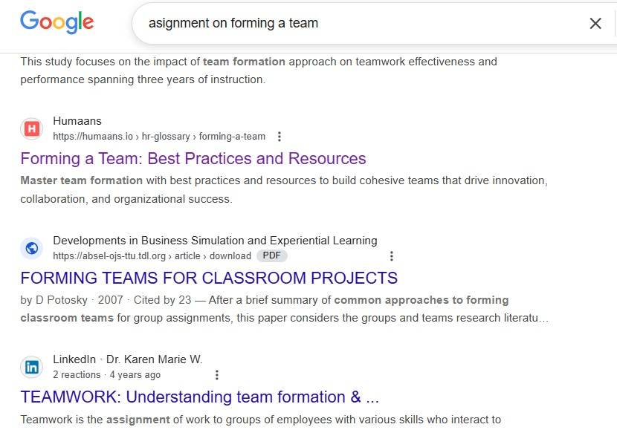
Then,click RefWorks,
,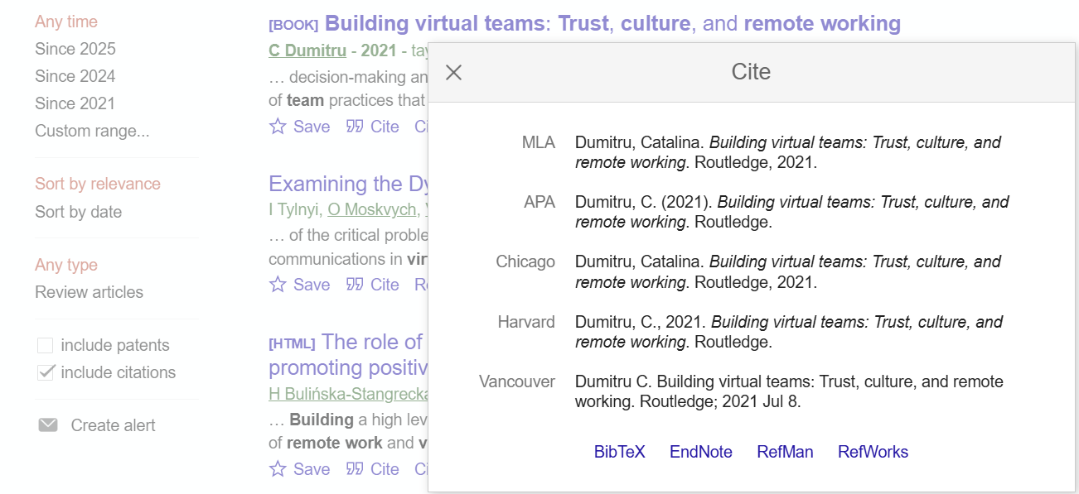
Then just followed this process
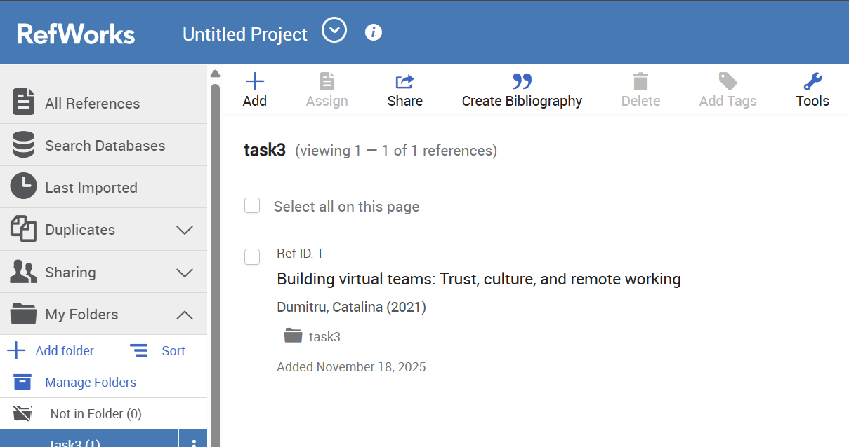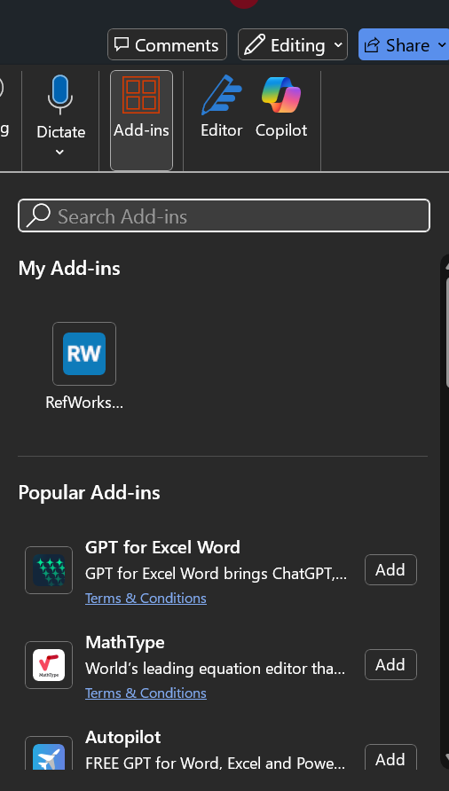
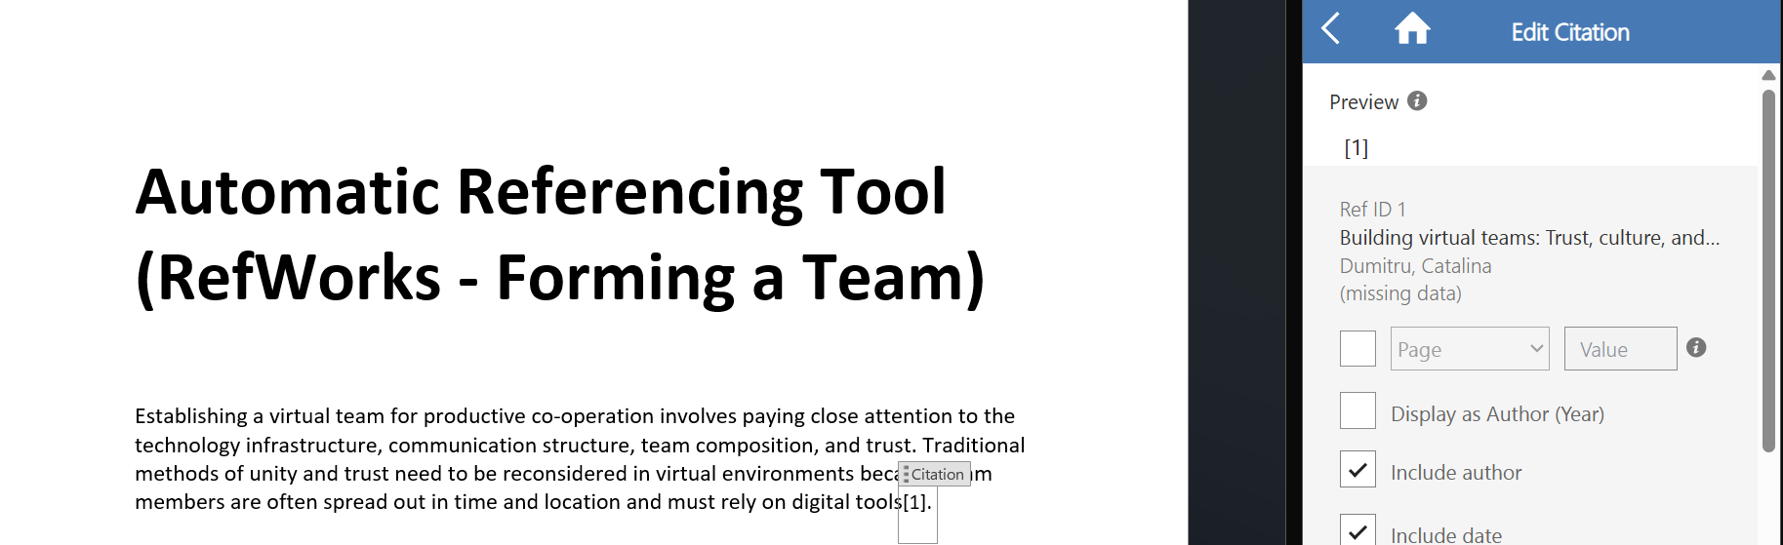
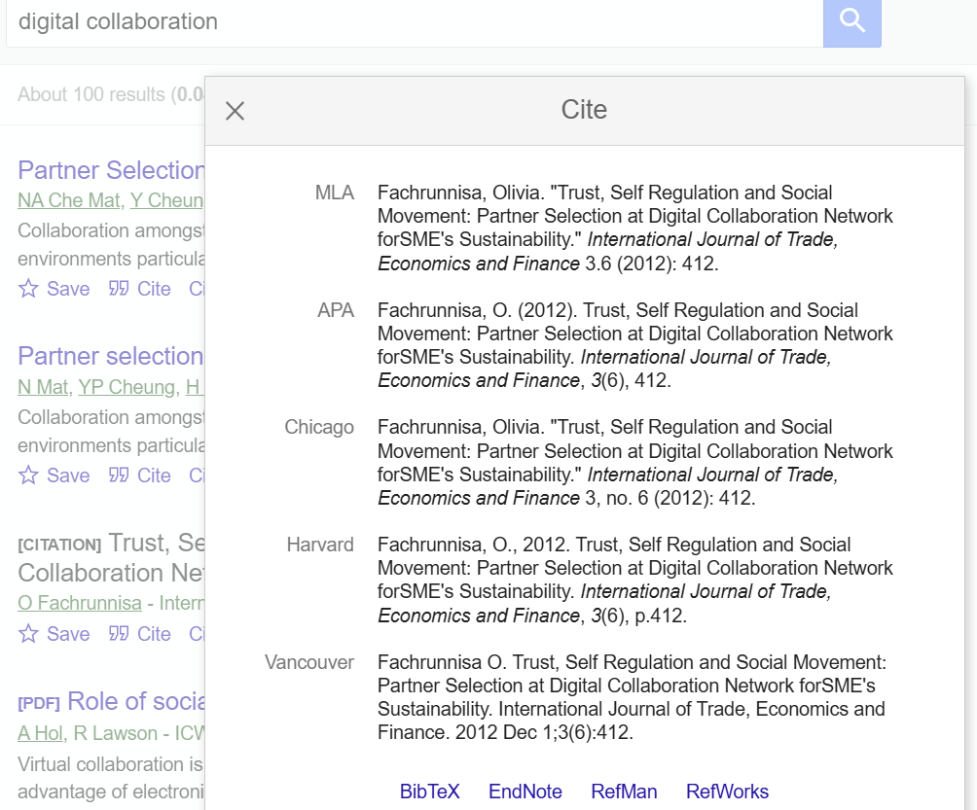

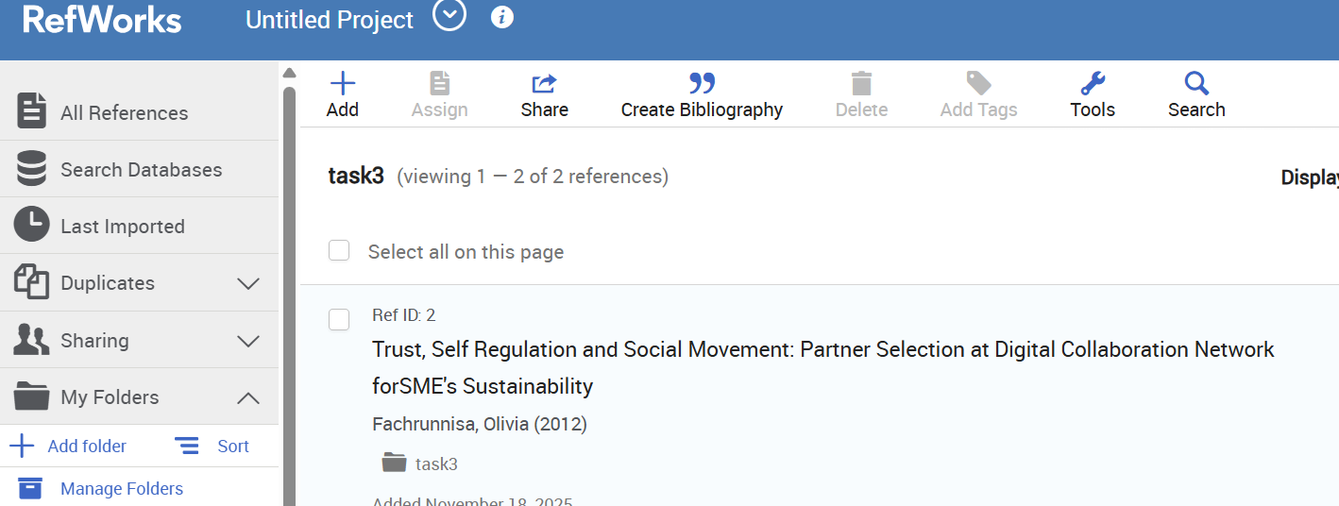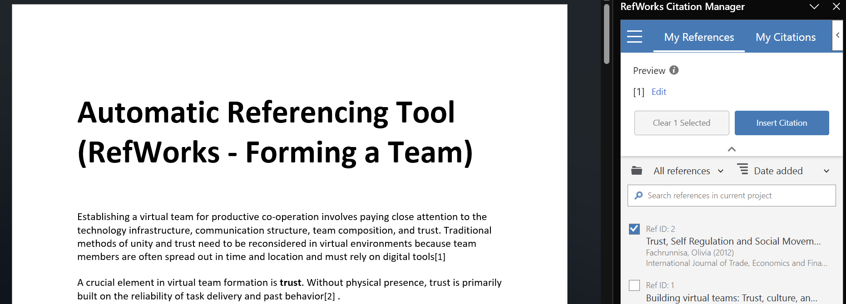
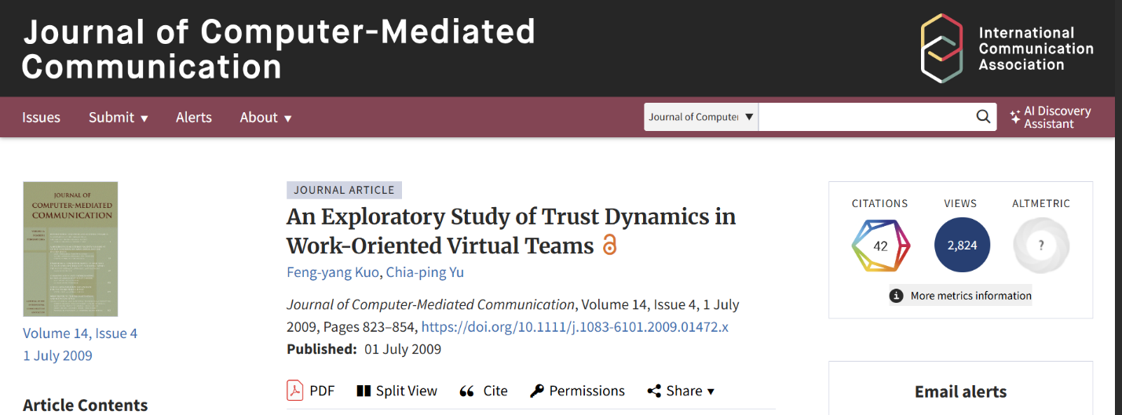
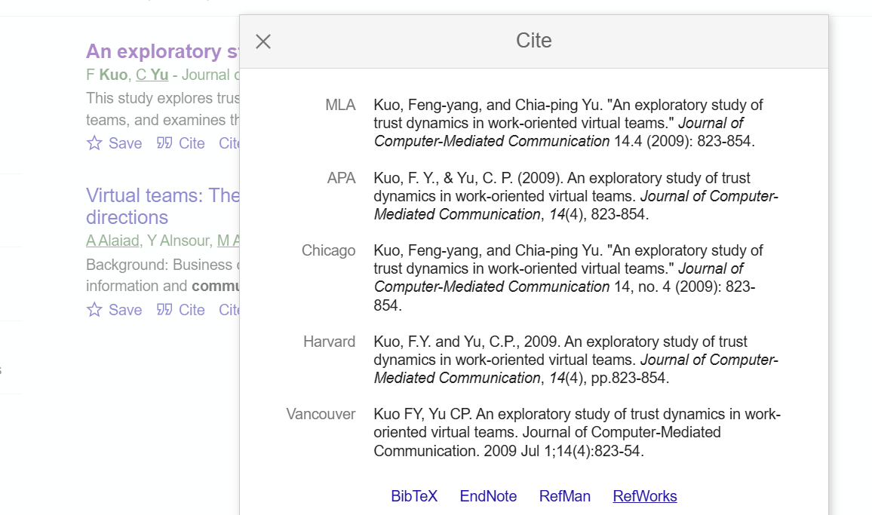
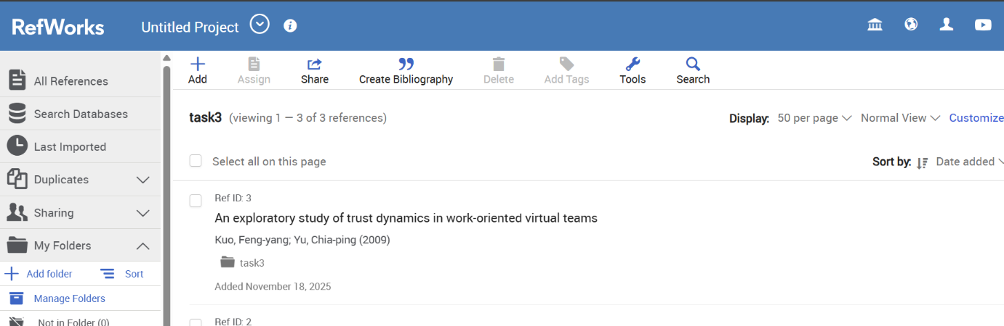
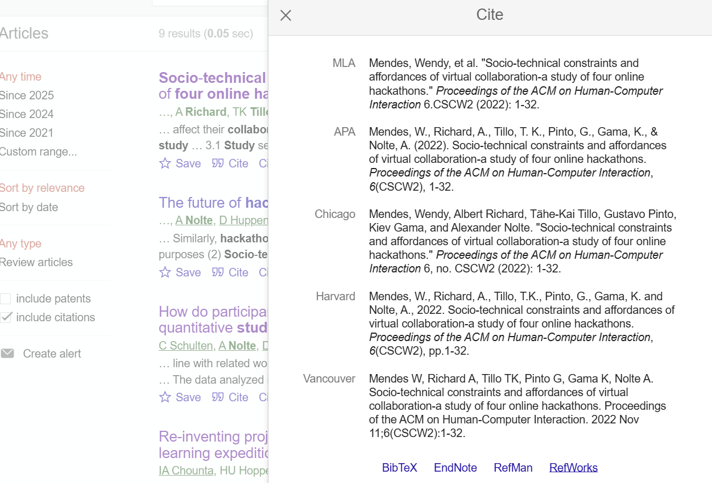
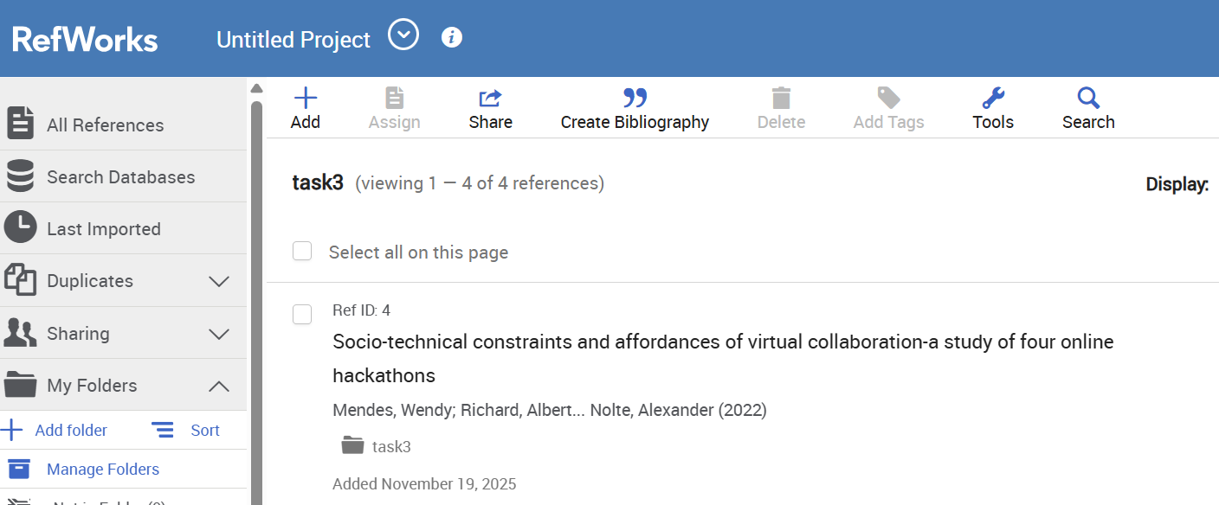
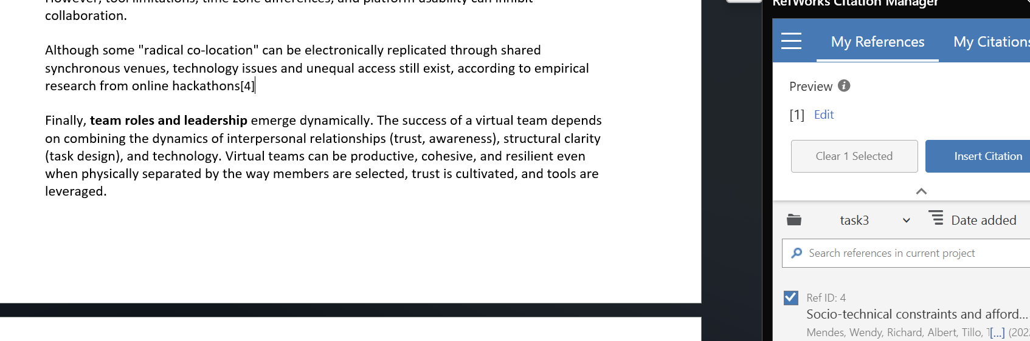
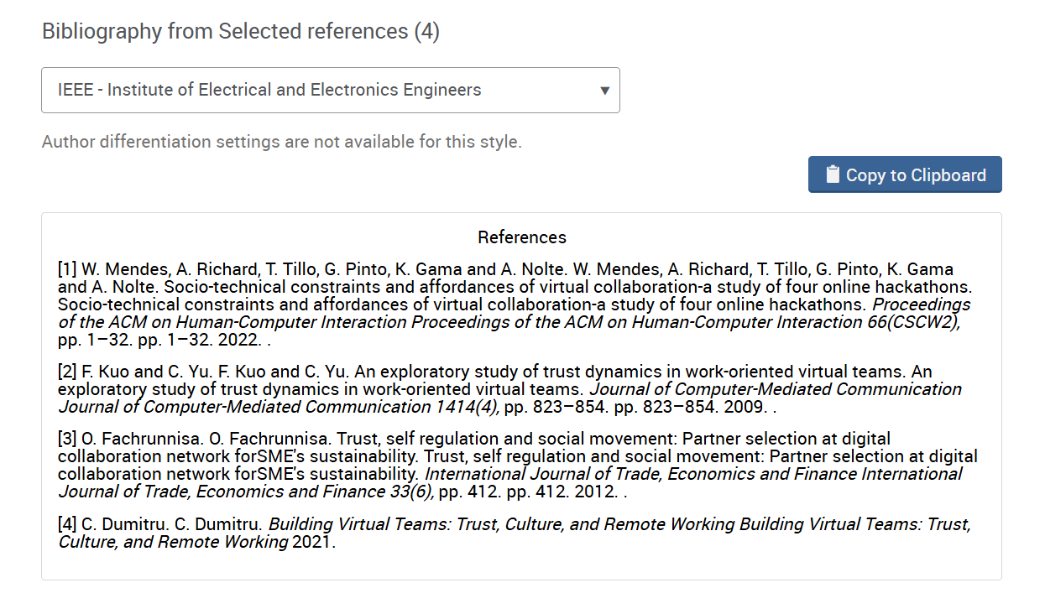

Task 4: E-Portfolio Creation and Evaluation

Task 4 (a): E-Portfolio Creation
https://25149756.wixsite.com/my-site-3


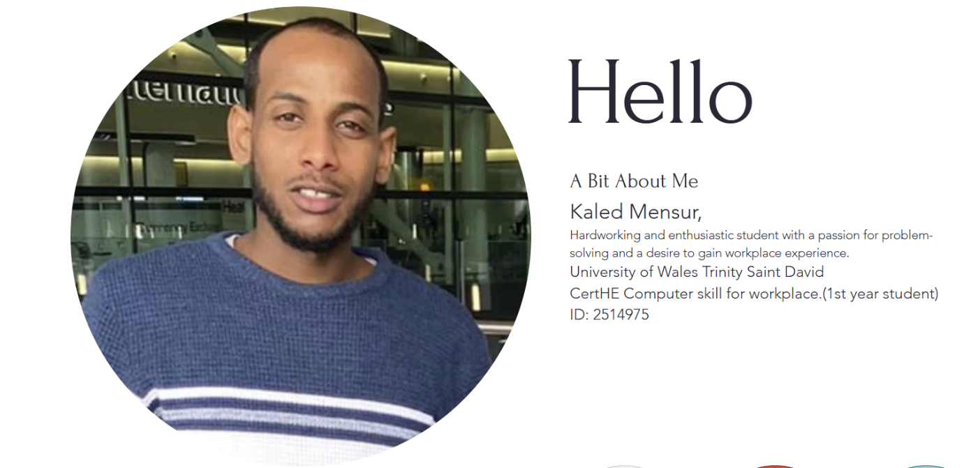
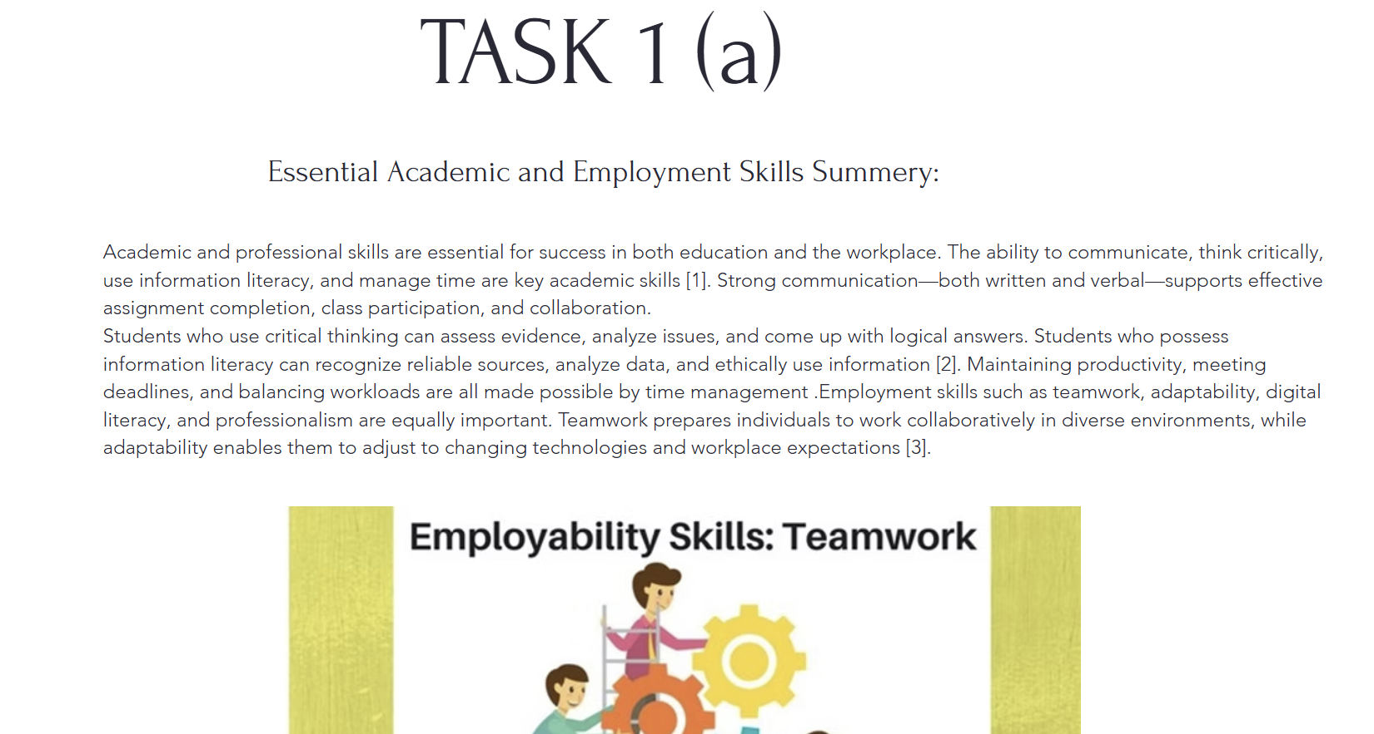
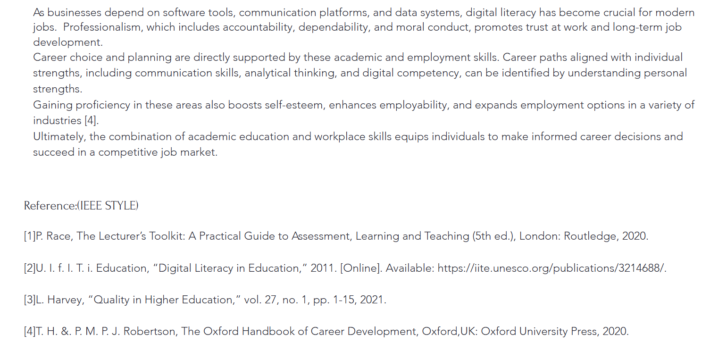
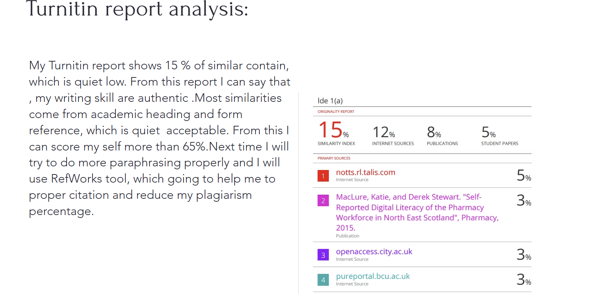
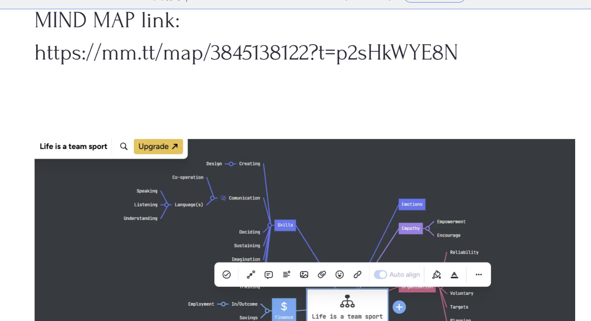
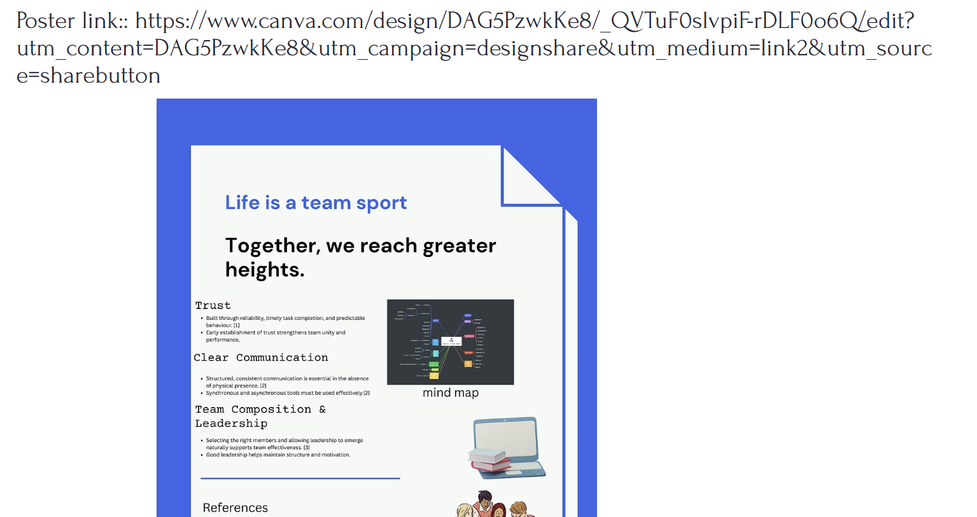
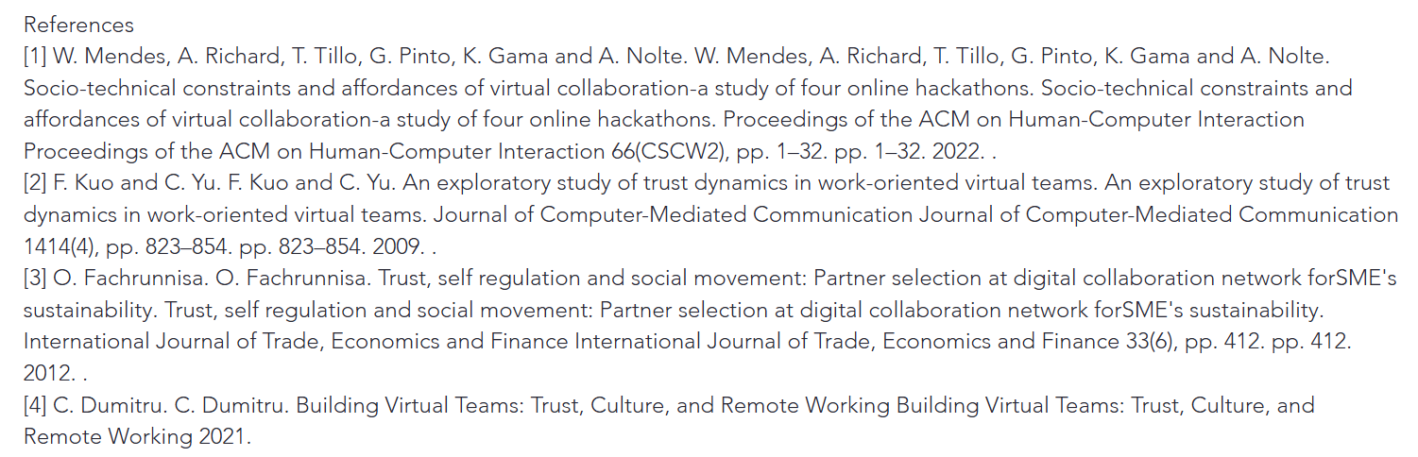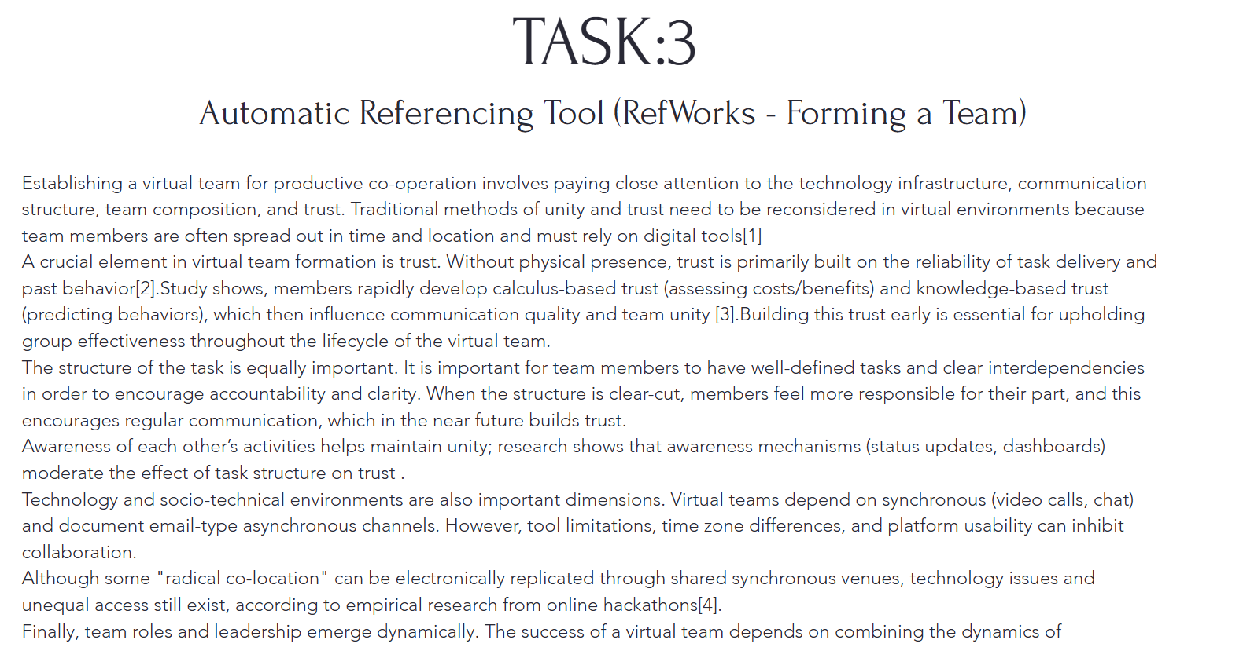

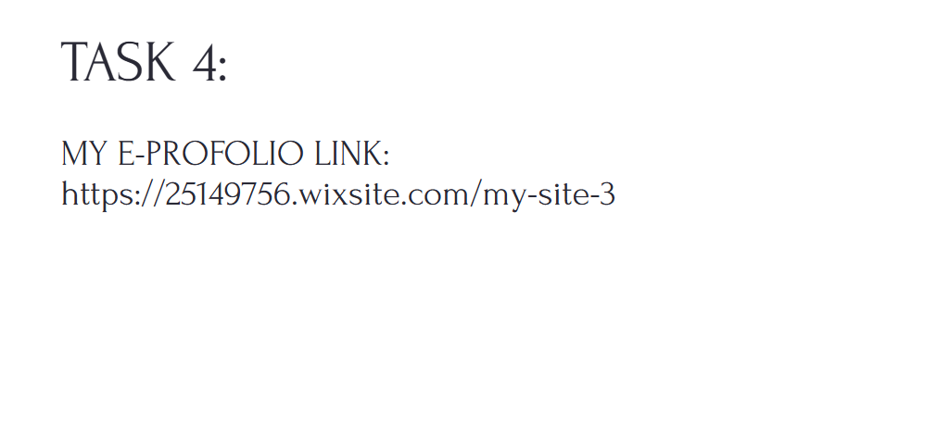
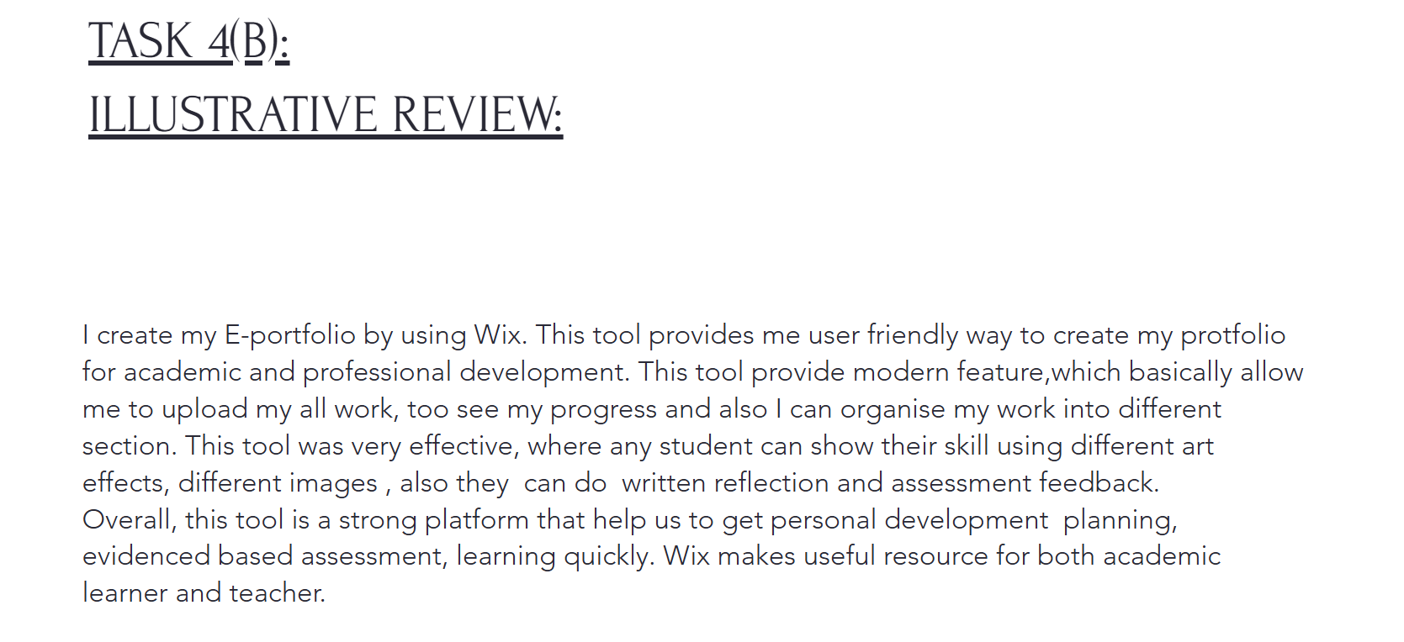

Task 4 (b): Illustrative Review of E-Portfolio tool Selection

I create my E-portfolio by using Wix. This tool provides me user friendly way to create my portfolio for academic and professional development. This tool provide modern feature, which basically allow me to upload my all work, too see my progress and also I can organise my work into different section. This tool was very effective, where any student can show their skill using different art effects, different images , also they can do written reflection and assessment feedback.
Overall, this tool is a strong platform that help us to get personal development planning, evidenced based assessment, learning quickly. Wix makes useful resource for both academic learner and teacher.

Conclusion:
This assignment help me to learn about how to manually IEEE referencing style and also how to use digital tool like RefWorks. I have also learn about Mind map and poster. Also help me to learn about how to do Portfolio and importance about portfolios in our academic and professional career. Also this course help me to learn about importance of team works in our daily lives.

References

Task 1 References:
[1] | P. Race, The Lecturer’s Toolkit: A Practical Guide to Assessment, Learning and Teaching (5th ed.), London: Routledge, 2020.
[2] | U. I. f. I. T. i. Education, “Digital Literacy in Education,” 2011. [Online]. Available: https://iite.unesco.org/publications/3214688/.
[3] | L. Harvey, “Quality in Higher Education,” vol. 27, no. 1, pp. 1-15, 2021.
[4] | T. H. &. P. M. P. J. Robertson, The Oxford Handbook of Career Development, Oxford,UK: Oxford University Press, 2020.

Task 3 References:
[1] W. Mendes, A. Richard, T. Tillo, G. Pinto, K. Gama and A. Nolte. W. Mendes, A. Richard, T. Tillo, G. Pinto, K. Gama and A. Nolte. Socio-technical constraints and affordances of virtual collaboration-a study of four online hackathons. Socio-technical constraints and affordances of virtual collaboration-a study of four online hackathons. Proceedings of the ACM on Human-Computer Interaction Proceedings of the ACM on Human-Computer Interaction 66(CSCW2), pp. 1–32. pp. 1–32. 2022. .
[2] F. Kuo and C. Yu. F. Kuo and C. Yu. An exploratory study of trust dynamics in work-oriented virtual teams. An exploratory study of trust dynamics in work-oriented virtual teams. Journal of Computer-Mediated Communication Journal of Computer-Mediated Communication 1414(4), pp. 823–854. pp. 823–854. 2009. .
[3] O. Fachrunnisa. O. Fachrunnisa. Trust, self regulation and social movement: Partner selection at digital collaboration network forSME's sustainability. Trust, self regulation and social movement: Partner selection at digital collaboration network forSME's sustainability. International Journal of Trade, Economics and Finance International Journal of Trade, Economics and Finance 33(6), pp. 412. pp. 412. 2012. .
[4] C. Dumitru. C. Dumitru. Building Virtual Teams: Trust, Culture, and Remote Working Building Virtual Teams: Trust, Culture, and Remote Working 2021.

