Sony UK Technology Centre
Green Belt Six Sigma Investigation into OTP Failures
Completed by Taylor Durban – February 2024
Please note that this report has been written based from an actual investigation completed by Taylor Durban, Product Engineer at Sony UK Tec.
The Data in this report is part of the NDA agreement that is signed between Sony UK Technology Center and University of Wales Trinity St David.

Contents
List of Figures and Tables 2
Executive Summary 3
Introduction 4
DMAIC 5
Define 6
Measure 7
Analyse 10
Improve 18
Control 19
References 21
Appendices 22

List of Figures and Tables
Figure 1 – Raspberry Pi 5
Figure 2 – Table Showing Quantity of OTP MAC Fails
Figure 3 – Table Showing Quantity of OTP MAC Fails
Figure 4 – Equipment Used for Extracting MAC Address Data
Figure 5 – MAC Address Data Collection
Figure 6 – Process Flow of the Testing Operation
Figure 7 – Fish Bone Diagram of Potential Causes
Figure 8 – KT Problem Analysis Method
Table 1 – KT Problem Analysis Step 1
Figure 9 – Process Flow for MAC Address Collection
Figure 10 – Process Flow of Collecting MAC Addresses When E-stopped
Figure 11 – Updated Process Flow for Collecting MAC Addresses
Figure 12 – Sony PCC Document

Executive Summary
This report outlines the investigation into the cause of the ‘OTP MAC’ failure mode found on a small percentage of Raspberry Pi 5 boards.
After collecting data around the failure volumes, testing process and possible failure causes the information has been analysed with the collaboration of other departments to theorise potential causes, test ideas and finally to identify the cause.

The cause of this failure mode has been linked back to two separate issues. Firstly, a handling error on behalf of the Engineering Technicians who work to keep the test equipment running day to day. This cause is down to a handling mistake that can be made when restarting the machine after it has been powered down or restarted. The quantities linked to this cause are extremely low and so this is not a major concern. A quick training exercise has taken place to update the Technicians on this issue.

The second cause is linked to a database error, this happens when a board is scanned, MAC addresses are reserved for it on the Alchemy database and then the machine is stopped/E-stopped. When restarted all the boards are sent for manual retesting. When scanned they are seen to have no MAC addresses written onto them as the scan checks the Couch database, and so more MAC addresses are assigned and written to them during the test process. Only at the end of the test when they are compared does the test software find that three addresses have already been given and so now, they do not match up. This results in the ‘OTP MAC’ failure mode.

It was found that this was due to an update that was made to the database. An immediate fix has been implemented and tested to make sure it is fit for purpose.

For future updates it is now policy for a PCC document to be completed for all CMS division changes, not just changes made in the Sony Imaging Products and Solutions division. This will help to identify if any future changes cause negative effects on the first-time test yield of the production lines.

Introduction
At Sony 100% of our circuit boards are tested to ensure that the products we sell are fit for market and without fault. To achieve this for our high-volume products, such as the Raspberry Pi 5, we have specially designed production lines that are designed and developed in-house for these exact products.
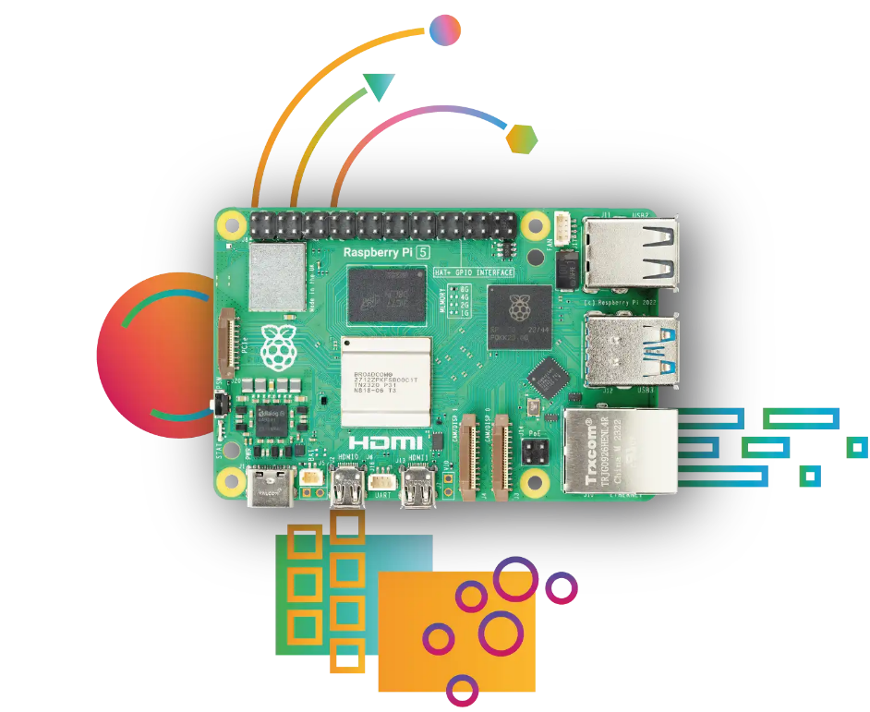
Figure 1 – Raspberry Pi 5
This six-sigma project investigates a particular failure mode found on the Raspberry Pi 5 production line; this failure mode is labelled on the failure ticket as “OTP MAC FAIL”. This failure mode only accounted for approximately 0.05% of the production line output for this model and so the issue, although recognised, was not investigated initially – other failure modes with higher fail volumes were prioritised.
The production management team requested that the investigation takes place after seeing a spike in OTP MAC fails during week 1 of the 2024 year, the information surrounding the failure data was shared with the Product Engineering team for them to being the investigation.

DMAIC
DMAIC is the key methodology for Six-Sigma and provides the investigation structure for defining the problem, measuring the relevant data, analysing the data that has been collected and then implementing a fix or solution. Finally, this structure discusses the importance of controlling the changes that have been implemented and making sure that they are successful and not causing any other problems or issues. This control section is also ideal for setting up measures that can identify if similar problems arise in the future, such as setting up new quality control checks etc. (Hessing, T. 2020)

Define
The spike seen on the Production dashboard was the instigating factor for this investigation. The repair ‘pot’ of boards that had been building up slowly due to this fail were being monitored but were not a priority until these spikes. The increase in product failing for this error was a suggestion that perhaps something had changed and there was risk of this turning into a failure epidemic.

At the time of this investigation being requested 99 boards have failed between 11/12/2023 and 08/01/2024. This averages at approximately 0.141% based on an average production volume of 70,000 units per week during this time.

The failed boards cannot be sold due to this issue as they will not operate correctly if they do have the same MAC addresses, this results in them being considered as scrap. Based on 47 weeks of manufacture per year and an average production volume of 50,000 per week (based on a year of production). This would equate to just over 3,300 boards per year going to scrap.

The investigation called for the OTP MAC fail boards to be analysed, data collected and for the correct people to be involved in order to help identify the cause of these fails and to find a solution to stop any ‘no fault found’ fails in the future (this is the term used for any product that fails during the production run, but when tested in the repair department is found not to have a fault, essentially a good board that has failed for no reason).

Measure

It was discussed that before this data collection that there was record of having 1 or 2 fails for this reason per day, as this is a very low quantity (considering the average production rate of around 12 thousand per day) it was only when this quantity increased was priority moved from the other failure modes to this failure. The data shared at the very beginning of this investigation is shown below in figure 2 and 3.

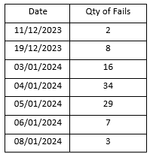
Figure 2 – Table Showing Quantity of OTP MAC Fails

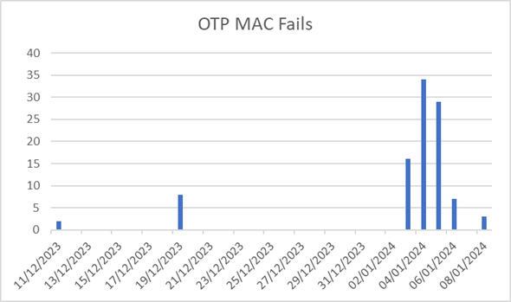
Figure 3 – Table Showing Quantity of OTP MAC Fails

Before anything started the investigation was handed over from Production Management and to the Product Group team, this group is responsible for NMI (New Model/Product Introduction) activities as well as product/component investigations. The Product Group team can pull other departments in for their support wherever necessary and so this allows investigations to gain pace quickly and solutions to be found as efficiently as possible.

After discussions around what this data suggested it was mutually agreed throughout the team that something had changed to create this spike in failures.
It was decided that the next steps should be for the failed boards from these dates to be further tested and the data recorded. As this was a failure linked to the MAC addresses, this was the part of the test that we were interested in for this part of the data collection. With support from the Test Engineering team a short process was set up involving the equipment shown in figure 4 below.

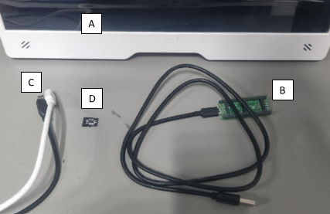
Figure 4 – Equipment Used for Extracting MAC Address Data

A = Raspberry Pi Computer Monitor
B = Raspberry Pi Pico, used to run a short script (program).
C = USB C and micro-HDMI used to power and connect the failed Raspberry Pi 5 board to the monitor.
D = SD card to be fitted to the failed Pi 5 board and give the board the operating system needed to run.

The process for collecting this data involved the failed Pi 5 board to have the SD card inserted, USB C plugged in and the micro-HDMI to be inserted, the board needed around 20 seconds to boot up. Once booted (this would be seen on the monitor screen) the Raspberry Pi Pico was connected using the USB A lead. This then automatically run the short script and the MAC addresses that were written onto the chip of the board were displayed.
To use this data, we also needed to scan the traceability barcode of the failed Pi 5 to check the serial numbers and to also find out what MAC addresses the Sony database thought should be written to the board. This data was then stored in the following table.

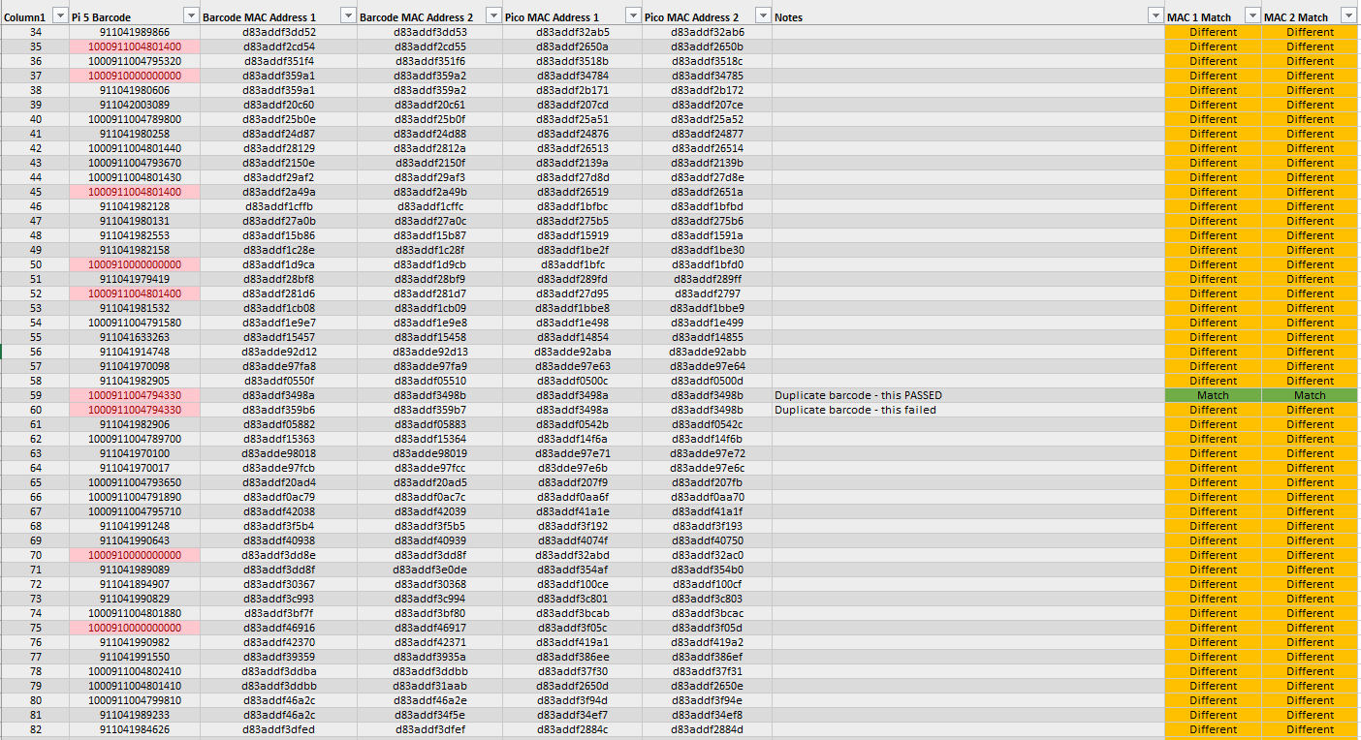
Figure 5 – MAC Address Data Collection

This data confirmed that the MAC addresses written to the failed Pi 5 boards are different to what the Sony database thinks is written to them. This is why, when tested, they fail for a MAC address error code.

Analyse

A team meeting was initially called between the Product team, production management team, quality control, database/network systems representative, the test engineer for this test software as well as one of the test software developers. This meeting allowed for a group discussion and brainstorming activity to take place surrounding the data that had been collected. Working through the test process step by step with the team of people who designed, developed, and wrote/integrated the test software allowed answers to be given quickly as such a vast amount of knowledge of the process was on hand.

To help understand exactly what the sequency of events for this process is the diagram shown below (figure 6) was created. This process flow diagram shows the start to end sequency of what happens within the testing phase of the board.

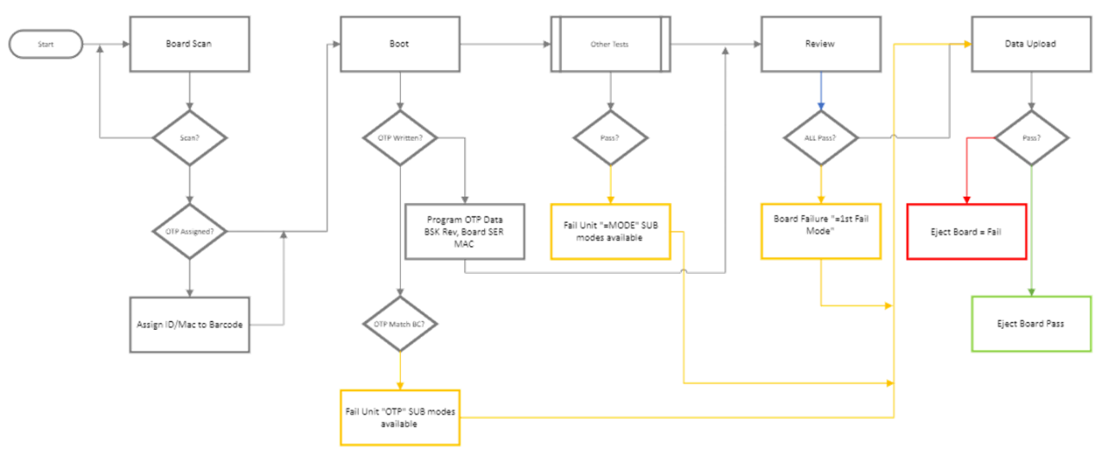
Figure 6 – Process Flow of the Testing Operation

Using the process flow diagram, the team was able to begin identifying all the inputs that could affect the output, such as: the equipment, test sequence, people, network, and the process itself.
All this information was set out in the fishbone diagram that is shown in figure 7.

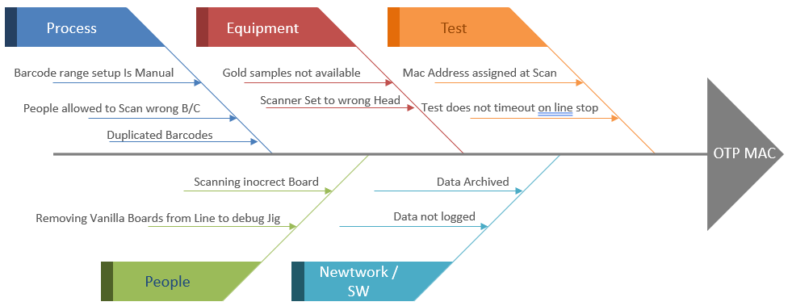
Figure 7 – Fish Bone Diagram of Potential Causes

Working though these possible options and a mixture of ‘problem re-creation trials’ and discussions with relevant departments allowed for us to cross certain points off the suspect list.

It was quickly found that a technician responsible for maintenance and for fixing day to day problems could easily re-create this failure mode. This was done by first allowing the test head to scan the board, then, before it enters the test head moving the carrier pallet/board and placing it in another test head. Although in theory this is not something that can happen, whenever there is a gantry crash within the machine the gantry’s need to go though the origin process. As part of this procedure the technician removes all the pallet from the test pod and then re-loads them once the machine is back up and running– this gives opportunity for them to be given to a different test head.
On the software this meant that the barcode scanned initially had MAC addresses reserved for it on the database, however, a different pallet/board was then entered into the test jig and so the MAC addresses are written onto the wrong board.

Despite this being a very quick discovery, it was realised through comparisons to the failure data that this was not happening in short time spans, instead this was occurring sporadically throughout the day, whereas the technicians may only need to origin the gantry systems once or twice a day and even then, there was only a slim chance of this error occurring.
Please see appendix 1 showing the data breakdown showing the time of day the failures occurred.

To verify that this was a cause of the failure mode the process was purposefully interfered with, resulting in a board that failed for the OTP MAC failure code.

After another team meeting to discuss this cause with the relevant departments everyone agreed that although this was one of the reasons this failure mode happens it was not the main problem and further investigation was needed. From this point the production management team organised short training discussions with the engineering technician team to teach them about the failure mode and this cause.

The next step to this investigation involved analysing the data that was collected from the failed boards (as shown in figure 5 in the Measure section).
This data showed that the MAC addresses written to the board were different to the MAC addresses that should have been written to the boards (comparing the board to the Sony database). This was in all but one case, where one board had passed the test and showed that the MAC addresses were in fact correct, but the serial numbers had been duplicated. This happens when a board is scanned, run through the test, and then gets re-tested in a test head that has already scanned a different board. Essentially this causes the serial number to have two sets of MAC addresses on the Sony database, for one board the MAC addresses are correct, for the other board they are incorrect. This is an output from a handling error and so has been counted as an anomaly to the rest of the data. However, this was noted down so that it could be referred to later.

The KT (Kepner-Trego) Problem Solving and Decision-Making methodology is a set way of working in the Engineering departments in Sony UK Tec. Where possible, KT methods, tools and language is used for all problems to help ensure everyone can understand the situation and to help guide people during problem investigations.

As part of this investigation the first KT Problem Analysis step was used, this involved stating the problem and then using an IS/IS NOT table, this method is shown in the image below (figure 8).

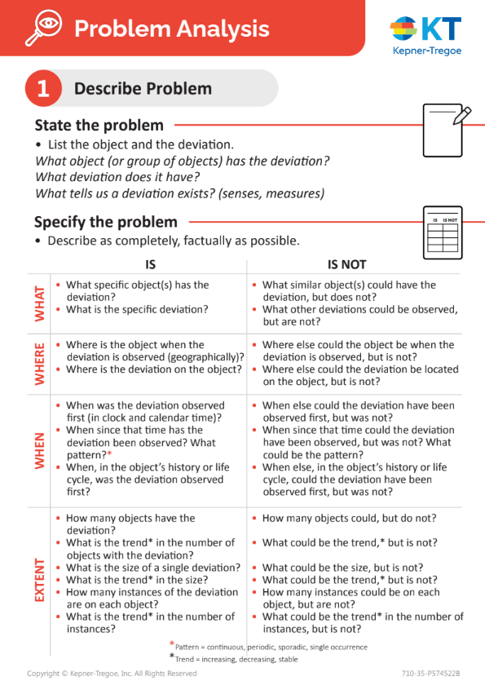
Figure 8 – KT Problem Analysis Method

Following this method resulted in the following statement and table.

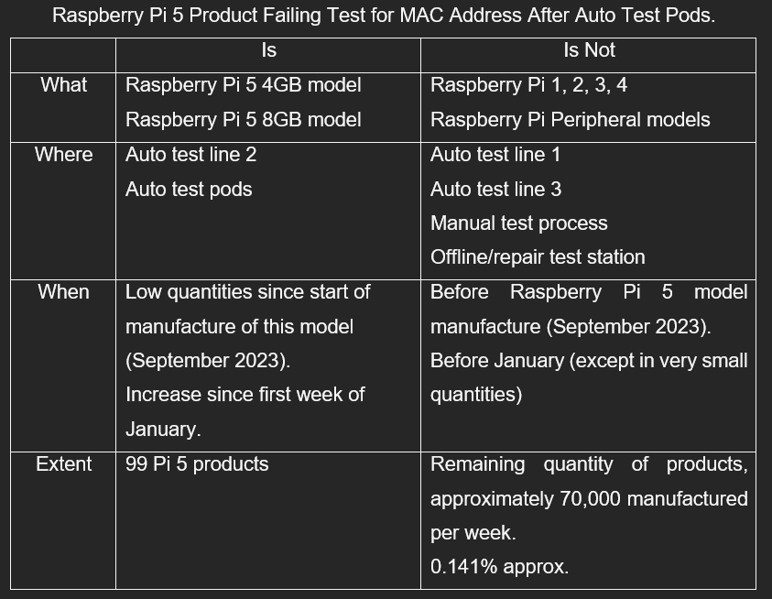
Table 1 – KT Problem Analysis Step 1

Using this tool helped to clarify that the problem was related to the auto test pods specifically, and only the test pods that are used for testing the Raspberry Pi 5 model range. This also narrowed down that something had changed before the start of production in January and this change had likely only been implemented on this production test line.

The information gathered strongly suggested that the problem causing these fails was likely to be a database/software issue oppose to a physical issue or human/robot handling error. Looking back the history of changes made to this production line there were no confirmed changes made during the weeks prior to the Christmas shutdown.

The decision was made to call a meeting with the software/database team for the factory, all the research, data and theories were shared with the team, and they were asked to support with identifying the exact process involved in how the MAC addresses were assigned. This process is illustrated in the below process flow.

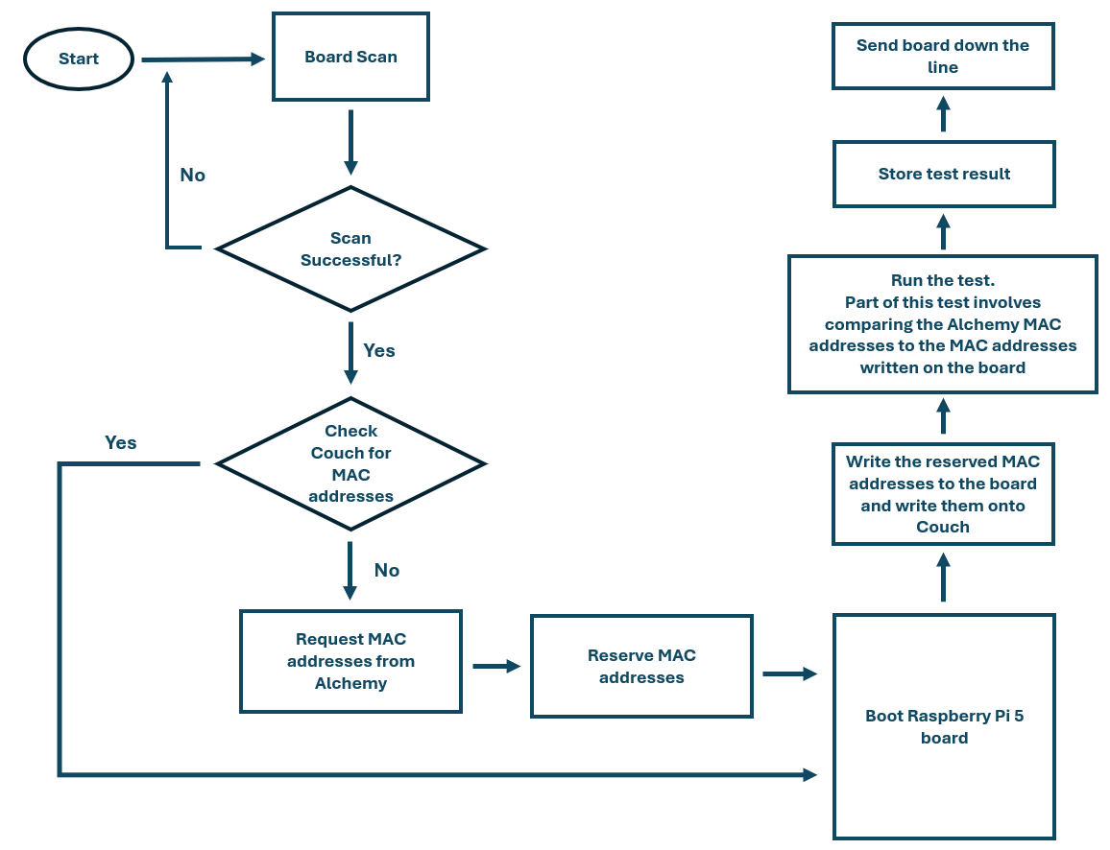
Figure 9 – Process Flow for MAC Address Collection

As can be seen in this flow chart where the MAC addresses are initially checked, and where they are requested from are two different locations (Couch and Alchemy). After further discussion, this was because the Couch system is used to monitor what information the product has written to it, whilst the Alchemy system is to monitor our own internal databases.
Step by step each part of the flow chart was evaluated to see what could happen that would affect this process once it was started. It was noticed that the only effect that could affect this process was a stoppage, such as a power cut or E-stop of the machine. From having previous job experience of building these machines it is known that for some errors the E-stop is used to allow for a full system re-set, without having to power down and wait for the PC’s etc to boot back up.

The below process flow shows what happens if the machine is E-stopped at the wrong time.
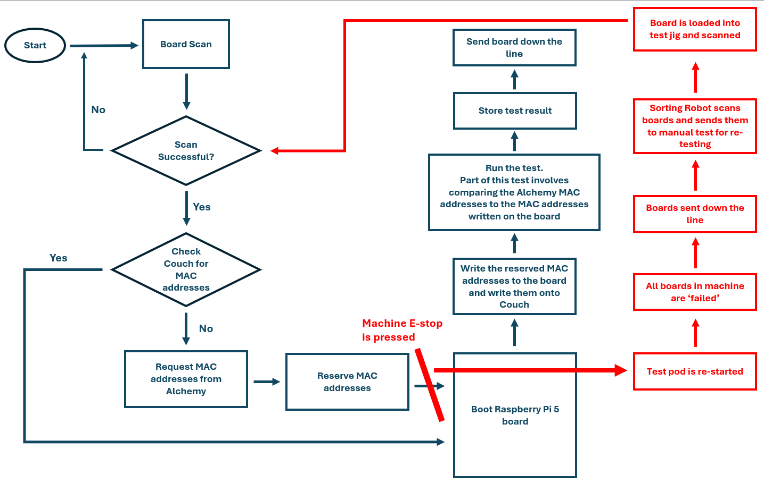
Figure 10 – Process Flow of Collecting MAC Addresses When E-stopped

Figure 10 (above) shows clearly that when E-stopped the serial number, nor the Couch database system have any record of the MAC addresses being ‘reserved’ in the Alchemy database. Therefore, it goes back through the process. This time the machine is not E-stopped, and so the new MAC addresses from Alchemy are written onto the board and saved into the Couch system. During the test when the boards MAC addresses are compared to those saved on Alchemy it finds that the MAC addresses do not match. This is because the board only has three, but the Alchemy database has six, the first three are the original three that the test software sees.

To prove this failure mode, during a break time the line was run, and a single board entered the test pod, after scanning the test pod E-stopped, restarted and the board observed whilst it travelled to the manual test jigs. After manual testing the board failed for ‘OTP MAC Fail’.

Further investigation with the software and database team resulted in identifying that a change was made to the MAC address reserve sequence prior to the Christmas shutdown period. This change involved the MAC addresses being reserved in Alchemy before this they were collected from Alchemy and reserved in Couch before being written to the board and officially being saved in both during the test process.

Improve

In this circumstance there was a very simply and quick solution to this issue. An amendment to where the test process checks the database, as well as a timer on how long the MAC addresses are reserved in Alchemy means that the follow process flow is now live.

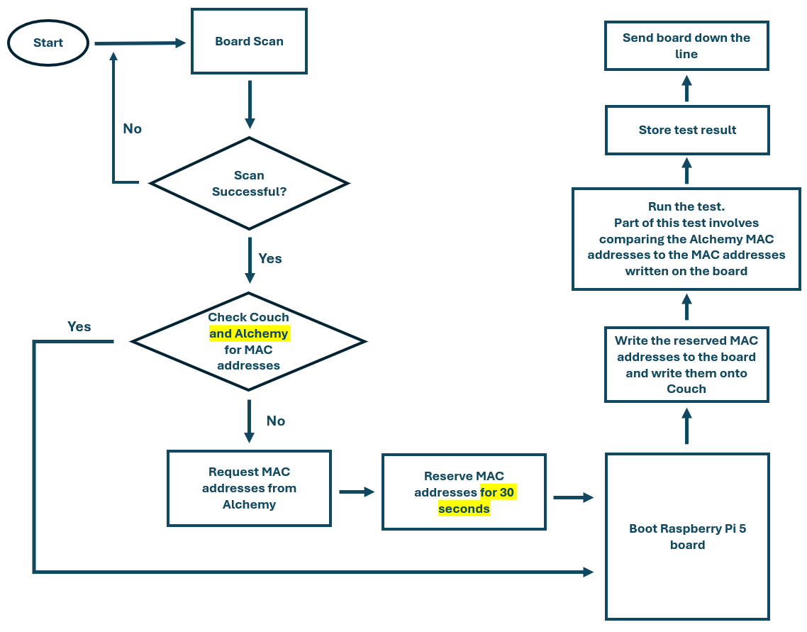
Figure 11 – Updated Process Flow for Collecting MAC Addresses

As can be seen in the updates process flow (figure 11), no matter if the test pod is E-stopped the Pi 5 boards are now always checked against both the Couch and Alchemy databases. As a secondary measure the MAC addresses that are reserved in Alchemy are only reserved for 30 seconds - this is 2 times the average time it takes to boot a Pi 5 board and if a Pi 5 board takes longer than 28 seconds for initial boot it will fail for a different ‘Boot Fail’ code.
This timer also means that it is very unlikely that a technician can make a board handling error during a machine restart and cause the failure mode this way, as the 30 second timer will wipe out any addresses that had been reserved – addressing previous concerns for this handling error causing the failure mode.

Control

The current production dashboard monitoring system sufficiently identified this problem within one week of it beginning, this dashboard to display large volumes of data from across the factory is monitored and updated regularly to ensure it is relevant with what product is being tested on which production lines and for any important product specific information that needs to be collected and displayed.

Relating to this specific investigation the cause was an update that was made to the database systems in which the test process depends upon. If this update was recorded and announced more thoroughly then it would likely have been much easier and quicker to identify the cause.

To improve this for future modifications a PCC (Process Change Control) document is now required for all changes/updates and modifications that are made to any of the production equipment, software relating to the test process and databases/networks in which the test sequence depends upon. Previously the PCC document was only required in the Sony Imaging Products and Solutions division of the company, now it will also be required in the CMS (collaborative manufacturing solutions) divisions of the company.

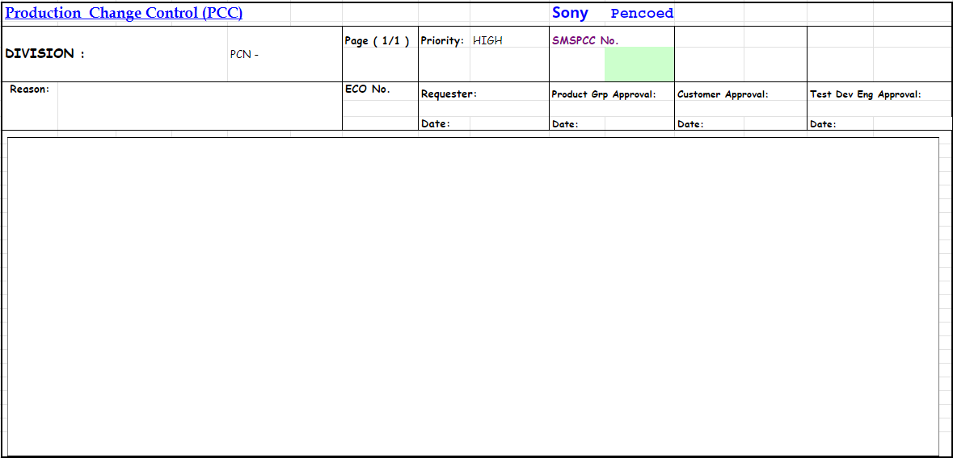
Figure 12 – Sony PCC Document
This document shows who requested the change, what the change is and needs to be counter signed by Product Engineering, Test Engineering as well as the customer (in this case this would be Production, as the change benefits them as they no longer have OTP MAC Fail boards). Part of the PCC process involved getting this signed before implementing any changes and then this being filed by the PADICS team, this Engineering-based team are responsible for BoM control as well as all changes relating to products, systems, and processes. Finally, the PADICS team send an announcement when the change has been filed and implemented to inform all the relevant Engineering divisions that a change has taken place.
The implementation of PCC’s in the CMS division of Sony UK Tec will help to ensure that all investigations can begin with an evaluation of what changes have been made to a particular product, process, or production line in any set time.

To verify that these improvements were successful a test was done during a breaktime to ensure that the failure mode ‘OTP MAC’ could no longer be created through the two known methods. It was found that the failure mode could not be re-created.
Further monitoring of the dashboards and failure mode data will continue to ensure that this failure mode does not reoccur.

References

Figure 1 – Raspberry Pi 5. [online] Available at: https://www.raspberrypi.com/products/raspberry-pi-5/ (Accessed on 11/03/24).
Hessing, T. 2020. DMAIC Overview. [online] Available at: https://sixsigmastudyguide.com/dmaic/ (Accessed on 27/04/2024).

Figure 8 – KT Problem Analysis Method. [online] Available at: https://kepner-tregoe.com/gbr/kepner-tregoe-cards-app/ (Accessed on 28/04/2024).

Appendices
Date | Time | Date | Time | Date | Time
3/1/2024 | 10:49 | 4/1/2024 | 15:53 | 5/1/2024 | 9:27
3/1/2024 | 10:50 | 4/1/2024 | 15:54 | 5/1/2024 | 10:23
3/1/2024 | 10:54 | 4/1/2024 | 16:13 | 5/1/2024 | 11:19
3/1/2024 | 12:34 | 4/1/2024 | 17:04 | 5/1/2024 | 11:19
3/1/2024 | 13:10 | 4/1/2024 | 16:55 | 5/1/2024 | 13:34
3/1/2024 | 14:03 | 4/1/2024 | 17:03 | 5/1/2024 | 13:44
3/1/2024 | 14:39 | 4/1/2024 | 17:11 | 5/1/2024 | 13:51
3/1/2024 | 14:41 | 4/1/2024 | 17:19 | 5/1/2024 | 14:36
3/1/2024 | 15:57 | 4/1/2024 | 17:20 | 5/1/2024 | 15:23
3/1/2024 | 16:00 | 4/1/2024 | 18:07 | 5/1/2024 | 16:37
3/1/2024 | 16:47 | 4/1/2024 | 18:05 | 5/1/2024 | 16:39
3/1/2024 | 20:12 | 4/1/2024 | 18:39 | 5/1/2024 | 17:58
3/1/2024 | 21:46 | 4/1/2024 | 18:27 | 5/1/2024 | 17:54
3/1/2024 | 22:11 | 4/1/2024 | 18:45 | 5/1/2024 | 18:40
3/1/2024 | 22:19 | 4/1/2024 | 18:57 | 5/1/2024 | 18:54
3/1/2024 | 22:33 | 4/1/2024 | 18:58 | 5/1/2024 | 19:32
3/1/2024 | 23:50 | 4/1/2024 | 19:03 | 5/1/2024 | 21:28
4/1/2024 | 7:53 | 4/1/2024 | 19:43 | 5/1/2024 | 21:44
4/1/2024 | 8:20 | 4/1/2024 | 20:33 | 5/1/2024 | 22:23
4/1/2024 | 8:37 | 4/1/2024 | 21:47 | 6/1/2024 | 0:48
4/1/2024 | 8:10 | 5/1/2024 | 2:52 | 6/1/2024 | 1:51
4/1/2024 | 8:40 | 5/1/2024 | 3:27 | 6/1/2024 | 1:56
4/1/2024 | 9:50 | 5/1/2024 | 3:51 | 6/1/2024 | 4:39
4/1/2024 | 11:13 | 5/1/2024 | 3:52 | 6/1/2024 | 4:44
4/1/2024 | 12:41 | 5/1/2024 | 4:08 | 6/1/2024 | 6:02
4/1/2024 | 11:24 | 5/1/2024 | 5:38 | 6/1/2024 | 6:27
4/1/2024 | 13:12 | 5/1/2024 | 5:41 | 8/1/2024 | 7:32
4/1/2024 | 13:56 | 5/1/2024 | 7:29 | 8/1/2024 | 7:37
4/1/2024 | 13:51 | 5/1/2024 | 8:25 | 8/1/2024 | 8:32
4/1/2024 | 14:25 | 5/1/2024 | 9:26

Appendix 1:

