
Module Name: Academic Skills in the Digital Era
Module Code: BMSW4013
Assessment 1:
Student Name: Ryan Burns
Student Number: 252636
Lecturer: Fhion
Deadline: 23.59 27th of February

Wordcount:
AI Acknowledgement
(This section is compulsory for all students.)
I acknowledge the use of [AI tool name] ([AI tool URL]) on [date] to support [state purpose – e.g. research / proofreading / none].
Prompt(s) used (if applicable):

I confirm that I have not presented any AI-generated text as my own work. I confirm that I have retained copies of drafts, notes, and resources used before and after the use of AI tools.
Contents
Component 1 – Development of Academic Skills (500 words) 4
Component 2 – Application of Academic Skills (1,000 words) 6
Component 3 – Academic Poster 8

Component 1 – Development of Academic Skills (500 words)
(Personal experience must NOT be included in this component)
Evaluating Academic Sources Using the CRAAP Test (250 words)
Choose TWO academic sources related to the use of digital skills in higher education.
Source 1
Author(s) and year: Florence Martin, Siyu Long, Katy Haywood, Kui Xui
Where you found the source (University library):
Using the CRAAP Test, briefly evaluate:
- Currency; This source is very current as it was published on the 7th of august 2025 therefore this source is very relevant for my report as the research is up to date.
- Relevance: The article is very relevant to this report as technology is depended upon as a major tool used by students in higher education.
- Authority: All authors of this article are more than respected in their own rights as are a team of researchers with a vast experience.
- Accuracy: This article is not only peer-reviewed, but all researchers are from highly respected universities across America.
- Purpose: There is real purpose to the research that this team has done due to the fact systematically reviewed and synthesized previous research
Full reference (Harvard style):
Martin, F., Long, S., Haywood, K., & Xie, K. (2025). Digital distractions in education: a systematic review of research on causes, consequences and prevention strategies. Educational Technology Research and Development, 73(6), 3423–3451. https://doi.org/10.1007/s11423-025-10550-6

Source 2
Author(s) and year: Talan Taric, Dogan Yunus, Kalinkara Yusuf(2024)
Where you found the source (University library ):
Using the CRAAP Test, briefly evaluate:
- Currency: This study reflects current issues experienced in a digital era. This is a recent article. Smartphones and social media usage increase among university students.
- Relevance: The article relates direct to the assignment theme and looks at how smartphones & social media addiction affect university students which is a challenge in a digital era.
- Authority: The studies are by academic researchers and published in a peer-review journal which leads to believe strong credibility
- Accuracy: The research was on data from over 200 university students and the findings are supported by evidence. As it is peer-reviewed indicates trustworthy source to use
- Purpose: The research is based on smartphone addiction and social media addiction which can affect university students so can use in assignment as relevant to digital era.
Full reference (Harvard style):
Talan, T., Doğan, Y. and Kalinkara, Y. (2024) “Effects of Smartphone Addiction, Social Media Addiction and Fear of Missing Out on University Students’ Phubbing: A Structural Equation Model,” Deviant behavior, 45(1), pp. 1–14. Available at: https://doi.org/10.1080/01639625.2023.2235870.
Synthesis of Academic Sources (150–180 words)
- What shared theme or issue do both sources address?
Both sources highlight the ever-increasing use of technology such as smartphones social media by university students and complement each other about being a digital distraction also known as phubbing when a student is so addicted to their phone they ignore any other people around them. Both state tec habits can cause problems.
- How do the sources agree, differ, or complement each other?
Both sources 1 & 2 basically agree that technology especially smartphones & social media heavily distract university students and can make it harder to learn
- How does combining these sources improve understanding of digital learning?
Using these sources together helps reader understand digital learning better and the challenges that come with it because they are kind of as each one explains the same problem from a different angle. When put together they make it easier to fully understand. With both sources presented together reader can see impact on students learning. Smartphone addiction is just a other form of digital distraction.
(Write objectively and include in-text citations.)
Identifying a Key Challenge and Opportunity (100–120 words)
Using ONLY the two sources above:
- One key challenge for students in the digital era:

Digital distraction is a major challenge like when technology interrupts the learner’s concentration a result of this harms learning. If distraction evolves to addiction all addiction can be a problem. Due to smartphones social media and digital distractions this is a challenge and can cause learners to lose focus on their studies. (Martin et al.,2025) (Talan et al.,2024)
- One key opportunity for students in a digital era:
Access to digital technology is a major opportunity for students and learners alike with access to learning material online platforms for flexible learning these accessible tools are a very important part of university life for students. 24-hour access to learning material opens opportunities for people with other responsibilities. (Martin et al.,2025) (Talan et al.,2024) (Both must be supported by academic evidence.)
Academic Planning for Component 2 (80–100 words)
- Which section(s) of Component 2 will you prioritise first? Why?
I will start with the introduction because it provides a good starting point for this report and helps me understand the main point and direction of this report.
- Which academic skills or lecture content will you develop further?
I want to develop my planning and organisation skills. critical thinking, also my ability to read academic articles and identify key points this can only improve my skills going forward, increasing my chances of succeeding in my studies
- Brief outline of how Component 2 will be structured
This report will follow the structure required for Component 2. It will Begin with a brief introduction giving readers an overview of digital learning. Then the report will discuss the challenges and opportunities students face in a digital era. It will identify strategies students can use to succeed. This report will conclude with a summary of the main points.
Timeline
Task | Date/ Deadline
Finish research
Draft first section
Complete first draft
Final editing

Reference List – Component 1
Martin, F., Long, S., Haywood, K., & Xie, K. (2025). Digital distractions in education: a systematic review of research on causes, consequences and prevention strategies. Educational Technology Research and Development, 73(6), 3423–3451. https://doi.org/10.1007/s11423-025-10550-6 go
Talan, T., Doğan, Y. and Kalinkara, Y. (2024) “Effects of Smartphone Addiction, Social Media Addiction and Fear of Missing Out on University Students’ Phubbing: A Structural Equation Model,” Deviant behavior, 45(1), pp. 1–14. Available at: https://doi.org/10.1080/01639625.2023.2235870.

(Harvard style, alphabetical order. Only sources used in Component 1.)

Component 2 – Application of Academic Skills (1,000 Word Report)
(Personal experiences must NOT be included in this component)
Introduction (100–150 words)
- Introduce digital learning in higher education
Digital learning involves using technology and online tools to support university teaching. In the digital era digital skills are needed. Universities are under pressure to provide students with strong digital learning options (Podorova et al., 2019). The report will outline the main challenges and opportunities of digital learning and show 3 strategies learners can use to succeed.
- Explain why understanding challenges and opportunities is important
Understanding opportunities and challenges of digital learning is important because it helps teachers create digital learning fair and effective for all students. It’s important for teachers to be aware of what digital tools can do and how they can make lessons can be more interesting and helpful to learners. When teachers understand what technical problems or lack of digital skills students have, they can support students better. When teachers are aware of the challenges and opportunities, they can design lessons more useful to they’re overall learning experience. (Zou, Y, et al 2025)

- Outline the structure of this report
This report will outline opportunities and challenges faced by students in a digital era, examine opportunities digital learning can provide, and present three strategies students can use to adapt and succeed.

Challenges for Students in the Digital Era (150–200 words)
- Identify one or two key challenges
A major challenge all students could possibly face in a digital era is digital distraction. Whilst technology assists students learn it can also be a major distraction if not managed in the right way and can make students lose focus smartphones laptops and social media and constant notifications can often interrupt times when students study which affects understanding and memory (Martin et al.,2025).
- Support with recent academic sources
- Explain why these challenges impact academic success
Digital distraction negatively impacts students’ academic success because it reduces students’ ability to focus and pay attention, this is essential when learning new information (Wang, C,.2022). Online learning increases the chances of distraction, which reduces students learning capabilities. Because distraction is so common in digital learning it is important to understand how it might affect academic performance (Wang, C 2022)
- Link discussion to academic skills taught in class
Digital distractions make it harder for students to use the academic skills learned in class, such as time management and independent study. Interruptions like notifications make it difficult for learners to stay focused on their study and manage time effectively. Lack of concentration reduces ability to read and take notes.
Opportunities in the Digital Era (150–200 words)
- Identify one or two opportunities provided by digital tools
One of the biggest opportunities provided to students by digital tools is they make it much easier to find, track, and organise information. Research groups internationally can use google scholar to stay organised and save time, students can find articles quickly access lots of different research in 1 place and save time when doing assignments. (Thoma, B & Chan, T.M 2019)
- Support with academic literature
Digital learning creates new opportunities because technology improves access and flexibility in teaching and learning ( Zou, Y. et al. 2025)

- Critically evaluate effectiveness (not description)
Digital tools like google scholar can be effective because they help find academic research more quickly (Thoma & Chan, 2019). However, their usefulness depends on whether students know how to choose reliable sources of information, which means tools are not always enough.
- Link discussion to classroom learning
In classroom learning environments these digital tools help students complete research tasks more effectively because they can find reliable articles quickly and organise information and take notes better. This supports the skills taught in class like academic reading, research, and preparing for assignments.
How Students Can Adapt to Succeed (200–250 words)

Propose THREE strategies students can use to succeed.
For EACH strategy:
- What is the strategy?
The first strategy students can use to adapt and succeed is time management if students manage their time correctly it can help leaning a lot. Planning when to study & turning off notifications during study that time can help them focus. This helps students with their self-discipline and stay more organised. Which is more important in online learning where distractions are common (Wan, C,.2022)

Secondly strategy students can use to succeed is using active study techniques like summarising notes can help students stay engaged with their learning. These methods help students understand more, they also help reduce the negative effects of distraction when studying online (Wang,C,2022)
Thirdly improving digital literacy helps students use technology better in smarter ways. Students can learn how check if the information online is reliable and how to use digital tools for studies and not just entertainment. These skills help students make better decisions and help stay focused on academic work (Martin et al 2025)

- Which academic skill does it develop?
Time Management
This strategy develops the academics skill of time management because planning study time helps students stay organised (Wang, 2022)
Active study techniques
This develops the skills of active learning and note taking because students engage more with the material when they summarise key points. (Wang, 2022)
Improving Digital Literacy
This develops digital literacy skills which because students learn how to check the reliability of the information they searched online. (Zou et al., 2025)

- How does it address challenges or opportunities?
Time management helps students because planning study time and turning off notifications helps them stay focused. (Wang, 2022)
Improving digital literacy helps students take advantage of digital tools because they learn to find reliable information online. (Zou et al., 2025)
Active Study Techniques
This strategy helps with the challenge of digital distraction due summarising notes keeps students focused and engaged during online learning which reduces the chances of losing concentration (Wang,2022)

- What academic evidence supports it?
Time management; Wang (2022)
Active Study Techniques; Wang (2022)
Digital Literacy; Zou et al (2025)

Conclusion (100–150 words)
- Summarise key challenges and opportunities
Smartphones, social media, notifications can distract students and make learning harder (Wang,2022; Martin et al., 2025). However, students can still succeed by changing their study habits. Time management, such as turning off notifications can help students stay focused (Wang,2022). Improving digital literacy helps students use technology for learning rather than entertainment (Martin et al.,2025). Also, active study methods like summarising notes can improve understanding and reduce distractions (Wang,2022).

- Summarise the three strategies
- Improving digital literacy helps students use technology for learning rather than entertainment (Martin et al.,2025). Also, active study methods like summarising notes can improve understanding and reduce distractions (Wang,2022).

Clearly answer the main question
Even if technology is distracting, students can adapt by using the skills mentioned in this report to succeed.
Reference List – Component 2
(Harvard style, alphabetical order. Only sources used in Component 2.)
Martin, F., Long, S., Haywood, K., & Xie, K. (2025). Digital distractions in education: a systematic review of research on causes, consequences and prevention strategies. Educational Technology Research and Development, 73(6), 3423–3451. https://doi.org/10.1007/s11423-025-10550-6
Thoma, B. and Chan, T.M. (2019) “Using Google Scholar to track the scholarly output of research groups,” Perspectives on medical education, 8(3), pp. 201–205. Available at: https://doi.org/10.1007/s40037-019-0515-4 .
Wang, C. (2022) “Comprehensively Summarizing What Distracts Students from Online Learning: A Literature Review,” Human behavior and emerging technologies. Edited by Z. Yan, 2022, pp. 1–15. Available at: https://doi.org/10.1155/2022/1483531 .
Zou, Y. et al. (2025) “Digital learning in the 21st century: trends, challenges, and innovations in technology integration,” Frontiers in education (Lausanne), 10. Available at: https://doi.org/10.3389/feduc.2025.1562391

Component 3 – Academic Poster
Copy and paste your academic poster below.
Your poster must include:
- A clear academic title
- Three academic skills
- Why each skill is important
- One academic source per skill
- A short concluding statement
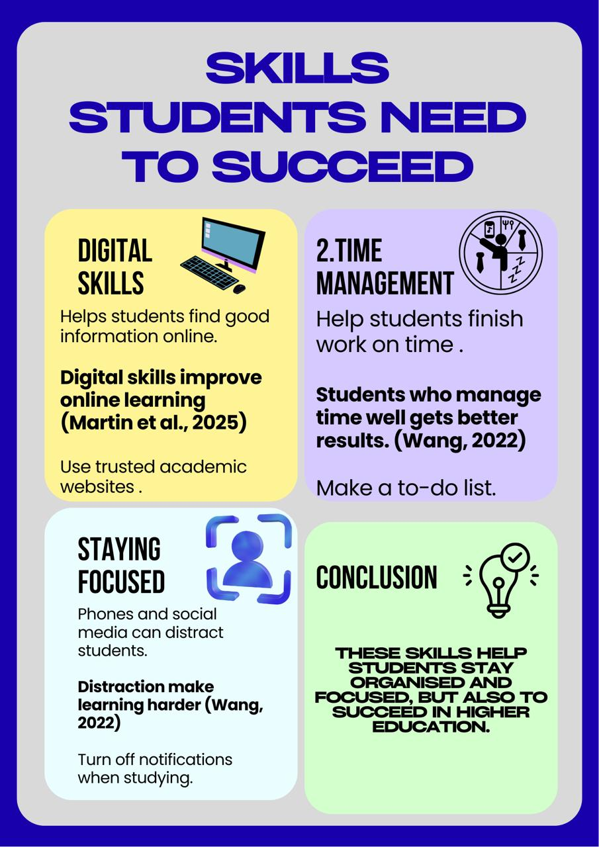
Reference List – Component 3

Martin, F., Long, S., Haywood, K., & Xie, K. (2025). Digital distractions in education: a systematic review of research on causes, consequences and prevention strategies. Educational Technology Research and Development, 73(6), 3423–3451. https://doi.org/10.1007/s11423-025-10550-6
Martin, F., Long, S., Haywood, K., & Xie, K. (2025). Digital distractions in education: a systematic review of research on causes, consequences and prevention strategies. Educational Technology Research and Development, 73(6), 3423–3451. https://doi.org/10.1007/s11423-025-10550-6

