NAME: Prasanna Dhakal
STUDENT NUMBER:2131567
MODULE: LCMB7000
LECTURER: Gladius David Kulothungan
COURSE: Master’s in business administration
SUBMISSION DATE:14/09/2022
TITLE: Human Resource Assessment 2



APPLE

Content
1. Introduction 1
2. Company’s Background 1
3. Change Management 2
* Change Management Model 3
* Relevance and Applicable 5
4. HR effective measurement 6
* Metrics for measuring HR effectiveness 6
* Relevance and significant in the context of micro soft 7
5. Compensation 8
* Compensation Theory 9
* Application and Relevance 10
6. Conclusion 11
7. Recommendation 12
8. References 13

- Introduction
With developments that have altered the manner in which individuals use PCs and cell phones, the Apple Company permanently affects the worldwide stage. Apple has made colossal progress and is presently worth billions of dollars (Farivar, 2012). Apple is the best organization in the specialized business, with an offer cost of more than $530. The effect of Apple based on the society in conditions of ordinary individuals, laborers, costs, and other electronic endeavors will be investigated in this article.
- Company’s Background
Mac was established in 1976, and its effect on regular individuals started with the approach of PCs. The PC changed the essence of innovation. PCs had a basic plan and were simple for individuals to utilize. Nonetheless, even with tough opposition from different organizations, Apple didn't accomplish an enormous piece of the pie.
Thus, it sent off an item that has turned into a vital piece of cutting-edge exercises going from the workplace to the home, as well as the brand of decision (Sanderson, 2008). Mac items, like the iPod, iPhone, and iPad, have become commonly recognized names. Apple workers should stay in their prime to keep delivering market-mixing items. They should maintain and try and surpass the elevated requirements set by past Apple items. Workers should stay focused on Apple's vision as epitomized by Steve Jobs. He is inseparable from Apple, and his demise powers the organization's representatives to manage the post-Jobs time.
They are often asked what Jobs would have done about the choices made by the new CEO Tim Cook, which might bother some. Representatives should adjust to working under Tim Cook, who is not quite the same as Jobs, and keep on striving to lead Apple toward its central goal (Cheng, 2012).

- Change Management
The significant qualities of changes that might be seen in the Apple Company are inseparably related with the need of the organization's continuous change in light of changing economic situations. This is the just (however generally important) reasoning for the undeniable change in the executives. Keeley (2007) Change of the board is viewed as the organization's fundamental reaction to the changing advertising climate and the necessities of the ideal interest group. In truth, change of the board is an arranged and accurately weighted technique to changing crafted by a solitary individual, a gathering, a group, a division, or a whole enterprise. Thus, change of the board at Apple is done to adjust as well as to advance changes in the climate. There aren't numerous instances of such changes, however, concentrating on the organization's way of behaving may assist you with recognizing some.
The highlights of the change the board methodology completed inside the firm might be inspected through the focal point of the change scales. Change the executives is separated into four levels: vital, specialized, underlying, and individuals. Subsequently, the presentation of another item requires specialized changes inside the association as well as the presentation of new creation abilities (or redistribution of the current). This kind of shift might be seen when the partnership joined the media area, giving the crowd an iPod. The organization's mechanical headways were driven by its CEO and were done in the specialized division as well as in the money, plan, limited time, and advertising offices. As a pioneer, Steve Jobs incited the vital changes to lay out an adaptable administration approach that can be adjusted to the showcasing climate. Carter (2008) thus, the basic meaning of the changes is legitimate not by the need to promote another item, yet by setting up the firm for the future fight for the interest group.

Change Management Model
Fig 1
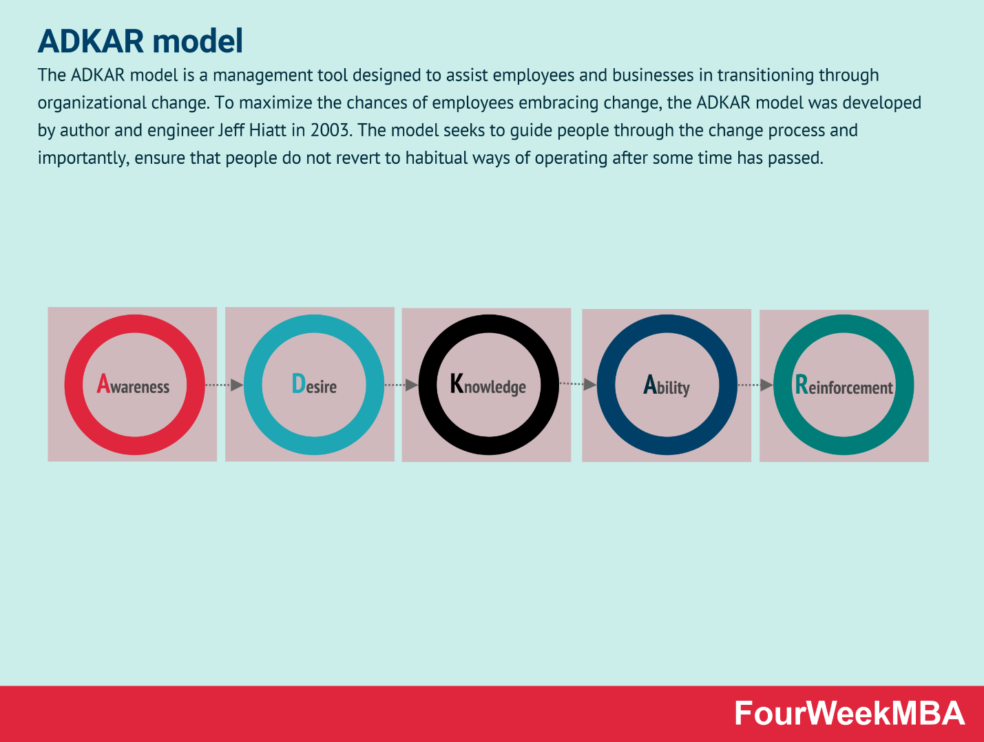
“Source: FourweekMBA.com”

Awareness
As you can naturally suspect, Kate was put off by the possibility of migrating and adding an hour to her drive.
Change is inescapable, and it frequently pushes people past of their usual ranges of familiarity. Kate was shocked by a change that was not planned for her in this present circumstance. Brad expected to illuminate Kate regarding the change before Dave showed up with boxes for her to set up the movement (Crowson, 2021).
Desire

People in your association will answer eagerly assuming they see the requirement for change and accept it will be advantageous. In the event that they don't completely uphold the change, they will lose the craving to draw in. You might have to go behind them all through the advancement period till they become all the more tranquil. You'll need to survey their feelings to decide their level of want. Some colleagues might be battling the progress secretly. They may not understand the reason why change is fundamental, however, they will in all likelihood organize when it is valuable to them. At the point when you are not there, they might return to past practices (Crowson, 2021).

Knowledge

The more data and readiness you can give, the more workers will figure out the change and see its advantages. Besides, the more effectively information is moved at the going with step in the ADKAR adjust the leaders cycle. Expecting the change requires new cycles and strategies, guarantee that enough readiness and tutoring is given to guarantee that positions can be finished effectively. Monitor these cycles since representatives are bound to follow best practices in the event that they have a reference to allude to. Visual documentation, like collaboration flowcharts, might be valuable all through this stage (Crowson, 2021).

Ability

Just however your workers comprehend the change doesn't mean they would want to meet their responsibilities as quickly as time permits. See yourself as a youthful person with swimming models. On the most essential level, you apparently comprehend that you need to move yourself through the water by kicking your legs and utilizing your arms. In any case, it turns out to be undeniably more troublesome with time. Swimming in shallow water with lightness helps requires practice before you can swim alone (Crowson, 2021).

Reinforcement
After you've made the change and your work processes are running great, support is a significant stage in the ADKAR model that ensures people don't return to old propensities. As per a review distributed in the European Journal of Social Psychology, it requires 66 days for individuals to acknowledge a change completely. The more extended a migration takes, the more troublesome it is. Accepting you feel your representatives ought to perceive finished progress, you ought to give good input to keep them on target and accommodating (Crowson, 2021).
Relevance and application in HR practice and policy
Given the organization's current condition as per the ADKAR Model standards, Apple Inc. is ready for a shift, especially in HR strategies. The need to keep awake with market advancements and satisfy client demands are the two vital reasons for this change. Keeping up with classification, the association's fundamental goal, is very possible, as is working on the progression of data through the organization and the development of representatives and products.
It is notable that Apple works together with various outsider firms the whole way across the globe. In certain conditions, the outsider firm is a material provider, while in others, it is an Apple-prepared help staff. The postponed progression of business is especially badly arranged for Apple-prepared outsider care staff (Calder, 2013).
- HR effective measurement
The solid cooperation between Microsoft Digital, the appearance and gathering group, and specialists added to the endeavor's prosperity. "Our workforce is exceptionally prepared, truth be told capable, and they figure out how this might help every expertise," Neirynck proceeds.
One more part of the test was setting up the accomplice gatherings and furnishing them with a customized, reliable message while being ready to respond to requests. The gathering endeavored to expect likely road obstructions, recorded its discoveries, and did activity plans in regions like transport, gathering, and business readiness (Kayl et al.,2017).
Fig 2
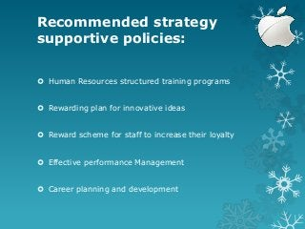
“Source: Slideshare.net”
"We pushed client conversations on KPIs, how they could procure more reliable business encounters, and what pointers they expected to find regardless," Osten makes sense of.
It wasn't just about getting the message out about the new stage. The course of action started with little consideration at first, to some extent on the grounds that encompassing associations couldn't check the precision of the data. A few workplaces had made their own dashboards and couldn't change their cycles.
"When and how would you begin accepting this information in MSXi versus detached gatherings?" Sarmiento gets it. "We burned through much energy characterizing data quality standards and procedural cycles to reject the potential that the data was dishonest" (Kayl et al.,2017).
Relevant and significant in the context of Microsoft
Overseers at Apple are proficient and charming to work with. Rather than punishing representatives for making blunders, they urge them to commit errors. A situation like this is considered as a feature of their way of learning, which turns them become experts in this innovation-based enterprise. Such a methodology is steady with my past professional training. The organization's CEO and the board had a strategy that precluded any sort of unjustifiable treatment of laborers who made mistakes while performing their responsibilities. All things being equal, they were told about the most proficient method to continue to accomplish improved results. Regardless, it is basic to research how much effective assets the board has added to Apple Company's monetary achievement (Hasibuan, 2021).
- Compensation
How much compensation, pay rates, and advantages that delegates get in return for making a given appearance is alluded to as compensation? It could incorporate fundamental compensation or time-based compensation, as well as prizes, advantages, and inspirations. Such advantages incorporate an assortment of clinical services, retirement commitments, and impermanent inadequacy insurance. Two or three of these parts are frequently associated with a far-reaching pay bundle (Bryant and Allen, 2013).
An entire compensation and advantages bundle might be hard to assemble. You should lawfully arrange illustrative advantages, but you should likewise give a serious bundle that draws in and holds uncommon laborers who can assist your association with succeeding (Bryant and Allen, 2013).
Consistently, the authorities' pay is not entirely settled by the compensation board of trustees. This compensation board of trustees is completely included autonomous chiefs. The leader or representative compensation stage's basic role is to enlist and keep a capable, innovative, and imaginative group of chiefs. These specialists will add to the organization's outcome in aggressive and dynamic commercial centers by offering authority. This is upheld by the latest monetary reports produced by Apple's money division. Apple Company's business expanded to 36.5 billion USD in 2009. This addressed a 4.1 billion USD gain over the earlier year. This addressed a 12% ascent. In 2009, the overall gain moved to 5.7 billion USD. Preceding 2009, this addressed an 18% or $870 billion USD rise. Besides, the complete number of partners in the association extended by 857%. These adjustments might be credited to the enterprise's pay methodology (Redpath and Vogel, 2020).
Expectancy and Reinforcement theory of compensation
Compensation is the installment made to laborers for the work they accomplish for the association. Subsequently, in return for his commitments to the organization, a specialist is qualified for both money related and nonmonetary motivators (Joshi and Bisht, 2016).
To figure out which part of compensation is useful, we want initially to dissect pay suppositions. There are three kinds of pay speculations, which are recorded underneath: Reinforcement and Expectancy Theory, Equity Theory, and Agency Theory (Joshi and Bisht, 2016).
Fig 3
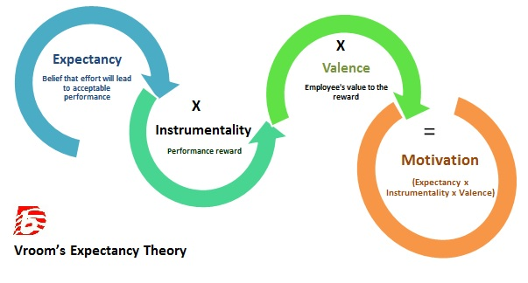
“Source: differencebetween.com”
As per the help speculation, a lead that outcomes in a great gathering will surely be rehashed. The result is that excellent specialist execution followed by a monetary honor improves the probability of future delegate execution. Likewise, a solid show that isn't gone with a prize makes overt repetitiveness implausible later on. The idea underlines how significant it is for an individual to encounter the prize, as a matter of fact.
Vroom's presumption speculation, similar to the help theory, centers around the connection between pay and conduct. As indicated by the hypothesis, motivation is the consequence of valence, instrumentality, and supposition. The impact of pay plans on different influence parts varies. As a rule, pay structures change the most with regards to their impact on instrumentality, or the apparent connection between direct and pay. The worth of pay results stays comparable across pay plans. Expectations are regularly affected by work plans and planning instead of pay plans.
Application of the relevance theory of Apple
As per Expectancy Theory, a human likes to act in a given way with the expectation that the demonstration will be trailed by an ideal outcome. Hope is the connection between exertion and execution; instrumentality is the connection between execution and prize; and valence is the excellence of the award. Apple Inc. uses the assumption hypothesis to move individuals to reach quantifiable, attainable, and characterized goals. Workers endeavor to further develop their work execution to get the ideal impetuses.
Notwithstanding, it appears to be idealistic since most of people see a critical level of connection among execution and prizes. Subsequently, Apple Inc. thinks often about every one of its laborers and gives them accommodating advantages. Albeit the honors are not as looked for by the laborers, this could support their presentation. Apple might ensure that the representative can achieve the ideal exhibition level by noticing the individual's ability to work on the effectiveness of the organization's tasks (Kol et al., 2021).

- Conclusion
Apple's merchandise has changed the globe. The effects on clients are peculiarities, and just the future will determine what things Apple will bring to showcase on the off chance that their verifiable example is any sign, and remaining a behemoth for quite a while is probable. They have made things that purchasers didn't understand they required until they were presented to them.
Apple is a mechanical exception, and the fruitful methods it utilizes are probably going to keep the partnership in a vertical direction, establishing its benefit and piece of the pie. The partnership has immense money-related holds available to it, which it can utilize to make merchandise and put resources into anything region it sees appropriate to keep up with its specialized administration. Accordingly, Apple's strong brands, which are notable all through the world, will keep on affecting society sooner rather than later.
- Recommendation
- HR devolution and vital change should be taken care of with alert.
- HR experts ought to get more familiar with an outside client's inspirations, objectives, and necessities.
- HR should conquer the customary resistance to turning into a piece of the hierarchical methodology by zeroing in more on every framework, practice, and activity that conveys a message about the present and future. Thus, HR should decide the certified vital worth that it can give to the organization and evaluate its impact on the authoritative procedure's main concern.

- Reference
- Bryant, P.C. and Allen, D.G., 2013. Compensation, benefits and employee turnover: HR strategies for retaining top talent. Compensation & Benefits Review, 45(3), pp.171-175.
- Calder, A.M., 2013. Organizational change: Models for successfully implementing change.
- Carter, E. (2008). Successful Change Requires More Than Change Management. The Journal for Quality and Participation, 31(1), 20.
- Cheng, Jacqui. The ghost of Jobs: Apple’s challenge to decide “what would Steve do?” 5 Oct. 2012. Web.
- Crowson, J. W. (2021). US Air Force Supply Chain Managers Share Attitudes Regarding the Use of the Five Elements of the Adkar Model as Critical Success Factors to Implement Enterprise Resource Planning Software (Doctoral dissertation, Oklahoma State University).
- Farivar, Cyrus. 30 years of Apple: Accessing Apple’s impact. 31 Mar. 2012. Web.
- Hasibuan, M.I., 2021. The Effectiveness of Change Management in Developing the Organizational Culture of it Darul Azhar. Budapest International Research and Critics in Linguistics and Education (BirLE) Journal, 4(1), pp.423-430.
- https://fourweekmba.com/adkar-model/
- https://www.differencebetween.com/difference-between-expectancy-theory-and-vs-equity-theory-2/
- https://www.slideshare.net/jahidkhanrahat/apple-company-86865742
- Joshi, P. and Bisht, N.S., 2016. Motivation: The compensation perspective. International Journal of Engineering and Management Research (IJEMR), 6(1), pp.70-76.
- Kayl, I.I., Zudina, E.V., Epinina, V.S., Bakhracheva, Y.S. and Velikanov, V.V., 2017. Effective HR management as the most important condition of successful business administration. In Integration and clustering for sustainable economic growth (pp. 23-30). Springer, Cham.
- Keeley, T. D. (2007). International Human Resource Management in Japanese Firms: Their Greatest Challenge. New York: Palgrave.
- Redpath, I. J., & Vogel, T. J. (2020). ACCOUNTING STANDARDS FOR STOCK BASED COMPENSATION–A CASE STUDY OF APPLE, INC. Journal of Business and Accounting, 13(1), 176-189.
- Sanderson, Rachel. The Apple brand has the biggest impact on the world’s consumers, while Microsoft and the United States nation brand are those considered most in need of a remake, a survey showed on Monday. 31 Mar. 2008. Web.

