Name - Gindra Urbonaviciute

Student number – 2243360

Title – A comparison of the marketing methods of two multinational hotel brands (Six Senses and Holiday Inn )

Module tutor- Scott James

Submission date- 19/05/2023

Word Count- 1512

This study aims to compare and evaluate marketing strategies and their success for two major hotel chains, Holiday Inn and Six Senses.
A considerable amount of effort has been put into marketing for the two giants to establish a positive public image. Taking their marketing into consideration, Holiday Inn placed itself to be affordable and convenient. However, with the ability to offer luxury experiences, Six Senses can attract high-profile clientele.
James Eagleman (2022) explains; both are under the IHG(InterContinental Hotels Group) umbrella, with this taken into account, is this marketing beneficial? Both can be found within the same website for the purpose of attracting and reaching their audience.
To gain a better understanding of their marketing tactics and how it is applied, SWOT and PESTAL will act as a measurement for their differences. Positioning tools will allow for a better understanding of the two brands’ similarities.
Rivalry among competitors is always at its peak. Especially with social media taking over and encouraging the public to communicate and engage to boost business’s further development to stay up to date. Enforcing a strong marketing strategy is vital, looking at external and internal aspects of the business. An example such as being green and healthy - Six Senses will fit right in. “Sustainable is not something that we do; it is who we are “(Six Senses homepage), a slogan on their website, the strength that puts them ahead of the competition and brings positivity. Holiday Inn, however, with an active Instagram account - boasting new locations and customer experiences, leaving green policy in a maze game. This could become one’s weakness and an area to revive.
With the most recent health outbreak, an economic change has given many a fear of instant collapse and no ability to control business, especially when talking about the hospitality industry. Holiday Inn and Six Senses – have both experienced a fallen revenue. A weakness that can not be controlled, however with experience comes knowledge that can be applied to avoid maximum fallback.
The economy and financial state of the public have produced further threats for both companies. Holiday Inn pursuing further destinations, however taking everything into account, offering customers more flexibility and reassurance whilst doing business with them. This is a great opportunity to bring in lost revenue and expand their customer base.
Six Senses thrives on customer experiences and puts its internal analysis in the front. A high level of professionalism and customer service is their priority to achieve a personalised and luxurious experience.
Keeping both brands in mind and their different approach to obtaining and securing longevity for the business, the future looks promising. From the climate to finances, venturing into new circles such as the IHG group can open up new opportunities. Holiday Inn steering away from customer perception of family holidaymakers and expanding public knowledge to widen towards Six Senses clientele. The question remains whether the two are in direct competition or their marketing strategies are aimed at different audiences.
“Six Senses spans some 20 hotels on four continents, with more in development.”(Mitchell Freedman 2022), with this in mind, we can assume their current success and future business expansion goals. But how will this be achieved? To produce a successful marketing campaign let’s explore the marketing mix 7 elements.
The product in this case is mental well-being and relaxation, spread wide across different countries in the form of hotels and resorts. To inject and absorb utter success, the hotel chain focuses on its internal knowledge and extensive training for employees to achieve customer satisfaction. The business travels in different locations, with stunning and bespoke scenery to accommodate the desired high-profile audience. Six Senses website is home to services offered, a glimpse of what to expect from this high cost associated holiday making. By minimising the middleman and promoting direct sales, allows the chain to manage customers and services tightly.
Premium pricing requires high skill and knowledge to conquer obstacles to reassure and stand confident. A well-navigated website, brand image, and history will reinforce common knowledge and recognition. Societal-oriented and environmental standards, Six Senses preferred marketing method is social media. ‘ A taste of plastic freedom’ youtube video (appendix 7), one of many to reach a wider audience.
Holiday Inn would agree to disagree, a long history and already memorable and well-recognised brand will require a different marketing strategy to either steer away or drive in the same direction as where the business currently stands.
Known for its family holiday and value-based pricing, the hotel chain uses a more playful and active marketing method. Instagram is a great example of bright and colourful destinations with plenty of content to attract working-class customers. Easy to use and book website, with a variety of options to cater to the majority. When comparing Holiday Inn’s classic website to Six Sense’s sleek and chic- the difference in service offered is clear. Holiday Inn strives for quantity and basic which is opposite to Six Sense’s luxurious experiences.
The product itself might be basic and kept at the general expectations however the current financial status within the country, Holiday Inn is a more appealing option. Expanding their business to the most common and requested destinations, by keeping standards at a minimum allows for a price freeze in return more customers.
To be considered family-friendly can drive other potential customers away if their needs differ, therefore a 33mil Marketing Campaign was created to relive the brand again and reintroduce the hidden or less visible core of their product opportunities. Could this be a new path for the future development of the Holiday Inn?
For better and steady-flowing growth for the two brands, targeting the right audience and understanding current customer breakdown can separate the business from its competitors by simply applying the right marketing techniques to stay relevant and appealing.
Similarweb is a tool used to track a website’s performance and audience. This basic guide can be navigated to compare Holiday Inn and Six Senses in terms of geography and demographics.
If looking at the overall rank, Six Senses is taking the lead, however, Holiday Inn not falling that far behind. With bouncing and large numbers of engagement, both brands benefit most from direct engagement, on their website.
Paid research can be beneficial to expand your marketing further and use the helping hand of other businesses to collaborate and persuade further audiences. Holiday Inn utilises this to its full advantage at over 40% and Six Sense at over 9% engagement. However, this could widen the potential customers but have little effect if targeted incorrectly.
Geographically both brands have established a successful business within different countries, for example, UK and Spain both gravitate towards a different hotel chain. (see appendix). This could be the perfect opportunity to explore and establish gaps in marketing.
The most competitive aspect for the two brands is the age groups which fall very closely together, meaning their audience requires a more memorable and highly effective marketing strategy to decide which giant is a more suited match.
Considering the product and the industry, both hotel brands need to target an audience that will benefit from the business and be most profitable. Diving the audience into smaller groups allows for a better understanding of the marketing tactics to be more attractive and recognised easier.
With Holiday Inn offering a more affordable option, the target audience can be wider with families, youth, business travel, and so on. However, Six Sense offers bespoke travel options with various added extras this also means a more clustered audience- people with more disposable income- high-profile clientele.
By establishing the right audience, both brands can manage loyalty and appreciation better, with customers feeling rewarded and business striving.
Holiday Inn and Six Senses reward customers and offer incentives by being under the IHG umbrella, this system offers a combined marketing that will bring in customers with little effort. Appendix positioning map )
Considering both brands offer services at different standards and price points, the Bowmans Strategy Clock can explore further competition. (Appendix ) . To place the two on the clock can be argued however Holiday Inn with a minimal level of unique service yet affordable can take position 3 – Hybrid. Six Sense on the other hand most suited position 4- Differentiation due to the nature of the services and exclusive locations.
“Marketing 3.0 is the stage when companies shift from consumer-centricity to human-centricity and where profitability is balanced with corporate responsibility” (Philip Kotler 2010) By looking at the core of the business such as Holiday Inn and Six Senses, customers always come first, the pride in their loyalty and craving more will keep the business ears peeled for direct feedback and personalised experiences.
Competition is vital to shake the industry and give choice, even being in the same industry the two giants have very little in common considering the different styles of services. Both with stunning and dated histories, the audience divides itself.
Like any successful business, goals and development are crucial, only the future can tell whether their paths will cross, and the rivalry will be revived.

Appendix

Reading and research information

IHG hotels and resorts website
https://www.ihg.com/content/ihg/hotels/en_GB/brand/customer-care/travel-advisory-covid-19.html
Six Senses sustainability
https://www.sixsenses.com/en/sustainability
Research Team 10
https://www.ukessays.com/essays/marketing/marketing-strategies-of-holiday-inn-hotel-marketing-essay.php
Holiday Inn Campaign
https://www.travelweekly.com/Travel-News/Hotel-News/Holiday-Inn-launches-33-million-marketing-campaign
Look again campaign https://www.travelweekly.com/Travel-News/Hotel-News/Holiday-Inn-launches-33-million-marketing-campaign
Holiday Inn sustainability
https://www.hiwinchester.co.uk/environmental-policy/
Six Senses awards
Six Senses Marketing Strategy – blogmarketing9113BC_10.3 (wordpress.com)
Differentiation and positioning of Six Senses
blogmarketing9113BC_10.3 (wordpress.com)
Holiday Inn research
Difference Between Hilton and Holiday Inn (askanydifference.com)
Holiday Inn research Appendix 1
Difference Between Hilton and Holiday Inn (askanydifference.com)
IHG - ownership
IHG's 17 Hotel Brands Explained (hoteltechreport.com)
What Hotels Are IHG? (travelinglight.com)
Appendix 2
James Eagleman
What Hotels Are IHG? (travelinglight.com)
Appendix 3
Piyush Yadav 2023
Difference Between Hilton and Holiday Inn (askanydifference.com)
Appendix 4
Similarweb screenshot

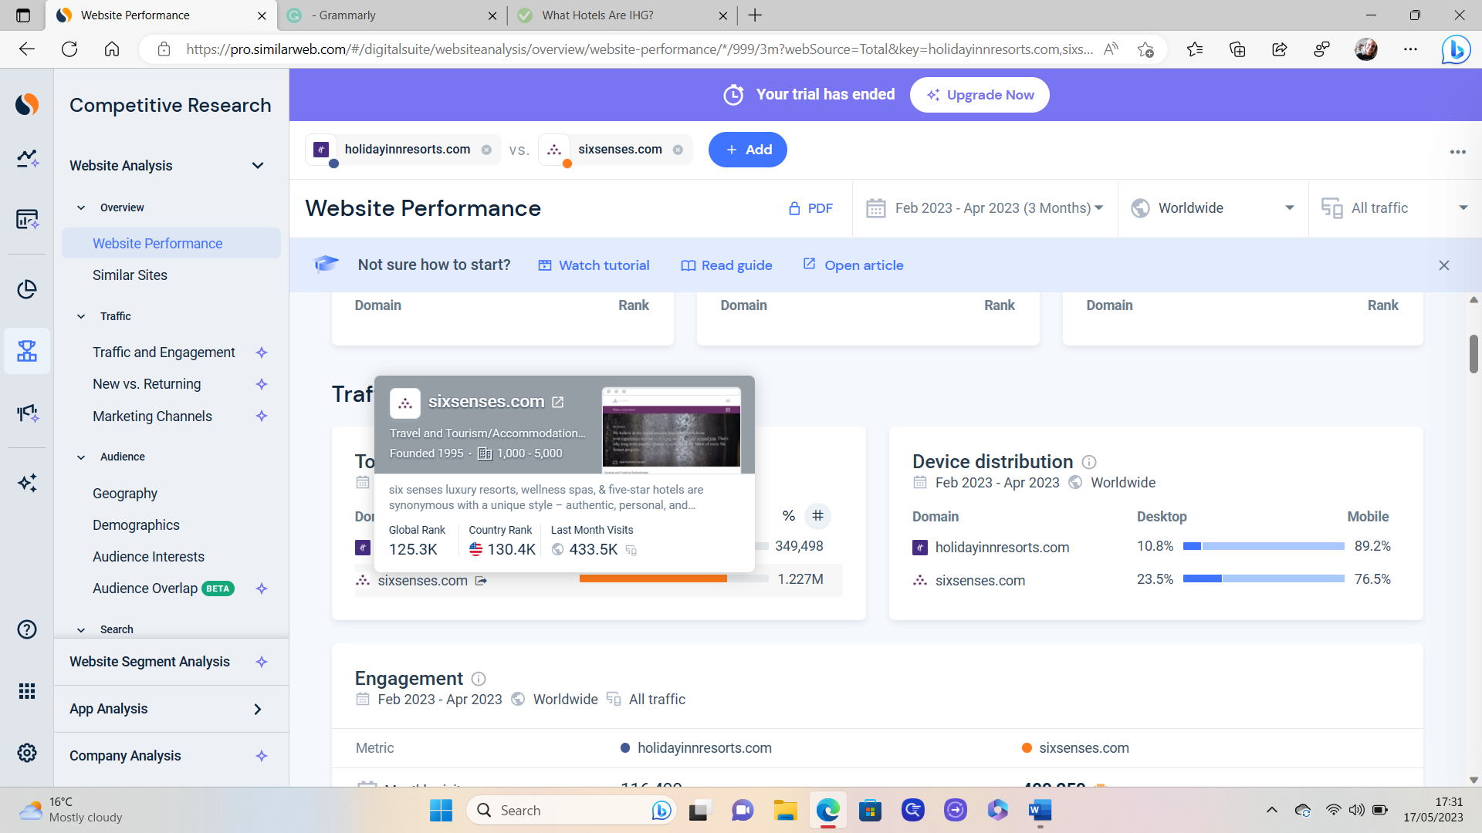
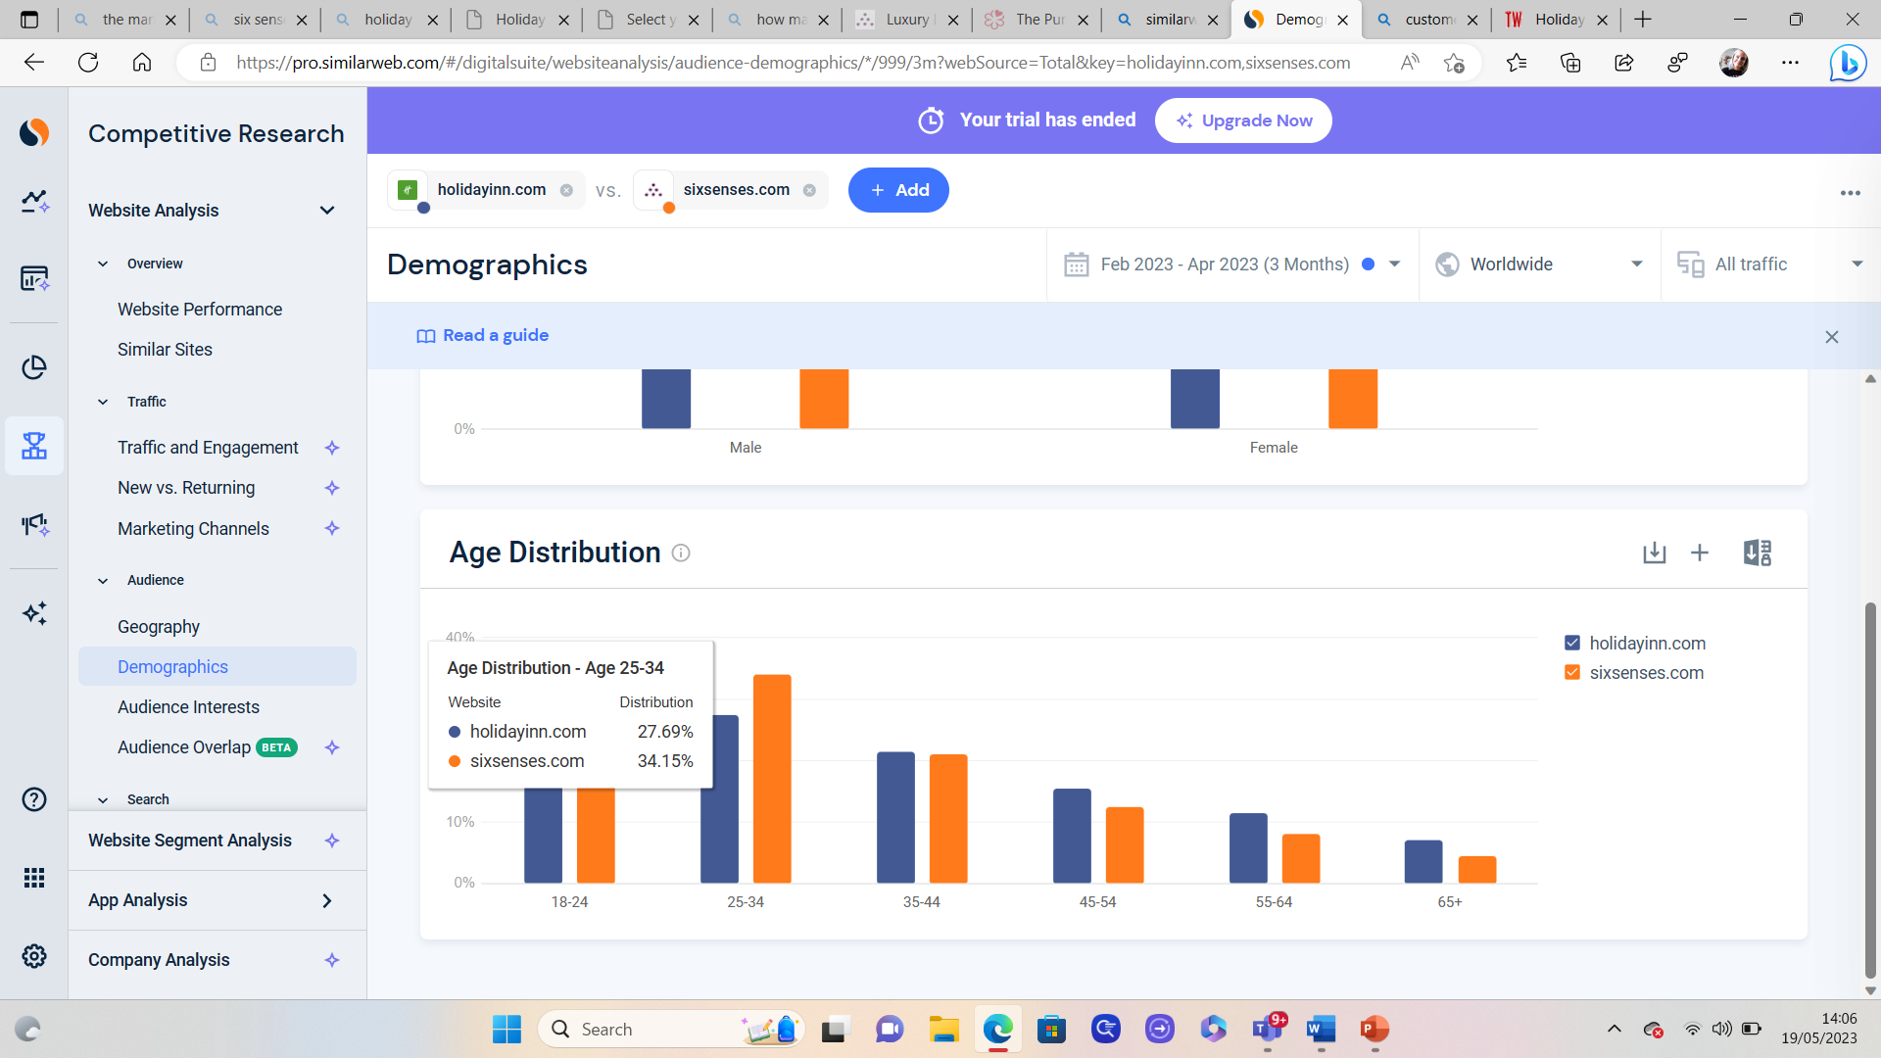

The Pursuit of Healthiness at Six Senses
https://guide.michelin.com/en/article/travel/six-senses-sustainability-michelin-guide#:~:text=Six%20Senses%20spans%20some%2020%20hotels,on%20four%20continents%2C%20with%20more%20in%20development.
Appendix 7
Holiday Inn Ad
https://youtu.be/lOVW7Wl3Gqg
Bowmans Strategy clock
https://www.mindtools.com/a2rq300/bowmans-strategy-clock

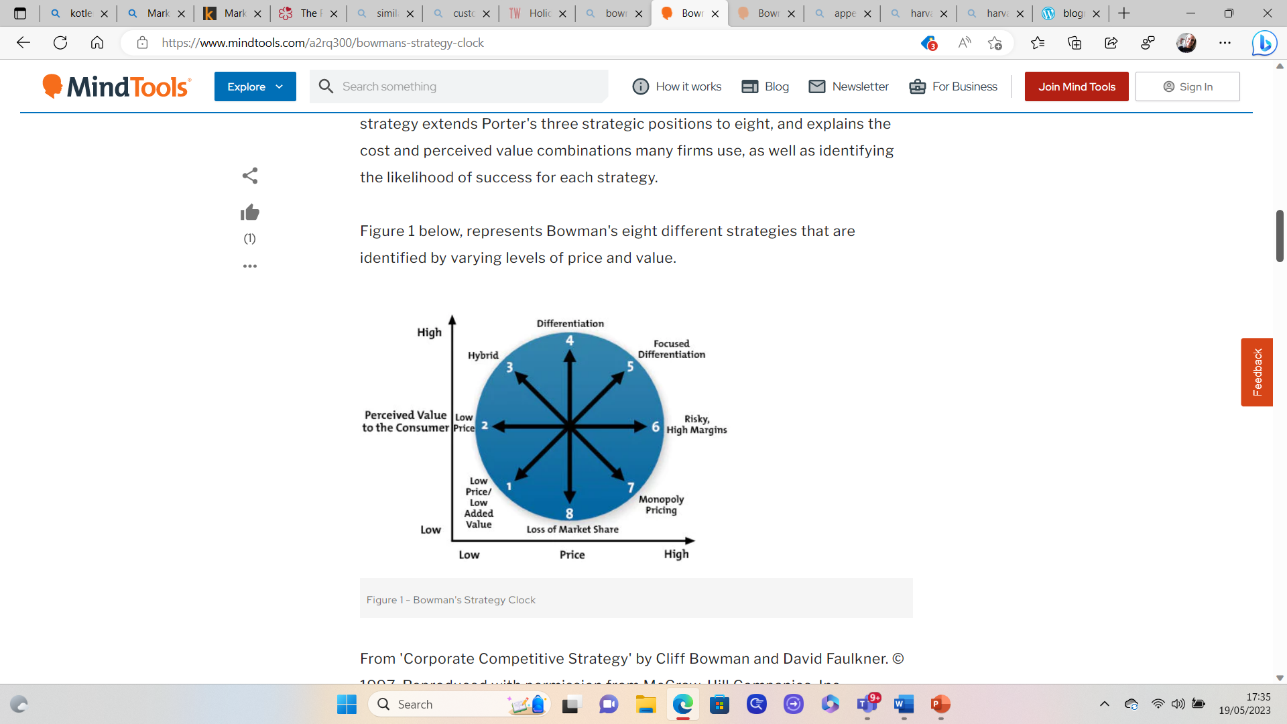
Marketing 3.0: From Products to Customers to the Human Spirit
Philip Kotler, Hermawan Kartajaya, Iwan Setiawan

