Progressive Web App-Poker Estimator

Your name: Sai Harsha Jangili
Student number: 1908692
Course: Web Development
Module: Application Development
Date: 29-05-2020

Table of Contents
1. Introduction 3
1.1. Abstract 3
1.2. Application Development Concepts 3
2. Requirements 4
3. Design and Implementation 4
3.1. Main design features 4
3.2. Implementation 4
3.2.1. Main scripts, methods, or classes 4
3.2.2. Screen shots 6
4. Evaluation 8
4.2. Testing 8
4.3. Common Tests for Application Pages 9
5. References 11

Introduction

Abstract
This application (Scrum Poker) implements a progressive web app (PWS), which contains capability of running with and without internet connection [1]. The App integrates both online and offline themes, similar to a native app. which are literally one of the major features of PWAs [1]. Typically it’s an agile estimator method that is consent-based. To start a poker planning session, the product owner or customer reads an agile user story or describes a feature to the estimators. The values represent the number of story points, ideal days, or other units in which the team estimates.
- ? = An indeterminate amount of work is required to complete this item.
- 0 = No work is required to complete the item.
- 1 = A tiny change with no impact and very low risk.
- 2 = A small and isolated change.
- 3 = A change with low impact.
- 5 = A change with medium impact.
- 8 = A change with high impact, or a small new feature.
- 13 = A medium feature or change to a few features.
- 21 = A large feature or product-wide change.
- 34 = A large feature or product-wide change with high risk.
- 55 = An extra-large feature or new infrastructure.
- 89 = A massive cross-product feature, infrastructure or technology change

Application Development Concepts
In this project, an estimator through a game using JavaScript and JSON (JavaScript Object Notation) API. With the feature, asking questions of the product owner as needed using querySelector(), which returns the initial element within the document that matches the specified selector, or group of selectors. When the feature has been fully discussed, each estimator privately selects one card to represent their estimate. All cards in the application are then shown at the same time. In case the entire estimators nominated the same value, then converts to the main estimate. If not, the estimators examine their assessments. The high and low estimators ought to particularly share their reasons. After further conversation, every estimator reselects a gauge card, and all cards are again uncovered simultaneously. The poker arranging process is rehashed until accord is accomplished or until the estimators conclude that deft assessing and arranging of a specific thing should be conceded until extra data can be procured. Besides, the use can utilise the web application share API for sharing text, links and other content to an arbitrary destination of the user's choice [2]. Lastly, the app also uses service worker function, which is an essential aspect of WPAs [1]. The service worker JavaScript function is used to cache the size limit, install, and activate, and fetch event of the service worker.

Requirements
- SCSS metalanguage syntax uses the file extension. With a few small exceptions, it's a superset of CSS, which implies essentially all valid CSS is valid SCSS as well.

- Bootstrap: Bootstrap is a structure to assist you with planning sites quicker and simpler. It incorporates mark-up language and CSS based structure layouts for typography, structures, catches, tables, route, modals, and images. It equally offers the developer with support for JavaScript modules. In this case, bootstrap have also been utilised to make the web application responsive and interactive.

- HTML: As the application Markup Language

- Javascript: In this project it supports event-driven, functional, and imperative programming styles. It has application programming interfaces (APIs) for working with text, dates, regular expressions, standard data structures, and the Document Object Model (DOM).

- Web Browser: This app is typically hosted in all modern web-browsers that supports CSS, HTML, and JavaScript, cookies as well.

Ideally this project demonstrates the following
- A progressive web app that run both online and offline
- Share API, for user to share texts, links
- Responsive and interactive website application

Design and Implementation

Main design features
Navigation Panel: Appearing on the left-side of the browser with links to help the application user select the application function to perform.
The estimator: located at the main browser inside a scroll-bar that retrieves all the application’s information.
Instructions: The app contains instruction to help the user understand how to play the poker.
Settings: Displays application’s settings that the user prefers. Once selected the application mode, theme, and background changes based on the settings.

Implementation

Main scripts, methods, or classes

The most essential function of the project web application is using JavaScript and HTML to allow use perform various selections. For example, using JavaScript selector function to allow the user selector a card, obtain card content, navigator, share texts, as well as allow the application to implement rules, settings, style and themes, navigate the container. The method could include the below statement;
const activePlayerCard = document.querySelector('.selected-card');
Further, the application is implemented using various JavaScript service worker API functions such as; to limit the cache size with a JS scripts, which is written as follows;

const limitCacheSize = (name, size) => {
caches.open(name).then(cache => {
cache.keys().then(keys => {
if(keys.length > size) {
cache.delete(keys[0]).then(limitCacheSize(name, size));
} }) }) };

The web API for fetch contains the event type for fetch events dispatched on the service worker global scope. It contains information about the fetch, including the request and how the receiver will treat the response. It provides the event. respondWith() method, which permits the app to offer a response to this fetch. The fetch even JS script is coded as follows;

self.addEventListener('fetch', evt => {
evt.respondWith(
caches.match(evt.request).then(cacheRes => {
return cacheRes || fetch(evt.request);
}) ); });

Also the App is implemented with share JavaScript API to share links and text via the application to other users. For instance, the app’s share link scripts are written as follows;
shareBtn.onclick = function(e) {

if (navigator.share) {
navigator.share({
title: pageTitle,
url: currentURL
})
.then(() => console.log('Successful share'))
.catch((error) => console.log('Error sharing', error));
} else {
const text = currentURL;
const input = document.createElement('input');
document.body.appendChild(input);
input.value = text;
input.focus();
input.select();
input.setSelectionRange(0, 99999);
document.execCommand('copy');
input.remove();
alert('Link Copied to Clipboard'); } }
The web application is also implemented with API and JavaScript features to allow user customise app settings, change theme, and set deck style. For instance, the following functions are implemented to permit the app user chance the settings.
settingTabs.forEach(function(e) {

let currentElement = e;
let currentTheme = e.dataset.theme;
let currentDeck = e.dataset.deck;
let themeStorage = localStorage.getItem('Theme');
let deckStorage = localStorage.getItem('Deck');

if(themeStorage === currentTheme) {
setTheme(currentElement, currentTheme,);
}
if(deckStorage === currentDeck) {
setDeck(currentElement,currentDeck);
}
e.addEventListener("click", function(e) {
if(currentTheme) {
setTheme(currentElement, currentTheme);
} else if(currentDeck) {
setDeck(currentElement, currentDeck);
} }); });

Screen shots
Main Navigation Panel
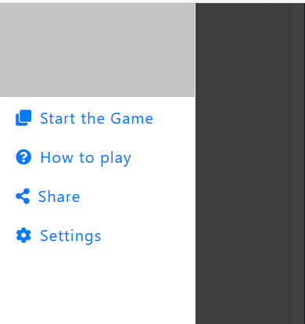

Application Settings
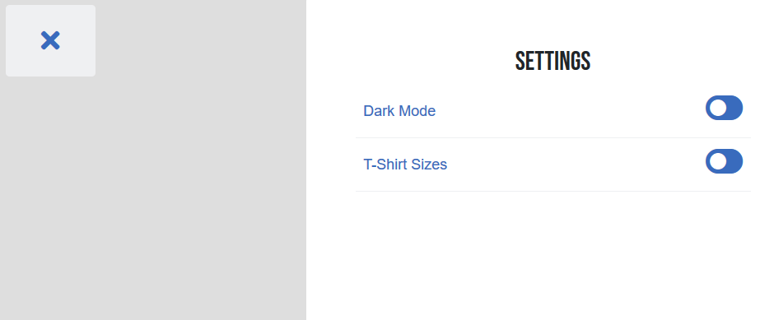
Application Instructions
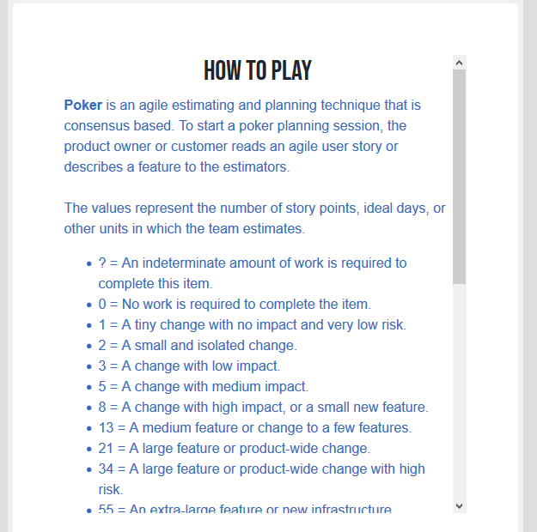
Application Content
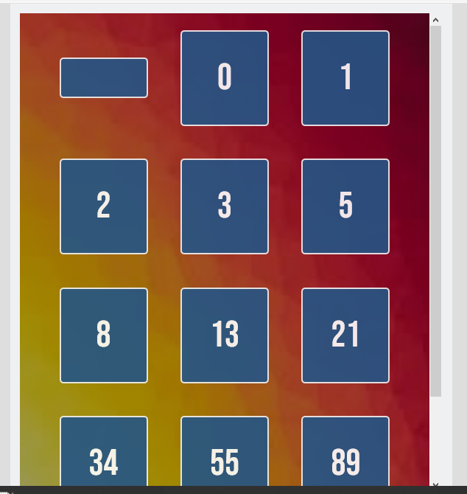
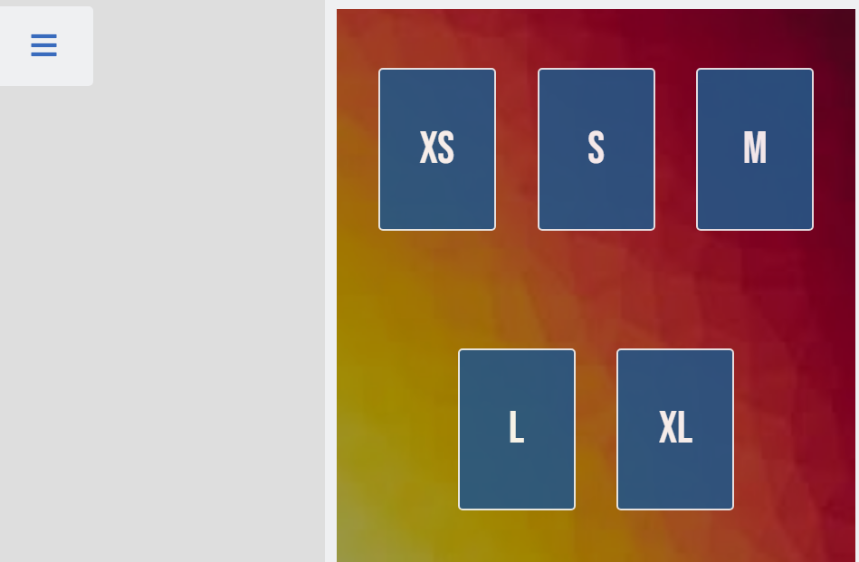

Evaluation

Programming Verification and approval is a significant piece of the product advancement process. Build up a lot of experiments to confirm and approve at any rate two of the centre practical necessities or highlights of the executed application [3]. Coming up next is a rundown of certain components that can be normally found in an experiment and you should mean to incorporate these in your model experiments

4.2. Testing

The following contents presented in tables below comprise a detailed alpha testing plan for the responsive websites [4]. The arrangement incorporates experiments for five classifications referenced underneath for each page of the site for versatile, tablet and work area stages. The experiments are shading coded by classification for simple review.

Testing Environmental Details:  Computer + Windows + Google Chrome Browser |  | Test date:  2020/28/5 | Name of the Tester:
Testing Categories:  (Functionality , Navigation , Content , Layout , Standards Compliance) |  | Testing Hardware System:  Screen with resolution of 1920 X 1080
Functionality |  | Resolution, size of the screen and type | Laptop display , 1920 X 1080
Navigation |  | Browser:  Chrome or Firefox
Content
Layout
St Compliance

4.3. Common Application Pages Tests
qTest Case | Device | Action/Input | Expected Result | Pass/Fail | Error Description
Content of test layout and Bootstrap | Mobile | Converting mobile display sized window | Content fits to size of device display | Pass
Test Content Layout and Bootstrap components | Tablet | Converting tablet display sized window | Content fits to size of device display | Pass
Test Content Layout and Bootstrap elements | Desktop | Converting desktop display sized window | Content fits to size of device display | Pass
CSS styling test on the webpage | Mobile | Go through all webpages | CSS Styles are significantly applied to webpage | Pass
CSS styling test on the webpage | Tablet | Go through all webpages | CSS Styles are significantly applied to webpage | Pass
CSS styling test on the webpage | Desktop | Go through all webpages | CSS Styles are significantly applied to webpage | Pass
Testing JavaScript components on webpage | Mobile | Go through all webpages | Javascript components are loaded and worked as expected | Pass
Testing JavaScript components on webpage | Tablet | Go through all webpages | Javascript components are loaded and worked as expected | Pass
Testing JavaScript components on webpage | Desktop | Go through all webpages | Javascript components are loaded and worked as expected | Pass
Testing “Home” Navigation Button | Mobile | Click the button | The button should navigate to the “Home” page | Pass
Test “Home” Navigation Button | Tablet | Click the button | The button should navigate to the “Home” page | Pass
Testing “Home” Button | Desktop | Click the button | The button should navigate to the “Home” page. | Pass
Standards compliance accessibility | Mobile | Check the code for WAI-ARIA roles | Roles are assigned and appropriate | Pass
Standards compliance accessibility | Tablet | Check the code for WAI-ARIA roles | Roles are assigned and appropriate | Pass
Standards compliance accessibility | Desktop | Check the code for WAI-ARIA roles | Roles are assigned and appropriate | Pass
Standards compliance CSS3 | Mobile | Stylesheet test in the W3C validating | No errors | Pass
Standards compliance CSS3 | Tablet | Stylesheet test in the W3C validating | No errors | Pass
Standards compliance CSS3 | Desktop | Stylesheet test in the W3C validating | No errors | Pass

Validators used while Accessibility testing
http://validator.w3.org/ html
https://jigsaw.w3.org/css-validator/#validate_by_input CSS

References

[1] S. Salits, "What is a Progressive Web App? (And Do You Need One)," Coredna, 6 April 2020. [Online]. Available: https://www.coredna.com/blogs/progressive-web-app. [Accessed 28 May 2020].

[2] J. Medley, "Share like a native app with the Web Share API," Web.Dev, 12 May 2020. [Online]. Available: https://web.dev/web-share/. [Accessed 28 May 2020].

[3] 1012-2012 IEEE Standard for System and Software Verification and Validation. 2012. doi:10.1109/IEEESTD.2012.6204026. ISBN 978-0-7381-7268-2.

[4] Jugo I., Kermek D., Meštrović A. (2014) Analysis and Evaluation of Web Application Performance Enhancement Techniques. In: Casteleyn S., Rossi G., Winckler M. (eds) Web Engineering. ICWE 2014. Lecture Notes in Computer Science, vol 8541. Springer, Cham

