Financial Management for the Hotel Industry

Ruksana Miah

2013067
Table of Contents

1. Introduction 2
2. The Continental Hotel Budget Planner 2
2. Theoretical Overview and Literature Review 4
3. Zero-based Budgeting and Implementation 5
4. Budgeting Control and Sustainability 6
5. Conclusion 7
Reference 8

1. Introduction
In traditional budgeting, the previous year's budget is considered as a foundation to forecast for the future period, which may be used to plan for the future (Roshan Waingankar, 2018). Every single dollar spent in a new fiscal year must be supported by a rationale. This is known as zero-based budgeting. The zero-based approach to budgeting examines the needs and costs of the company (Kagan, 2019). Additionally, this report details how zero-based budgeting may be put into practice and how budget management can lead to long-term sustainability.

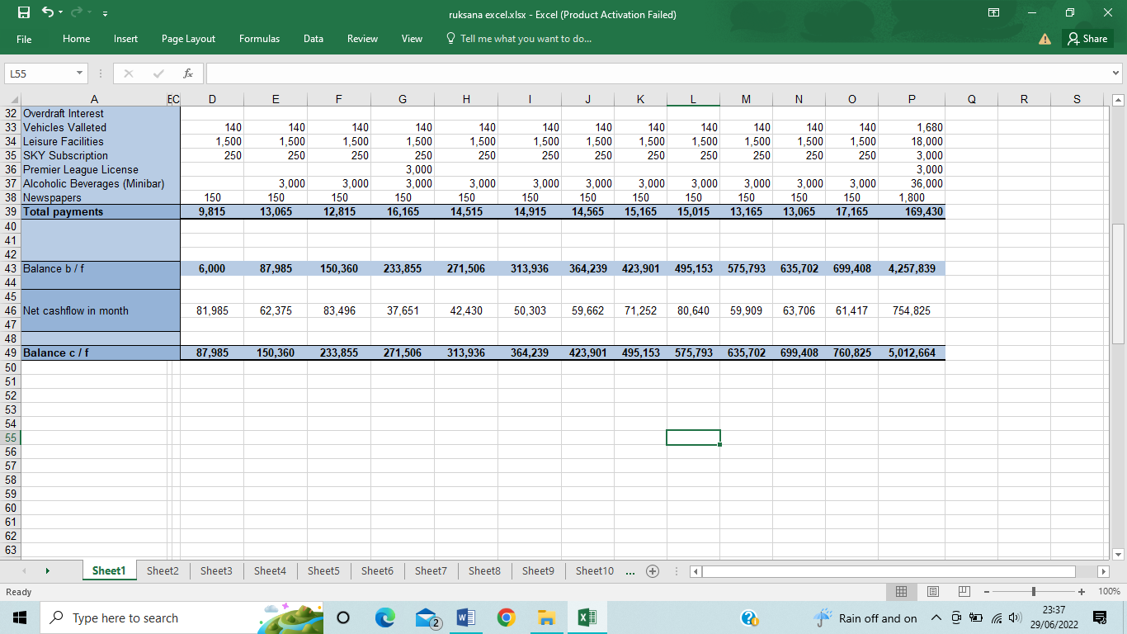
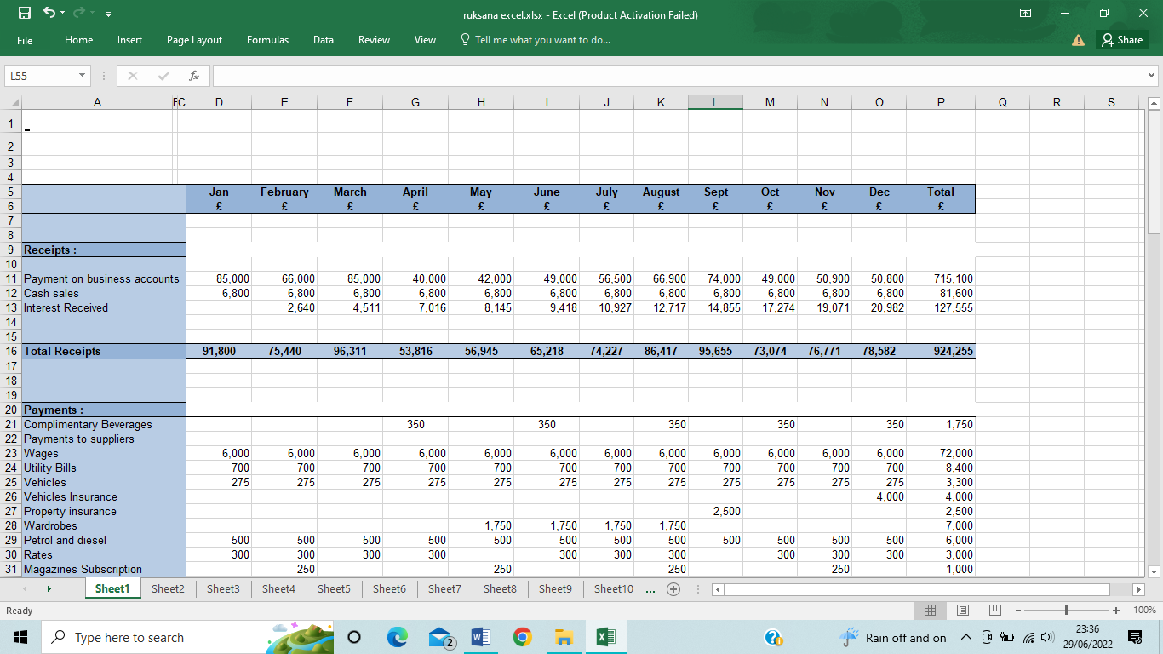
2. The Continental Hotel Budget Planner

Working Out





2. Theoretical Overview and Literature Review
2.1 Traditional Budgeting
Management Accounting describes quantitative planning for a certain time, which may contain anticipated income, contingent benefits or revenues, future obligations, and flow of cash (Garrison, Noreen and Brewer, 2018). A budget provides the organization with a focal point, promotes the coordination of operations, and enables management (Drury, 2018). Budgets are often prepared by adding incremental sums to the previous year's budget. This is according to Abdullahi (2011), a budgeting expert. According to Abdullahi (2007), government agencies typically employ the incremental budgeting strategy because of its convenience. Nevertheless, according to Danago and Tijjani (2005), the budgeting system lacks budget knowledge, alternative assessment, flexible budgeting, and consideration of future cost implications. Traditional budgeting provides departments with more authority over their budgets, hence fostering decentralization within the organization. Because conventional budgets employ the budgets from the previous period as a starting point, undiscovered mistakes may be carried over to subsequent periods, and traditional budgets are stiff and inflexible since they do not account for changes.
2.2 Zero-based Budgeting
Unilever, Kraft-Heinz, Anheuser-Busch, and Mondelz are among the notable companies that have reported adopting ZBB in the last several years, which seems to be an unexpected trend. In addition, consulting firms started to include ZBB in their portfolios (Fitzpatrick and Hawke, 2015). Given ZBB's reputation for being sophisticated and resource-intensive, it's interesting to see this kind of acceptance. When using the ZBB method, high-level strategic goals are linked to specific business functions so that spending may be pooled and then evaluated in light of previous performance and current expectations (Binder Hamlyn Fry & Co, 1982). ZBB is a technique or management strategy that overcomes some constraints of conventional budgeting. Specifically, Pyhrr says that the gradual and static character of conventional budgeting prevents management and lawmakers from evaluating the efficacy and efficiency of operations and projects (Pyhrr and Kneese, 1973). When managers use zero-based budgeting, each department has to defend its budget against cuts to ensure that every dollar is spent wisely. In the long run, this method might result in a significant misallocation of resources. It is very costly because this method requires extensive effort regarding money and time to evaluate the decisions units of the budget than it does to produce budgets conventionally by focusing on the previous one and simply considering new items (Investopedia, 2019).

3. Zero-based Budgeting and Implementation
Four main processes are identified by Pyhrr (1977) as part of the ZBB process. Decision units are identified, analyzed in terms of decision packages, ranked, and a comprehensive operational budget is prepared using the authorized decision packages. The zero-based budgeting process includes several phases.
3.1 Goals and Objectives Establishment
Every level of management is required to take an active role in the goal establishment. Upper-level managers must be engaged in the planning process early on to ensure that capital budgeting and long-term investment decisions regarding the proper allocation of scarce financial resources are distributed considering the alignment with strategic goals and objectives. Lower-level managers are also responsible for helping and discussing the goals and objectives and ensuring optimal allocation of resources.
3.2 Decision Units Identification
In this processing step, management identifies independent and mutually exclusive decision units which align with strategic goals and objectives where a specific budget is required. This process is crucial in the ZBB method. Organizations should also avoid excessive division of decision-making units. The excessive division has the direct effect of increasing the amount of paperwork and time required by an organization's decision-making processes. Additionally, companies that define decision units too broadly lose out on the opportunity to appropriately examine the task at hand (Sarant, 1978). Management may be guided by the purpose and program statements of the company in the division of the organization into distinct decision units (Shelby, 2013).
3.3 Decision Packages Development
The ZBB system would be incomplete without the decision package. The purpose of decision packages is to provide key information to decision-makers about activities and programs, as well as the goals of these programs. This document specifies and describes the objectives of each decision unit for management to evaluate each unit, rank them against one other, and finally decide whether or not to support any one of them (Pyhrr, 1977). This is a collaborative effort that involves all levels of management, as the initial activity packages include comprehensive data on each company's key activities (Mueller, 1981). Hentschke (1978) argues that decision packages frequently include the objective of a specific action, the penalties for failing to carry it out, a list of performance indicators, a description of an alternative route, and an analysis of the costs and benefits of such an activity.
3.4 Decision Packages Ranking
Managers use the ranking of decision packages to assess all decision packages and give them varying degrees of relevance. Each decision package would be listed in decreasing order of priority in a listing table the manager created based on the degree of development at which it was created. Three criteria affect involvement in a ranking process, according to Versel (1978): the number of units and decision packages being ranked, the technique used to rate those units or packages and the amount of difficulty, comprehensiveness and clarity of rules. According to Cheek (1977), ranking techniques must be fast, comparable, flexible, and cognizant of the organization's goals and objectives.

3.5 Detailed Budget Preparation
Continuing from the previous step of zero-based budgeting, the managers will enter this next phase of budgeting. Those decision packages that obtained a sufficient number of rankings points are given funds. Legislative review and possible change of this appropriation must occur before funds may be issued.
3.6 Evaluation of Performance
Program services and benefits are analyzed and assessed using the assessment approach. It is recommended by Stonich (1977) that both decision units and ranking units’ financial performance be evaluated every month, as well as quarterly reviews of the output of each unit and the ranking unit's performance. These studies intend to give prospects for the consolidation of these unrequired units by supporting decision-makers in identifying redundant operations.

4. Budgeting Control and Sustainability
McKinsey surveys reveal that many organizations are actively incorporating sustainability concepts into their operations, pursuing aims that go well beyond prior worries about reputation management, such as energy savings, green product development, and staff retention and motivation. A financial manager or accountant is responsible for setting budgets for a company in all three approaches. Increasingly, company plans throughout the globe factor in societal norms and expectations. This has led to the development of more environmentally friendly corporate practices. For an organization or a country to survive, it must have a budget in place. Dow Jones Sustainability Index is one of several new sustainability indexes that are helping companies get national and worldwide recognition for their efforts to better the environment and society (2007). Financial management is often used to encourage sustainable business practices and economic success. A company's financial management, according to Morgan (2011), helps it function more efficiently by keeping track of the money it has coming in and the money it expects to spend. A company's long-term sustainability is ensured by limiting expenditures and making long-term decisions on capital budgeting by financial management and managerial accountants. Financial managers and accountants typically put in a lot of time and effort to reduce expenses while increasing profits for the benefit of the firm. Corporate social responsibility (CSR) has grown to include environmental and social sustainability as foundations (CSR). Capital budget analysis and comprehensive strategic planning are essential components of CSR projects. For example, a consulting business may just invest in environmental footprint reduction and employee involvement at the office whereas a manufacturing firm may increase their CSR budget to encompass sustainability activities across their whole supply chain, as is the case with consulting firms. Responsible business financing and investment are two ways a bank keeps these programs going and on track.

5. Conclusion
Traditional budgeting has certain drawbacks, and zero-based budgeting avoids some of those drawbacks. When managers use zero-based budgeting, each department has to defend its budget against being slashed at every step of the way. A lack of foresight might lead to a large misallocation of resources over time. Part of the process of zero-based budgeting is the creation of clear goals and objectives; the identification and analysis of decisions; and the creation of an operational budget that includes an evaluation of the budget's efficiency and effectiveness. Financial managers and accountants help companies achieve long-term sustainability by assisting with budgeting for operational plans, capital expenditures, and corporate social responsibility initiatives.

Reference
Abdullahi, A. A. (2007). Public sector accounting: Theory and practice (1st ed). Zaria: Sa‟ad-Deen Press.
Abdullahi, S. R. (2011). Mastering cost and management accounting (1st ed). Kano-Nigeria: GidanDabinoPublishers.
Binder Hamlyn Fry & Co (1982). Zero based budgeting. London 2 St Bride St., Ec4a 4Hr: Binder Hamlyn Fry & Co.
Cheek, L. M. (1977). Zero-Base Budgeting Comes of Age. New York: AMACOM.
Colbert, B. and Kurucz, E. (2007). Three conceptions of triple bottom line business sustainability and the role for HRM.
Dandago, K. I. & Tijjani, B. (2005). Cost and Management Accounting (2nd ed). Kano – Nigeria: GidanDabinoPublishers.
Drury, C. (2018). Management and cost accounting. 10th ed. Andover: Cengage Learning.
Fitzpatrick, M. and K, Hawke. (2015). The return of zero-base budgeting. McKinsey Insights.
Garrison, R.H., Noreen, E.W. and Brewer, P.C. (2018). Managerial accounting. New York, Ny: Mcgraw-Hill Education.
Hentschke, G. (1978). Evaluating Zero-base Budgeting in the Light of Earlier Budget Reform. Journal of Education Finance, 4(2), p.234.
Investopedia. (2019). Zero-Based Budgeting: Benefits and Drawbacks. [online]
Kagan, J. (2019). Zero-Based Budgeting (ZBB). [online] Investopedia.
Mueller, K. J. (1981). Zero-Base Budgeting in Local Government. Washington: University Press of America.
Morgan, M. J. (2011). A new role for finance: Architect of the enterprise in the information age. Strategic Finance, 83(2), p.36.
Pyhrr, P.A. and Kneese, A.V. (1973). Zero-base budgeting : a practical management tool for evaluating expenses ; With computer exercises. New York: Wiley.
Pyhrr, P. A. (1977). The Zero- Base Approach to Governmental Budgeting. Public Administration Review, 37(1), p.1.
Roshan Waingankar (2018). Traditional Budgeting - Does it Work? | Advantages & Disadvantages. [online] Wallstreet Mojo.
Sarant, P. (1978). Zero-Base Budgeting in the Public Sector. Addison-Wesley Publishing Company.
Shelby, R. (2013). Zero-base Budgeting for the 21st Century Public Administrators (FRC Report No. 260). Fiscal Research Center, Georgia State University.
Stonich, P. J. (1977). Zero-Base Planning and Budgeting. Illinois: Irwin Publisher.
Versel, M. J. (1978). Zero-Base Budgeting: Setting Priorities through the Ranking Process. Public Administration Review, 38(6), p.524.

