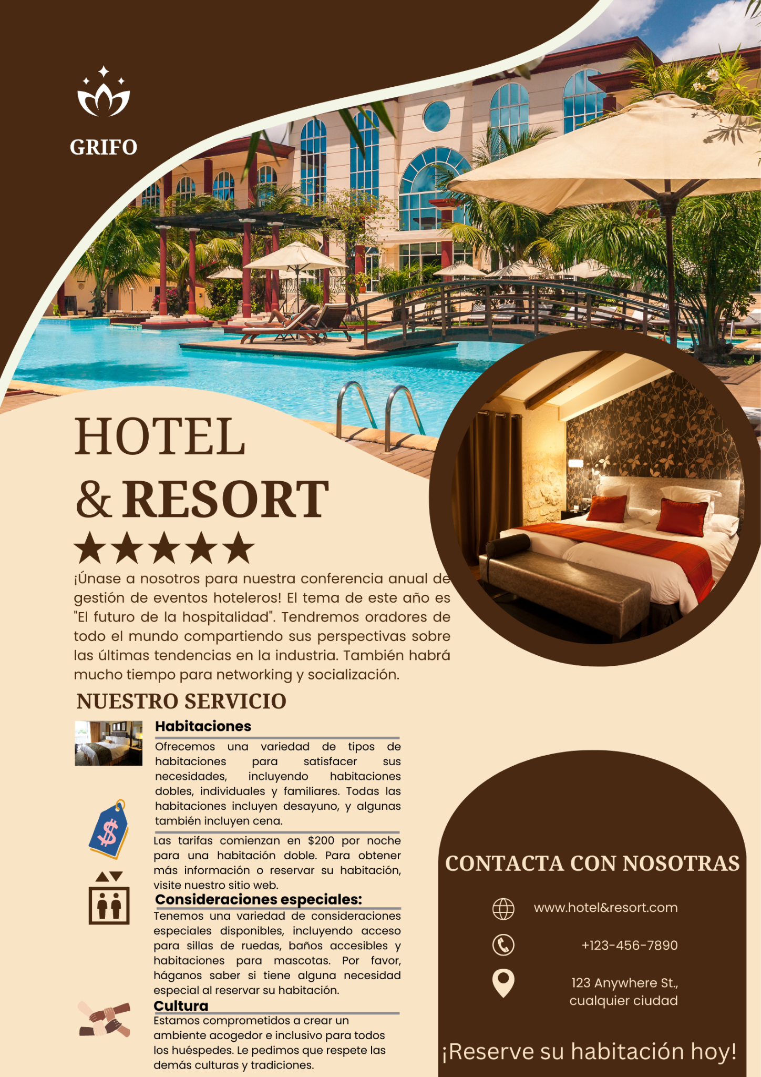
References:
- Lynn V. Wagen & Lauren W. (2018) Event Management | For Tourism, Cultural, Business and Sporting Events. 2nd edn. Cengage Learning Australia.
- Dimitri T. (2005) Event Management | A Professional and Developmental Approach. Juta.

