

Arron Simpson

ACDB 5013: Safety and Hazard Assessment

115mm Large Calibre Gun

University of Wales Trinity Saint David
Ordnance, Munitions and Explosives Professional Degree Apprenticeship

Academic Year: 2024- 2025

Supervisor: Austin Clark
July 2025

Table of Contents

Introduction and Description 3
Aim 3
Introduction 3
ALARP Justification Report for Hazard 01 - Effects of Weapon System Impacting Operator 8
Annex A – Risk Acceptance Criteria 1
Annex B – 115mm Large Calibre Hazard Log 1
References 1

Table of Tables

Table 1 – Key Subsystems 4
Table 2 – Hazard Causes 5
Table 3 – Hazard / Accident Relationship 5
Table 4 – Initial Risk Estimation 6
Table 5 – Post Control Initial Risk Estimation 7
Table 6 – Accident Severity Thresholds 1
Table 7 – Accident Probability Categories 1
Table 8 – Risk Classification Matrix 2
Table 9 – Risk Classification Definitions 2

Introduction and Description

Aim
- The aim of this report is to describe the hazard identification and subsequent risk assessment associated with the allocated 115mm Large Calibre Gun. Focusing on the hazard identification techniques used, the initial risk estimation and any controls required to justify that the risks associated with the system are As Low As Reasonably Practicable (ALARP).

Introduction
- Systems Description. A 115mm Large Calibre Gun is an armoured-vehicle-mounted weapon system used for armoured warfare and support operations. Capable of firing a variety of munitions such as, Armour Piercing Fin-Stabilised Discarding Sabot, High Explosive (blast) and High Explosive Anti-Tank rounds. It provides direct-fire capability against enemy armour, fortifications, and soft targets. The system comprises several integrated subsystems designed to ensure accurate, reliable, and safe operation.
- Key Subsystems:
Subsystem | Sub-subsystem | Description
Gun Barrel and Breech Mechanism | Breech Block Assembly | Manages loading and sealing of ammunition; includes firing pin, obturator, and locking lugs.
Gun Barrel and Breech Mechanism | Barrel Liner and Muzzle Brake | High-strength steel tube; controls gas discharge and reduces recoil force.
Recoil Management System | Hydro pneumatic Recoil Cylinder | Absorbs recoil energy using fluid compression.
Recoil Management System | Recuperator System | Returns the barrel to its firing position post-recoil.
Ammunition Handling System | Auto-loader or Manual Feed System | Delivers ammunition to the breech; may be automated or manual.
Ammunition Handling System | Ammunition Storage Racks | Shock-mounted compartments with blast mitigation for shell storage.
Fire Control System (FCS) | Gunner’s Display Unit and Sight | Provides visual interface and targeting feedback.
Fire Control System (FCS) | Ballistics Computer | Calculates aim based on environment, munition, and barrel condition.
Gun Mount & Traverse System | Gun Cradle and Trunnion Bearings | Mechanical supports allowing elevation and recoil travel.
Gun Mount & Traverse System | Electric Traverse Motor | Allows aiming in azimuth with high precision.
Crew Operation Station | Loader/Gunner/Commander Consoles | Human-machine interfaces used during target engagement and diagnostics.
Table 1 – Key Subsystems
- Hazard Identification. In accordance with UK Military of Defence (MoD) guidance, such as Defence Standard 00-056 Part 2 [1] and the Acquisition Safety & Environmental Management System (ASEMS) Safety Management Procedure (SMP) 04 [2]. A Preliminary Hazard Analysis (PHA) was conducted for a general qualitative study of the 115mm Large Calibre Gun system design concept in its intended operating environment to detect and define hazards, either real and or potential. Such hazard information contributes to the identification of high-risk components in the system, identifies safety critical sub-system or components and software, and initiates controlling design criteria for safety.
- The Hazard and Operability (HAZOP) method was used in combination with a Hazard Checklist focusing on the Operation and Maintenance of the system to identify the potential hazards in a concise, comprehensible and auditable manner, and develop a structured approach for the subsequent safety assessment.
- Causes to the identified hazards were determined as shown in Table 2.
Haz ID | Hazard | Cause ID | Cause
H01 | Effects of Weapon System Impacting Operator | Z01  Z02  Z03  Z04  Z05  Z06 | Operator in danger area  Unprotected bodily parts  Procedural error  Moving parts  Slips and Trips  Sharp edges or protruding parts on weapon housing or controls
H02 | Exposure to Extreme Temperatures | Z07  Z08  Z09  Z10 | Contact with hot weapon surfaces High ambient temperature exposure  Cold weather exposure  Ammunition heat/cook-off
H03 | Exposure to Harmful Substances | Z11  Z12  Z13 | Inhalation of toxic fumes from propellant gases after firing  Skin contact with hydraulic fluids, oils, cleaning solvents, and lubricants  Exposure to lead, heavy metals, or particulates from primer or propellant residues
H04 | Hangfire / Misfire | Z14  Z15  Z16 | Faulty ammunition  Faulty firing mechanism  Incorrect loading procedures or improper seating of the round
H05 | Noise Exposure | Z17  Z18  Z19  Z20 | Muzzle blast from live firing  Weapon operation  Internal overpressure and reflected noise in enclosed turrets  Mechanical noise from recoil and loading systems  Repeated exposure during sustained firing (e.g. training or combat)
H06 | Mechanical Failure - Breech Explosion / Malfunction or Associated Components | Z21  Z22  Z23  Z24 | Structural fatigue or failure of breech block or carrier  Failure of obturation mechanism (e.g. obturator pad erosion)  Overpressure due to ammunition overcharge or incorrect round Misalignment or mechanical interference of moving parts (e.g. breech not fully closed)
Table 2 – Hazard Causes
- With the preliminary Hazards and causes identified, they were reviewed and the identification of the corresponding Accidents those Hazards may lead to during the operation and maintenance of the 115mm Large Calibre Gun were agreed upon, as captured in Table 3.
Hazard ID | Hazard | Accident ID | Accident
H01 | Effects of Weapon System Impacting Operator | A01 | Serious injury or fatality due to exposure to blast, recoil or moving components.
H02 | Exposure to Extreme Temperatures | A02 | Injury to personnel due to hot/cold temperatures
H03 | Exposure to Harmful Substances | A03 | Inhalation of gaseous waste products, inhalation of toxic substances, ingestion of toxic substances, skin contact with toxic substances
H04 | Hangfire / Misfire | A04 | Operator fatality/injury due to explosion
H05 | Noise Exposure | A05 | Damage to hearing
H06 | Mechanical Failure / Breech Malfunction or Associated Components | A06 | Fatality or Injury due to incorrect function of weapon system
Table 3 – Hazard / Accident Relationship
- An initial risk estimation was undertaken as per best practice under UK MoD Def Stan 00-56 [1], Defence Safety Authority (DSA) 02. [3] and 03. [4], and following guidance of the ASEMS Project Orientated Safety Management System (POSMS) SMP 06 [5] where, prior to the identification of any controls, the estimated frequency of occurrence of hazardous events leading to harm, and the severity of that harm (Accident) were assessed and agreed under the generic accident severity categories, probability ranges, risk classification matrix and definitions at Annex A – Risk Acceptance Criteria resulting in the initial risk classification Table 4.
Hazard ID | Accident ID | Accident | Frequency | Severity | Risk Classification
H01 | A01 | Fatality or Injury due to weapons system effects | Frequent | Catastrophic | A
H02 | A02 | Injury to personnel due to hot/cold temperatures | Frequent | Marginal | A
H03 | A03 | Inhalation / ingestion / skin contact of toxic products. | Frequent | Critical | A
H04 | A04 | Operator fatality/injury due to explosion | Probable | Catastrophic | A
H05 | A05 | Damage to hearing | Frequent | Critical | A
H06 | A06 | Fatality or Injury due to incorrect function of weapon system | Probable | Catastrophic | A
Table 4 – Initial Risk Estimation
- The output from the PHA was be used to generate a Hazard Log for the 115mm Large Calibre Gun system. Additional work was carried out to identify a list of Accidents that might result from the identified Hazards, a list of Causes that might produce the hazards and a list of controls that can be used to remove or mitigate against the Causes arising which can be found at Annex B – 115mm Large Calibre Hazard Log.
- The Hazard Log demonstrate that all identified hazards have been subjected to a structured assessment process. Controls have been implemented that reflect recognised good practice and industry standards. Where further risk reduction is theoretically possible, the cost (in operational capability, technical feasibility, or economic terms) would be grossly disproportionate to the safety benefit. Independent review of all evidence has been undertaken by subject matter experts and conclude that the residual risks associated with the 115mm large calibre gun system are reduced to a level that is ALARP and tolerable (Table 5) when the system is operated with established procedures and oversight.

Hazard ID | Accident ID | Accident | Frequency | Severity | Risk Classification
H01 | A01 | Fatality or Injury due to weapons system effects | Frequent | Catastrophic | C
H02 | A02 | Injury to personnel due to hot/cold temperatures | Frequent | Marginal | C
H03 | A03 | Inhalation / ingestion / skin contact of toxic products. | Frequent | Critical | C
H04 | A04 | Operator fatality/injury due to explosion | Probable | Catastrophic | C
H05 | A05 | Damage to hearing | Frequent | Critical | C
H06 | A06 | Fatality or Injury due to incorrect function of weapon system | Probable | Catastrophic | C
Table 5 – Post Control Risk Estimation

ALARP Justification Report for Hazard 01 - Effects of Weapon System Impacting Operator
- This ALARP justification is for Hazard 01, "Effects of Weapon System on Operator" associated with the 115mm large calibre gun system.
- The nature of this hazard includes physical harm to crew members and maintenance personnel from interaction with the weapon system during operation, maintenance, and loading activities. The primary causes assessed include unprotected bodily parts near moving equipment, procedural error, sharp edges, mechanical movement, slips/trips during operation or servicing, and protrusions that may cause injury.
- This ALARP justification demonstrates that all reasonably practicable measures have been implemented to reduce the risk to operators to a level that is "As Low As Reasonably Practicable", in accordance with the UK Health and Safety at Work etc. Act 1974 (HSWA), Management of Health and Safety at Work Regulations 1999, and Defence-specific requirements outlined in JSP 375 [6], DSA02. [3] and DSA03. [4] and the POSMS suite.
- Hazard 01 - Effects of weapon system on operator encompasses the potential for:
  - Entrapment or crush injuries from recoil systems or breech blocks.
  - Pinch points in the loading and ramming mechanisms.
  - Injuries from sharp edges or protruding fittings in the turret/gun area.
  - Slips, trips, and falls due to poor layout or obstruction.
  - Manual handling injuries during loading and maintenance.
  - Accidental actuation of moving components (e.g. hydraulic loaders).
  - Ergonomic stress and repetitive strain during prolonged operation.
- The hazard is applicable during operation, maintenance, and training, and particularly affects the gunner, loader, and maintainer roles.
- A combination of engineering, procedural, human factors, and Personnel Protective Equipment (PPE) controls were considered and implemented to reduce this hazard. The process of control selection followed a hierarchy of risk reduction:
- Engineering Controls (Primary Controls)
  - Mechanical Guards and Interlocks
    - Mechanical guards were installed around high-risk moving components such as breech closing mechanisms, auto-loaders, and recoil dampers. Interlocks were used to prevent operation unless safe conditions are met (e.g. breech cannot open while firing pin is cocked).Applying recognised standards to the design of the system.
    - These controls eliminate access to hazardous areas during movement, and their implementation was considered cost-effective due to their passive nature and minimal impact on system design.
  - Edge Radiusing and Surface Finishing:
    - All operator-accessible surfaces were assessed and finished to eliminate sharp edges. Panel interfaces, handles, and hatches were radiused or covered with compliant materials to reduce laceration risk.
    - This control was low in cost and high in risk reduction value and was implemented as part of standard manufacturing Quality Assurance.
  - Ergonomic Layout and Access Design:
    - Operator stations were arranged to reduce excessive reach, awkward posture, and blind operation of controls. Reach envelopes and control placements were designed using anthropometric data.
    - Cost of implementing this during early design was low. Late-stage changes (e.g., relocation of control handles) were evaluated and implemented only where the ergonomic benefit justified the redesign time and cost.
- Procedural and Training Controls:
  - Standard Operating Procedures (SOPs):
    - Detailed operator and maintenance SOPs were developed under the framework of JSP 375 [6] and JSP 822 [7] . These include clear warnings, defined danger zones, and step-by-step actions to prevent operator exposure to moving parts.
    - These were supported by job-specific training modules and assessments, ensuring competence.
  - Lock-Out/Tag-Out (LOTO):
    - A formal Lock-Out/Tag-Out procedure was implemented to ensure energy sources (hydraulic, mechanical, electrical) are isolated during maintenance. This was introduced as a safety critical control based on good practice outlined in HSE guidance and MOD maintenance policy.
  - Supervised Loading Drill:
    - Crew loading procedures were designed and practised to ensure alignment, communication, and safe movement. Use of safety observers during live fire and weapon drills was mandated.
  - Cost of implementation was marginal as it integrated with routine training activities.
- PPE Controls:
  - Where residual risks remain (e.g. crush or laceration during manual loading), operators are issued:
    - Padded gloves to prevent impact injuries.
    - Slip-resistant footwear.
    - Flame-retardant overalls with elbow/knee protection.
- Emerging and Creative Solutions:
  - Several innovative technologies and methods were also assessed for potential inclusion:
    - Integration of proximity sensors and visual/audible alarms to detect human presence near moving components.
    - Use of augmented reality (AR) training environments for procedural reinforcement.
    - Implementation of low-friction turret flooring and self-cleaning mechanisms to reduce trip hazards.
  - These were considered either too early-stage in maturity (e.g., AR) or not cost-effective at this time (e.g., sensor installation inside confined gun housing). However, they remain under review as part of continuous improvement.
- Grossly Disproportionate Controls (Rejected):
  - Some potential controls were assessed but rejected on the grounds of being grossly disproportionate, in line with HSE’s ALARP guidance and JSP 454:
    - Full Automation of Loader System - A fully automated loading and ramming system would eliminate manual handling, but would:
      - Add significant weight and space requirements.
      - Require extensive redesign of turret layout.
      - Introduce additional failure modes (electromechanical).
      - Cost in excess of £1.5M per platform (based on supplier data).
      - A Cost-Benefit Analysis (CBA) showed that the risk reduction benefit did not justify the time, cost, and performance impact for a platform with a relatively low annual firing rate. Instead, semi-assisted manual loading with hydraulic rammer and training was retained.
    - Turret Refit with Active Hazard Detection - Installing infrared or LIDAR sensors to detect operator presence around moving parts during maintenance was considered. This system would have added software complexity, cost (est. £200k/system), and presented reliability concerns in the combat environment (dust, thermal interference).
      - Risk reduction was marginal compared to mechanical guards already in place. This was therefore considered grossly disproportionate.
- Legal and Regulatory Compliance
  - The following regulations and MOD policies were used to inform minimum acceptable standards:
    - Health and Safety at Work etc. Act 1974.
    - Management of Health and Safety at Work Regulations 1999.
    - Provision and Use of Work Equipment Regulations (PUWER) 1998.
    - Control of Substances Hazardous to Health (COSHH) 2002.
    - JSP 375 – MOD Health & Safety Handbook.
    - JSP 454 – Safety and Environmental Management Systems.
    - JSP 822 – Defence Individual Training and Education.
    - STANAGs and DEF STANs referenced within the hazard log.
- ALARP Justification:
  - Following implementation of the aforementioned controls, the risk associated with operator injury from interaction with the weapon system is considered:
    - Likelihood: Improbable.
    - Severity: Catastrophic.
    - According to the systems Risk Classification Matrix, this yields a risk level category C, with sufficient control measures implemented. Additional controls that could further reduce risk were evaluated and ruled out as grossly disproportionate.
- A layered control approach (engineering, procedural, PPE) ensures redundancy and adaptability to operational variations. Controls are also compliant with legal requirements and aligned with recognised good practice.
- Maintaining ALARP into the Future:
  - The ALARP status will be sustained through the following lifecycle by:
    - Annual safety reviews as per POSMS and project safety programme.
    - Operator feedback mechanism via unit safety representatives and reporting mechanisms.
    - Mandatory incident/near miss reporting and root cause investigation.
    - Configuration control and review of SOPs based on in-service experience.
    - Inclusion of hazard awareness in pre-deployment training.
    - Periodic review of technological advances (e.g., automated loading, sensors) as part of capability upgrades.
  - Any emerging hazards, design changes, or incident trends will trigger a reassessment of this hazard and, if needed, the implementation of additional controls.
- Conclusion
- Through the systematic application of design standards, procedural rigor, and operator training, the risk of harm to operators from the weapon system has been reduced to a level that is demonstrably ALARP. All credible and reasonably practicable measures have been taken, and further controls have been assessed as grossly disproportionate or unsuitable for current operational conditions.
- This position will be reviewed regularly through the safety assurance framework and in-service monitoring. Accordingly, this hazard is accepted with justification and continued ALARP management.

Annex A – Risk Acceptance Criteria
- Accident severity thresholds. Denote the degree of harm that results from an accident and are provided in Table 6.
Category | 1st Party / Associated Personnel  (Persons directly involved) | 3rd Party / Non-Associated  Personnel (Persons not directly  involved)
Catastrophic | Multiple deaths | A single death and / or multiple severe injuries or equivalent occupational illness.
Critical | A single death and / or multiple severe injuries or equivalent occupational illness. | A single severe injury or occupational illness and / or multiple minor injuries or minor occupational illness.
Marginal | A single severe injury or occupational illness and / or multiple minor injuries or minor occupational illness. | At most a single minor injury or minor occupational illness.
Negligible | At most a single minor injury or minor occupational illness. A non-sporting injury requiring professional medical attention (may include a Medical Orderly or an Army Combat Medical Technician). | Any injury or occupational illness, however minor.
Table 6 – Accident Severity Thresholds
- Accident Probability Thresholds. Accident probability thresholds are shown in Table 7 and apply over the life of the weapon system.
Qualitative  Probability | Description (Through life) | Quantitative  Equivalent
Frequent | Likely to be continually experienced during the life of the system. | >1x10-3
Probable | Likely to occur often during the life of the system. | 1x10⁻³ to 1x10⁻⁴
Occasional | Likely to occur several times during the life of the system. | 1x10⁻⁴ to 1x10⁻⁵
Remote | Likely to occur sometime during the life of the system. | 1x10⁻⁵ to 1x10⁻⁶
Improbable | Unlikely, but may exceptionally occur during the life of the system. | 1x10⁻⁶ to 1x10⁻⁷
Incredible | Extremely unlikely that the event will occur during the life of the system. | < 1x10⁻⁷
Table 7 – Accident Probability Categories
- Risk Acceptance Criteria. Risk Acceptance Criteria (RAC) for 115mm Large Calibre Gun system are to be based on the Risk Classification Matrix in Table 8 and the risk classification definitions provided in Table 9.

Probability | Catastrophic | Critical | Marginal | Negligible
Frequent | A | A | A | B
Probable | A | A | B | C
Occasional | A | B | C | C
Remote | B | C | C | D
Improbable | C | C | D | D
Incredible | C | D | D | D
Table 8 – Risk Classification Matrix

Risk Class |  | Description
A | Intolerable | Intolerable, and shall not be accepted. A formally  delegated person may only accept this risk in  extraordinary circumstances.
B | Undesirable | Undesirable, and shall only be accepted by the system accountable person, or equivalent, when further risk reduction is impracticable.
C | Tolerable | Tolerable with the endorsement of the Safety  Committee if risk is demonstrated to be ALARP.
D | Broadly  Acceptable | Broadly acceptable, but risk shall be monitored by the  Safety Committee to ensure that it remains ALARP.
Table 9 – Risk Classification Definitions

Annex B – 115mm Large Calibre Hazard Log
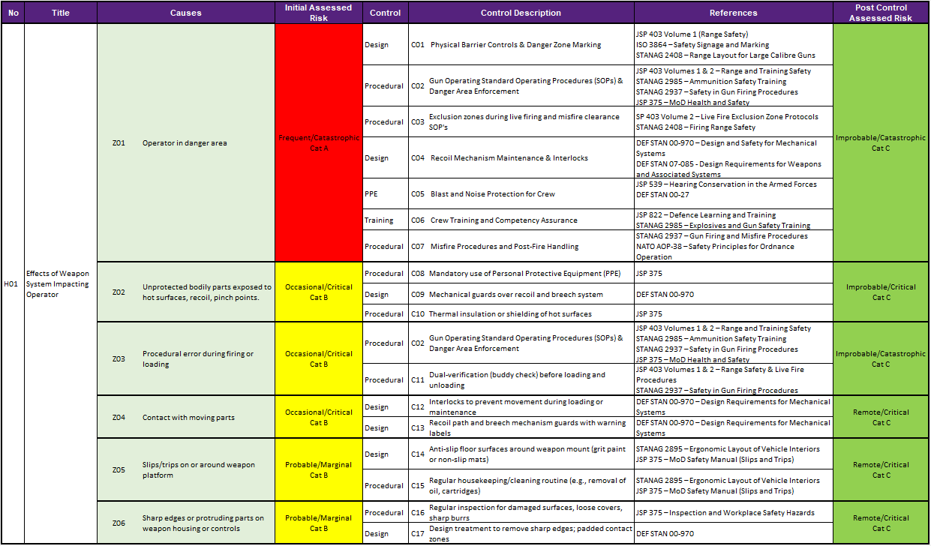
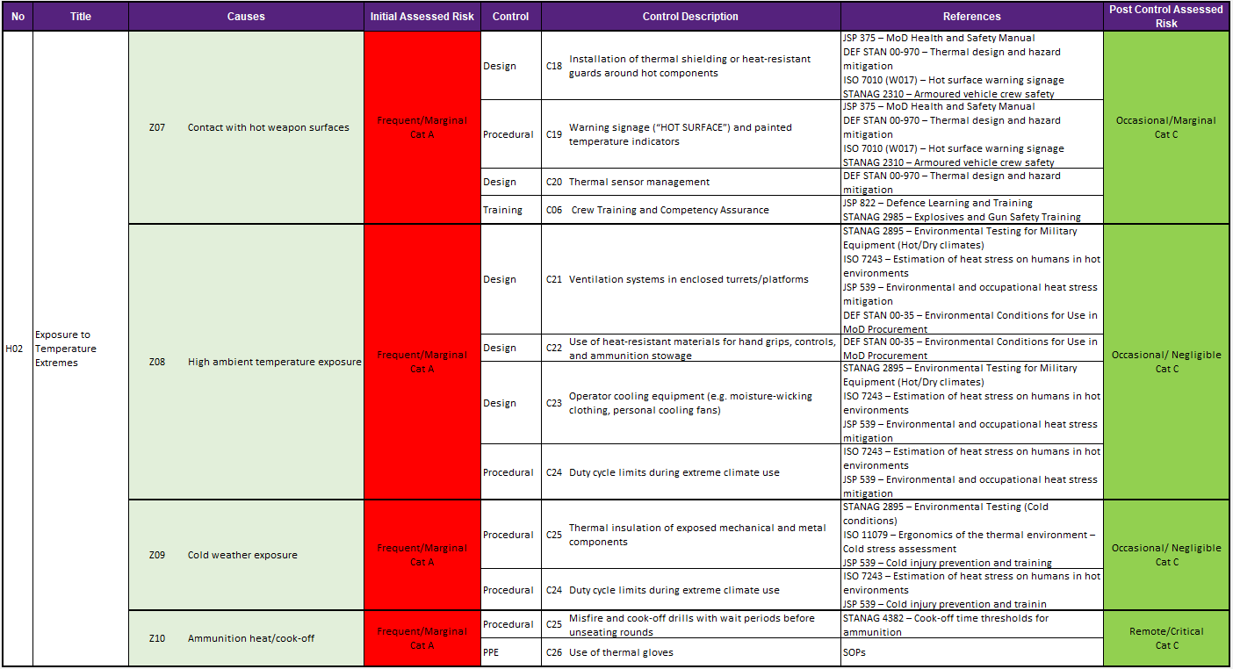

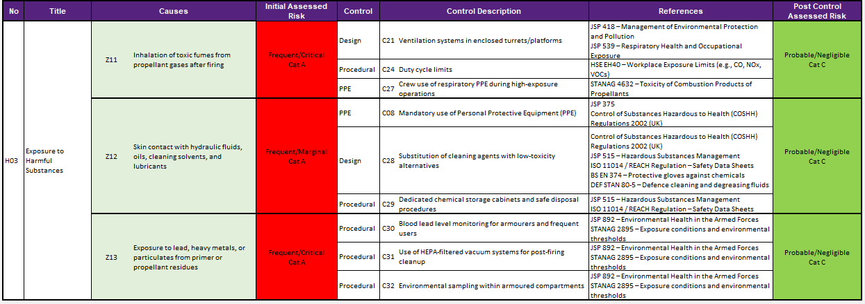

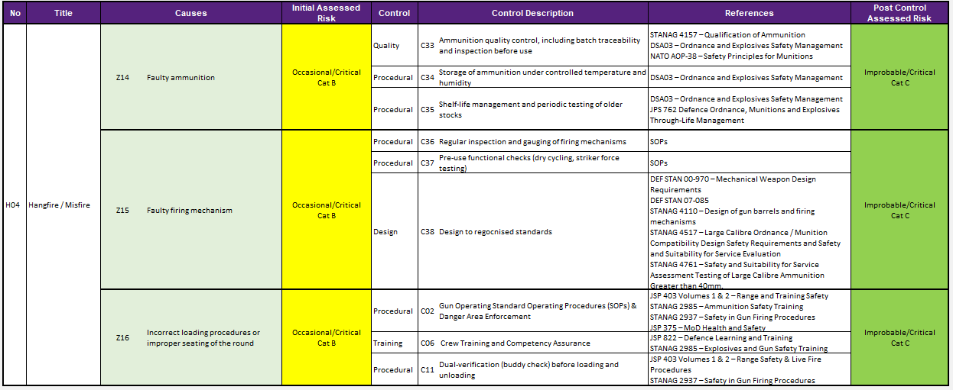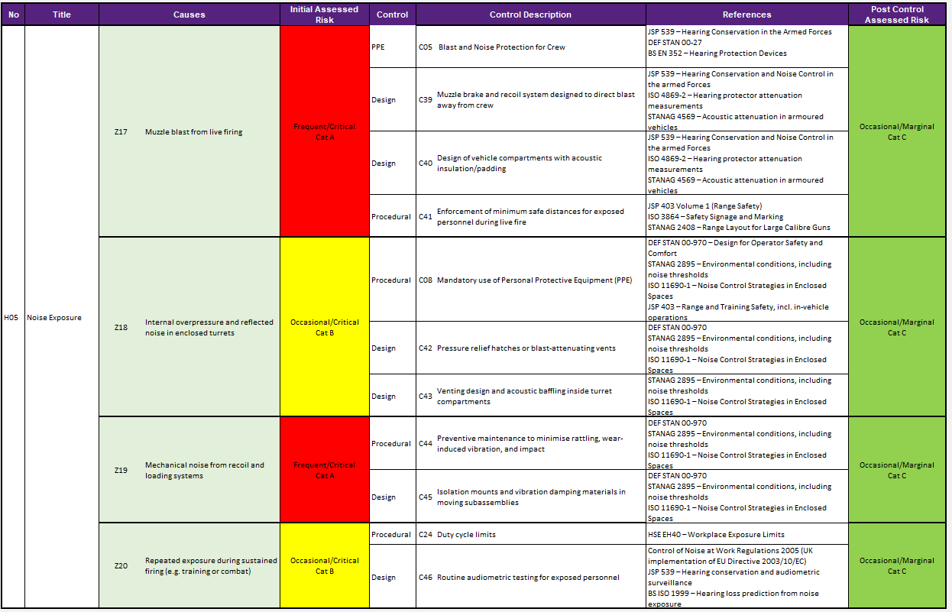
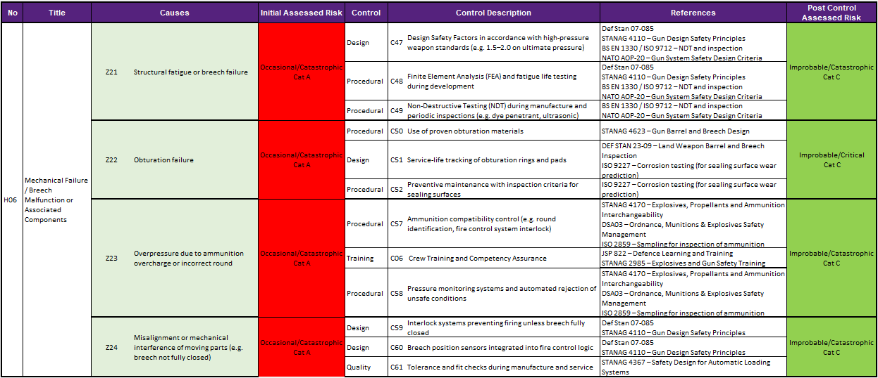

References

[1] | UK MOD, “Safety Management Requirements for Defence Systems Part: 01 : Requirements and Guidance,” Defence Equipment and Support, Glasgow, 2023.
[2] | DE&S, “Aquisition Safety & Environmental Management System, SMP04 - Preliminary Hazard Identification and Analysis, V4.2,” 2022.
[3] | Defence Safety Authority, “DSA02.DLSR.LSSR - Land System Safety and Environmental Protection Defence Codes of Practice,” 2017.
[4] | Defence Safety Authority, “DSA03.DLSR.LSSR Land System Safety and Environmental Protection Defence Codes of Practice,” 2017.
[5] | DE&S, “Aquisition Safety & Environmental Management System, SMP06 - Risk Esimation V4.1,” 2021.
[6] | MoD, “JSP 375 Mangement of Health and Safety in Defence,” 2025.
[7] | MoD, “JSP 882 Defence Traning and Education,” 2024.

