- Use Case Diagram

Actors
- Customer
- Admin Staff

Use Cases
- Browse Catalogue
- Shop Cart
- Login
- Register Now
- Place Order
- Invoice
- Order Info
- Feedback
- Updates
- Generate Report

Association
- Customer can browse the catalogue without being logged in.
- After adding items into the shop cart in order to place the order automatically the customer will be asked to login or in case if is not a user yet to register itself
- Placing the order include an invoice which customer will get it
- Also after placing the order customer has access to its order information
- Admin Staff in order to update the system has to access the catalogue
- In order to generate reports the admin has to store the invoices and all the orders information

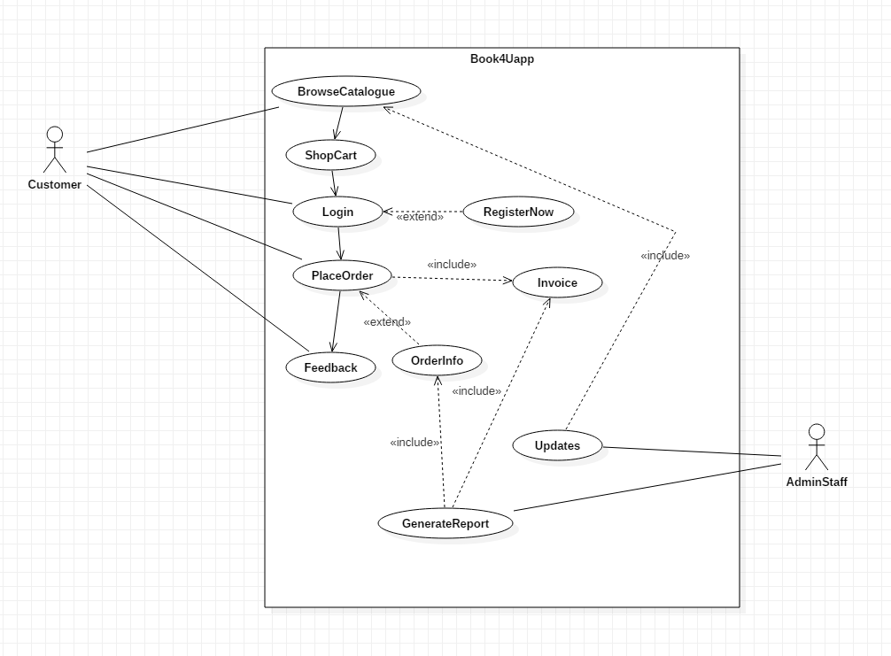

- Entity Relationship Diagram

Entities
- Shop – Primary Key – Shop Id
- Customer – Primary Key – Customer Id
- Customer Detail – Primary Key – Customer Detail Id
- Order – Primary Key – Order Id
- Book – Primary Key – Book Id
- Book Detail – Primary Key – Book Detail Id
- Record – Primary Key – Record Id
- Invoice – Primary Key – Invoice Id



