EAEE5002 1905083
Element 1
Why is reflective practice useful
Lindon and Trodd (2016) claim that reflective practice is of great importance to maintain and create in early years setting that is self-sustaining and active, that is sure to meet new challenges. Lindon and Trodd (2016) go on to state that reflection is an essential part of learning to be and become professional and encourages open-mindedness, taking responsibility and lack of carelessness. Greater outcomes for children can be achieved through reflection and continuous improvement states PACEY (2016). Reed and Canning (2010) state reflective practice not only involves critical thinking, it is also an open-ended creative process with a wide range of possible interpretations. PACEY (2016) claims reflective practice is a process of analysing and thinking about one’s own practice in order to challenge, alter, create and improve it. They go on to state this should be a never-ending cycle of improvement and reflection.
According to Tarrant (2013) reflecting in practice is a skill that progresses as practitioners’ progress from inexperience to experienced in their profession. Reflective practice helps practitioners’ become more aware of themselves, their experiences, competencies and understandings, knowledge and skills, and general workplace practice claims City and Guilds (2019). Canning and Reed (2010) state upon discovering new ways to teach, being reflective will ensure practitioners have a broader set of skills. As practitioners discover the best ways to deliver your knowledge of a subject, they will develop their confidence (Canning and Reed, 2010). Bassot (2016) claims reflective practice enables practitioners to tailor lessons to their learners needs. To achieve optimal success, practitioners can build and experiment with new ideas and approaches to their teaching (Bassot, 2016). Hansen (2012) agrees and states by reflecting, practitioners’ construct an environment which centres on the learner, this setting will help learners and practitioners all around to become more creative, confident, engaged and responsible.
Hallet (2013) claims that there is an evolving importance for practitioners to be reflective within the changing environment within the early years sector. Hallet (2013) goes on to state the purpose behind reflective practice is to create good quality experiences for not just children but for their families also. Dewey (1933, cited in Hallet, 2013) explains practitioners who are open-minded will accept others perspective, and accept that the possibility that their practices and views can be developed further with the use of others viewpoints.

Gibbs Reflection Cycle
Gibbs (1998, citied in The University of Edinburgh, 2020) expanded on the theoretical method of reflection as a cyclical model. This model follows a six-stage process that starts with a description of the experience and ends with conclusions and suggestions for future events (The University of Edinburgh, 2020). Although most of the core concepts of Gibbs reflection cycle is similar to other models such as Kolb’s, Gibbs model is further broken down to allow practitioners’ to reflect on their own thoughts and emotions claims University of Cambridge (2021). According to Rumson (2018) Gibbs’ model is a helpful tool for helping practitioners and professionals reflect after an event because it is broken down into clearly defined parts. Rumson (2018) goes on to state it is also a useful model if you are new to reflection because it is broken down into clear defined thorough parts. The first three parts of Gibbs’ model are focused with what happened (Cambridge International Education, 2020). The last three parts are about making sense of what happened and how you, as the practitioner, can improve on the situation (Cambridge International Education, 2020). The University of Edinburgh (2020) suggests Gibbs’ model is a useful tool for working through a difficult situation. They go on to state this may be considered a one-time experience or a scenario that occurs regularly, such as meetings with a team with whom practitioners and professionals would collaborate. While Gibbs advocate for the stages to be used in repetitive situations, the stages and concepts could be applied to single experiences as well (University of Edinburgh, 2020).

Schon’s Reflection Cycle
Schon’s work is another method to reflection states Cambridge International Education (2020). Schon (1991, citied in Cambridge International Education, 2020) distinguishes between two parts known as reflection-in-action and reflection-on-action. Buwert (2012) states reflection-in-action is when a practitioner reflects while they are in the ‘doing stage’, this is reflecting on the situation while it can still benefit the learning. Rather than thinking on how a practitioner can do things better in the future, this is done during the lesson (Buwert, 2012). Buwert (2012) goes on to suggest this is a very effective method of reflection because it helps practitioners to respond to and after an even as it occurs. Sage Publications (2013) states reflection-in-action enables practitioners to deal with unexpected events that can arise in the classroom. They go on to state that it enables practitioners to be responsible and resourceful by encouraging them to rely on their own skills and knowledge and apply it to new situations. According to Meierdirk (2017) reflection-on-action, entails thinking about to further practice after a lesson has been taught. Meierdirk (2017) goes on to state Schon recognises the value of looking back to see how practitioners knowing-in-action could have led to an unexpected result. Cambridge International Education (2020) claims reflection-on-action means after the event the practitioner would reflect on how their knowledge of previous teachings could have contributed to the experience they received. Schon’s model is often a preferred reflection cycle due to its easy use of real-life applicability (Cambridge Assessment, 2018). Cambridge Assessment (2018) suggests Schon’s reflective cycle appeals to practitioners’ who do not have time on their side to carry out in-depth reflective cycles such as Gibbs’. This is due to practitioners’ need to be quick thinkers in their professions (Cambridge Assessment, 2018).

Practitioners’ in a variety of professions have been known to benefit from the practice of reflection (Cadwell and Grobbel, 2013: LaPrade et al., 2014). However it is indeed important to note that reflective practice is a broad concept that encompasses a wide range of reflective models, each with their own set of perspectives (Herbert, 2015). Herbert (2015) suggests practitioners should choose a model or models that best reflect their own needs and skills in order to become skilled at reflection. Herbert (2015) goes on to state if practitioners and settings do not choose a reflective model critically, “the very spirit of reflection practice can be undermined”. Reflection needs to have some impact or else it becomes superficial reflection states Tarrant (2013). Tarrant (2013) goes on to state this impact should lead practitioners to progress in their understanding, expertise or practice, therefore after reflection there should be action which is then put into place. Any model of reflection can be used to help individuals grow personally or professionally, because it puts the individual in control and allows them to facilitate their own development claims DunnGalvin et al (2019). As a result, reflection is seen as an encouraging and long-term method of learning (Mantzourani et al, 2019). PACEY (2016) agrees and also adds reflection is considered a crucial aspect of any setting and can support and benefit children, as well as the parents and care givers. Practitioners will also benefit personally and professionally, therefore reflective practice will assist settings in maintain and improving its performance to follow the Oftsed guidelines.

Element 2 Briefing Paper

Brock (2015) states reflection and reflective practice are centre importance’s of practitioners and is an essential part of professional training. According to PACEY (2016) reflective practice helps to maintain and continually better the quality in early years practices. According to Queen Margaret University (2014) reflection is a thought process and explanation of individual’s experiences. The Open University (2013) claims reflection helps practitioners to learn and through the process individuals develop their skills, values and enhance their knowledge.

Values
City and Guilds (2019) state emotion is significant in reflective practice because it allows workers to explore their feelings, values and opinions about a particular practice. This is to encourage in depth learning about what happened and why it happened (City and Guilds, 2019).
NHS Education for Scotland (no date) states being effective in reflective practice, you should be aware of your values, beliefs, strengths and weakness and how they can be influenced.

Knowledge and Skills
Reflection is an essential component of both teaching and learning. It aims to increase the awareness of your own professional knowledge and actions by challenging daily practice assumptions and critically, objectively examining practitioners own responses to practice situations states Finlay (2008, cited in Cambridge International Education, 2020).
Koshy et al., (2017) claims through reflective practice you will develop your own skills and knowledge and become a better learner and professional. Reflection greatly enhances your skills and knowledge so the benefits of reflecting are clear.

Effective Practitioner
Koshy et al., (2017) state reflective practice is important for professional and personal progression.
We must accept reflective practice as a continuous, never-ending, cyclical process of self-monitoring and self-evaluation in order to be effective reflective practitioners (Pollard et al, 2014).
Tarrant (2013) states reflection has a positive impact on professionalism, which is one of its advantages; we become more conscious, in charge and able to see our strengths and growth needs by focusing on our practice.
PACEY (2016) claims that as a childcare or early childhood professional, you want to provide the best possible care for the children within your setting. They go on to state reflective practice is a great way to maintain the quality of your practice and continuously improve it in the future.

Gibbs
University of Edinburgh (2020) explains this model is a useful tool for working through a difficult situation. Brown (no date) states the aim of this model is to manage and isolate emotions by systematising reflections. Brown (2020) goes on to suggest the various stages generally support us in slowing down our thinking processes so that we do not reach definitive conclusions too quickly.
Learning Performance (2019) claims it is also impossible to improve for the next time without this reflection of your own learning. According to Gibbs (1988, citied in Learning Performance, 2019) it is difficult to learn simply by experiencing a situation/event/activity, so reflection is important in order to truly learn and improve.
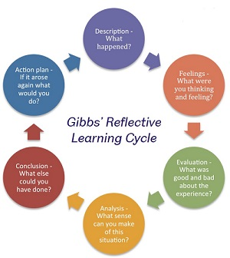

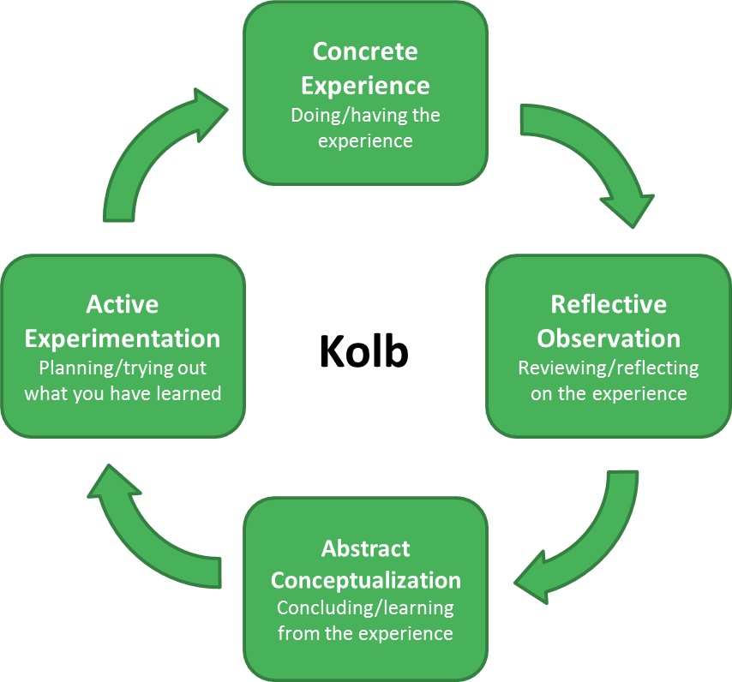
Kolb
Reflective practice is highlighted in Kolb’s Cycle (1984, cited in University of Leicester, 2018) as a method for gaining conclusions and ideas from an experience. University of Leicester (2018) states the aim is to apply what has been learned to new situations, thereby completing the cycle. Kolb’s Cycle is divided into four stages.
Dennison (2009) claims Kolb’s model emphasises the importance of drawing on both personal knowledge and academic research to help us progress. Kolb (1984, cited in Dennison, 2009) explains it is not enough for you to simply reflect, this reflection must lead to a change in educational study.

Overall
To become a reflective practitioner, the practitioner needs a balanced view of their practice, recognizing and praising the strengths and what works well but acknowledging what could also be improved (PACEY, 2016).
PACEY (2016) claims evaluating the practice will assist practitioners in identifying their professional development needs and will support them to gain more confidence in their practice over time.
Tarrant (2013) claims to progress as professionals, reflection is crucial and needed in practice.
Cambridge International Education (2020) state reflection is a systematic evaluation process for all practitioners that helps you to connect one experience to the next, ensuring that students make the most progress possible.
Dahlberg et al, (2007, cited in Hallet, 2013) claim looking back a lens of reflection, informs new ways of thoughts processes and developing practice professionally to put policy into practice.

Element 3 Reflective log
Brief description of the activity (no more than 50 words)
Storytelling activity for ages 3-4 year olds. The story chosen is about Santa and his helpers during Christmas eve and how they make and deliver the presents. The story involves colours, shapes and counting to encourage literacy and mathematics.

Aim/Objective of the activity
The aim of this activity is to encourage and develop literacy, language and mathematic skills to early years’ children in a fun way. This activity not only encourages the use of language, literacy and mathematics, it also helps to encourage and develop children’s imagination and characterisation skills with their peers.

Your role
My role as the practitioner during this activity is to enhance children’s practice with communication. Removing barriers to help children develop their speech and communication by encouraging them to join in with the story and repeated phrases. Provide opportunities for children to learn old and new vocabulary by introducing sounds also alongside quality questioning by asking open-ended questions and sustained shared thinking to enable children to think and problem solve. My role as a practitioner is to create a communication friendly environment that supports children holistically.

Positive aspects – why? How could these be developed further?
Books and story time introduces children to a world of excitement and curiosity and helps them learn to express their own emotions and thoughts. Imagination is also a key aspect of story time which opens children’s minds to endless possibilities alongside developing their psychological and emotional capacities that helps them understand the world they live in and are a part of. Story time encourages focus development which gives children the ability to pay attention, learn and remember as well as self control. The development of social skills allow children to establish boundaries and how other children react to their actions and allowing them to resolve possible conflict in an amicable way; all valuable skills that they will need in adulthood. All of these positive aspects can be developed further by ensuring the environment and learning not only enhances these skills and children but also grows and adapts with their journey through education; making sure that their learning environment is stimulating and enabling.

Challenging aspects – why? Link to your own practice.
There were a few challenging aspects during this activity. Children are active and very stimulated and making sure they stayed seated during the story was a challenge. Some children have anxiety so fidgeting is how they learn to cope. Keeping the children focus and making sure they listened was also challenging. Not all children like sitting down and listening to stories, so therefore my activity might not have been stimulating to all of the children. Interaction was also challenging as some confident children dominated the story time leaving some children either not a chance to intervene or they were too shy to voice themselves. The last challenging aspect I found during my activity was attention, some of the children who are known to lose attention during activities tried to break the focus of the other children by talking and playing during story time.

What knowledge did you demonstrate?
The knowledge I demonstrated during my activity was literacy, mathematics, communication and characterization. I taught the use of language and story structure to enhance my own knowledge and help develop the children’s. Mathematics was a part of my story by counting presents so I encouraged the children’s knowledge of numbers through vocabulary and vision. Communication used in my activity allowed myself to gain confidence in my own communication and encouraging the children to communicate with myself and their peers. Characterization was also demonstrated to the children to keep their attention and excitement, making it more fun and showing them not everyone sounds or looks the same; teaching them to distinguish different characters.

What skills did you demonstrate?
In my activity I demonstrated skills such as facial expressions, passion, timing, use of voice and suspense. Showing passion during storytelling demonstrates to children that I believe in my story and encourages all partakers imagination. The use of facial expressions I used was to express the characters emotions to draw the children into the story. The use of my voice allowed me to use different voices and tones for different characters; everyone and every character is different fiction or non-fiction. Timing is a skill required for storytelling. Children’s attention span tends to be short so my story was more effective to be short. And finally bringing suspense to my story allowed the children to feel more connected and excited while keeping them guessing during the story.

Which values did you demonstrate?
My values I demonstrated in my activity were purpose, motivation and listening. Listening is essential during storytelling. Listening and paying attention during this activity to children gives you an inside to their development and skills they are showing you while I showed them respect and interest in what they were communicating. The activity I chose involved purpose in every area. I being the storyteller gave purpose to the children, bringing imagination and stimulation. The story itself gave the children the understanding of what happens every Christmas eve. The activity purpose overall was to enhance, support and develop all skills and knowledge for children holistically. The motivation used during the activity allowed me to encourage and support children to communicate and participate with not only myself but with their peers. Myself being motivated encouraged the children to be motivated during this activity which kept their attention to the story.
What could be done differently in future? Why?
A handful of things could be done differently in future practice of this activity such as the placement of children and the catering of different children. Placement of children during an activity like this is key and could make the activity more of a success. Children who are quieter could be placed closer to the practitioner so the practitioner can motivate and encourage their participation. Children who are known to lose focus and wonder would benefit more if they were placed in the middle so they cannot up and leave and they would be in view of the practitioner. Children who have more confidence and are outspoken could be positioned at the back. Still allowing them to voice themselves without over speaking others. With regards to the catering aspect, some children may have speech and hearing difficulties so it is essential to take this into consideration. The use of props can help children with sensory deprivation. While making sure the practitioner is positioned to cater everyone, allows their lips to be read without obstruction for children who may have hearing difficulties.

Element 4 Personal Development Plan

Area for further development (provide further details) | Why? | How? | Who/Where? | When?
Organise my time better when it comes to university work | Assignments are due at the end of week 4, I do not start my work until half way through week 3 thus making myself feel overwhelmed and rushed | Set out a plan with timing.  Dedicating certain times for research and sections.  Spreading my time equally for my assignments. | I am to do this at home and in university. | Duration of this course.
Better my communication with my tutors and lecturers during university | I struggle due to my mental health and shut myself off from my work and people which results in my work becoming affected. | Communicate with my tutor or lecturers more with regards to I am stuck or struggling the work or understanding. | Tutors  Lecturers  In university and online. | Duration of this course.
Gain more confidence as a student. | My lack of confidence can course myself to question my work resulting in low self esteem and starting work over again or struggling. | If I have doubts about my work, I will communicate with my tutor or lecturer. | Tutors  Lecturers  In university and online. | Duration of this course.
To resolve the uncertainty of my future pathway once my course ends. | I have no knowledge of what pathways you can take once my course is completed. I am also uncertain what profession I would like to do. | Reaching out to the university and programme leader of my course or tutors in regards to this.  Attending the CPD week during my course. | Tutors  Lecturers  Former students  In the university and online. | End of this course in 2022.
Personal and professional reflection. | To make myself a better person and future professional. Learn from the past and find another alternative for the future. To continuously strive to be a better person in my personal and professional life. | Every time I come across an issue or moment where I question if I could have done anything different, I will make ma note of it. Then at the end of the week or month I will reflect on the past and set up a plan to learn, understand and look at what could have been done differently and what I will do going forward. | In workplace, in university and at home by myself.  I will communicate with tutors, managers or family for their opinions and points of views for constructive criticism. | Ongoing goal.

Reference List

Bassot, B. (2016) The Reflective Practice Guide. Oxon: Routledge.
Brock, A. (2015) The Early Years Reflective Practice Handbook. Oxfordshire: Routledge.
Brown, N. (no date) Reflective model according to Gibbs. Available at: https://www.nicole-brown.co.uk/reflective-model-according-to-gibbs/ (Accessed: 16th April 2021).
Buwert, P. (2012) The Reflective Pracititoner by Donald Schon. Available at: https://graysreadinggroup.wordpress.com/2012/12/18/the-reflective-practitioner-by-donald-schon/. (Accessed: 16th April 2021).
Caldwell, L. and Grobbel, C. (2013) ‘The importance of reflective practice in nursing’, International Journal of Caring Sciences, 6(3).
Cambridge Assessment (2018). Getting started with Reflective Practice. Available at: https://www.cambridge-community.org.uk/professional-development/gswrp/index.html (Accessed: 16th April 2021).
Cambridge International Education, (2020) Getting started with reflective practice. Available at: https://www.cambridge-community.org.uk/professional-development/gswrp/index.html (Accessed: 16th April 2021).
City and Guilds, (2019) Professional practice as a health and social care worker: principles of reflective practice and why they are important. Available at: http://resource.download.wjec.co.uk.s3.amazonaws.com/vtc/2018-19/HSC18-19_2-5/_multi-lang/unit06/9-reflective-practice.html (Accessed: 16th April 2021).
Dennison, P. (2009) Reflective Practice: The enduring influence of Kolb’s Experiential Learning Theory. Available at: https://journals.gre.ac.uk/index.php/compass/article/view/12/28 (Accessed: 16th April 2021).
DunnGalvin, A. et al., (2019) ‘Applied reflective practice in medicine and anaesthesiology’, British Journal of Anaesthesia, 122(5), pp. 536-541.
Hansen, A. (2012) Reflective Learning and Teaching in Primary Schools. London: SAGE Publications Ltd.
Hébert, C. (2015) ‘Knowing and/or experiencing: a critical examination of the reflective models of John Dewey and Donald Schön’, Reflective Practice, 16(3), pp. 361–371.
Koshy, K. et al., (2017) Reflective Practice in health care and how to reflect effectively. Available at: https://www.ncbi.nlm.nih.gov/pmc/articles/PMC5673148/ (Accessed: 16th April 2021).
LaPrade, K. et al,. (2014) ‘Impact of reflective practice on online teaching performance in higher education’, Journal of Online Learning and Teaching, 10(4).
Learning Performance, (2019) Gibbs’ Reflective Cycle and Learning. Available at: https://learningperformance.com/gibbs-reflective-cycle-and-learning/ (Accessed: 16th April 2021).
Lindon, J., and Trodd, L. (2016) Reflective Practice and Early Years Professionalism. 3rd edn. London: Hadder Education.
Mantzourani, E. et al., (2019) ‘The role of reflective practice in healthcare professions: Next steps for pharmacy education and practice’, Research in Social and Administrative Pharmacy, 15(12), pp. 1476-1479.
Meierdirk, C. (2017) Schon’s Reflective Practice: Dr. Charlotte Meierdirk [video]. Available at: https://www.youtube.com/watch?v=Tzjz-l8L1lc (Accessed: 16th April 2021).
NHS Education for Scotland, (no date) Reflective Practice. Available at: https://www.effectivepractitioner.nes.scot.nhs.uk/personal-and-professional-development/reflective-practice.aspx (Accessed: 16th April 2021).
Pacey, (2016) Developing Self Reflective Practice. Available at: https://www.pacey.org.uk/Pacey/media/Website-files/PACEY%20member%20practice%20guides%20(PDFs)/PG04-self-reflective-practice.pdf (Accessed: 16th April 2021)
Pollard, A. et al., (2014) Reflective Teaching in Schools. 4th ed. London: Bloomsbury.
Queen Margaret University, (2014) Reflection. Available at: https://www.qmu.ac.uk/media/5533/reflection-2014.pdf (Accessed: 16th April 2021).
Reed, M. and Canning, N. (2010) Reflective Practice in the Early Years. London: SAGE Publications Ltd.
Rumson, R. (2018) Gibbs – Reflective Cycle Model 1988. Available at: https://www.eln.io/blog/gibbs-reflective-cycle-model-1988 (Accessed: 16th April 2021).
Sage Publications, (2013) Chapter 1: Reflective Practice. Available at: https://uk.sagepub.com/sites/default/files/upm-binaries/59229_Sellars.pdf (Accessed: 16th April 2021).
Tarrant, P. (2013) Reflective Practice and Professional Development. London: Sage Publications Ltd.
The Open University, (2013) Learning to teach: becoming a reflective practitioner. Available at: https://www.open.edu/openlearn/education-development/learning-teach-becoming-reflective-practitioner/content-section-0?active-tab=description-tab (Accesssed: 16th April 2021).
The University of Edinburgh, (2020) Gibbs’ Reflective Cycle. Available at: https://www.ed.ac.uk/reflection/reflectors-toolkit/reflecting-on-experience/gibbs-reflective-cycle (Accessed: 16th April 2021).
University of Cambridge, (2021) Reflective Practice Toolkit. Available at: https://libguides.cam.ac.uk/reflectivepracticetoolkit/models (Accessed: 16th April 2021).
University of Leicester, (2018) David Kolb. Available at: https://www2.le.ac.uk/departments/doctoralcollege/training/eresources/teaching/theories/kolb (Accessed: 16th April 2021).

