

Evaluating the effectiveness of the use of modern technologies within the workplace and exploring social media as a tool for marketing.

Digital skills and research methods BMSK4003
Student: Alifjan Bibi
Student Number: 1713548
Tutor Name:

Table of Contents

1. Introduction-Modern technologies in the workplace
1.1 Different types of technologies in the workplace and their advantages and disadvantages

2. Cloud Storage and Comparison between two online storage providers
2.1 I Cloud: Its features and how it can improve efficiency in the workplace
2.2 One Drive: its features and how it can improve efficiency in the workplace
2.3 Table of Comparison

3. Conclusion and Recommendation

4. Exploring Social Media as a tool for marketing
4.1 How organisations communicate via technology/social media
4.2 My online Professional Presence

5. References

1. Introduction: Modern technologies in the workplace
In this report I will be talking about modern technologies and their effectiveness in the workplace. Modern technology plays a huge role in an office environment when it comes to communication, producing, exchanging and relaying information. Their effectiveness plays a crucial part on the running and success of businesses worldwide. This is because day to day tasks have been made simpler and more efficient by relying on different type of technologies and its software in the workplace.
1.1 Different types of technologies in the workplace and their advantages and disadvantages
The different types of technologies I speak of that are used in the workplace daily are things such as:
Web Based Email: These are web based email accounts that are available to all at no cost required. They are operated from specific websites which provide a medium to send and retrieve information via the web in which you can attach documents, audio, pictures and exchange messages back and forth.
Advantages of webmail allow you to access your email anywhere in the world allowing you to continue your work wherever you may be as long as there is a web browser and internet connection available. The downside is not being able to access your emails without a connection and also at risk of losing some emails unless copying yourself into the emails by Carbon copy or blind carbon copy.
Tablets and Smartphone: Tablets and Smartphone’s are used widely as a means of communication on the go for colleagues and managers that are working whilst outside the office answering emails, delegating tasks, approving paperwork, managing meetings and attending events. It’s the most common use of teleporting messages and reaching someone as unlike computers phone and tablets are portable to be taken along everywhere. Both now come with all the software that can be found in computers leaving no restrictions when it comes to completion of tasks or being in the know without physically being there.
The disadvantage can be that technology can have mishaps where they can freeze, stop working run out of charge at the most inconvenient times. Date can be lost or deleted due to touch sensitivity of both. This could stall and prevent workload and also most apps require working internet connections which could also cause a delay.
Web Conferencing: Web conferencing is a central means for various different online collaborations through which participants are able to hold meetings, web seminars, Presentations and training. This can be done with web content or individual applications through real time screen sharing between two or more computers or mobile devices. Most web conferences are supported by video so participants are able to see each other whilst connecting via web but are usually also audio supported.
An advantage of web conferencing is being able to pass control around to attendees meaning anyone can take charge as the lead presenter as and when required. This saves money on travelling to meetings and time taken to organise. However it will always be less personal compared to face-to-face meetings and another disadvantage may be that to gain full access for all conference features it will come as a cost from the service provider.
Office Applications: Microsoft Office software bundle is the most common and efficient software worldwide which includes Microsoft Word, Excel, Outlook and PowerPoint holding the base for productivity and running of the workplace daily. Word is the essential application for official documents and letter producing, outlook being the most common used software for email communication and calendar management in offices and hospitals. Excel is used to accumulate figures and annual reviews/revenues, also to collate analytical data and statistics. Microsoft PowerPoint has the tools and latest updates to create some of the most well constructed presentations fit for its purpose on the workplace.
The disadvantage may be that seeing as the efficiency of this package is so high this reflects on the price. Just an individual package comes at a cost of £9.40 per month annually per user. (Microsoft Office Website)
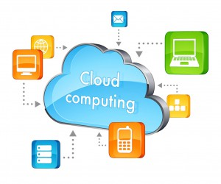

2. Cloud Storage and Comparison between two online storage providers
Cloud storage is an online file storage device where data is managed, maintained, stored and backed up remotely in multiple servers spread across several locations as opposed to saving it on your own hard drive. You are able to retrieve anything you have saved or backed up such as photos, music, documents, videos which you can access from any of your devices anywhere via the internet. These are owned, provided and managed by hosting companies. I have chosen two online storage providers to compare and contrast them are I cloud and One Drive I will be looking and their features and differences.
2.1 I Cloud: Its features and how it can improve efficiency in the workplace
I cloud is a cloud storage and cloud computing software designed and managed by Apple. It is usually pre-installed into every apple product which allows synchronisation of all your data from one apple device to another. These include details such as your contacts, merging calendars and even notes and to do lists. This will be beneficial in the workplace as it would limit time transferring information over, finding details, not lose information regarding business associates, tasks you have to complete, notifications and arrangements for meetings. Any document/presentation you have been working on your phone can be visible instantly in another device simultaneously.
I Cloud offers up to 5 GB of free storage for users and unlimited storage capacity after that if you wish to continue the service at a monthly payment plan. Very easy to keep up with latest software updates as they are continually working on upgrading their software giving you access to the latest features.(Apple Website 2018) Their service is encrypted which doesn’t allow third parties to gain access to the system providing high security and protection to all data.
I Cloud securely store your photos, videos, documents, music, apps, and more and keep them updated across all your devices. It lets you easily share photos, calendars, locations, and more with friends and family. You can even use I Cloud to help you find your device if you lose it. (Imore Website 2018)
2.2 One Drive: its features and how it can improve efficiency in the workplace
One Drive is a cloud storage service hosted and provided by Microsoft which is available to anyone who holds a Microsoft account. Its purpose like the other cloud storage providers is to share, store and exchange information online. It has up to 15 GB storage for free and the advantage of working closely with Microsoft which is a huge advantage for work support. It is intended and tailored to suit both personal and business needs.
One drive for personal use is linked to the Windows software that phones, tablets and computer software can be running on, where it is pre installed and is available as the default option for saving pictures, documents and data saving space on device storage.(Digital Trends Website 2018) Often things can go wrong with devices which cause them to lose important data, or freeze and lose the ability to start up that is where One Drive would come in as a means for back up online and retrieving everything related to and within to your Microsoft account.
One Drive for business use combined with Office 365 software makes it the ultimate product that every office needs to improve their efficiency as it is the comprehensive data management system that holds it altogether. One Drive allows employees to share documents view and modify back and forth between client and host. It gives individuals the ability to track projects and receive feedback, enhancing collaboration online making transition easy. Also allows data to be secured through exchange and retrieval giving peace of mind to privacy and confidential information.
2.3 Comparison and discussion between me cloud and One Drive
Table of Comparison
Storage Device | I Cloud | One Drive
Pro’s | 5GB of storage free | 15 GB of storage free
 | Personal features down to text messages app, photos | Close collaboration with Microsoft Office for work support
 | Unlimited storage capacity | Free and enabled alongside Microsoft account
Cons | Accessibility issues | More benefit for business than personal use
 | Only compatible with IOS | External sharing available
 | Pay monthly to continue using software | No 1 target for hackers around the world

3. Conclusion and Recommendation
After looking at the specifications for both products I have come to the conclusion that One Drive is the more practical software and suitable cloud storage for the workplace. I would recommend one drive as it has more storage available and its availability is widespread and can be even used united alongside IOS technology, this is not vice versa for I Cloud which is not compatible with Microsoft. Although both software have reserved the right to scan files and search for copyright infringement, I cloud has higher restrictions when it comes to their security and third party which reduces the access to modify and share external files significantly, this would be insufficient to the workplace.
Overall one drive has aimed their Office package to entwine and boost their software, offering even more storage and capacity when used together, allowing businesses maximum productivity when it comes to completing and competing with work related tasks to run their organisation effectively.

4. Exploring Social Media as a tool for marketing
Social media has become an increasingly popular new communication tool for businesses big and small to make their mark and target their marketers. They are able to preserve their unique positioning by providing an impactful, visual content reinforcing their store or brand as opposed to traditional methods of advertisement before. It is especially advantageous for that start up business or small business that is able to cut down costs and spread awareness through impact on followers. There are a lot of PR events that take place which have proven a huge success whether it has been food or beauty or new collections on furniture. There are many social media influencers that have large followings who companies now approach to review and promote their product which has been reaching the target audience most effectively as people believe and trust those opinions of those who they look up to
4.1 How organisations communicate via technology/social media
Companies, brands and organisations are using social media to communicate to customers by using promotion codes, attractive pictures and events to promote their products and services on social media by appealing to the largest platform currently where most people engage and are influenced to shop. They have an online assistance which is a fast effective way to answer any queries and also live chat to help you decide if you are unsure as though you are virtual shopping just as you would in the store. Rather than browse in store new and latest products is brought to your attention in release order and notification and regular updates. The most common ones used are Facebook and Instagram below are some examples of marketing on social media.
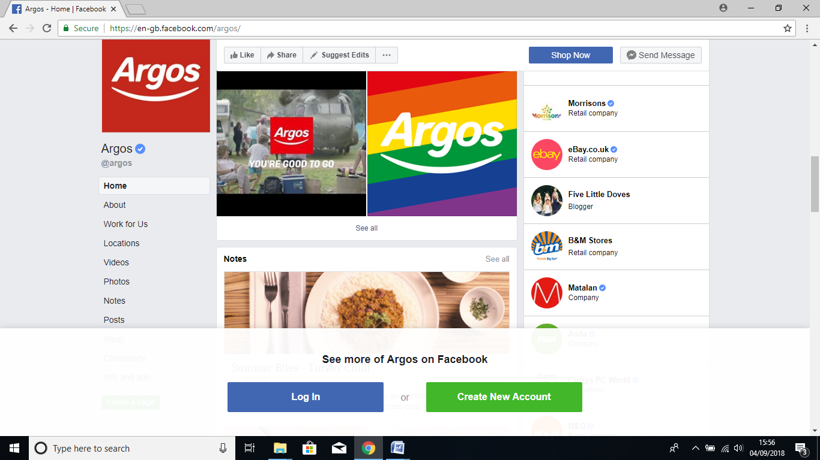

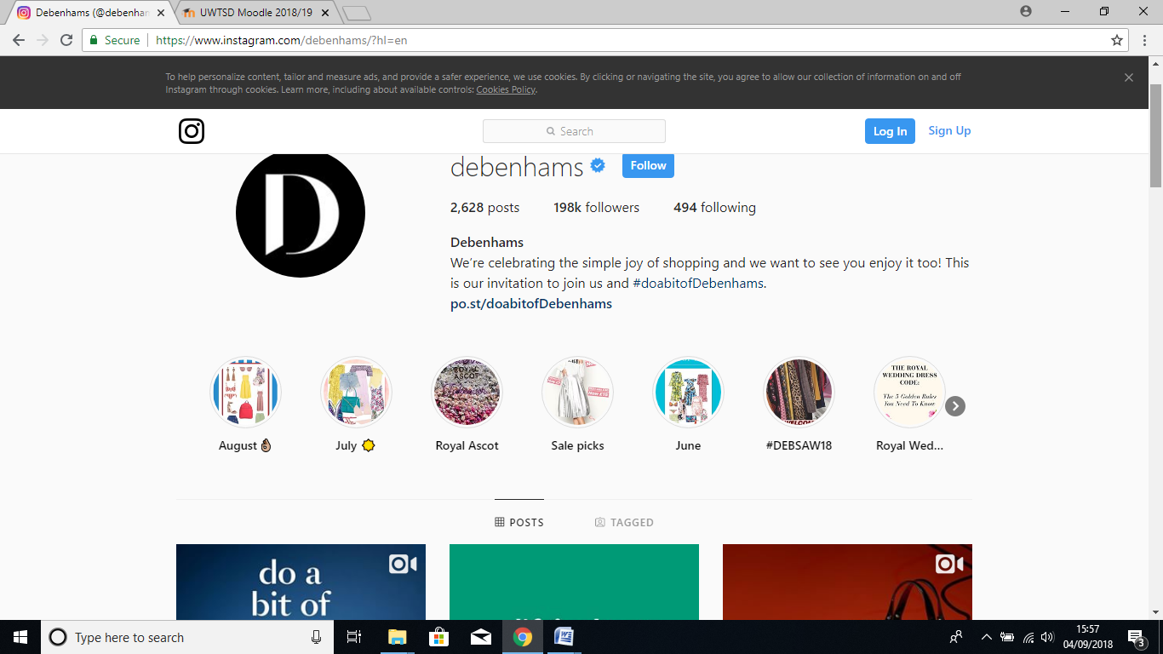

4.2 My online Professional Presence
https://www.linkedin.com/in/alifjan-bibi-306a2216a/

5. References
Microsoft One Drive Website (2018) Available at https://onedrive.live.com/about/en-gb/ (Last accessed Monday 3rd September 2018)
Imore Website (2018) I cloud the ultimate guide Available at https://www.imore.com/icloud (Last acsessed Monday 3rd September 2018)
Apple Website (2018) Icloud Available at https://www.apple.com/uk/icloud/ Last acsessed (Sunday 2nd September 2018)

.

