Using one of the establishments visited examine the strengths and weaknesses of their collection rationale.
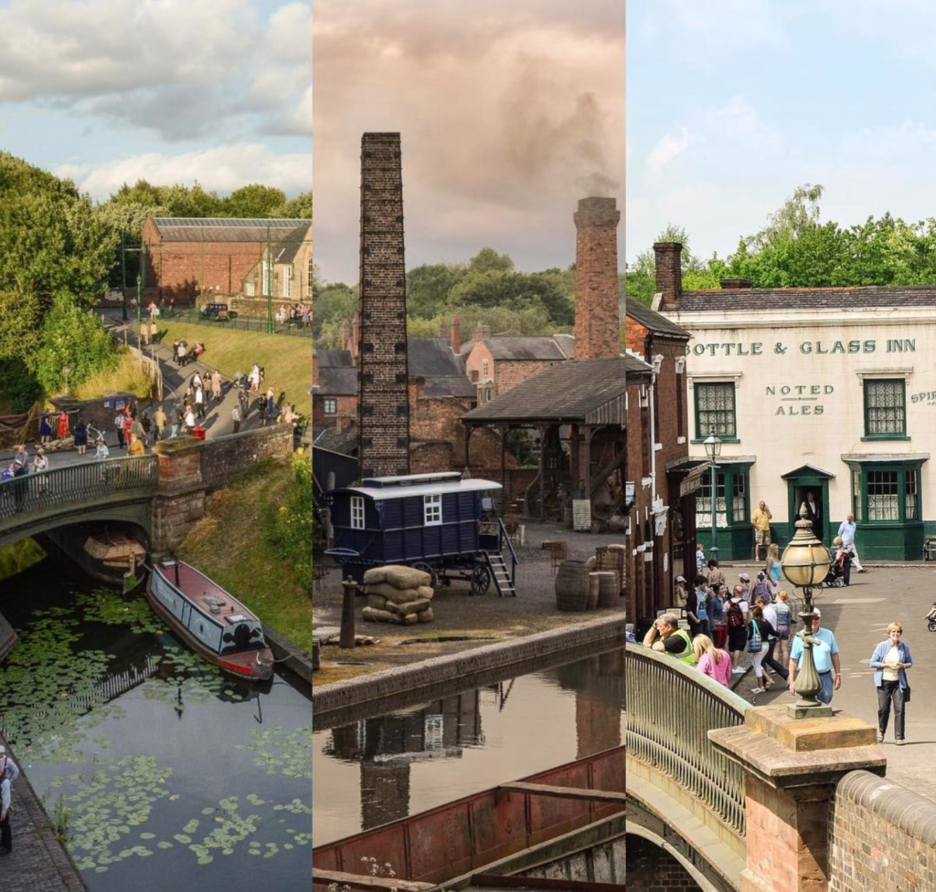
Image One: Black Country Living Museum (BCLM, 2021)
Student number: 1804649
Word Count: 2,000
Module code: HPHE6008
Date: 25/09/2021

Contents
Introduction 2
Strengths of their collection 3
Weaknesses of their collection 5
Discussion 6
Conclusion 7
Bibliography 8

Introduction
This report will be discussing the strengths and weaknesses of the collections that are held at the Black Country Living Museum. It will go into detail about how these strengths and weaknesses affect the overall use and outlook of the museum. The Black Country Living Museum is a dedicated place of 26 acres of land which holds a collection from 20 towns within Wolverhampton, Sandwell, Dudley and Walsall creating a sense of community throughout the museum. The museum had been created in the late 1960s after the last mine closed down in 1968.
When researching into the Black Country Living Museum, it is clear to see that their aim from creating this is to show to the public that the Black Country changed the world regarding industry. The museum’s rationale is to collect all elements of buildings and artifacts from the associated area and period in question so that an authentic representation of this as a realistic townscape can be experienced by visitors in an interactive and immersive manner. This is enhanced by there being real people engaging in real tasks using original items on show to the public.
In total, the museum holds roughly 80,000 items in the collections. The official website states that ‘Each house, shop and workshop has been filled with collections, from sad irons to nails, that would have been seen in situ from the 1800s to 1940s’. This suggests that the museum has thought strongly about how they present and showcase the collection that they have contained. It is clear that when looking into the houses, they have put items that they have managed to gain and been given by the public and put them inside the houses to make it become a realistic experience to feel like the original owners recently left it.

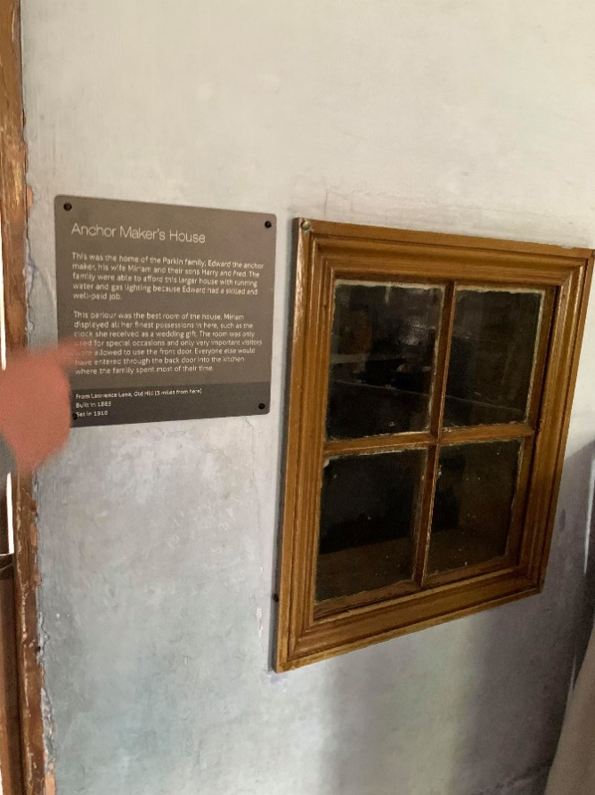
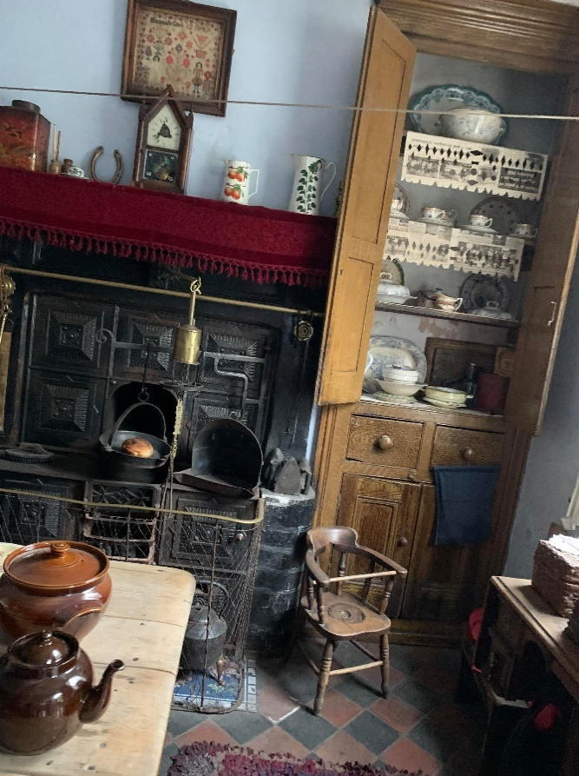
Strengths of their collection
In the Black Country Living Museum, there is a wide collection of various items which include houses that have been removed brick by brick and placed in the museum to be restored and viewed in their original state. Within these homes, there are items that were used at the original time which creates a sense of authenticity in the home. When looking around the inside of these houses, they all had signs with writing on them which informed people who used to live in these homes and in-depth information on their personal life. For example, in the home of the anchor makers, it mentioned about the life that the couple had and that they were a wealthier family because they had the use of electric in their home. This means that people who go and view the museum can feel like they are living the same life and gaining a personal connection to those who had previously lived in these homes.
In the museum, people can walk down the streets that have been recreated to revisit what a town would have been like in this period and people can go inside the shops and buy items. One of the most incredible parts of this museum is that they have a barber shop for people to go into, the added advantage of this is that people can go and get their hair cut on the day if they wished. This is done with all the authentic items and tools that were used at the time, meaning that people can truly experience life and not just view it from a shop window with mannequins pretending to do the work. The museum also contains working animals that would have been seen in gardens and yards such as chickens, pigs, and horses that would have been pulling carts around the villages. These animals are still present here meaning that it adds to the atmosphere of the sights, smells and sounds of this town.
Another strength for the museum is the gift shop, this is because when a purchase is made it is put towards the funds for expanding the education section to grow even bigger than it already is. It suggests that again the museum creators have thought of helpful ways to increase and expand the best they can with the resources at hand. In relation to the educational side of the museum, they are currently expanding the shops and creating a new area for people to be able to go and explore. This suggests that the museum has plans to further expand in general and the idea of educating people is a top priority for them.
One of the key elements of the museum that is noticeable when walking around, is the canal that has been kept going with the barge boats here. The canal is one of the main features at the museum because it has been shown in various television shows such as the popular Peaky Blinders. The creators of the museum have clearly thought about the position of this canal because it has been a main element of the town being built around to create the sense of a town atmosphere.

Weaknesses of their collection
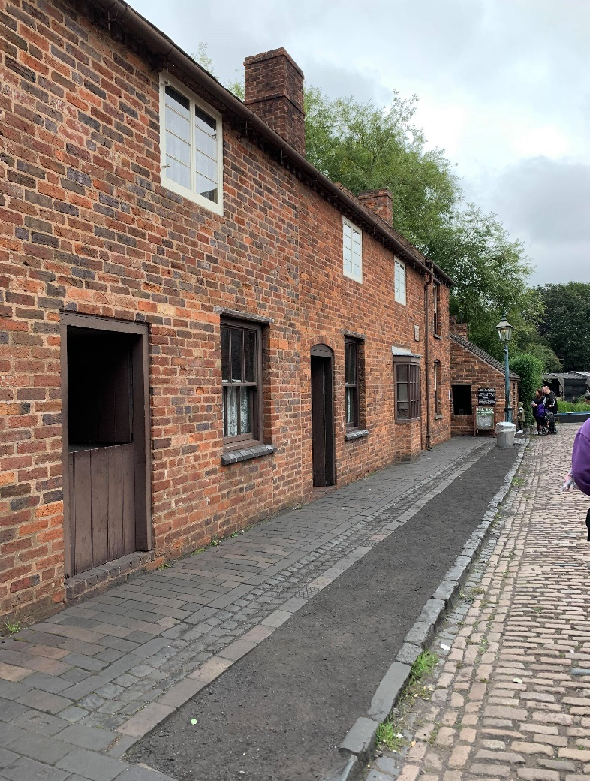
One of the main potential weaknesses from the Black Country Living Museum is by moving the houses from their original place into a new area could get rid of the authenticity. This means that the location of the houses that have been moved, are not in the correct places which could make people think that they were always in that position and not where they were moved from.
Whilst the audience may be tricked a little, the museum has done a good job of maintaining a similarity in the look of the buildings, for instance the materials used to build them are not changing in colour of brick and type of roofing available locally because they were all sourced from a similar area where the same materials would be available. The fact that the museum sourced everything from a small area and focussed on a specific time period avoided too much of a problem occurring with authenticity. One issue with the collection could be that there were quite a lot of changes in the 140 years that the museum covers and there is not a specific definition showing how things changed over time, although the information in each building explains which period that building or room is representing, so the museum has tried to address this.

Discussion
When comparing the Black Country Living Museum to other places like the Jorvik Museum, it is evident that the Black Country Living Museum has engaged further in their research of how to get the public involved in an immersive way, rather than an educational way. The Jorvik Museum uses pumped in smells and recorded sounds of what people would experience in the town in the period it focusses on, with people in costume demonstrating the use of tools, whereas, the Black Country Living Museum has actors and real animals that are present and just going about their normal daily tasks in situ, to give the realistic experience for people who were not around at this historical period to remember it. The Jorvik museum feels much more educational in the way that they deliver information on the history of their time period, however, the Black Country Living Museum shows that the creators have figured out exactly how people remember information by being able to join in with what life would have been like for them in a realistic way. As a result, from the different ways that both museums work, the Jorvik museum presents their historical artifacts inside class cabinets meaning that as a visitor, people can only look at the items at a distance. However, the Black Country Living Museum put forward their artifacts inside the houses and shops without having to view through glass. This implies that both museums have seen that people interact better in the period when having the items in front of them, despite that, the Black Country Living Museum has taken this a step further to engage with the public by understanding that not having glass around the artifacts makes the experiences more realistic and exciting.
Furthermore, when discussing the reason behind the rationale ideas of the museum, it is evident that they have thought about how to keep in touch with the community. This is mentioned in Elizabeth Crooke’s article where she says that ‘if a local museum is not connected with its community the rationale for the museum may come into question’. The information about the individuals who lived in the actual houses helps to keep the community connection in place as does the fact that the museum itself is in the middle of the area in Britain that it represents. This means that local people can easily visit it and see elements of the places they live now shown in the buildings there as well as information about the cultural history of their families.

Conclusion
In conclusion, after researching and visiting the Black Country Living Museum it is clear to see that it has been thoroughly thought about the best ways to get the public engaged and excited at the thought of visiting this museum. When comparing the Black Country Living Museum to places such as the Jorvik museum, it is evident that they have different approaches to involve the public with the history in their periods, however the Black Country Living Museum has taken this a step further than any others in regard to having actors and the real sights, sounds and smells immersing the public. Researching in-depth into the Black Country Living Museum has ignited the interest to visit again to take in even more of an appreciation for the work that they have done evolving around the collection rationale that is present here and how they have kept the heritage and history in this town. Looking at this report, there is evidence that the Black Country Living Museum has far more strengths than it does weaknesses in how they hold the collections and engage the public interest. Overall, the Black Country Living Museum has a strong collection of rationale and is very appealing to make anyone go and visit this fascinating museum.

Bibliography
Crooke, Elizabeth, ‘The Politics of Community Heritage: motivations, authority and control’, International Journal of Heritage Studies, 16.1 (2010) 16-29 <DOI: 10.1080/13527250903441705>
Falk, John, H., and Lynn D. Dierking, Learning from Museums, (Rowman & Littlefield, 2000), p. 199 - 201
Jorvik Viking Centre, Welcome to Jorvik (2021) <https://www.jorvikvikingcentre.co.uk/> [accessed 1 October 2021]
Peaky Blinders. 1. BBC. (2013)
Slingsby, Leila, Own Photograph, 31 August 2021
The Black Country Living Museum, Discover Our Story: About Us (2021) <https://bclm.com/about/> [accessed: 27 September 2021]
The Black Country Living Museum, Our Collections (2021) <https://bclm.com/collections/> [accessed 28 September 2021]
The Black Country Living Museum, Photograph, [accessed 2 October 2021]

The Black Country Living Museum, Discover Our Story: About Us (2021) <https://bclm.com/about/> [accessed: 27 September 2021]
The Black Country Living Museum, Our Collections (2021) <https://bclm.com/collections/> [accessed 28 September 2021]
Leila Slingsby, Own Photograph, 31 August 2021
Leila Slingsby, Own Photograph, 31 August 2021
Peaky Blinders. 1. BBC. (2013)
Leila Slingsby, Own Photograph, 31 August 2021
Jorvik Viking Centre, Welcome to Jorvik (2021) < https://www.jorvikvikingcentre.co.uk/> [accessed 1 October 2021]
John H. Falk, and Lynn D. Dierking, Learning from Museums, (Rowman & Littlefield, 2000), p. 199 - 201
John H. Falk, and Lynn D. Dierking, Learning from Museums, (Rowman & Littlefield, 2000), p. 199 - 201
Elizabeth Crooke, ‘The Politics of Community Heritage: motivations, authority and control’, International Journal of Heritage Studies, 16.1 (2010) 16-29 <DOI: 10.1080/13527250903441705>
Elizabeth Crooke, ‘The Politics of Community Heritage: motivations, authority and control’, International Journal of Heritage Studies, 16.1 (2010) 16-29 <DOI: 10.1080/13527250903441705>

