Application Development

  - Name: Sarann Strange

Student Number: 1701763

University of wales Trinity saint David

Stream: B.Sc. Software engineering

Assignment code: ACCA5012

Lecturer: Kemi Ademoye

Table of Contents
1 Table of Contents 1
2 Table of figures 2
3 Introduction 3
4 Application development concepts 4
4.1 Purpose & intended audience 4
4.2 Design constraints 4
4.3 Specific requirements 4
4.4 Future developments 5
4.5 Security vulnerabilities in web applications 6
4.5.1 SQL injection 6
4.5.2 Cross-site scripting (XSS) 7
4.6 Object pool pattern 8
5 Design 9
6 Implementation 10
6.1 Entities 10
6.2 Enums 12
6.3 Database 13
6.4 Repos 15
6.5 Controllers 17
6.6 Views 19
6.7 Web pages 20
6.7.1 Welcome /Home page 20
6.7.2 Login page 20
6.7.3 Registration page 21
6.7.4 Events page 23
6.8 Specifically clicked events 24
6.8.1 Purchase ticket page 25
7 Evaluation 27
8 Conclusion 28
9 References 29

Table of figures
Figure 1 entity relationship diagram (ERD) 9
Figure 2 Entities: the ApplicationUser and Booking Entities 10
Figure 3 Entities: the Bookingticket and events Entities 11
Figure 4 Entities: the Eventtime and Tickettype Entities 11
Figure 5 Enums: the ageRating, BookingStatus and TicketStatus Enums 12
Figure 7 the EventTimes table 13
Figure 6 the TycketType table 13
Figure 8 the Event table 13
Figure 10 the bookingticket table 14
Figure 9 the booking table 14
Figure 11 the baseRepo 15
Figure 12 the eventsRepo 16
Figure 13 the bookingRepo 16
Figure 14 the Booking Controller 17
Figure 16 the events and event times controler 18
Figure 15 the home controler 18
Figure 17 the views for the bookings, events, eventtimes and the home 19
Figure 18 Index page / home page of website 20
Figure 19 login page 20
Figure 20 Register page of website 21
Figure 21 Incorrect completed fields of register page 22
Figure 22 events page of the website 23
Figure 23 notification box to redirect the user to purchase a ticket as a guest of as a registered user of the website 24
Figure 24 specifically clicked events page of the website 24
Figure 25 booking page 25
Figure 26 failed attempt at purchasing tickets 26

Introduction
This report discusses the design and creation of the application for the imagination pet shop company and the purpose of the application its target market and the design constraints the specific requirements that the application must have and the future developments of the application to improve its overall functionality and usability.
Numerous security threats are discussed these include SQL injection and XSS cross sight scripting along with a software design pattern known as object pool pattern.
Images of the code along with the working website displaying its functionality and design. A follow-up evaluation and testing was conducted to discover strengths and flaws of the web application.

Application development concepts

Purpose & intended audience
Due to the increased popularity that imagination pet shop received after the creation and distribution of their pet shop website, they wished to extend their branding and business to an activity park who’s target audience are families and individuals who have a love for animals. Imagination pet shop requires a website that connects to a database that allowes users to register with a username and password which is used to log into the website where they were able to view the activities and purchase available tickets.

Design constraints
The design of the website must be simple with intuitive navigation that follows conventional designs, all pages on the website must use the same style and design to remain consistent. This includes the navigation bar, the background colour of pages, the shape and size of buttons, size and font of text, the size and the way in which navigation text alters if a cursor hovers over it, the way in which all events are presented to the user.
The website must be welcoming and friendly to young children and families this involves large hit boxes, links and a recognisable navigation bar. Larger click areas encourage easy use of the website, when individuals feel that they can navigate a website with ease they are more likely to continue to use the website or return to it, therefor the websites must be child friendly and designed for individuals with poor dexterity.
Each of the events that are available will be displayed within a list with its image and title, once an individual event is clicked the page that is presented must display an individual page of the clicked event along with the age rating, duration, review rating, dates and times, the type of activity that it is, an image and the description of the activity and clear clickable links that allow the user to purchase tickets.

Specific requirements
The website is required to allow users to navigate between the many events that imagination pet shop offer. The website must allow users to purchase tickets, register and log into the website. If a user attempts to purchase a ticket while they are not logged into the website, a dialog box will encourage the user to log into their own personal account to continue or book a ticket as a guest.
A simple and user-friendly registration page that allows the user to enter their first name, surname, phone number, Email, password, a password checking filed to ensure they have re-entered the password correctly and a registration button. On the registration page a warning must display if the user has failed to complete the first name, surname, Email, or has not entered a password. Further constraints will be presented on the email if it is not a valid Email address. A restriction on the password filed will be implemented were it must be over 5 characters in length but under 100, the field in which the user must re-enter their password must present the user with a warning message if they have failed to re-enter the password correctly.
The login page to provide the user with the option of login in with a google account, their Microsoft account or the E-mail address and password that they entered on the registration page. For a forgotten password link to be present on the login page to allow the user the option of recovering a forgotten password. For the database to have the ability to use CRUD for the data held within the database to be created for new events to be input into the system and for the new events to be displayed and accessible to users, for the data within the database to be read and displayed onto the website, for the data within the database to be freely updated when it needs to be updated such as the availability of tickets and for the data to be delete if it is no longer required

Future developments
Due to the time constraints and date in which the system must be functioning some developments were forecast for future updates. Both the original Imagination pet shop and the Imagination pet shop events websites would be combined so users would freely navigate between both websites. The website would allow users to enter their bank details and choose the method that they wanted to purchase tickets, for instance PayPal or directly with their card. Appropriate advertisements and promotional banners would be created advertising events and other products of the imagination pet shop brand.

Security vulnerabilities in web applications
There are numerous security risks and vulnerabilities that hackers can manipulate to cause harm to a web application.

SQL injection
SQL injections are used on areas of a website that allow a user to input their own information such as login pages. SQL injections can be used to alter, delete or view data that is stored within a database. An attacker achieves this level of access by using the same SQL syntax used to create the database. If the database is not protected from SQL injections, once the SQL injection is entered it is passed to the database and run on the database as an SQL statement, an example of SQL injection is “OR 1=1".
On the login page the data entered such as the user id and the password are checked against the database and programmed to check if a statement is true, 1=1 is always true and will potentially return data on users, such as their passwords and id. This breach of security allows hackers to log into the website as users and cause serious harm.
There are numerous forms of SQL injections such as union, this uses two select statements through the use of the union statement [1]. Error, this form of SQL injection allows the attacker to view the errors that the website throws and presents on webpages after they have attempted an SQL injection, using the different errors the attacker can work-out what is happening on the backend and the effects that they are causing as the different errors mean different things. Blind, this form of SQL injections are queries that do not display a result such as errors, this is more difficult as the attacker is not informed directly if their SQL injection was or wasn’t successful. A response will be given to the input though and using Boolean responses the hacker can create and preform queries that return true or false and continue to input numerous queries until gaining access to the data that they are after [2].
Websites that connect to a database and allow user input can be tested using automated SQL injection tool such as “SQLninja” or “SQLmap”. These tools can reveal errors and automatically attack servers preforming GET, POST and cookie-based SQL injections. They allow access to tables and columns allowing for editing, deleting and accessing of servers [3].
Different SQL languages such as “SQLight”, PHP or .NET require variations on the ways to prevent SQL injections [4]. There are many ways to protect a database from SQL injections they include:
- Parameterised queries which protect the database through the use of parameters which are values that are left unspecified and are labelled “?”[5], the malicious insert is not inserted into the command directly and not run in the backend of the system. When a attacker enters 1=1 along with valid input data the parameterized querie searches tables using the entire string so 1=1 is not executed.
- Validating data checks the values that are being entered to ensure that they are the correct format, type of data and length.
- Hiding error messages makes it difficult for hackers to learn about the architecture of the database as they are unable to distinguish between what they are inputting and if it is having the desired impact.

Cross-site scripting (XSS)
Cross-site scripting (XSS) is a form of injection that attackers use to send malicious scripts, to users of a website without their consent or knowledge [6]. XSS scripting is used to create client-side attacks such as key logging, session stealing or downloading malicious software on to a user’s machine, XSS can gain access to cookies [7] saved by a user’s web-browser allowing the attackers access to a slew of data such as users passwords or account details and personal information [8][9][10].

Three types of XSS are:
Stored XSS (persistent): This type of XSS is saved by a server and when users of the website navigate to the page containing the stored XSS the script is run automatically. This script can gain access to various data of the user such as passwords or bank details. If a website uses a user-based system as most do these scripts can spread across accounts. If the application uses un-sanitised user input the script can save and send what the user inputs to another location to be stored and viewed later by the attacker [9].

Reflected XSS (non-persistent): this form of XSS is usually sent in an email or is found on a webpage of a website and the user is presented with a URL, if clicked the URL will redirect the users browser to a webpage that contains the XSS and the users browser will execute the XSS to steal data or users private information.

Dom-based XSS: Dom XSS can write to a document the attacker owns which logs and steals the user’s cookies from their web-browser witch can be used to steal data or gain access to a user’s account.

To prevent XSS attacks frameworks can be implemented to prevent and escape XSS injections. Sanitising the input of users means converting the string of characters entered to a type of variable which is kept separate from the query or command it is then “binded” to form a prepared statement which only executes the command it was originally intended to execute and does not recognise the command put in by the user [11].
Validating input is another method to protect against XSS as it prevents malicious data from being entered into the database by restricting certain characters such as special characters [12].
Ensuring that sessions are properly destroyed if a user choses to exit or log out of their account or if they have been inactive for a specified period of time will prevent attackers gaining access to a session which is also known as broken authentication.

Object pool pattern
Software design patterns are a preestablished collection of classes and code that have previously been created for reusability. The advantages of using software design patters is that it has been tested and deployed on many previous solutions therefor they have been established as being reliable and fit for purpose [13].
Object pool patterns are created to improve performance, it does this by using pre-established instances of objects rather than creating and destroying them, once an object is created instead of it being destroys it is sent to the pool then once an object has completed it purpose it is returned to the pool to be used again. The object pool pattern is used on complex programs to reduce the work load of creating and destroying object [14].
The object pool pattern would be useful to the Imagination pet shop application as user’s travers the web site as objects are created to load and display events of the business and other data. Rather than making new instances of the objects of the classes they would be kept within the pool reduce the runtime of the application as objects are at hand and do not require re-creating as they are not destroyed [15].
The benefits of using the object pool pattern is the significant increase in the performance of the program. The drawbacks of object pooling is the need to ensure that the state of the object is set to a suitable state for future use of the object, if it is not the object will be in a state that the program was not expecting and errors can occur due to an object behaving in a manner that is unexpected [16].

Design
Figure 1 Shows the entity relationship diagram (ERD) of the website, it is how the tables relate to one another in the database and how data is linked and will be accessible.
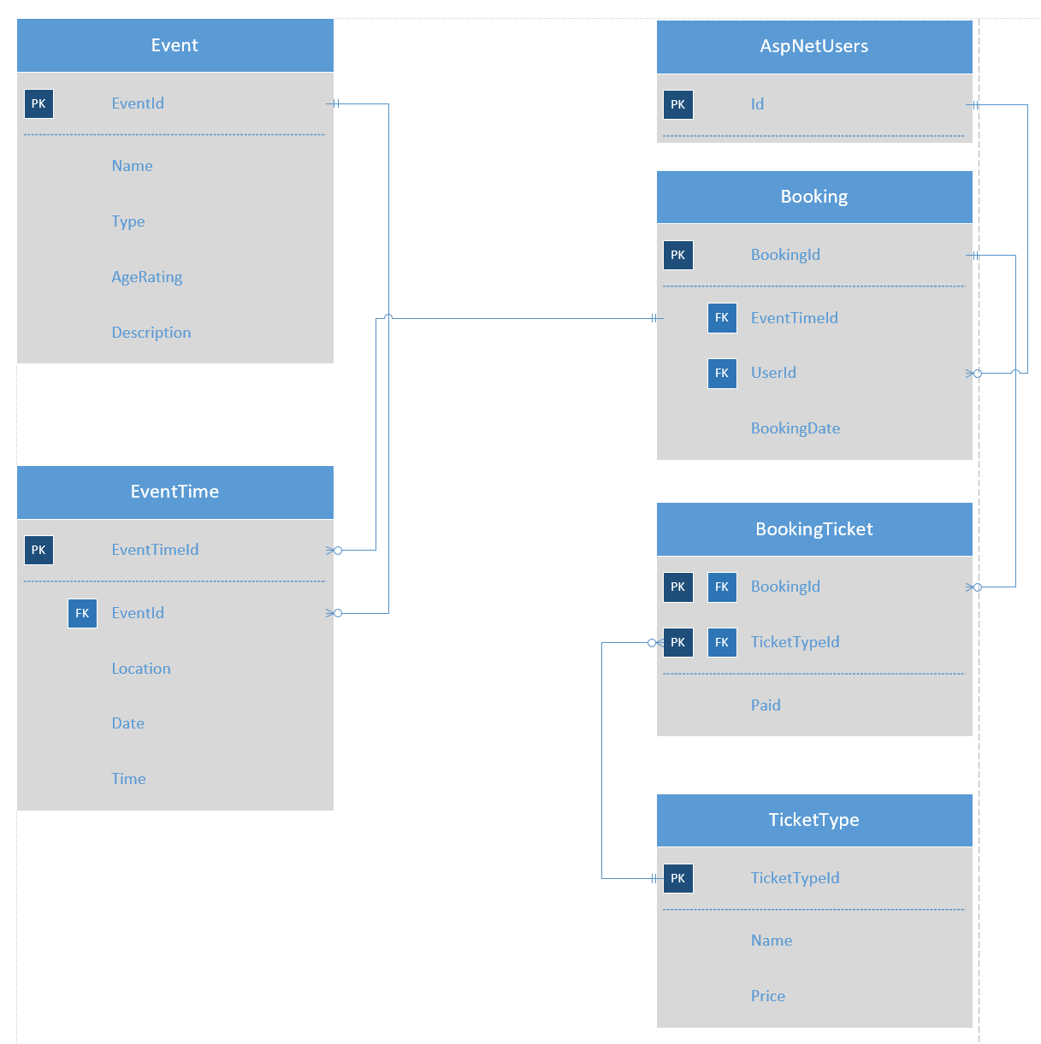
Figure 1 entity relationship diagram (ERD)

Implementation

Entities
A number of entities were used these are the tables in the database the images found in figure 2, 3 and 4 display all of the entities found in the imagionationPetShop.data within the Entities folder.

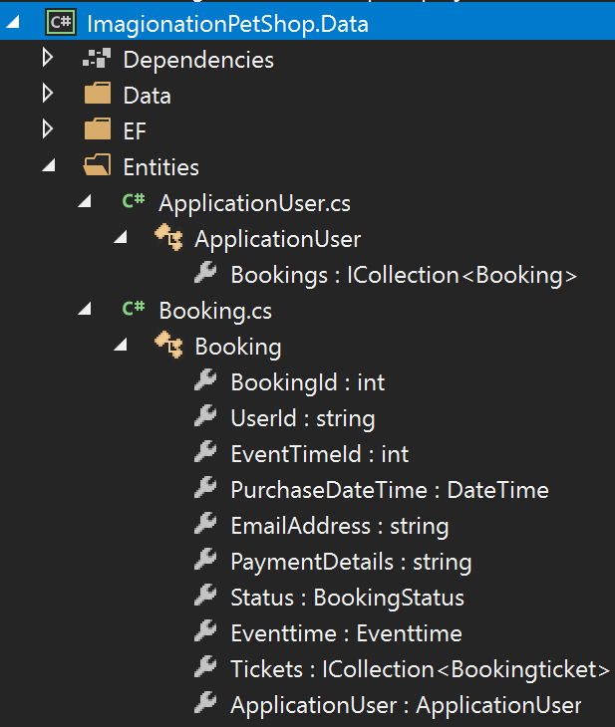
Figure 2 Entities: the ApplicationUser and Booking Entities

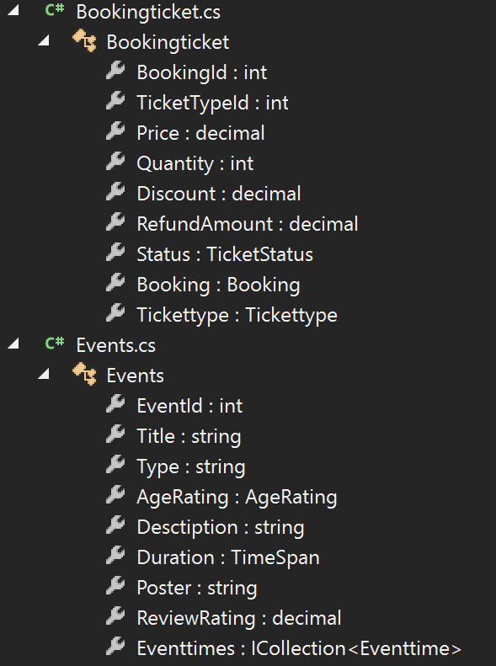
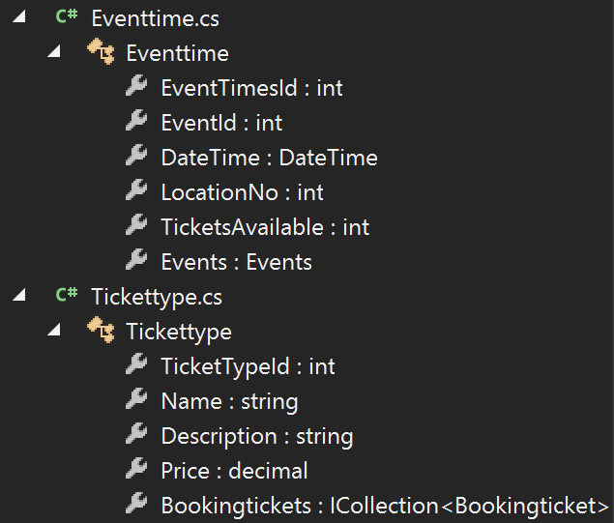
Figure 3 Entities: the Bookingticket and events Entities
Figure 4 Entities: the Eventtime and Tickettype Entities

Enums
The enums are used to display and allow the entry of repeated data the image found within figure 5 Shows the age rating data that holds all the age ratings, the booking status and the ticket status

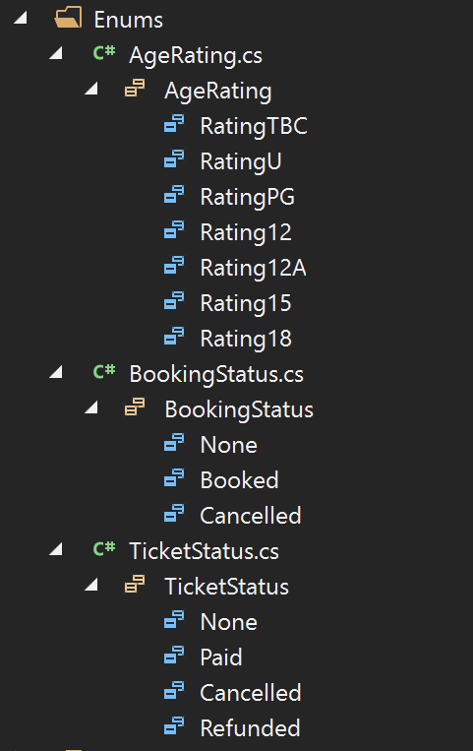
Figure 5 Enums: the ageRating, BookingStatus and TicketStatus Enums

Database
The system was connected to a database that held all of the data to do with events as seen within figure 8, the age ratings of the events as seen in figure 6, the even times that held all of the data of the different times of the events and other data such as number of tickets available and the location of the events as seen within figure ,7 the booking of the tickets and who purchased tickets as seen within figure 9 and the information of the tickets such a their price and other details as seen within figure 10.
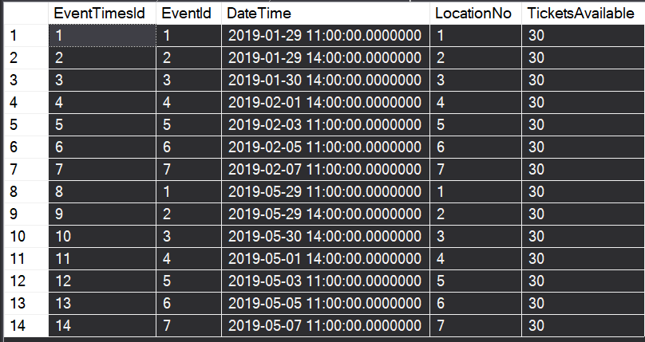
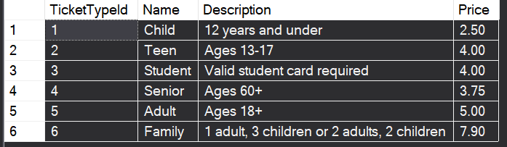
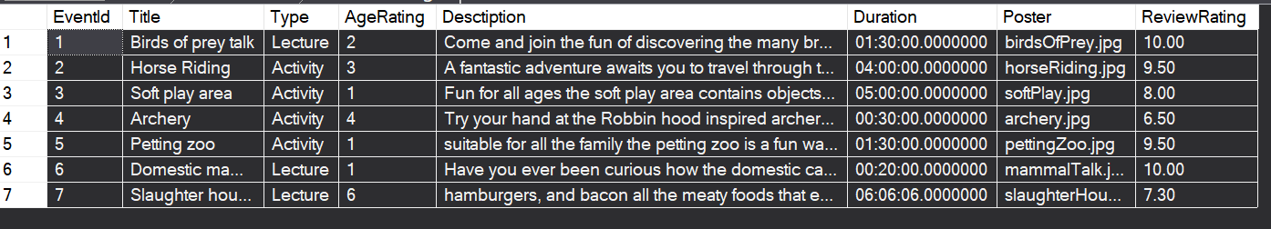
Figure 7 the EventTimes table
Figure 6 the TycketType table
Figure 8 the Event table
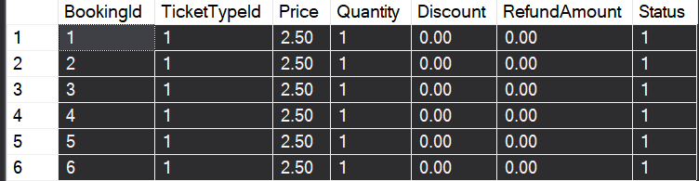
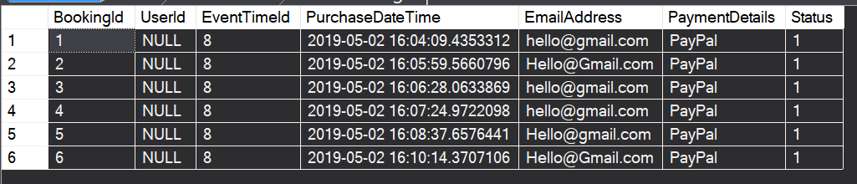
Figure 10 the bookingticket table
Figure 9 the booking table

Repos
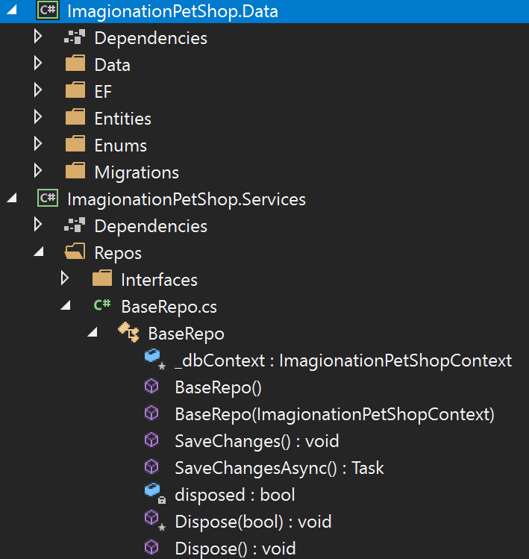
The repos that were implemented can be seen within figure 11, 12, 13 they work alongside the controllers to grab and display data.
Figure 11 the baseRepo

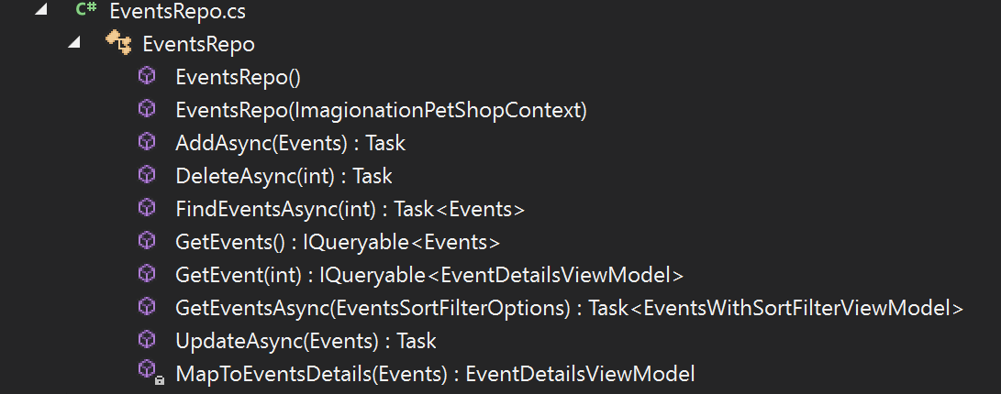
Figure 12 the eventsRepo

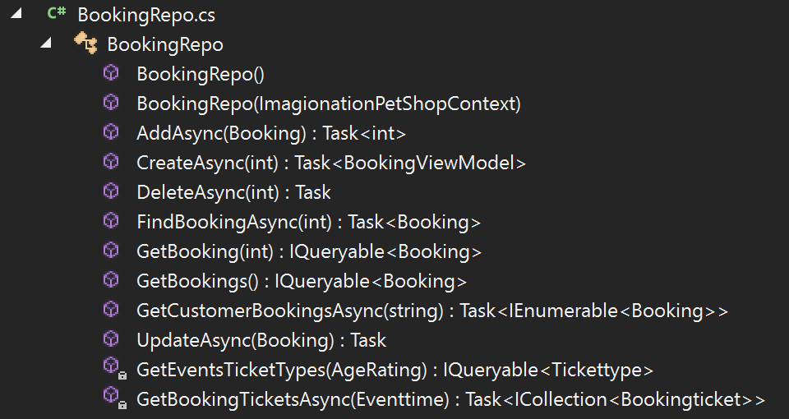
Figure 13 the bookingRepo

Controllers
The controllers allow access to the website under certain conditions, the controllers basically make things happen on the website if the right conditions are met figures 14,15, 16 are the controllers used.
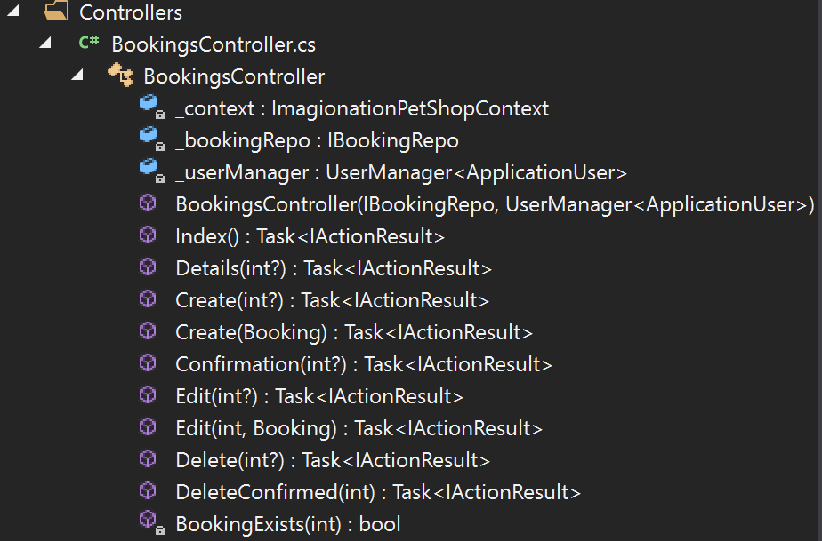
Figure 14 the Booking Controller

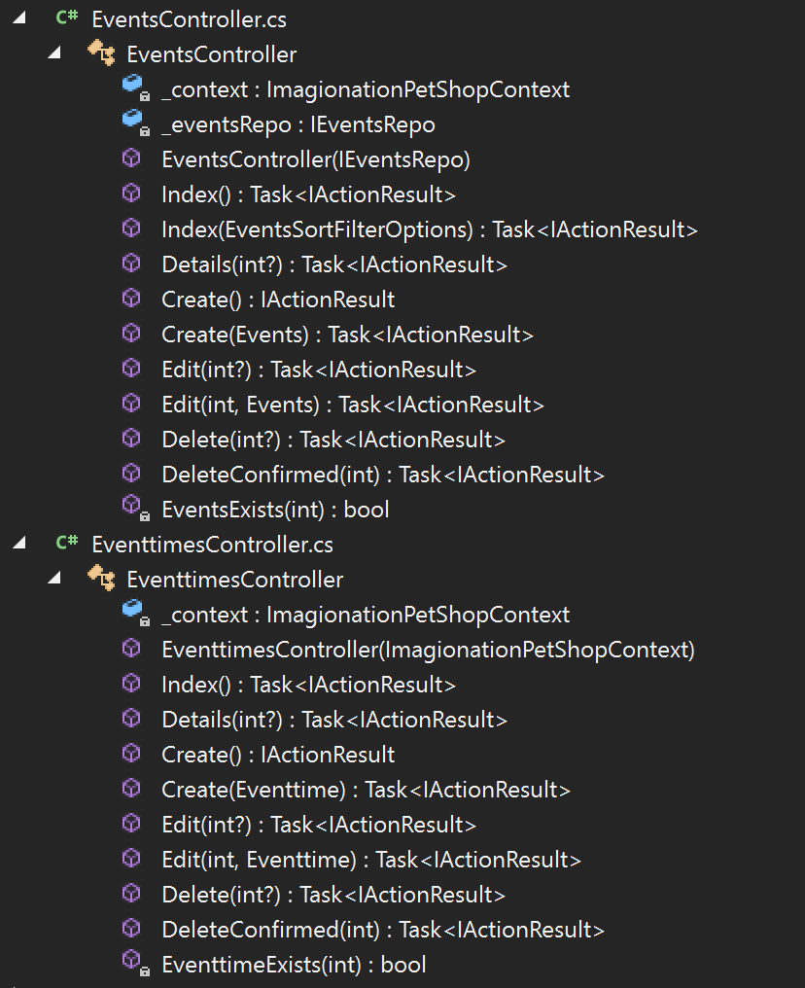
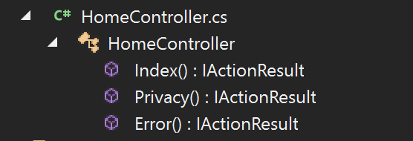
Figure 16 the events and event times controler
Figure 15 the home controler

Views
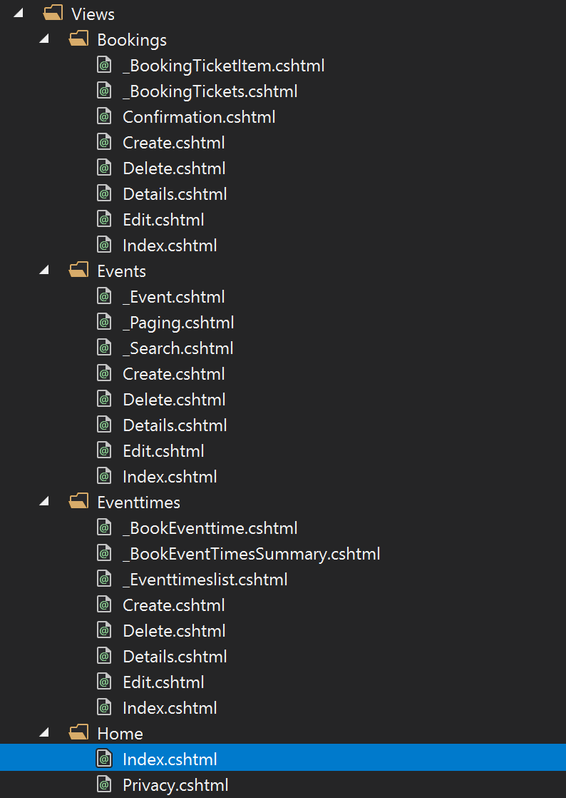
the views control how the website looks to people using it the views that were implemented within the system can be seen within figure 17
Figure 17 the views for the bookings, events, eventtimes and the home

Web pages

Welcome /Home page
The image within figure 18 Shows the index page of the website from this page the user is capable of logging in, registering or navigating to the events pages of the website
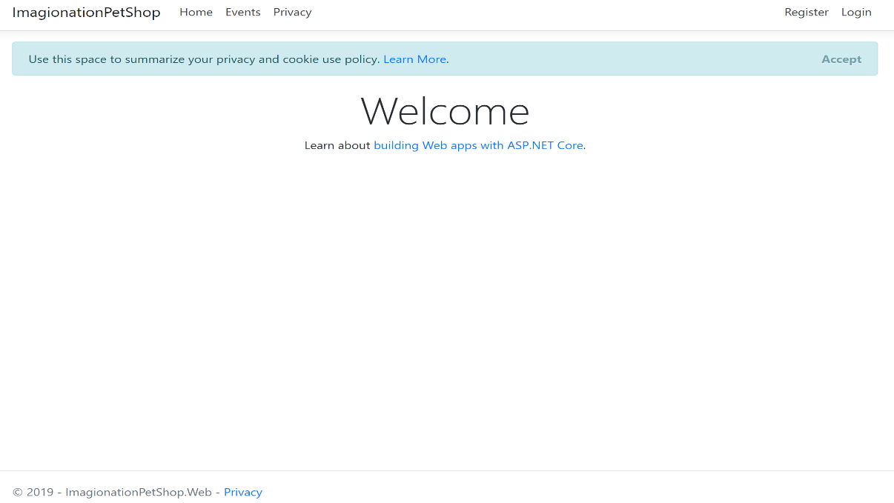
Figure 18 Index page / home page of website

Login page
Figure 19 shows the login page. This page of the website allows the user to enter their email and password to gain access to the website, the user is capable of logging into the website with the Gmail or their Microsoft account from this page of the website.
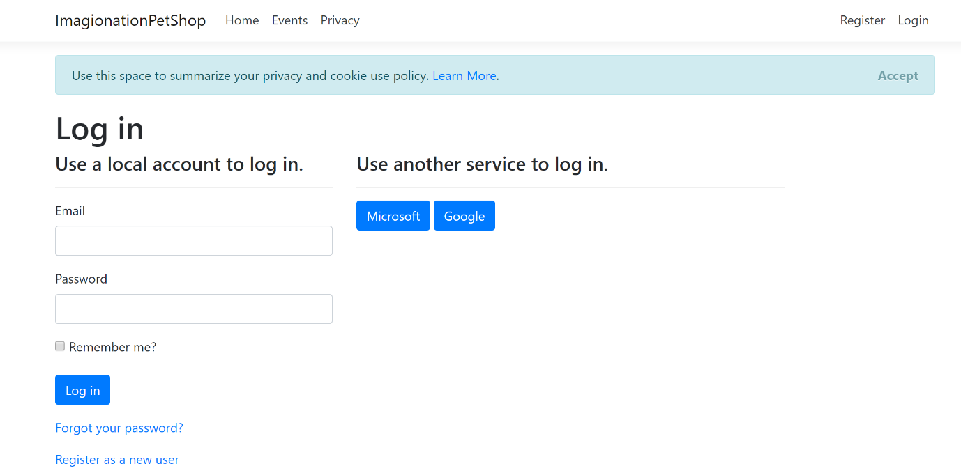
Figure 19 login page

Registration page
The registration page allows the user to enter their details to register to the website so that they can login to the website freely to purchase tickets. Figure 20 shows the registration page successfully filled in.
Figure 21 shows all of the fields with their constraints and the messages that are shown if they are not filled in correctly if the fields are not filled in correctly the user is unable to create a user account.

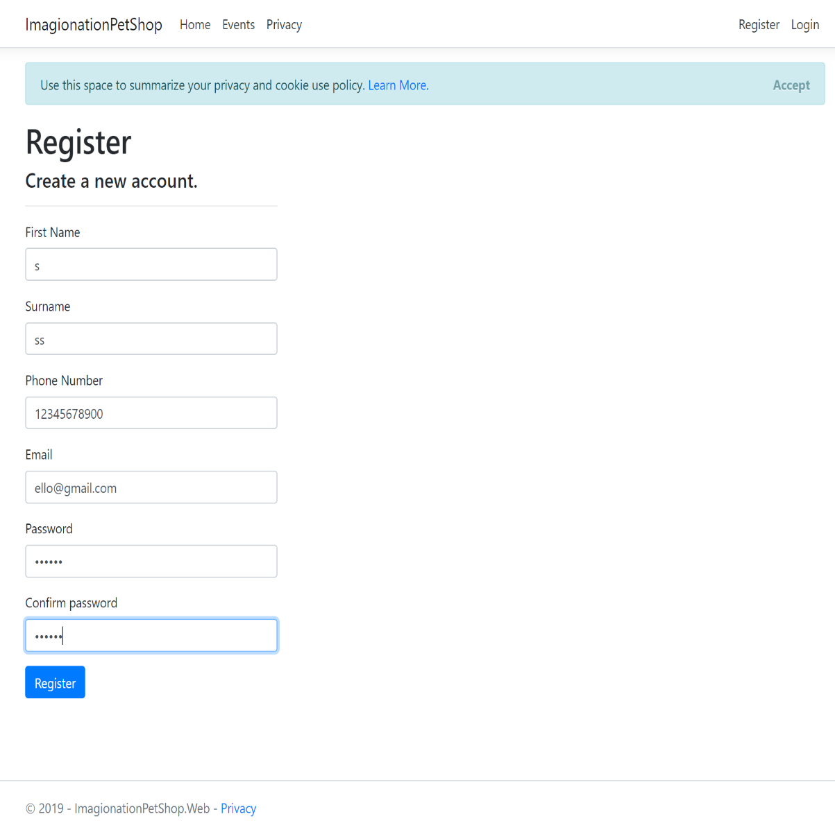
Figure 20 Register page of website

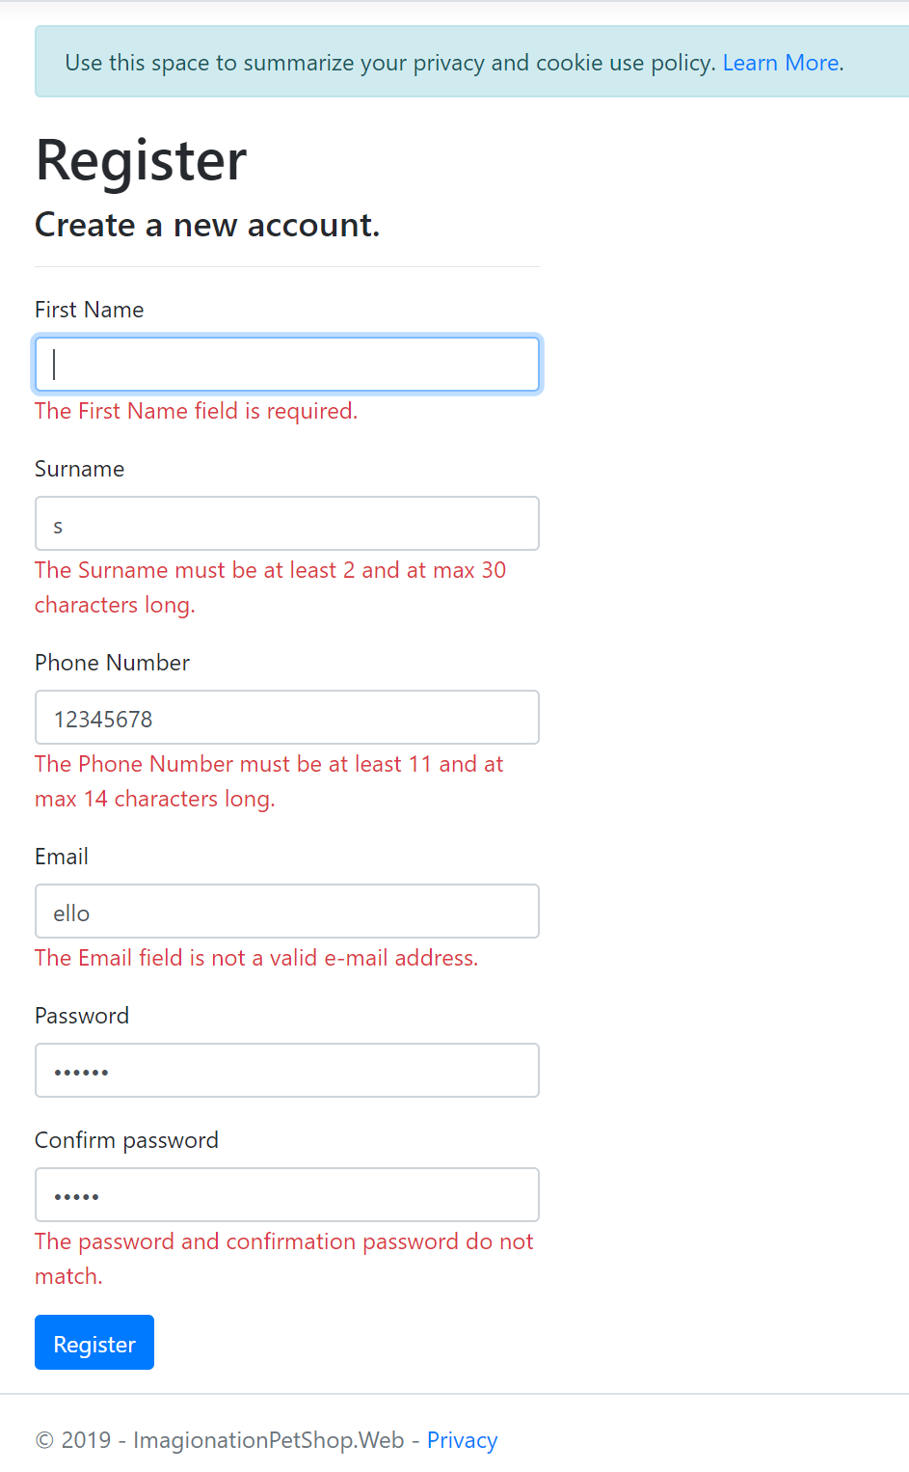
Figure 21 Incorrect completed fields of register page

Events page
The events page displays all the events that the website has to offer each of the events when clicked redirects the user to a full page on the details of the event and a link to purchase tickets to the event. There are filter systems on this page that allow the user to filter to specific events or to filter certain queries the user can also choose how many events that they wish to display on one page at any time.
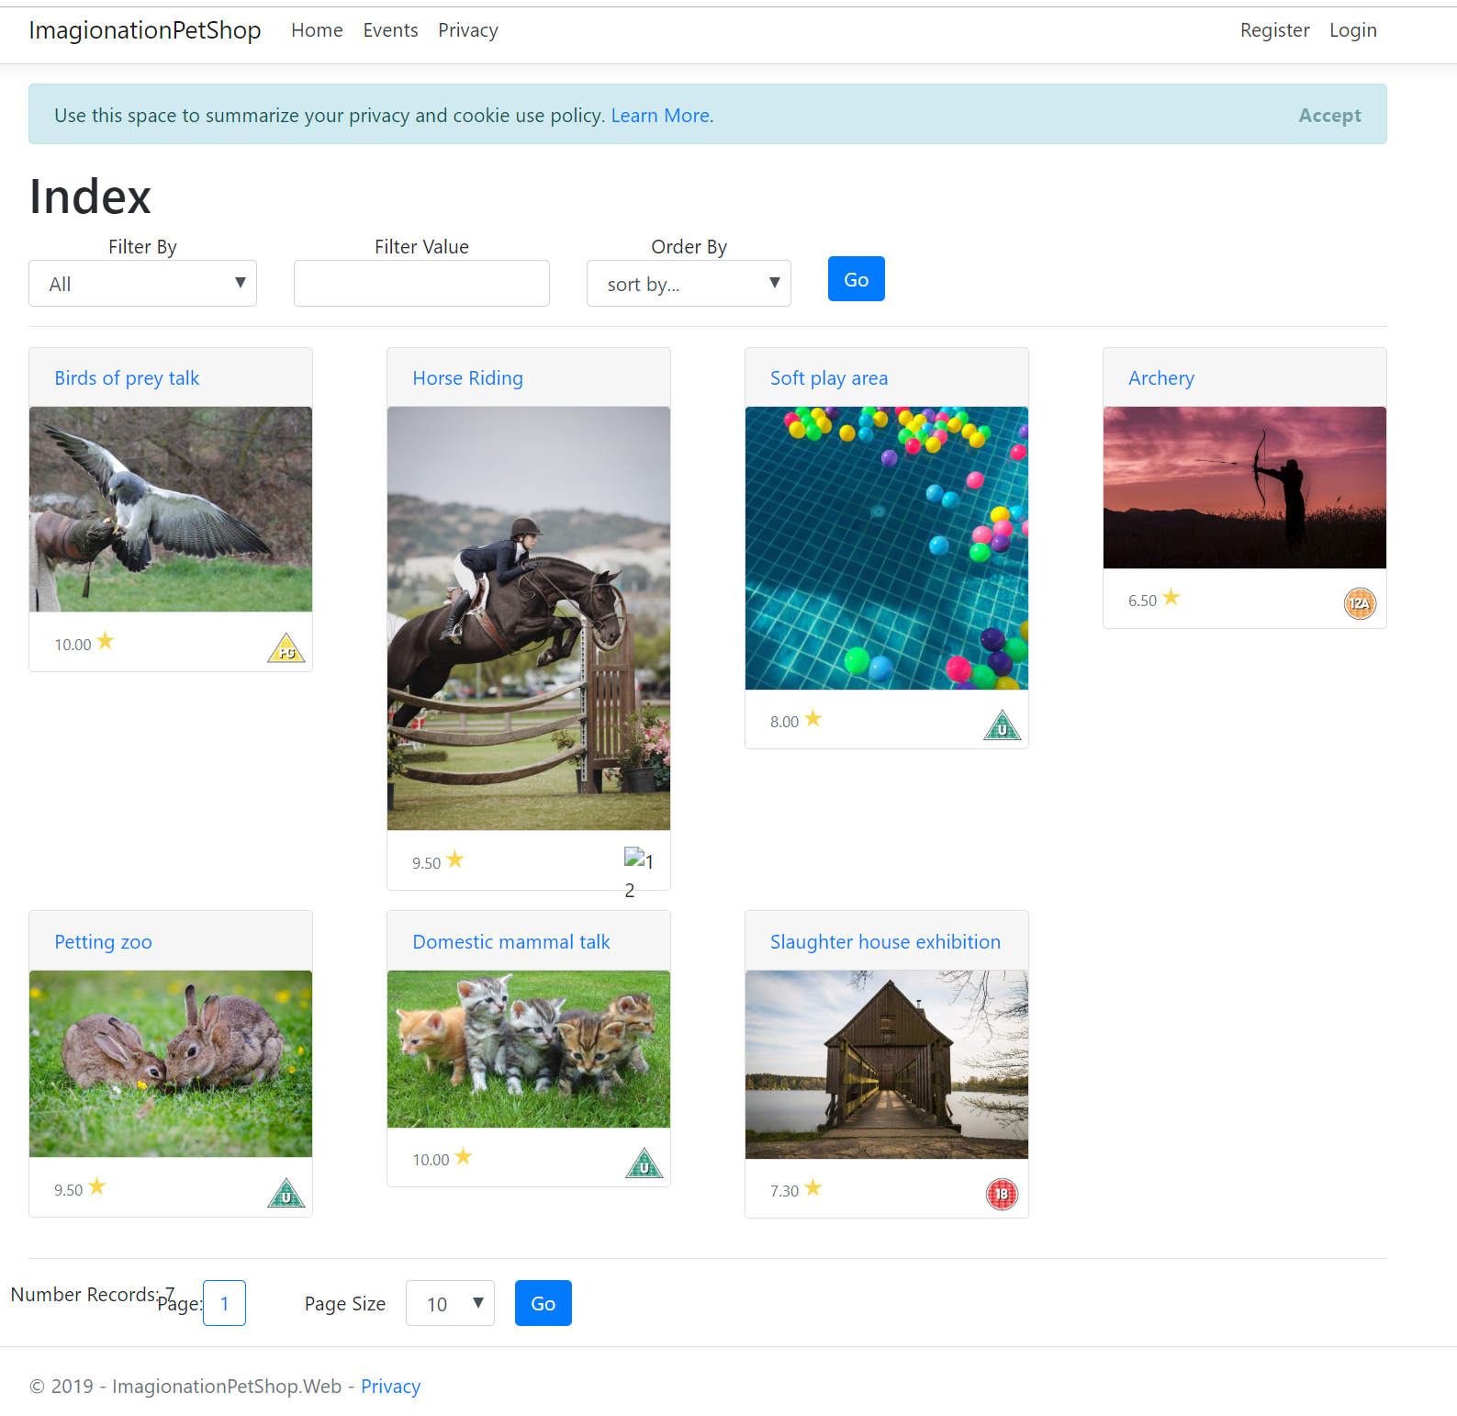
Figure 22 events page of the website

Specifically clicked events
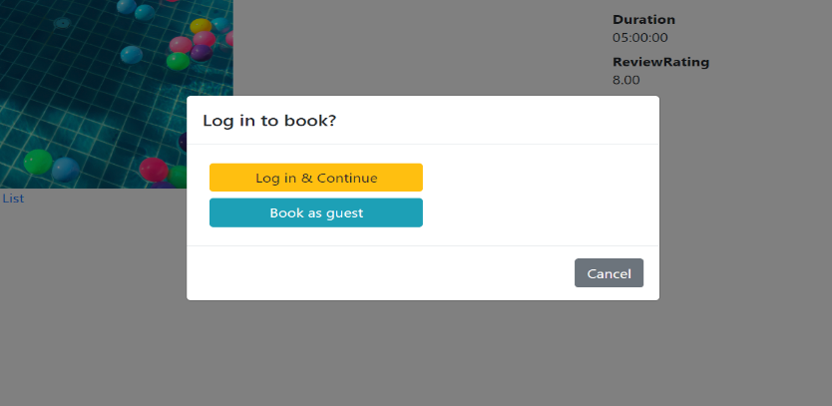
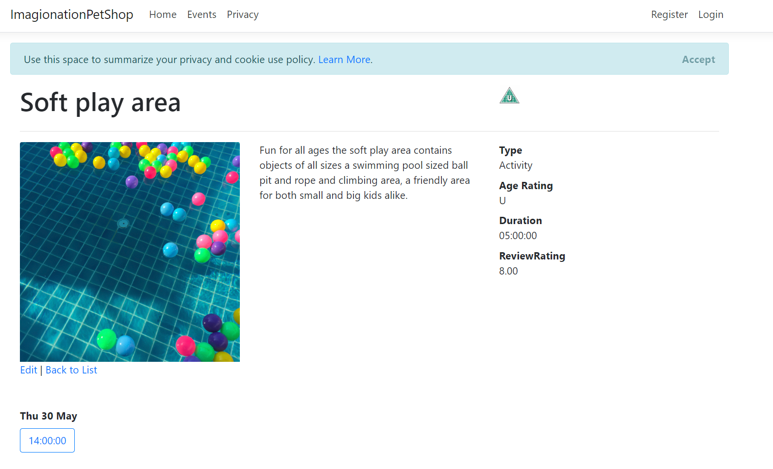
When a specific event is clicked the image in figure 24 Is displayed, on this page of the website the user can view details to with the specific event. If the user clicks on the date and time of the event of displayed under the image of the event a information box ill appear requesting the user to log in or purchase a ticket as a guest as shows in figure 23 the user after they click one of the option will be redirect to a purchasing ticket page of the website.
Figure 23 notification box to redirect the user to purchase a ticket as a guest of as a registered user of the website
Figure 24 specifically clicked events page of the website

Purchase ticket page
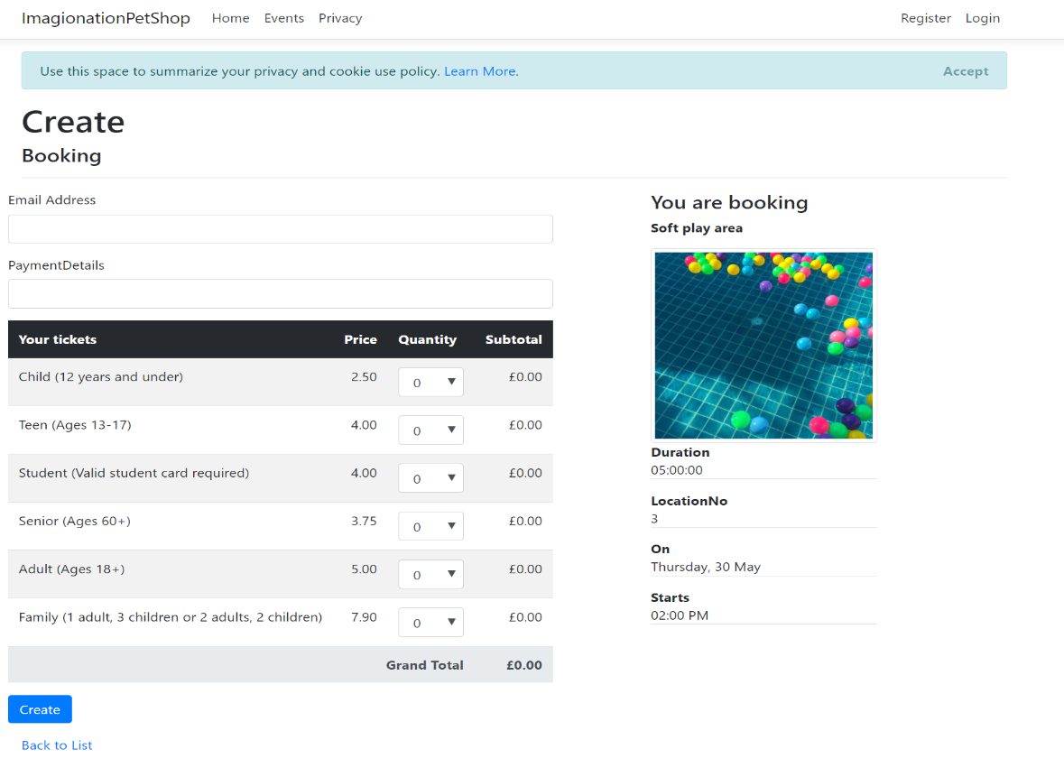
The image below displays the purchase ticket page of the website, on this page the user has the ability to purchase a limited number of tickets and the option of what age the ticket will be for, the different prices are shown along with the option of the user if they are booking as a guest to enter an email address and a payment method . If the details are not entered correctly the messages displayed within figure 26 making the user know that they have not entered their details.
Figure 25 booking page
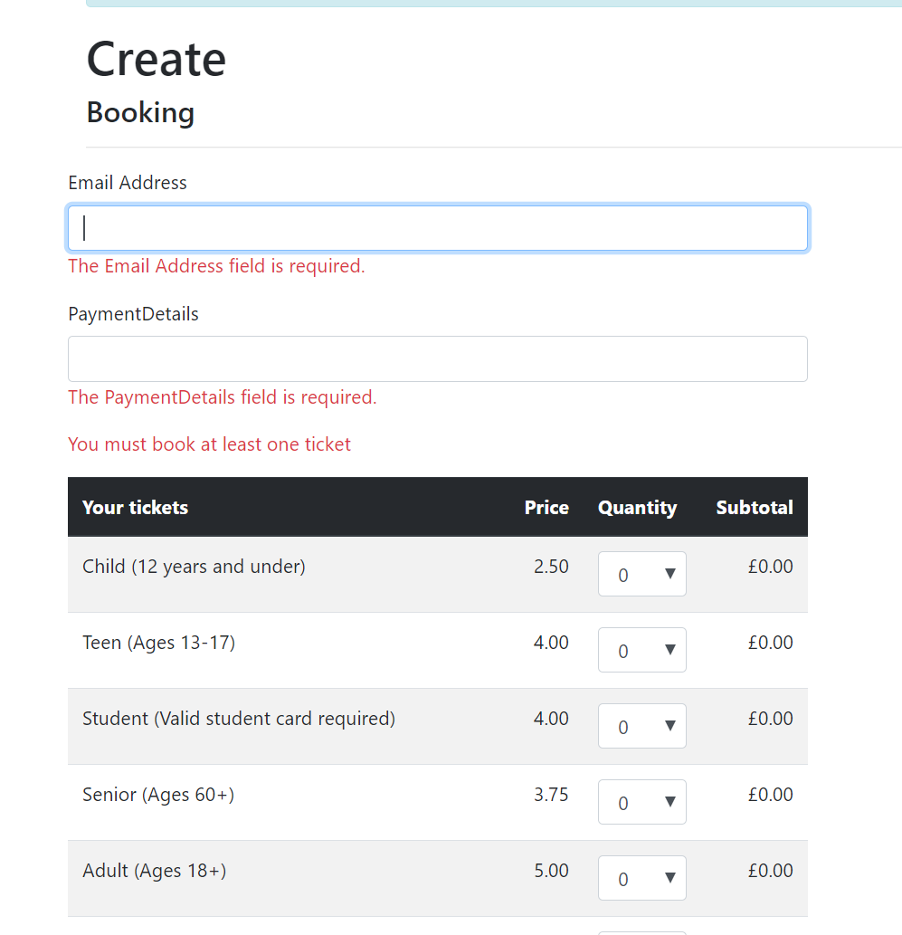
Figure 26 failed attempt at purchasing tickets

Evaluation
To test the system and its functionality the navigation bar was explored, and each individual link was clicked to discover if they navigate to the correct location. The ensure that the registration page restricts a user from inputting incorrect data each filed on the registration page were tested with invalid data as seen within figure 21 the test proves that invalid data is incapable of being input in to the fields.

The registration page was tested further to ensure that users were capable of not only registering an account but can successfully log into the system. A fake user was created and tested to ensure that they were able to log into the system and it was a success, the Microsoft login system was also tested and it worked allowing a user to access the website through the use of a Microsoft account, but the google login system does not work as it should and does not allow the user to log in using a google account. The google login system was a failure.

Upon testing the filtering system on the events page, it was found that it did not work there for the application has failed to allow a user to filter the different events and narrow down searches, due to time constraints the application creator was unable to resolve these issues and the filtering system doesn’t function as required.
It is recommended that the creator fixes the filtering system on the events page to allow users of the system to narrow their searches to make it easier to find what they are looking for, another recommendation is the use of icons in place of text in the navigation menu along with a colour alteration of the application to suit the original website of Imagination pet shop.
The google login system would be fixed in a future update allowing individuals to login to the website using a google account.
The images on the events page would be altered so they are all the same length and height as they stand currently, they make the website look unorganised and messy.

Conclusion
To conclude the website application was successfully created and contained events that the imagination pet shop company wished to market and sell on their own easy to navigate website that was user friendly that allowed for multiple ways to log into the system.
There were a number of issues with the final application, but the creator recognises these issues and the requirement and necessity to fix and alter the application to work as expected.
A knowledge and understanding was achieved through the research into different attacks that can be made on the web application and a level of knowledge to protect and prevent the success of those attacks such as SQL injections or XSS. The further research into object pools was conducted and an appreciation of the numerous software design patterns was recognised and their importance in the creation and implementation of web applications.

References

[1] latest hacking news, “Types of SQL Injection - Latest Hacking News,” 2017. [Online]. Available: https://latesthackingnews.com/2017/10/31/types-of-sql-injection/. [Accessed: 01-May-2019].
[2] Arvind Doraiswamy, “Blind SQL Injection 1.0 - Attack Anatomy,” 2011. [Online]. Available: https://resources.infosecinstitute.com/blind-sql-injection/. [Accessed: 01-May-2019].
[3] infosec, “Best Free and Open Source SQL Injection Tools [Updated 2019],” 2019. [Online]. Available: https://resources.infosecinstitute.com/best-free-and-open-source-sql-injection-tools/. [Accessed: 01-May-2019].
[4] table plus, “8 best practices to prevent SQL Injection Attacks | TablePlus,” 2018. [Online]. Available: https://tableplus.io/blog/2018/08/best-practices-to-prevent-sql-injection-attacks.html. [Accessed: 01-May-2019].
[5] w3school, “PHP Prepared Statements,” 2019. [Online]. Available: https://www.w3schools.com/php/php_mysql_prepared_statements.asp. [Accessed: 01-May-2019].
[6] A. ALECU and F. Alecu, “Cross Site Scripting (XSS) in Action,” Oeconomics Knowl., vol. 4, no. 3, pp. 2–10, Jul. 2012.
[7] A. K. Sinha and S. Tripathy, “CookieArmor : Safeguarding against cross-site request forgery and session hijacking,” Secur. Priv., vol. 2, no. 2, p. e60, Mar. 2019.
[8] S. C. V. and S. Selvakumar, “BIXSAN: browser independent XSS sanitizer for prevention of XSS attacks,” ACM SIGSOFT Softw. Eng. Notes, vol. 36, no. 5, p. 1, Sep. 2011.
[9] U. Sarmah, D. K. Bhattacharyya, and J. K. Kalita, “A survey of detection methods for XSS attacks,” J. Netw. Comput. Appl., vol. 118, pp. 113–143, Sep. 2018.
[10] I. Hydara, A. B. M. Sultan, H. Zulzalil, and N. Admodisastro, “Current state of research on cross-site scripting (XSS) – A systematic literature review,” Inf. Softw. Technol., vol. 58, pp. 170–186, Feb. 2015.
[11] C. Kern, “Securing the tangled web,” Commun. ACM, vol. 57, no. 9, pp. 38–47, Sep. 2014.
[12] A. Shrivastava, S. Choudhary, and A. Kumar, “XSS vulnerability assessment and prevention in web application,” in 2016 2nd International Conference on Next Generation Computing Technologies (NGCT), 2016, pp. 850–853.
[13] S. Christou, Ioannis T. ; Efremidis, “To Pool or Not To Pool? Revisiting an Old Pattern,” Vis. Comput., vol. 33, no. 2, pp. 221–233, Feb. 2017.
[14] Geeks for Geeks, “Object Pool Design Pattern - GeeksforGeeks,” 2019. [Online]. Available: https://www.geeksforgeeks.org/object-pool-design-pattern/. [Accessed: 12-May-2019].
[15] source making, “Object Pool Design Pattern,” 2019. [Online]. Available: https://sourcemaking.com/design_patterns/object_pool. [Accessed: 12-May-2019].
[16] Sławomir Kowalski, “Design patterns: Object pool – Sławomir Kowalski – Medium,” 2018. [Online]. Available: https://medium.com/@sawomirkowalski/design-patterns-object-pool-e8269fd45e10. [Accessed: 12-May-2019].

