Blog post

Name: Gita Dasa
Student Number: 2506059
Module Code: LCHS7009
Module Name: Population Health and Digital Health Promotion
Lecturer’s Name: Dr Besty Jose
Assignment Title: Component 1

BLOG 1
The Impact of NHS Active 10 Walking Tracker in Health Promotion

Public Health Concern: Physical Inactivity
Physical inactivity is a major global health issue that contributes to chronic diseases such as cardiovascular disease, type 2 diabetes and mental health disorders. According to the World Health Organization (WHO), it is one of the leading risk factors for global mortality. In the UK, around one-quarter of adults do not meet recommended physical activity levels. Therefore, scalable public health interventions are needed to promote active lifestyles and reduce healthcare costs (Zhang et al., 2022; Pradal-Cano et al., 2020).
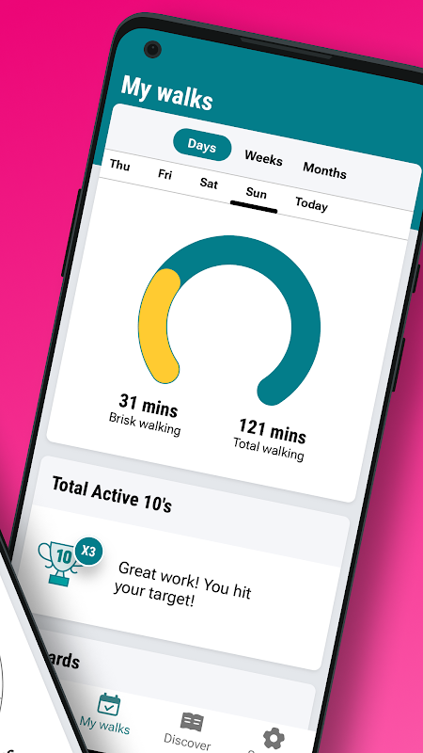
Figure 1: Users of the NHS Active 10 Walking Tracker
(Source: NHS, 2025)
As shown in Figure 1, individuals use the Active 10 application to monitor their walking activity and increase daily movement. The figure highlights how smartphone-based health applications can support behaviour monitoring and encourage people to become more physically active.
NHS Active 10 Walking Tracker: A Digital Health Promotion App
NHS Active 10 Walking Tracker is a mobile application that encourages people to walk briskly for at least 10 minutes daily. The app provides real-time feedback, goal-setting notifications and motivational prompts that help users monitor and improve their physical activity behaviour (Ciravegna et al., 2019; Pradal-Cano et al., 2020).
The intervention is delivered through smartphones, which function as the main digital device supporting the application. Smartphones contain sensors such as accelerometers and GPS that track walking speed, distance and duration. These technological features allow users to monitor their physical activity and receive instant feedback, making smartphones an effective platform for digital health promotion.
Case Study: Effect of NHS Active 10
A time-series study involving 201,688 participants between July 2021 and January 2024 evaluated the effectiveness of the Active 10 application. The results showed that brisk walking increased by around 9 minutes per day, while non-brisk walking increased by 2.6 minutes per day after using the app. This represents a 73% increase above baseline activity levels. Although activity levels slightly declined over time, they remained higher than before the intervention (Yerrakalva et al., 2025).
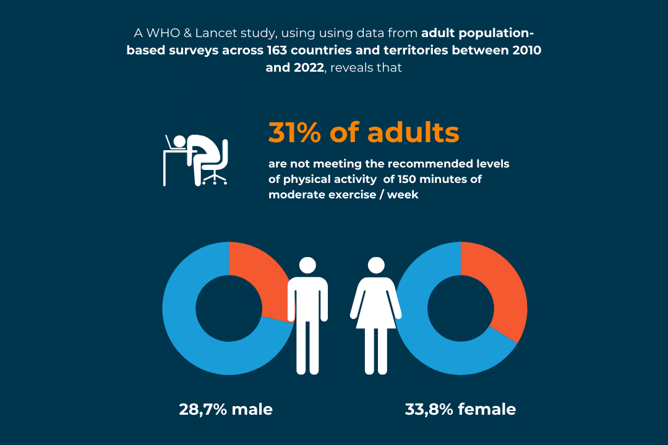
Figure 2: Physical inactivity levels across different regions
(Source: Guthold et al., 2024)
As illustrated in Figure 2, a large proportion of adults remain physically inactive across different regions. The graph demonstrates the widespread prevalence of sedentary lifestyles and highlights the need for accessible interventions. Smartphone-based applications such as NHS Active 10 can help address this problem by encouraging regular walking and daily physical activity.
Advantages and Limitations
The Active 10 app is simple, accessible and aligned with public health guidelines. Users can track progress, set goals and receive motivational reminders that encourage behaviour change (Zhang et al., 2022; Mateo-Orcajada et al., 2024). However, long-term engagement remains a challenge, as many individuals stop using health apps after several months. In addition, environmental barriers such as unsafe walking spaces may limit physical activity (Ciravegna et al., 2019).
Addressing the Shortfalls
To improve long-term engagement, features such as group challenges and personalised feedback could be added. Improving accessibility and supporting people with lower digital literacy may also reduce digital health inequalities and increase the effectiveness of smartphone-based health promotion interventions (Pradal-Cano et al., 2020).
‌
Reference list

Ciravegna, F., Gao, J., Ireson, N., Copeland, R., Walsh, J. and Lanfranchi, V. (2019) ‘Digital technologies for promoting physical activity’, Proceedings of the PervasiveHealth Conference 2019, ACM, pp. 11–20.
Guthold, R., Stevens, G.A., Riley, L.M. and Bull, F.C. (2024) ‘Global trends in insufficient physical activity among adults from 2010 to 2022’, The Lancet Global Health, 12(6), pp. e832–e844. Available at: https://www.thelancet.com/journals/langlo/article/PIIS2214-109X(24)00150-5/fulltext (Accessed: 20 February 2026).
Mateo-Orcajada, A., Ponce-Ramírez, C.M., Abenza-Cano, L. and Vaquero-Cristóbal, R. (2024) ‘Effects of 10 weeks of walking with mobile step-tracking apps on body composition, fitness, and psychological state in adolescents who are overweight and obese: Randomized controlled trial’, Journal of Medical Internet Research, 26, e55243. Available at: https://pmc.ncbi.nlm.nih.gov/articles/PMC11668985/ (Accessed: 20 February 2026).
NHS (2025) Active 10 walking tracker mobile application interface. Available at: https://www.nhs.uk/better-health/get-active/active-10/ (Accessed: 20 February 2026).
Pradal-Cano, L., Lozano-Ruiz, C., Pereyra-Rodríguez, J.J., Saigí-Rubió, F., Bach-Faig, A., Esquius, L., Medina, F.X. and Aguilar-Martínez, A. (2020) ‘Using mobile applications to increase physical activity: A systematic review’, International Journal of Environmental Research and Public Health, 17(21), p. 8238. Available at: https://www.mdpi.com/1660-4601/17/21/8238 (Accessed: 20 February 2026).
Yerrakalva, D., Hajna, S., Brage, S. and Griffin, S.J. (2025) ‘Evaluation of the NHS Active 10 walking app intervention through time-series analysis in 201,688 individuals’, npj Digital Medicine, 8(1). Available at: https://pmc.ncbi.nlm.nih.gov/articles/PMC12328748/ (Accessed: 20 February 2026).
Zhang, M., Wang, W., Li, M., Sheng, H. and Zhai, Y. (2022) ‘Efficacy of mobile health applications to improve physical activity and sedentary behaviour: A systematic review and meta-analysis for physically inactive individuals’, International Journal of Environmental Research and Public Health, 19(8), p. 4905. Available at: https://www.mdpi.com/1660-4601/19/8/4905 (Accessed: 20 February 2026).

‌

Blog 2
The impact of the move Together App on Physical activity

Public Health Problem: Physical Inactivity
Physical inactivity is a significant public health challenge globally, contributing to chronic conditions such as obesity, cardiovascular disease, type 2 diabetes and mental health disorders including anxiety and depression. According to the World Health Organization (WHO, 2020), approximately one in four adults do not meet the recommended levels of physical activity. Sedentary lifestyles, especially among students and individuals who spend long hours using digital devices, increase the risk of inactivity-related diseases. Therefore, innovative digital health interventions are needed to encourage people to increase their daily physical activity levels (Bi et al., 2024; Wang et al., 2024).
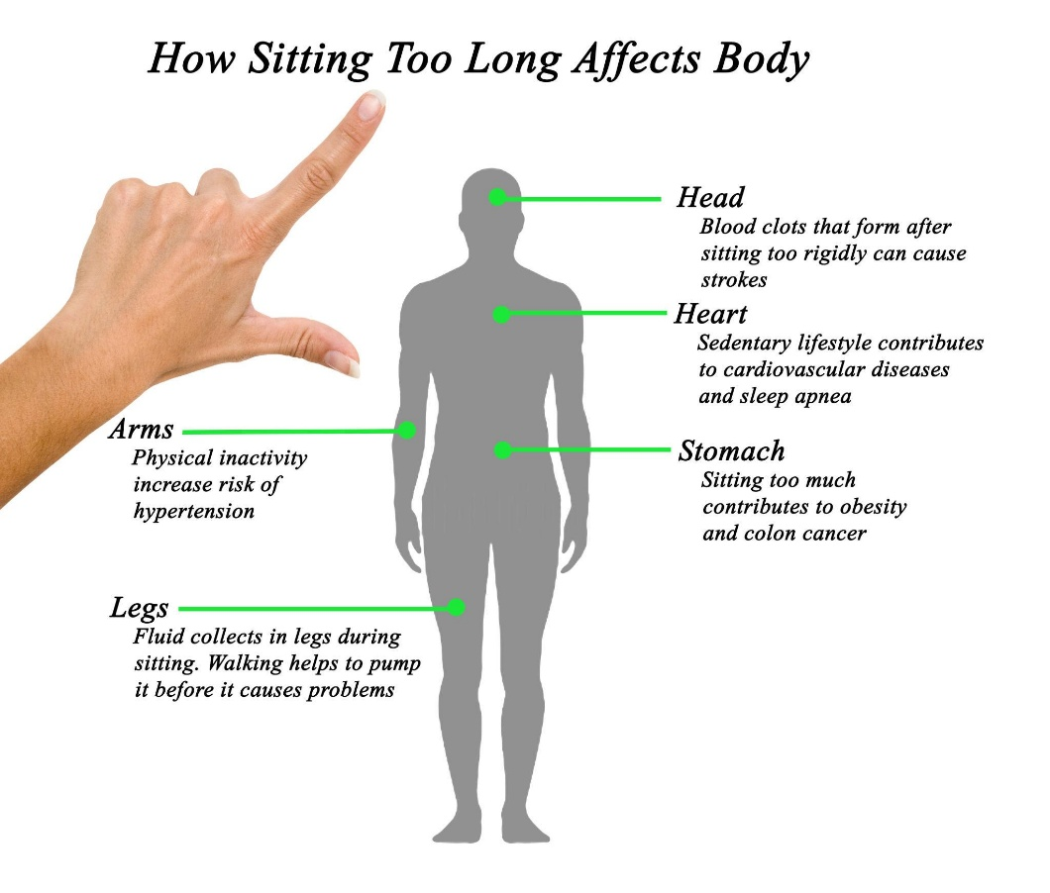
Figure 4. The impact of prolonged sitting and sedentary behaviour on health
(Source: Workplace Health Infographic, 2023).
As it is shown in Figure 4, sedentary behaviour and prolonged sitting are linked to the increased risks of obesity, cardiovascular disease and reduced physical fitness. The figure demonstrates the importance of encouraging people to be active throughout the day. Digital health technologies can therefore play an important role to reduce sedentary behaviour and promote healthier lifestyles.
Designed Digital Technology: MoveTogether
To address this issue, a mobile health application called MoveTogether has been designed to promote physical activity through personalised goals, social networking and behavioural nudges. The app integrates artificial intelligence to generate personalised recommendations based on the user’s activity level and preferences. Gamification features such as group challenges, rewards and community participation are included to increase user engagement and motivation. In addition, the application provides motivational messages and reminders when a user has been inactive for a prolonged period, supporting both physical and mental wellbeing (Kardan et al., 2024).
The MoveTogether intervention works through smartphones, which are the primary digital device used in support of the application. Smartphones have sensors, such as accelerometers and GPS that monitor movement, steps and period of activity. These technologies capabilities allow the app to track physical activity as well as providing real-time feedback, that makes smart phones an effective platform for digital health promotion.
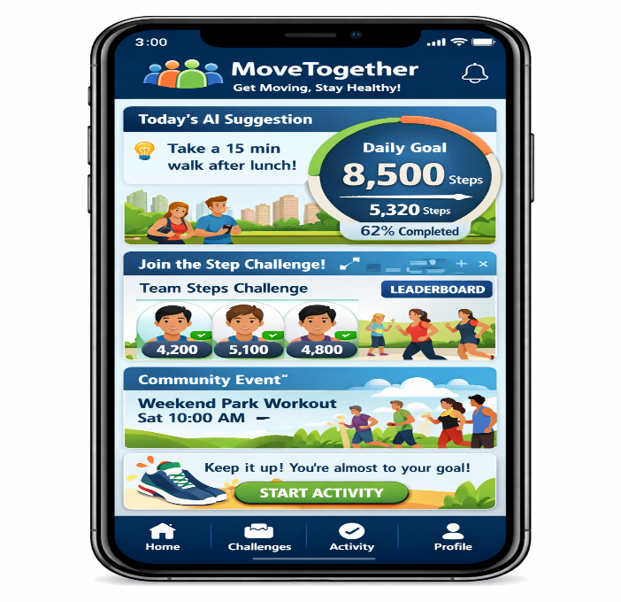
Figure 5. Smartphone interface displaying the MoveTogether dashboard

Figure 5 shows what a possible interface of the MoveTogether app would look like on a smartphone screen. The dashboard provides users with the ability to track their progress in their activities, view personalised goals and take part in community challenges, which may encourage individuals to be more active each day.
Critical Discussion: MoveTogether Effects
MoveTogether offers several strengths compared with traditional activity tracking applications. Personalised feedback, social interaction and gamification features can increase motivation and long-term engagement with physical activity behaviours. However, there are also limitations. The app depends on smartphone access and internet connectivity, which may exclude individuals with limited digital resources. Additionally, concerns about data privacy and the collection of personal health information may discourage some users from adopting the technology (Bi et al., 2024; Di Pumpo et al., 2025).
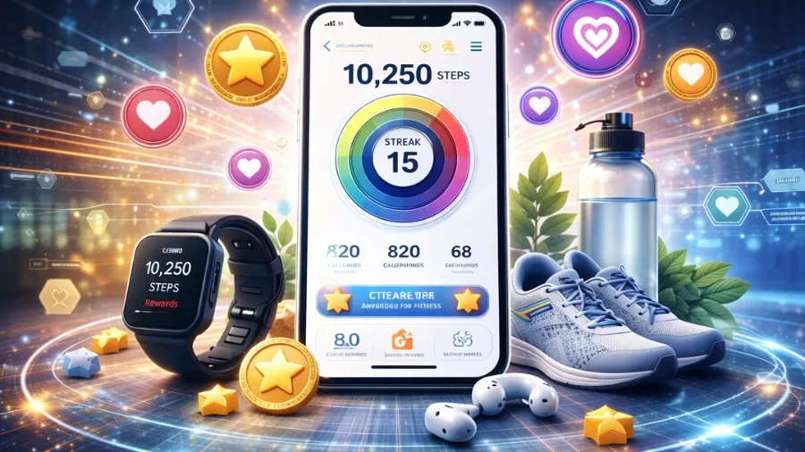
Figure 6. Gamification strategies used in digital health to increase engagement
(Source: Magazine, 2026)
Figure 6 emphasises the use of gamification elements such as rewards, competition and challenges to encourage people to take up healthier behaviours. Incorporating these strategies in digital health applications can enhance participation and promote physical activity engagement.
Addressing the Shortfalls
To address these limitations, MoveTogether could integrate offline functionality and collaborate with local health organisations to improve accessibility. Data protection measures and anonymised data management systems would help increase user trust. Personalised notifications, community challenges and partnerships with public health programmes may further strengthen long-term engagement and support sustainable behaviour change.
Reference list

Bi, S., Yuan, J., Wang, Y., Zhang, W., Zhang, L., Zhang, Y., Zhu, R. and Luo, L. (2024) ‘Effectiveness of digital health interventions in promoting physical activity among college students: Systematic review and meta-analysis’, Journal of Medical Internet Research, 26, e51714. Available at: https://pmc.ncbi.nlm.nih.gov/articles/PMC11618011/ (Accessed: 11 February 2026).
Di Pumpo, M., Miatton, A., Riccardi, M.T., Graps, E.A., Baldo, V., Buja, A. and Damiani, G. (2025) ‘Digital health interventions to promote physical activity in community-dwelling older adults: A systematic review and semiquantitative analysis’, International Journal of Public Health, 69. Available at: https://www.ssph-journal.org/journals/international-journal-of-public-health/articles/10.3389/ijph.2024.1607720/full (Accessed: 11 February 2026).
Kardan, M., Jung, A., Iqbal, M., Keshtkar, S., Geidl, W. and Pfeifer, K. (2024) ‘Efficacy of digital interventions on physical activity promotion in individuals with noncommunicable diseases: An overview of systematic reviews’, BMC Digital Health, 2(1). Available at: https://link.springer.com/article/10.1186/s44247-024-00097-6 (Accessed: 11 February 2026).
Sousa Basto, P. and Ferreira, P. (2025) ‘Mobile applications, physical activity, and health promotion’, BMC Health Services Research, 25(1). Available at: https://link.springer.com/article/10.1186/s12913-025-12489-z (Accessed: 11 February 2026).
Wang, J.-W., Zhu, Z., Shuling, Z., Fan, J., Jin, Y., Gao, Z.-L., Chen, W.-D. and Li, X. (2024) ‘Effectiveness of mHealth app-based interventions for increasing physical activity and improving physical fitness in children and adolescents: Systematic review and meta-analysis’, JMIR mHealth and uHealth, 12, e51478. Available at: https://mhealth.jmir.org/2024/1/e51478/ (Accessed: 11 February 2026).
Wellable (2023) The impact of prolonged sitting: Health risks and workplace solutions. Available at: https://www.wellable.co/blog/the-impact-of-prolonged-sitting-health-risks-and-workplace-solutions/ (Accessed: 20 February 2026).
Workplace Health Infographic (2023) The impact of prolonged sitting: Health risks and workplace solutions. Available at: https://www.wellable.co/blog/the-impact-of-prolonged-sitting-health-risks-and-workplace-solutions/ (Accessed: 20 February 2026).
.

