Jack Frampton (2413011)

Lab report 3- calorimetry
Chemistry ACDB4011

Contents
Introduction 2
The Purpose – 2
Hypotheses being Tested - 2
Variables of the Experiment – 2
Equations – 2
Results 3
Example 1 - 3
3
Example 2 - 4
Discussion 4
Significance of Results – 4
Relevance to OME – 4
Limitations and Sources of Error – 5
Conclusions 5
References 5
Appendix: Materials and Methods 6
Materials – 6
Experiment No.1 6
Experiment No. 2 6
Experiment No. 3 6
Methods – 6
Measure the value of the heat capacity of the calorimeter 6
Measure the specific heat capacity of a metal 7
Measure the molar heat of reaction of HCl with NaOH 8

Introduction

The Purpose –
The purpose of this experiment is to measure the specific heat capacity of a metal and reaction. This is achieved by creating an isolated system

Hypotheses being Tested -
The hypotheses being tested is the link between heat transfer and the isolated system, the process of the law of conservation of energy.

Variables of the Experiment –
These include the initial temperature of the water, the temperature you are heating the water up to, the mass of the aluminium.

Equations –
Q = m × c_{p} × ΔT (Eq. 1)

- Q_{metal} = Q_{water} + Q_{calorimeter} (Eq. 2)

m_{metal} × c_{p metal} × ΔT_{metal} = - (m_{water} × c_{p water} × ΔT_{water} + HC_{calorimeter}× ΔT_{calorimeter}) (Eq. 3)

Q_{reaction} = - (m_{water} × c_{p water} × ΔT_{water} + HC_{calorimeter} × ΔT_{calorimeter}) (Eq. 4)

- Q_{hot-water} = Q_{cold-water}+ Q_{calorimeter} (Eq.5)
Q_{calorimeter} = HC_{calorimeter} × ΔT_{calorimeter} (Eq.6)

Results

Example 1 -

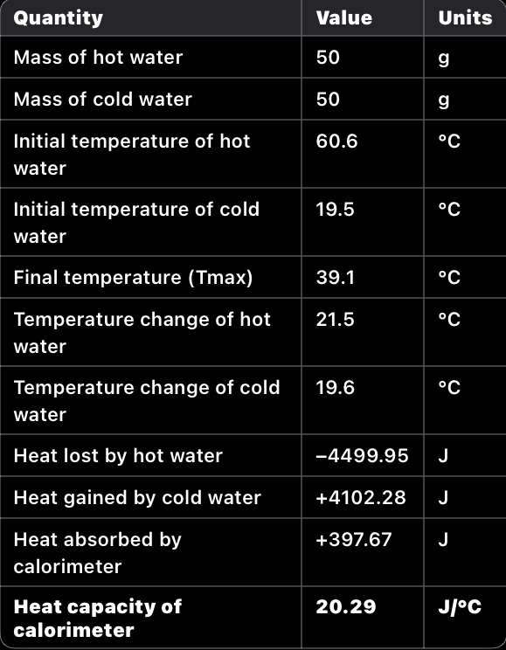

The key findings of this table is that the heat lost by the hot water and the heat gained by the cold water are nearly equal, showing that the law of conservation of energy is accurate as some of this heat energy was lost to the calorimeter and the surroundings.

Example 2 -
Time(s) | T(water)C |  | Time(s) | T(water)C
0 | 28.1 |  | 96 | 27.8
8 | 28.1 |  | 104 | 27.8
16 | 28.1 |  | 112 | 27.8
24 | 27.9 |  | 120 | 27.7
32 | 27.9 |  | 128 | 27.7
40 | 27.9 |  | 136 | 27.7
48 | 27.9 |  | 144 | 27.6
56 | 27.9 |  | 152 | 27.6
64 | 27.9 |  | 160 | 27.6
72 | 27.8 |  | 168 | 27.6
80 | 27.8 |  | 176 | 27.6
88 | 27.8 |  | 184 | 27.6

This experiment had an extremely slow reaction, as shown in the tables above, the water and aluminium took an extended period of time to reach equilibrium. One way in which to improve this method would be to not the temperature in 10-15 second increments, this condenses our results table and gives a much easier summary of the reaction.

Discussion

Significance of Results –
These results show that the law of conservation of energy is accurate for an extreme degree as the heat gained by the hot water by hot water plus heat gained by cold water and heat gained by the calorimeter is equal to 0.

-4499.95 J + 4102.28 J + 397.67 J = 0

Relevance to OME –
All processes (physical or chemical) are accompanied by the generation or consumption of energy, usually in the form of heat. It follows that, in principle, all processes can be studied using some sort of calorimeter. [1] This shows that even when stored at magazine temperature standards, explosive content can undergo a non-intentional conditioning trial, meaning if a chemical reaction occurs in a propellant, for example, this can lead to decomposition of the product. This will indefinitely affect its performance and dependability of the asset
Thermal analysis or calorimetry is a widely used technique for obtaining both qualitative and quantitative information about thermal transitions associated with a particular material or process. Because all chemical reactions and most physical changes are associated with intake or release of heat, a quantification of thermal energy provides a simple and universal method for characterizing materials and processes. Thermal analysis has been effectively employed in forensic and customs applications and for the analysis of pharmaceuticals, asphalts, oils, and waxes. Despite these advantages, there is an ongoing need for next-generation calorimetric devices to provide advanced sensing capabilities for use in chemical process-safety, homeland security, and military applications. The ability to perform chemical fingerprinting on the basis of thermal characterization will provide new capabilities that will be broadly applicable in both current benchtop scale and future microscale calorimetric systems. [2] This journal show that calorimetry can be used as a form of chemical identification. It states that if a sample of explosive is contaminated that standardised methods of identification become extremely inaccurate or obsolete.

Limitations and Sources of Error –
An error that was noticed during the experiment is that a significant amount of heat was lost to the surroundings skewing our results. The only effective way to counteract this error would be to create a perfectly isolated, contained system but as of yet this is impossible as all materials conduct some heat, no matter how small. The most effective way, with the systems that are available, would be to repeat the experiment multiple times in the same systems to see a trend in results.

Conclusions
In the first experiment, the transfer between hot and cold water was explored. The heat gained by the cold water, heat lost by the hot water and heat gained by the calorimeter supports the law of conservation of energy: energy cannot be lost or destroyed, only transferred from one form to another.
These results do in fact support the law of conservation of energy as all heat gain and loss was recorded and all limitations and errors were taken into account.

References

[1] | P. Bunyan, C. Baker and N. Turner, Application of heat conduction calorimetry to high explosives, Sevenoaks, Kent: Thermochimica Acta, 2002.
[2] | Y.-S. Liu, V. M. Ugaz, S. W. North, W. J. Rojers and M. S. Mannam, “Development of a miniature calorimeter for identification and detection of explosives and other energetic compunds,” Journal of Hazardous Materials, vol. 142, no. 3, pp. 662-667, 2007.

Appendix: Materials and Methods

Materials –

Experiment No.1
- 2 Styrofoam cups
- Lid for the cups
- Thermometer
- Stirring rod
- Stand and clamp

Experiment No. 2
- Aluminium piece
- Bunsen burner
- Calorimeter (as seen in Experiment No. 1)

Experiment No. 3
- 1.0M HCl
- 1.0MK NaOH
- Beaker
- Calorimeter (as seen in Experiment No. 1 and No.2)

Methods –

Measure the value of the heat capacity of the calorimeter
- Add 50.0 mL of water to the Styrofoam coffee cups, and close with a lid. Add the thermometer and stirring rod to set up your calorimeter.
- Take 50.0 mL of water in a separate beaker and heat to about 80 °C. Close the gas and wait till the temperature reaches 60 °C. When the "hot water" is ready, record its temperature as Thot.
- Measure the temperature of the water in the calorimeter, and record it as Tcold.
- Add the hot water to the water in the calorimeter, and mix thoroughly, while watching the thermometer. Record the maximum equilibrium temperature of the mixture, record it as Tmax.
- Calculate the heat capacity of the calorimeter, HCcalorimeter where Qhot-water is the heat lost by the hot water, while QCold-water and Qcalorimeter are the amounts of heat gained by the cold water and calorimeter, respectively. Calculate Qhot-water and Qcold-water with Eq.1, then use Eq. 5 to find Qcalorimeter, and finally Eq.6 to obtain the value of heat capacity of the calorimeter, HCcalorimeter

Measure the specific heat capacity of a metal

- Obtain a piece of the metal sample. Weigh the metal and record its mass as m_{metal}.

- Set up a water bath, heat the water until boiling, and then carefully put your metal into it. Keep boiling for another 5 minutes, to allow the metal to reach the same temperature as the water. Try to avoid heating the metal directly! To reduce the effect of direct heating, close the gas after 5 min and wait 2 minutes for the temperature of boiling water and piece of metal to equilibrate.
- While this is being done, measure 30.0 mL of water and add it to the calorimeter. Measure the temperature of the water in the calorimeter, as done previously, and record it as T_{cold}.

- Once the metal has reached "thermal equilibrium" with the boiling water, measure and record the temperature of the hot water as T_{hot}, and quickly add the metal to the water in the calorimeter using the tongs.

- Stir the water and record the temperature every 10 seconds, filling in the datasheet provided at the end of this script with the entries (time, T_{water}). The temperature will increase at the start. Continue until the temperature of the water has reached a maximum and then cooled down by about 2 ºC. Record the maximum temperature reached by the water as T_{max}.

- Calculate c_{p} _{metal} the specific heat of the metal using Eq.3 and the value of heat capacity of the calorimeter found previously. Assume that calorimeter and water are in thermal equilibrium, c_{p} _{water} = 4.186 J/(gºC), and always give the units of the results of your calculations.

Measure the molar heat of reaction of HCl with NaOH

- Place 52.0 mL of 1.0 M NaOH into the calorimeter and pour 50.0 mL of 1.0 M HCl into a beaker.

- Place the two side-by-side until they attain the same temperature. Record this value as 𝑇_{start}.

- Add the HCl quickly to the calorimeter and record the temperature when it reaches a maximum as 𝑇_{end}.

- Calculate Q_{reaction}, the heat of reaction, using Eq.4 and the heat capacity of the calorimeter found previously. Again, assume that calorimeter and water are in thermal equilibrium, c_{p water} = 4.186 J/(g°C), and always give the units of the results of the calculations.

- Calculate 𝑞_{reaction}, the molar heat of reaction, as the heat of reaction per mole of the limiting reactant where the number of moles of reactant is: n _{reactant} = V _{reactant} x C _{reactant} , where V _{reactant} is the volume of LIMITING reactant and C _{reactant} is the concentration of LIMITING reactant.

