Design Portfolio
ACDA5021
Systems Engineering



Theodore Dunning
2317700
Table of Contents
List of Figures 3
List of Tables 3
Table of Abbreviations 4
1 Abstract 5
2 Introduction 5
3 Literature Review 6
3 Key Customer Requirements 7
3.1 Requirements Set 7
3.2 Rationalised Requirements Pairwise and Requirements Importance Chart 8
3.2.1 Requirements Importance Graph 9
4 Critical System Functionality 10
4.1 Required Functionality 10
4.2 Design QFD 1 11
4.2.1 Functional Importance Graph 11
5 Concept Derivation and Design Choices 12
5.1 Function Means Analysis 12
5.2 System Pugh 13
5.3 Functional Metrics 14
6 Potential Failure Modes 15
6.1 FMEA Spreadsheets 15
7 Critical Design Features 17
7.1 Design QFD2 17
7.1.1 Feature Importances Chart 17
7.2 Prime P-Diagrams 18
7.2.1 What Why Diagram 18
7.2.2 Control and Noise Factor Graphs 19
8 The Manufacturing Processes 20
8.1 Manufacturing Requirements 20
8.2 Process Map 20
8.3 Manufacturing QFD1 21
8.3.1 Process Importance Chart 21
8.4 Process FMA 22
8.5 Process Pugh 22
8.6 Manufacturing QFD2 23
8.6.1 Manufacturing Means Importance 23
9 Critical process Steps 24
9.1 Manufacturing QFD 3 24
9.1.1 Technique Importance Chart 25
9.2 Manufacturing P-Diagram 25
9.2.1 “What Why” Table 26
9.2.2 Key Controls Chart 26
9.2.3 Key Noise Chart 27
10 Process Control Measures 28
10.1 Manufacturing QFD 4 28
10.1.1 Importances Chart 28
11 Waste and End of Life Disposal 29
12 Conclusion 29
13 Reflection 29
14 References 31
15 Annexes 32
15.1 Annex A 32
15.1.1 Extra QFD 2 What Why tables, P-Diagrams and Graphs 32

List of Figures
Figure 1, Rationalised Requirements Pairwise 9
Figure 2, Functional Importance Graph 11
Figure 3, Feature Importance Graph 17
Figure 4, Control Factors & Noise Factors Graphs 19
Figure 6, Process Map 20
Figure 7, Process Importance Chart 21
Figure 8, Manufacturing Means Importance 23
Figure 9, Technique Importance Chart 25
Figure 10, Manufacturing P-Diagram 25
Figure 11, Manufacturing Key Controls 26
Figure 12, Manufacturing Key Noises 27
Figure 13, GPR Control Factors 33
Figure 14, GPR Noise Factors 33
Figure 15, EOD Control Factors and Noise Factors 35

List of Tables
Table 1, Requirements Set 7
Table 2, Chosen Requirements 8
Table 3, Rationalised Requirements 8
Table 4, Required Functionality 10
Table 5, Design QFD 1 11
Table 6, Function Means Analysis 12
Table 7, Design System Pugh 13
Table 8, Functional Metrics 14
Table 9, Test and Evaluation FMEA 15
Table 10, Safety on Operations FMEA 15
Table 11, FMEA Key 16
Table 12, Design QFD 2 17
Table 13, Prime P-Diagram 18
Table 14, Prime "What Why" 18
Table 15, Manufacturing Requirements 20
Table 16, Manufacturing QFD 1 21
Table 17, Process FMA 22
Table 18, Process Pugh 22
Table 19, Manufacturing QFD 2 23
Table 20, Manufacturing QFD 3 24
Table 21, Manufacturing "What Why" 26
Table 22, Manufacturing QFD 4 28
Table 23, QFD 4 Importances 28
Table 24, GPR P-Diagram 32
Table 25, GPR "What Why" 32
Table 26, EOD P-Diagram 34
Table 27, EOD "What Why" 34

Table of Abbreviations
QFD | Quality Function Deployment
FMA | Function Means Analysis
FMEA | Failure Mode and Effect Analysis
NFS | Non-Functional System Requirement
NFP | Non-Functional Performance Requirement
GPR | Ground Penetrating Radar
UAV | Unmanned Ground Vehicle
UGV | Unmanned Air Vehicle
RPN | Risk Priority Number
EOD | Explosive Ordnance Disposal
PE-8 | Plastic Explosive No. 8
PBX | Plastic Bonded Explosive

1 Abstract
1.1 This work evaluates the application of systems engineering tools in the development of a mine clearance system designed to enable safe convoy passage through a mine field. A structured QFD (Quality Function Deployment) approach was used to translate stakeholder requirements into system functions, design concepts and manufacturing processes. Methods such as Function Means Analysis, Pugh Matrices, Failure Modes and Effect Analysis, and Parameter Diagrams supported concept selection, risk identification and robustness analysis.

1.2 The resulting design integrates unmanned aerial and ground systems for mine detection, neutralisation and route preparation, minimising risk to personnel. Manufacturing and lifecycle considerations were incorporated to ensure feasibility, safety and compliance. The study demonstrates how the use of systems engineering tools enables traceable decision making, early risk mitigation and the development of a practical and robust solution.

2 Introduction
2.1 This portfolio presents an overview of the systems engineering tools applied by Group 1 to develop a solution for the case study; clearing a safe route through a mine field so that a convoy of light off-road vehicles could safely pass through to deliver medical supplies. The initial requirements demanded that none of the personnel from the convoy would be exposed to the danger of the field, the product remained safe during manufacture and operation, logistically transportable, environmentally friendly, IM compliant and capable of similar or improved performance when compared to existing methods.

2.2 Group 1 consisted of a 7-person team of ordnance, munitions and explosives engineering students, who had not previously worked together. Each member was assigned a role aligned with their professional background:
- William – Research and Development
- Theo – Manufacturing
- Euan – Manufacturing Safety
- Casper – Operations Safety
- Shaun – Trials and Evaluation
- James – Trials and Evaluation Safety
- Arron – Waste and Disposal

2.3 The group followed a structured systems engineering QFD design book (Quality Function Deployment), which contained tools such as QFD tables, Function Means Analysis, Pugh Matrices, Failure Mode Effect Analysis (FMEA), P Diagrams and What Why tables. In this portfolio, each method is detailed on how they helped to identify customer requirements, critical system functionality, concept derivation, potential failure modes, critical design features, manufacturing processes, critical process steps, process control measures, and waste considerations. This portfolio demonstrates the systems engineering mindset the development of a robust design solution, supported by the appropriate tools.

3 Literature Review
3.1 The design book mainly consists of the well-established Quality Function Development (QFD) toolset. The QFD method provides a way of planning and developing a project while precisely defining customer requirements and then translating these into design parameters. This was first developed in Japan around 1966 by Yoji Akao, then further developed in 1972 by employees of the Mitsubishi Heavy Industries, it eventually spread into the US in the 1980s where it was applied to major defence projects, including the F-35 Fighter Jet. It is a useful tool as it maintains traceability between stakeholder requirements and engineering decisions while also being highly structured which keeps a good level of organisation. However, it is criticised for its time consumption and complexity increasing rapidly if the customer requirements are large, and weighting in each section is subjective to the person assigning them, which can introduce bias. [1] [2] [3]

3.2 The Pugh Matrix (also called Controlled Convergence Method) was developed around the 1980s by Stuart Pugh. It is used as a structured and qualitative way to evaluate and rank different design concepts. It is completed by comparing against a criteria using a datum standard and simple +/S/- scoring system, which promotes discussion and convergence of thought towards the stronger solution in the selection of options. It is commonly used alongside the QFD process to support decision making. [4] [5]

3.3 Failure Modes and Effects Analysis (FMEA) originated in the United States military in the 1940s (Military procedure MIL-P-1629) and is now widely used in OME, aerospace and NASA programmes to identify single point failures and support design iteration, maintenance planning and hazard analysis. The method outlines the evaluation of potential failure modes, consequences of failure, effect on components, effect on whole system, hazard classification, probability of failure, detection methods, compensation provisions and recommendations. These investigations support the implementation of safety controls. [6] [7]

3.4 Parameter Diagrams (P-Diagrams) are used to identify the noise factors of a system by looking at its inputs and desired outputs. The method highlights control factors, error states and functional relationships which helps to build on making products and processes insensitive to noise factors (variation from manufacturing, environment, usage or ageing). This was created by Genichi Taguchi in the 1980s, his philosophy revolved around making products “right first time” by optimising controls, minimising variation and designing quality into the product. It is a good tool to use alongside a FMEA, as it investigates noises that can be easily missed like temperature, which is sometimes assumed and not analysed. [8]

3 Key Customer Requirements

3.1 Requirements Set
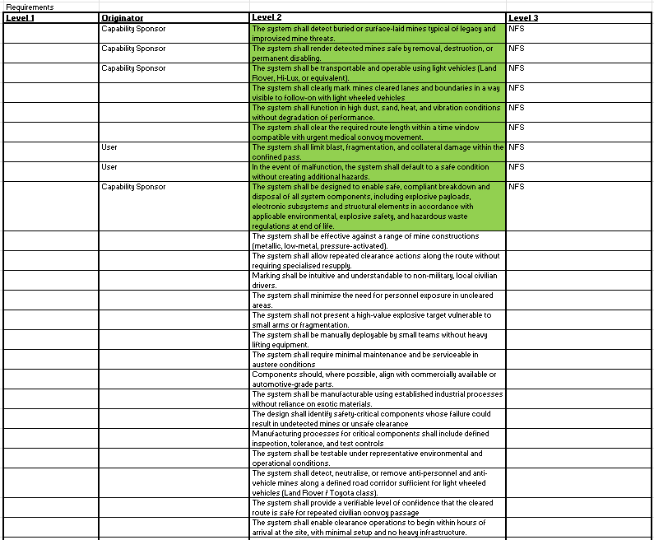
Table 1, Requirements Set

3.1.1 The first step was identifying the stakeholders’ requirements for the system; this was completed in a requirements set, and requirements were derived from the design brief that was presented in lectures. Each requirement was labelled as NFS (Non-Functional System Requirement - how the system should perform) or NFP (Non-Functional Performance Requirement – how well the system should perform).

3.1.2 Due to the complicated scenario, the initial requirements list was extensive. The reduction to nine requirements was necessary to maintain the usability of the QFD matrices that would come later, as excessive inputs significantly increase complexity and reduce clarity of prioritisation.

No. | Chosen Requirement
1 | The system shall detect buried or surface-laid mines typical of legacy and improvised mine threats.
2 | The system shall render detected mines safe by removal, destruction, or permanent disabling.
3 | The system shall be transportable and operable using light vehicles (Land Rover, Hi-Lux, or equivalent).
4 | The system shall clearly mark mines cleared lanes and boundaries in a way visible to follow-on with light wheeled vehicles.
5 | The system shall function in high dust, sand, heat, and vibration conditions without degradation of performance.
6 | The system shall clear the required route length within a time window compatible with urgent medical convoy movement.
7 | In the event of malfunction, the system shall default to a safe condition without creating additional hazards.
8 | The system shall be designed to enable safe, compliant breakdown and disposal of all system components, including explosive payloads, electronic subsystems and structural elements in accordance with applicable environmental, explosive safety, and hazardous waste regulations at end of life.
Table 2, Chosen Requirements

3.2 Rationalised Requirements Pairwise and Requirements Importance Chart
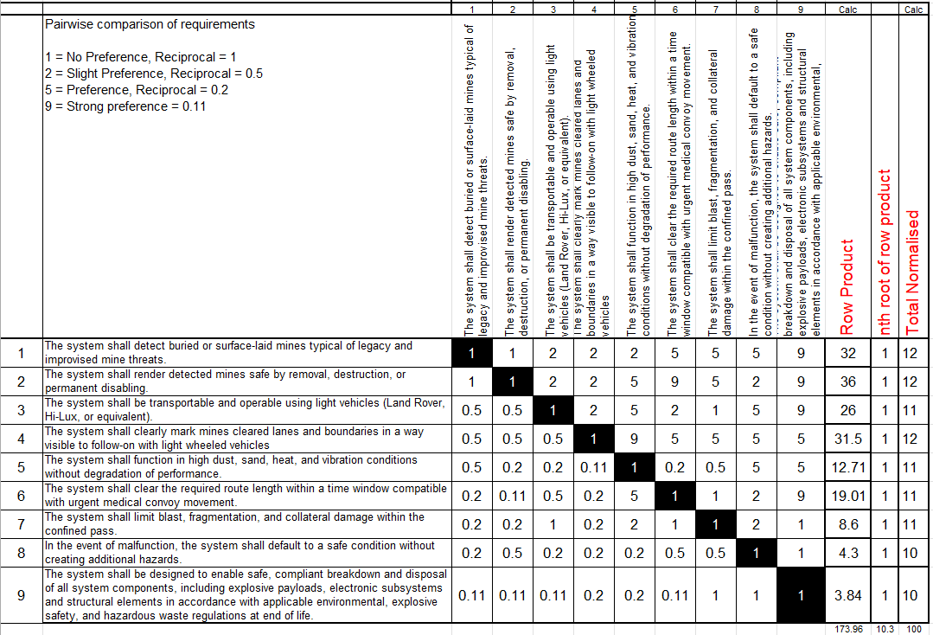
Table 3, Rationalised Requirements

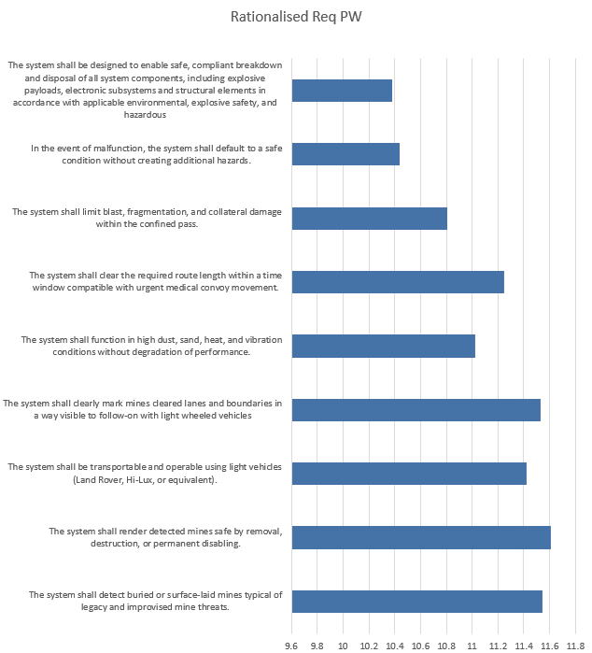
3.2.1 Requirements Importance Graph
Figure 1, Rationalised Requirements Pairwise

3.2.2 The chosen requirements were then placed into a pairwise comparison table (figure 1) that allowed each requirement to be ranked individually against all other requirements. The relative importance scores from this could be used in a graph to visualise the importance of each requirement for the success of the system.

3.2.3 The pairwise comparison showed that mine detection and neutralisation requirements ranked highest, indicating that the system’s effectiveness and safety were to be prioritised over logistical and environmental considerations.
3.2.4 The output from this stage was a rationalised and prioritised customer requirements set, supported by importance ranking. This provided a clear foundation for the design and development of the project to be centred around the stakeholder requirements.

4 Critical System Functionality

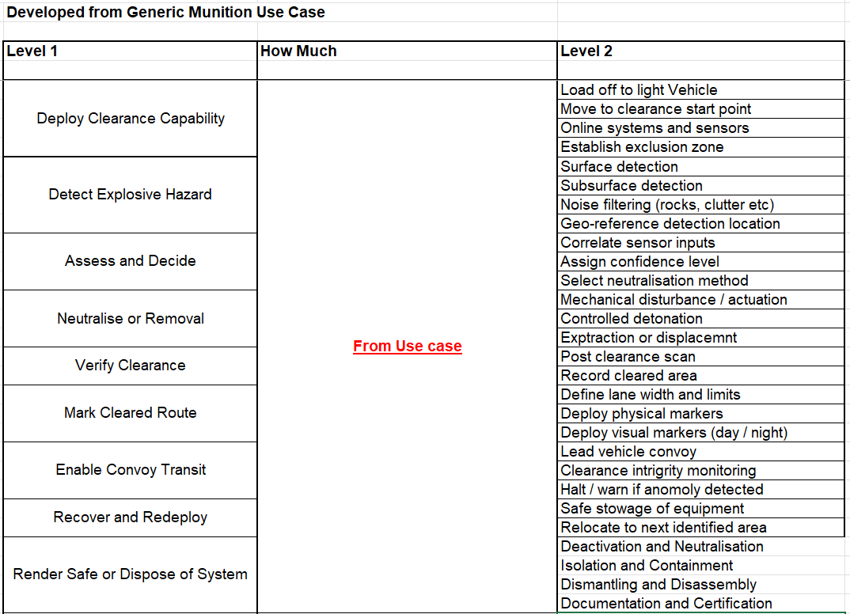
4.1 Required Functionality
Table 4, Required Functionality

4.1.1 Following the identification of stakeholder requirements, the next stage involved defining the critical system functionality by using the required functionality table. This process started with creation of top level (level 1) system functions being decided, which were then broken down into more specified level 2 functions, this created the first ideas of how the system would work.

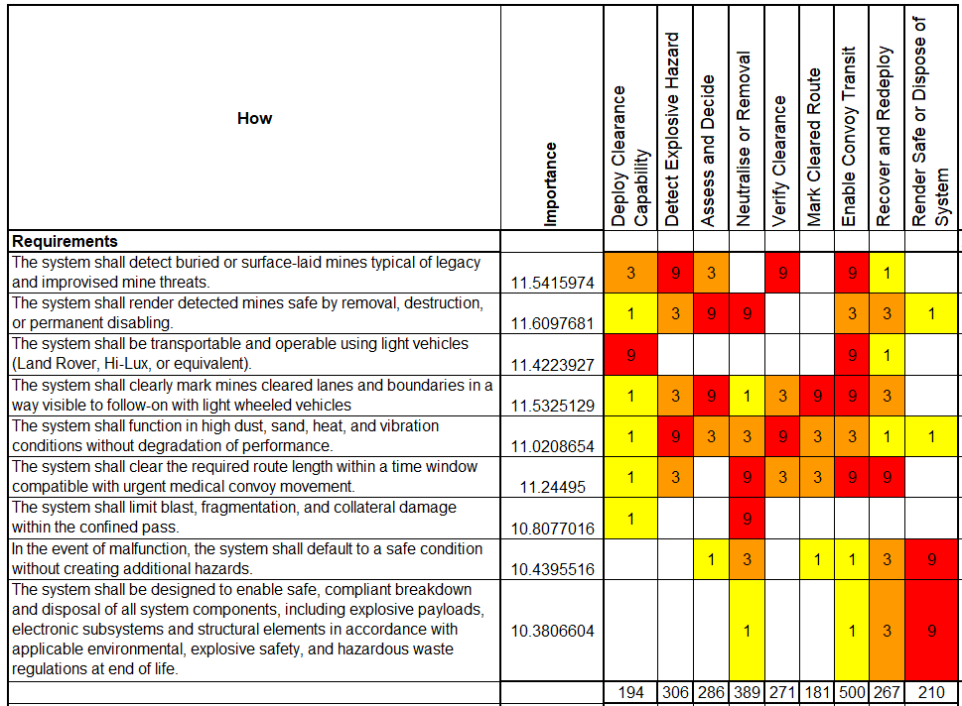
4.2 Design QFD 1
Table 5, Design QFD 1

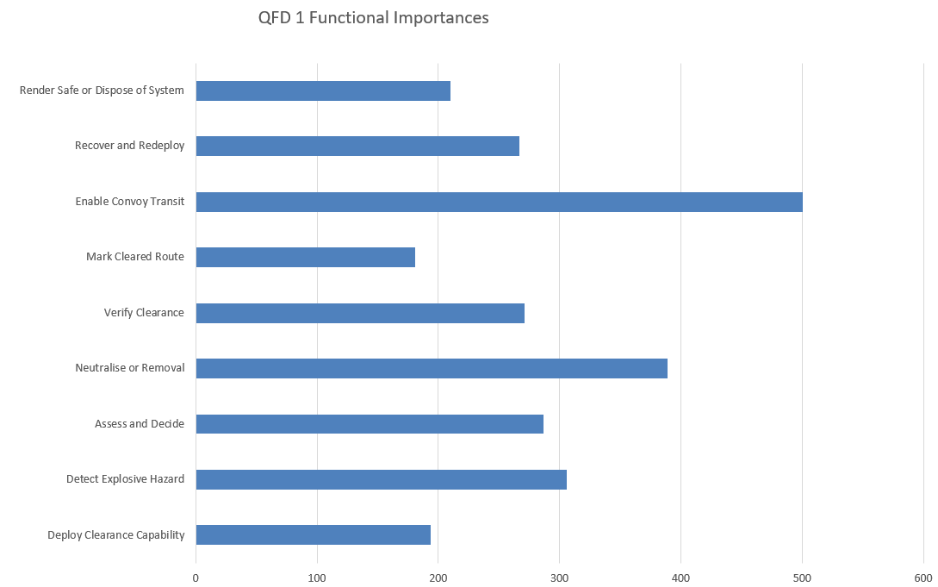
4.2.1 Functional Importance Graph
Figure 2, Functional Importance Graph
4.2.2 The level 1 functions were then placed into the QFD 1 table, where each function was rated against the stakeholder requirements. This gave relative importance values to the functions; these could be used in a graph to visualise the importance of each function against each other.

4.2.3 From the functional importance graph, the areas highlighted are the enabling of safe convoy passage and ensuring neutralisation or destruction of mines, these functions contribute most of the systems success. Functions like route marking, deployment and disposal of the system ranked lower, but these were still important to consider.

4.2.4 The key outcome of this stage was linking functionality to requirements; importantly all the requirements are being considered, this is part of ensuring the system will operate how the stakeholders need it to. Also, it helped to focus early design on the high-impact functions, reducing the chance of over-engineering lower value subsystems. This leads onto the start of concept generation where designs will be based on the systems functions.

5 Concept Derivation and Design Choices

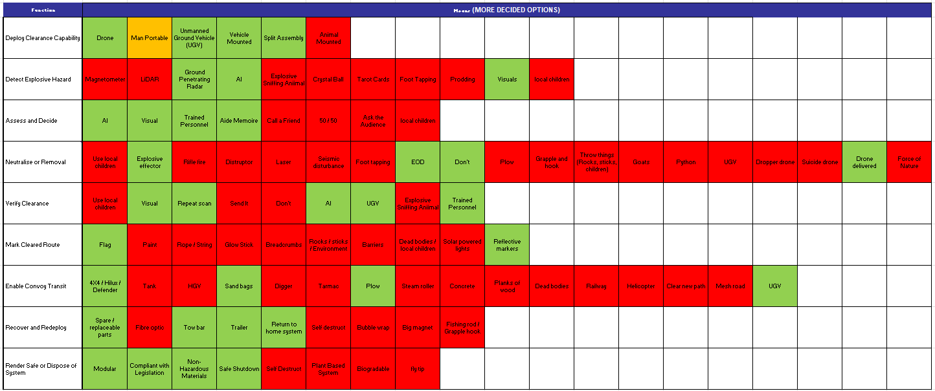
5.1 Function Means Analysis
Table 6, Function Means Analysis

5.1.1 Concept derivation involved generating solutions for each of the functions in a Function Means Analysis (FMA) table. Although some concepts were impractical, their inclusion encouraged divergent thinking and reduced the risk of premature design fixation. This broad thinking ensured a great range of approaches were considered before narrowing down to realistic solutions, which were then highlighted green. Options included manual clearance, animal-based detection, mechanical flail systems and unmanned drones.
5.1.2 By completing this table, all the solutions are directly responsible for completing a critical function, which is also linked to the customer requirements, so each step of the QFD design book ensures that the system operates aligned with the stakeholders’ requirements.

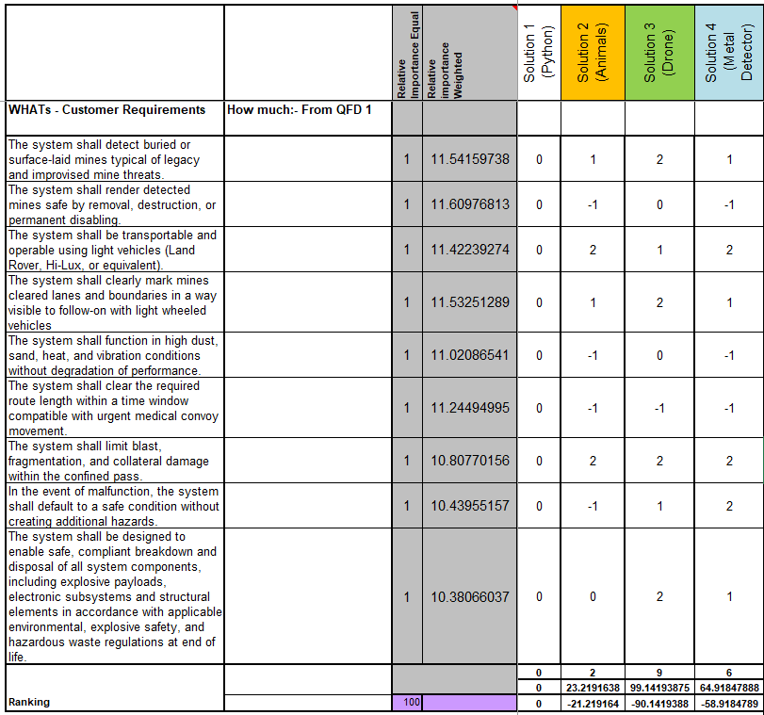
5.2 System Pugh
Table 7, Design System Pugh

5.2.1 After the solutions had already been narrowed down on the function means analysis, there were still 3 possibilities for solutions. Each of these systems was added to a System Pugh table to converge onto the best. The team ranked each of the ideas against the customer requirements, using Python as a datum standard, as this was a proven system that in the design brief was stated not permitted to be replicated.

5.2.2 The Pugh matrix relied on qualitative scoring, which introduced subjectivity, especially where limited performance data exists (e.g. UAV-mounted Ground Penetrating Radar effectiveness). However, group discussion helped to mitigate individual bias.

5.2.3 From this Pugh, the system that suited to the stakeholder requirements the most included the UAV and UGV system that operates in four stages:
- Detection and mine mapping by UAV-mounted GPR (Ground Penetrating Radar).
- Route calculation and UAV-mounted Shaped Charge placement.
- Neutralisation through controlled detonation.
- Route preparation using a UGV plough and flag markers.

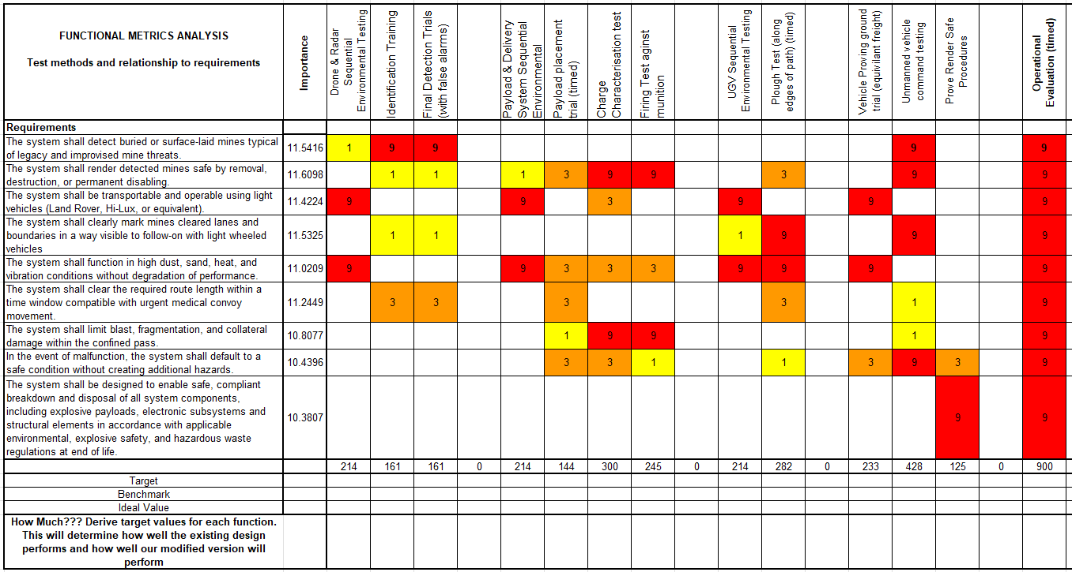
5.3 Functional Metrics
Table 8, Functional Metrics

5.3.1 The functional metrics table was completed by the testing and evaluation team; this could be completed as the design of the system had been chosen. Using the function means analysis, requirements and use case, trials were created that would test each function of the system. This would help to identify where parts of the system need improvement to have the most reliable output.

6 Potential Failure Modes

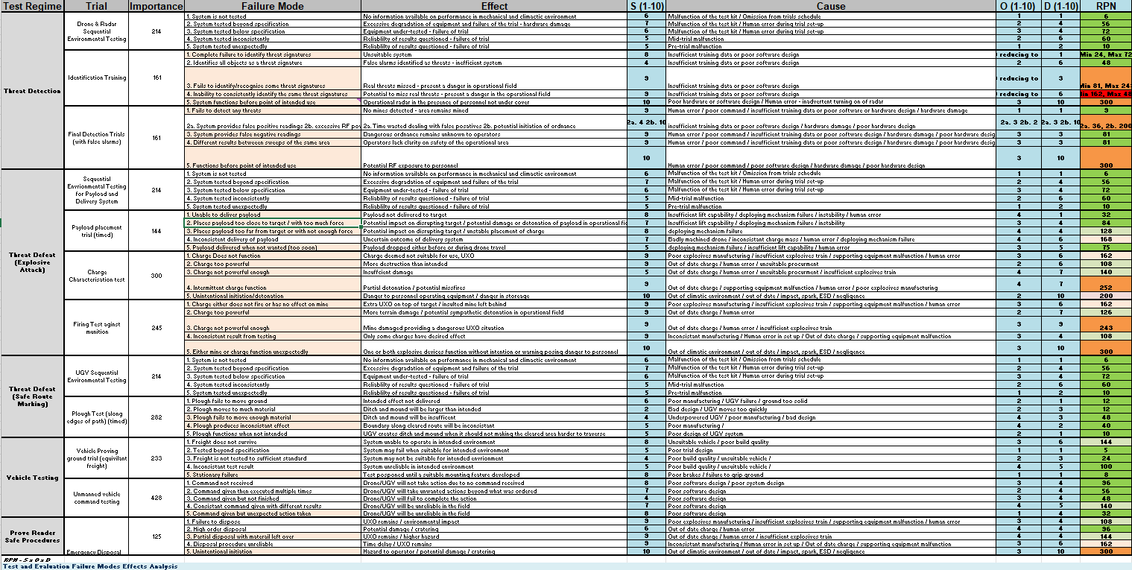
6.1 FMEA Spreadsheets
Table 9, Test and Evaluation FMEA
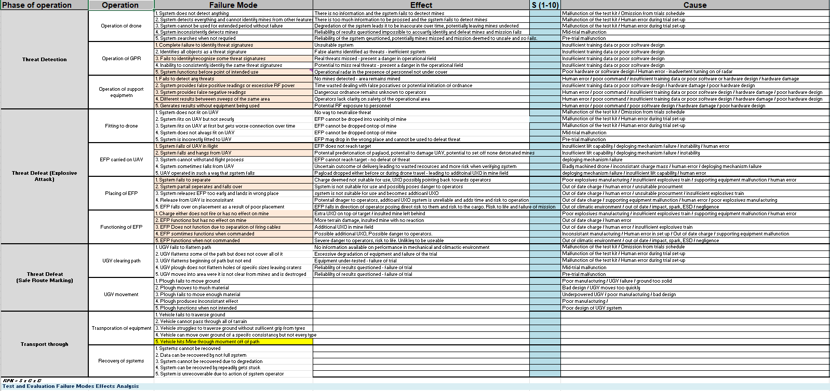
Table 10, Safety on Operations FMEA

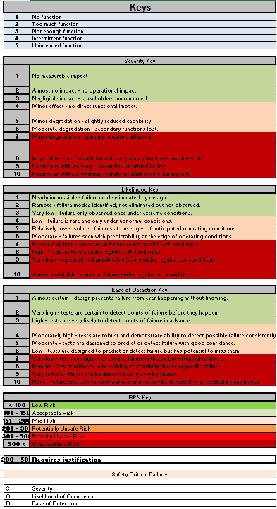

Table 11, FMEA Key

6.1.1 A design failure mode analysis was completed by the test and evaluation team. This was completed to systematically identify potential failure modes within the proposed system and assess their impact on performance and safety. For example, mine identification failure was found as a high-severity failure mode due to the risk it placed on the convoy if a mine was missed during initial scanning, a mitigation for this was completing multiple scans of the same area.
6.1.2 Each failure mode was assessed in terms of severity, occurrence and detectability, allowing risk priority numbers (RPNs) to be calculated and failure modes ranked. The RPN ranking allowed priority of controls to be placed onto the highest risk areas. The benefit of the FMEA is the identification of risks before they are manufactured into the system and only found during testing, incorporating mitigation measures during initial design instead of complete re-design.

7 Critical Design Features

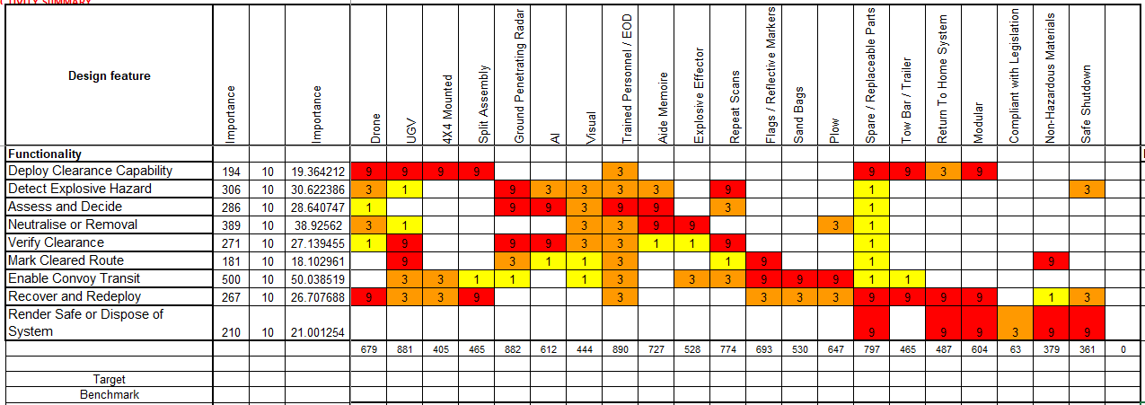
7.1 Design QFD2
Table 12, Design QFD 2

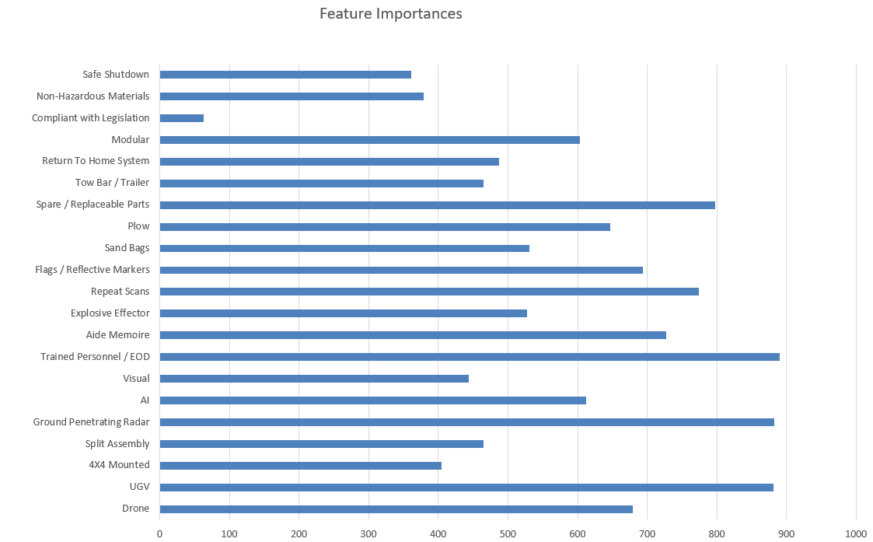
7.1.1 Feature Importances Chart
Figure 3, Feature Importance Graph

7.1.2 In design QFD 2, the systems critical functions are compared against potential function means, with each being given a relative value which is then plotted into the feature importance graph. This graph shows the importance of each function means for the system to complete its critical functions. This is beneficial as it shows traceability of what the system must achieve and how it will be completed, helping to ensure that all functions are adequately supported by the design. The graph also gives easy identification of where priority of effort and risk management should be focused, on the most influential parts of the system.

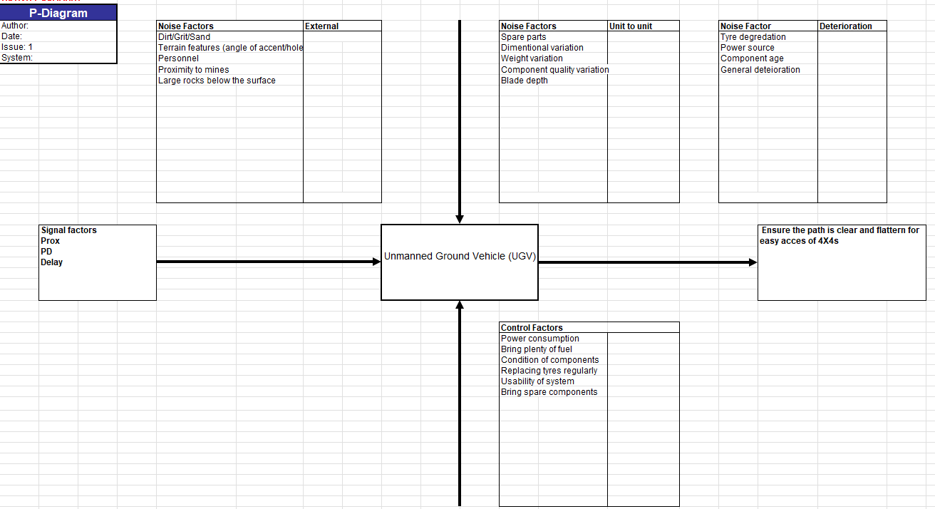
7.2 Prime P-Diagrams
Table 13, Prime P-Diagram

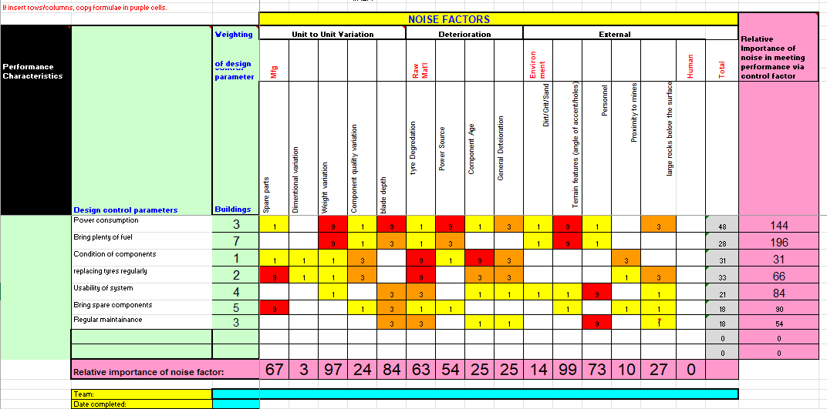
7.2.1 What Why Diagram
Table 14, Prime "What Why"

7.2.2 Control and Noise Factor Graphs
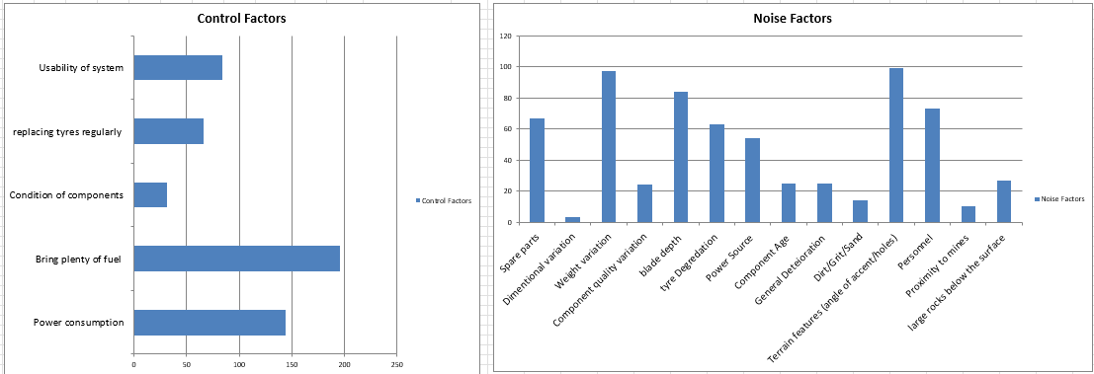
Figure 4, Control Factors & Noise Factors Graphs

7.2.3 To identify the robustness of the features, Parameter designs (P-Diagrams) were completed for the three most important features of the system, this included EOD personnel, GPR and UGV (EOD and GPR shown in Annex A). The P-Diagrams identified control factors and noise factors which introduced variation to operating conditions, this was followed by a “What Why” analysis that provided insight into how well each control mitigated the influence of noise.

7.2.4 This section helps to understand how variation propagates through the system and how small deviations in critical features can result in impacts on the whole system performance, the graphs show the most important control factors and most prominent noise factors to focus on.

8 The Manufacturing Processes

8.1 Manufacturing Requirements
No. | Manufacturing Requirements
1 | Reasonable cost
2 | Volume capability
3 | Reliability
4 | Effective maintenance schedule
5 | Quality consistency
6 | Safe processes
Table 15, Manufacturing Requirements

8.1.1 Due to the complexity of the system, the manufacturing analysis was focused on the PE-8 fill of the shaped charge, which represented one of the most critical components. A table of manufacturing requirements was created, detailing each aspect that should be considered when developing the manufacturing processes.

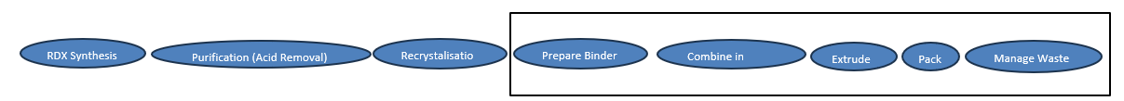
8.2 Process Map
Figure 6, Process Map

8.2.1 Through extensive research, a top-level process map was created. This included materials preparation, mixing of explosive components, mould filling and waste. Due to limited publicly available data on explosive manufacturing, several assumptions and informed decisions based off generic plastic bonded explosives (PBX) were made regarding process methods, which may impact real-world feasibility.

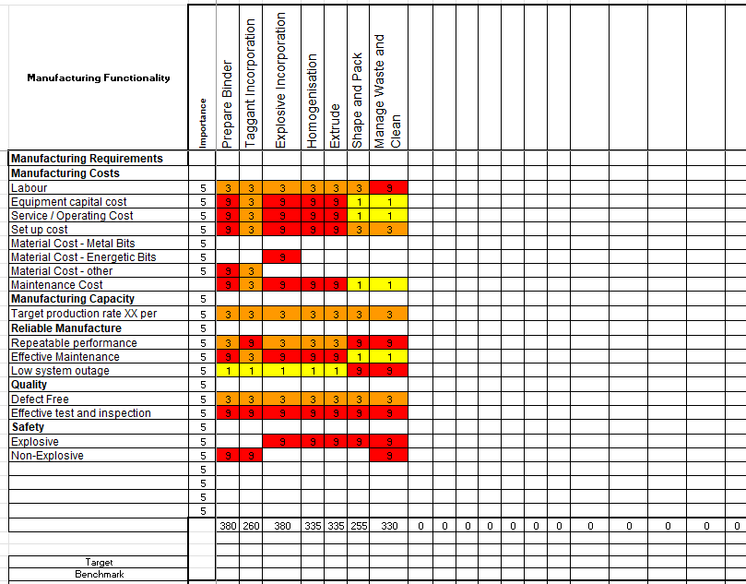
8.3 Manufacturing QFD1
Table 16, Manufacturing QFD 1

8.3.1 Process Importance Chart
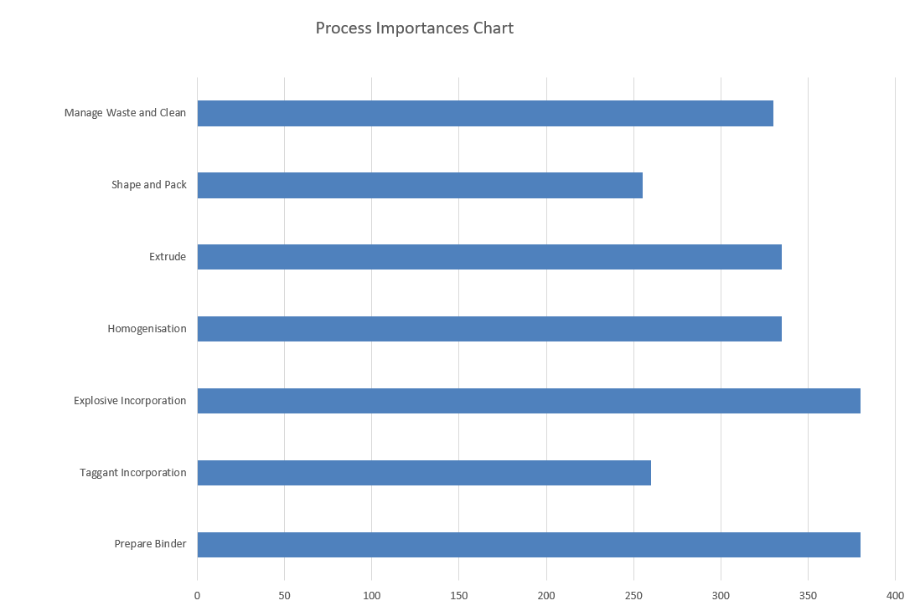

Figure 7, Process Importance Chart
8.3.2 Manufacturing QFD 1 was used to link the manufacturing requirements to the process steps. The resulting relative importance values were used to populate a process importance chart which highlighted the explosive incorporation and binder preparation as the most important steps. This is understandable as material consistency directly impacts the explosive performance. All the steps showed high importance, this can be expected as the process map being at a basic level only lists the most important steps.

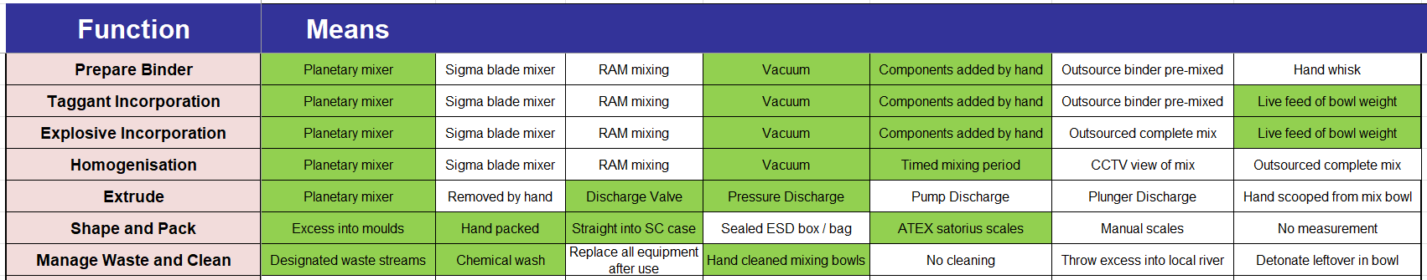
8.4 Process FMA
Table 17, Process FMA

8.4.1 A process Function Means Analysis (FMA) was completed to define how each process step would be completed. Using the FMA structure again allows for the broad selection of proposed ideas similarly to when the design FMA was completed.

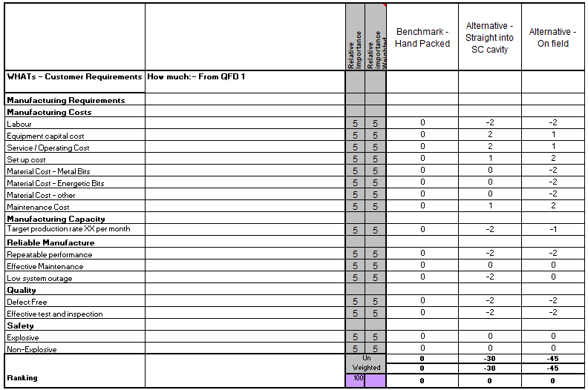
8.5 Process Pugh
Table 18, Process Pugh
8.5.1 A Process Pugh was completed to converge on a way of packing the shaped charge, as the team was unsure if the explosive should be packed straight into the shaped charge or if it should be packed into blocks and stored until use. The Pugh confirmed that the best option was packing it straight into the shaped charge cavity, this also allowed for better contamination and void control from being included in the manufacturing process instead of being done later.

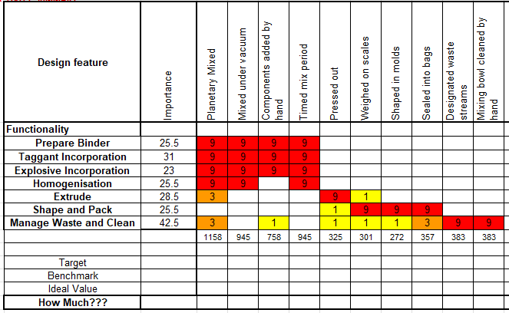
8.6 Manufacturing QFD2

Table 19, Manufacturing QFD 2

8.6.1 Manufacturing Means Importance
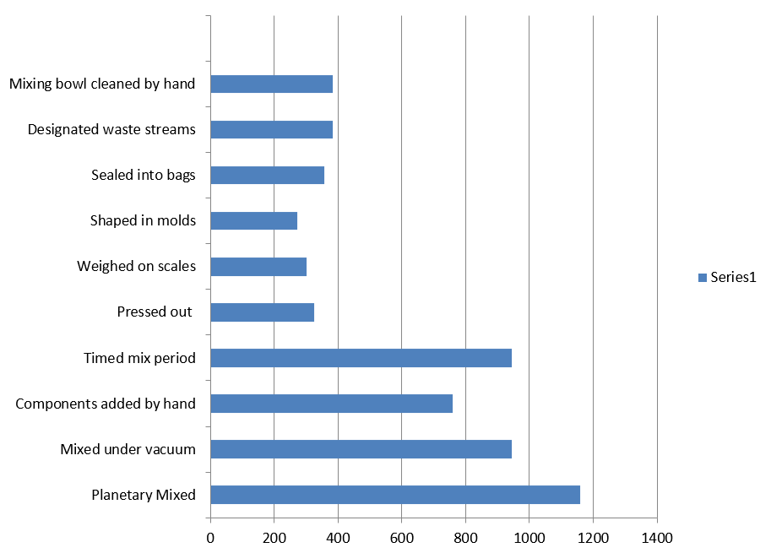

Figure 8, Manufacturing Means Importance
8.6.2 Manufacturing QFD 2 compared the process steps to the chosen process means, these values were used for a means importance graph that shows the most important function means for achieving successful explosive manufacture.

8.6.3 The selected methods could utilise automation for the mixing steps which is beneficial to remove any human error and mixing remotely increases operator safety. However, the cost of setting up automated mixing would be high, so all other processes including packing were decided to be done by hand.

8.6.4 This section demonstrates how systems engineering tools ensure that the design remains grounded in realistic production capability, it also brings up risks such as contamination at an early stage. By picking realistic processes early on, feasibility is increased while minimising the costly risk of a re-design later in development.

9 Critical process Steps

9.1 Manufacturing QFD 3
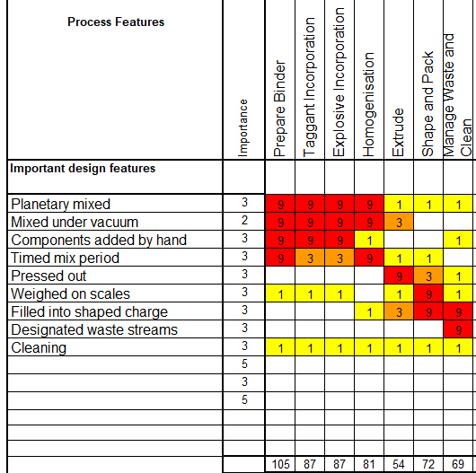

Table 20, Manufacturing QFD 3

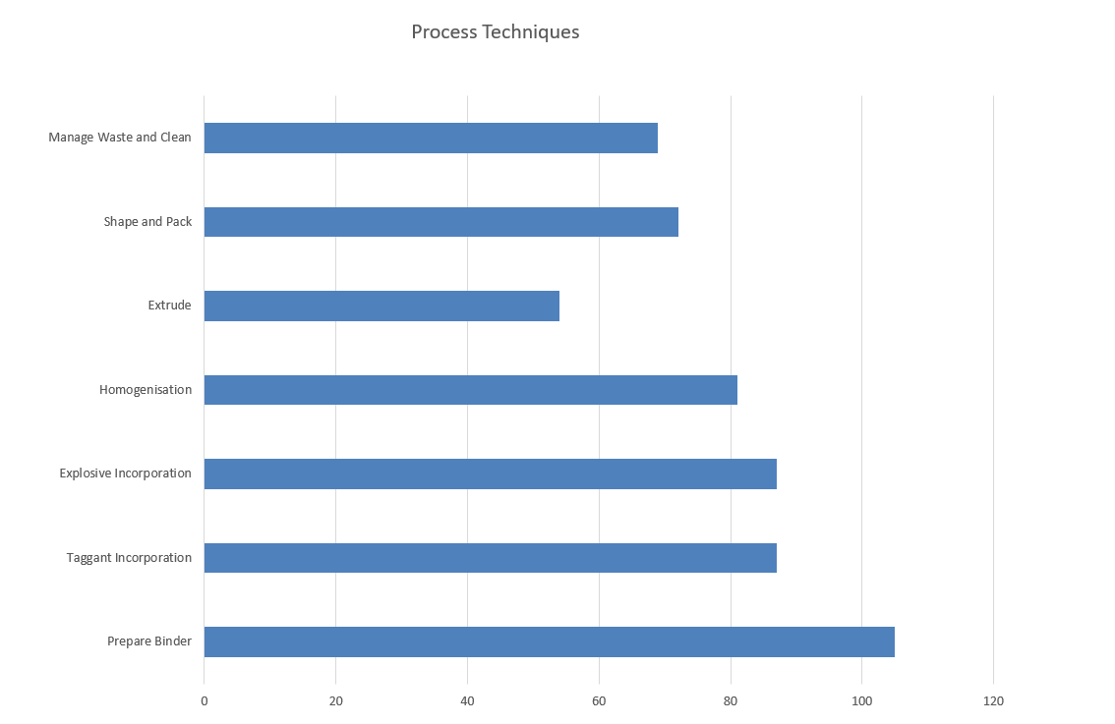
9.1.1 Technique Importance Chart

Figure 9, Technique Importance Chart

9.1.2 Manufacturing QFD 3 was used to identify and analyse the most important process steps within the shaped charge manufacturing process. The graph created from the values gained from QFD 3 show that the initial mixing steps are the most important, which is to be expected as the components added and mix quality have the greatest effect on the performance of the shaped charge.

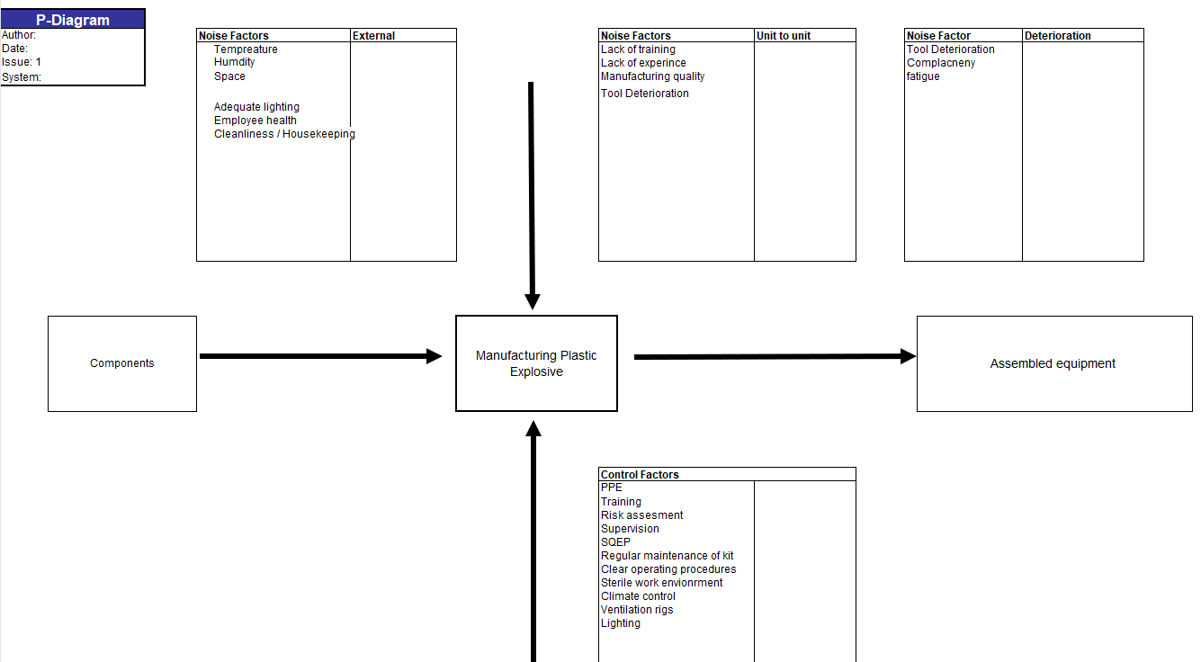
9.2 Manufacturing P-Diagram
Figure 10, Manufacturing P-Diagram

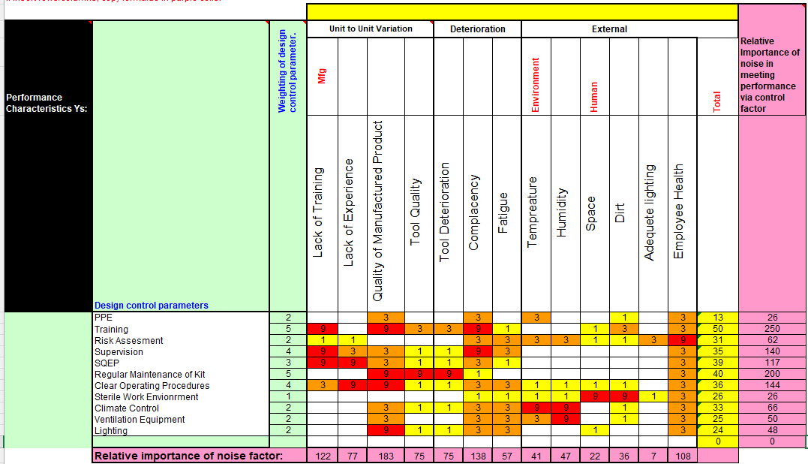
9.2.1 “What Why” Table
Table 21, Manufacturing "What Why"

9.2.2 Key Controls Chart
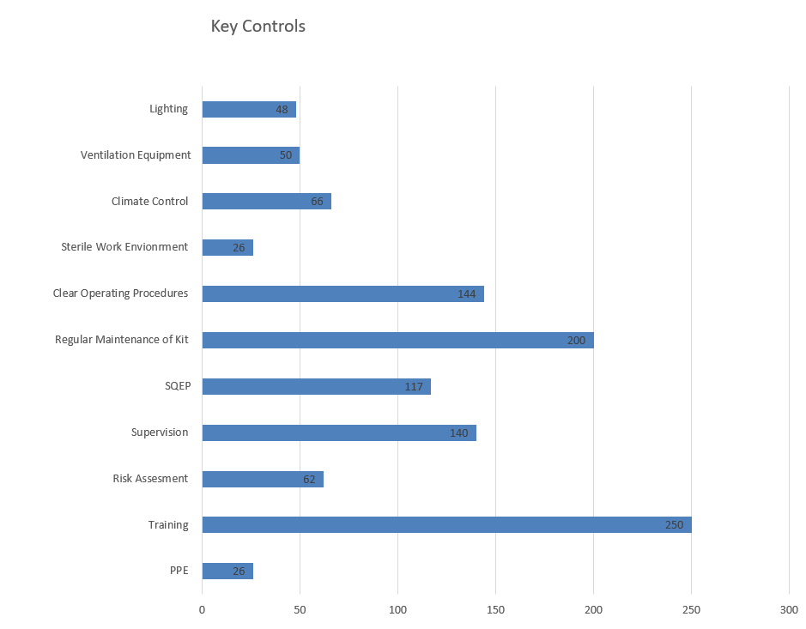

Figure 11, Manufacturing Key Controls

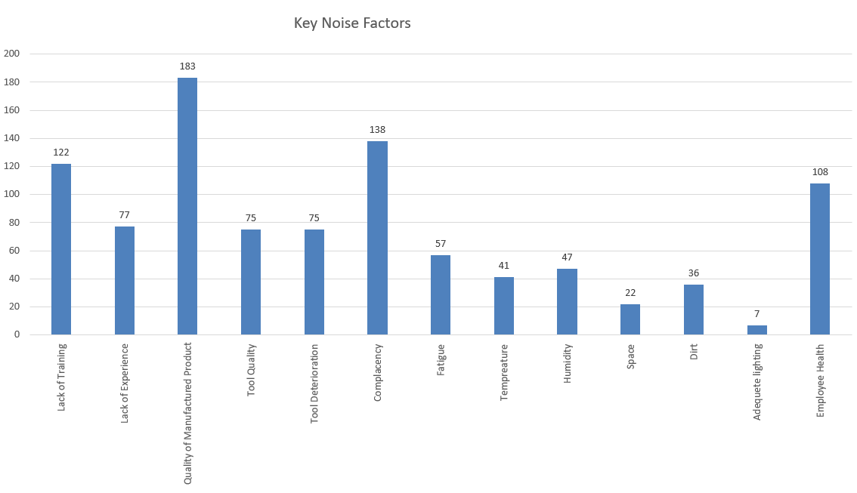
9.2.3 Key Noise Chart
Figure 12, Manufacturing Key Noises

9.2.4 Parameter diagrams were applied at this stage to understand variation in the processes. Control factors included maintenance, training and PPE. The “What Why” table highlighted that operator performance and maintenance of equipment were critical for the successful completion of the mix.

9.2.5 These systems engineering tools highlighted where controls were needed and shows that not all process steps need the same level of control, each one is different and some need more than others. By identifying the critical process steps, it is found where the biggest impact on quality and safety will be. Implementing controls improves efficiency while maintaining high standards, supporting the overall goal of producing a reliable product.

10 Process Control Measures

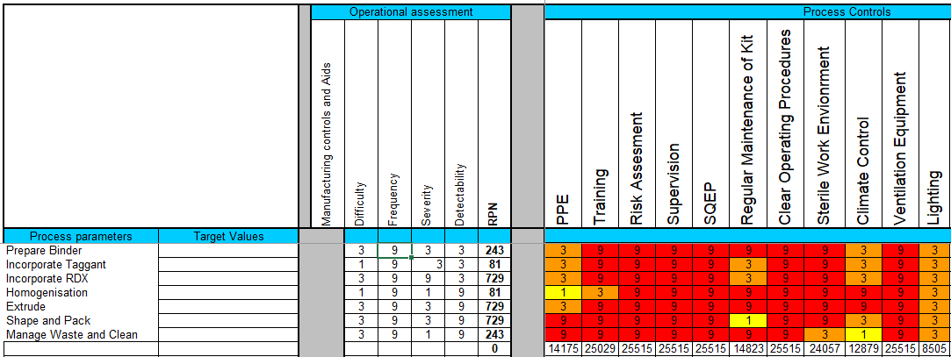
10.1 Manufacturing QFD 4
Table 22, Manufacturing QFD 4

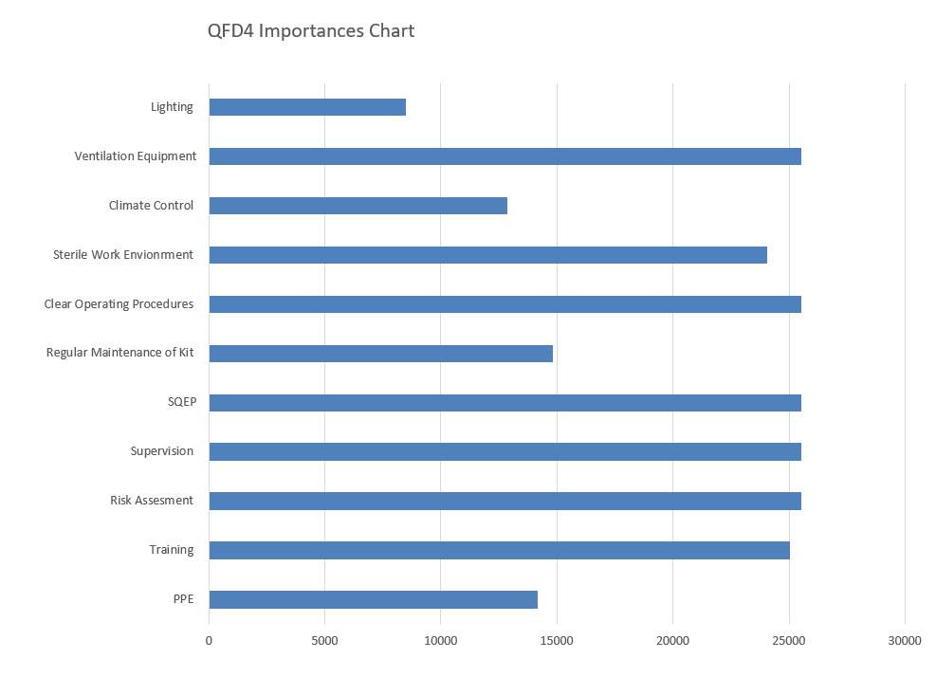
10.1.1 Importances Chart
Table 23, QFD 4 Importances

10.1.2 The final manufacturing QFD 4 and process control plan were used to define appropriate control measures to ensure that the process steps consistently result in required outcomes. Without effective controls, process variability could degrade the explosive performance, undermining an otherwise robust design. Further analysis through P-Diagrams can be completed but was not in this case due to time constraints.

11 Waste and End of Life Disposal
11.1 Inputs from the disposal representative were integrated throughout the whole of the QFD process, emphasising things like modular design for ease of disassembly and recyclable components where possible. During manufacture, waste streams were required to control the output of waste so that everything went to the correct disposal method, while compliant with environmental and explosive regulations, feeding back into the design choices for sustainability and closing the life-cycle process.

12 Conclusion
12.1 The application of QFD, supported by Pugh matrices, FMEA and Taguchi P-Diagrams, enabled the structured development of a UAV / UGV mine clearance system. This approach ensured that stakeholder requirements were translated into design, manufacturing and lifecycle considerations with clear traceability.

12.2 The final concept integrated UAV-based detection and neutralisation with UGV assisted route preparation, reducing personnel exposure while maintaining operational effectiveness. Key design strengths include the systems performance being aligned with manufacturing feasibility, as well as identification of high-risk areas such as detection accuracy and explosive processing.

12.3 However, the process relied partially on assumptions, particularly regarding the UAV-mounted GPR performance and explosive manufacturing methods, which would require further validation. Overall, the study showed the value of systems engineering tools in managing complexity, supporting informed decision making and developing a robust, safety-focused solution.

13 Reflection
13.1 The application of systems engineering tools highlighted their effectiveness in structuring the development of a complicated system. However, a key challenge was the time-intensive nature of the methodology used, which limited the depth of later-stage analysis. Additionally, some decisions relied on subjective judgment due to limited data, particularly surrounding concept selection and manufacturing planning. Realistically, the PE-8 explosive mix would likely be bought in from another manufacturer, as the low quantity needed for the mission would make the cost to set up to manufacture out of budget.
13.2 Despite the drawbacks, the collaborative use of the tools improved communication between team members and gave a feel for how effective they would be in a professional environment.

Total Word Count - 2746

14 References
[1] R. Wolniak, “The use of QFD method advantages and limitation.”, Production Engineering Archives, Silesian University of Technology, Sciendo, 2013, Available Online: (PDF) The use of QFD method advantages and limitation, Accessed 20/04/2026.
[2] Y. Akao, G. Mazur, “The leading edge in QFD: past, present and future.”, International Journal of Quality & Reliability Management, Emerald, Vol 20 No. 1 2003, Available Online: (PDF) The leading edge in QFD: Past, present and future, Accessed 21/04/2026.
[3] L. Chan, M. Wu, “Quality function deployment: A literature review.”, European Journal of Operational Research, Vol 143 Issue 3, 16 Dec 2002, Available Online: Quality function deployment: A literature review - ScienceDirect, Accessed 21/04/2026.
[4] D. Frey, P. Herder, Y. Wijnia, E. Subrahmanian, K. Katsikopoulos, “The Pugh Controlled Convergence Method: Model-Based Evaluation and Implications for Design Theory.“, Research in Engineering Design 20(1), OAI, Oct 2009, Available Online: (PDF) The Pugh Controlled Convergence Method: Model-Based Evaluation and Implications for Design Theory, Accessed 21/04/2026.
[5] IfM, “Design Management”, University of Cambridge, Available Online: Controlled convergence, Accessed 21/04/2026.
[6] A. Chakrabarty, S. Mannan, T. Cagin, “Process Safety.”, Multiscale Modeling for Process Safety Applications, Butterworth-Heinemann, 2016, Available Online: Failure Modes and Effects Analysis - an overview | ScienceDirect Topics, Accessed 21/04/2026.
[7] S. Berga, “Advanced Techniques for Quality Management: The Failure Mode and Effects Analysis (FMEA).”, Available Online: https://upcommons.upc.edu/server/api/core/bitstreams/9dfeead8-f248-449d-afb7-179c5a21b638/content, Accessed 21/04/2026.
[8] L. Pangeni, “The Hidden Power of the P-Diagram in Engineering Design”, Accendo Reliability, Available Online: The Hidden Power of the P-Diagram in Engineering Design - Accendo Reliability, Accessed 21/04/2026.

15 Annexes

15.1 Annex A

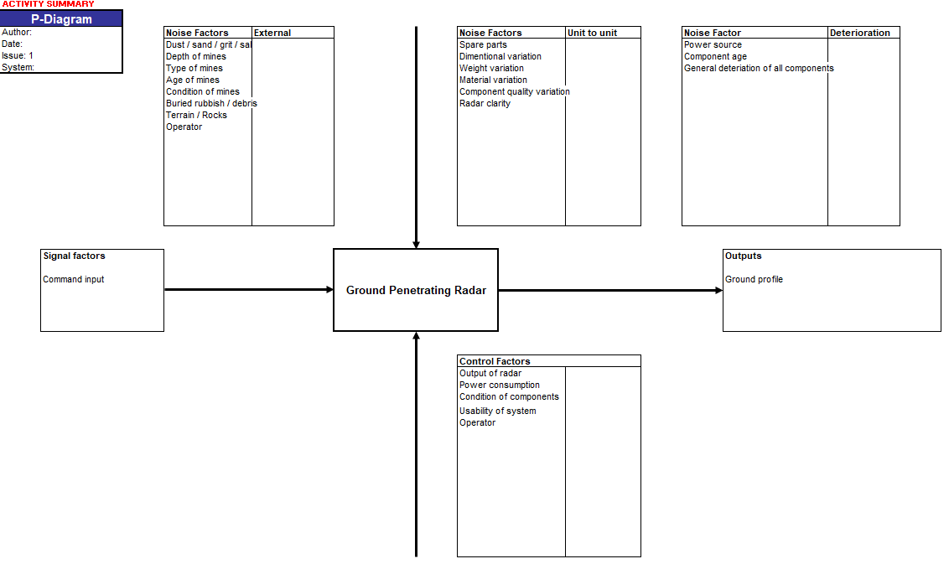
15.1.1 Extra QFD 2 What Why tables, P-Diagrams and Graphs
Table 24, GPR P-Diagram
Table 25, GPR "What Why"

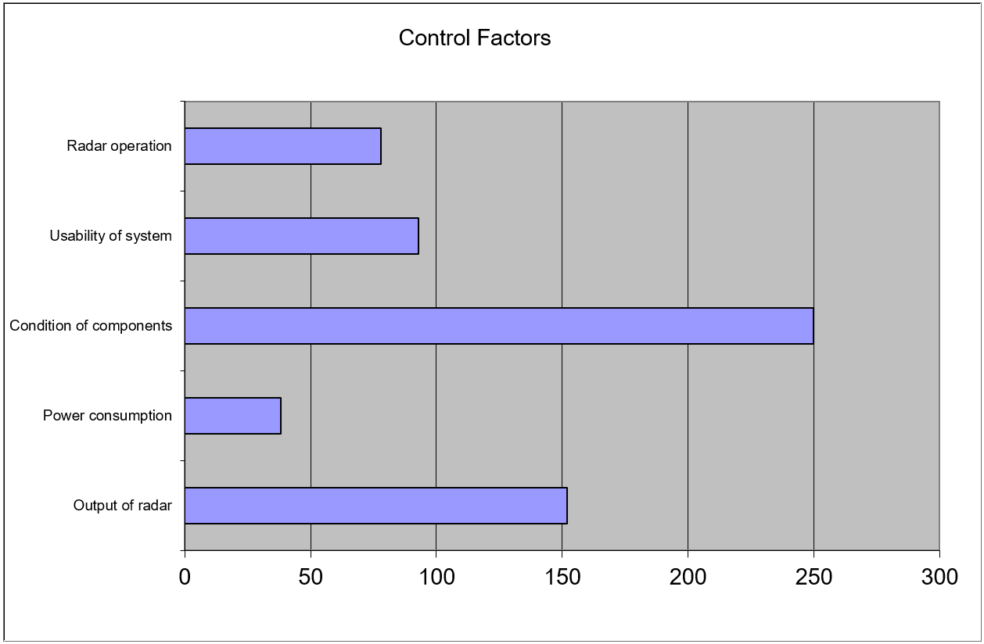

Figure 13, GPR Control Factors
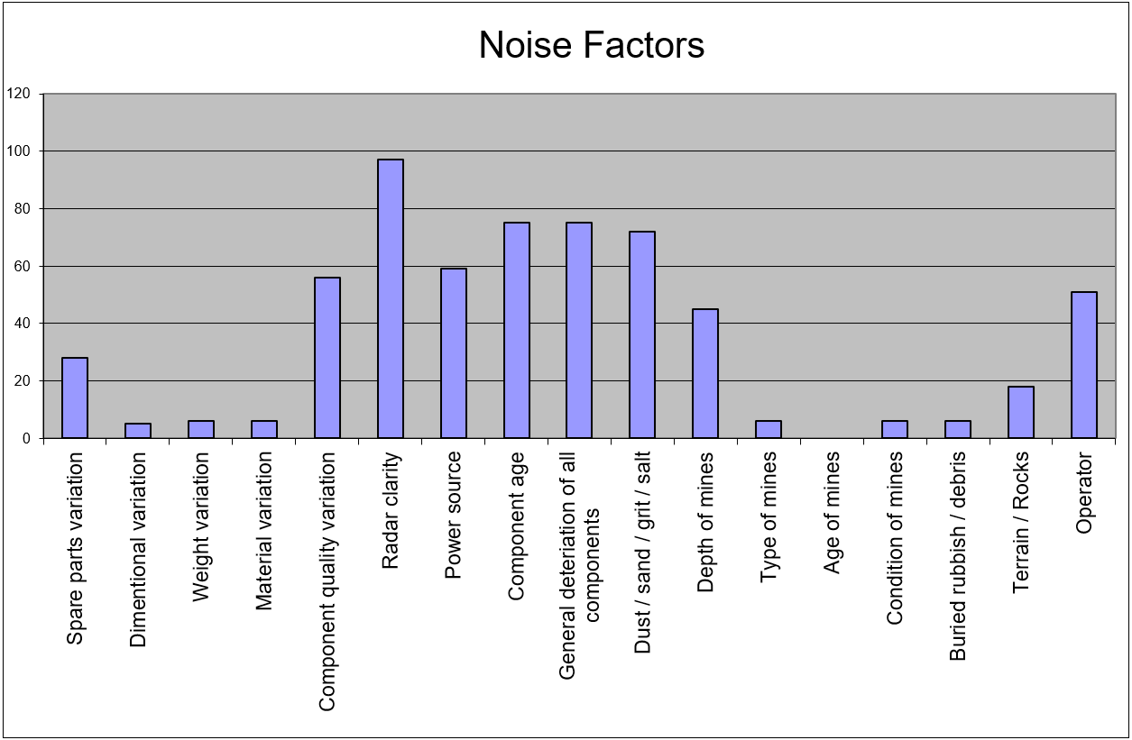
Figure 14, GPR Noise Factors

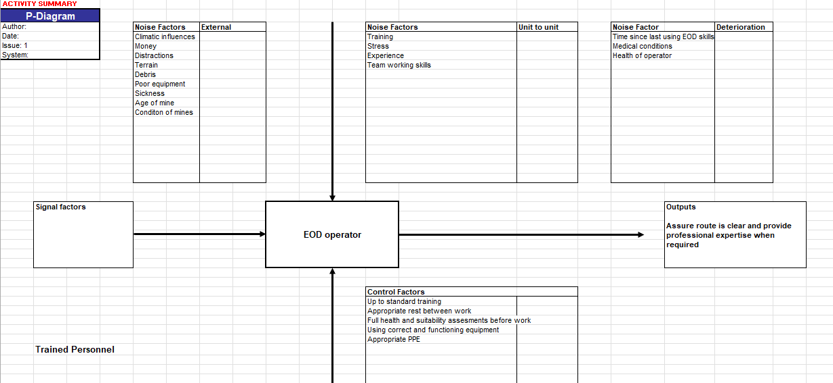
Table 26, EOD P-Diagram
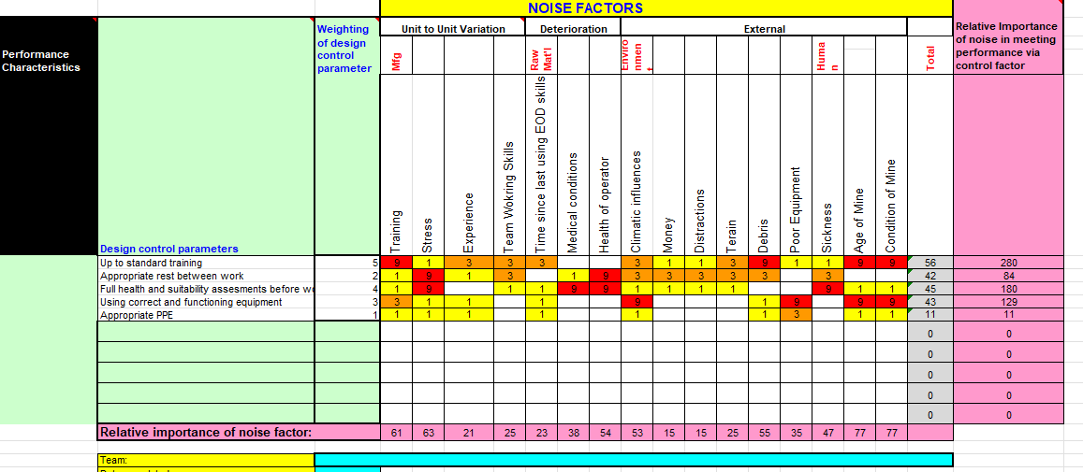
Table 27, EOD "What Why"

Control Factors
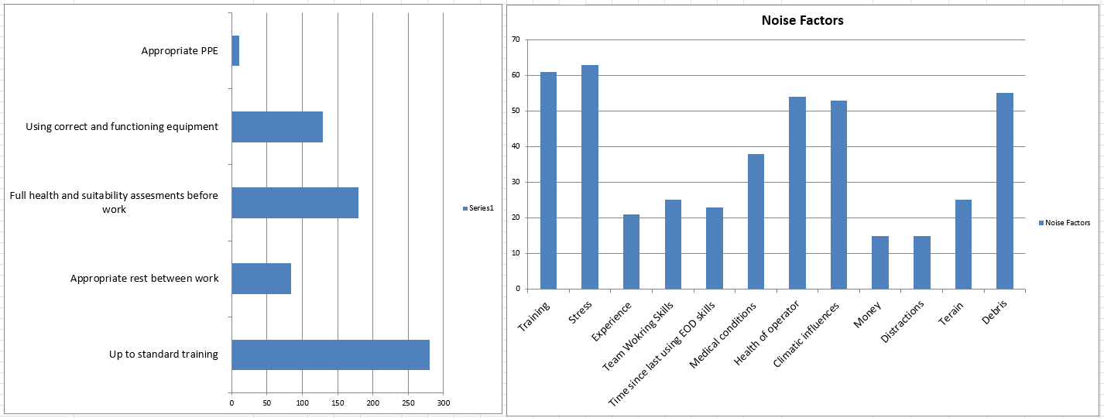
Figure 15, EOD Control Factors and Noise Factors

