

Task 1 – Reading Task Template
Upload your photo of your A3 in-class notes here:
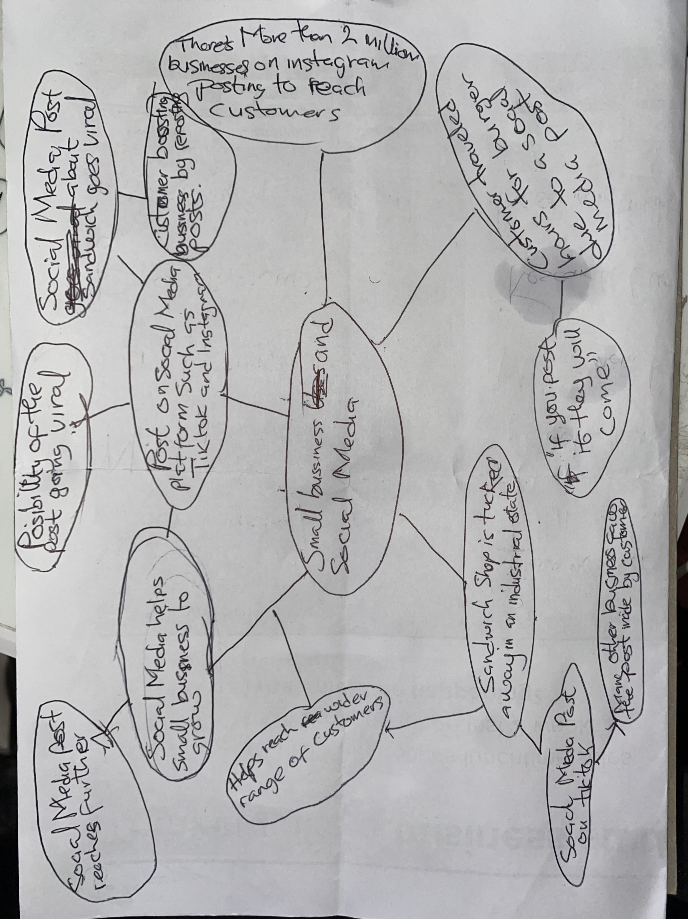

1. Answer these questions using the sentence starters below
a. What is the main idea of the text?
How social medial can help small businesses excel
b. What are two key points?
1. Very Effective tool for businesses if used the right way
2. Most people will skip an ad but will not skip a skit about how authentic your product is and maybe share it with others. “People buy from people”
c. What part of the text did you find most important? Why?
The most important part is most businesses in UK thrive on social media or post going viral which helps their livelihoods.
d. Was anything unclear or difficult to understand?
I was not sure about how the article was written it seemed a bit scattered and not clearly stating the purpose of the article in the end but I figured it out
e. How did your group help you understand the text better?
My group helped me by sharing ideas and comparing what we wrote down to get better understanding of or notes
3. One sentence reflection
Question: What did you find challenging about this task?
The hardest part was reading through the article to find a specific subject to add to my mind map.

