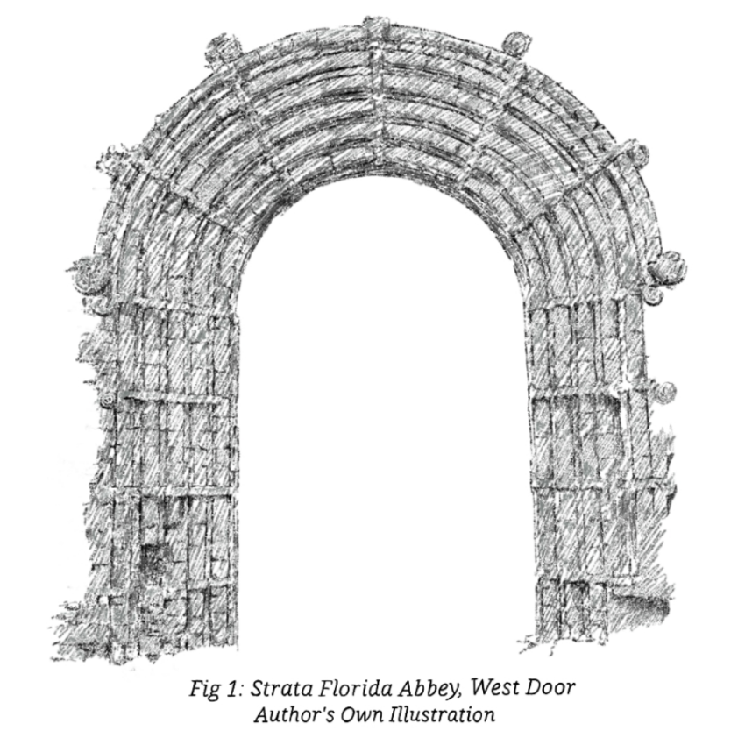
The West facing door of the Strata Florida Abbey is the main part of the Abbey left standing today. It was built in 1164 and founded by monks from the Whitland Abbey [1]. What I found interesting was the mix of origin of architecture in the door, which would have been the one that the public would have seen.
The curved pipe-like design of the arch is Norman, like the monks who founded the Abbey would have been. The swirl designs around the edges, however, are Welsh Celtic in nature. This is interesting, because the church would have been supported by England, and the monks are showing support to Welsh culture, which would have been a bold move at the time.

[1] Phil Carradice. Strata Florida Abbey. 23-07-2012. https://www.bbc.co.uk/blogs/waleshistory/2012/07/strata_florida_abbey.html. (Accessed 2023-21-10)

