Mrs Julie Anne Simpson

BA Youth and community

2019

Rural Youth work
The contribution to the
lives of young people.



Abstract
The research in this paper considers, can youth work in rural communities help and support young people in their lives.
The aims of the study are to show that, by young people, having youth workers and being able to engage in youth work activities would help young people gain better outcomes in their lives.
Through questionnaire’s in a mixed methods approach with young people living in rural communities in wales, data was discovered to provide the results that show that the impact of youth workers and youth work activities had positive impacts upon the lives of young people it reaches.
All research agrees with the youth work in wales: principles and purposes (YWRRG,2018)

Acknowledgements
I would like to take this opportunity, to say Thank you to all of the people that have helped support me through this applied research project, Family, friends, colleagues, classmates and lecturers for their support during this applied research project.
To all youth and community degree lecturers, that have inspired me not only during the writing of my applied research project but throughout my time on the course. There has been many a time, that I have thought, I could not carry on, but your belief in me, the support and dedication have got me through every time. Thank you.
To Eve Warburton, friend and, executive widening participation and community engagement officer(uwtsd) Thank you, you believed in me when, I didn’t really believe in myself. You helped me return to education and helped me to pursue my youth worker dream. Thank you
To my family and friends, who have understood, my dedication to my studies and haven’t had much of me in their lives, the last three years and especially over the last six months researching for my Applied research project. Thank you.
To my Husband and children. Thank you for giving me time and understanding.
And a final Thank you must go the young people who took part in my study and to the staff and young people within youth justice Ceredigion, for my fieldwork time, for giving me input for the applied research and being truly inspirational.
Julie Simpson

Table of contents

Chapter 1. Introduction. Page 6
Chapter 2. Literature review. Page 9
Chapter 3. Methodology of data collection. Page 15
Chapter 4. Presentation of results. Page 20
Chapter 5. Discussion, critical reflection and conclusion. Page 29
Chapter 6. Recommendations for practice. Page 33
References. Page 36
Appendices.
Appendix 1. Ethical approval. Page 40
Appendix 2. Letter of information. Page 56
Appendix 3. Consent forms. Page 58
Appendix 4. Copy of questionnaire. Page 61
Appendix 5. Questionnaire responses. Page 63

CHAPTER ONE

INTRODUCTION

Introduction
My research stirs from both passion of youth work and the compassion to help young people through troubling times in their lives. I have noticed in my three years of study on the youth and community degree at the University of Wales, Trinity Saint David, that the community that I reside in, has no youth led community space or activities, either run by young people or youthwork. By research and while looking for placements during my time on the course, I have identified that the county of Ceredigion does not offer many youth provisions compared to other county’s throughout Wales (2015-16,statistics first release pg.2).
Starting this research, I feel there is a need to verify if youth work can help these communities? What type of youth work would help? And the impact of involvement and non-involvement.
In Ceredigion, villages can be isolated and neighbours can live up to a mile away from each other. This is especially difficult for young people who do not have the transportation to get them to places, this can have an impact on young people and can affect their personal emotional and social development. It can leave young people feeling stressed and anxious with low self-esteem, and can have a knock-on effect with mental health issues on the rise for young people in Wales. This has been addressed recently within the Welsh Government. The Welsh Government alongside NHS Wales are currently leading a ‘Together for Children and Young People’ programme (T4CYP) to improve emotional and mental health services for young people in Wales. Two of the programme focuses are: promoting wellbeing and resilience in young people and, early identification and identification. (Welsh government,2018) This research will link into these two focuses underlined by the T4CYP and explore the question can youth work in communities help and support young people in their lives.
I am hoping that through this Applied Research Project, young people will benefit because after completing my degree in Youth and community, I am looking to open a youth centre in my local area, to support young people in their development. Young people need to feel empowered and included and to be allowed to expressed themselves and participate in activities that enable them to be educated. These five pillars of youth work in Wales are the core values of youth work to offer these opportunities to young people (YWWRD,2018.pg 6).
This Applied Research Project that looks at rural communities, the impact on young people and how youthwork can help, this can used within my professional practice and development when I apply for funding and community support if the research proves it would have a positive impact on the lives of young people.
The methods that I will use for data collection are questionnaires and focus groups with young people and questionnaires and interviews with youth workers, professional and volunteer – These are the methods that will help me find out the answers that I am searching for. There are not any research limitations apart from word count meaning this will be a small-scale project, when it does have the scope to be more in depth.
I look forward to engaging in the Applied Research Project and building on the concepts, skills and techniques that I have developed. I will know research the literature surrounding this subject to enhance my knowledge of the research area.

CHAPTER TWO

LITERATURE REVIEW

Literature Review
The purpose of this literature review is to research if youth work in rural communities in Wales help support young people in their lives and aims to gain knowledge into where youthwork can help and support young people.
The literature review will look closely at three main elements:
- What support do young people need?
- Rural communities and the implications on young people.
- What can youth work offer young people in their communities?
The literature in my review has come from books, peer reviews journals ,pdf’s and websites.
What support do young people need?
Ingram and Harris (2001) refer to the needs of young people as things that young people need in order to live and to thrive; like water, food, warmth, shelter and clothing. Maslow (1982) agrees, and proposes that we cannot meet higher needs if the basic needs are not met. Without these basic needs being in place there is a lack of focus for meeting other needs. Young people’s needs are often part of an emotional framework, where they have a need for friendships; other people that will make them feel valued and appreciated. This links in with the need for security and not having to accept major responsibilities and having a safe place to live where they are free from fear. Young people need challenge and stimulation: doing exciting things to break daily life patterns and conquering fears. They need to learn how to cope with authority and to handle this in a positive way such as discussions with teachers, police and other officials. Young people need to be able to cope with sexuality and different sexualities, and accepting themselves as sexual beings and the responsibilities this brings. (Button,1974)
(Pringle 1980) describes the developmental needs of young people which are important for their growth and the transition into adult life. These are:
Emotional needs - knowing their feelings and recognising that others have feelings.
Social needs – building and keeping friendships, communicating freely with respect and treating everyone equally.
Physical needs – coordination and balance skills and the need for body knowledge and confidence and how to keep their bodies well.
Cognitive needs – using the brain, keeping educated and stimulated.
There are also spiritual needs developing right from wrong. Development of academic and political needs are important in today’s social climate to understand the concept of power and how the world is changing.
The need in my opinion for young people is the need for empowerment and this links in with one of the five pillars of Youthwork Wales (2018) When young people are empowered, it raises their confidence and that helps them to move forward by being encouraged and enables them to aspire to further achieve.
There may be debating literature on the needs of young people but they all seem to agree that to identify these needs we need to be where the young people are, observing, listening, investigating and running participatory activities. This is further backed up by Max-Heefs,(1991) who suggests that if young peoples need for participation is not met then this will impact on other areas of their lives. This is why Youthworks try to encourage participation as we know that this encourages other human needs such as creation, identity, recreation, understanding, affection, protection and survival.
Rural communities and the implications on young people.
Life for young people living in rural communities is often portrayed as having distinct advantages and disadvantages and these can have implications on young people’s sense of self and their wellbeing. Recent studies (e.g., Matthews et al., 2000; Ní Laoire, 2000; Jamieson, 2000) have asked to what extent images of rural youth lifestyles, are viewed as isolating, limiting and socially exclusive, and in other ways, as healthy, idyllic and socially inclusive. For Shucksmith(1990), one important conclusion was that rural youth lack a ‘voice’ in their home communities, and that they are not engaged in local meetings to do with their communities. (Tyrrell,N.and Harmer,N. (2015) This is where youth work can step up and provide services to support young people.

According to Bawden (2009) The advantages of living in rural communities are, security and safety, and young people have knowledge of the area and the people that live there. Crime rates are lower. Space and privacy are an advantage although privacy can be contradictory as everyone knows everything and everyone. Disadvantages appear high on the agenda for young people. The issues they have with rural life are transport, isolation, limited opportunities and bad internet connections which lead to insufficient social inclusion. There is insufficient life skills knowledge for young people in these areas compared to the young people living in urban communities. (Bawden,2009)
Through looking at all the research and data on the issues surrounding young people and rural communities, it is clear there will be negative implications for young people, if they do not get support and guidance during this important transition in their lives. Mental health will become a bigger problem as well as young people’s health and well-being.
What can youth work offer young people in their communities?
Youth work has a value base that is grounded in respect for young people and in the values of inclusion and equal opportunity. Through the voluntary relationship that youthwork has with young people it offers openings for learning in educative, expressive participatory inclusive and empowering ways (Ywrrg,2018).At the heart of youthwork is respect and we work where young people are, with a positive, participative and anti-oppressive approach .Through engaging with young people youth work aim to value address the needs and interests of young people(sapin,2013)
Downshifting for a simple life of country air, may be the ambition of many adults, but for young people life growing up in rural communities, it can mean boredom and isolation. Having to get up extra early to catch the bus to school, relying on parents for lifts and not being able to just pop round to friends' houses are just some of the issues these young people have to endure.
Research studies have picked up on the importance of youthwork, with youth workers been seen as good role models, with respect and understanding of young people’s lives and how young people can be supported. Youthwork is important in helping young people build relationships generations by drawing on common ground. This safe relationships with adults help these young people to explore adulthood and develop new skills and confidence which then helps the m feel a belonging to their community. (The benefits of youthwork,2008)
The focus of this research is to identify the need for youth work in rural areas in Ceredigion to do this the next chapter of this paper will look at the method and methodology that will be used to conduct a research into the lives of young people in rural communities and the need for youthwork provisions.

CHAPTER THREE

METHODOLOGY FOR
DATA
COLLECTION

Methodology for data collection
The research question that I need answering is, can youth work in rural communities help and support young people in their lives? As referred to in the literature review young people in rural communities can feel isolated and lonely at times.
My personal feeling is that young people are not supported enough in these rural towns and villages and the rise in mental health issues could be a factor relating to this. I believe that if more support was given to young people, the future generation, we can then provide happier and better communities with a happier more prosperous future. The purpose of this chapter is to determine young people’s feelings on this issue, and identify if youth work in rural communities is a need and how it could be effective.
The approach I decided to take was to use online questionnaires. I wanted to reach a broader audience, and at this time of year, with the majority of young people being on holidays, this seemed the most productive way for me to get the answers due to the timescale that was left to complete the applied research project. I made up a questionnaire with twelve questions, named “Youth work in rural Wales.” It was made short for two reasons. One was academic as word count for the applied research is low and a shorter questionnaire has less to analyse and data proper, so I made sure that I had the specific questions I needed to proceed. The second reason is when questionnaires are too long young people get easily bored and do not complete them properly or use little thought, sometimes not even reading all the questions properly.
I compiled the questionnaire using google forms, this method enabled me to set participation numbers, which I set to thirty participants. I felt this was enough for me to get the data that I needed for this short-applied research project, this method enabled me to reach a broader range of participants.
I asked for data on age and gender, as I wanted to find out if there was a difference in gender in participation of youth work and what were the opinions of different ages. I added age ranges of eleven to fifteen, sixteen to twenty-five, and twenty-five and over. I wanted to hear from the twenty-five and overs to see if they felt they could have benefited from youth work experiences when they were younger. In this section I will explain my questioning. I asked the questions, (3) Can you describe what a youth worker does? This was a question I wanted to know from the start that, the role of the youth worker was understood because even when I am running workshops and clubs, some young people when asked "What is a youth worker?" have no answer and are surprised when we reply that we are youth workers. (4) Did you or do you attend any clubs for young people? This was needed to find out how many had this experience and how many did not. I then asked if they had answered yes if they could (5) Describe what types of youth clubs/groups they attended. I was interested in what was available, (6) Are/were these clubs or groups run by youth workers? This was asked so that I could see where the youth work was and who was running it. (7) Do you think that being part of a club or group helped or helped you? This will help answer my question for research in defining if youth work in the rural communities had helped and supported them. (8) What stops/stopped you from attending youth clubs/groups- this was to find out what stops young people from attending these groups and then we can see how we can support by helping with these problems.(9) Do you think that if you could have attended a youth club or group it could have helped you and why?-I asked this to try and see where young people needed support and where they still do.(10) What kind of youth support or activities would you like in your community, this will help me to see what the young people need and want in their towns to help them to grow holistically.(11) What are your feelings on living in a rural community? It is important to find out the feelings of young people on their lives and where they live. Finally, I asked the question (12) Do you feel that you had the same opportunities as young people living in the big towns and cities. I wanted to see if they felt that life was equal for all young people regardless of where they live. (questionnaire is available in appendix)
The methods of using questionnaires is a mixed methods approach, using both quantitative and qualitative and this is dependent on the nature of the questioning. Close ended questions that have multiple choice answers, such as yes or no, are analysed using a quantitative approach specifically if the data analysis involves charts and percentages. Open ended questions require more thought from the participant, these are more than a simple one worded answer and are qualitative approaches involving critical analysis and discussion. (research methodology,2018)
Due to advances in technology, it is possible when researching to design conduct and analyse questionnaires in a quicker time scale then it has done in the past. The advantages of online questionnaires with young people is that they can access them instantly online whenever it is convenient for them. They are able to read respond and reply in a short time scale. This is better for the environment as I did not use countless supplies of paper, envelopes or stamps, this is something that always goes down well with young people. The disadvantages are that they might not reach everyone in the rural communities due to lack of internet connections. (Cvent, G,2016)
I will analyse data using graphs and charts doing all my analysing in a quantitative nature working with numbers and percentages and look for patterns and differences within answers. All data will need to be analysed, interpreted and summarised.
The ethical issues in this research method was low. I do think that when using questionnaires online that it is hard to see where parental consent can come into the work as surveys were displayed on social media, ethically for me this left me with doubts. Reflecting on the methodology process I can see how the plans for my research methodology changed. The original plans to interview youth workers and youth leaders, to find out their opinions on rural youth work and its pros and cons, unfortunately, has been lost in the Christmas break, with time becoming an issue and the word count getting low, this along with the focus groups, that I had planned with two groups, one being a group who has no youth work provisions and another group from a neighboring town's youth club. However, I do feel that in an informal way, these objectives were reached, during informal discussions in the various youth work parties that we organised for the young people.
I believe that this is the most efficient way for youth workers to communicate and gain relationships with young people in relaxed informal environments. (simpson,2018)

CHAPTER FOUR

PRESENTATION OF
RESULTS

Presentation of results
Results from Youth work in Rural wales questionnaire.
1. Gender

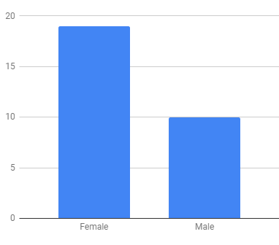
2.Ages.
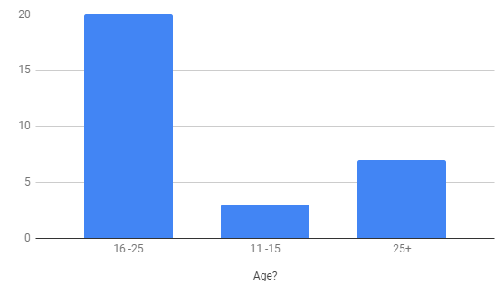
3.Can you describe what you think a youth worker does?
Can you describe what you think a youth worker does?
Supports young persons into adulthood and enables them to be the best they can be
Helps kids
Engages with Youth to Get Them Interested in Other Things Rather Than Loitering About :)
Helps children in need
They work with youth to provide a safe and friendly environment for youth in distress
Works with the youth
Reaches out to the youth in the community/helps youth
Works and helps young people
An adult who works with young people
Helps youth
Play scheme
Helps young people who have unstable home lives
Someone who helps you, and someone who works one on one with you and organises activities
Support
Help and support a young person to achieve success in life because they don't have the necessary skills
Supports young people for many reasons during their younger/teenage years and adaptation to the big world and the problems that may arise
Empowers and mentors’ young people.
Develop and support young people to enable them to find the tools in life and themselves to manage life and achieve their potential.
Works with the youths of today
Works with the youth to help them make hard decisions they can’t themselves
Supports young people with any difficulties they my have
A youth worker is someone you can go talk to or someone you can ask for help who doesn’t know you
Someone who works with young people
Youth work
Supportive
Works with young people and creates clubs for them
Helps young people
Help young people
someone there for us

4.Did you /Do you attend any clubs for young people?

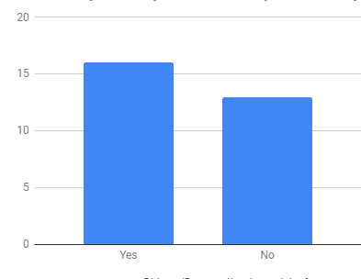
5. If your answer is yes, what type of youth clubs/groups did you attend?
If your answer is yes, what types of youth clubs/groups did you attend?
Local youth club
Aberaeron Drop In
Counselling
Bont youth club, 5x60, sports clubs
Used to go to youth club until it shut down
The drop in Aberaeron
village youth club
BBC School Report
Young carers and looked after children
Can’t remember
community youth club, St John Club.
Yfc youth club
Lampeter youth club
Yfc, brownies

6. Are / were these clubs or groups run by a youth worker?
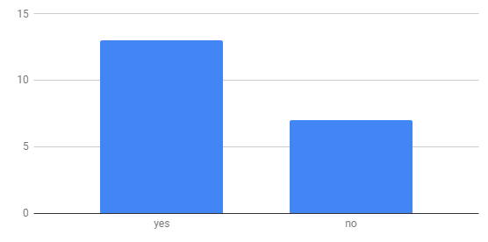
7. Do you think being part of a club/group helps/helped you?

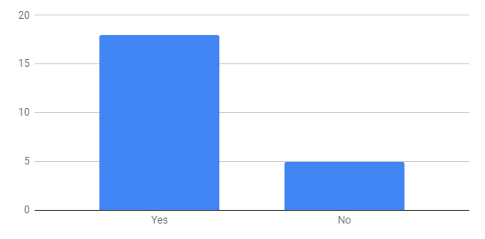
8.What stops/stopped you from attending youth groups/clubs?
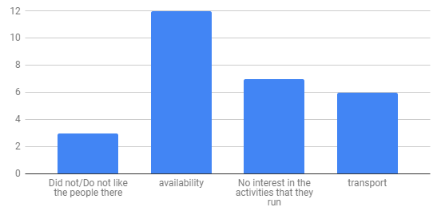
9. Do you think that if you could/could have attended a youth group/club it could have helped you and why?
No because it’s pointless
N/A
If there were more activities that were enjoyable to everyone it would have helped because it was have provided a big sociable space for youth to enjoy together instead of separating into smaller groups which happens in rural areas a lot
Helps with confidence. Make new friends. Something to do.
Yes, as attending clubs improves self confidence
Yes, with social things
I would have snogged more as a teenager
Yes, I was bullied at school and it meant I struggled in social situations. A youth group could have helped me learn to socialise and make friends in a safe environment
No
Yeah, I guess I don’t know
Yes, it’s a neutral none judgemental helpful form of support during difficult years and transitions through teens to adolescence, would allow healthy safe distractions from bad outside influences which can be formed due to lack of things to do, knowledge, peer pressure and places to go that are away from home but are safe and supportive
Support to enable you to achieve potential, skills etc, is always a benefit.
I think it could have helped my social skills
Nahhh
Yes! Something to do and somewhere to go would have given me a lot of purpose. I think it would have majorly helped my self-esteem.
Probably not
It would have helped me to socialise more
Yeah, would have given me an outlet so I wouldn’t have gotten into trouble
I am very under confident and find socialising hard. I think this would have helped me

10. What kind of youth support/activities, would you like in your community?
Younger child-based activities
Bike riding
Ice Hockey Rink!!! :)
More clubs and places for people to lounge around as well as more government funded activities for youth
Decent places to get support
More parks/skate parks/ice rink.
Sports based activities
Something everyone can get involved in
Pool
Something that caters to all ages and helps kids who struggle in school situations as well as providing fun activities
Group activities to bring community together
Badman ones
More practical help for young people. I know a few you g men in the area who have support workers but it seems that there is little practical support, rather it's talking to the client which doesn't work because they just can't navigate the system alone
Sports, outdoor pursuits, mental health support, team building, life skills, calming and listening areas of support for all, more areas for children with special needs/disabilities
Desperately need something for young teens/ skatepark/ place to hang out
More open, cooperation of youth services, Urdd/ Yfc/ Stat/ comm Youth services/ youth councils etc in each town/ community... to be developed with each town and community council.
Computer programming
Just more shit to do around this place
Groups, sports clubs, film clubs, theatre groups
Disneyland
Open a youth club for young children again
Mental health awareness.
D&D
Just a metropolitan with people my own age
meet ups. counselling
somewhere to go

11. What are your feelings on living in a rural community?
Not enough for younger children to do
No Ice Rink For 90 Miles Deeside or Cardiff Nearest :/ So Given Up A Sporting Hobby (Which Is an Important Thing for Children to Have) Due to Lack of Opportunities in the Area
Nice and piece full
there’s no support for youth in rural communities
It’s quite boring
There isn’t enough to do we have to travel miles to do anything
It can be lonely / isolated
I'm not sure
I like it but wouldn’t mind living in the city
Idk
I feel like it is much closer knit, especially young parents
Dunno
I love it but there's little support
Not enough for youngsters to do or take part in to get them off the streets, no mental health support before things get serious it can feel like we are forgotten as we are not a big enough community when in reality, we usually need it more so many struggles in silence and quite often ending badly
Transport issues limit young people and there’s too much reliance on organisations like YFC and Urdd to provide for the youth.
Amazing resources that we need to appreciate and take advantage of and build on lack of urban type resources.
I like it
No feelings?
I love it here
There isn’t a lot to do for the younger generation
It’s lovely
Drama
Some parts I love and then other parts for example going out to socialise is harder because everyone lives so far from each other
Negative
A bit cut off since there's not great transport
I feel lost sometimes

12.Do you feel that you have the same opportunities as young people living in big towns and villages?
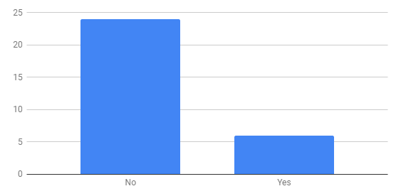

  - CHAPTER SIX

DISCUSSION,
CRITICAL REFLECTION,
CONCLUSIONS.

Discussion, Critical reflection and conclusion
The evidence presented in chapter four, identified the main findings of the applied research project carried out by young participants and after looking through the data from the questionnaires, I can see that what other youth work professional’s say and what was referred to in the literature review, is true, that there are not enough youth provisions in our county. You can see by the answers from young people that they want the support, but that they have issues with travelling to youth activities. Although many attended village youth clubs, many also state that these have slowly been shut down, with young people really feeling the impact. The data suggests that although some young participants enjoyed living in a close-knit community, it also shows a strong point that young people do not feel they have the same opportunities as those that were living in larger towns and cities.
Through this applied research project, I have learned more about the young people that live in my community, their feelings towards life and how they would like to fulfil it. Society is letting our young people down, they are crying out for help and we are saying we will support them, but there is no service for us to sign post these young people to.
This research has not changed my mind on this topic, what I thought when starting my degree in 2016 still stands, that someone needs to do something to change the lives and prospective of young people, and stand up for their rights as the future generations of Wales. This research will help me in future practice in setting up a youth hub in my local community.
There seems to be no disagreement in any form of literature, that in Wales we need a statutory youth service, with an outreach system that can get to these young people in rural communities and let them have the opportunities, to be empowered, included and expressive while being participative and educative. (Ywwrg,2018)
What I don’t understand is why we don’t have a statutory youth service. It seems to be a question that does not have an answer, we can see that they need is there. Welsh government is saying this is what young people are entitled to. (2014-2018, The national youth strategy for Wales).
I wondered if I was seeing all my research through one lens on the side of the youth worker, so tried to put myself in a different frame of mind but still all I see is young people crying out for support, a service and a voice.
In conclusion of discussion in providing an exploration into the analysis and interpretation of the data gathered in this paper I have been able to explore and provide evidence that youth work in rural communities can help and support young people in their lives. Through reviewing relevant literature on the subject of young people and their specific needs, it demonstrated the positive outcomes of participation in Youth Work activities has had on those young people.
In conclusion
I have enjoyed this applied research project. It has enabled me to build on techniques, skills and concepts that I have been taught through my module. I can now critically evaluate research findings within my field of youth work and apply research and evaluation skills.
Research projects are more complex than what I anticipated in the beginning, and It was a struggle when it came to the limited word count.
This applied research project has helped me realise more in depth that I need to assist in providing more adequate youth work support facilities and activities for young people.
Can youth work in rural communities help and support young people in their lives?
My opinion to this is yes and research also suggests that the answer to the question is yes.

The final chapter in this project will explore recommendations for further practice and summarise the main findings in the research.

CHAPTER SIX

RECOMMENDATIONS
FOR
FURTHER
PRACTICE

Recommendations for future practice.
Summary of main findings
Fourteen out of thirty young participants attended youth groups/clubs, with twelve of these groups being run by what young people described as a youth worker. Unfortunately, data shows that these are the same organisations and many of these have been closed down due to lack of funding.
Eighteen out of the thirty participants felt that being part of a youth group had helped them in life, with five saying that it had not helped them.
Twelve out of thirty participants said that there were no youth club activities available, and stated other issues such as transport, with seven saying that the activities run held no interest to them.
The majority of the young people felt that they would have benefitted from youth work support and it would have helped them with many issues with a lot stating it would have helped their mental health and wellbeing.
There is insufficient support available for these young community members, leaving them feel isolated. These young people have shown us a need and a want for youth work activities and for someone to advocate on their behalf. They would also appreciate a safe warm environment to hang out.
Recommendations for future practice.
Future practice would include:
- A statutory youth service, so that young people feel that they are worthy of a voice and an opinion.
- Out-reach services for those young people that live in rural locations outside of the villages. This is a service currently run within the youth offending team in Aberystwyth, with their low risk preventions project.
- To open a youth hub within the local community that offers accessible opportunities with activities and support.

REFERENCES

References

- Anna Bawden(2009)A tale of two teenagers -urban and rural[online]Available at https://www.theguardian.com/society/2009/apr/15/teenagers-lives-urban-rural [Accessed on 11.12.2018]
- Button,L(1974) Development group work with adolescents:London:universiuty of London press
- Cvent,G(2016)Advantages and disadvantages of online surveys.[online]Available at https://blog.cvent.com/events/advantages-disadvantages-online-surveys/ [Accessed 30.12.2018]
- Ingram,G,Harris,J.(2001)Delivering good youth work.Dorset:Russel house publishing.
- Jamieson, L., (2000), Migration, place and class: youth in a rural area, The Sociological Review,48: 203–223.
- Lifelong learning uk(2008)The benefits of youthwork[pdf].London:unite the union.Available at https://www.cywu.org.uk/assets/content_pages/187799973_Benefits_Of_Youth_Work.pdf. [Accessed 15/12/2018]
- Maslow,A.H.(1982)Towards a phycology of being (2nd ed) Reinold ,van nost
- Matthews, H., Taylor, M., Sherwood, K., Tucker, F. and Limb, M., (2000), Growing-up in the countryside: children and the rural idyll, Journal of Rural Studies, 16: 141–153
- Max- Heef, M.A(1991)Human scale development: concept appreciation and further reflections.newyork;Apex press
- Ní Laoire, C., (2000), Conceptualising Irish Rural Youth Migration: a biographical approach,International Journal of Population Geography, 6: 229–243.
- Pringle,M,K (1980) The needs of young people:A personal prospect.Hutchinson
- Research methodology(2018)Questionnaires.[online]Available at https://research-methodology.net/research-methods/survey-method/questionnaires-2/ [Accessed 30.12.2018]
- Saplin
- statistics for wales(2015-16)(statistic first release)[pdf].Cardiff. Available at https://dera.ioe.ac.uk/27778/1/161020-youth-work-2015-16-en.pdf
- Tyrrell, N. and Harmer, N. (2015) ‘A good move? Young people’s comparisons of rural and urban living in Britain’, Childhood, 22(4), pp. 551–565
- Welsh government(2018)Child and adolescent mental health.[online]Available at https://gov.wales/topics/health/nhswales/mental-health-services/policy/child-mental/?lang=en[Accessed 07/12/2018
- Welsh government, 2014-2018.(the national youth work strategy for wales)[pdf].Cardiff ;welsh government .Available at https://beta.gov.wales/sites/default/files/publications/2018-03/the-national-youth-work-strategy-for-wales-2014-2018.pdf [Accessed 03.01.19].
- YWWRG,2018.Principles and purposes of youth work wales.

APPENDICIES

Appendix 1

APPLICATION FOR ETHICAL APPROVAL

In order for research to result in benefit and minimise risk of harm, it must be conducted ethically. A researcher may not be covered by the University’s insurance if ethical approval has not been obtained prior to commencement.

The University follows the OECD Frascati manual definition of research activity: “creative work undertaken on a systematic basis in order to increase the stock of knowledge, including knowledge of man, culture and society, and the use of this stock of knowledge to devise new applications”. As such this covers activities undertaken by members of staff, postgraduate research students, and both taught postgraduate and undergraduate students working on dissertations/projects.

The individual undertaking the research activity is known as the “principal researcher”.

Ethical approval is not required for routine audits, performance reviews, quality assurance studies, testing within normal educational requirements, and literary or artistic criticism.

Please read the notes for guidance before completing ALL sections of the form.

This form must be completed and approved prior to undertaking any research activity. Please see Checklist for details of process for different categories of application.

SECTION A: About You (Principal Researcher)

Full Name: |  |  | Julie Anne Simpson
Tick all boxes which apply:
Member of staff: | ☐ | Student: |  | ☒ | Honorary research fellow: | ☐

Faculty/School/Centre: | Social Justice and inclusion
Campus: | Carmarthen
E-mail address: | 1601970@student.uwstd.ac.uk
Contact Telephone Number: | 07772440149
For students:
Student Number: | 1601970 | Undergraduate | ☒
Programme of Study: | Youth and community | Taught Postgraduate | ☐
Director of Studies/Supervisor: | Angharad Lewis | Research | ☐

SECTION B: Approval for Research Activity

Has the research activity received approval in principle?  (please check the Guidance Notes as to the appropriate approval process for different levels of research by different categories of individual) |  | YES | ☒ | NO | ☐
 |  |  |  | Date
If Yes, please indicate source of approval (and date where known): | Research Degrees Committee |  | ☐
 | Faculty Research Committee |  | ☐
 | Other (write in)  Angharad Lewis |  | ☒ | 27.10.18
Approval in principle must be obtained from the relevant source prior to seeking ethical approval.

SECTION C: External Ethical Guidance Materials

Please list the core ethical guidance documents that have been referred to during the completion of this form (including any discipline-specific codes of research ethics, and also any specific ethical guidance relating to the proposed methodology). Please tick to confirm that your research proposal adheres to these codes and guidelines.
BERA educational Guidelines | ☒
Community Participatory Research Ethical Guidelines | ☒
Code of Occupational Ethics for the Youth Service in Wales | ☒

SECTION D: External Collaborative Research Activity

Does the research activity involve collaborators outside of the University? |  | YES | ☐ | NO | ☒
If Yes, please provide the name of the external organisation and name and contact details for the main contact person:
Institution
Contact person name
Contact person e-mail address

Where research activity is carried out in collaboration with an external organisation
Does this organisation have its own ethics approval system? | YES | ☐ | NO | ☐
If Yes, please attach a copy of any final approval (or interim approval) from the organisation

SECTION E: Details of Research Activity

Indicative title: | In modern society, how can youth work help build a stronger community?
Proposed start date: | 12th of November | Proposed end date: | 12th of January
Purpose of research activity (including aims and objectives)
Outline the purpose, aims and objectives of the research activity, including key research questions. Show briefly how existing research has informed the proposed activity and explain what the research activity will add and how it addresses an area of importance. (Maximum 300 words)
- To research and conclude if youthwork can aid communities in being stronger
- Examine the need for youth work in the community

- Explore the practicalities of youth work in communities

- To show that youthwork is important in shaping happier more rounded communities.

- The research will show the difference between communities with youth provisions and communities that don’t have any youth work provisions.
Questioning in research will search to answer these questions
- The opinions of young people on communities
- The opinions of communities on young people
- The research is addressing areas of need within the youth work sector and the community
- The research will add to the hot topic of the need and use of youth work.

Proposed methods
Provide a brief summary of all the methods that may be used in the research activity, making it clear what specific techniques may be used. If methods other than those listed in this section are deemed appropriate later, additional ethical approval for those methods will be needed. (Maximum 600 words)
- Outreach-Discussions with community members-discussions with 16+
- Questionnaires (11+) With parental consent
- Focus groups (11+) With parental consent.
- Interviews (16+)
- Methodology used will be of mixed methods, mainly qualitative but as questionnaires will be used there will be some quantitative methods used
- Research will also be desktop and include some social media research there will be no use any personal data.
- Once all data has been authenticated, it will be organised in a professional way to show the findings through tables, graphs and charts to show data.
- The use of audio equipment to help researcher to remember what has been said during the sessions. All participants will be notified of this prior to the start of the session

Location of research activity
Identify all locations where research activity will take place.
- Out reach-in researcher’s local community
- Outreach -where young people are
- Local youth club where researcher volunteers.
- Local community meetings.

Research activity outside of the UK
If research activity will take place overseas, you are responsible for ensuring that local ethical considerations are complied with and that the relevant permissions are sought. Specify any local guidelines (e.g. from local professional associations/learned societies/universities) that exist and whether these involve any ethical stipulations beyond those usual in the UK (provide details of any licenses or permissions required). Also specify whether there are any specific ethical issues raised by the local context in which the research activity is taking place, for example, particular cultural sensitivities or vulnerabilities of participants.

SECTION F: Scope of Research Activity

Will the research activity include: | YES | NO
Use of a questionnaire or similar research instrument? | ☒ | ☐
Use of interviews? | ☒ | ☐
Use of diaries? | ☐ | ☒
Participant observation with their knowledge? | ☐ | ☒
Participant observation without their knowledge? | ☐ | ☒
Use of video or audio recording? | ☒ | ☐
Access to personal or confidential information without the participants’ specific consent? | ☐ | ☒
Administration of any questions, test stimuli, presentation that may be experienced as physically, mentally or emotionally harmful / offensive? | ☐ | ☒
Performance of any acts which may cause embarrassment or affect self-esteem? | ☐ | ☒
Investigation of participants involved in illegal activities? | ☐ | ☒
Use of procedures that involve deception? | ☐ | ☒
Administration of any substance, agent or placebo? | ☐ | ☒
Working with live vertebrate animals? | ☐ | ☒
Other primary data collection methods, please explain in this box  Focus groups | ☒ | ☐

If NO to every question, then the research activity is (ethically) low risk and may be exempt from some of the following sections (please refer to Guidance Notes).

If YES to any question, then no research activity should be undertaken until full ethical approval has been obtained.

SECTION G: Intended Participants

Who are the intended participants: | YES | NO
Students or staff at the University? | ☐ | ☒
Adults (over the age of 18 and competent to give consent)? | ☒ | ☐
Vulnerable adults? | ☐ | ☒
Children under 18? | ☒ | ☐
Prisoners? | ☐ | ☒
Young offenders? | ☐ | ☒
Those who could be considered to have a particularly dependent relationship with the investigator or a gatekeeper? | ☐ | ☒
People engaged in illegal activities? | ☐ | ☒
Others (please identify): | ☐ | ☒

Participant numbers and source
Provide an estimate of the expected number of participants. How will you identify participants and how will they be recruited?
Groups.
And small focus groups.
I will not have one to one group.
All participants will be asked if they wish to be part of the research and be told of right to withdraw.
The identification of applicant will come from youth work leaders putting names forward and young people asking to take part with researchers’ agreement

Information for participants: | YES | NO | N/A
Will you describe the main research procedures to participants in advance, so that they are informed about what to expect? | ☒ | ☐ | ☐
Will you tell participants that their participation is voluntary? | ☒ | ☐ | ☐
Will you obtain written consent for participation? | ☒ | ☐ | ☐
Will you explain to participants that refusal to participate in the research will not affect their treatment or education (if relevant)? | ☐ | ☐ | ☒
If the research is observational, will you ask participants for their consent to being observed? | ☒ | ☐ | ☒
Will you tell participants that they may withdraw from the research at any time and for any reason? | ☒ | ☐ | ☐
With questionnaires, will you give participants the option of omitting questions they do not want to answer? | ☒ | ☐ | ☐
Will you tell participants that their data will be treated with full confidentiality and that, if published, it will not be identifiable as theirs? | ☒ | ☐ | ☐
Will you debrief participants at the end of their participation, in a way appropriate to the type of research undertaken? | ☒ | ☐ | ☐
If NO to any of above questions, please give an explanation
(this box should expand as you type)

Information for participants: | YES | NO | N/A
Will participants be paid? | ☐ | ☒ | ☐
Is specialist electrical or other equipment to be used with participants? | ☐ | ☒ | ☐
Are there any financial or other interests to the investigator or University arising from this study? | ☐ | ☒ | ☐
Will the research activity involve deliberately misleading participants in any way, or the partial or full concealment of the specific study aims? | ☐ | ☒ | ☐
If YES to any question, please provide full details

SECTION H: Anticipated Risks

Outline any anticipated risks that may adversely affect any of the participants, the researchers and/or the University, and the steps that will be taken to address them.

If you have completed a full risk assessment (for example as required by a laboratory, or external research collaborator) you may append that to this form.

Full risk assessment completed and appended?

Yes ☐
No ☒

Risks to participants
For example: emotional distress, financial disclosure, physical harm, transfer of personal data, sensitive organisational information
- Disclosure of sensitive information-policies surrounding confidentiality will be discussed with participants on the onset of involvement and every time the researcher meets up with participants
- Risk of harm could come from participants falling out from differences of opinions-conduct and rules to be discussed before participation.
- There is minimal risk in this research project as a youth work researcher risk is always at the for forefront of my mind
If research activity may include sensitive, embarrassing or upsetting topics (e.g. sexual activity, drug use) or issues likely to disclose information requiring further action (e.g. criminal activity), give details of the procedures to deal with these issues, including any support/advice (e.g. helpline numbers) to be offered to participants. Note that where applicable, consent procedures should make it clear that if something potentially or actually illegal is discovered in the course of a project, it may need to be disclosed to the proper authorities
- n/a

Risks to investigator
For example: personal safety, physical harm, emotional distress, risk of accusation of harm/impropriety, conflict of interest
- Personal safety/Risk of accusation – been attacked by a participant or accused I will minimise this risk by never working alone with participants.
- Attachment risk – Be friendly with participants but not friends.
- Medical risk- I am Disabled student- I will make sure my medications are with me every time I conduct research.

University/institutional risks
For example: adverse publicity, financial loss, data protection
There will be no risks to the university as I will conduct my research in a dignified polite and courteous manner bearing in mind that I am an ambassador of the university
Adverse outcomes
List measures put in place to limit any adverse effects or outcomes of research activity where appropriate. Include any emergency protocols.
Participants will be informed at the start of research by letter of the nature of the study and will be informed that they can withdraw at any point in the research and can ask for their data not to be used.

Disclosure and Barring Service
If the research activity involves children or vulnerable adults, a Disclosure and Barring Service (DBS) certificate must be obtained before any contact with such participants. | YES | NO | N/A
Has a DBS certificate been obtained? | ☒ | ☐ | ☐

SECTION I: Feedback, Consent and Confidentiality

Feedback
What feedback will be provided to participants, how will this be done and when?
- Letters will be provided informing participants of the nature of the study.
- They will also be informed that they can see the finished research if they so wish.

Informed consent
Describe the arrangements to inform potential participants, before providing consent, of what is involved in participating. Describe the arrangements for participants to provide full consent before data collection begins. If gaining consent in this way is inappropriate, explain how consent will be obtained and recorded.
- A letter stating the nature of the study
- There will be a statement in my letter of information detailing consent ethics
- Asking for consent to participate.
- Rights to withdraw
- Parental consent to participate must be sought for young people under the age of 16

Confidentiality / Anonymity
Set out how anonymity of participants and confidentiality will be ensured in any outputs. If anonymity is not being offered, explain why this is the case.
- participants will use object numbers or letters to identify
- Participants will be informed about confidentiality and disclosure policies.

SECTION J: Data Protection and Storage

In completing this section refer to the University’s Research Data Management Policy and the extensive resources on the University’s Research Data Management web pages (http://uwtsd.ac.uk/library/research-data-management/).
 | YES | NO
Does the research activity involve personal data (as defined by the Data Protection Act)?  “personal data” means data which relate to a living individual who can be identified—  (a) from those data, or  (b) from those data and other information which is in the possession of, or is likely to come into the possession of, the data controller, and includes any expression of opinion about the individual and any indication of the intentions of the data controller or any other person in respect of the individual. | ☐ | ☒
If YES, provide a description of the data and explain why this data needs to be collected:
(this box should expand as you type)
Does it involve sensitive personal data (as defined by the Data Protection Act)?  “Sensitive personal data” means personal data consisting of information as to –  (a) the racial or ethnic origin of the data subject,  (b) his political opinions,  (c ) his religious beliefs or other beliefs of a similar nature,  (d) whether he is a member of a trade union (within the meaning of the Trade Union and Labour Relations (Consolidation) Act 1992),  (e) his physical or mental health or condition,  (f) his sexual life,  (g) the commission or alleged commission by him of any offence, or  (h) any proceedings for any offence committed or alleged to have been committed by him, the disposal of such proceedings or the sentence of any court in such proceedings. | ☐ | ☒
If YES, provide a description of the data and explain why this data needs to be collected:
(this box should expand as you type)

Will the research activity involve storing personal data on one of the following: | YES | NO
Manual files (i.e. in paper form)? | ☐ | ☒
University computers? | ☐ | ☒
Private company computers? | ☐ | ☒
Home or other personal computers? | ☐ | ☒
Laptop computers/ CDs/ Portable disk-drives/ memory sticks? | ☐ | ☒
“Cloud” storage or websites? | ☐ | ☒
Other – specify: | ☐ | ☒
For all stored data, explain the measures in place to ensure data confidentiality, including details of password protection, encryption and anonymisation:
Will the research activity involve any of the following activities: | YES | NO
Electronic transfer of data in any form? | ☐ | ☒
Sharing of data with others at the University? | ☐ | ☒
Sharing of data with other organisations? | ☐ | ☒
Export of data outside the European Union or importing of data from outside the UK? | ☐ | ☒
Use of personal addresses, postcodes, faxes, emails or telephone numbers? | ☐ | ☒
Publication of data that might allow identification of individuals? | ☐ | ☒
Use of data management system? | ☐ | ☒
Data archiving? | ☐ | ☒
If YES to any question, please provide full details, explaining how this will be conducted in accordance with the Data Protection Act (and/or any international equivalent):

List all who will have access to the data generated by the research activity:
Julie Simpson

List who will have control of, and act as custodian(s) for, data generated by the research activity:
Julie simpson

(this box should expand as you type)
Give details of data storage arrangements, including where data will be stored, how long for, and in what form. Will data be archived – if so how and if not why not.
data will be stored/destroyed in accordance with current legislation and UWTSD policy.
(this box should expand as you type)

SECTION K: Declaration

The information which I have provided is correct and complete to the best of my knowledge. I have attempted to identify any risks and issues related to the research activity and acknowledge my obligations and the rights of the participants.

In submitting this application I hereby confirm that I undertake to ensure that the above named research activity will meet the University’s Research Ethics and Integrity Code of Practice
Signature of applicant: | Jasimpson | Date: | 25.10.2018

For students:
Director of Studies/Supervisor: | Angharad Lewis
Signature: | 
Date: | 07.11.18

For staff:
Head of School/Assistant Dean:
Signature:
Date:

Checklist: Please complete the checklist below to ensure that you have completed the form according to the guidelines and attached any required documentation:
☒ | I have read the guidance notes supplied before completing the form.
☒ | I have completed ALL RELEVANT sections of the form in full.
☒ | I confirm that the research activity has received approval in principle
☒ | I have attached a copy of final/interim approval from external organisation (where appropriate)
☐ | I have attached a full risk assessment (and have NOT completed Section H of this form) (where appropriate)
☒ | I understand that it is my responsibility to ensure that the above named research activity will meet the University’s Research Ethics and Integrity Code of Practice.
☒ | I understand that before commencing data collection all documents aimed at respondents (including information sheets, consent forms, questionnaires, interview schedules etc.) must be confirmed by the DoS/Supervisor, module tutor or Head of School.

RESEARCH STUDENTS AND STAFF ONLY
All communications relating to this application during its processing must be in writing and emailed to pgresearch@uwtsd.ac.uk , with the title ‘Ethical Approval’ followed by your name.
You will be informed of the outcome of your claim by email; therefore it is important that you check your University and personal email accounts regularly.

STUDENTS ON UNDERGRADUATE OR TAUGHT MASTERS PROGRAMMES should submit this form (and receive the outcome) via systems explained to you by the supervisor/module leader.

This form is available electronically from the Academic Office web pages: http://www.uwtsd.ac.uk/academic-office/

Application Process

All staff research projects and all research students must submit the Ethical Approval Form to the University Ethics Committee via the Academic Office (pgresearch@uwtsd.ac.uk). Staff research directly in relation to personal study for taught undergraduate or Masters programmes should be submitted via the Faculty procedures explained below.

Taught masters and taught undergraduate research Ethical Approval Forms are considered within Faculties. Faculties will provide details of the specific processes for this. Where the Ethical issues within any single ethical application are of particular concern the Faculty will refer these to the University Ethics Committee. Any student activity that involves the collection of primary data needs to undergo Ethical approval, this includes assignment work as well as dissertations.

Notes for guidance in completion of this form

Section A: About You
Please complete all relevant sections

Section B: Approval for research activity
Research proposals must be approved in principle before applying for Ethical Approval. The proposal approval only becomes final when the ethical approval is received.

The process for proposal approval varies according the individual and programme of study:
- Research students, by application on form PG1 to the Research Degrees Committee
- Taught students by review of research proposal within Faculties (Faculties provide specific details of these processes)
- Staff, by agreement by the Head of School/Assistant Dean

Section C: External Ethical Guidance materials
Many discipline areas are required to operate with the discipline specific codes of research ethics (for example health, psychology, education etc.), any such codes must be listed and you must tick to confirm that you have consulted with these.

Section D: External Collaborative Research Activity
Provide details of the external collaborative partners, where appropriate you might want to submit a copy of the external collaboration agreement with the Ethical Approval Form. If the partner requires the research to be subject to its own internal Ethical approval process then please provide details of that process and a copy of any final (or interim) approvals received from the organisation.

Section E: Details of Research Activity
Remember that the individuals reviewing this Ethical Approval Form may not have seen your research proposal, and also may not be experts in the specific area of your research. The information provided should therefore be jargon free and clearly stated.
Indicative Title: please use the same title as used on the research proposal.
Purpose: the Ethical approval process will want to ensure that the methods you propose are adequate and appropriate to address the research aims and objectives. Excessive additional data collection can be seen as unethical.
Proposed Methods: the Ethical approval process seeks to ensure that you understand the methods that are intended, and that the implementation of those methods will be appropriate and without unnecessary impact on respondents. Please be specific.
Location: this needs to mention geographical location and also local situation (for example, within Local Authority Offices in Cardiff, using a private room but close to other individuals). If you are collecting data within an organisational setting then you need to explain the permissions that you have obtained to do this.
Research Activity outside of the UK: please complete this section in detail, and note any guidance you have received. Also describe your own familiarity (or not) with the location that you will be utilising.

Section F: Scope of Research Activity
Please tick ALL of the research activities that might be undertaken. If any additional types of activity are intended then please add an extra box and describe these.
If you have answered no to all questions in F then sections G and J do not need to be completed. Section H should be considered, and may be completed. Signatures are still required in section K.

Section G: Intended Participants
Please tick all categories that might apply.
Numbers & Source: if you are using a series of different methods or research activities please list numbers for each stage/phase. Be clear about how you will find respondents. Will you use intermediaries, and if so how? How will you ensure compliance with your sampling strategy?
Information for participants: all participants should be appropriately informed about the research, what is expected of them and what will happen to the information that they provide. The Ethical review process does not ask to see this documentation, but requires this to be reviewed and approved by the Director of Studies in the case of research students, the supervisor/module tutor in relation to students on taught programmes and the Head of School/Assistant Dean in relation to staff research.

Section H: Anticipate Risks
All research carries some level of risk. The answers you provide to questions in this section will be reviewed to ensure that you have an appropriate understanding of the type of risks involved and how you can mitigate against these risks. If you have completed a full risk assessment, as required for example for laboratory work, field work, clinical tests, diving operations, or by a collaborative partner, you may append that to this form. In that case, please tick the box indicating this has been provided. You will not then be required to complete Section H.
Risk to participants Think very carefully about how your actions/questions/discussions might affect the people you are involving as participants. You might identify the risk as small but it would still be a risk. Many types of question have the potential to make respondents less content with their life / job; you need to recognise and try to ameliorate any such effects
If these are business owners, time with you may reduce profit.
In some locations physical risk is very real to both participants and yourself, please consider this.
Risk to you, the researcher Think about where you will meet people, if there are any dangers involved in the location. If you are meeting people as individuals think about using a public place. In general do not visit people in their own homes or remote locations. If you are talking to individuals about certain issues think about how their responses might affect you emotionally. What about the risk of collecting insufficient data?
Risk to the University When undertaking your research, you are acting as a member of the University (student or staff). Professionalism is important, so it is important to be well organised and well prepared. Punctuality, clarity etc. are all part of this. What will you do to ensure this? You must ensure you do not harm the good name of the University in any way and do nothing to undermine the reputation of the research it conducts and sponsors. Upholding high standards of conduct and integrity are vital in this regard. You must also conduct the research in such a way to minimise the potential for claims of negligence made against the University, its researchers and any collaborating individual or organisation. In this respect you should always comply with ethical, legal and professional frameworks, obligations and standards as required by statutory and regulatory authorities, as well as the university’s Research Integrity and Ethics Code of Practice. Research misconduct in this respect can take many forms, including:
- fabrication: making up results or other outputs (eg, artefacts) and presenting them as if they were real
- falsification: manipulating research processes or changing or omitting data without good cause
- plagiarism: using other people’s material without giving proper credit
- failure to meet ethical, legal and professional obligations: for example failure to declare competing interests; misrepresentation of involvement or authorship; misrepresentation of interests; breach of confidentiality; lack of informed consent; misuse of personal data; and abuse of research subjects or material
- improper dealing with allegations of misconduct: failing to address possible infringements such as attempts to cover up misconduct and reprisals against whistle-blowers

Adverse Outcomes. Think carefully about the possibilities, and cover here

Section I: Feedback, Consent and Confidentiality
Feedback to participants: outline your approach. Will interview transcripts be shared with respondents to check accuracy? Will summaries of questionnaire analysis be made available to respondents in some way? Will an overview report be provided? How and when?
Informed consent: Draft letter / e-mail / or heading (or footer) section of questionnaire must be approved by DoS/supervisor (if research student), supervisor/module tutor if taught student, or Head of School / Assistant Dean if a member of staff.
Confidentiality/Anonymity. Explain clearly how you will ensure confidentiality and anonymity.

Section J: Data Protection and Storage
Before completing this section it is necessary to read the University’s Research Data Management information. The questions that follow are designed to ensure compliance with the Data Protection Act as well as established research protocols.

Many research activities will involve electronic transfer of data and use of data management systems in the summarisation and analysis of data. You will need to explain these in relation to compliance with the Data Protection Act.
Think carefully about who will have access to your data, this will include supervisors and examiners. Also, that a thesis will be made available via the University library and the British Library system. If you are seeking an access bar for a period of time after completion then mention it here. If you will provide a copy of your findings, or intend to give a presentation, to a facilitating/ supporting/accessing organisation then explain that in this section. But also think about the general principle of data sharing, as explained in the Research Data Management information.
In terms of storage of data please ensure security, and also mitigate against loss of data.

Section K: Declaration
Ensure the appropriate countersignatures have been provided
Look carefully at the checklist and ensure that you comply with and tick all that are relevant to your research.

APPENDIX 2
FFURFLEN GANIATÂD CYFRANOGIAD | PARTICIPANT INFORMATION SHEET
Teitl Y Prosiect: / Project Title: can youth work in communities help and support young people in their lives.

Dear Participant:

My name is Julie simpson and I am studying in the School of Social justice and inclusion, studying a degree in youth and community

I would like to invite you to participate in my research project. This project will research the need for youth activities in rural and local communities and aims to use the findings to see if there is a need for youth led activities to help the support of young people.
Attached to this letter is a short questionnaire developed by myself, which will assess these needs. I believe your opinions will be extremely helpful to me.

Through your participation in the questionnaire and/or interviews, I hope to ascertain your opinions on youth work and youth work led activities.

All questionnaires will be kept strictly confidential to the researchers involved and at NO time will individual questionnaires be released to the general public. This gives you a chance to express your views on your programme a confidential and anonymous forum and still be able to make a difference. Your participation in this study is completely voluntary so you can withdraw from the questionnaire at any stage.

Our questionnaire should take about five minutes to complete, but there is no time constraint. There are also no right or wrong answers. Attached to this letter along with the questionnaire is a consent form and a feedback form. As this is a new project, your feedback is also important to us and we would be much obliged if you could also complete the feedback sheet along with the questionnaire. We understand that your time is at a premium but your opinions are very valuable to us.

After careful and precise analysis of the data obtained from this questionnaire, I will be happy to provide you with a copy of the findings at your request. The results of this questionnaire will hopefully enhance my understanding of youth and community issues. The results of the research will be fed back to my university lectures on completion of my applied research project.

We thank you in advance for your time and participation. If any questions do arise, feel free to contact me at your convenience.

ENW A CHYFEIRIAD YR YMCHWILYDD | NAME & ADDRESS OF RESEARCHER  Julie Simpson  University of Wales Trinity Saint David  Carmarthen Campus  Carmarthen SA31 3EP

APPENDIX 3

Date: | Rhif Adnabod Cyfranogwr:  Participant Identification Number:
FFURFLEN GANIATÂD CYFRANOGIAD | PARTICIPATION CONSENT FORM
Teitl Y Prosiect: / Project Title: Can youth work in communities help and support young people in their lives.
Enw'r Ymchwilydd / Name of Researcher: Julie Simpson

Rhowch Llythrennau cyntaf eich enw yn y blwch / Please initial box
1 | Cadarnhaf fy mod wedi darllen a deall y daflen wybodaeth dyddiedig__________ar gyfer yr astudiaeth uchod. Rwyf wedi cael y cyfle i ystyried y wybodaeth, gofyn cwestiynau, ac rwyf wedi cael ateb boddhaol i’r rhain. |  | I confirm that I have read and understand the information sheet dated _______ for the above study. I have had the opportunity to consider the information, ask questions and have had these answered satisfactorily.
2 | Deallaf fy mod yn cymryd rhan o’m gwirfodd a bod croeso i mi dynnu’n ôl ar unrhyw adeg, heb roi rheswm. |  | I understand that my participation is voluntary and that I am free to withdraw at any time, without giving any reason.
3 | Deallaf y gellir defnyddio unrhyw wybodaeth a roddir gennyf mewn adroddiadau, erthyglau neu gyflwyniadau gan y tîm ymchwil. |  | I understand that any information given by me may be used in future reports, articles or presentations by the research team.
4 | Deallaf na fydd fy enw’n ymddangos mewn unrhyw adroddiadau, erthyglau neu gyflwyniadau. |  | I understand that my name will not appear in any reports, articles or presentations.
5 | Cytunaf i gymryd rhan yn yr astudiaeth  uchod. |  | I agree to take part in the above study.
Enw’r Cyfranogwr Name of Participant |  |  |  | Llofnodwyd  Signature
Enw’r Rhiant/Gwarcheidwad (os yn berthnasol)  Name of Parent/Guardian (if relevant) |  |  |  | Llofnodwyd  Signature
Ymchwilydd  Researcher |  | Julie simpson |  | Llofnodwyd  Signature

Cewch wrthod cymryd rhan yn yr astudiaeth hon. Cewch ddod â’ch cyfranogiad yn yr astudiaeth hon i ben unrhyw bryd. Os penderfynwch barhau’n ddienw, bydd sicrhau hynny’n flaenoriaeth a chymerir pob cam ymarferol i guddio pwy ydych. Os yw’n well gennych fod yn anhysbys, ni fydd unrhyw wybodaeth yn eich enwi ar dapiau sain na thrawsgrifiadau o’r cyfweliad hwn nac o unrhyw un arall. Ni fydd neb yn clywed unrhyw dapiau sain nac yn gweld unrhyw drawsgrifiadau heb eich cydsyniad o flaen llaw. Bydd deunyddiau a grëir yn sgil y cyfweliad hwn neu unrhyw gyfweliad arall yn aros yn gyfrinachol. | You may decline to participate in this study. You may end your participation in this study at any time. If you decide to remain anonymous, maintaining your anonymity will be a priority and every practical precaution will be taken to disguise your identity. If you prefer anonymity, there will not be any identifying information on audiotapes or transcripts of this or any interview. No-one will hear any audiotapes or see any transcripts without your prior consent. All materials generated from this or any interview will remain confidential.

Ar ôl llenwi’r ffurflen, dychwelwch hi yn yr amlen a ddarperir (lle bo’n berthnasol). Rhoddir un copi i’r cyfranogwr a chedwir y gwreiddiol yn ffeil y tîm ymchwilio yn: | When completed please return in the envelope provided (if applicable). One copy will be given to the participant and the original to be kept on the file of the research team at:
ENW A CHYFEIRIAD YR YMCHWILYDD | NAME & ADDRESS OF RESEARCHER  Julie Simpson  University of Wales Trinity Saint David  Carmarthen Campus  Carmarthen SA31 3EP

Appendix 4
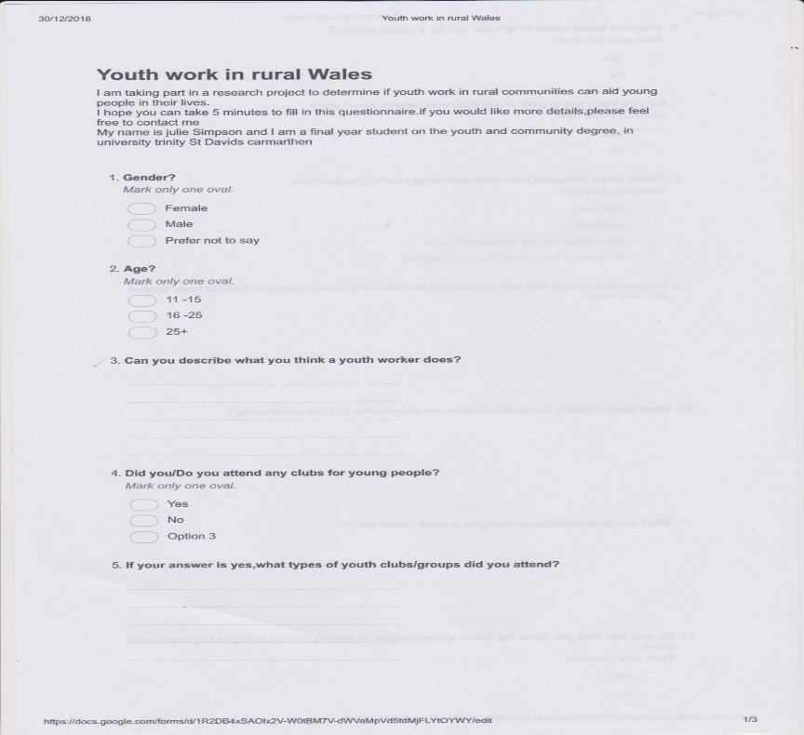

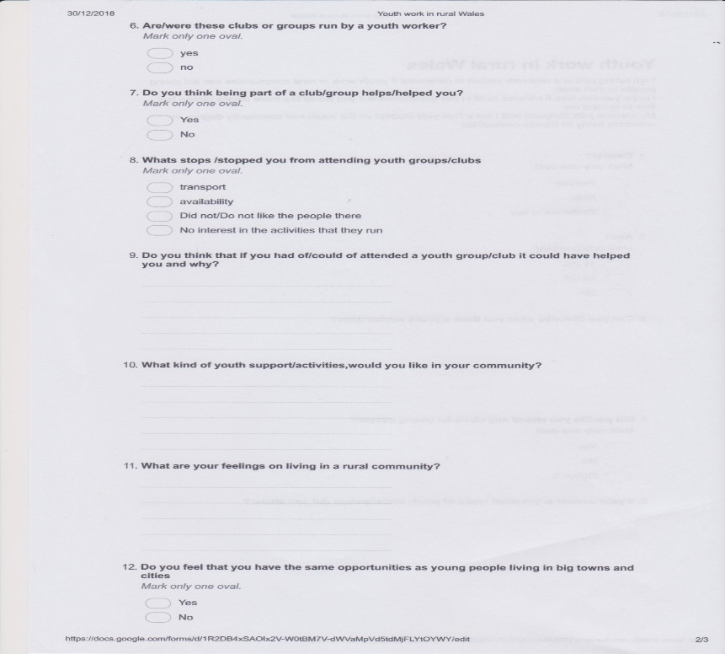

Appendix 5



