Effective Team working and Communication
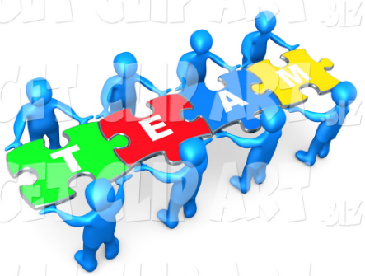
Name: Mario Robinson
Student ID: 1917203
Lecturer: Molly Jack
Programme: BMSW4002

Contents
Introduction 1
Types of Communication 1
Nonverbal Communication 1
Verbal Communication 2
Written Communication 3
Models of Communication 4
Shannon and Weaver Model of Communication 4
Schram Model of Communication 4
Berlo’s Model of Communication 5
Using Communication in the Workplace 5
Impact of Communication 7
Conclusion 8
References 9
Appendices 11
Appendix A Shannon and Weaver Model Classwork 12
Appendix B Schram Model Classwork 13
Appendix C Berlo’s Model Classwork 14

Introduction
This report will discuss and analyse communication in general and the various types of communication. Different models of communication and the effects or impact of communication in the workplace will be highlighted, with the assistance of in-class activities and published literature.
According to Nordquist (2019) and Adair (2009),the use of verbal and nonverbal means to send and receive messages describes communication. It includes speech, oral communication, written material, graphical images such as charts and diagrams, as well as signs, signals, and behaviour. Creating information, and exchanging that information is regarded as communication.
Good communication skills are very important in order to facilitate the understanding of information quickly and accurately. Having strong communication skills assists in all aspects of a person’s life, both personally and professionally. From a business point of view, all transactions result from some form or forms of communication. Poor communication skills on the other hand may result in frustration and frequent misunderstanding. Research studies have shown that communication tops the list of the most sought-after soft skills among employers in a 2016 LinkedIn survey in the(CFI, 2020).
Types of Communication
Non-Verbal Communication
Communicating without the use of words is referred to as nonverbal communication.When no words are used, whether written or oral, the conveying of information and understanding is achieved using physical movements, signs, symbols, and these non-verbal cues are relied on to express feelings, give information, or show attitudes. Even without words, many human emotions can be expressed nonverbally and sometimes even more accurately than the use of verbal communication methods (Dalley& Burton, 2010; Maund, Schriek, &Tinkler, 2017).
Body language, facial expression, eye contact, posture and body orientation, gestures, and even silence are a few common types of nonverbal communication. Body Language is an extremely popularly used and well-known form of nonverbal communication used to convey meaning and messages effectively. This can be an unconscious movement or a deliberately controlled movement. Facial expressions may inform of surprise, shock, grief, happiness, sadness or other emotions. Eye contact helps to control rate of information delivery or flow, interest in a subject or person, or audience (Dalley& Burton, 2010; Maund, Schriek, &Tinkler, 2017).
An individual’s posture and body orientation can assume a friendly or a threatening stance and send that message. For example, standing upright with hands akimbo and leaning forward could be considered threatening, whereas standing upright not rigid and slightly leaning forward indicates approachable or receptive.
Gestures can be attention grabbing especially when used in a way that generates excitement. Gestures can captivate an audience or a class and heightens interest and attention. It increases entertainment value and engagement as well. Gestures may also be used in situations of danger to warn other persons.
Verbal Communication
Transmission of messages through voicing of words or oral communication is considered verbal communication. Rane (2010) states that verbal communication comprises 7% of the forms of communication, while non-verbal communication represents 55%, and vocal tone 38%. This shows that the use of words to communicate messages is limited and is heavily supported by the other components of communication.
Verbal communication is therefore a component in a network of strategies used to successfully convey messages and may be employed in both formal and informal settings. A speaker or the sender of a message may use conversations, presentations, speeches and discussions to get a message across to a receiver. The persons to whom the messages are sent must also receive the message with the same understanding with which it was intended. Dialogue may ensue as verbal communication has the advantage of immediate feedback, and there can be interchange and exchange of words. Active listening and interpretation are part of the process of verbal communicationand adds to the level of understanding achieved (Kane, 2010; Maund, Schriek, &Tinkler, 2017).
Written Communication
Written communication is essential for every business organization to develop. And uses written symbols to convey information. Emails, memos, reports, documents, letters, journals, job descriptions, and employee manuals are commonly used written documents in organizations.Written communication is preferred when bulky information is to be transmitted and may include terms that are difficult to explain verbally. Many organizations still maintain written documents in archives for purposes of evidence and reference (Morgan, 2016).
The information in writing is considered more legal and valid than the spoken words. The effectiveness of written content depends on the accurate choice of words. Also, written content is relied upon more by people than what has been said orally. The feedback of written communication is not immediate as it is not random and requires suitable time to get into an understandable form, unlike verbal communication (Morgan, 2016).
Models of Communication
Shannon and Weaver Model
The Shannon and Weaver theory/model of communication (Appendix A) was primarily designed to improve technical communication. It was however later used to describe different fields of communication. According to the Shannon and Weaver model, communication includes the following concepts: Sender, Encoder, Channel, Decoder, Receiver and Feedback. Moreover, there is a concept of noise included in the model, which goes through the channel and renders the message more difficult to understand by the receiver (Class Notes, 2020).
Schramm Model of Communication
This model of communication (Appendix B) was proposed by Wilber Schramm in 1954. Information is of no use unless and until it is carefully put into words and conveyed to others. The process of communication is initiated through Encoding which is very important and is done by converting the thought into content. The primary responsibility of the recipient when the information arrives is to understand what the speaker intends to convey. The message is of no use unless and until the second party is able to understand or decode the information what the sender wants to communicate. Without encoding and decoding which are the two most essential factors in effective communication, information can never flow between two individuals. Coding and decoding are the two important processes of an effective communication (Research Gate, 2020; Class Notes, 2020).

Berlo’s Model of Communication
Berlo’s model of communication (Appendix C) uses four components to show the process of communication. The origin of a message is with a sender and goes from sender through a selected channel to the receiver. The four components are therefore the sender, message, channel, and receiver. There are factors that affect the sending and receipt of a message, such as one’s ability to create a message, culture, and other systems (Class Notes, 2020).
Audio, video, voice, and text are media used to generate message content. These messages are transmitted by a selected channel. The sender may select channels such as telephones, internet, broadcast media, and other technical equipment. When humans transmit messages, they may be affected by the human senses. One feature of Berlo’s communication model is that the sender and receiver need to be similar for effective communication to be achieved (Class Notes, 2020).
Using Communication in the Workplace
Karen Carris a friend who currently works at a William Hill Betting shop as a supervisor for the past 4 years. Carr briefly explained and discussed how communication is used in her place of work. She stated that within the last three years, there have been many changes within the organization as it relates to communication. At first there was direct face to face communication with managers who would normally walk to each shop to speak with supervisors and cashiers. There were only 4 shops in her district at first in close proximity to each other, about 400 metres apart. Communication was regarded by members of staff as being clear, concise, and direct. After rapid expansion and growth of the company,four shops became 10 shops in a year in the district, and face to face communication with the manager was no longer practical.
Supervisors would be asked to join staff meetings at the district manager’s office on a bi-monthly basis. However, this would no longer be very practical as shops had a drastic increase in customers and as supervisor, she would have to leave cashiers for at least an hour and a half on their own. To facilitate meetings, as endorsed by Impact of Video-conferencing Report (2019), a virtual video conferencing and meeting platform called Zoom which comprises of audio and visual was introduced. This enabled supervisors to virtually attend monthly meetings while not having to leave their shops.
Telephone communication in a bookie shop is an important part of the business when dealing with customers to lay bets. This activity requires constant back and forth calling of racetracks to lay customer bets. Using phones to communicate messages by managers would not be reliable as there would be constant interruptions. The company is highly multicultural, so staff members may experience difficulty understanding managers’ over-the-phone communication. The result is that the message is conveyed incorrectly, and sometimes ends up like ‘Chinese telephone’, which would negatively impact business. Berlo’s model of communication takes into account the multicultural nature of the operation.
To address the increased frequency of communication, tablets were introduced which enabled managers to send emails and messages to all shops at once with the option to change the language so that staff from other cultures were able to understand clearly what is being communicated. This method of communication proved to be very effective and the company became even more productive and efficient. The importance of the channel used to communicate is relevant in this situation (Class Notes, 2020).
Embracing technology is important, and virtual meetings is an effective way of continuing successful communication as the businesses grow with additional locations (Mind Tools Content Team, 2020). This is particularly so considering 62% of mainstream businesses are using video for meetings with staff, business partners, and consumers (Impact of Video-conferencing Report, 2019).
Guidelines for conducting virtual meetings were set as there were differences that employees were made aware of. Verbal communication was strong in this setting, however, because of the video component, staff members were able to utilise non-verbal communication as well. The virtual environment proved to be more dynamic than expected, and the employees and managers were satisfied and adjusted well.
Impact of Communication
Communication is important in all aspects of life whether at home, school, socialising or at work. As it relates to the workplace in particular, businesses need to have a clear communication channel for it to be successful and stand out. This can be done through traditional or modern methods (Blanchard, Hersey, & Johnson, 2000; Belbin, 2012). Applying the 7Cs of communication is a plus as well; Clarity, Correctness, Completeness, Conciseness, Concreteness, Consideration, and Courtesy (Adair, 2009; Covey, 1989)). These factors were considered in the workplace communication scenario at William Hill.
This helps the business to run smoothly hence becoming successful and obtaining a larger market share. In any organization, communication is critical for it to function effectively. When a message is correctly transferred internally or externally, the firm is less prone to be affected by poor communication, but instead is more likely to benefit from an increase in productivity and efficiency. However, if the channels are not clearly defined, relaying of information may be a big problem. Poor communication channels may lead to redundancy of task and production of low-quality goods and services (Covey, 1989; Dalley& Burton, 2010).
As Rane (2010) showed, with 93% of communication being non-verbal, awareness of and proper use of body language is critical to effective workplace communication. This leads to overall personal enhancement and professional growth of employees. With such achievement of employees, the organization ultimately benefits.
Conclusion
Based on the evidence and research, it is imperative for individuals in the workplace to possess good communication skills and have effective communication within an organization. This will improve relationships amongst employees thus enabling better teamwork, decision making and problem-solving capacity (Adair, 2009; Belbin, 2012). Communication can make or break an organization as this skill is foundational to all business processes.

References
Adair, J.E. (2009) Effective Teambuilding: How to make a winning team. London: Pan Books
Belbin, M.R. (2012) Team roles at work. 2nd ed. Oxford: Butterworth-Heinemann
Blanchard, K.H., Hersey, P. and Johnson, D.E. (2000) Management of organizational behavior: Leading human resources. 8th ed. United Kingdom: Prentice Hall
Bridgestock, R. (2009). The graduate attributes we’ve overlooked: enhancing graduate employability through career management skills. Higher Education Research & Development, 28(1), pp.31-44.
Class Notes, 2020.
CFI Corporate Finance Institute (2020). What Is Communication?.Retrieved from https://corporatefinanceinstitute.com/resources/careers/soft-skills/communication/
Covey, S. R. (1989) The 7 Habits of Highly Effective People: Powerful Lessons in Personal Change. 5th ed. New York: Simon and Schuster.
Dalley, D.,& Burton, L. (2010). Developing your Influencing Skills: How to influence people by increasing your credibility, trustworthiness and communication skills. Universe of Learning Ltd.
Impact of Video-conferencing Report. (2019). Retrieved from https://blog.tmcnet.com/blog/rich-tehrani/wp-content/uploads/2019/09/2019-Impact-of-Video-Conferencing-Report-Lifesize_FINAL.pdf
Maund, A. Schriek, M. &Tinkler, P. (2017). Certificate in Higher Education: Skills for the Workplace Student Yearbook. Sage Publications
Mind Tools Content Team. (2020). How to run effective virtual meetings: Communicating well with technology. Retrieved from https://www.mindtools.com/pages/article/running-effective-virtual-meetings.htm
Morgan, P. (2016). The Business Student’s Guide to Study and Employability. Sage Publications
Nordquist, R., 2019. Learn The Art Of Communication And See How It's Used Effectively. Retrieved from https://www.thoughtco.com/what-is-communication-1689877
Rane, D. B. (2010). IUP Journal of Soft Skills. Dec2010, 4(4), 17-26.
ResearchGate. 2020. Figure 1: Schramm Model Of Communication, retrieved from https://www.researchgate.net/figure/Schramm-Model-of-Communication_fig1_254051534

Appendices

Appendix A
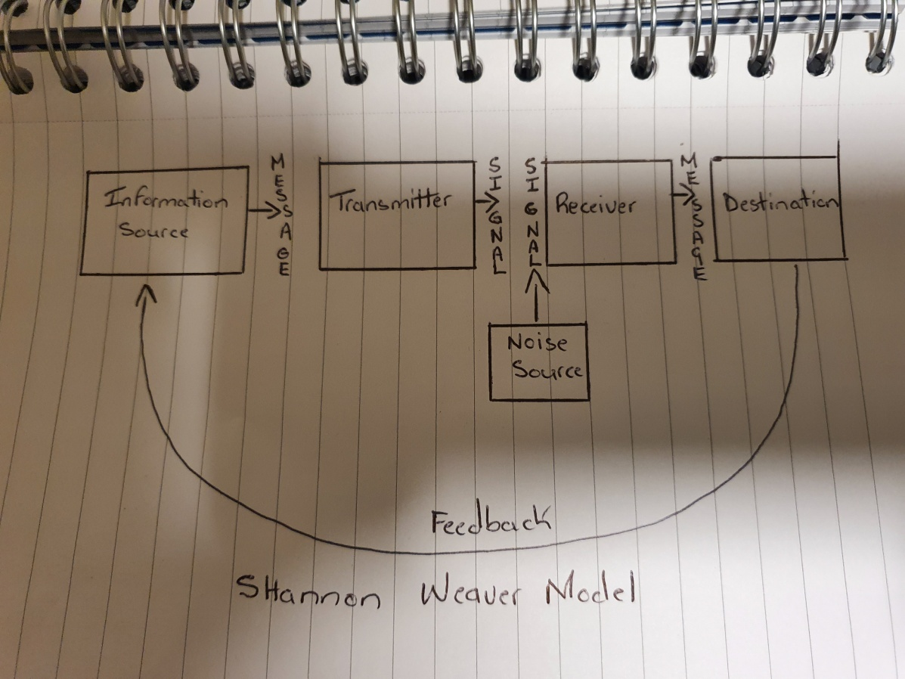

Appendix B
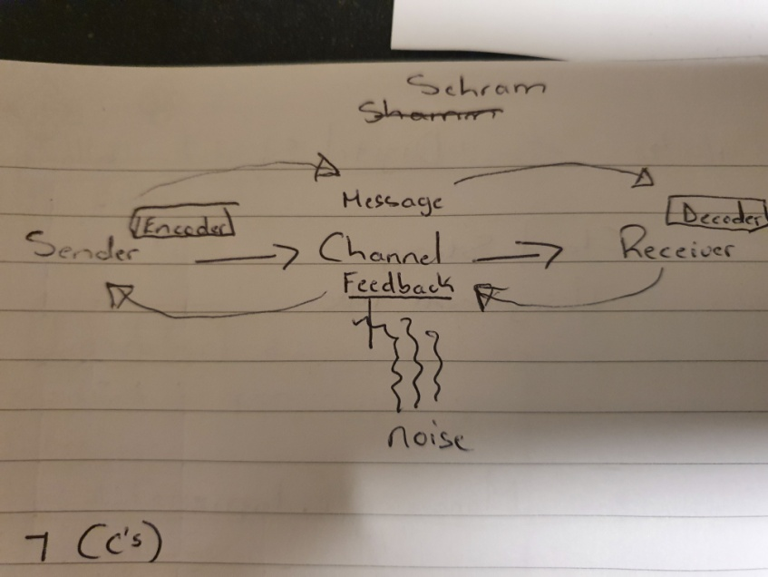

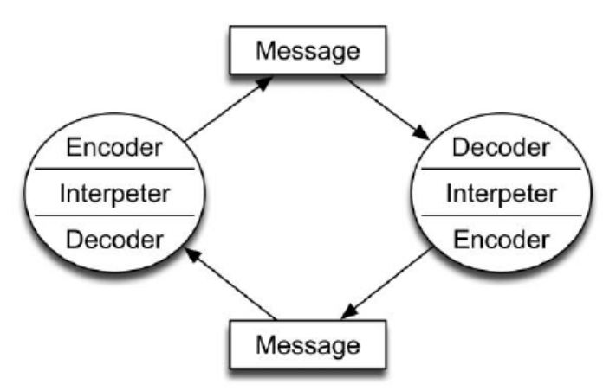

Appendix C


