Student : Laura Bucurean
Student Number :1807728

Group membe : Beata Beck

Wesite email : bucureanlaura@gmail.com

Password : dob10.12.79

Print screen shots of questionnaires:

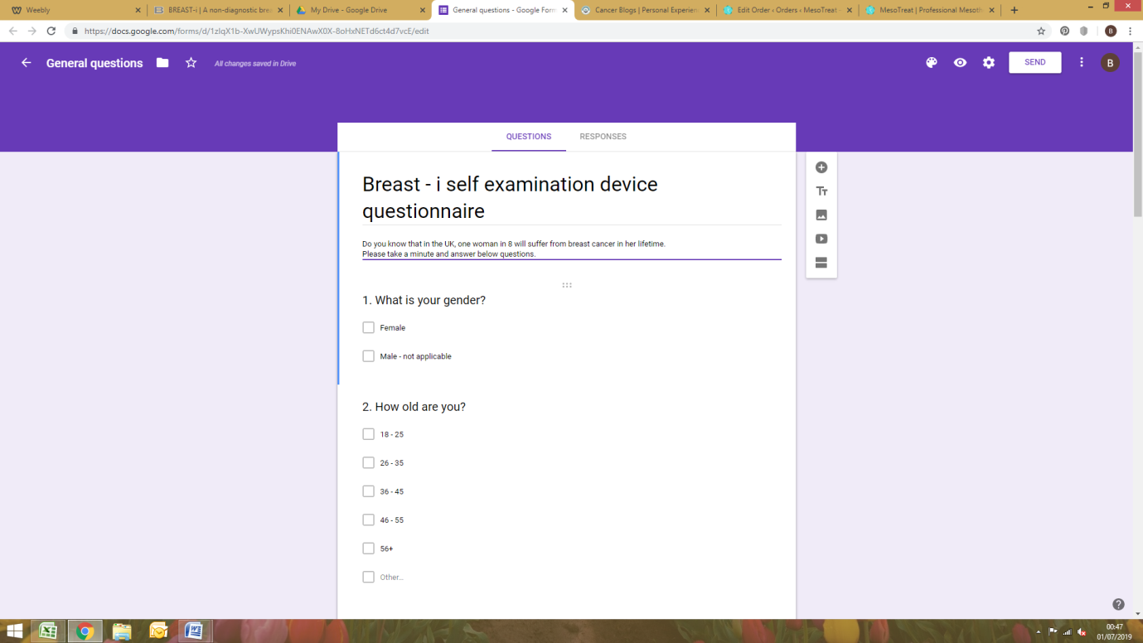

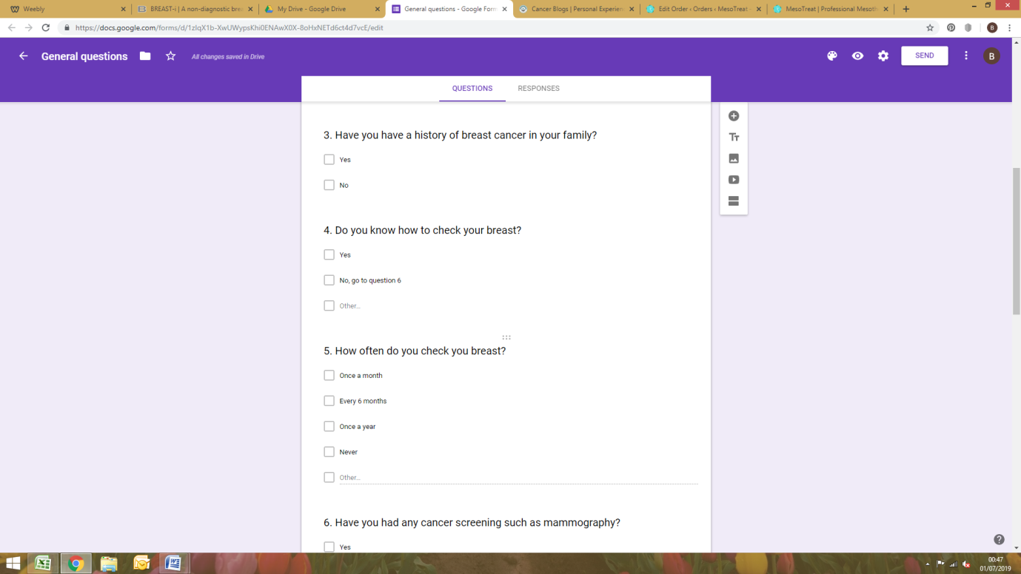
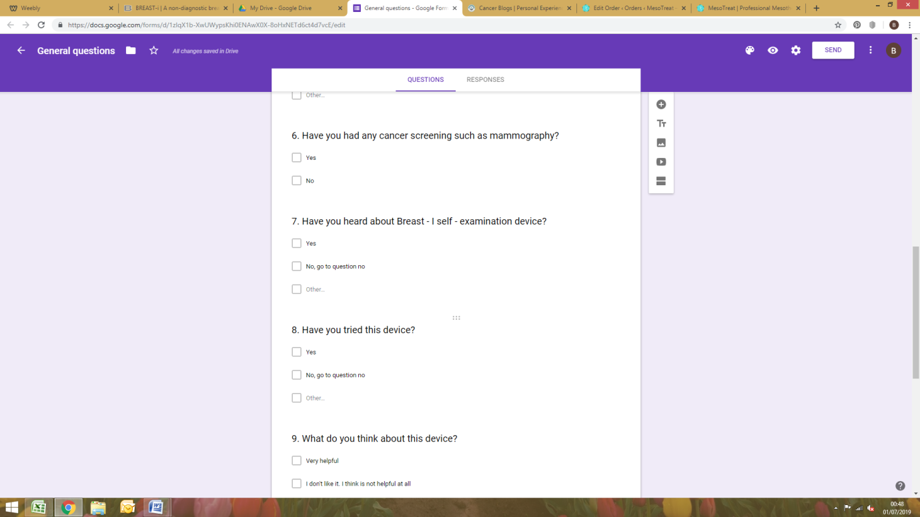

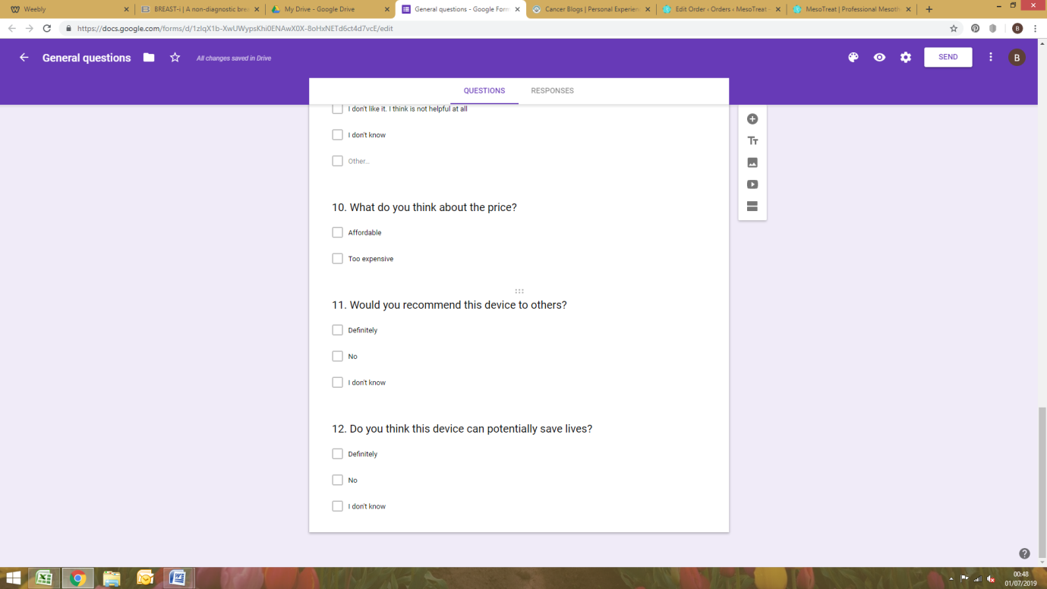

Question no 3- Have you have a history of breast cancer in your family?

This question is very important in our survey, and it will be treated with strict confidentiality and only used to establish the prevalence of breast cancer.
Breast cancer is the most common cancer in the UK.
The questionnaire has identified that 55% of the women asked have had one of a family member diagnosed with breast cancer. According to National Institute for Health and Clinical Excellence (NICE) guidelines, all women have more than 3% 10-year risk of developing breast cancer in view of their family history.
After going through the questionnaire an informed decision could be made whether or not to see their general practitioner for further examination.

NICE Women with breast cancer in the family-Information about NICE clinical guideline 41: Issue date Oct.2006 http://www.priory.com/family_medicine/Breast_Cancer_Questionnaire.htm

Question no 7 -Have you heard about Breast –I self examination Device?

In order to establish the interest in our device, we conducted a public survey to find out how many women have heard about Breast –i Non Diagnostic self examination device.
Majority of the women asked did not hear about Breast –i Self examination device; only 40% of our responders hear about breast I which indicates that our device needs more advertising.
After analysing the survey i decided to promote this amazing device to all women in the world, and choose to design the promoting page on our website.

During my study in the university, I had the opportunity to learn about blogging and proudly say that I look forward in putting all my learning’s into my work.
I have used advertising Breast –i Self examination device through our business website “MesoTreat “using Weebly which offers all individual elements to built the website quickly and free.
The page clearly points out that our product is NON DIAGNOSTIC Device, lets the user know if there is a spotted shadow during self examination of the breast then the information should be taken for further check to a specialist.

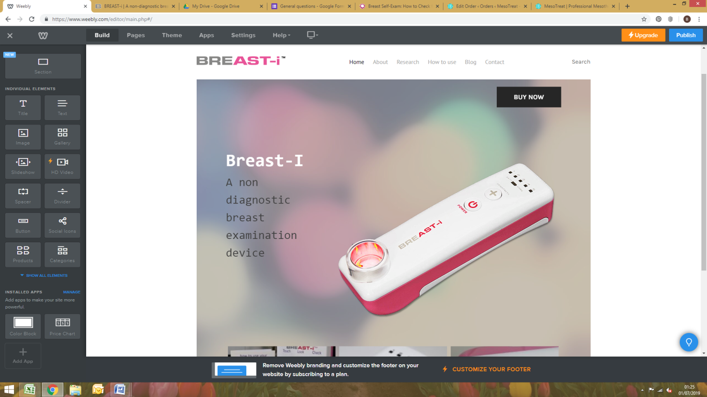

MesoTreat https://www.mesotreat.com/product-tag/breast-cancer/



