

UNIVERSITY OF WALES: TRINITY SAINT DAVID

BA Business Management

Management Economics
LCBB5005

Assessment 1

Report: Critically evaluate the Cross Rail Project, Elizabeth Line.

Name: Anastasia Ursu
Student ID: 2024744
Lecturer: Dr Molly Jack
Date: 12.09.2022
Word count: 2500

2022

Table of Contents

Introduction 3
1.Definition of Project Management 4
1.1.The method of project management 4
2. Project Initiation: Cross Rail, Elizabeth line. 5
2.1. Concept of Project 6
3. Project Definition and Planning 7
3.1. Ticketing 8
3.2. Project scope 8
3.3. Risk 9
4. Project Launch or Execution 9
4.1. Crossrail Project Delivery Strategy 9
5. Project Monitoring and Controlling 10
5.1. The timetable for construction 10
5.2. Contract administration, project controls 11
6. Project Close. 12
6.1. Lessons learned 12
Conclusion 13
References 14

Introduction

The research includes an analysis of fundamental aspects of the project known as the Cross Rail "Elizabeth line," such as the finances, the timeline, the quality of the stakeholders, and the risk factors. This analysis report must focus on the preliminary project plan in order to figure out what went wrong and why there were such significant time and cost overruns as a consequence.
To implementing our solid understanding of the foundations of project management. To apply successfully, the ideas and concepts of project management to real-world situations and make a positive contribution to any environment in which a project is being carried out.

1.Definition of Project Management

The application of information, skills, tools, and procedures to project activities in order to fulfil the requirements of the project is what constitutes project management. The process of organising and arranging the use of an organization's resources in order to advance the completion of a certain activity, event, or responsibility. The management of resources in a project often entails a one-time activity rather than an activity that occurs continuously, and the types of capital that are handled include both human and financial. (Burke, 2013)
What exactly is the Project?
A project is a unique and short-term endeavour. It is carried out with the end aim in mind, which might be specified in terms of outputs, outcomes, or benefits. If the project's objectives were met, and the acceptance criteria for those objectives were met, and if the project was completed within the agreed-upon time period and budget, then the project is deemed successful. (Kidston, 2015)
  - The method of project management relies on the five fundamental processes involved in project management. These processes are as follows:
• The first phase, known as "Initiation," is when the nature and parameters of the project are established. It has been decided on all the fundamental aspects of the project, such as the study of needs and feasibility, the evaluation of existing operations, and the objectives. It is the stage that has the most potential to determine the success or failure of the whole project if it is not completed appropriately.
• Planning and design: This stage is mainly helpful in planning the amount of time, expense, and resource that will be used during the development process. In order to properly deal with uncertainties, risk planning must also be conducted.
• The phase known as "Executing" is comprised of the processes and actions that are carried out in order to operate in tandem with the project plan in order to fulfil the target dates for the various milestones.
• Monitoring and controlling: These procedures evaluate and validate the activities, as well as their order and timeframes, to ensure that they conform to the project plan. In this context, the quality of the activities is also taken into consideration.
• The last step, known as closing, involves the official acceptance of the product that was produced. After the product has undergone exhaustive testing, the administrative process and any other necessary official actions are carried out so that it may be delivered to the customer. (Highsmith, 2009)

Project Initiation: Cross Rail, Elizabeth line.

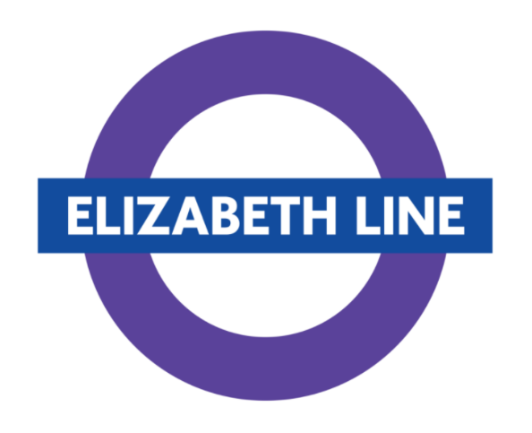
Figure nr:1
Source: crossrail.co.uk

At the moment, the new Elizabeth Line railway project is the biggest infrastructure project that is presently under development anywhere in Europe. It is possible to classify it as a megaproject on account of its size, expense, and level of complexity. (CROSSRAIL, 2022)
The new train line that cost £16 billion ($21 billion) would greatly improve the environmental performance of the whole city of London by significantly increasing the capacity of London's rail system by 10%. In terms of preserving the environment, this is the "correct initiative." Nevertheless, it is difficult to "do the project properly" when it comes to sustainability in a megaproject. This is because the managers and stakeholders of megaprojects are generally hesitant to accept new methods. Because they want to minimise risk, they give priority to proven and true approaches.
In contrast to this viewpoint, the management team for Crossrail actively explored innovation and established a new standard in terms of sustainability for a project of this magnitude. Crossrail's building process and its innovation and sustainability strategy have generated a legacy of excellent practises and lessons learned. (Hedeman & Seegers, 2009)
2.1. Concept of Project: In the nineteenth century, the Regents Canal & Railway Company was the first to propose the notion of a direct line running from Paddington to London's ports. This proposal has been around for quite some time. There have also been other versions of the idea that have come and gone. 1) Crossrail in its present form goes back to the January 1989 Central London Train Study, which was commissioned by the Thatcher Government to look at options to reduce congestion on the London rail system. Crossrail in its current form has been under development since that time. It proposed many additional lines and expansions, including as the East-West Crossrail (also known as Crossrail 1) and the Chelsea-Hackney line (Crossrail 2). Liverpool Street was supposed to be connected to Paddington and Marylebone by the Crossrail 1 line. (Lawton, 2017)
The research evaluated it as part of a "full cross" proposal, which would have included a north-south route from Euston/Cross King's to Victoria and would have increased the overall construction cost by £885 million (including rolling stock). The cost of building the Chelsea-Hackney line was predicted to be 1.33 billion pounds. These were condensed versions of what Crossrail 1 and 2 would eventually become; comprehensive and "regional" plans. (SKY.UK, 2022)

3. Project Definition and Planning

Following an extensive period of study and planning that began in 1974, a bill was presented to the UK parliament in 2005, and it was given royal assent in 2008 under the name of the Crossrail Act 2008. This Act of Parliament granted the required authorities to construct the line and authorised the Secretary of State to appoint Crossrail Ltd. as the operating company. (Murray-Webster, 2007)
Initial timetable plans suggest that several trains on the western branches will run at a speed that is somewhere between a fast and a moderate speed. However, once the Elizabeth line is fully operational, the central core section and the eastern branches will continue to operate a service in the familiar all-stops style of the London Underground. According to the preliminary plans, the only trains that will stop at Acton Main Line, West Ealing, and Hanwell will be those heading toward Heathrow. The Elizabeth line as part of the £14.8 billion Crossrail project a brand new high-frequency and high-speed suburban train that will serve the Greater London and the areas immediately around it. (CROSSRAIL, 2022)
During rush hour, the Elizabeth line operates at a frequency of 24 trains per hour (tph) in each direction along its central section (Paddington to Whitechapel). Of these, 12 trains will travel between Shenfield and Paddington, 6 will travel between Abbey Wood and Heathrow, and 6 will travel between Abbey Wood and either Reading or Maidenhead. According to the preliminary schedule, the Elizabeth line would have 24 peak-hour trains per hour (tph) in the central. On the Reading branch, certain trains will not make stops at each station. It is necessary to change trains in the centre portion for passengers who are travelling between stations that are located west of Paddington and those that are located on the north-eastern branch. When travelling between Hanwell, West Ealing, or Acton Main Line and other stations on the Reading branch, you will be forced to change trains at Hayes & Harlington. (SKY.UK, 2022)
At peak times, it is anticipated that the north-eastern segment that goes through Stratford would witness an increase of four trains per hour (tph) between Gidea Park and the current main line Liverpool Street station's high level ending platforms. This will take place through Stratford. Whitechapel will not be serviced by these trains since they go from Liverpool Street to Stratford on existing above-ground lines, which are why Whitechapel is not on their route. (CROSSRAIL, 2022)
3.1. Ticketing -is linked to the rest of London's public transportation networks, albeit Oyster pay-as-you-go will not be accepted on the western section between West Drayton (the boundary of TfL's Zone 6) and Reading. On that section of rail, only contactless cards will be accepted. Travelcards and discounted passes will be valid in the area that makes up Greater London. The Elizabeth line is depicted on the standard Tube map and connects to the rest of the Tube, TfL, and NR systems in London. (CROSSRAIL, 2022)
Passenger numbers-Before the Covid-19 pandemic, the Elizabeth line was expected to have over 200 million annual passengers after opening. This is expected to relieve pressure on London Underground's lines, especially the Central line. Farringdon, a vital Thameslink junction, is predicted to become one of the UK's busiest stations. Transport for London estimated yearly revenues of roughly £500 million from the line in 2022/23 (its first full year of operation). (SKY.UK, 2022)
3.2. Project scope- A new network that will link east, west, and central London, as well as Heathrow and City Airports, will be established in London as a result of the construction of the Elizabeth Line. There are a total of 41 stations along the route, and 10 of them are brand new. (Lawton, 2017)
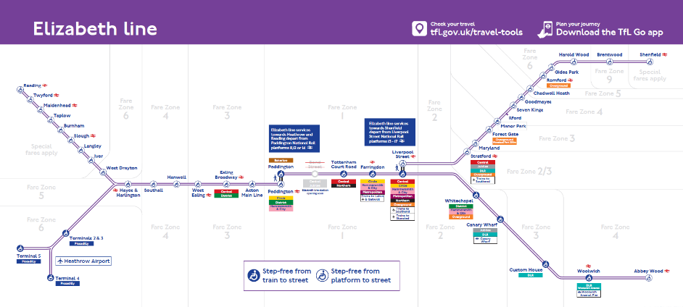
Figure nr:2
Source: crossrail.co.uk
3.3. Risk-Crossrail has determined that several the stations' storage rooms, some of which are in inaccessible parts of the station and more than 30 metres below ground level, need fire suppression systems. During construction, the hazards had become apparent or had been effectively prevented via design or management. (Kidston, 2015)
Some of the serious risks were:
- groundwater - especially, groundwater management in tunnelling and excavation, groundwater levels over the long term, and gas entrapment from dewatering recovery
- mixed face circumstances - comprises varying strata like the Lambeth Group, faulted ground, and drift-filled hollows, which poses a threat to the stability of the ground and the flow routes for perched groundwater.
- limestone and cemented units in the Lambeth Group and claystones in the London Clay are examples of hard strata.
- notably for the long-term endurance of concrete and cast-iron tunnel components, hostile ground and groundwater
- pile and foundation depths, well and borehole locations, and other obstacles
- abrasive soil, especially when flints are present in the Chalk and the thick Thanet Sand layers.

unexploded ordnance

4. Project Launch or Execution

4.1. Crossrail Project Delivery Strategy

Crossrail's execution strategy was first detailed in a 2009 internal document titled Crossrail Project Delivery Strategy. This model called for Crossrail and its industry partners, third party stakeholders, and supply chain to engineer, procure, construct, and commission the overall programme of work in a series of projects. This project required the work of a multidisciplinary team called an integrated delivery team, which included Crossrail.
- remained accountable for sponsor requirements
- have signed contracts with other companies including Network Rail and London Underground to carry out the programme
- outlined the framework for ensuring the program's delivery is safe, sustainable, and high-quality
- money and financing management
- programme delivery strategies for design, construction, and other services were created and put into action.
- coordinated the whole project
- set up and directed PR for the whole programme
- programme-wide, well-coordinated, optimum insurance coverage.
One of the most important parts of the plan of action was a well-thought-out procurement strategy that considered the overall vision, objectives, goals, constraints, policy environment, and procurement best practises. The Utilities Contracts Regulations of 2006 mandated that Crossrail's procurement processes follow those set out for utilities. (Murray-Webster, 2007)
Crossrail might utilise regulated or negotiated processes, pre-qualify economic operators for proposal lists, and award contracts based on the most economically advantageous offer. Best practise concepts:
- Offer good value
- Engage supply chain early
- Create contracts that allocate risk to the best-suited party
- Responsible and sustainable procurement
- Create performance management contracts
- Work with other clients to save money.

5. Project Monitoring and Controlling

5.1. The timetable for construction

In 2009 was the year when the schedule for the different phases' design, procurement, building, and commissioning activities was established. The illustration seen below presents an overview of the original project schedule, although it needs to be highlighted that this is no longer valid due to the subsequent setbacks that have occurred. The following table that provides a more in-depth building and delivery schedule. (Kidston, 2015)
5.2. Contract administration, project controls. Each project has its own dedicated construction and service engineering crew. Employees with essential responsibilities in health and safety, environmental protection, quality assurance, risk management, and community relations were allotted to work with the project teams as support staff. These previously stated changes in the management structure of the central section delivery team only meant that the project manager may report to a new director; they did not alter the fundamental organisation of the teams themselves at the project level. (Burke, 2013)
We used conventional methods for project management, such as a work breakdown structure, complete with corresponding cost control and financial management, an integrated programme management schedule, commodity-based earned value reporting, and a stringent methodology for controlling trends and changes. Nevertheless, Crossrail also made an effort to encourage its contractors to go above and beyond the minimal requirements for their reporting.
The client will be presented with an increased number of interfaces to manage in proportion to the number of sub-divisions included within the scope of the project. In order to comply with the requirements of the execution strategy, a comprehensive interface management and control mechanism has to be designed and published before any procurement can started.
It is impossible to place an adequate amount of emphasis on the significance of the client having a distinct vision as well as a set of values that serve as the basis for their behaviours and decisions. Throughout the whole of a project's lifespan, each activity, as well as the evaluation of the project's success, must continue to be inextricably linked to the project's vision and values.
All parties in the supply chain need to be in agreement with the client's stated aims and objectives, which must be clearly communicated throughout the contracts. There must be an in-depth analysis of the supply chain's efficiency in light of the stated goals and objectives. When applied to the whole supply chain, healthy competition has been shown to increase productivity.
Comprehensive identification of how the project will be tested, commissioned, and handed over must be accomplished as early as possible and used as a foundation when determining the overall execution strategy and the delivery timeframe for a large project. This must be completed immediately. The final consumers, along with any other interested parties, must be part of this process. (Lawton, 2017)
Crossrail Ltd claims the summer 2021 deadline is due to the epidemic and does not give a new opening date. The National Audit Office estimates that Crossrail will cost £18.9 billion in July 2021, which is £3 billion more than the initial estimate. TfL announced in May 2022 that the central branch of the Elizabeth Line will open on May 24, 2022, with the additional branches opening in stages between fall 2022 and May 2023. The Elizabeth Line has been in the works for the last 20 years and has accumulated billions of dollars in expenses for the government. (CROSSRAIL, 2022)
Since they started in 2009, engineering and construction activities have been taking place every weekend, which has caused significant disruption to the lives of those living in and around London. Its whole economic case was very highly dependent on the continuous expansion of the economy of central London, and that growth was substantially dependent on itself. The United Kingdom's economy had a contraction of 0.8% in March, while inflation reached a new all-time high of 7%. The construction of Crossrail 2, which would run from the southwest to the northeast of London, has been halted for a variety of reasons, including this one.

6. Project Close.

6.1. Lessons learned

To this point, much of Crossrail's success can be attributed to the fact that the project's execution—both in terms of "how" it is being delivered and "what" it is being delivered—has received equal attention. To achieve this goal, the Crossrail learning legacy will fund not just this paper, but also additional technical publications that will be recording the best practises and lessons gained from Crossrail for the benefit of the industry's future usage. (L & C, 2016)
The new Elizabeth Line, which is part of Crossrail, will bring major economic and environmental advantages to the area, City of London as well as the United Kingdom. The evaluation of advantages and costs on a scale that encompasses the whole city reveals a
compelling economic justification for the project, particularly regarding its potential to ease traffic on London's current transportation network and to enable the city to create new employment opportunities. The advantages to the economy of the United Kingdom are predicted to be at least £42 billion, while the cost of building the new railway is anticipated to be £16 billion. Crossrail is not just the "correct project," but it has also been "done well." Megaprojects are often described as "actually done." (Hedeman & Seegers, 2009)
Stick to tried-and-true methods and steer clear of forward-thinking or environmentally conscious tactics at all costs to include both danger and expense. However, Crossrail placed an early emphasis on innovation and integrated sustainability, therefore establishing a standard for the management of large-scale construction projects. Utilizing the BREEAM and CEEQUAL grading systems allows for verification of the project's commitment to environmentally responsible practises throughout its whole systems. (Highsmith, 2009)
The Elizabeth Line is now opened after 20 years of planning, construction, and delays.

Conclusion

In conclusion, it is important to note that the commencement date for full Elizabeth line services will continue to be contingent upon increased dependability, as well as the successful installation of further enhancements to signalling and rolling stock software. It is anticipated that services from Reading, Heathrow, and Shenfield will link with the central tunnels in the fall. At that time, the frequency of trains running between Paddington and Whitechapel would rise to up to 22 during the peak hours and 16 during the off-peak hours.
May 2023 is the target month for the completion of the entire schedule for the Elizabeth line, which will include up to 24 trains per hour during peak hours between Paddington and Whitechapel and 20 trains per hour during off-peak hours. In order to deliver the railway in its ultimate shape, alignment with National Rail schedule alterations will need to take place. The connection between the core portion (which runs from Paddington to Abbey Wood) and the surface segment, which runs between Stratford and Paddington, is an essential component in the delivery of the whole Elizabeth line service. This changeover must have an extremely high degree of dependability, and work is now being done with our signalling provider to get this reliability up to the needed level.
The Elizabeth line in its completed form will be delivered according to the current plans for the project by the end of May 2023 at the latest.

References

Black, M., 2016. Crossrail project: managing geotechnical risk on London’s Elizabeth line. ice Proceedings, 170(CE5), pp. 23-30.
Burke, R., 2013. Project Management Planning and Control Techniques, 5th ed. Wiley: West Sussex. 5 ed. s.l.:Wiley.
CROSSRAIL, 2022. CROSSRAIL PROJECT UPDATE. [Online]
Available at: www.crossrail.co.uk
Hedeman, B. & Seegers, R., 2009. Prince 2 TM 2009 Edition - A Pocket Guide. 2 ed. s.l.:Van Haren.
Highsmith, J., 2009. Agile Project Management: Creating Innovative Products, 2nd Ed., Addison-Wesley Professional. 2 ed. s.l.:Addison-Wesley Professional.
Kidston, P., 2015. Planning, Scheduling, Monitoring and Control: The Practical Project Management of Time, Cost and Risk.. s.l.:APM.
Lawton, I., 2017. PRINCE2 Made Simple: Updated 2017 Version. 2nd. 6 ed. s.l.:RATIONAL Spirituality Press.
L, M. & C, M., 2016. Promoting Positive Environmental Behaviour Change at Crossrail – Lessons Learned from Implementing the Green Line. s.l.:s.n.
Murray-Webster, R. S. P., 2007. Starting Out in Project Management: A Study Guide for the APM Introductory Certificate in Project Management, 2nd Ed., Association for Project Management (APM): Beds. 2 ed. s.l.:s.n.
SKY.UK, 2022. Sky UK. [Online]
Available at: https://news.sky.com/story/elizabeth-line-years-of-delays-and-billions-over-budget-but-can-crossrail-transform-the-capitals-fortunes-12619900
Tucker, W., 2016. Crossrail project: the execution strategy for delivering London’s Elizabeth line. Civil Engineering, 170(CE5), pp. 3-14.

