Qualification: CIPD Diploma in Applied Human Resources

Module Name: Using a Research Approach in Human Resources – Activity 2

Assessment 5CIHR-I1C1003

Word Count: 2,461

Student Name: Sharon Richards
Student Number: 2014447
CIPD Membership Number: 57493181

By signing below, I confirm that the work/evidence presented is my own, unaided work. I understand the regulations pertaining to candidate malpractice and the action that may be taken as a result.

Signed: S Richards
Date: 31st July 2021

Medical staffing:
Why do hospital doctors leave the Health Board and what actions can it take to improve retention?

Executive Summary

Overview
The Hywel Dda University Health Board (2019) ‘Workforce, Organisational Development and Education Strategy 2020 – 2030’ sets out a vision to become an ‘Employer of Choice’. One of the key success outcomes is to understand why staff leave the organisation and to develop interventions to retain staff who are contemplating leaving.

This report provides an analysis of the reasons why hospital doctors leave the organisations and the actions that the organisation can take to improve retention amongst hospital doctors.

Methods of analysis
A literature review was conducted to gain an understanding of the importance of retention and the reasons that might lead to a doctor’s decision to leave. An analysis of the national and local position in terms of hospital doctor turnover rates and reasons for leaving was also conducted.

Primary research was undertaken through interviews with a range of key stakeholders including consultants, assistant directors, general managers and medical staffing.

Findings
An analysis of primary research showed that that the main reason why doctors leave is for career development. This correlates with the findings from the literature review.

Within Hywel Dda University Health Board, this can be for two reasons:
- Availability of further training within specialities; and / or
- A lack of consideration of alternative and flexible opportunities in-house.

A second interesting finding was the strong sense amongst those interviewed that the employee’s experience of the recruitment, onboarding and induction was critical to retention, particularly during the first two years of employment.

Other factors raised included culture and leadership, facilities and amenities and workload pressure.

The golden thread running through all feedback was the need for much stronger communication at, and across, all levels; in particular, the importance of treating people as individuals and providing that ‘personal touch’ is crucial.

Recommendations
Based on the analysis of both primary and secondary evidence, recommendations are to:

- Introduce earlier intervention, e.g. ‘stay interviews’ (Disruptive HR, 2021), at the point that the doctor indicates they are intending to leave to explore what the organisation can provide to meet the individual’s needs.
- Building on what is already in place in some areas, adopt and encourage a mentoring approach (BMA, 2021) amongst clinicians to support personal and professional development aspirations, improve confidence and increase the sense of feeling valued.
- Building on good practice demonstrated elsewhere in the Health Board, develop an end-to-end personalised approach to recruitment, onboarding and induction, managed jointly between clinicians and medical recruitment.

Conclusion
The time investment required to interview, type up notes and analyse qualitative data restricted the number of interviews that could be undertaken. However, there are clearly challenges for the Health Board in terms of retaining doctors who aspire to progress their career.

Table of Contents Page
- Introduction 1
- Literature Review 2
- Methodology 5
- Findings 6
- Conclusion 8
- Recommendations 9
- Limitations 9
- Reference List 10

Appendix A Screenshot of front page and declaration page of Ethical Approval form

Appendix B Invitation to interview email

Appendix C List of stakeholders

Appendix D Example screenshot of thematic analysis
- Introduction

The Hywel Dda University Health Board (2019) ‘Workforce, Organisational Development and Education Strategy 2020 – 2030’ sets out a vision to become an ‘Employer of Choice’. One of the key success outcomes is to understand why staff leave the organisation and to develop interventions to retain staff who are contemplating leaving. This report focuses on the retention of hospital doctors.

Objectives are to:

- Understand turnover rates and trends. Make comparisons against other staff groups and across Wales.

- Understand the reasons why doctors leave and what action can be taken to encourage retention.

- Make recommendations on actions to improve retention.

Over recent years, the Health Board has used high levels of bank and agency workers which has resulted in high variable pay costs that have contributed to a significant deficit against budget (Hywel Dda Health Board, 2019).

The Royal College of Physicians (RCP) (2019) report that in 2018 in Wales:
- almost one-third of consultant posts were vacant;
- more than one-third of consultants were likely to retire within the next decade; and
- 46% of consultants are due to reach 60 in the next 10 years.

Wales Online (2021) recognise that the NHS is at risk of losing a significant number of medical staff and a focus on retention is key to address the growing waiting list as a result of COVID-19.

- Literature Review

Importance of retention
The NHS is facing medical staffing challenges with a lack of doctors and funding to achieve a ‘committed, fully operational and integrated healthcare workforce. (Dacre, 2016).

Turnover of staff can be a challenge for organisations, particularly where employees with specialist skills leave their jobs (CIPD, 2021a). In the NHS, high turnover can result in cost pressures as vacancies are filled by using agency workers. Between 2016 and 2020, the Welsh NHS spent over £500 million on medical agency staffing (Welsh Conservatives, 2020).

The Kings Fund (2019, p41) suggests that focusing on retention is important to ensure continuity and improved quality of care for patients and that the key to improving retention is to understand the reasons why individuals leave their jobs.

Factors that influence doctors to leave
The Welsh NHS Confederation (2018) consider factors such as pressure of work, lack of flexibility, pay or lack of career development as reasons why many individuals leave.

Whitehouse (2018) states that 21% of those leaving the NHS in 2016/17 cited a better reward package, lack of opportunities, promotion, further education or poor work-life balance as their reason for leaving.

Employees are more likely to stay with an organisation if they have access to personal and professional development opportunities (Kossivi et al, 2016, p262).

Shen et al (2004) found that pay was not a significant contributor, although recognition and a sense of being valued was important.

Local position
The Medical and Dental staff group have historically had the highest turnover rate of all staff groups in the Health Board.

Chart 1: Turnover rate by staff group 2018/19 – 2020/21

As at October 2020, the Health Board’s turnover rate for this staff group was 16.7% compared to the NHS Wales average of 13.1% (NHS Wales, 2020).

During 1st January 2021 to 30th June 2021, 33 employees from this staff group left the organisation.

Chart 2: Reason for leaving (termination form) 01/01/21 – 30/06/21

According to this data, 36% of leavers retired. Whilst this is based on the manager’s assessment, and individuals may not be willing to share their genuine reason for leaving if it involves criticism of managers or the organisation (CIPD, 2021), the age profile of retirees is consistent, with 92% over the age of 56.

During January to June 2021, 13 doctors provided feedback on the reasons for leaving the organisation.

Chart 3: Reason for leaving (leaver feedback) 01/01/21 – 30/06/21

Of all respondents, only 1 (8%) cited retirement as their reason for leaving.

Conclusion
Given the lack of availability of leaver feedback, primary research focused on gathering from critical insight and context from key internal stakeholders with specialist knowledge and experience of working with doctors.

3 Methodology

It was not possible to participate in or undertake exit interviews within the timeframe. Consideration was given to independently requesting feedback from doctors who had left the organisation, but this was not viable due to time constraints.

Semi-structured interviews (The Open University, 2021) were chosen as a method to collect qualitative data (Bryman and Bell, quoted in Taylor and Woodhams, 2016, p94). This allowed a better focus on understanding meaning, or ‘the story’ behind the data. The significant time commitment required was offset by the benefits of this approach. An interpretivist approach (Anderson, 2013) was chosen due the limitations of exit interviews and surveys, particularly where staff experiences have been poor (CIPD, 2021a).

This approach aligns to Anderson’s ‘case study’ research design (quoted in Taylor and Woodhams, 2016, p.96), used to understand a specific issue within a particular context. This approach ‘tells the story’ but results and recommendations cannot be generalised and applied to other organisations.

A purposeful sampling strategy (Patton, 2002, p230) was used, alongside a stratified approach (McCombes, 2021) to ensure that evidence was gathered from across the Health Board geographical footprint and across clinical specialisms to explore variances in turnover rates.

Focus groups were also considered, although due to current unprecedented work pressures, bringing groups of operational managers together would have been a significant challenge.

An ethical practice approach (CIPD, 2021b) was critical to the integrity of this research and the subsequent recommendations made to the organisation (Appendix A). Participation was entirely voluntary and consent was requested via email (Appendix B) and informed consent was assumed through the participant’s agreement to attend the interview.

14 stakeholders were interviewed (Appendix C). The stakeholder group was representative of a breadth of managers and senior leaders across the organisation, many of whom work directly with hospital doctors as colleagues or managers.

Two key questions were asked:
- What are the key factors that influence hospital doctors to leave the Health Board?
- What actions can the Health Board take to improve retention of hospital doctors?

A thematic analysis (Guyan, 2018, p6) approach was taken to analyse data collected at stakeholder interviews to identify common words or themes (Appendix D). The results of the thematic analysis were used to draw conclusions on the key reasons why doctors leave the Health Board.

4 Findings

An analysis of the themes emerging from the interviews is provided in Table 1. Discussions mainly focused on the retention of Specialty and Associate Specialist (SAS) doctors (NHS Health Careers, 2021).

Table 1: Analysis of findings from interviews

Theme | No. participants / comments | Findings
Career development | 14 / 53 | There is a sense that Hywel Dda is considered as a ‘stepping-stone’ to greater opportunities for many doctors, particularly those from abroad who want to gain NHS experience. There appear to be two main barriers to development opportunities within the organisation 1. Lack of availability of training within specialities, leading to doctors leaving to join other organisations who can offer this. 2. A lack of consideration of alternative and flexible opportunities e.g. developing specialist interests / clinical leadership roles / flexible working arrangements / service development. It is evident that mentoring is being used in some areas to support the development of individuals. However, it was acknowledged that some turnover must be expected and that it is important to respect the decision of doctors who wish to pursue development opportunities outside of the organisation if it is in their interest.
Recruitment / onboarding / induction | 11 /40 | There was a strong sense that retention starts at the pre-application stage and runs through to induction and beyond. An employee’s experience of this process is critical to retention (Maurer, 2021). The overriding message was the importance of regular and personalised communication. Examples were provided of doctors not understanding the area that they are moving too, not having any contact from offer to start, not being met on their first day and of doctors being unable to settle; all of these factors can result in a loss for the organisation be it at the recruitment stage or within the first couple of years of employment.
Culture | 12 / 20 | The importance of culture and the role of leaders in shaping this was felt to be fundamental to retention. Interestingly, participants who were based at a hospital site felt that the culture there was positive, although this was not necessarily reflected across the whole organisation.
Remuneration | 8/8 | In general, and in line with Shen et al (2004) observations, remuneration was not considered a significant factor in retention as doctors are all employed under the same Terms and Conditions.
Accommodation / Facilities | 6 /10 | Accommodation, facilities and equipment are lacking across the Health Board although this was not considered significant in terms of retention.
Workload pressure | 5 / 8 | Depleted staffing levels in some services, such as A&E, can put additional pressure and stress on doctors. The clinical risk of worker in smaller hospitals is deemed greater than in larger hospitals as doctors are often working alone and without a full suite of specialities available.
Exit interviews | 5 / 8 | The existing exit interview process is considered a ‘data collection’ exercise which doesn’t maximise the opportunity for leavers to give their true reason for leaving (CIPD, 2021). As exit interviews are retrospective, they don’t provide an opportunity to resolve issues.

In terms of the actions that the Health Board could take to improve retention, two key themes emerged:

Career development
The SAS Charter (Academy of Medical Royal Colleges, 2016) sets out a “commitment to supporting and developing the role of the SAS doctor as a highly valued and vital part of the medical work force”.

The Health Board have started to work towards delivering the Charter recommendations. Key actions include:

- Establish an SAS Steering Group;
- A listening and learning exercise with SAS doctors;
- Appoint a CESR (Royal College of Physicians, 2021) lead;
- Develop a system to code SAS doctor activity;
- Establish a New SAS Contract Implementation Group; and
- Employ an SAS advocate to support doctor’s wellbeing and welfare.

The Health Board Psychiatry Service has already developed a CESR training programme in conjunction with the Deanery, the first one for psychiatry in Wales, with the first recruit appointed into 5-year programme to become a consultant.

There was a sense that turnover of SAS doctors should not always be considered as negative. Supporting a doctor to develop, should be seen as a success for the organisation even that means that they need to move on to continue their progression.

However, exploring opportunities and being flexible to new ways of working that will support individuals to develop their clinical or non-clinical interests where possible was considered important.

Recruitment, onboarding and induction
Inextricably linked to career development is the importance of building a trusting relationship with doctors from the early stages of recruitment right through to induction and beyond. For example:

- Clinical engagement before interview to ascertain if the role is in the best interests of the candidate;
- Ensuring that doctors understand the geographical and demographic profile of the area, the hospital configuration and the training opportunities that may (or may not) be available to them in the future;
- Keeping in regular touch during the onboarding process - a regular two-way communication channel to keep the doctor updated and resolve any potential questions or issues;
- Providing a personalised welcome to the doctor on arrival and on their first day and beyond;
- Providing and encouraging networking opportunities amongst colleagues;
- Ongoing mentoring to explore career opportunities including
  - internal clinical and non-clinical development; and
  - external development, if in the best interests of the doctor.
- Being open and responsive to alternative working arrangements such as flexible working patterns or hybrid job plans across more than one specialty.

There are clearly already examples of excellent practice in terms of continuous and personalised engagement across the Health Board. Whilst engagement takes significant investment in terms of time and commitment (Allen, 2014), the benefits are invaluable – increased productivity, well-being, job satisfaction and retention (CIPD, 2021). Engagement can facilitate behaviours aligned with organisational values, ultimately leading to an improved culture (Holcroft, 2019).

5 Conclusion

There are clearly challenges to the retention of doctors for the Health Board, compared to other staff groups and across other Health Boards in Wales.

There was limited secondary data available to make any robust conclusions about the reasons why doctors leave the Health Board due to the lack of responses to exit interviews. The value of exit interviews as they currently exist is questionable in terms of really understanding why our doctors leave. Whilst the data may show the reason for leaving as ‘change of career’, a fuller insight into what attempts have been made to support that doctor to develop in-house would be far more valuable.

Interviews with key stakeholders provided some rich context in terms of the key factors that impact on a doctor’s decision to leave. Recommendations will focus on the two most significant and recurring themes identified through the primary research undertaken:
- Career development – adopting a flexible approach to creating in-house development opportunities;
- Getting the candidate journey right – attracting the right people, keeping in touch and providing a positive induction experience.

Clearly, running alongside both themes is a real want to treat people as individuals, to engage at an early stage and to maintain communication at regular touch points.
6 Recommendations

The following recommendations are based on the literature review and findings of primary research:

Recommendation 1
Building on good practice demonstrated elsewhere in the Health Board, develop an end-to-end personalised approach to recruitment, onboarding and induction, managed jointly between clinicians and medical recruitment. This could potentially be supported by a system-wide ‘Candidate Support Hub’.

Recommendation 2
Building on what is already in place in some areas, adopt and encourage a mentoring approach (BMA, 2021) amongst clinicians to support personal and professional development aspirations, improve confidence and increase the sense of feeling valued.

Recommendation 3
Introduce earlier intervention, e.g. ‘stay interviews’ (Disruptive HR, 2021), at the point that the doctor indicates they are intending to leave to explore what the organisation can provide to meet the individual’s needs. These should be held with senior clinicians with responsibility for decision-making who can facilitate resolution.

Limitations
The time investment required to interview, type up notes and analyse qualitative data restricted the number of interviews that could be undertaken. Whilst only 14 interviews took place, data saturation (Marshall et al, 2013) was becoming evident as the interviews progressed, with fewer factors and ideas forthcoming.

Reference list
Academy of Medical Royal Colleges (2016) SAS Doctors and Dentists Charter for Wales. Available at sas_charter_wales_0416-16.pdf (aomrc.org.uk). (Accessed: 27th July 2021)

Allen, M (2014) Employee Engagement – A Culture Change. Available at employee-engagement-a-culture-change.pdf (insights.com). (Accessed: 29th July 2021)

Anderson, V. (2013) Research Methods in Human Resource Management: Investigating a Business Issue. London: CIPD

BMA (2021) Mentoring for doctors. Available at Mentoring for doctors (bma.org.uk). (Accessed: 25th July 2021)

CIPD (2021a) Employee turnover and retention. Available at Employee Turnover & Retention | Factsheets | CIPD. (Accessed: 17th June 2021)

CIPD (2021b) Ethical practice and the role of people professionals. Available at https://www.cipd.co.uk/knowledge/culture/ethics/role-hr-factsheet. (Accessed: 4th July 2021)

CIPD (2021c) Employee Engagement and Motivation. Available at Employee Engagement & Motivation | Factsheets | CIPD. (Accessed: 29th July 2021)

Dacre, J (2016) Physicians on the front line: The medical workforce in Wales in 2016. Available at https://www.rcplondon.ac.uk/projects/outputs/physicians-front-line-medical-workforce-wales-2016-0. (Accessed: 17th June 2021)

Disruptive HR (2021) Introducing Stay Interviews. Available at https://disruptivehr.club/toolkit-introducing-stay-interviews/. (Accessed: 25th July 2021)

Guyan, K (2018) Analysing Qualitative Data – A Guide for University and College Practitioners. Available at http://www.ecu.ac.uk/wp-content/uploads/2018/12/Research-Data-briefing-6-Analysing-Qualitative-Data.pdf. (Accessed: 8th July 2021)

Holcroft, P (2019) The Connection between Employee Engagement and Retention. Available at The Connection between Employee Engagement and Retention | Economic Journal. (Accessed: 29th July 2021)

Hywel Dda Health Board (2019) Workforce, Organisational Development & Education Strategy 2020 – 2030. Internal unpublished strategy.

King’s Fund (2019) Closing the gap: Key areas for action on the health and care workforce. Available at https://www.kingsfund.org.uk/sites/default/files/2019-03/closing-the-gap-health-care-workforce-full-report.pdf. (Accessed: 13th May 2021)

Kossivi, B, Xu M, Kalgora, M (2016) Study on Determining Factors of Employee Retention. Available at Study on Determining Factors of Employee Retention (semanticscholar.org) (Accessed: 25th July 2021)

Marshall, B, Cardon, P, Poddar, A and Fontenot, R (2013) ‘Does sample size matter in qualitative research? A review of qualitative interviews in IS research’ in The Journal of Computer Information Systems; Stillwater Vol.54, Iss 1. Available at DOES SAMPLE SIZE MATTER IN QUALITATIVE RESEARCH?: A REVIEW OF QUALITATIVE INTERVIEWS IN IS RESEARCH - ProQuest (uwtsd.ac.uk) (Accessed: 25th July 21)

Maurer, R (2021) ‘New Employee Onboarding Guide’ in SHRM. Available at New Employee Onboarding Guide (shrm.org). (Accessed 25th July 2021)

McCombes, S (2021) An introduction to sampling methods. Available at https://www.scribbr.com/methodology/sampling-methods/. (Accessed: 4th July 2021)

NHS Health Careers (2021) SAS Doctors. Available at SAS doctors | Health Careers. (Accessed: 27th July 2021)

NHS Wales (2020) Performance Measures Dashboard. Unpublished.

Patton, M Q (2202) Qualitative Evaluation and Research Methods, 2nd edition. Sage Publications.

Perkin, G and Woodhams, C (2016) ‘Using Information in Human Resources’ in Taylor, S. and Woodhams, C. (ed) Studying Human Resource Management. 2nd edition. London: CIPD

Royal College of Physicians (2019) Doing things differently: supporting junior doctors in Wales. Available at https://www.rcplondon rcplondon.ac.uk/search?keys=doing+things+differently&sort_by=search_api_relevance&=Search. (Accessed: 17th June 2021)

Royal College of Physicians (2021) Navigating the CESR Route. Available at Navigating the CESR route | RCP London. (Accessed: 25th July 2021)

Shen, J, Cox, A and McBride A (2004) Factors influencing turnover and retention of midwives and consultants: a literature review. Available at https://journals.sagepub.com/doi/pdf/10.1258/0951484042317769. (Accessed: 19th June 2021)

Taylor, S and Woodhams, C (2016) Studying Human Resource Management, 2nd edition. CIPD: London

The Open University (2021) Postgraduate study skills: conducting an interview. Available at https://help.open.ac.uk/conducting-an-interview. (Accessed: 8th July 2021)

The Welsh NHS Confederation (2018) Retaining our staff – a key to success in difficult times. Available at https://www.nhsconfed.org/sites/default/files/media/Retaining-our-staff-key-to-success-in-difficult-times_0.pdf. (Accessed: 19th June 2021)

Wales Online (2021) NHS Wales staff could 'leave in their droves' without urgent recruitment plan. Available at https://www.walesonline.co.uk/news/health/nhs-wales-staff-could-leave-20217652. (Accessed: 17th June 2021)

Welsh Conservatives (2020) More than half a billion pounds spent on agency staff in the Welsh NHS over the past four years. Available at https://www.conservatives.wales/news/more-half-billion-pounds-spent-agency-staff-welsh-nhs-over-past-four-years. (Accessed: 19th June 2021)

Whitehouse, E (2018) ‘The NHS crisis: can HR help?’ in People Management. Available at The NHS crisis: can HR help? (peoplemanagement.co.uk) (Accessed: 19th June 2021)

Appendix A – Screenshot of front page and declaration page of Ethical Approval form

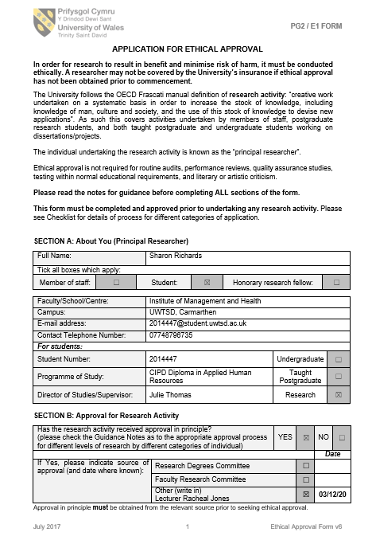

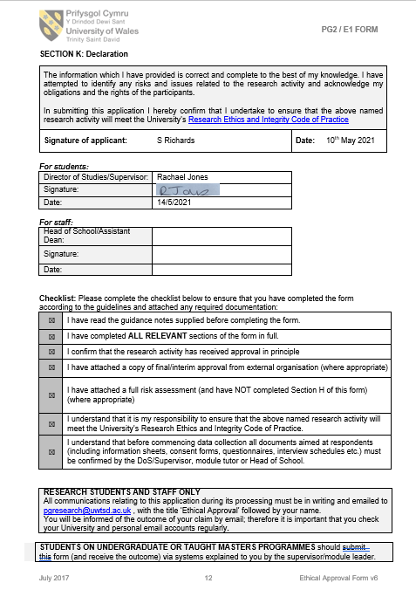
Appendix B – Sample interview invitation email

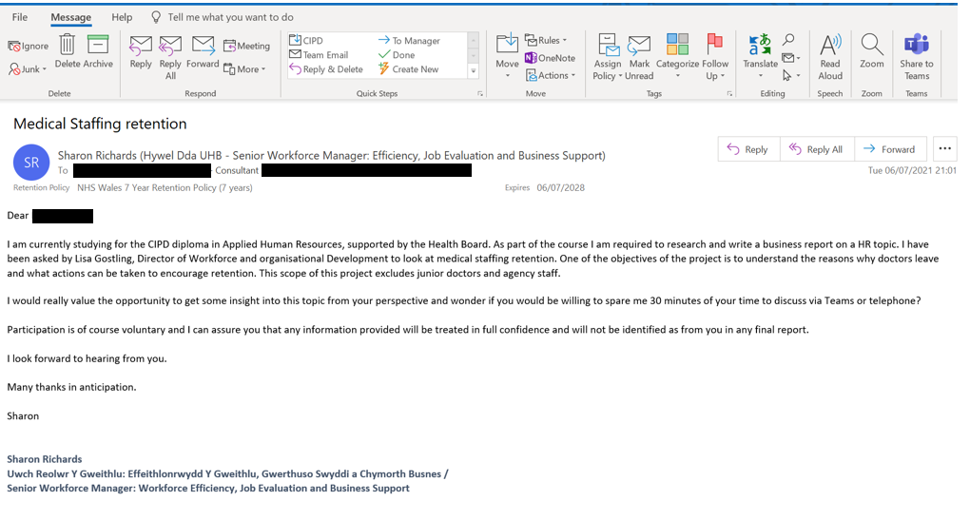

Appendix C – Stakeholder list

Role
Medical staffing / recruitment x 3
General Manager x 2
Consultants x 4
Assistant Director / Deputy Director x 2
Clinical Lead x 1
Direct Provider x 1

Appendix D – Example screenshots of thematic analysis

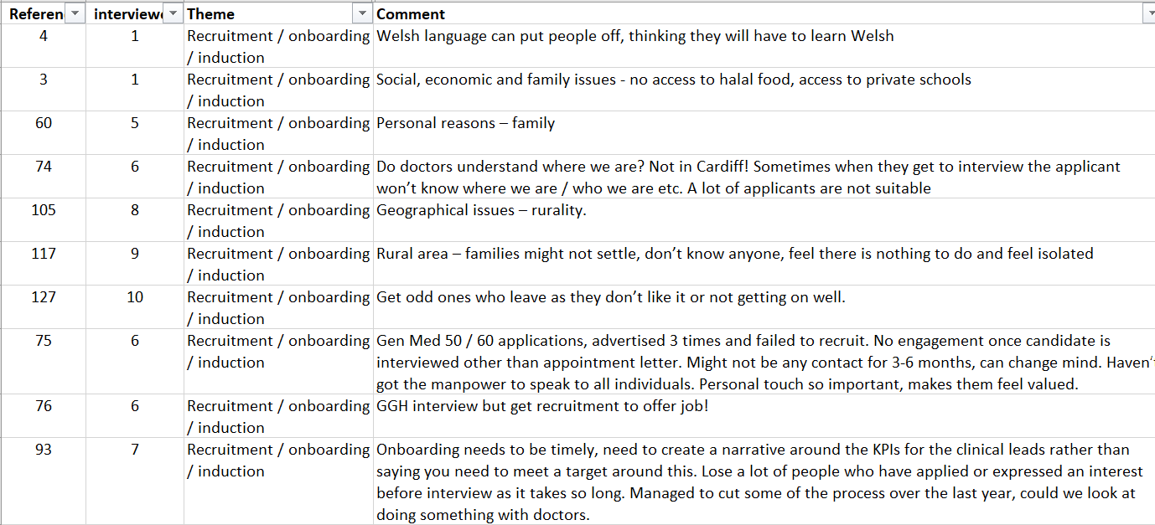

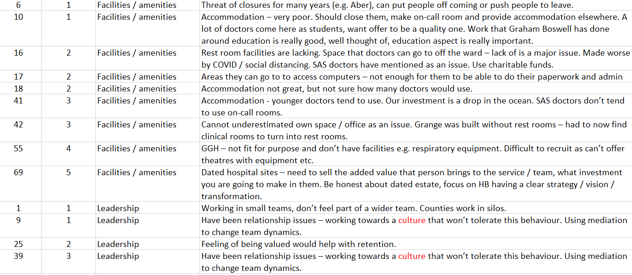

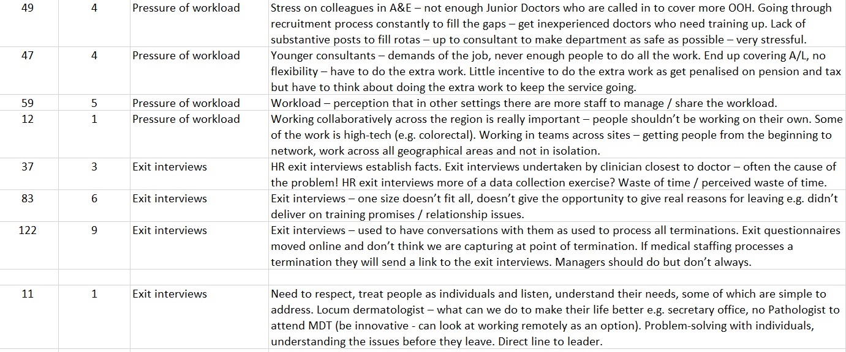

Dentists account for only 2% of the total M&D staff group.
The turnover rate for estates and ancillary staff was significantly and temporarily inflated in 2020/21 as a result of the higher number of staff employed on temporary short-term contracts to support the pandemic response.

