Blog 1 – LGBT Teachings - Time for Change

Over the decades, the possibility of including lesbian, gay, bisexual and transgender (LGBT) Gay Centre, (2020) teachings into the curriculum seemed an impossible ask, because of the LGBT community seemingly being considered not normal and identifying with deviant behaviour (Kinney, 2015). Defining sexual orientation to school children has evidently not been addressed by the current curriculum. Why? The paragraph below gives a very good indication of the numbers that identify under the LGBT community. Surely this provides justification to educate young people.
Statistics
The Office of National Statistics (ONS) state that for every twenty young people in the United Kingdom (UK), age ranged from 16-24, one will identify as being under the LGBT umbrella (Office of National Statistics, 2019). This is a significant increase in comparison to the last record count. With figures highlighting a crucial breakthrough in individuals being able to come out, and identify as gay, lesbian or bisexual. This is because for the first time ever, there has been a record number of over1 million people identifying as gay, lesbian or bisexual (Bulman, 2017). Clearly showing how young people are feeling increasingly able to come out within today’s society.
Do you think it’s time to change?
We have drilled the concept of boy, girl, associated with pink and blue through to young children from an early age, connecting colour with gender (Frassanito and Benedetta, 2008). Are we to blame for expecting children to think they have to behave in a certain way according to their identity (Ruble, Martin and Berenbaum, 2006)?
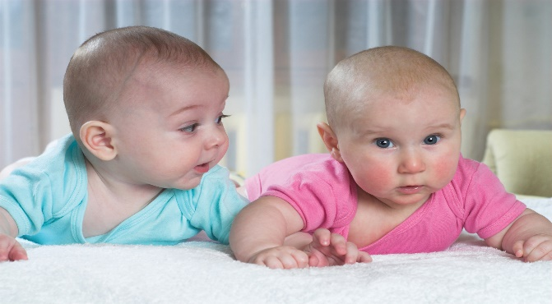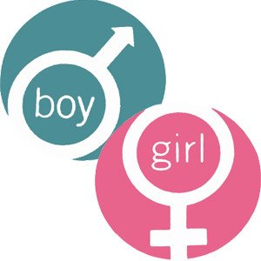

Why can’t children choose their preference of colour and not be identified from it? Which poses the question in the following paragraph?
Is sexual orientation genetic or chosen? Are people ill informed?
Foucault (1990), theory is that sexuality is a social construction, in that you choose to affiliate with. In comparison, there is the genetic biological argument, stating that you are born with a particular sexual identity, therefore, not socially constructed. Which has been evidenced through research carried out on three gene studies, finding that gay brothers share genetic markers on the X chromosome. Furthermore, current research has also established shared markers on chromosome 8 (Rahman, 2015). Providing, not just food for thought on the highly controversial issue, but hard evidence to theory that sexuality is biological. With this in mind opinions on sexual orientation are changing, with people being less ignorant to diversity and cultural change. Education establishments have had to introduce the changing family units, sexual orientation, and loving relationships through the new planned curriculum which will be introduced in 2022 (Christian.Org, 2018). Laws, policy and practice has changed, therefore providing a whole new outlook to acceptance, and most of all the right to be true to the person you are and the person you love. Same sex marriage is now legal, with partnerships undertaken. This came into force in 2013, with the marriage same sex couples bill given royal assent (GOV.UK, 2013). Which poses the question of?
Is it time for all round change?
Family dynamics have changed, along with society evolving gradually, with attitudes and understandings to the traditional 2.4 family, consisting of mam and dad altering (Hussung, 2015). With the development of technology and the internet informing individuals of changing families and relationships (Antonucci, Ajrouch, and Manalel, 2017). The Christian faith has adapted their understandings to what context a loving family is (Insight. Org, 2010). Albeit through the constraints of many people’s opinions. The understanding that the bible informed people of what is excepted by God in which people are to live their lives in accordance with the theory that women partner men and then procreate, surely is under serious question (Donadio, 2013). As a young child brought up as a catholic member of the church, I still do not think god has a right to decide who we choose to love, albeit same sex partnerships. To even consider forming an opinion through scripture that was written trillions of years ago is not worthy of a discussion in my opinion. I have my faith, although I still won’t form judgements on people through the bible. Surely, we do not have the right to form an opinion on people’s lifestyles in accordance with a book.
For education establishments, changing family units have been observed through many young people, identifying with same sex parents or transgender changes. Additionally, identifying with their own sexual identity, the need to address change has become paramount along with the significance of broadening teaching concepts of relationships and the changing shapes. The Wellbeing of Future Generations Wales Act 2015 clearly states within one of its goals is that Wales should identify as a more equal Wales, providing equal opportunities for all, regardless, of race, gender, disability, socio-economic status and sexual orientation (Future Generations, 2020).This clearly shows how the government identify with the need for social change. Although finally, the LGBT community is now welcomed by the majority and not the minority, there are still families fighting against their children being exposed to LGBT teachings. This has become apparent with the recent disputes in Birmingham schools, with parents from Muslim faiths abhorred by the prospect of their child being taught LGBT teachings (Parveen, 2019).

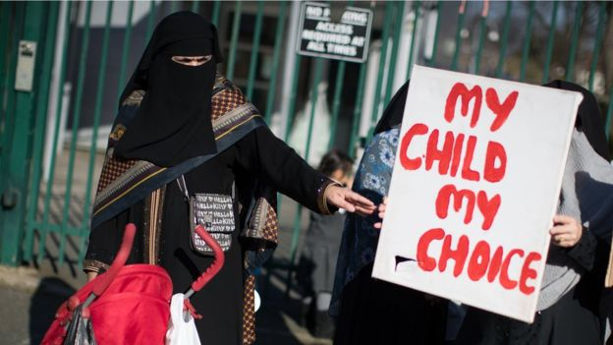
As parents, should we have the right to say no to these teachings and carry on the ignoramus attitudes towards the LGBT community?
There is the argument from some, which is, my child, my choice, my right? However, if you choose to live in a country such as the United Kingdom, which promotes diversity and is culturally aware, you have to consider the variety of its beliefs and population (Community Toolbox, 2019). Which reverts back to the Wellbeing of Future Generations act and its goals of a cohesive communities and a fair society. This identifies and signifies a definite need for cultural change, with other countries hailing the significance of the act, stating what Wales is doing today the rest of the world will follow tomorrow. Albeit, controversial and misleading due to the highlighted issues within Birmingham schools.
To be continued within Blog 2:

References
Antonucci, T, Ajrouch, K, and Manalel, J. (2017) Social Relations and Technology: Continuity, Context, and Change. Innovation in Ageing. 1, (3): p, 1-27
Bulman, M. (2017) Number of lesbian, gay and bisexual people in UK reaches 1 million for first time since records began. Independent. 4th October 2017. Available at: https://www.independent.co.uk/news/uk/home-news/lgbt-people-uk-gay-lesbian-numbers-figures-record-high-a7982571.html
Christian.Org, (2018) 5-year-olds to get LGBTQ+ sex education in Wales. Available at: https://www.christian.org.uk/news/5-year-olds-get-lgbtq-sex-education-wales/. (Accessed 18th February 2020)
Community Toolbox, (2019) Section 2. Building Relationships with People from Different Cultures. Available at: https://ctb.ku.edu/en/table-of-contents/culture/cultural-competence/building-relationships/main. (Accessed 18th February 2020)
Donadio, R. (2013) “On Gay Priests, Pope Francis Asks, ‘Who Am I to Judge?’.” New York Times. 29th July 2013. Available at: (http://www.nytimes.com/2013/07/30/world/europe/pope-francis-gay-priests.html). (Accessed 20th February 2020)
Foucault (1990), The History of Sexuality:1. Penguin: London.
Frassanito, P and Benedetta, P. (2008) Pink and Blue: the colour of gender. Child’s nervous system. Official Journal of the International Society for Paediatric Neurosurgery. 24, (8) p, 881-882
Future generations (2015) Well-being of Future Generations (Wales) Act 2015. Available at: https://futuregenerations.wales/about-us/future-generations-act/ (Accessed 11th February 2020)
Gay Centre. Org, (2020) What is LGBTQ? Available at: https://gaycenter.org/about/lgbtq/ (Accessed 9th February 2020)
Gov.Uk, (2013) Same sex marriage becomes law. Available at: https://www.gov.uk/government/news/same-sex-marriage-becomes-law (Accessed 11th February 2020)
Hussung, T. (2015) The Evolution of American Family Structure. Available at: https://online.csp.edu/blog/family-science/the-evolution-of-american-family-structure Accessed 15th February 2020)
Insight.Org, (2010) What Is a Christian Family? Available at: https://www.insight.org/resources/article-library/individual/what-is-a-christian-family (Accessed 18th February 2020)
Kinney, R. (2015) Homosexuality and scientific evidence: On suspect anecdotes, antiquated data, and broad generalizations. The Linacre Quarterly. 82, (4): p, 364-390
Office of National Statistics (ONS) (2019) Sexual orientation, UK: 2017. Available at: https://www.ons.gov.uk/peoplepopulationandcommunity/culturalidentity/sexuality/bulletins/sexualidentityuk/2017. (Accessed 18th February 2019)
Parveen, N. (2019) The Guardian.14th October 2019. Court bid to stop LGBT lesson protests at Birmingham school starts. Available at: https://www.theguardian.com/uk-news/2019/oct/14/court-bid-to-stop-lgbt-lesson-protests-at-birmingham-school-starts (Accessed 11th February 2020)
Rahman, Q. (2015) 'Gay genes': science is on the right track, we're born this way. Let’s deal with it. The Guardian. 24th July 2015. Available at: https://www.theguardian.com/science/blog/2015/jul/24/gay-genes-science-is-on-the-right-track-were-born-this-way-lets-deal-with-it. (Accessed 18th February 2020)
Ruble, D, Martin, C and Berenbaum, S. (2006) Gender Development. Handbook of child psychology. Vol. 3. Social, emotional, and personality development, 6th ed. New York, NY: Wiley

Following on from Blog 1 = Blog 2 – LGBT Teachings - Time for Change
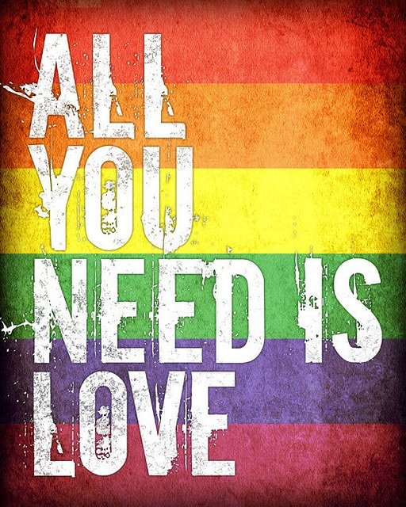
Continuing on from Blog 1:
It appears to suggest that when parents adopt such extreme attitudes towards relationships and family dynamics that they consider to be out of the norm, history might often repeat itself, as behaviours are learned according to Bandura, 1977 social learning theory (Nabavi. 2012). Therefore, highlighting how the LGBT community might be forever stigmatised as sinners, from some, adopting deviant, not normal behaviour. Which points towards Goffman, (1963) definition of stigma, as individuals who are not fully accepted within society, because they don’t quite fit with what others deemed to be considered as social norms (Fitzpatrick, 2008). Therefore, steering back to behaviours, as children are naturally curious, are inclined to ask questions, albeit, very resilient. If we bring our children up to be accepting of everyone and teach them that a loving family can consist of many changing dynamics, surely this is a fundamental aspect of the new curriculum?
If we continue to repress change, bury it, and pretend it doesn’t exist within normal families, there will be continuous pain and suffering for those who have been deemed as not normal for such a long period of time. Education is the best way forward to tackle ignorance and homophobia, with many ways that can incorporate changing relationships and improve wellbeing. Sometimes, it’s not just about educating children and families. Teachers need educating too. Metro Youth Chances, (2016) highlight that the majority of LGBTQ young people, felt that their school life experience was particularly damaging to their wellbeing and safety. With little support, guidance, ultimately, providing a negative impact on their grades. The fear of feeling different, from school life in general was not made any easier by educators themselves, who tended not to deal with LGBTQ issues.
“The Children and Social Work Act 2017 and associated regulations require relationships and sex education to be taught in all English schools from September 2020” this is mandatory (Gov.UK, 2017). However, as a mum and a practitioner, I feel that this might pose issues for some.
If the curriculum can influence change through their teachings of LGBT, this could be a game changer, life change, in view of influencing wellbeing, health and attitudes. There is so much stigma attached to what many might consider the “norm”. Acceptance and inclusion need to be at the forefront, with children being kinder and more person centred to their classmates wellbeing. Finger pointing, whispers and intolerance has gone on long enough for those individuals who have come under the LGBT umbrella. When education has the power to change such attitudes, enhance wellbeing and make change more accepting for children, the mental health and anxiety for many might reduce extremely quickly (Evans, Boriello and Field, 2018). Learning the power of acceptance and integration does not mean that your maths will improve, or your fine motor skills will develop quicker, however it might make the process of learning that much more enjoyable, therefore allowing the child to develop freely, instead of feeling increasingly worried and stressed and inhibited.
We live in a democratic society where everyone has freedom of speech and their own opinions (Howie, 2017). Don’t you think it’s time that we were kinder to each other? More accepting? Less hypocritical and judgemental? Should we start bringing our children up to just love who they love, instead of loving the opposite sex?

Mental health is a fundamental aspect of young children’s health and wellbeing, significantly impacting around one in every ten children (Mental Health foundation, 2016a). Further evidence suggesting that children feel unloved, not knowing where they might fit in the world, along with feeling different to others (Mental Health Foundation, 2016b). The reason for this could be a child responding to any negative issues that might be causing them distress, along with having no coping mechanisms to make them resilient to their feelings, with the possibility of feeling not normal or accepted. There are different concepts of normal for each family and each individual, therefore, accepting and respecting everyone could be the key to a healthier wellbeing for all (Healthy Children. Org, 2020). None of us have the right to make a judgement call of defining someone else as “normal”.

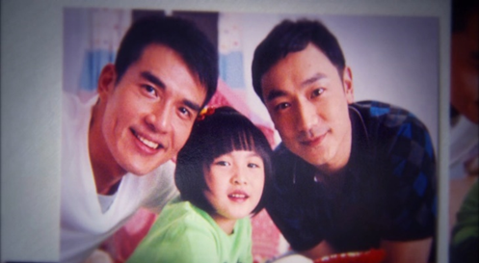
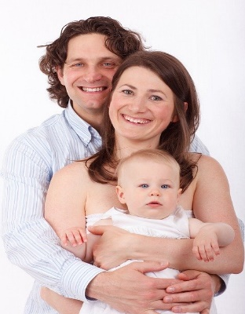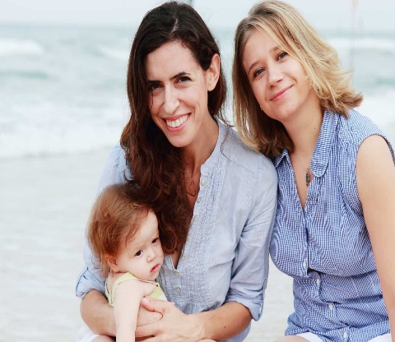
We cannot define any one of these pictures as normal. Although many individuals will teach their children to identify normal as the middle nuclear family picture, consisting of a mother, father and children (Cambridge Dictionary, 2020). Surely love, kindness and caring are paramount to the wellbeing of individuals and families.
Article 28 of the United Nations Convention on the Rights of the Child (UNCRC) states that all children have the right to an education (UNICEF, 2020). Surely, educating children on inclusion, acceptance, diversity and sexual orientation comes under that jurisdiction?
The moral high ground taken by many individuals because of their religion, which specifies that the bible says, is not a justifiable argument to state that being anything other than heterosexual is not normal. When inflicting beliefs albeit through upbringing or choice could be deemed damaging to a young person’s perception on reality, due to not knowing any better. Therefore, as adults, educators or just simply parents, it is surely our duty to provide a safe, comfortable and accepting society for young generations to grow, prosper and include everyone within their living environment.
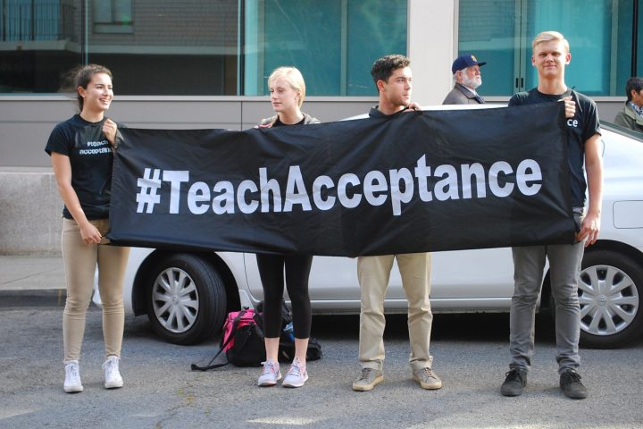

We all have a right to our own opinion, however not at the expense of someone else’s health, wellbeing and acceptance.

References
Bandura, A. (1971) Social Learning Theory. Stanford University.
Cambridge Dictionary. (2020) Nuclear Family. Available at: https://dictionary.cambridge.org/dictionary/english/nuclear-family (Accessed 21st February 2020)
Evans, D, Boriello, G, and Field, A. (2018) A Review of the Academic and Psychological Impact of the Transition to Secondary Education. Front Psychol. 9, (1482) p, 1-18
Fitzpatrick, M. (2008) Stigma. British Journal of General Practice. 58, (549) p, 294
Goffman E. (1963) Stigma: Notes on the management of spoiled identity. London: Penguin.
GOV.UK, (2017) The Children and Social Work Act (2017). Available at: http://www.legislation.gov.uk/ukpga/2017/16/contents/enacted (Accessed 18th February 2020)
Healthy Children.Org, (2020) Types of Families. https://www.healthychildren.org/English/family-life/family-dynamics/types-of-families/Pages/default.aspx (Accessed 10th March 2020)
Howie, E. (2017) Protecting the human right to freedom of expression in international law. International Journal of Speech-Language Pathology 20 (1), p, 3 -11.
Mental Health Foundation, (2016a, b) Children and Young People. Available at: https://www.mentalhealth.org.uk/a-to-z/c/children-and-young-people (Accessed 15th February 2020)
1 METRO Youth Chances (2016), Youth Chances Survey of 16– 25-year olds: ﬁrst reference report, London: METRO. Available at: https://metrocharity.org.uk/sites/default/files/2017-04/National Youth Chances... (Accessed 21st February 2020)
UNICEF, (2020) How we protect Children's rights with the UN Convention on the Rights of the Child. Available at: https://www.unicef.org.uk/what-we-do/un-convention-child-rights/ (Accessed 11th February 2020)

Blog 3 – Children and Young People in Focus
Has school now become one of the emergency services for children and families? You decide!
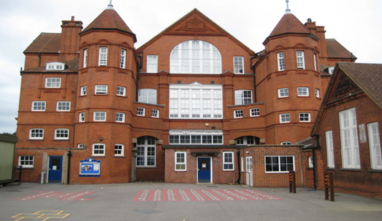

As an individual who experienced many years as a teaching assistant within a school residing in an area of deprivation, the above question was one that was bandied about repeatedly from myself and peers. As school is defined as an institute to provide education for children Dictionary Cambridge.Org (2020), the mindset was, am I in the wrong place? I often became surprised at the numerous initiatives that were introduced to the classroom planning from the directive provided from the Head of School. The number of hours left to provide the children with the required curriculum quickly diminished, with the incorporation of the many initiatives and social issues that will be mentioned further on.

Points to consider:
Are we just running around in circles to tackle insurmountable issues that we cannot cope with? Therefore, impacting on children’s learning experiences.
When the school environment is used as a food bank service, drop-in centre, hygiene centre for head lice, counselling centre, clothes and laundry service, the term community school could be seen as governed by the community. These were everyday occurrences within this particular school setting, and according to (Ellen, 2019) is happening around the UK. Often taking precedence over the children’s learning. Why are schools being tasked with such demands from services? Is it a case of passing the buck from Government policy? The school curriculum is based on a learning experience of six hours a day with breaks in between, however, these valuable learning hours were often diminished and taken up with situations such as toilet training, putting on thirty plus gloves to children during cold weather, hats and scarves were a must, sun cream during warm weather, can you keep my child in the shade? Antibiotics to children who were on prescriptive medicine for infection, should they have been attending school? With the answer of I need to go to work or he or she needs to be in school, I can’t cope! Asthma pumps, insulin monitoring, gastronomy feeding, eczema cream, water provided at every request and daily phone calls from worrying parents. These issues were all incorporated into an extremely tight curriculum, which also included daily tooth brushing for the infant children, to tackle poor dental health (Design to Smile, 2020). The daily mile around the yard to tackle the obesity issue (The Daily Mile Cymru, 2020). The wellbeing feelings circle, to tackle children’s wellbeing (Roffey, 2014). Feed and cleaning the ducks to ensure children are mindful of taking care of someone. Along with family learning, which supposedly helps family to learn together (Gov.UK, 2019). How many more initiatives could be incorporated? Furthermore, the class would almost always have children who had additional needs, who were awaiting to be assessed by the child psychologist, had no statement, however, needed support and would also have a significant number of children with behavioural difficulties. When this issue was brought up the reply would be that there is a long waiting list, consequently, impacting on the child and their learning experience. Yet again! Passing the buck by Government policy.
Points to consider:
How many learning quality hours does a child actually receive during the day? Will the new curriculum that is being introduced in 2022 factor these issues? Is there any wonder that schools are failing to respond to the pressures of the curriculum? When circumstances are different for schools and their children, their needs to be considerations to the individual child, their residence and homelife. You cannot expect a child to function when they are hungry or mentally stressed. How many more failed curriculums need to be put into place before action is taken. School should be a respite, a learning environment and a place where children look forward to attending. Not an establishment that tries to tackle austerity, health issues and the numerous other factors that are currently happening within schools. It’s time for the government to step up and stop expecting schools to tackle issues that are not in their directive. If issues such as working rates of pay, zero hours contracts and universal credit were looked at fairly and equally (Institute for Government, 2017), surely school could function to do as it’s defined as, a place of learning. Finally, focusing on school as an educational provider and not as a social services focal point. Moving away from the title given to our country as being a “nannying state”.
Posing the question that children from low socio-economic backgrounds and areas have mountains to climb (NHS, Scotland, 2019). This is because their quality of education experiences is short lived, limited and simply not addressing the fundamental elements that children require to prosper within their future. Suggesting that not only might their homelife be lacking, but their education also! It also corresponds with Garcia and Weiss, (2017) who have stated that children who begin life at a socio-economic disadvantage are more inclined to struggle when trying to address their situation and pathway at a later life stage. We all know that this is the case! And yet, the same issues rear their ugly head constantly. Should we not focus on providing the best educational experience for children instead of ticking every tick box and badly addressing the huge amount of socio-economic issues? Therefore, providing them with the greatest life chance to move out of the poverty bracket at a later life stage. There are great expectations riding on the new introduction of the 2022 curriculum, however, until austerity is tackled head on, the education for some children will always be insufficient, inadequate and sadly lacking. Which predominantly points to social class always taking precedence over status, opportunities, educational attainment and general life expectancy. The Future Generations Act of Wales 2015 shines brightly and indicates great expectations for individuals, promising a better Wales (Future Generations Commissioner for Wales, 2020). However, there is a constant feeling of it simply being just that. Great expectations!

References
Designed to Smile, (2020) Designed to Smile. Available at: http://www.designedtosmile.org/welcome-croeso/welcome/ (Accessed 30th January 2020)
Dictionary Cambridge, (2020) School. Available at: ttps://dictionary.cambridge.org/dictionary/english/school (Accessed 30th January 2020)
Ellen, B. (2019) Hungry, unwashed children fill our schools – how has it come to this? The Guardian. 16th March. Available at: https://www.theguardian.com/commentisfree/2019/mar/16/hungry-unwashed-children-fill-our-schools. (Accessed 17th February 2020)
Future Generations Commissioner for Wales, (2020) Well-being of Future Generations (Wales) Act 2015. Available at: https://futuregenerations.wales/about-us/future-generations-act/ (Accessed 15th March 2020)
García, E. and Weiss, E (2017) Education inequalities at the school starting gate: Gaps, trends, and strategies to address them. Available at: https://www.epi.org/publication/education-inequalities-at-the-school-starting-gate/ (Accessed 30th January 2020)
GOV.UK, (2019) Family Learning and Essential Skills. Available at: https://www.swansea.gov.uk/familylearningandessentialskills (Accessed 21st February 2020)
Institute for Government, (2017) The problems with Universal Credit. Available at: https://www.instituteforgovernment.org.uk/blog/problems-universal-credit (Accessed 21st February 2020)
NHS, Scotland, (2019) Child Poverty Overview. Available at: http://www.healthscotland.scot/population-groups/children/child-poverty/child-poverty-overview/impact-of-child-poverty (accessed 30th January 2020)
Roffey, S. (2014) Circle Solutions for Student Wellbeing. 2nd Edition. Sage Publications: London
The Daily Mile Cymru, (2020) Welsh Government encourages schools to adopt The Daily Mile. Available at: https://thedailymile.cymru/media-centre/backed-by-todays-childhood-obesity-strategy-the-daily-mile-founder-calls-on-all-english-schools-to-run-a-mile-a-day/ (Accessed21st February 2020)

