ERD for Celtic Caterers.
Clear and easy to read.
No annotation of relationships, all compulsory??
Some relationships difficult to follow.
1-1 relationships??
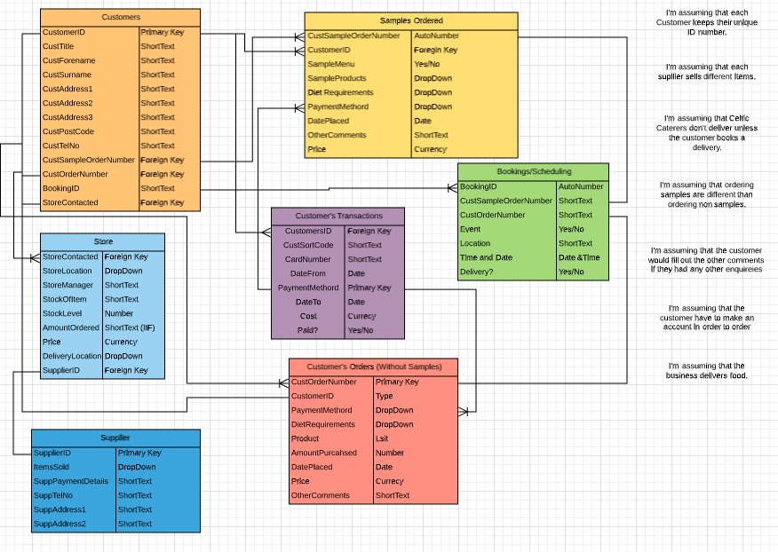
Data Flow diagram for Celtic Caterers
Clear and easy to read.
Additional dataflows could be identified?
Level 0
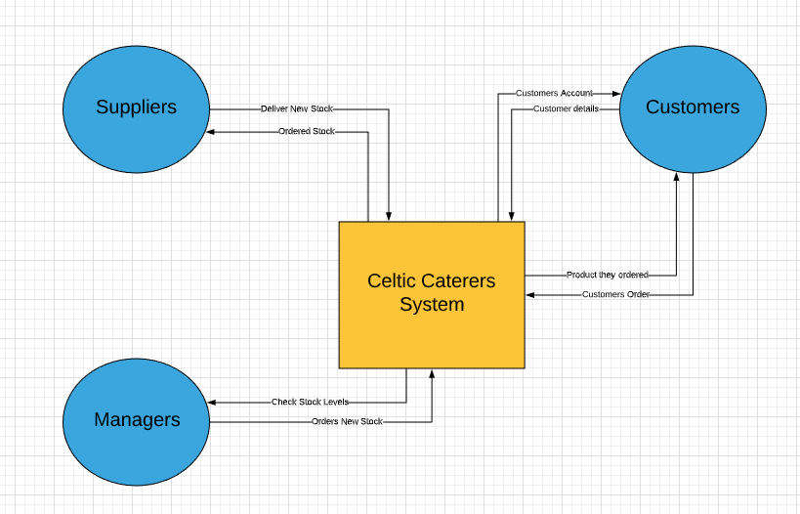
Level 1
Clear and easy to read.
Additional dataflows and data stores could be identified?



