A critical evaluation and the identification of next teaching and learning steps focusing on a case study of an individual learner or a group of learners, based on an observed critical incident.

Introduction
The following essay sets out to critically evaluate an observed critical incident involving a group of learners within a school setting, and then identify how the incident and literature surrounding it can inform my own teaching practice.
In terms of identifying the critical incident, Tripps Critical Incident methodology will be used (Tripp, 2011). Dewey’s reflective model and Brookfield’s four lenses will be used to reflect upon the findings and detail the next steps in my practice (Dewey, 1933; Brookfield, 2017). During the observation three critical incidents were recorded as can be seen in appendices, however this essay will focus on only the critical incident involving peer assessment as an assessment for learning (AfL).
The essay will first describe critical reflection and its role in developing teaching practice.
It will then lay the foundation for the observation that took place, however, as per BERA (2018) ethical guidelines for educational research, my observations of the learners as well as the written class and school context portion within the essay are kept anonymous to ensure all the participants and their school settings rights to confidentiality are ensured.
The observed peer assessment critical incident will then be analysed and linked to Donaldson’s four purposes (Welsh Government, 2022a).
The literature surrounding the critical incident of peer assessment in school settings will then be critically evaluated. Alongside the evaluation, literature giving guidance to teaching practitioners for best practice when using peer assessment, in the context of AfL for their pupils will be discussed.
From the observation, evaluation, and brief discussion, I will then critically reflect and identify my next teaching and learning steps enabling me to inform and develop my teaching practice relevant to using peer assessment.

The role of critical reflection
Before describing the role of critical reflection, it is first important to establish the need for it. Shandomo (2010) highlights the necessity of introspective growth. They use the example of a veteran teacher who was described as, instead of having ten years teaching experience, having one years’ teaching experience ten times. Shandomo explains this shows that the teacher stopped growing and developing professionally after their first-year teaching. Tripp (2011) supports this by highlighting the importance for educational practitioners critically reflecting on critical incidents to enhance their professional development and avoid complacency. Tripp states that when critically reflecting on their own practice, educational practitioners must also look at recent and relevant literature, research theories and apply findings to their teaching (Tripp, 2011:3).
When describing the attributes an educational practitioner must possess in order to engage in critical reflection, Farrel (2012) refers back to Dewey’s (1933) work on reflective inquiry, describing the attributes as: open-mindedness, responsibility, wholeheartedness, and directness. Open-mindedness is paramount when considering the need for practitioners to be able to look at new concepts of teaching and implement them into their own practice.
Critical reflection is particularly important in Wales right now, in order for the Welsh Government’s (2021) ‘Curriculum for Wales’ to work effectively, educational practitioners must adapt their old practice to follow the new curriculum. The Welsh Government (2022b) states that the need for the change in the curriculum was down to the fact society is constantly changing, as is technology, giving the example of when the national curriculum was first introduced back in 1988, Google, on-line shopping and the Cloud did not even exist. Given the change in society and technology it is important for children and young people to become more digitally competent and to be more ‘confident, capable and compassionate citizen’ of Wales and of the world (Welsh Government, 2022b:1).
Prior to the Curriculum for Wales, lessons were differentiated by subject, whereas now lesson subjects will be combined and overlap in order for learners to understand the links between them, with Welsh Government (2022b) using the example of teaching the topic of climate change as humanities holistically through the lenses of geography, history, and impact on society. This simple change of combining subjects in the new curriculum alone will mean that educational practitioners will need to critically reflect on their practice and see where their previous differentiated lessons could be combined and where other areas of learning can be introduced. Similarly, with the new emphasis on skills and experience in the curriculum, practitioners may also need to adapt their teaching styles to a more hands on approach, particularly with the move away from formal assessment to AfL in which assessment is now taking place on a day-to-day basis, assessing each individual child’s progress, identifying their next steps and monitoring their progress over time (Welsh Government 2022b:1). It is important to reiterate that critical reflection requires directness, which Farrel (2012) defines as a belief that something is worth doing, that the idea of teaching is to teach pupils and not lessons. Educational practitioners must believe in the role of critical reflection in order for it to be effective.
Observation School & Class context
The school observed was a primary school within a city in South Wales. As per the schools 2014 Estyn report, the school had 353 pupils, with an above average 35% of pupils eligible for free school meals – at the time the national average was 21%. The report stated that the school had identified that around 16% of their pupils had Additional Learning Needs (ALN), around 18% came from ethnic minority backgrounds with approximately 16% speaking English as an Additional Language (EAL). With regard to the schools’ ethos, the report described it as being caring, positive, and entirely child centred (Estyn, 2014).
The classroom I observed was one of the Year 4 classes, located on the first floor of the building - the school had two Year 4 classes side by side with a sliding dividing wall between them. The sliding wall was opened when one of the two Year 4 teachers were out of class in order for the other teacher to oversee both classes as one large class of 38 pupils (with support from teaching assistants). The Year 4 classes were split by chronological age, the older half of Year 4 children in one class, the younger half in the other.
I was in the younger Year 4 class, where I sat at the table with one group of children but observing the entire class. The observation took place in the morning just after a fun music session, so the children were on a high. The class had 19 pupils with a mix of abilities, with some children with ALN and some children with EAL. The children were all sitting in their assigned seats at their mixed ability tables to continue their ‘Talk for Writing’ literacy session.
Critical incident linked to Donaldson’s Four Purposes
The critical incident observed was during the tail end of the ‘Talk for Writing’ session, where the children were now presenting their stories in their groups of 4 or 5 in front of the class. The groups presenting rotated, with the teacher using the assessment for learning method of peer assessment to give feedback to each group.
The teacher gave each pupil in the class a laminated sheet of paper, on one side of sheet were “Star Comments” with a list of examples of positive feedback and on the other side of the sheet were “Wish Comments” with a list of examples of constructive criticism.
When the group presenting at the front had finished, the pupils observing would hold their sheet up with the side of sheet (Star Comments or Wish Comments) facing the teacher with what type of feedback they wanted to give. This enabled the teacher to select significantly more positive feedback than constructive criticism from the pupils observing. In doing this, the teacher was enabling the children to become healthy, confident individuals who are ready to lead fulfilling lives as valued members of society (Welsh Government, 2020). By giving the children the opportunity to both give and receive constructive criticism in order to develop themselves, the teacher is building the children’s mental and emotional well-being by developing their confidence, resilience, and empathy (Welsh Government, 2022a).
What was most striking however, was that when the group performing went to sit down after receiving their group feedback in front of the class, one of the children approached a child from another group. This child had been holding up “Wish Comments” during the feedback part of the task but hadn’t been asked to give their opinion (Star Comments were favoured), the child who had just performed asked “What was your Wish Comment for me?” to which the other child replied that they “all could have spoken” (rather than just some of the group) and the child responded with “Thank you, I think you are right, I didn’t speak loud enough”.
This final observation finds that two of Donaldson’s four purposes underpinning Curriculum for Wales were clearly taking place (Welsh Government, 2020). It firstly showed that children are becoming ‘ambitious capable learners who are ready to learn throughout their lives’ by acknowledging that children are setting themselves high standards, whilst displaying that they are enjoying seeking challenge and questioning by asking for further feedback from their peers on how and where they can improve (Welsh Government, 2022a).
Secondly, it showed that the children are becoming ‘healthy, confident individuals who are ready to lead fulfilling lives as valued members of society’ in myriad of ways, it identified that the children had the confidence to participate in performance, that they had formed positive relationships based upon trust and mutual respect and that children had resilience and empathy when giving and receiving the feedback from peers (Welsh Government, 2022a).
This critical incident really resonated with me as prior to observing I was of the opinion that constructive criticism from peers would lead to lower self-esteem. However, the child who received the feedback appeared genuinely excited to hear what areas they could improve upon.

Literature Review
During this literature review it became apparent that peer assessment in its entirety is not a universal method but viewed differently by different authors.
What can be seen to be a universally agreed process is that peer assessment will always, at some point involve two or more pupils assessing one another in their methods, progress, and difficulties (Colognesi, Vassart, Blondeau, & Coertjens, 2020; Gielen, Dochy, & Onghena, 2010).
The variances in the process are apparent in the differing methods used. Some such as Topping (1998:250) and Black & Wiliam (2009) describe peer assessment loosely, as “an arrangement for peers to consider the level, value, worth, quality or successfulness of the products or outcomes of learning of others of similar status”. Whereas Brookhart (2008) is more formal and states that there are three forms of peer assessment. Firstly, normative – using a numerical value between peers against the performance being assessed. Secondly, qualitative – commentary is used to assess the work. Finally, descriptive – specific criteria are used when observing peers to identify strengths and weaknesses.
This review has highlighted that whilst there are certain areas that can be seen to be negative, overall, correctly managed peer assessment is an excellent AfL tool.
From a negative perspective, authors such as Laveault & Allal (2016) highlight the importance of using the correct methodology and ensuring teachers are fully aware of the role and process of peer assessment. Bourgeois (2016:345) accept that peer assessment makes “a strong contribution to learning” but have found that often teachers find difficulty in adopting formative assessment approaches that encourage and involve students. Many teachers struggle with the concept of children giving and acting upon peer feedback, with the belief that direct instruction is significantly more efficient. Often teachers with this mindset are also frustrated with the quality of student feedback or find their pupils lack the ability to regulate their own learning. It would appear that the key to avoiding this would be excellent planning and communication with pupils as to the expectation of the process. Bourgeois (2016) suggests an appropriate methodology would before the teacher to start small and gradually scale down their control of the assessment process and gradually give the pupils more control as they learn to regulate their learning processes. This methodology avoids problems with management and control of feedback and ultimately gives the students control of most of the assessment decisions. Heritage, Kim, Vendlinski & Herman (2009) also suggests that while teachers may be able to judge the strengths and weaknesses of students’ work, they often struggle with the next steps in facilitating student learning via peer assessment. They have been found to have capacity when making correct judgements on the quality of their students work but struggle with ‘their capacity to use the information gathered on student learning to make pertinent assessment decisions about the adjustments to be undertaken.’
This review has highlighted that whilst there are certain areas within the process that can be seen to be negative, overall, correctly managed peer assessment is an excellent AfL. It places the onus on the teacher to embrace the process and ensure that students are aware of what is expected from the process. Panadero, Jonsson & Strijbos (2016:323) state ‘it is of utmost importance to clarify the rationale for peer assessment in advance, involve students in determining the criteria, clearly specify the peer assessment format as well as how students are supposed to interact, and provide them with sufﬁcient training and scaffolds to conduct the peer assessment activities.’ Hadwin & Oshige (2011) suggest that implementation of the peer assessment has to be carefully managed to allow students to take the role of both assessor and assessee to assist the students in developing their own internal standard of quality and underpin their capacity and ability to make better judgments of their own work. McCaslin & Hickey (2001) and Farrel (2012) concur and indicate that it is the teacher’s ability to adapt their teaching methods, plan effectively and give the students more control of the assessments that is the pivotal to the success of this process as an AfL. It is also worth noting that Panadero et al (2016:320) highlights that ‘effective peer assessment also hinges on the quality of the peer assessment provided as well as whether the assessee agrees with the peer assessment and uses the suggestions.’
Laveault & Allal (2016) further suggests that teacher intervention is virtually always necessary when introducing peer assessment and highlighted that approaches such as peer feedback, positive pupil interaction reduced the impact of feelings of unfairness. They did state however that teachers need to be aware of the positives and negatives of peer assessment to ensure any negative issues are eliminated.
Leenknecht & Prins (2018) argues that the greater the understanding of the criteria the student has will result in the student having more competence when providing feedback but note that teachers must be aware that students who have knowledge about standards and criteria may use more ‘final vocabulary’ (Boud, 1995), such as censoring word terms like ‘good’ or ‘right’. As maintained by Leenknecht & Prins (2018), the teacher needs to avoid the use of these ‘final vocabulary’ words.
In their studies Yurdabakan (2011) found that without fully understanding the criteria and process, students based their assessments on friendship or race not quality of work.
How peer assessment works as an AfL is widely discussed and has had an increase in interest in recent years.
Many authors identify peer assessment as a Vygotskian process. Laveault & Allal (2016) propose that the co-regulation that occurs with peer assessment supports the Vygotskian view, by using the zone of proximal development (ZPD), suggesting that peer assessment creates a scaffolding process. They submit that Scaffolding may be particularly important in situations where students’ domain speciﬁc knowledge and skills are limited.
Again, from a Vygotskian approach Hadwin & Oshige (2011) concur and provide a definition of the process, citing three distinct categories of student regulation. Firstly, self-regulation, requiring the student to actively monitor and regulate their own learning. Secondly Co regulation is considered to be a transitional process whereby the student gains self-regulations abilities through interactions with someone more able i.e., a teacher. Thirdly Socially Shared regulation is seen as being a co constructed, collective regulation by peers of a similar level.
Laveault & Allal (2016) also believe that co-regulation through interaction with peers incorporates the Vygotskian theory of ZPD, which outlines what a student is able to achieve with some scaffolding. They describe peer assessment as a process where the peer becomes a source of support and in this manner a co-regulator of learning.
Volet, Vaurus & Salonen (2009) states that it must be noted however that some authors view co regulation in a looser sense, covering any socially mediated regulation, whether with others who are more capable or of an equal status. Other authors use the expression co-regulation in a broader sense with peers of equivalent status
Weaver & Cotrell (1986:25) sate peer assessment ‘stresses skills, encourages lesson participation, increases concentration on learning, provides feedback to the students, increases course attendance and teaches responsibility’, whereas Freeman (1995) and Lejk & Wyvill (2001) assert peer assessment encourages cooperative learning as opposed to competitive learning.
How peer assessment feedback is given is a critical area reported in literature. With Colognesi et al (2020) explaining that descriptive language is often the most appropriate language to use, sounding less judgemental and thus being a more receptive form of communication.
Many qualitative studies have reported that students who have participated in well planned and managed peer assessment found the process increased their active participation and found it to be an interesting experience, describing it as ‘rewarding and encouraging’ (Lourdusamy & Divaharan, 2000). Yurdabakan (2011) also observed that students participating in competently managed peer assessment had a higher expectation of the group to participate more, strengthening the interdependence of the group members.
Reflection / Evaluation & Next Steps
From the observed critical incident and the literature review surrounding it, I can see the importance of using peer assessment as an AfL method.
When reflecting on the critical incident, aside from following Dewey’s (1933) model of reflective inquiry, being open-minded, responsible, wholehearted, and direct, I followed Brookfield’s four lenses of reflection: self (autobiographical), students (through the students’ eyes), peers (from colleagues’ experiences) and scholarship (theoretical literature) (Brookfield, 2017).
Firstly, reflecting upon my own experiences of peer assessment, I had negative preconceptions on its impact as I was previously of the mindset that children hearing negative views about their work from their friends may hurt their self-confidence. I then reflected on how the students in the observation found peer assessment and saw how positive it can be when used correctly causing me to reassess my misconception. I was lucky enough to be able to speak with the classroom teacher and they told me how they gradually built-up the use of peer assessment, which gave me an insight into how peer assessment can be introduced efficiently. Finally, reading literature I further found evidence of how beneficial peer assessment can be when used appropriately and information on what I can personally do to enhance peer assessment within my classroom.
I believe that it is important to note that the teacher not only used peer assessment as an AfL but had also created a classroom environment in which peer assessment was the norm, where the children were already fast becoming healthy, confident individuals as well as ambitious and capable learners. (Welsh Government, 2020). This could be seen not only in the resilience of the child asking for constructive criticism from their peers, but the confidence and mutual respect of the entire class in being able to go up in front of one another and perform their presentation tasks and give and receive feedback (Welsh Government, 2022a). Due to this I will strive to create a safe environment where it is the norm that pupils within my class settings will feel they can give and receive feedback in a way that is comfortable for them.
Witnessing the use of peer assessment in such a positive way, really allowed me to reflect and challenge my preconceptions. Prior to observing this critical incident, I believed that a child hearing negative feedback – be that constructive criticism – would damage the child’s confidence and self-esteem and put them off from engaging in lessons in the future. However, seeing this work so well in practice has really allowed me to reassess my use of AfL and I will now adapt a similar teaching activity to that observed, into my own teaching repertoire. I do however feel it is important to note, that in order for the observed task to work as well as it did, it needs to be gradually introduced.
From the literature reviewed I now know that when I begin to introduce or use peer feedback it is paramount I give definitive parameters in order for the children’s feedback to be relevant (Bourgeois, 2016). Furthermore, I need to model and guide the children into using descriptive vocabulary so that children do not simply use ‘final vocabulary’ or closed answers (Leenknecht & Prins, 2018). When observing, the teacher had a good method for this, by having several sentence starter suggestions of positive and constructive feedback on each side of the feedback star sheets.
The observation of the child eagerly enquiring constructive criticism from their peers is supported by Lourdusamy & Divaharan (2000) in their finding that children’s active participation increased due to a greater enjoyment of the task when using peer assessment, which I believe strongly resonated with me. It was not simply that children engaged more in the task and developing themselves, it was that I could see they genuinely enjoyed giving and receiving feedback from their friends in a safe setting.
Conclusion
The peer assessment identified within the observed critical incident is just one showcase of many effective AfL methods that can be used within the school environment to assess children. The peer assessment task observed showed how something so simple can have such a positive impact on learning. Had the educator used direct instruction instead of peer assessment, children are far less likely to become ‘ambitious, capable learners’, just as not allowing the children to take ownership of their assessment would hinder the development of ‘healthy, confident individuals’ (Welsh Government, 2020).
I hope to adapt the teaching techniques from the observation experience along with my own knowledge, past experiences, and further research to improve my own teaching style. When reflecting, I chose to focus on all five professional standards: pedagogy; collaboration; professional learning; innovation; and leadership (Welsh, Government, 2019). In terms of pedagogy, I was able to review and enhance my practice through observation and research on relevant literature. As for collaboration, I worked with others, discussing observations with other observers within the school setting. I was able to speak to the practitioners I was observing in order to enhance my professional learning, with the practitioners advising me on theories and concepts to research. I included innovation by incorporating peer assessment techniques learnt from my observation and refined using literature. Finally, in regard to leadership, I not only took responsibility for myself when demonstrating professional attitudes and behaviours whilst developing positive relationships but assisted co-observers when necessary.
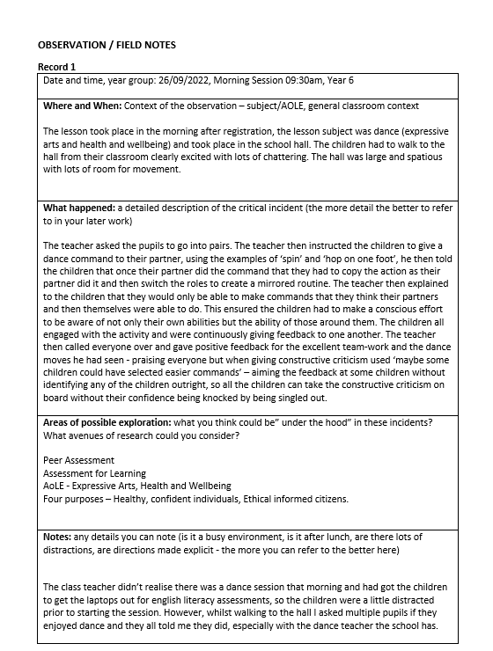
Appendices
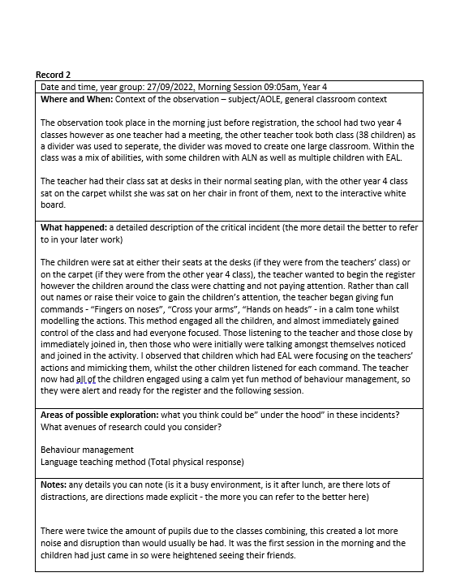

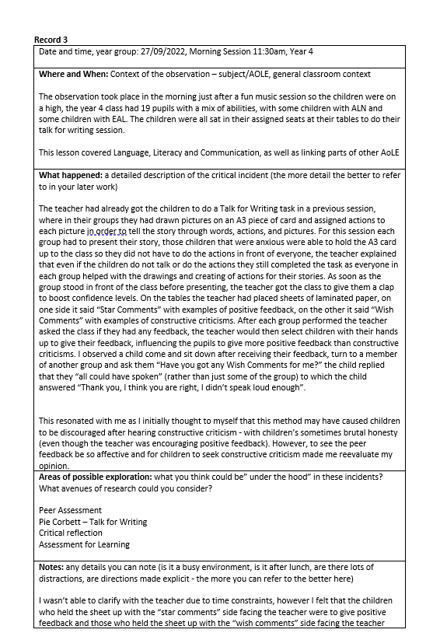
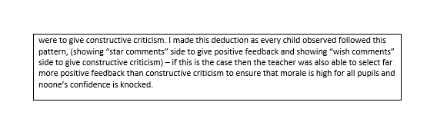
Reference List
BERA (2018) Ethical Guidelines for Educational Research. 2nd edn. London: British Research Association.
Black, P., & Wiliam, D. (2009) Developing the theory of formative assessment. Educational Assessment, Evaluation and Accountability, 21(1), pp.5–31. DOI:10.1007/s11092-008-9068-5.
Boud, D. (1995) ‘Assessment and learning: contradictory or complementary?’ In Knight, P. (edn), Assessment for learning in higher education. London: Kogan Page Limited, pp.35-48.
Bourgeois, L. (2016) ‘Supporting Students’ Learning: From Teacher Regulation to Co-Regulation Assessment for Learning: Meeting the Challenge of Implementation’, in Laveault, D., and Allal, L. (4th edn) Assessment for Learning: Meeting the Challenge of Implementation. London: Springer International Publishing. pp.345-363.
Brookfield, S. (2017) Becoming a Critically Reflective Teacher. 2nd edn. San Francisco: Jossey-Bass.
Brookhart, S. (2008) How to Give Effective Feedback to Your Students. Alexandria: Association for Supervision & Curriculum Development.
Colognesi, S., Vassart, C., Blondeau, B., & Coertjens, L. (2020) ‘Formative peer assessment to enhance primary school pupils’ oral skills: Comparison of written feedback without discussion or oral feedback during a discussion’, Studies in Educational Evaluation, 67, pp. 100917. DOI: 10.1016/j.stueduc.2020.100917
Dewey, J. (1933) How we think: A restatement of the relation of reflective thinking to the educative process. Boston: Houghton Mifflin.
Estyn (2014) A report on ** ****** ********* ******* ******. Available at: https://www.estyn.gov.wales/ (Accessed: 01 November 2022)
Farrel, T. (2012) ‘Reflecting on Reflective Practice: (Re)Visiting Dewey and Schön’, TESOL, 3(1), pp.7-16.
Freeman, M. (1995) ‘Peer assessment by groups of group work’, Assessment & Evaluation in Higher Education, 20(3), pp.289. DOI:10.1080/0260293950200305
Gielen, S., Dochy, F., & Onghena, P. (2010) ‘An inventory of peer assessment diversity’, Assessment and Evaluation in Higher Education, 36(2), pp.137-155.
Hadwin, A. F., & Oshige, M. (2011) Self-regulation, co-regulation, and socially-shared regulation: Exploring perspectives of social in self-regulated learning theory. Teachers College Record, 113(2), pp.240-264.
Heritage, M., Kim, J., Vendlinski, T., & Herman, J. (2009) From evidence to action: A seamless process in formative assessment. Educational Measurement: Issues and Practice, 28(3), pp.24-31.
Laveault, D., & Allal, L. (2016) Assessment for Learning: Meeting the Challenge of Implementation. 4th edn. London: Springer International Publishing.
Leeknecht, M. J. M., & Prins, F. J. (2018) ‘Formative peer assessment in primary school: the effects of involving pupils in setting assessment criteria on their appraisal and feedback style’, European Journal of Psychology of Education, 33(1), pp.101-116.
Leenknecht, M. & Prins, F. (2018) Formative peer assessment in primary school: the effects of involving pupils in setting assessment criteria on their appraisal and feedback style, European Journal of Psychology of Education, 33(1), pp.101-116.
Lejk, M., & Wyvill, M. (2001) Peer assessment of contributions to a group project: A comparison of holistic and category-based approaches, Assessment & Evaluation in Higher Education, 26(1), pp.61–72.
Lourdusamy, A., & Divaharan, S. (2000) Peer assessment in higher education: Students’ perceptions and its reliability. Journal of Applied Research in Education, 4(1), pp.81-93.
McCaslin, M., & Hickey, D. T. (2001) ‘Self-regulated learning and academic achievement: A Vygotskian view’, in Zimmerman, B., & Schunk, D. (2nd edn), Self-regulated learning and academic achievement. New York: Lawrence Erlbaum Associates. pp.227-252.
Panadero, E., Jonsson, A., & Strijbos, J. (2016) ‘Scaffolding Self-Regulated Learning Through Self-Assessment and Peer Assessment: Guidelines for Classroom Implementation’, in Laveault, D., and Allal, L. (4th edn) Assessment for Learning: Meeting the Challenge of Implementation. London: Springer International Publishing. pp.311-326.
Shandomo, H. M. (2010) ‘The Role of Critical Reflection in Teacher Education’, School-University Partnerships, 4(1), pp.101-113.
Topping, K. J. (1998). ‘Peer assessment between students in colleges and universities’, Review of Educational Research, 68(3), pp.249-276.
Tripp, D (2011) Critical Developing in Teaching: Developing Professional Judgement. London: Routledge.
Volet, S., Vaurus, M., & Salonen, P. (2009) Self and social regulation in learning contexts: An integrative perspective. Educational Psychologist, 44, pp.215-226.
Weaver, R. & Cotrell, H. (1986) Peer evaluation: A case study. Innovative Higher Education, 11, pp.25–39.
Welsh Government (2019) Professional standards for teaching and leadership. Available at: https://hwb.gov.wales/api/storage/19bc948b-8a3f-41e0-944a-7bf2cadf7d18/professional-standards-for-teaching-and-leadership-interactive-pdf-for-pc.pdf (Accessed on: 06 November 2022).
Welsh Government (2020) Curriculum for Wales: overview. Available at: https://gov.wales/curriculum-wales-overview (Accessed: 01 November 2022).
Welsh Government (2021) Introduction to Curriculum for Wales guidance. Available at: https://hwb.gov.wales/curriculum-for-wales/introduction/ (Accessed: 05 November 2022).
Welsh Government (2022a) Developing a vision for curriculum design. Available at: https://hwb.gov.wales/curriculum-for-wales/designing-your-curriculum/developing-a-vision-for-curriculum-design/#curriculum-design-and-the-four-purposes (Accessed: 14 October 2022).
Welsh Government (2022b) Education is Changing. Available at: https://gov.wales/education-changing (Accessed: 05 November 2022).
Yurdabakan, I. (2011) The investigation of peer assessment in primary school cooperative learning groups with respect to gender, Education 3–13, 39(2), pp.153-169.

