

Program of Study: Certificate in Higher Education Business Skills for the Workplace
Module Title: Enterprise & Entrepreneurship
Module Code: LCLM 4006
Assessment: Individual Written Business Plan
Student Name: Aneta Kozlowiecka
Student Number ID: 2438990
Lecturer’s Name: Dr Chung Lai Johnny Wan

Executive Summary
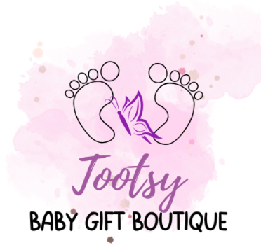
Baby Gift Boutique is a small online business called Tootsy, based in Stoke-on-Trent, that sells personalised baby gifts such as nappy cakes and personalised birth prints. This business is aimed at expectant parents, as well as family members and friends looking for unique gifts.
The business will operate mainly online through a website and social media platforms such as Instagram, Facebook and TikTok. It will also offer a premium local delivery service within a 20-mile radius, with fast 24-hour delivery on selected products.
Start-up funding of £2,500 from a government grant will be used to cover initial costs, including materials, marketing, insurance, and setting up the online shop. Additional support may come from personal savings if needed. In the first month, the business expects around £330 in sales.
The business aims to grow by building a strong online presence and offering good quality personalised products at low prices. Overall, Baby Gift Boutique is expected to be a simple, low-cost start-up with good potential to grow in the future.

Table of Contents

Overview of the Business Idea 4
Legal Format 5
Management Structure 6
PESTEL Analysis 7
Competition 8
Marketing plan 8
Funding and expenses 9
References 11

Overview of the Business Idea
My business idea is an online Baby Gift Boutique called Tootsy, offering personalised gifts for newborn babies and their parents. The business operates online through a website where customers can easily view products, customise orders, and place orders. The unique selling proposition (USP) of the boutique is the combination of personalised nappy cakes, a custom gift builder, and a 24-hour local delivery service.
- Personalised nappy cakes contain hidden baby items such as clothing, toys and care products. Each nappy cake also includes a birth card with the baby’s details.
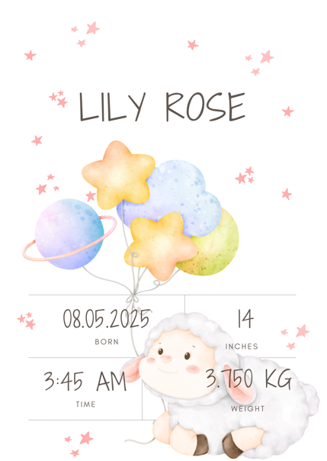 | 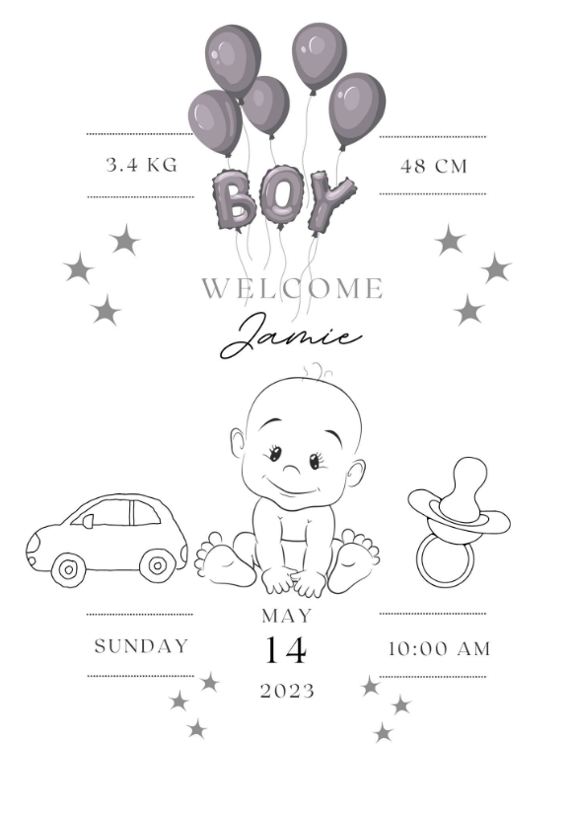 | 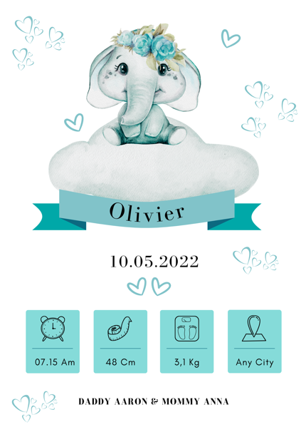

- Customers can choose a ready-made nappy cake or use a Custom Gift Builder to create their own nappy cake. This allows them to suit their budget and needs.

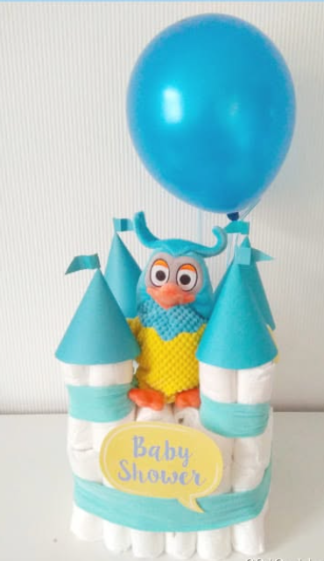 | 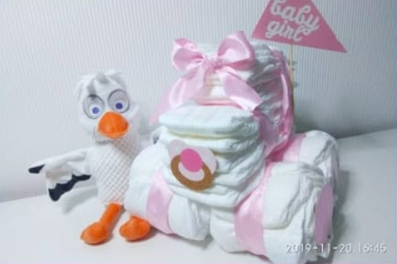 | 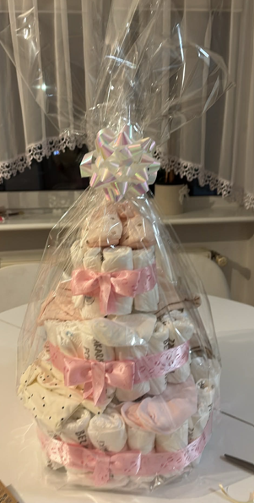

- In addition, the business will offer a premium express local delivery service within a 20-mile radius, with delivery within 24 hours. This service is designed for last-minute situations. However, orders must be placed before 12 noon to guarantee order processing and delivery within 24 hours. Orders placed after this time will be processed on the following working day. This service will apply to pre-made products that are ready for immediate personalisation.

The idea comes from my personal experience of making personalised gifts. This experience made me realise that there is demand in the market for unique, personalised gifts and keepsakes. Many parents value products made specially for their children, which they can keep for many years and which have sentimental value. I believe this suggests strong market potential.
This business is aimed at expectant parents, as well as family members and friends looking for unique gifts. According to the Office for National Statistics (2025), there were 585,396 live births in England and Wales in 2025. Although this represents a 1.6% decrease compared with 594,677 births in 2024, these figures show that there is still a large market for baby gifts.
Market research shows several local competitors, including small physical and online businesses offering personalised gifts and nappy cakes. This still shows a gap in the market for a specialised baby gift business offering personalised nappy cakes, customisation options, and quick delivery.

Legal Format
My business will start as a sole trader. I believe this is the best option when starting a new business because it is simple to set up and the start-up costs are low. It also allows me to run the business on my own and make all important decisions, such as pricing, sales, orders, costs, and customer service.
As a sole trader, I will also manage my finances myself. I will keep records of income and expenses and make sure all payments and orders are handled correctly. This is suitable for a small business because accounting requirements are simple and low-cost.
However, I understand that there are some disadvantages to this structure. According to GOV.UK (2026), sole traders have unlimited liability, which means that the owner is personally responsible for any debts or financial issues that the business may have. I am aware of the risk and understand how important it is to manage the business carefully and responsibly.
Even so, if the business grows in the future and becomes more successful, I will consider changing the legal structure to a private limited company (Ltd). This would help protect my personal finances and make it easier to grow the business in the future.

Management Structure
My business will operate as a sole trader, where I will be responsible for all areas of the business, including management, production, marketing, and finance. This is a practical option for a start-up because it is simple to set up and has low costs, while also allowing full control over decisions.
This structure gives me control over key areas such as customer orders, product quality, pricing, and customer service. This is important as the business will focus on personalised products like nappy cakes and keepsakes, where quality and detail matter. I will manage marketing on social media and organise deliveries within a 20-mile radius. Orders will be completed within 24 hours, which is realistic in the early stages while maintaining good service.
If the business grows in the future, I may employ full-time staff to help with running the business.

PESTEL analysis
- Political
The political environment in the UK is supportive for small businesses. As I will run a baby gift business, I must follow UK laws and safety rules. All products, especially those for babies, must meet UK safety standards to make sure they are safe for customers.
- Economic
After the COVID-19 pandemic, inflation in the UK increased, making customers more careful with their spending. According to Hick and Collins (2024), inflation peaked at 11.1% in October 2022. However, even with higher living costs, people still buy personalised baby gifts due to their emotional value.
- Social
Personalised gifts have strong emotional value. Customers prefer unique and handmade products made specially for their child. Products like birth announcement frames are popular because they are keepsakes that remind parents of special moments.
- Technological
Social media such as Instagram, Facebook, and TikTok are very important for small businesses. They provide cheap and effective advertising. Online selling also helps reach more customers, makes communication easier, and improves business management. E-commerce platforms make it easier to run and grow the business.
- Environmental
The business will use recyclable and eco-friendly packaging for gift designs and products to reduce waste and support sustainability. Companies that offer more environmentally friendly options may attract more customers.

- Legal
The business must follow UK law, including registering as a sole trader, paying taxes to HM Revenue & Customs (HMRC), and following safety regulations for baby products. It must also comply with data protection laws (GDPR) to keep customer information safe and ensure it is used only for order processing.

Competition
The market for personalised gifts is highly competitive, especially online, where many businesses offer a wide range of products. Local shops like Vision Personalised Gifts and Adored Bespoke Creations sell personalised items but are not focused on newborn gifts. In addition, there are small online businesses operating through Facebook, such as Sophie's Nappy Cakes and Creations, which offer similar products but without a 24-hour delivery service. Furthermore, there are also online stores, such as Babyblooms and Bumbles & Boo that offer next-day delivery to Stoke-on-Trent, which increases competition in the local market. However, there is still a gap in the local market for a fast, personalised baby gift service.

Marketing plan
“Successful marketing involves having the right product available in the right place at the right time and making sure that the customer is aware of the product” (Westwood, 2013).
This means businesses need to consider where and when they sell their products, and how they promote them so customers know about them and can buy them.
For Baby Gift Boutique, marketing will focus mainly on social media platforms such as Instagram, Facebook, and TikTok. These platforms are commonly used by online businesses to promote their brand and attract customers. Instagram will be used to showcase product photos and completed orders. Facebook will help reach the local community and parenting groups in Stoke-on-Trent and surrounding areas. TikTok will be used to share short videos showing the process of creating products, which will help build the brand.
The business will also operate an online shop where customers can view products easily, personalise orders using a gift builder, and place orders directly.
In addition, local marketing will be important due to the 24-hour delivery service within a 20-mile radius. This will help attract customers who need last-minute gifts.
The overall marketing strategy will focus on social media presence and online shopping to attract a wide range of customers.

Funding and expenses
I estimate that the start-up cost for my business is £2,500. This will cover all the main costs needed to start and run the business. The main source of funding will be a government grant for small businesses. However, if this funding is not sufficient, I will use my personal savings to support the business. At the beginning, I will not use bank loans or business investors due to the low start-up costs.
In the first month, expenses will be higher as I will need to invest in materials for nappy cakes and personalised birth prints, such as nappies, baby accessories, frames, and decorations. Other important costs include setting up an online shop, social media advertising, insurance, delivery costs, producing and printing personalised products. Monthly costs are estimated at £1,485.
I expect the business to make around £330 in sales in the first month, from nappy cakes priced at £50 and personalised birth prints priced at £13.99
The business is expected to be financially stable at the beginning, with funding covering the start-up costs and supporting gradual growth. All financial figures are presented in the tables below for clarity.

CASH IN – Month 1
Cash in | Month 1
Government start-up funding | £2,500
Sales (nappy cakes + birth prints) | £330
Personal savings | £500
Total cash in-flows (A) | £3,330

CASH OUT – Month 1
Cash out – expenses | Month 1
Insurance | £100
Marketing and advertising | £150
Vehicle running costs | £50
Equipment purchase (printer, basic tools) | £120
Postage, printing, stationery | £80
Transport and delivery | £100
Cost of sales (nappies, gifts, materials) | £700
Telephone and internet (home use % for business) | £20
Utilities (electricity/gas/water business share) | £15
Website and domain | £150
Total cash out-flows (B) | £1,485

NET CASH FLOW
Cash in (A) | £3,330
Cash out (B) | £1,435
Net cash flow (A − B) | £1,845

I expect sales to increase after the first month due to growing brand awareness through social media marketing and local advertising. By Month 3, sales should be around £1,000–£1,200, helping the business reach break-even and become financially stable in the long term.

References
Office for National Statistics (2026) Births in England and Wales: 2025. Available at: https://www.ons.gov.uk/peoplepopulationandcommunity/birthsdeathsandmarriages/livebirths/bulletins/birthsummarytablesenglandandwales/2025 (Accessed: 2 June 2026).

Office for National Statistics (2025) Births in England and Wales: 2024. Available at: https://www.ons.gov.uk/peoplepopulationandcommunity/birthsdeathsandmarriages/livebirths/bulletins/birthsummarytablesenglandandwales/2024 (Accessed: 2 June 2026).

GOV.UK (n.d.) Become a sole trader: What a sole trader is. Available at: https://www.gov.uk/become-a-sole-trader (Accessed: 28 June 2026).

Westwood, J. (2013) How to write a marketing plan. London: Kogan Page.

Hick, R. and Collins, M.L. (2023) ‘The Cost-of-Living Crisis in the UK and Ireland: on inflation, indexation, and one-off policy responses’, Social Policy and Society. Cambridge: Cambridge University Press. Available at: https://doi.org/10.1017/S1474746423000456 (Accessed: 1 July 2026).

Bumbles & Boo (2026) Luxury Baby Gifts. Available at: https://www.bumblesandboo.com/ (Accessed: 29 June 2026).

Babyblooms (2026) Personalised Baby Gifts. Available at: https://www.babyblooms.co.uk/ (Accessed: 29 June 2026).

Sophie’s Nappy Cakes and Creations (2026) Facebook page. Available at: https://www.facebook.com/... (Accessed: 1 July 2026).

Chevorne’s Nappy Cakes Creations (2026) Facebook page. Available at: https://www.facebook.com/... (Accessed: 1 July 2026).

Vision Personalised Gifts (2026) Personalised gift shop website. Available at: https://visionpersonalisedgifts.co.uk/ (Accessed: 1 July 2026).

Adored Bespoke Creations Ltd (2026) Personalised gift shop website. Available at: https://adoredbespokecreations.co.uk/ (Accessed: 1 July 2026).

