

Proactive vs reactive. Should police officers be proactive or reactive in an effort to reduce crime rates?

Name of student: Jacob Llewellyn Morgan
Student number: 2031237
Degree: Policing and criminology
Word Count: 6447 words at moment

Declaration
This work has not previously been accepted in substance for any degree and is not being concurrently submitted in candidature for any degree.
Signed: J.L.Morgan
Date: 08/04/2024

STATEMENT 1
This dissertation is being submitted in partial fulfilment of the requirements for the degree of BA.
Signed: J.L.Morgan
Date: 08/04/2024

STATEMENT 2
This dissertation is the result of my own independent work/investigation, except where otherwise stated.
Other sources are acknowledged by footnotes giving explicit references. A bibliography is appended.
Signed: J.L.Morgan
Date: 08/04/2024

STATEMENT 3
I hereby give consent for my dissertation, if accepted, to be available for photocopying and for interlibrary loan, and for the title and summary to be made available to outside organisations.
Signed: J.L.Morgan
Date: 08/04/2024

STATEMENT 4
I hereby give consent for my dissertation, if accepted, to be available on the university’s IT system to those who have consent to use the system.
Signed: J.L.Morgan
Date: 08/04/2024

Acknowledgements
I would like to thank my supervisor Lewis Tandy for his support and guidance throughout the process of this dissertation.
Additionally, I would like to give thanks to all the staff within the university for their continued guidance and support over the past three years.
Lastly, I would like to thank my family for their continued support over the past three years and express how grateful I am to have their support now and in the future.

Abstract
Proactive vs reactive. Should police officers be proactive or reactive in an effort to reduce crime rates? – The aim of this dissertation is to analyse current policing strategies being utilised in the United Kingdom and come to the conclusion on what strategy if one alone should be utilised to reduce and deter crime within the UK
The purpose of this dissertation is to come to the conclusion on which policing strategy should be utilised to reduce and deter crime within the UK. Within this dissertation an in depth critical analyse was conducted on current policing strategies being utilised and their effectiveness within modern policing.
A survey was conduced with serving police officers to ascertain their opinions on current policing strategies being utilised and their thoughts on what policing strategies should be utilised.

Table of contents
Chapter 1 – Introduction ------------------------------------------------------------------------------------------------- 7
1.0 introduction ------------------------------------------------------------------------------------------------------------- 7
1.1 background and rationale ------------------------------------------------------------------------------------------- 7
1.2 Aims and objective ---------------------------------------------------------------------------------------------------- 7
1.3 Research structure ---------------------------------------------------------------------------------------------------- 7
1.4 Conclusion -------------------------------------------------------------------------------------------------------------- 8

Chapter 2 – Literature review ------------------------------------------------------------------------------------------ 9
2.0 Introduction ------------------------------------------------------------------------------------------------------------ 9
2.1 Identifying problem -------------------------------------------------------------------------------------------------- 9
2.2 Definition crime ------------------------------------------------------------------------------------------------------- 9
2.3 Definition of proactive policing ----------------------------------------------------------------------------------- 10
2.4 Definition of reactive policing ------------------------------------------------------------------------------------- 11
2.5 Critical evaluating proactive and reactive policing ----------------------------------------------------------- 11
2.6 Conclusion/Gap in research --------------------------------------------------------------------------------------- 14

Chapter 3 – Research Methodology 16
3.0 Introduction ----------------------------------------------------------------------------------------------------------- 16
3.1 Research onion ------------------------------------------------------------------------------------------------------- 16
3.1.1 Research philosophy ---------------------------------------------------------------------------------------------- 17
3.1.2 Research approach ------------------------------------------------------------------------------------------------ 18
3.1.3 Research strategy and choices ---------------------------------------------------------------------------------- 18
3.1.4 Time horizon -------------------------------------------------------------------------------------------------------- 19
3.2 Sampling --------------------------------------------------------------------------------------------------------------- 19
3.3 Limitations ------------------------------------------------------------------------------------------------------------- 19
3.4 Conclusion ------------------------------------------------------------------------------------------------------------- 20

Chapter 4 – Data analysis and findings ----------------------------------------------------------------------------- 21
4.0 Introduction 21
4.1 Data analysis ----------------------------------------------------------------------------------------------------------- 21
2.3 Method for analysis -------------------------------------------------------------------------------------------------- 21
4.3 Survey findings -------------------------------------------------------------------------------------------------------- 22
4.3.1 Policing role statistics --------------------------------------------------------------------------------------------- 22
4.3.2 Opinions on crime rates ------------------------------------------------------------------------------------------ 22
4.3.3 How long do you spend utilising the proactive policing strategy -------------------------------------- 23
4.3.4 How long do you spend utilising the reactive policing strategy ---------------------------------------- 24
4.3.5 Benefits and negatives of proactive policing and reactive policing ------------------------------------ 24
4.3.6 Participants thoughts on proactive vs reactive policing to prevent crime --------------------------- 25
4.4 Conclusion ------------------------------------------------------------------------------------------------------------- 25

Chapter 5 – Findings and conclusion -------------------------------------------------------------------------------- 26
5.0 Introduction ----------------------------------------------------------------------------------------------------------- 26
5.1 Completion of achievement of objectives --------------------------------------------------------------------- 26
5.2 Main findings ---------------------------------------------------------------------------------------------------------- 27
5.3 Limitations ------------------------------------------------------------------------------------------------------------- 28
5.4 Future research ------------------------------------------------------------------------------------------------------- 28
5.5 Conclusion ------------------------------------------------------------------------------------------------------------- 28

Chapter 6 – Recommendations --------------------------------------------------------------------------------------- 29
6.0 Introduction ---------------------------------------------------------------------------------------------------------- 29
6.1 Recommendations -------------------------------------------------------------------------------------------------- 29

Bibliography --------------------------------------------------------------------------------------------------------------- 30
Appendices ---------------------------------------------------------------------------------------------------------------- 33
Appendix A Copy of survey and answers --------------------------------------------------------------------------- 33
Appendix B Proposal sheet -------------------------------------------------------------------------------------------- 40
Appendix C Ethics form ------------------------------------------------------------------------------------------------- 44

Chapter 1 – Introduction
- Introduction
The purpose of this dissertation is to critically evaluate current policing strategies being utilised by the police and answer the question: ‘’Proactive vs reactive. Should police officers be proactive or reactive in an effort to reduce crime rates?’’. This chapter aims to deliver a background and rationale for the study and will outline the aims and objectives of the research and its structure.

1.1 Background and rationale
According to Maron (2017) police officers identify specific problems, try to understand them and make a tailored plan to solve them in an effort to ‘’reduce crime’’ (Maron, 2017). Within policing there are many policing strategies with the aim of deterring and preventing crime. The purpose of this dissertation is to identify the most effective policing strategy or strategies to reduce crime within the UK.

  - Aims and Objectives
The aim of this research project is to identify if the police in the UK should prioritise being proactive or reactive in an effort to reduce crime rates. This aim will be achieved by completing the following objectives:
- To analyse current data surrounding proactive and reactive policing strategies and their effectiveness in reducing crime.
- To identify the most suitable research approach required too appropriately allow a critical evaluation of both proactive and reactive policing strategies.
- To analyse data collected to determine if police officers should be proactive or reactive in an effort to deter crime based on servicing police officers’ thoughts and opinions.
- To provide recommendations surrounding the discovered key issues of serving police officers thoughts on proactive vs reactive.

  - Research structure
To meet the objectives of this research, the dissertation will contain six main chapters.
Chapter one has presented the research of this dissertation by providing a background, outlining the reasoning for the research and the aim and objectives that will be met in order to complete the research. The research will consist of primary and secondary data in the form of a literature review and a survey.
Chapter two presents the literature review which is based on current policing strategies being utilised by the police in the UK. The literature review will provide a critical analysis of current policing strategies and their effectiveness in reducing crime rates in the UK. It will also identify any gaps is current knowledge surrounding the research question.
Chapter three will identify the research methodology suitable for obtaining primary research for this dissertation.
Chapter four will analyse primary date collected through the research method in chapter three.
Chapter five will review the aims and objectives of the research. This chapter will discuss the main findings of the research and any limitations that have been identified.
Chapter five will deliberate and review the aim and objectives of the research. To finalise, a discussion will occur explaining the main findings, and limitations to the research.
Chapter six will discuss the recommendations identified from the research and the review within chapter five.

  - Conclusion
Chapter one introduced the research, identified the aim and objectives, and outlined the research benefits in the field of policing.

Chapter 2 – Literature Review
2.0 Introduction.
This study will identify and analyse the existing published literature surrounding proactive and reactive policing as well as their effects in reducing crime rates. It will critically review current policing practices within both categories of policing and their effectiveness in reducing crime. This chapter will complete the first objective of this dissertation: To analyse current data surrounding proactive and reactive policing strategies and their effectiveness in reducing crime. The literature review below contains a wide range of sources which have been obtained from Google Scholar, Sage Journals, Government websites and statistics.

2.1 Identifying problem.
According to the Office for National Statistics (2022) there were ‘’6.3 million crimes’’ recorded in 2022 with it being estimated that ‘’adults aged 18 years and over experienced 11.3 million offences’’ (Office for National Statistics, 2022) in England and Wales. With these statistics in mind, it can be seen why it is so important to identify the most effective policing strategies to reduce crime rates in the UK. It is important to identify which strategy is the most appropriate in an effort to reduce crime rates due to the limited resources the police have at their disposal. The pressures of contemporary policing are noted by Clark (2023) who stated that there are approximately ‘’164,000’’ police officers in the UK. Consequentially this clearly demonstrates the need to identify and implement the most effective forms of policing. Particularly as the number of officers has decreased from the ‘’172,000’’ in 2010 (Clark, 2023). On comparing statistics of police officers in the UK with crime statistics it can be seen how large the task of reducing crime in the UK is and emphasise why identifying the most effective policing strategy is critical.

2.2 Definition of crime.
Firstly, it is important to establish what a crime is, the Cambridge Dictionary (2023) defines crime as ‘’an action or activity that is against the law’’. According to Williams (1955) a Welsh legal scholar ‘’The definition of crime has come to be regarded as one of the thorny intellectual problems of the law’’ suggesting that defining crime isn’t as straightforward as originally thought. Lamond (2007) suggests there are many answers to the questions ‘’what a crime is’’ and that the definition of crime might differ depending on an individual’s perspective. Lamond (2007) gives the example that ‘’to a practising lawyer, a crime is anything prohibited under criminal law’’ (Lamond, 2007). This may differ from another’s definition of crime due to their individual perspective. Casare Lombroso, who is considered the father of Morden criminology, believed that crime was a result of biological traits and abnormalities and that ‘’criminality is inherited’’ (Brookes, 2023). Brookes theory suggests that if crime is biological and that traits can be influenced and inherited by individuals it may be more difficult to reduce crime than simply tackling high crime areas. In contrast to Casare Lombroso’s theory Emile Durkheum a French sociologist viewed crime as a normal and necessary part of society, highlighting the importance of social norms and values (Taylor, 2023). Durkheim argued that crime is an inevitable and a normal aspect of social life, arguing that crime is inevitable in all societies, and that the crime rate was in fact higher in more advanced, industrial societies (Thompson, 2022). Durkheum theory suggests that crime is important in society and that without it society cannot function (Thompson, 2022). Each of these criminologists offered unique perspectives on the definition and understanding of crime. Due to the different interpretations and theories of what a crime is, it clearly highlights the nuanced nature of crime and the inherent issues faced both historically and within contemporary policing when seeking to tackle this issue within society. When considering theories suggested by the previous mentioned criminologists it can be seen how complex the issue of preventing crime is. In order to prevent crime consideration must be given to individuals behaviour and biological traits in addition to criminal law. If crime can be as a result of an individual’s biological traits, consideration must be given to this when implementing strategies to prevent crime. It is key that policing strategies utilised in modern policing not only aim to prevent members of the public breaching criminal law but also aid in tackling other traits that influence crime rates.

2.3 Definition of proactive policing.
Within policing there are a variety of different strategies to reduce and deter crime. All these strategies fall in to one of two categories. Proactive policing which is defined as a ‘’policing strategy that aims to prevent or reduce crime and disorder by taking actions before they occur’’ (USLegal.com, No date). It involves the use of police powers as well as engaging with the public to allow the police to stop and prevent crime before it happens. Some of the strategies that fall into this category are ‘’place-based interventions, problem-solving interventions, person-focused interventions, and community-based interventions.’’ (National Academies Press, 2018). John P Crank a United States police psychologist states that proactive policing involves the police ‘’acting on their own initiative, to develop information about crime and strategies for its suppression" (Government of Canada, 2021).

2.4 Definition of reactive policing
In contrast the second category is reactive policing which is defined as ‘’police responding to specific requests from individuals or groups in the community’’ (Government of Canada, 2021). Reactive policing consists of ‘’routine patrols, immediate response to calls" and "follow-up investigations" (Government of Canada, 2021). This strategy of policing is heavily utilised in detecting crime and is dependent on the member of the public’s cooperation with the investigation. It relies on individuals to provide material to the investigation (College of policing 2013). One of the strategies that falls within this category as stated by John P Crank is the use of routine or random preventative patrol (Government of Canada, 2021). Crank goes on to state that routine or random patrol is reactive policing as ‘’There is no initiative on the part of the officer or the organization to target a specific area or problem within the geographical patrol district’’ (Government of Canada, 2021).

2.5 critically evaluating proactive and reactive policing.
Current policing policies are based on the assumption that proactive policing strategies not only deter crime but also improve community relations which can aid in reducing crime rates (Wiley and Esbensen, 2016). According to Wiley and Esbensen (2016) ‘’Deterrence theorists argue that general and specific deterrence can be achieved through such policing strategies’’ and that proactive policing allows for the most positive reduction in crime rates through targeting high crime areas and improving community relations. American literature suggests that proactive policing resulted in more arrests, detention and filing of reports than reactive policing (Seagrave, 1997) (Government of Canada, 2021). This aids in tackling crime rates by arresting those that are responsible and bringing them to justice. This also aids in decreasing crime rates through improving community relations due to victims of crime witnessing positive action being taken as suggested by the College of policing (2013) which states that ‘’fair decision making, and positive public interaction and engagement can improve perceptions’’. The report also suggests that one of the reasons for more arrests, detention and filling of reports is that officers have decided beforehand in relation to tackling the crime in a specific way for example through arrest which prompted proactive mobilisation resulting in reducing crime (Government of Canada, 2021).

Wiley and Esbensen (2016) conducted a study on does police officer intervention through proactive policing strategies have an effect on youth deviance. Willey and Esbensen (2016) study concluded that being stopped or arrested by the police not only increases future delinquency but also amplifies deviant attitudes, showing the negative effect of proactive policing. Willey and Esbensen (2016) study shows that proactive policing can result in an increase in offending in youths leading to an increase in crime rates and re-offending. On review proactive policing can lead to more arrests which can have a negative effect on crime rates with some individuals re-offending and committing more crimes due to having a negative experience with the police. This can lead to reduced community relations and higher crime rates.

Research into public expectations of policing in the UK has previously highlighted a strong preference for a highly visible police presence (College of Policing, 2021) which is a result of reactive policing. According to Sherman and Eck (2002) and Weisburd and Eck (2004) visible police patrol can reduce crime, however, only if it is targeted in the small geographic locations or hot spots where crime is concentrated. This shows that proactive policing can reduce crime rates through a visible presence.

A systematic review by Braga, Turchan, Papachristos and Hureau (2019) concluded that overall, hot spots policing can be effective at reducing crime. Braga, Turchan, Papachristos and Hureau (2019) states that ‘’62 out of 78 studies included in the review’’ reported that crime fell in the locations targeted with police presence and activity relative to other locations that were not targeted. This shows that reactive policing through police presence and patrols are effective in reducing crime. In contrast to this whilst proactive policing may reduce crime other scholars imply that this form of policing may actually increase re-offending forming the argument that whilst it may reduce crime it may also increase crime rates in the long term. One study by Ratcliffe, Taniguchi, Groff and Wood (2011) found that property crime fell by ‘’31%’’ in hot spots patrolled by marked police vehicles compared to hot spots where patrols weren’t conducted. Ratcliffe, Taniguchi, Groff and Wood (2011) also found that property crime did not fall in hot spots patrolled by unmarked police cars, highlighting the importance of the police providing a visible deterrence and the effect that visible policing can have of deterring crime. This shows that reactive policing can have a positive effect on reducing crime rates by responding to crimes and conducting patrols of areas, whether this is on route to reported calls or random patrols.

In contrast to this according to Sherman and Eck (2002) and Weisburd and Eck (2004) Random or reactive patrols, which involve officers patrolling places regardless of the crime rate or passing an area on route to attending a call from the public, have been shown to have no crime reduction effect arguing the opposite of Ratcliffe, Taniguchi, Groff and Wood (2011). This suggests that reactive policing strategies such as random patrols don’t affect crime rates.

One US study by Taylor, Kooper and Woods (2011) compared the effectiveness of different policing strategies by randomly assigning 83 hot spots of street violence to receive high-intensity foot patrol, problem-solving and the standard police response which utilises both proactive and reactive policing strategies. Within Taylor, Kooper and Woods (2011) study during the 90-day intervention period, the intensive patrol hot spots showed large initial reductions in violence compared to the other areas that hadn’t received the same high intensity foot patrol, problem-solving and the standard police response. However, this effect was not sustained, and crime returned to its previous level in the 90-day following period when the intervention was withdrawn. This suggests that by utilising proactive and reactive policing strategies in high crime areas this can have a positive reduction on crime rates compared to when not utilised as showed in the 90-day period following the utilisation of these strategies. Taylor, Kooper and Woods (2011) also suggests that while problem-solving took slightly longer to reduce crime rates, it had a larger and longer-lasting effect overall suggesting that proactive policing is more effective in reducing crime overall than reactive policing.

Additionally Proactive policing contrasts with the standard model of policing or reactive policing, which involves an emphasis on reacting to particular crime events after they have occurred, mobilising resources based on requests coming from outside the police and focusing on the particulars of a given criminal incident (National Academies Press, 2018). Proactive and reactive policing can be utilised and interpreted in many ways (Government of Canada, 2021). One example of this is as given by (Government of Canada, 2021) which states that ‘’an officer responding reactively to a dispatched call could, nonetheless, resolve the issue proactively by mediating between the parties or using informal action’’. This suggests that two strategies are able to work together and allow for a positive action in the form of crime reduction. It that you can interchange which strategy to utilise to fit the incident that has taken place.

2.6 Conclusion/Gap in research.
This chapter has achieved the third objective: To analyse current data surrounding proactive and reactive policing strategies and their effectiveness in reducing crime.

In conclusion to this literature review it is evident that there is substantial amount of research that has been carried out on proactive policing strategies and their effects on local communities but not so much on reactive policing strategies and their effects. This research has identified the key issue facing police in the UK with this being the high number of crimes compared to the number of police officers and discussed why the issue of reducing crime in the UK is so key and the how important it is for the police to utilise the most effective policing strategies to tackle this problem.

The research has defined what a crime is and discussed the multiple interpretations and theories of this emphasising the difficulty the police have in tackle crime due to the different interpretations and factors influencing crime.

This research has also identified the two main categories of policing strategies which are used to reduce crime rates in the UK. It has examined both the advantages and disadvantages of proactive and reactive policing strategies and the effects they have on reducing crime rates. The research discusses the police’s utilisation of these strategies and how they aid in reducing crime rates and evaluated if they are beneficial in reducing the crime rates as well as discussing academic thoughts surrounding this issue. This research has also discussed the use of proactive and reactive policing strategies together to reduce crime rates.

This research has identified that there is little to no acknowledgement of current police officers’ thoughts and opinions to the question proactive vs reactive policing strategies how they preserve the strategies to be utilised.

The next chapter of this dissertation will seek to identify the methodology that will be the most appropriate and suitable to conduct research surrounding the observed gaps identified within the literature review.

Chapter 3 – Research Methodology
3.0 introduction
Firstly, it is important to outline the previous chapter of this dissertation achieved the first objective of this study after analysing current data surrounding proactive and reactive policing strategies and their effectiveness in reducing crime. The previous chapter of this dissertation identified that there is a gap within current research surrounding the question proactive vs reactive. Should police officers be proactive or reactive in an effort to reduce crime rates? The previous chapter identified that there is little to no acknowledgement of current police officers’ thoughts and opinions. Consequentially this clearly demonstrates the contribution to knowledge which may be offered by answering the overarching question within this research.

This chapter of the dissertation will seek to achieve objective two of the dissertations which is: To identify the most suitable research approach required to appropriately allow a critical evaluation of both proactive and reactive policing strategies.

DiscoverPHDs (2020) defines research as ‘’research is about using established methods to investigate a problem or question in detail with the aim of generating new knowledge about it’’. There are two main types of research primary and secondary research. Primary research is defined as a ‘’research method that relies on direct data collection, rather than relying on data that’s already been collected by someone else’’ (George, 2023). Whereas secondary data involves ‘’using data that has already been collected’’ (George, 2023).

Due to there being a gap in research surrounding current police officers’ thoughts and opinions to the question proactive vs reactive policing strategies and how they perceive the strategies are being utilised. Primary research will be required to assist in answering the projects question. According to Walker (2021) Primary research has many benefits such as ‘’data is drawn from first-hand sources and will be highly accurate’’. Another benefit is the ‘’collected data is aligned with your specific problem’’ (Walker, 2021).

3.1 Research Onion (research strategy)
One research technique regarding the collection of primary data Is the research onion. Created by Saunders
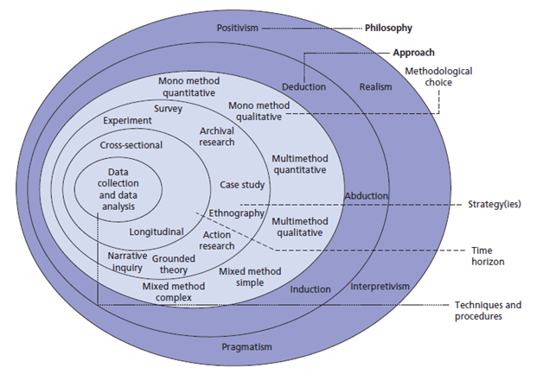

Figure 3.1 – Annotated Diagram – Research Onion (Business Research Methodology, No Date)

The diagram shown in figure 3.1 shows the chosen research process for this dissertation. According to Phair and Warren (2021) ‘’The onion is made up of 6 layers, which you’ll need to peel back one at a time as you develop your research methodology’’.

3.1.1 Research Philosophy
The first layer of the onion is research philosophy. Research philosophy refers to ‘’the set of beliefs, assumptions, and principles that underlie the way you approach your study’’ (Jansen, 2023). According to research onion in Figure 3.1 – Annotated Diagram – Research Onion (Business Research Methodology, No Date) there are four main research philosophy these being ‘’positivism, interpretivism, pragmatism and realism’’.

The first research philosophy is positivism research which takes the view that ‘’knowledge exists outside of what’s being studied. In other words, what is being studied can only be done so objectively, and it cannot include opinions or personal viewpoints ‘’ (Jansen, 2023). According to Jansen (2023) positivism suggests that things can only be true or false and that anything else is meaningless. The second research philosophy is Interpretivism which emphasises the influence that ‘’social and cultural factors can have on an individual. This view focuses on people’s thoughts and ideas, in light of the socio-cultural backdrop’’ (Jansen, 2023). The third research philosophy is pragmatism which highlights the ‘’practical point of view, where knowledge is not fixed, but instead is constantly questioned and interpreted’’ (Jansen, 2023). The fourth research philosophy is realism which relies on the idea of ‘’independence of reality from the human mind’’ (Business Research Methodology, No Date).

With this research project aiming to cover areas of current police officers’ opinions on proactive and reactive policing it is more appropriate to utilise the interpretivism philosophy which focuses on people’s thoughts and ideas. This will allow for research to be gathered on serving police officers thoughts and opinions on policing strategies.

3.1.2 Research approach
According to Phair and Warren (2021) ‘’It’s important to clearly identify your research approach as it will inform the decisions you take in terms of data collection and analysis in your study’’. As evidenced in Figure 3.1 – Annotated Diagram – Research Onion (Business Research Methodology, No Date) there are two types of research approaches. These being inductive and deductive. Inductive approaches consist of ‘’generating theories from research, rather than starting a project with a theory as a foundation’’ (Phair and Warren, 2021). While Deductive approaches ‘’begin with a theory and aim to build on it (or test it) through research’’. (Phair and Warren, 2021).

With these approaches in mind this research will utilise the inductive approach utilising theories to answer the project question.

3.1.3 Research strategy and choices
The research onion in Figure 3.1 – Annotated Diagram – Research Onion (Business Research Methodology, No Date) suggests mono-method, mixed method and multi-method as possible choices for conducting research. The mono-method comprises ‘’only one method for the study’’ (15 writers, No Date). The mixed method is based on the use of ‘’two or more methods of research and commonly refers to the use of qualitative and quantitative methodology.,’’ (15 writers, No Date) and multi-method uses a ‘’wider selection of methods’’ (15 writers, No Date).

Within this research the Mono-method will be utilised in the form of surveys and questionnaires to gather opinions and thoughts from serving police officers. Through conducting surveys and questionnaires this will gather information on what serving police officers think is the most effective strategy.

3.1.4 Time horizon
The finial aspect of the research onion is the time horizon which illustrates how long collection can take. Within this study ‘’cross sectional’’ is the most appropriate time horizon as it is the most appropriate when utilising surveys. Thomas (2020) states that a cross sectional study is a study in which the researcher collects data from many different individuals at a single point in time. This form of collection is the most appropriate collection method to ensure that a multitude of responses are collected within a set time.

Sampling 3.2 (data collection)
There are four main types of sampling types. The first being simple random sampling which according McCombes (2019) ‘’every member of the population has an equal chance of being selected. Your sampling frame should include the whole population’’. The next sampling technique is systematic sampling which McCombes (2019) states ‘’every member of the population is listed with a number, but instead of randomly generating numbers, individuals are chosen at regular intervals’’. The next is stratified sampling which according to McCombes (2019) involves ‘’dividing the population into subpopulations that may differ in important ways. It allows you draw more precise conclusions by ensuring that every subgroup is properly represented in the sample’’. The final sampling technique is cluster sampling which involves ‘’dividing the population into subgroups, but each subgroup should have similar characteristics to the whole sample. Instead of sampling individuals from each subgroup, you randomly select entire subgroup’’ (McCombes, 2019).

Within this research simple random sampling will be utilised in the form of a survey to gather information from current police officers.

Limitations 3.3
Limitations in research refer to factors that may affect the results of the study (Hassan, 2024). Within this research consideration must be given to limitations.

The first limitation that must be considered is the time limitation. With this research being conducted within a dissertation consideration must be given to the time available to conduct this study. This will be resolved by ensuring that the data is collected within a suitable time to allow enough time for respondents to answer and the analysis of the data received.

The second limitation that must be considered is the selection bias when conducting the research. To minimise this the data will be collected from a variety of serving police officers in a number of different departments to allow a difference in view and opinions on the research topic.

Conclusion 3.4
This chapter has successfully identified the most suitable for of methodology used for the dissertation as well as achieved objective four of the project.

Chapter 4 – Data Analysis and Findings
- Introduction
Following on from the methodology chapter, this chapter will seek to achieve the third objective:
To analyse data collected to determine if police officers should be proactive or reactive in an effort to deter crime based on servicing police officers’ thoughts and opinions.

This chapter will analyse data collected through primary research. Nasrudin (2022) suggests that primary research allows the researcher to collect data that is more up to date and more relevant to the researcher’s objectives. An online survey was conducted and shared with serving police officers enabling them to provide their thoughts and opinions on the research question. During this chapter, reference will be made to specific questions that have been answered by these serving police officers.

4.1 Data analysis
Data analysis requires the collection, cleaning and transforming of collected data in order to interpretate the data as findings which allows for any patterns or themes to become clear (Eldridge, 2023). The data was collected and analysed through Survey Monkey. Using Survey Monkey to collect data allowed for many advantages for example, it permitted swift response times from respondents with easy to understand data. According to Gaille (2020) surveys are a practical solution for data gathering.

4.2 Method for analysis
Due to the data being both qualitative and quantitative in nature, it is important to find two methods of analysis that analyses both types of results. Data that is collected that is quantitative in nature will be displayed in the form graphs. According to Graphia (No Date) graphs allow for easy to spot trends and patterns when compared to other traditional spreadsheets. Data that is collected that is qualitative in nature has been complied into one to assist in analysing the data.

4.3 Survey findings
4.3.1 Policing role statistics
Participants were categorised by role within the police service to allow for a range of different participant views depending on what their specific role is. This survey shows the answers of 25 serving police officers. This survey was shared via WhatsApp to serving police officers.
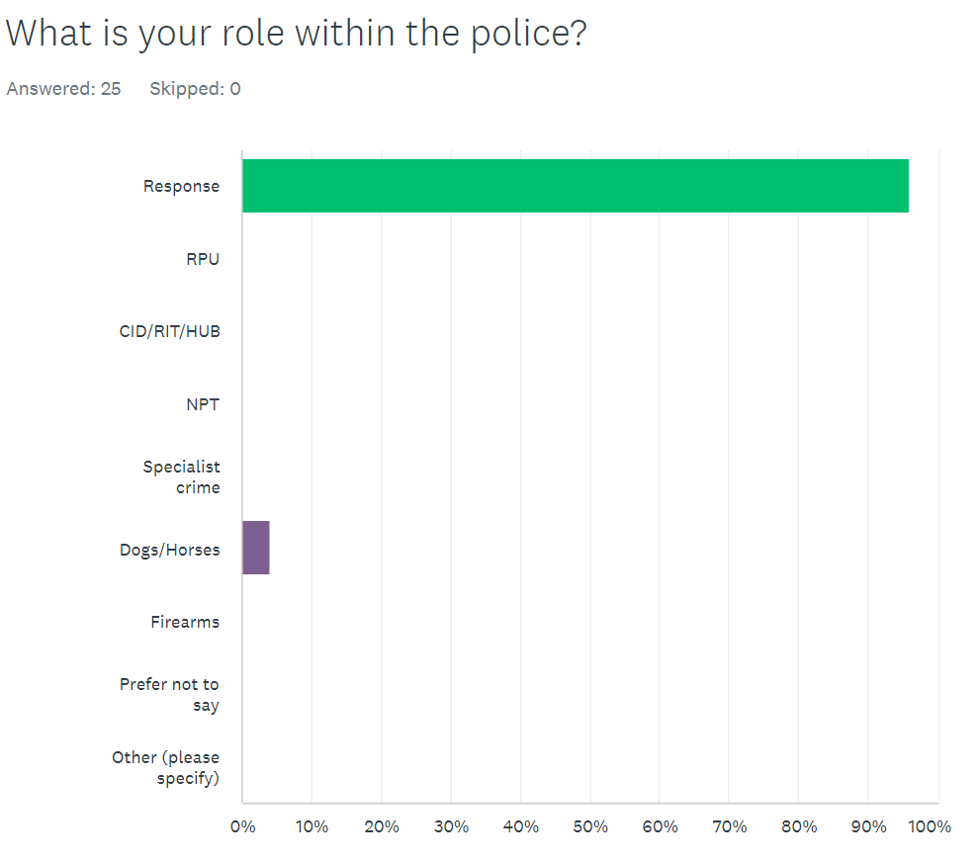
Figure 4.3.1 – Graph showing which department participants are in

As seen in Figure 4.3.1 of the 25 precipitants 96% were part of the response department and 4% were dogs/horse department. This research was undertaken as the literature analysed identified a gap in knowledge regarding little to no acknowledgment of current police officers’ thoughts and opinions on the question should police officers be proactive or reactive in an effort to reduce crime rates? Previous research outlined in the previous literature review chapter discussed the benefits and negatives of both crime prevention strategies but didn’t provide current police officers thoughts or opinions on these strategies. All participants gave their permission in question 1 of the survey for their answers provided to be used within the dissertation.

4.3.2 Opinions on crime rates
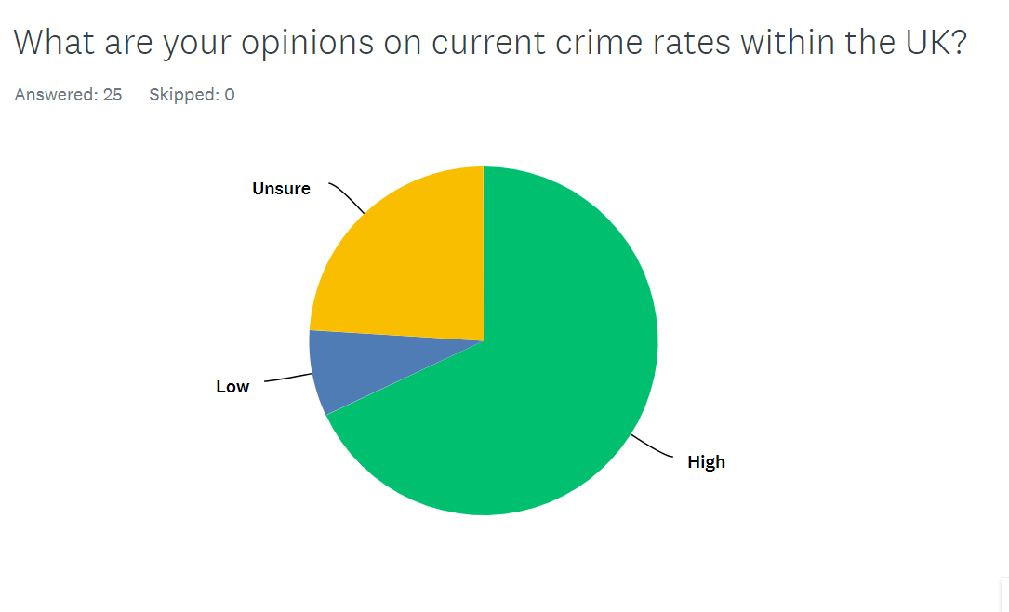
Figure 4.3.2 – Pie chart showing participants thoughts on crime rate within the UK.

As seen in Figure 4.3.2 the majority of participants are under the perception that the current crime rate in the UK is high with 68% of participants answering high with only 8% answering low and 24% answering unsure. This shows that the majority of participants believe that the current crime rate in the UK is high, which when compared with the Office for National Statistics (2022) statistics of crime in 2022 it can be shown that crime is high.

4.3.3 How long do you spend utilising the proactive policing strategy
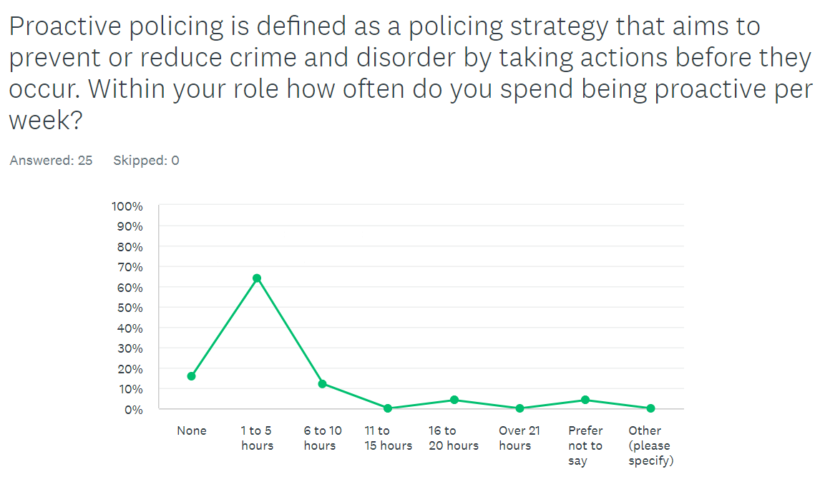
Figure 4.3.3 – Line graph showing how long participants spend being proactive per week.

As shown in Figure 4.3.3 that shows how much time serving police officers spend utilising the proactive policing strategy per week with 64% answering that they spend between 1 to 5 hours a week being proactive, 12% answering that they spend between 6 to 10 hours, 4% answering that they spend between 16 and 20 hours and 4% preferring not to say. Overall, between the participants in this survey none of them spent over 21 hours utilising proactive policing with the overall percentage being quite low.
4.3.4 How long do you spend utilising the reactive policing strategy
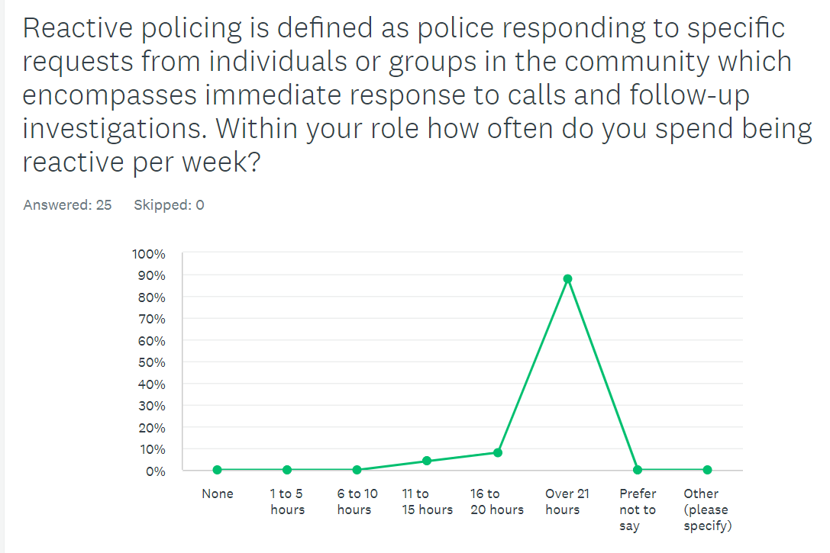
Figure 4.3.4 - Line graph showing how long participants spend being reactive per week.
In contrast to Figure 4.3.3, Figure 4.3.4 shows that the time per week police officers spend utilising the reactive policing strategy is significantly higher when compared to Figure 4.3.3 with 4% of participants answering 11 to 15 hours per week, 8% of participants answering 16 to 20 hours per week and 88% of participants answering over 21 hours per week. This shows that participants in this survey spend significantly more time being reactive rather than proactive.

4.3.5 Benefits and negatives of proactive policing and reactive policing.
Within the survey participants were asked about the benefits and negatives they have experienced of both proactive and reactive policing. Participants provided the following responses to proactive policing ‘’Proactive policing can increase workload/ prevent recourses being available to respond or be reactive. Positive: Prevent crimes occurring reducing need to respond/react’’ with another participant answering the following:
‘’One benefit would be preventing offences and targeting repeat offenders. Officers rarely have the time to commit to being proactive. This is due to the high volume of calls, low number of officers and the demand on mental health calls’’. When comparing these answers with the responses to reactive policing which are ‘’The benefit of reactive policing is safeguarding victims and conducting the relevant golden hour enquires’’ and ‘’The negatives of reactive policing are waiting for a crime to be committed. Public perception on policing is affected when they see police only react to incident rather than being proactive and preventing the crime.’’ It can be seen that participants have experienced both positives and negatives in both policing strategies but that they agree in both that proactive policing can prevent crimes before they take place.

4.3.6 Participants thoughts on proactive vs reactive policing to prevent crime.
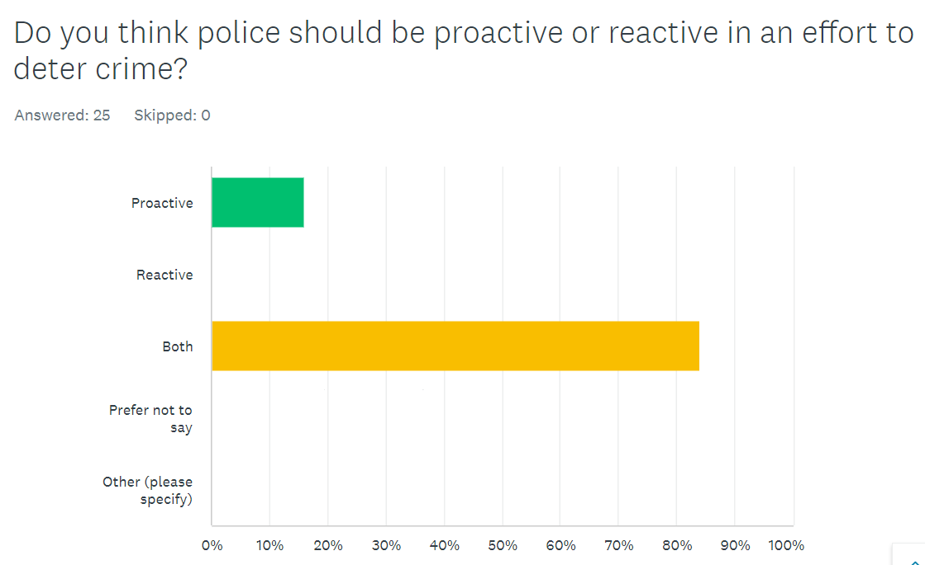
Figure 4.3.6 – Bar graph showing participants answers to which policing strategy should be utilised to deter crime.

As shown in figure 4.3.6 16% of participants answered proactive and 84% answered both. This shows the majority of participants believe both strategies should be utilised to deter crime with some answering that proactive policing should be utilised to deter crime. With this in mind it and comparing these findings with figure 4.3.3 and figure 4.3.4 it can be seen that currently, time isn’t equally spent utilising both policing strategies and that participants believe this should be equal.

4.4 conclusion
This chapter has successfully presented the findings of the research project derived from primary data collection in the form of a survey. This chapter has also completed the achieved the third objective.
In conclusion the present study identified that the majority of participants believe that both policing strategies should be utilised to deter crime and that currently the reactive strategy is being utilised significantly more than the proactive strategy. This study agrees with literature previously outlined in the literature review chapter that discussed the benefits of proactive policing and deterring crime with many participants believing it can prevent crime.
Chapter 5 – Findings and conclusion
5.0 introduction
The previous chapter of the dissertation analysed data found within this study and achieved the third objective. This chapter will meet the final objective: To provide recommendations surrounding the discovered key issues of serving police officers thoughts on proactive vs reactive (add to introduction objectives). This chapter will also provide a conclusion surrounding the research question of, Proactive vs reactive. Should police officers be proactive or reactive in an effort to reduce crime rates? As well as highlighting the limitations of this project and potential future research is this area.

5.1 completion of achievement of objectives
- To analyse current data surrounding proactive and reactive policing strategies and their effectiveness in reducing crime.
An analysis of existing literature was successfully carried out in chapter two of this dissertation. This identified existing literature around the dissertation subject and the effectiveness of proactive and reactive policing strategies in reducing crime. This object also identified a gap within the current research surrounding this top and that there is there is little to no acknowledgement of current police officers’ thoughts and opinions to the question proactive vs reactive policing strategies.

- To identify the most suitable research approach required too appropriately allow a critical evaluation of both proactive and reactive policing strategies.
This objective was achieved in chapter three of the dissertation. This objective identified the most suitable research approach to allow for a critical evaluation of the previous identified gap in current research surrounding proactive and reactive policing. By completing this objective, it allowed for a identified gap to be research effectively and identify serving police officers thoughts and opinions on proactive and reactive policing strategies.

- To analyse data collected to determine if police officers should be proactive or reactive in an effort to deter crime based on servicing police officers’ thoughts and opinions.
Objective three was achieved in chapter four following an analysis of data. This objective identified the results of the research and the results within the previous mentioned gap in current literature. This objective allowed for the results of the research to be critically analysed.

- To provide recommendations surrounding the discovered key issues of serving police officers thoughts on proactive vs reactive.

This final objective will be achieved within the final chapter of this dissertation. This
objective identified the recommendations made from analysing the results of the research.
and allows for further research to be conducted within this area.

5.2 Main Findings
Throughout the dissertation multiple findings have been presented. Identifying gaps in the research question ‘’Proactive vs reactive. Should police officers be proactive or reactive in an effort to reduce crime rates?’’ with there being no research on serving police officers thoughts and opinions. Findings from research within this gap identified the following.
Firstly, that the majority of participants being 68% believe that crime rate within the UK is high. Showing that serving police officers thoughts are that crime rate is currently high with current policing strategies.
Secondly, that more time is being spent utilising the reactive policing strategy by serving police officers with 88% of participants stating that they spend more than 21 hours a week being reactive compared to the 64% of participants stating they spend between 1 and 5 hours per week being proactive.
Finaly that the majority of participants within this study believe that both proactive and reactive policing strategies should be utilised to deter crime and that from their observations the reactive policing strategy is being utilised significantly more than the proactive strategy. This study identified that the thoughts and opinions of serving police officers agrees with previously mentioned literature outlined in the literature review chapter of this dissertation. This study shows that serving police officers believe that both proactive and reactive policing strategies have benefits in Morden policing and can aid in preventing and reducing crime in various ways.

5.3 Limitations
The biggest limitation surrounding this research project was the sample size that was gathered. When utilising SurveyMonkey to collect the responses it only allows the first 20 respondents results to be analysed, this doesn’t allow for the best representation of the policing population as a whole due to the small sample size and doesn’t allow for very accurate patterns and trends to be identified.
Another limitation is that the majority of the respondents being 96% were from the response department within the police and as a result only allows for a insight into one department and their thoughts and opinions as a whole.

5.4 future research
As the data collected was from a small proportion of serving police officers with the majority of participants being in the response department of the police. A lot of response weren’t collected due to the small sample allowed within SurveyMonkey. Future research should be conducted to obtain a wider and more balanced distribution of responses. Further research could be collected from a larger sample size with a equal amount of respondents being from a variety of different departments within the policing. This would allow a variety of different insights and opinions on the research question.

5.5 conclusion
This project has successfully achieved the research aims and objectives but also answered the question Proactive vs reactive. Should police officers be proactive or reactive in an effort to reduce crime rates by coming to the conclusion that police officers should utilise both policing strategies to allow for the benefits of both when deterring crime. This dissertation has presented key findings surrounding the issues involved in policing and utilising these crime prevention strategies.

Chapter 6 recommendations
6.0 Introduction
The following recommendations are based on discoveries and findings made whilst conducting the research project and surveys. Recommendations are important as they identify specific interventions/strategies to address issues identified through this study (Dhanya, 2023).
6.1 Recommendations
A first recommendation that can be made is for more time to be spent by serving police officer being proactive rather than reactive. This is evidence within the survey where the majority of serving police officers believe that they only spend a few hours per week being proactive when comparing this to being reactive.
A second recommendation is that proactive and reactive policing strategies should be utilised together in an effort to deter crime. As evidence In the survey the majority of serving police officers believe there are many benefits to both strategies and that both strategies should be utilised to deter crime.

Bibliography
- 15 writers. (No Date) Understanding the research onion [Internet]. Available at https://15writers.com/research-onion/ (Accessed: 18/12/2023)
- Braga, A, Turchan, B, Papachristos, A and Hureau, D. (2019) Hot spots policing of small geographic areas effects on crime [Internet]. Available at https://onlinelibrary.wiley.com/doi/10.1002/cl2.1046 (Accessed: 01/11/2023)
- Brookes, E. (2023) Cesare Lombroso: Theory of crime, Criminal man, and atavism [Internet]. Available at https://www.simplypsychology.org/lombroso-theory-of-crime-criminal-man-and-atavism.html (Accessed: 25/10/2023)
- Business Research Methodology. (No Date) Research philosophy [Internet]. Available at https://research-methodology.net/research-philosophy/#_ftn1 (Accessed: 21/11/2023)
- Cambridge Dictionary. (2023) Crime [Internet]. Available at https://dictionary.cambridge.org/dictionary/english/crime (Accessed: 13/10/2023).
- Clark, D. (2023) Number of police officers in the United Kingdom from 2003 to 2022 [Internet]. Available at https://www.statista.com/statistics/303963/uk-police-officer-numbers/ (Accessed: 29/10/2023).
- College of policing. (2013) Engagement [Internet]. Available at https://www.college.police.uk/app/engagement-and-communication/engagement (Accessed: 07/04/2024).
- College of policing. (2013) Managing effective investigations [Internet]. Available at https://www.college.police.uk/app/investigation/managing-effective-investigations (Accessed: 07/04/2024).
- College Of Policing. (2021) The effectiveness of visible police patrol [Internet]. Available at https://www.college.police.uk/research/what-works-policing-reduce-crime/visible-police-patrol (Accessed: 31/10/2023).
- Dhanya, A (2023) What are implication and recommendations in research? How too write it, with examples. [Internet]. Available at https://esearcher.life/blogarticle/what-are-implications-recommendations-in-research/#:~:text=Research%20recommendations%20suggest%20future%20actions%20or%20subsequent%20steps,research%20or%20provides%20frameworks%20for%20decision-makers%20or%20policymakers. (Accessed: 21/02/2024)
- DiscoverPHDs. (2020) Types of research – Explained with examples [Internet]. Available at https://www.discoverphds.com/blog/types-of-research (Accessed: 17/12/2023)
- Eldridge, S. (2023) Data analysis [Internet]. Available at https://www.britannica.com/science/data-analysis (Accessed: 02/02/2024)
- Gaille, L. (2020) 20 advantages and disadvantages of survey research [Internet]. Available at https://vittana.org/20-advantages-and-disadvantages-of-survey-research (Accessed: 08/04/2024).
- George, T. (2023) Primary research | Definition, types, & examples [Internet]. Available at https://www.scribbr.com/methodology/primary-research (Accessed: 21/11/2023)
- Government of Canada. (2021) Police discretion with young offenders [Internet]. Available at https://justice.gc.ca/eng/rp-pr/cj-jp/yj-jj/discre/org/styles.html (Accessed: 30/10/2023)
- Graphia. (No Date) Why use graphs? [Internet]. Available at https://graphia.app/guide/section1/3_why_use_graphs.html#:~:text=Compared%20to%20a%20traditional%20spreadsheet%2C%20graphs%20allow%20an,the%20right%20conclusions%20about%20the%20data%20at%20hand. (Accessed: 08/04/2024).
- Hassan, J (2024) Limitations in research – Types, examples and writing guide [Internet]. Available at https://researchmethod.net/limitations-in-research/#:~:text=Types%20of%20Limitations%20in%20Research%201%20Sample%20Size,5%20Measurement%20Error%20...%206%20Ethical%20Limitations%20 (Accessed: 08/04/2024).
- Jansen, D. (2023) Research philosophy & paradigms [Internet]. Available at https://gradcoach.com/research-philosophy/ (Accessed: 18/12/2023)
- Lamond, G. (2007) What is a crime? [Internet]. Available at https://academic.oup.com/ojls/article-abstract/27/4/609/1459997?redirectedFrom=fulltext&login=true (Accessed: 12/10/2023).
- Maron, D. (2017) Sciendce says these police tattics reduce crime. [Internet]. Available at https://www.scientificamerican.com/article/science-says-these-police-tactics-reduce-crime/#:~:text=When%20police%20officers%20identify%20specific%20problems%2C%20try%20to,or%20reduce%20crime%29%20has%20good%20evidence%20behind%20it. (Accessed:08/04/2024)
- McCombes, S. (2019) Sampling methods| types, techniques & examples [Internet]. Available at https://www.scribbr.com/methodology/sampling-methods/ (Accessed: 18/12/2023)
- Nasrudin, A. (2022) Primary research: Methods, advantages and disadvantages [Internet]. Available at https://penpoin.com/primary-research/ (Accessed: 08/04/2024).
- National Academies Press. (2018) Proactive policing: effects on crime and communities [Internet]. Available at https://nap.nationalacademies.org/read/24928/chapter/2 (Accessed: 30/10/2023)
- Office for national statistics. (2022) Crime in England and Wales: year ending March 2022 [Internet]. Available at https://www.ons.gov.uk/peoplepopulationandcommunity/crimeandjustice/bulletins/crimeinenglandandwales/yearendingmarch2022 (Accessed: 29/10/2023).
- Phair, D and Warren, K. (2021) Saunders’ research onion: explained simply [Internet]. Available at https://gradcoach.com/saunders-research-onion/ (Accessed: 21/11/2023)
- Ratcliffe, J, Taniguchi, T, Groff, E and Wood, J. (2011) The Philadelphia foot patrol experiment: A randomized controlled trial of police patrol effectiveness in violent crime hotspots [Internet]. Available at htttps://onlinelibrary.wiley.com/doi/abs/10.1111/j.1745-9125.2011.00240.x (Accessed: 01/11/2023)
- Sherman, L and Eck, J. (2002) Police for crime prevention [Internet]. Available at https://www.ojp.gov/ncjrs/virtual-library/abstracts/policing-crime-prevention-evidence-based-crime-prevention-p-295-329 (Accessed: 31/10/2023)
- Taylor, B, Kooper, C and Woods, D. (2011) A randomized controlled trial of different policing strategies at hot spots of violent crime [Internet]. Available at https//link.springer.com/article/10.1007/s11292-010-9120-6 (Accessed: 01/11/2023)
- Taylor, J. (2023) Functionalist views of crime and deviance – Durkheim, Merton & Cohen [Internet]/ Available at https://exploresociology.com/crime-and-deviance/functionalist-views-of-crime-and-deviance-durkheim-merton-cohen/#:~:text=Durkheim%20suggested%20that%20crime%20is%20both%20a%20normal,are%20termed%20criminal%20are%20not%20everywhere%20the%20same. (Accessed:07/04/2024).
- Thomas, L. (2020) Cross-sectional study| Definition, uses & examples [Internet]. Available at https://www.scribbr.com/methodology/cross-sectional-study/ (Accessed: 08/04/2024)
- Thompson, K. (2022) The functionalist perspective on crime and deviance [Internet]. Available at https://revisesociology.com/2016/04/03/functionalist-explanations-of-deviance/ (Accessed: 30/10/2023)
- USLegal. (No Date) Proactive policing law and legal definition [Internet]. Available at https://definitions.uslegal.com/p/proactive-policing/ (Accessed: 30/10/2023)
- Walker, J. (2021) Advantages of primary research – Types & Advantages [Internet]. Available at https://www.researchprospect.com/advantages-of-primary-research/ (Accessed: 07/04/2024).
- Weisburd, D and Eck, J. (2004) What can police do to reduce crime, disorder and fear [Internet]. Available at https://cebcp.org/wp-content/publications/WeisburdEck04.pdf (Accessed: 31/10/2023)
- Wiley, S and Esbensen, F. (2016) The effects of police contact: Does official intervention result in deviance amplification? [Internet]. Available at https://journals.sagepub.com/doi/abs/10.1177/0011128713492496 (Accessed: 25/10/2023)
- Williams, G. (1955) 7 The definition of crime [Internet]. Available at https://academic.oup.com/clp/article-abstract/8/1/107/359572 (Accessed: 25/10/2023).

Appendices

Appendix A Copy of survey and answers
Question 1
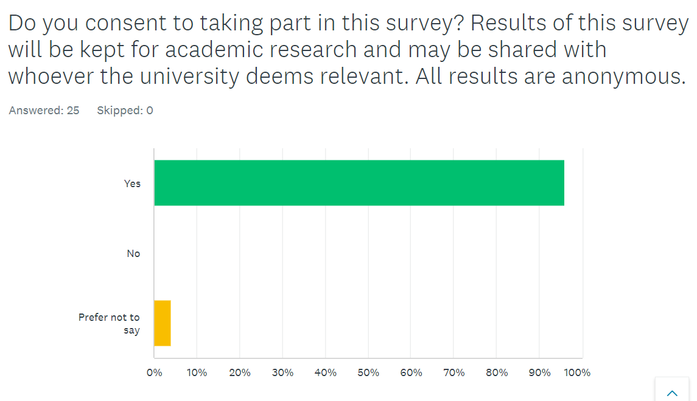

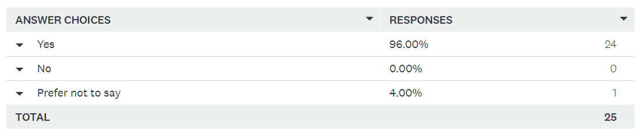

Question 2

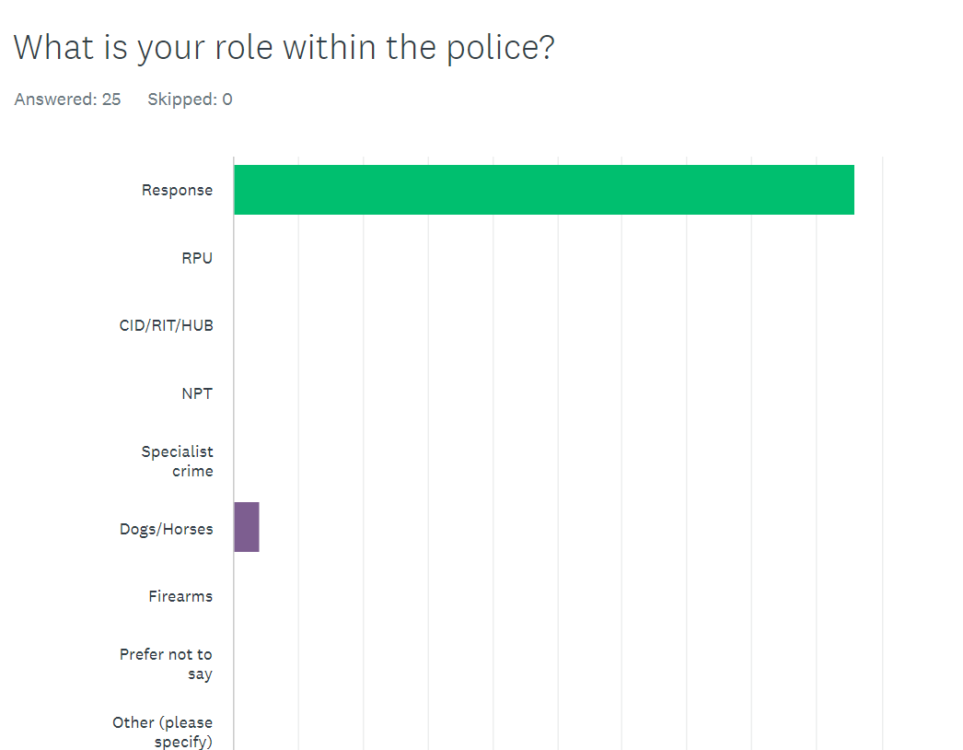

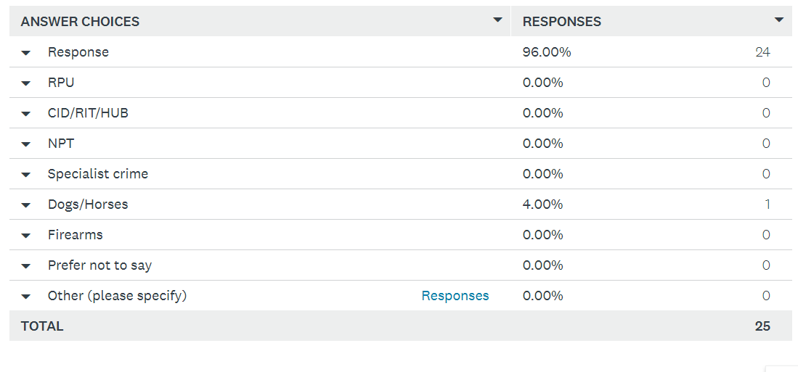
Question 3

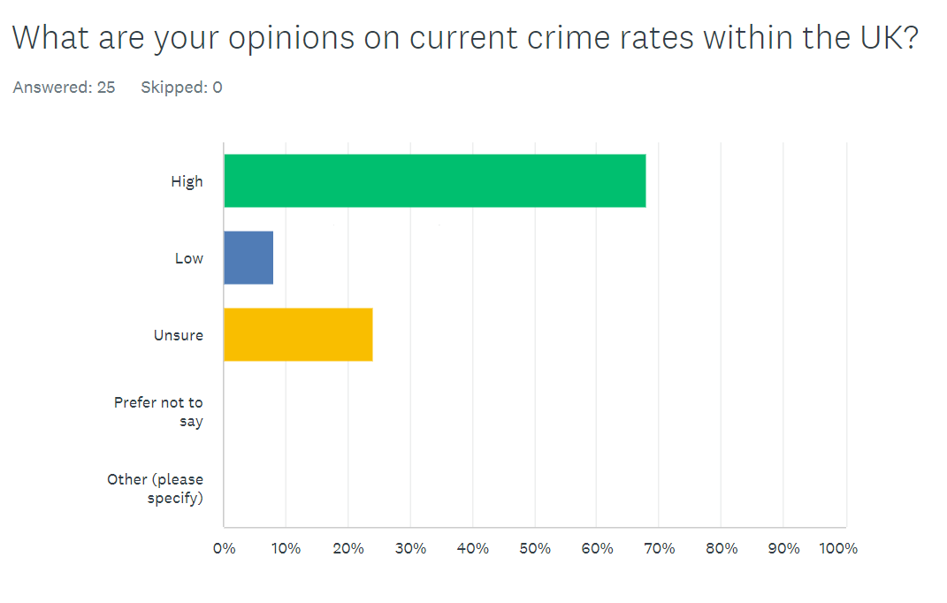

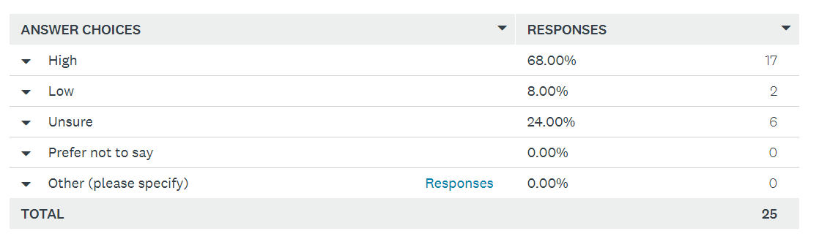

Question 4
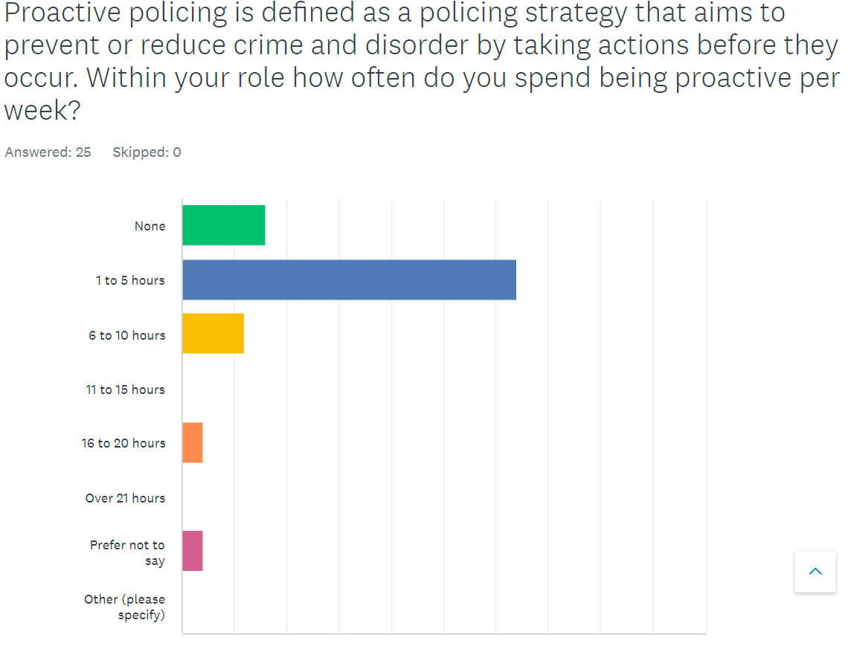

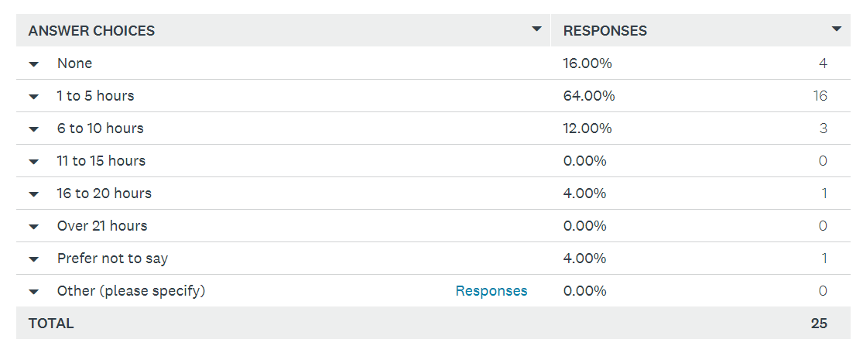

Question 5

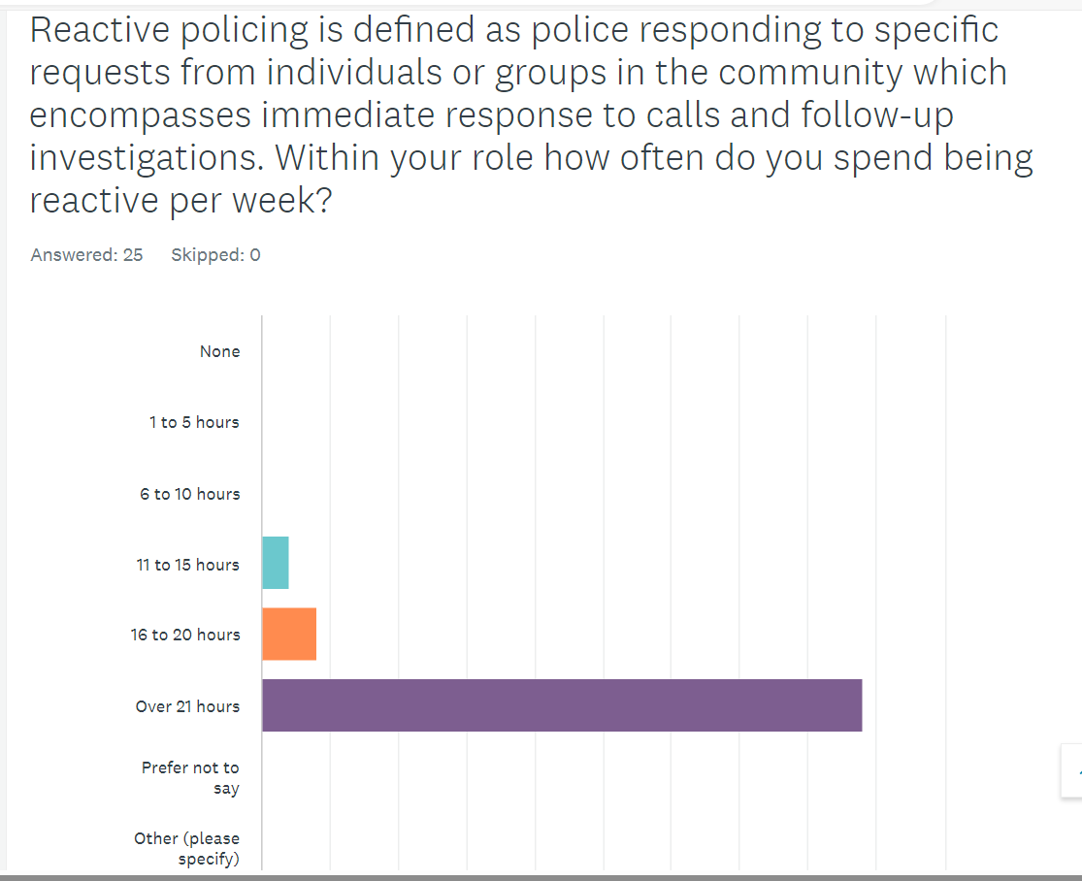

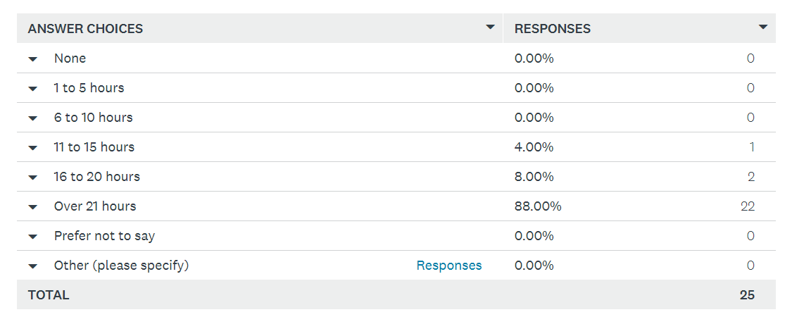

Question 6

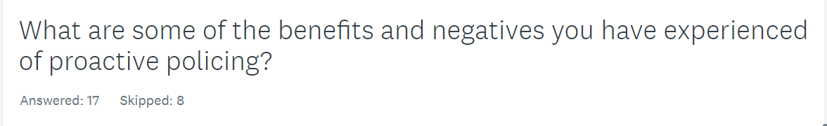
Answers
Benefits is that you can detect and solve crime that is currently occurring unknown to police knowledge and so create intelligence. Negatives is that it’s creates more work for the officer, meaning more stress for them.

Negative: Proactive policing can increase workload/ prevent recourses being available to respond or be reactive. Positive: Prevent crimes occurring reducing need to respond/react

The benefits are police officers are more visible in the community and we are able to collect more intelligence.

Prevented crimes occurring/ situations getting worse Public perception of police increases Little time to be proactive

Reduction of complaints and greater community cohesion

Benefits are you can stop crime before it happens and be more visible in the community. Negative is that you can only be as proactive as you want to be. If you want to look for crime you can but it depends on the officer

Allowing me to target more vulnerable locations which may not get the same coverage. Negative - Some days there is nothing to be proactive about

Benefits - being proactive is quintessential to policing. It allows us to intervene and disrupt crimes before they’re even committed. Negative - Nowadays due to demand we simply do not have the time to be proactive and any spare time we do have it’s nice to have 5 minutes of downtime. Negative - being proactive often leads to creating more workload for myself when I am already struggling with the workload I do have.

Officers often patrol areas to reduce crime. It allows crime to be detected, prevented as we act as a deterrant and we reassure victims.

Showing high visibility presence preventing crime

Police struggle to be pro-active due to the following reasons: Dealing with case files. Dealing with work overloads such as G4's. Sitting with people at hospital to see the crisis team.

Benefits community perception, negatives sometime it looks like nothing has been achieved

Benefits... Stopping the problem becoming bigger, negatives... Doing other agencies work/ mental health etc

One benefit would be preventing offences and targeting repeat offenders. Officers rarely have the time to commit to being proactive. This is due to the high volume of calls, low number of officers and the demand on mental health calls

Preventing re-offending and improving community cohesion
Showing a good presence while patrolling, providing reassurance and engaging with the public.

Proactive policing enables us to tackle crime before it happens or reduce serious crime by the use of police powers such as stop search

Question 7

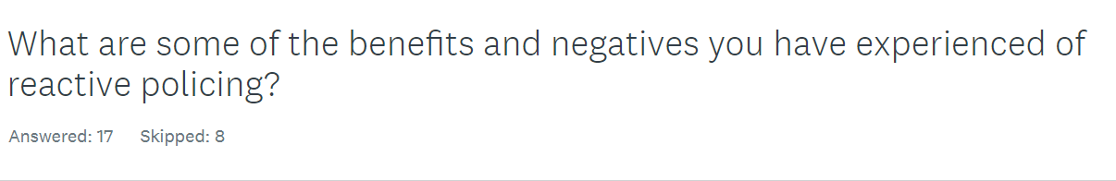

Answers

Benefits is we can solve crime there and then, negatives is that we don’t have enough time to do our own workload or to be proactive

Negative: Rarely prevents the route cause of the problem

The negative with response policing is that officers are more expected to go to calls on behalf of other emergency services.

Quickly dealt with When dealing reactive usually the situation has gotten worse Not preventative

Frustrated communities

Benefits are that you are called to support victims and prevent any further offences taking place for the immediate time. Negative is that you are called after a crime has taken place so someone is usually hurt or at a loss

Always keeping me busy Workload piles up

Benefits - protecting vulnerable persons and victims of crime Negatives - often the calls we attend are not as first reported and often are not even crimes. Negatives - the follow up investigations can be time consuming

Police are able to quickly respond to vulnerable victims of crime.

Reactive immediately deals with the issue but does not solve it long term

Reactive immediately deals with the issue but does not solve it long term

Would benefit police but cannot do it often due to the above previous answers in questions 6.

Benefits reacting to a need, negatives sometimes there is a better agency that could deal with the issue however due to time of week/day they fall to police
The benefits of reactive policing is safeguarding victims and conducting the relevant golden hour enquires.

The negatives of reactive policing are waiting for a crime to be committed. Public perception on policing is effected when they see police only react to incidnet rather than being proactive and preventing the crime.

Responding to immediate calls are effective and within required timescales. Responding to non-immediate calls are sometimes delayed and take longer than required due to outstanding demands. Some teams ‘cherry pick’ calls to deal with and leave the complex incidents for other teams.

Reactive policing means the crime has already occurred and therefore there is often a victim . This means that someone may have come to harm before we’ve been made aware.

Question 8

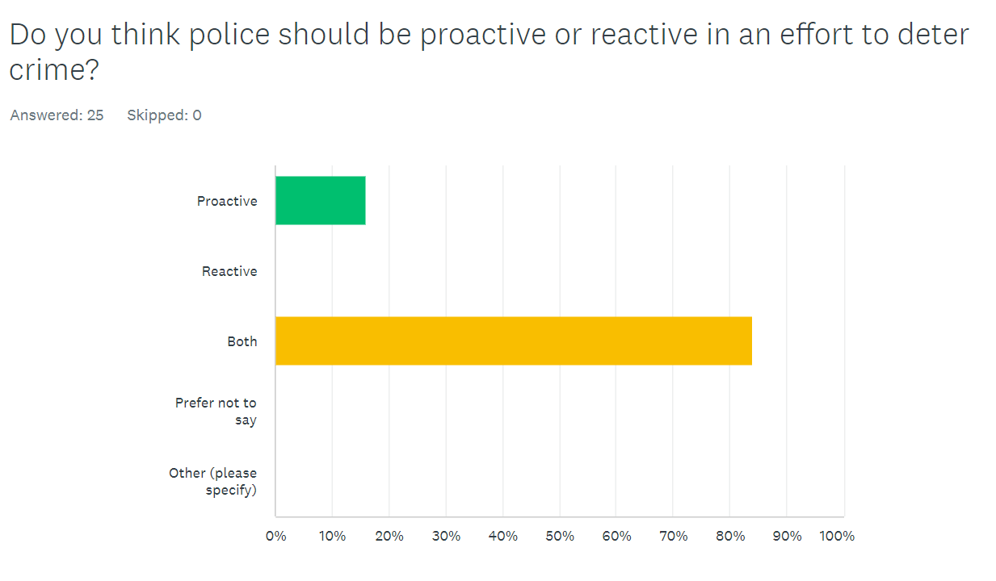

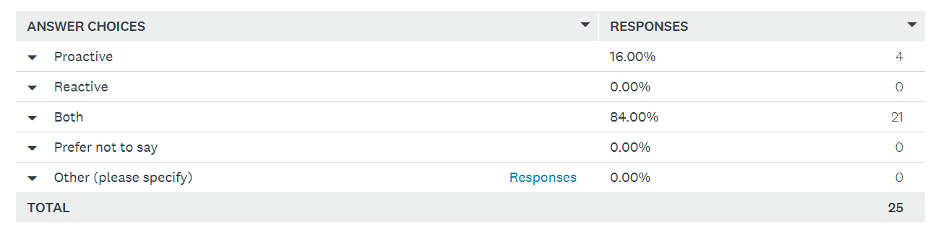

Appendix B Research proposal sheet



UNDERGRADUATE DISSERTATION
RESEARCH PROPOSAL FORM

Please complete the following research proposal and submit it to Turnitin.

Which project option are you taking? Please tick:

8,000 word project:

NAME: Jacob Llewellyn Morgan | STUDENT ID No.: 2031237
DRAFT RESEARCH TITLE QUESTION:
INTRODUCTION:

Proactive vs reactive. Should police officers be proactive or reactive in an effort to reduce crime rates?

According to the Office For National Statistics (2022) there were ‘’6.3 million crimes’’ recorded in 2022 with it being estimated that ‘’adults aged 18 years and over experienced 11.3 million offences’’ (Office For National Statistics, 2022) in England and Wales 2022. With that in mind, this proposal will discuss the differences between proactive and reactive policing strategies and their effects on the reduction of crime. It will also identify if the police service is spending enough time being proactive in their local communities and which policing strategy should be prioritised in an effort to deter crime and decrease current crime rates.

Within policing there are many strategies to tackle and deter crime. Two of the main policing strategies undertaken by the police service are proactive policing and reactive policing. (supporting literature may have strengthened your discussion here)

Proactive policing is a ‘’policing strategy that aims to prevent or reduce crime and disorder by taking actions before they occur’’ (USLegal.com, No date). it involves the use of police powers as well as engaging with the public to allow police to stop/prevent crime before it happens.

According to the College of policing (2021) ‘’targeting the places that create the most demand for the police can be an effective crime reduction strategy’’. The College of policing (2021) also states that ‘’Out of 78 tests of hot spots policing, 62 had a positive effect on crime’’.

Reactive policing is defined as ‘’police responding to specific requests from individuals or groups in the community which encompasses "immediate response to calls" and "follow-up investigations" (Justice.ac.ca, 2021). This strategy of policing is heavily utilising in detecting crime and is dependent on the member of the publics cooperation in the form of witness statements.

This topic is worthy of consideration for an undergraduate dissertation due to its link with the key role of the policing service as well as its link with detecting and preventing crime.

It is hoped that by the end of this dissertation it can be identified which policing strategy should be prioritised in an effort to decrease crime rates in the UK.

SUMMARY OF RESEARCH OBJECTIVES:

The aim of this research project is to identify if the police should prioritise being proactive or reactive in an effort to reduce crime rates in the UK. These aims will be achieved by completing the following objectives:
- To analyse current data surrounding proactive and reactive policing strategies and their effectiveness in reducing crime.
- To identify the most suitable research approach required too appropriately allow a critical evaluation of both proactive and reactive policing strategies.
- To analyse data collected to determine if police officers should be proactive or reactive in an effort to deter crime based on servicing police officers’ thoughts and opinions.
- To provide recommendations surrounding the discovered key issues of serving police officers thoughts on proactive vs reactive

LITERATURE REVIEW:

The literature review will evaluate and review current academic literature which will identify current policing strategies and their ability to tackle crime as well as the strategies under evaluation in this dissertation.

Within this dissertation I will be utilising articles, government reports, organisational strategic plans and online documents. These sources consist of primary research in this topic.

SUMMARY OF RESEARCH –SURVEY METHOD:

Within this dissertation will be utilising qualitative and quantitative methods to obtain facts and figures relating to the chosen subject. I will also be utilising secondary sources reviewing information that has been collected by organisations, government reports and articles. I will also be using questionnaires to obtain current opinions on policing strategies within the police service.

I will be utilising these research methods as they will allow me to obtain the most accurate and current statistics and information surrounding my chosen subject.

SUMMARY OF SAMPLING FRAMEWORK:

I will be utilising a variety of different sources and trusted website with figures on crime rates and the effectiveness of different strategies within my dissertation. These will be the most appropriate way to obtain reliable information that can aid in determine which strategy should be prioritised within the police service.

When completing the questionnaire, I will be utilising South Wales Police officers to ascertain their thoughts on current policing strategies and how they reduce crime rates.
ETHICAL ISSUES:

Within this dissertation the policing strategy of proactive police can be seen as intrusive, and some may say the strategy of police officers targeting a specific area or individuals as ethically immoral due to a variety of different reasons
TIME SCALE:
Research proposal(1000words) & Ethics form (500 Words) Submission – 28/08/2023

Literature review submission (2500 words) submission – 06/11/2023

Research methodology & Planning (1000 words) submission – 18/12/2023

Analysis of results (1000 words) Submission – 05/02/2024

Findings & Conclusion (1000 words) submission – 11/03/2024

Final project submission – 08/04/2023

REFERENCE LIST:

College Of Policing. (2021) Target approaches to crime and disorder reduction [Internet]. Available at Targeted approaches to crime and disorder reduction | College of Policing (Accessed: 12th August 2023).

Justice.ac.ca. (2021) Police discretion with young offenders [Internet]. Available at 6.0 Policing styles: Reactive versus proactive policing - IV. Organizational Factors Affecting Police Discretion - Police Discretion with Young Offenders (justice.gc.ca) (Accessed: 13th August 2023).

Office For National Statistics. (2022) Crime in England and Wales: year ending March 2022 [Internet]. Available at Crime in England and Wales - Office for National Statistics (ons.gov.uk) (Accessed: 27th August 2023).

USLegal.com. (No date) Proactive policing law and legal definition [Internet]. Available at Proactive Policing Law and Legal Definition | USLegal, Inc. (Accessed: 12th August 2023).

Appendix C Ethics form
APPLICATION FOR ETHICAL APPROVAL

RESEARCH STUDENTS
This form is to be completed by the student within SIX months for full-time students and TWELVE months for part time students, after the commencement of the research degree or following progression to Part Two of your course.

Once complete, submit this form via the MyTSD Doctoral College Portal at (https://mytsd.uwtsd.ac.uk).

This document is also available in Welsh.

RESEARCH STAFF ONLY
All communications relating to this application during its processing must be in writing and emailed to pgresearch@uwtsd.ac.uk , with the title ‘Ethical Approval’ followed by your name.

STUDENTS ON UNDERGRADUATE OR TAUGHT MASTERS PROGRAMMES should submit this form (and receive the outcome) via systems explained to you by the supervisor/module leader.

In order for research to result in benefit and minimise risk of harm, it must be conducted ethically. A researcher may not be covered by the University’s insurance if ethical approval has not been obtained prior to commencement.

The University follows the OECD Frascati manual definition of research activity: “creative work undertaken on a systematic basis in order to increase the stock of knowledge, including knowledge of man, culture and society, and the use of this stock of knowledge to devise new applications”. As such this covers activities undertaken by members of staff, postgraduate research students, and both taught postgraduate and undergraduate students working on dissertations/projects.

The individual undertaking the research activity is known as the “principal researcher”.

Ethical approval is not required for routine audits, performance reviews, quality assurance studies, testing within normal educational requirements, and literary or artistic criticism.

Please read the notes for guidance before completing ALL sections of the form.

This form must be completed and approved prior to undertaking any research activity. Please see Checklist for details of process for different categories of application.

SECTION A: About You (Principal Researcher)
1 | Full Name: |  | Jacob Llewellyn Morgan
2 | Tick all boxes that apply: |  | Member of staff: | ☐ | Honorary research fellow: | ☐
 | Undergraduate Student | ☒ | Taught Postgraduate Student | ☐ | Postgraduate Research Student | ☐

3 | Institute/Academic Discipline/Centre: | University of Wales Trinity ST David
4 | Campus: | Swansea
5 | E-mail address:
6 | Contact Telephone Number:
 | For students:
7 | Student Number: | 2031237
8 | Programme of Study: | Professional police practice
9 | Director of Studies/Supervisor:

SECTION B: Approval for Research Activity
1 | Has the research activity received approval in principle?  (please check the Guidance Notes as to the appropriate approval process for different levels of research by different categories of individual) |  | YES | ☐ | NO | ☒
 |  |  |  |  | Date
2 | If Yes, please indicate source of approval (and date where known): Approval in principle must be obtained from the relevant source prior to seeking ethical approval | Research Degrees Committee |  | ☐
2 |  | Institute Research Committee |  | ☐
2 |  | Other (write in) |  | ☐

SECTION C: Internal and External Ethical Guidance Materials
 | Please list the core ethical guidance documents that have been referred to during the completion of this form (including any discipline-specific codes of research ethics, location-specific codes of research ethics, and also any specific ethical guidance relating to the proposed methodology). Please tick to confirm that your research proposal adheres to these codes and guidelines. You may add rows to this table if needed.
1 | UWTSD Research Ethics & Integrity Code of Practice | ☒
2 | UWTSD Research Data Management Policy | ☒
3 | [List any other relevant documents here] | ☐

SECTION D: External Collaborative Research Activity
If there are external collaborators then you should gain consent from the contact persons to share their personal data with the university. If there are no external collaborators then leave this section blank and continue to section E.
1 | Institution
2 | Contact person name
3 | Contact person e-mail address
4 | Is your research externally funded? |  | YES | ☐ | NO |  | ☐
5 | Are you in receipt of a KESS scholarship? |  | YES | ☐ | NO |  | ☐
6 | Are you specifically employed to undertake this research in either a paid or voluntary capacity? | Voluntary | YES | ☐ | NO | ☐
7 |  | Employed | YES | ☐ | NO | ☐
8 | Is the research being undertaken within an existing UWTSD Athrofa Professional Learning Partnership (APLP)? | If YES then the permission question below does not need to be answered. | YES | ☐ | NO |  | ☐
9 | Has permission to undertake the research has been provided by the partner organisation? | (If YES attach copy)  If NO the application cannot continue | YES | ☐ | NO |  | ☐

Where research activity is carried out in collaboration with an external organisation
10 | Does this organisation have its own ethics approval system? | YES | ☐ | NO | ☐
 | If Yes, please attach a copy of any final approval (or interim approval) from the organisation (this may be a copy of an email if appropriate).

SECTION E: Details of Research Activity
1 | Indicative title: | Proactive vs reactive. Should police officers be proactive or reactive in an effort to reduce crime rates?
2 | Proposed start date: | 10/08/2023 | Proposed end date: | 08/04/2023
Introduction to the Research (maximum 300 words per section)
Ensure that you write for a Non-Specialist Audience when outlining your response to the points below:
- Purpose of Research Activity
- Proposed Research Question
- Aims of Research Activity
- Objectives of Research Activity
Demonstrate, briefly, how Existing Research has informed the proposed activity and explain
- What the research activity will add to the body of knowledge
- How it addresses an area of importance.
3 | Purpose of Research Activity  To examine if police officers should be proactive or reactive in an effort to reduce crime rates.  (this box should expand as you type)
4 | Research Question  Proactive vs reactive. Should police officers be proactive or reactive in an effort to reduce crime rates?  (this box should expand as you type)
5 | Aims of Research Activity  The aim of this research project is to identify if the police should prioritise being proactive or reactive in an effort to reduce crime rates in the UK.  (this box should expand as you type)
6 | Objectives of Research Activity  - Critically evaluate both proactive and reactive policing strategies  - Evaluate the current strategies being utilised by the police service and their effectiveness in deterring crime.  - To analyse current date surrounding proactive and reactive policing strategies and their effectiveness in reducing crime.  (this box should expand as you type)
Proposed methods (maximum 600 words)
Provide a brief summary of all the methods that may be used in the research activity, making it clear what specific techniques may be used. If methods other than those listed in this section are deemed appropriate later, additional ethical approval for those methods will be needed. You do not need to justify the methods here, but should instead describe how you intend to collect the data necessary for you to complete your project.
7 | Within this dissertation will be utilising qualitative and quantitative methods to obtain facts and figures relating to the chosen subject. I will also be utilising secondary sources reviewing information that has been collected by organisations, government reports and articles. I will also be using questionnaires to obtain current opinions on policing strategies within the police service.  Within this dissertation will be utilising qualitative and quantitative methods to obtain facts and figures relating to the chosen subject. I will also be utilising secondary sources reviewing information that has been collected by organisations, government reports and articles. I will also be using questionnaires to obtain current opinions on policing strategies within the police service.  (this box should expand as you type)
Location of research activity
Identify all locations where research activity will take place.
8 | A questionnaire will be disseminated to South Wales Police officers via the police home page. Research will also take place online using a variety of different reliable sources such as articles, studies and reports.  (this box should expand as you type)
Research activity outside of the UK
If research activity will take place overseas, you are responsible for ensuring that local ethical considerations are complied with and that the relevant permissions are sought. Specify any local guidelines (e.g. from local professional associations/learned societies/universities) that exist and whether these involve any ethical stipulations beyond those usual in the UK (provide details of any licenses or permissions required). Also specify whether there are any specific ethical issues raised by the local context in which the research activity is taking place, for example, particular cultural and/or legal sensitivities or vulnerabilities of participants. If you live in the country where you will do the research then please state this.
9 | n/a  (this box should expand as you type)

10 | Use of documentation not in the public domain: Are any documents NOT publicly available? | NO | ☒
10 |  | YES | ☐
11 | If Yes, please provide details here of how you will gain access to specific documentation that is not in the public domain and that this is in accordance with the current data protection law of the country in question and that of England and Wales.  (this box should expand as you type)

 | Does your research relate to one or more of the seven aims of the Well-being of Future Generations (Wales) Act 2015? | YES | NO
12 | A prosperous Wales | ☐ | ☒
13 | A resilient Wales | ☐ | ☒
14 | A healthier Wales | ☐ | ☒
15 | A more equal Wales | ☐ | ☒
16 | A Wales of cohesive communities | ☐ | ☒
17 | A Wales of vibrant culture and thriving Welsh language | ☐ | ☒
18 | A globally responsible Wales | ☐ | ☒
19 | If YES to any of the above, please give details:
 | (this box should expand as you type)

SECTION F: Scope of Research Activity
 | Will the research activity include: | YES | NO
1 | Use of a questionnaire or similar research instrument? | ☒ | ☐
2 | Use of interviews? | ☐ | ☒
3 | Use of focus groups? | ☐ | ☒
4 | Use of participant diaries? | ☐ | ☒
5 | Use of video or audio recording? | ☐ | ☒
6 | Use of computer-generated log files? | ☐ | ☒
7 | Participant observation with their knowledge? | ☐ | ☒
8 | Participant observation without their knowledge? | ☐ | ☒
9 | Access to personal or confidential information without the participants’ specific consent? | ☐ | ☒
10 | Administration of any questions, test stimuli, presentation that may be experienced as physically, mentally or emotionally harmful / offensive? | ☐ | ☒
11 | Performance of any acts which may cause embarrassment or affect self-esteem? | ☐ | ☒
12 | Investigation of participants involved in illegal activities? | ☐ | ☐
13 | Use of procedures that involve deception? | ☐ | ☒
14 | Administration of any substance, agent or placebo? | ☐ | ☒
15 | Working with live vertebrate animals? | ☐ | ☒
16 | Procedures that may have a negative impact on the environment? | ☐ | ☒
17 | Other primary data collection methods. Please indicate the type of data collection method(s) below. | ☐ | ☒
 | Details of any other primary data collection method:  (this box should expand as you type) | ☐ | ☒
If NO to every question, then the research activity is (ethically) low risk and may be exempt from some of the following sections (please refer to Guidance Notes).

If YES to any question, then no research activity should be undertaken until full ethical approval has been obtained.

SECTION G: Intended Participants
If there are no participants then do not complete this section, but go directly to section H.

 | Who are the intended participants: | YES | NO
1 | Students or staff at the University? | ☒ | ☐
2 | Adults (over the age of 18 and competent to give consent)? | ☒ | ☐
3 | Vulnerable adults? | ☐ | ☒
4 | Children and Young People under the age of 18? (Consent from Parent, Carer or Guardian will be required) | ☐ | ☒
5 | Prisoners? | ☐ | ☒
6 | Young offenders? | ☐ | ☒
7 | Those who could be considered to have a particularly dependent relationship with the investigator or a gatekeeper? | ☐ | ☒
8 | People engaged in illegal activities? | ☐ | ☒
9 | Others. Please indicate the participants below, and specifically any group who may be unable to give consent. | ☐ | ☒
 | Details of any other participant groups:  (this box should expand as you type) | ☐ | ☒

Participant numbers and source
Provide an estimate of the expected number of participants. How will you identify participants and how will they be recruited?
10 | How many participants are expected? | Estimated 50 - 100  (this box should expand as you type)
11 | Who will the participants be? | Police officers  (this box should expand as you type)
12 | How will you identify the participants? | Sharing on police home pages  (this box should expand as you type)

 | Information for participants: | YES | NO | N/A
13 | Will you describe the main research procedures to participants in advance, so that they are informed about what to expect? | ☒ | ☐ | ☐
14 | Will you tell participants that their participation is voluntary? | ☒ | ☐ | ☐
15 | Will you obtain written consent for participation? | ☒ | ☐ | ☐
16 | Will you explain to participants that refusal to participate in the research will not affect their treatment or education (if relevant)? | ☒ | ☐ | ☐
17 | If the research is observational, will you ask participants for their consent to being observed? | ☐ | ☐ | ☒
18 | Will you tell participants that they may withdraw from the research at any time and for any reason? | ☒ | ☐ | ☐
19 | With questionnaires, will you give participants the option of omitting questions they do not want to answer? | ☒ | ☐ | ☐
20 | Will you tell participants that their data will be treated with full confidentiality and that, if published, it will not be identifiable as theirs? | ☒ | ☐ | ☐
21 | Will you debrief participants at the end of their participation, in a way appropriate to the type of research undertaken? | ☒ | ☐ | ☐
22 | If NO to any of above questions, please give an explanation
 | (this box should expand as you type)

 | Information for participants: | YES | NO | N/A
24 | Will participants be paid? | ☐ | ☒ | ☐
25 | Is specialist electrical or other equipment to be used with participants? | ☐ | ☒ | ☐
26 | Are there any financial or other interests to the investigator or University arising from this study? | ☐ | ☒ | ☐
27 | Will the research activity involve deliberately misleading participants in any way, or the partial or full concealment of the specific study aims? | ☐ | ☒ | ☐
28 | If YES to any question, please provide full details
 | (this box should expand as you type)

SECTION H: Anticipated Risks

Outline any anticipated risks that may adversely affect any of the participants, the researchers and/or the University, and the steps that will be taken to address them.

If you have completed a full risk assessment (for example as required by a laboratory, or external research collaborator) you may append that to this form.
1 | Full risk assessment completed and appended? |  | Yes | ☐
1 |  |  | No | ☒
2 | Risks to participants  For example: sector-specific health & safety, emotional distress, financial disclosure, physical harm, transfer of personal data, sensitive organisational information
 | Risk to participants:  (this box should expand as you type) | How you will mitigate the risk to participants:  (this box should expand as you type)
3 | If research activity may include sensitive, embarrassing or upsetting topics (e.g. sexual activity, drug use) or issues likely to disclose information requiring further action (e.g. criminal activity), give details of the procedures to deal with these issues, including any support/advice (e.g. helpline numbers) to be offered to participants. Note that where applicable, consent procedures should make it clear that if something potentially or actually illegal is discovered in the course of a project, it may need to be disclosed to the proper authorities
 | (this box should expand as you type)
4 | Risks to the investigator  For example: personal health & safety, physical harm, emotional distress, risk of accusation of harm/impropriety, conflict of interest
 | Risk to the investigator:  (this box should expand as you type) | How you will mitigate the risk to the investigator:  (this box should expand as you type)
5 | University/institutional risks  For example: adverse publicity, financial loss, data protection
 | Risk to the University:  (this box should expand as you type) | How you will mitigate the risk to the University:  (this box should expand as you type)
6 | Environmental risks  For example: accidental spillage of pollutants, damage to local ecosystems
 | Risk to the environment:  (this box should expand as you type) | How you will mitigate the risk to environment:  (this box should expand as you type)

 | Disclosure and Barring Service
 | If the research activity involves children or vulnerable adults, a Disclosure and Barring Service (DBS) certificate must be obtained before any contact with such participants. | YES | NO | N/A
7 | Does your research require you to hold a current DBS Certificate? | ☐ | ☒ | ☐
8 | If YES, please give the certificate number. If the certificate number is not available please write “Pending”; in this case any ethical approval will be subject to providing the appropriate certificate number.

SECTION I: Feedback, Consent and Confidentiality

1 | Feedback  What de-briefing and feedback will be provided to participants, how will this be done and when?
Information will be provided to participants at the end of the questionnaire whereby they can see the current results of the questionnaire.

(this box should expand as you type)
2 | Informed consent  Describe the arrangements to inform potential participants, before providing consent, of what is involved in participating. Describe the arrangements for participants to provide full consent before data collection begins. If gaining consent in this way is inappropriate, explain how consent will be obtained and recorded in accordance with prevailing data protection legislation.
Information will be provided to all participants before the question so that they can make an informed decision. Participation is voluntary and there will be no pressure to answer any of the questions.

(this box should expand as you type)
3 | Confidentiality / Anonymity  Set out how anonymity of participants and confidentiality will be ensured in any outputs. If anonymity is not being offered, explain why this is the case.
The questionnaire will be anonymous.
(this box should expand as you type)

SECTION J: Data Protection and Storage

 | Does the research activity involve personal data (as defined by the General Data Protection Regulation 2016 “GDPR” and the Data Protection Act 2018 “DPA”)? | YES | NO
1 | “Personal data” means any information relating to an identified or identifiable natural person (‘data subject’). An identifiable natural person is one who can be identified, directly or indirectly, in particular by reference to an identifier such as a name, an identification number, location data, an online identifier or to one or more factors specific to the physical, physiological, genetic, mental, economic, cultural or social identity of that natural person. Any video or audio recordings of participants is considered to be personal data. | ☐ | x
 | If YES, provide a description of the data and explain why this data needs to be collected:
2 | (this box should expand as you type)
 | Does it involve special category data (as defined by the GDPR)? | YES | NO
3 | “Special category data” means sensitive personal data consisting of information as to the data subjects’ –  (a) racial or ethnic origin,  (b) political opinions,  (c ) religious beliefs or other beliefs of a similar nature,  (d) membership of a trade union (within the meaning of the Trade Union and Labour Relations (Consolidation) Act 1992),  (e) physical or mental health or condition,  (f) sexual life,  (g) genetics,  (h) biometric data (as used for ID purposes), | ☐ | x
 | If YES, provide a description of the special category data and explain why this data needs to be collected:
4 | (this box should expand as you type)

 | Will data from the research activity (collected data, drafts of the thesis, or materials for publication) be stored in any of the following ways? | YES | NO
5 | Manual files (i.e. in paper form)? | ☐ | ☒
6 | University computers? | ☐ | ☒
7 | Private company computers? | ☐ | ☒
8 | Home or other personal computers? | ☐ | ☒
9 | Laptop computers/ CDs/ Portable disk-drives/ memory sticks? | ☐ | ☒
10 | “Cloud” storage or websites? | ☒ | ☐
11 | Other – specify: | ☐ | ☒
12 | For all stored data, explain the measures in place to ensure the security of the data collected, data confidentiality, including details of backup procedures, password protection, encryption, anonymisation and pseudonymisation:
 | (this box should expand as you type)

 | Data Protection
 | Will the research activity involve any of the following activities: | YES | NO
13 | Electronic transfer of data in any form? | ☐ | ☒
14 | Sharing of data with others at the University outside of the immediate research team? | ☐ | ☒
15 | Sharing of data with other organisations? | ☐ | ☒
16 | Export of data outside the UK or importing of data from outside the UK? | ☐ | ☒
17 | Use of personal addresses, postcodes, faxes, emails or telephone numbers? | ☐ | ☒
18 | Publication of data that might allow identification of individuals? | ☐ | ☒
19 | Use of data management system? | ☐ | ☒
20 | Data archiving? | ☐ | ☒
21 | If YES to any question, please provide full details, explaining how this will be conducted in accordance with the GDPR and Data Protection Act (2018) (and any international equivalents, where appropriate):
 | (this box should expand as you type)
22 | List all who will have access to the data generated by the research activity:
 | (this box should expand as you type)
23 | List who will have control of, and act as custodian(s) for, data generated by the research activity:
 | (this box should expand as you type)
24 | Give details of data storage arrangements, including security measures in place to protect the data, where data will be stored, how long for, and in what form. Will data be archived – if so how and if not why not.
 | (this box should expand as you type)
25 | Please indicate if your data will be stored in the UWTSD Research Data Repository (see https://researchdata.uwtsd.ac.uk/ ). If so please explain. (Most relevant to academic staff)
 | (this box should expand as you type)
26 | Confirm that you have read the UWTSD guidance on data management (see https://www.uwtsd.ac.uk/library/research-data-management/) | YES | ☒
27 | Confirm that you are aware that you need to keep all data until after your research has completed or the end of your funding | YES | ☒

SECTION K: Declaration
The information which I have provided is correct and complete to the best of my knowledge. I have attempted to identify any risks and issues related to the research activity and acknowledge my obligations and the rights of the participants.

In submitting this application I hereby confirm that I undertake to ensure that the above named research activity will meet the University’s Research Ethics and Integrity Code of Practice which is published on the website: https://www.uwtsd.ac.uk/research/research-ethics/
1 | Signature of applicant: | PC 8014 MORGAN | Date:28/08/2023

For STUDENT Submissions:
2 | Director of Studies/Supervisor: |  | Date:
3 | Signature: |  | Date:

For STAFF Submissions:
4 | Academic Director/ Assistant Dean: |  | Date:
5 | Signature: |  | Date:

Checklist: Please complete the checklist below to ensure that you have completed the form according to the guidelines and attached any required documentation:
☒ | I have read the guidance notes supplied before completing the form.
☒ | I have completed ALL RELEVANT sections of the form in full.
☐ | I confirm that the research activity has received approval in principle
☐ | I have attached a copy of final/interim approval from external organisation (where appropriate)
☐ | I have attached a full risk assessment (where appropriate) ONLY TICK IF YOU HAVE ATTACHED A FULL RISK ASSESSMENT
☒ | I understand that it is my responsibility to ensure that the above named research activity will meet the University’s Research Ethics and Integrity Code of Practice.
☒ | I understand that before commencing data collection all documents aimed at respondents (including information sheets, consent forms, questionnaires, interview schedules etc.) must be confirmed by the DoS/Supervisor, module tutor or Academic Director.

RESEARCH STUDENTS ONLY
Once complete, submit this form via the MyTSD Doctoral College Portal at (https://mytsd.uwtsd.ac.uk).

RESEARCH STAFF ONLY
All communications relating to this application during its processing must be in writing and emailed to pgresearch@uwtsd.ac.uk , with the title ‘Ethical Approval’ followed by your name.

STUDENTS ON UNDERGRADUATE OR TAUGHT MASTERS PROGRAMMES should submit this form (and receive the outcome) via systems explained to you by the supervisor/module leader.

