DS 1 Jorge Fitzgerald Assessment

My Screenshots/Photos

Screenshot/Photo 1
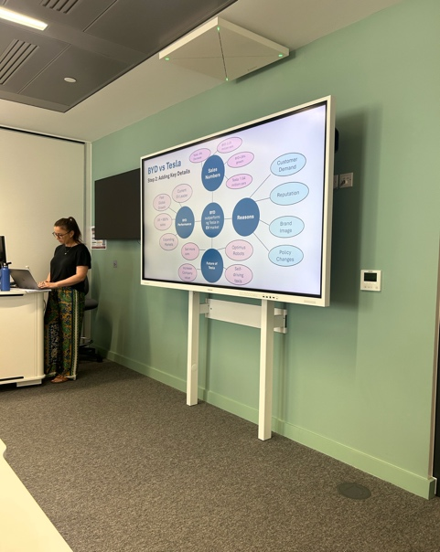
Class AS Mindmap presentation upload one drive

Screenshot/Photo 2
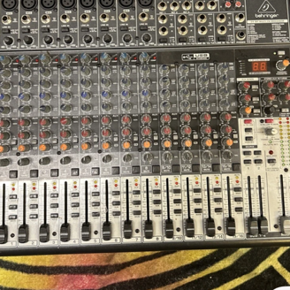
Picture mixer I am selling on the EBay marketplace

Screenshot/Photo 3
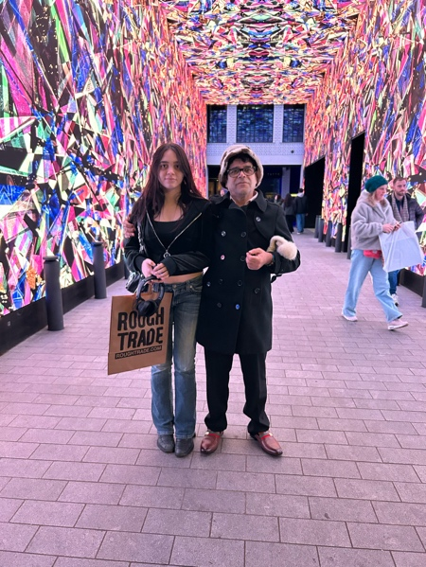
Marisa my daughter and myself posted on facebook.

Screenshot/Photo 4
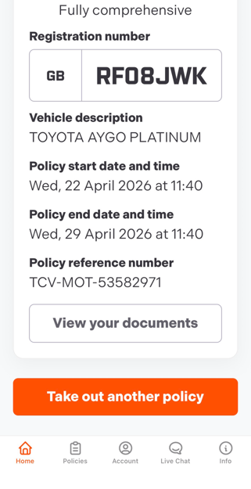
My insurance policy on line

Screenshot/Photo 5
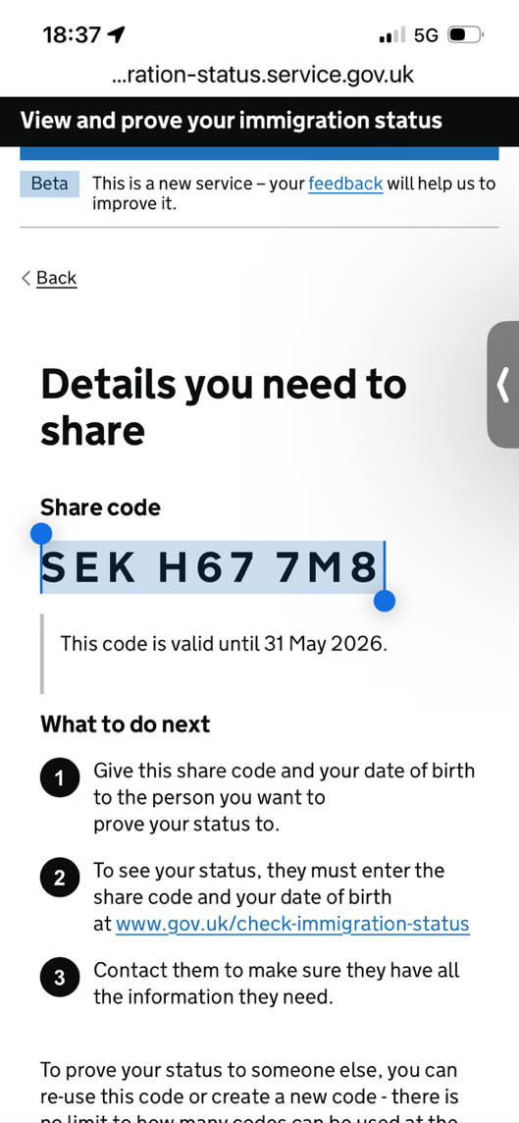
Digital ID share code to prove my status in UK

Screenshot/Photo 6
[Insert Photo/Screenshot below]
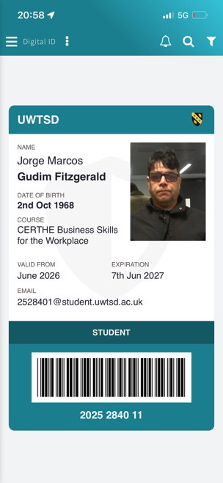
UWTSD Digital ID Card

My Short Reflection
- Write 5–8 simple sentences about your digital life.
- You can use the sentence starters below
I think this course will help me o long run.

Sentence starters
- I use digital tools to automate tasks
- I feel confident when I write with in word because spelling checks correct spelling and grammar.

- I want to improve my digital skills
- I often use these tools adobe acrobat, photoshop and illustrator.
- I sometimes feel nervous about exams, work and bills.
- I hope this module will help me to organise and support to understand business practices.
- Digital skills are important for me because I want to do own business planning more professionally.

