University of Wales Trinity Saint David
School of Engineering



Project Second Assignment

Integrating Project – ACHA4008

Daniel Hannis – Tim James – Drew Malcom – Freddie Watkins
2102864 – 2112656 – 2103851 - 2107574
13/05/2022

Contents
Evaluating the Process of Designing the Soapbox 1
Suitability Of the Design 2
Quality of the Result 3
Aspects That Could Have Been Changed or Improved 5

Evaluating the Process of Designing the Soapbox

The design process was done through multiple meetings and conversations as a group on what we wanted to achieve with our soap box. Through designing the soapbox, the whole team wanted to see costs and production value along with performance. We looked for the soapbox to be usable for what it is made for and whether it will withstand the ground of the track. Looking through the track was part of our design process. We made a CAD model for the final design which appears to be the most efficient from our research and personal experience.
Through designing the car, we also wanted it to be interchangeable, like a Formula 1 car where multiple parts like the wing can be changed easily in case of an incident, we also looked at this but including to make building the soapbox itself far easier for ourselves if we came to build this. When discussing how to design the product we looked at how it would work as a soapbox with aerodynamics, downforce, suspension, steering all coming into play. As a team we looked through multiple designs other teams have made of cars and what processes they took whilst designing them. The braking system was an important aspect throughout our meetings as differences in braking performance vs cost were researched. The materials used were chosen for price for performance as we could not use carbon fibre or expensive alloys so we decided that rolled steel would be the perfect option.

Suitability Of the Design

We decided to choose the second design for our final product due to the balance between performance, quality, and cost. The total cost for this design is reasonable for a group of people who are serious about a soapbox competition, however, it will still be made of high quality and durable materials, as well as deliver much higher performance when racing. This is especially true compared to the lower-cost design we came up with. The other designs showed different prices and suitability for a variety of soapbox racing. We believe our chosen design means it will perform all round for what it is made for. The second design allowed for a bit more of a budget but not excessive which means a team that as stated before wants to be competitive but on a budget. We would use plywood for main body panels and floor panels whilst adding a small splitter and spoiler. This car is Formula 1 inspired as what we wanted to look for. Formula 1 cars can take a bit of a rigid approach but not excessive as a 4x4. This was important for our work as we did not want a slow car overall.

Quality of the Result

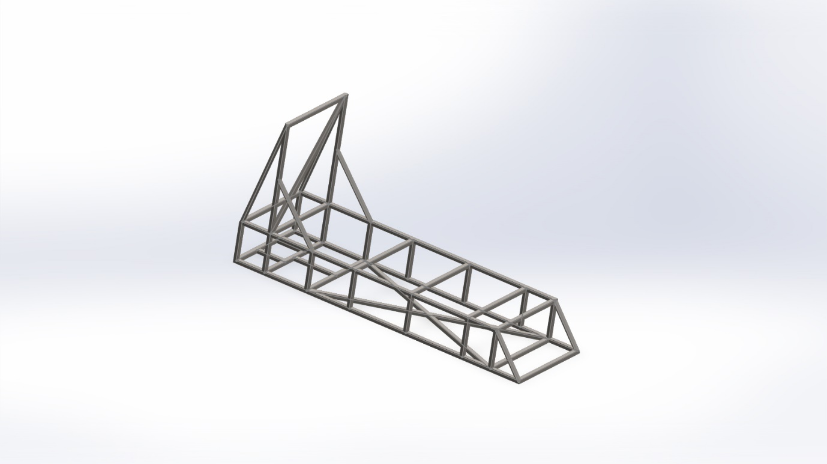
Figure 1 - Chassis CAD
Figure 1 shows design 2 which was designed using Cold Rolled 1020 Steel tubing for the chassis with a yield strength of 350. It includes a roll over hoop to increase safety should the soap box roll over. Side impact structures have also been included for increased safety. Improvements could have been made to the overall design by including triangle support sections in the side impact to make the structure more rigid.

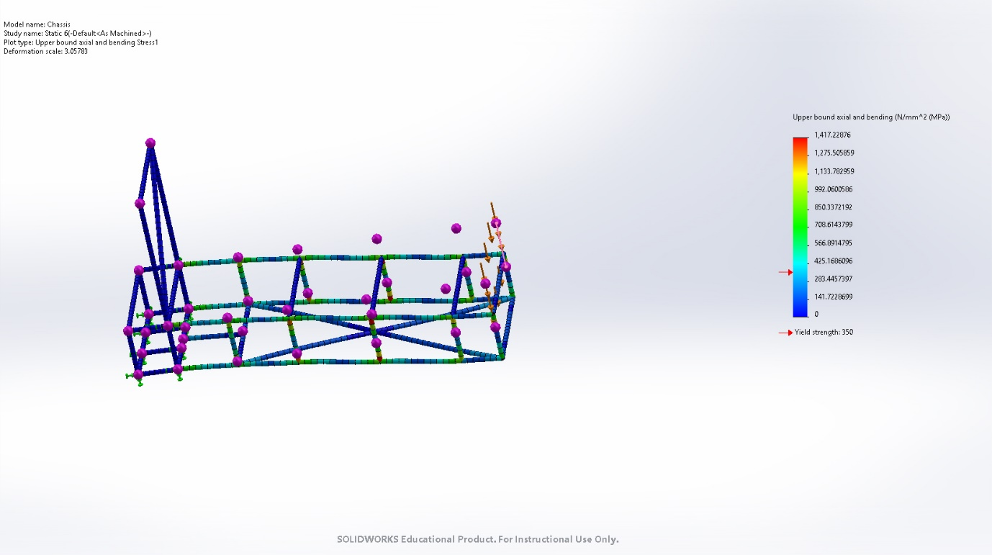
Figure 2 - Frontal load case
Figure 2 shows a frontal load case where a force of 10kN is applied to the front tubing of the chassis to simulate potential stress due to impact. The results show an upper boundary of 1,417N/mm^2 MPa and a deformation of 3.1mm from base.
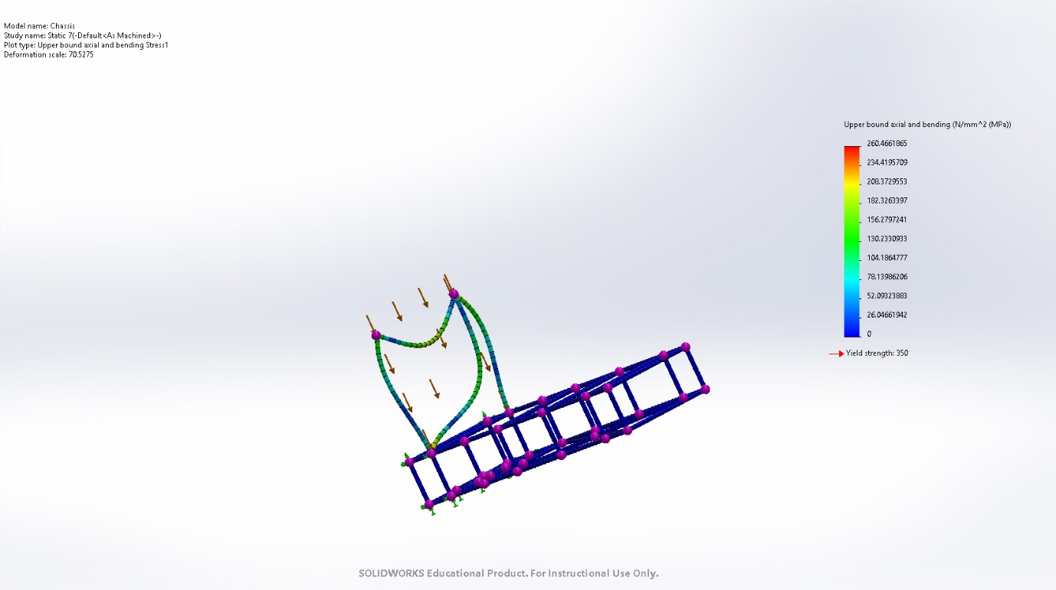
Figure 3- Roll Hoop Load case
Figure 3 is a simulation of a force of 10kN applied to the roll hoop of the chassis to show potential deformation if the soap box were to turn over. The resulting deformation and forces aren’t accurate to the real world potential of forces if the soap box were to turn over, however it gives us an idea of how much force the roll hoop can withstand acting down on it. The overall deformation was 70.5mm from it’s starting point.

Aspects That Could Have Been Changed or Improved

Through the design process, we came across challenges such as what brakes to choose to go for brake discs or callipers or hand braking. Through team discussions, we looked upon the better choices. We could have improved this design with testing and real-time figure compared to personal experiences of both systems. To improve the designs, we looked at multiple avenues including a three-wheeled base compared to four. Things we could change such as tyres being more slim-lined the writing up went decently well regarding corresponding with each other. This design could have been better relayed with more meetings with design through. With more time things we believe would have been changed and improved. For example, the steering column with welding could have been thought up better for the steering wheel. For the soapbox, we looked at the track with a couple of bumps and realised that suspension was important for it but was varying in design. Aerodynamics is a vital part of the soapbox and something that was not overthought. Downforce was not so much of a thought and that could have been improved here if we had more time. We looked for it around Formula 1 cars and how they use high and low pressure. For the overall design of the car, we believe alloys could have been looked at more in-depth for materials use and what would be more beneficial also depending on the driver, this would be more of top-end serious soapbox racing. Overall, we believe more time with this project would have seen further development through research and possibly testing a few areas in real terms.

