University of Wales Trinity Saint David
Wales Institute of Science and Art


Environmental Pollution Control Plan
Environmental Pollution Control | ACMA6006

Morgan Davies
2205285
November/December 2024

Contents
1 Introduction 2
2 Pollution Assessment 2
3 Regulatory Frameworks 7
4 Pollution Control Strategies 7
4.1 Sulphuric Acid 7
4.2 Ammonia and Nitrogen Oxides 8
4.3 Polyethylene 9
4.4 Costs Associated with a Biofilter 10
5 Conclusion 10
6 Reference List 12

Table of Figures
Figure 1- Image of Marine algal blooms (Natural Resources Wales, 2024) 4
Figure 2- PE Microplastics in the food chain (Ziani, 2023) 7
Figure 3- Image showing diffusion dialysis in hybrid membrane technology (Loza et al., 2022) 8

Introduction
The purpose of this report is to assess the pollution conditions of the ChemCo manufacturing plant by analysing its pollutants, the consequences of releasing these pollutants, identifying major regulations the manufacturing plant must adhere to and by designing suitable pollution control strategies. The predominant type of pollution assessed is air and water pollution caused by the Sulphuric acid, Ammonia and Polyethylene released from the manufacturing plant, in the local river basins and further widespread to the atmosphere and oceans. This is necessary to mitigate these pollutants using various control strategies such as, membrane technologies, neutralisation and pretreatment of water, low NOx burners, automated pollutant monitoring, biofiltration systems and reduction in polymer packaging. By integrating these strategies with regulatory frameworks, the report highlights both the costs of implementation and the legal and financial risks of non-compliance, to provide a comprehensive approach for mitigating pollution and ensuring sustainable operation of the plant.

Pollution Assessment
The source of water pollution can be identified using point sources. A point source is the single point of discharge where waste is released, which is generally connected from networks of pipes and channels. From The Chemco Manufacturing plant, is the point source of pollution as it releases Sulphuric acid (H₂SO₄), Ammonia (NH₃), Polyethylene (PE). These contaminants are chemical inorganic matter, meaning that they are non-biological components which may be present in sewage effluent or released into the atmosphere. Sulphuric acid is the main cause for acid rain. When Sulphur dioxide (SO2) is released into the atmosphere, while Nitrogen oxides (NOx) are present, they undergo photooxidation with oxygen and sunlight, react with water and other atmospheric components. These acidic materials are dispersed across great distances by wind and air currents. Eventually, they precipitate as moist deposits like fog, snow, mist, and rain (including sulfuric and nitric acids) (Mukherjee, 2020).
Acid rain has a pH of approximately 4.2 to 4.4, this has effects on the environment such as causing a disruption in soil quality, which can influence the agricultural sectors due to the impact on crop production. In addition, due to acid rain disrupting soil composition, this allows for essential nutrients and minerals to be washed away stunting plant growth which can lead to a lower biodiversity of species. Further, acid rain will impact water bodies such as lakes, ponds and rivers which can negatively impact aquatic life, including freshwater mussels, snails, and shrimp (Mukherjee, 2020). This can lead to a negative impact on the health of the environment by causing imbalances in food chains, the carbon cycle, an increase in algae blooms, and a decrease in resources for organisms and human populations. Furthermore, a pH of less than 5 is fatal to many fish species as the water bodies become devoid of life when the pH drops to 4 (Mukherjee, 2020).
Another pollutant released from the ChemCo Manufacturing plant is Ammonia. Ammonia causes a reduction in water quality when discharged through industrial waste as it is highly soluble when it encounters water and can lead to a froth-like substance within water bodies (as shown in figure 1). This pollutant can reduce the quality of water people use in day-to-day consumption (Times of India, 2021). The areas ammonia pollution can impact are local water bodies, such as the nearby lake, when it has formed a solution by dissolving into the water. This can cause a decrease in biodiversity as it may lead to the death of aquatic life due to a change in the nitrogen cycle.

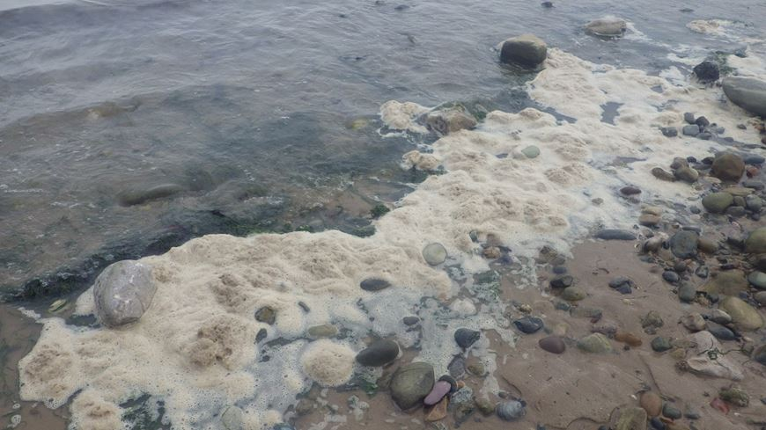
Figure 1- Image of Marine algal blooms (Natural Resources Wales, 2024)

Consequently, this happens as nitrifying bacteria present in the water will convert the ammonia with it into nitrites. Levels of ammonia within the water body will begin to decrease while the levels of nitrite increase. If there are not sufficient bacteria, for example, Nitrobacter which convert nitrites to nitrates to be taken up by plants or an insufficient number of plant life present to take up these nitrates, aquatic life such as fish may be at risk of harm or may die as a result (Florida Department of Agriculture and Consumer Services, 2024). This is because nitrite is a toxic substance to fish as it binds to the haemoglobin in their red blood cells to form methaemoglobin. Unlike haemoglobin, methaemoglobin cannot carry oxygen molecules through the organism’s body, which will lead to the fish suffocating even if a substantial amount of dissolved oxygen is present in the water (Florida Department of Agriculture and Consumer Services, 2024).
In addition, ammonia also has a role in air pollution, as when it is emitted it contributes to the development of nitrogen oxides (NOx), an additional greenhouse gas which causes global warming by trapping the infrared radiation (heat) being released by the planet (Erisman, 2021). Both pollutants affect a large area of the environment, not just locally. This is due to dispersion occurring by the wind which contributes to the transportation and transformation of polluting particles in the atmosphere. This process reduces the concentration of pollutants in a particular area by diluting them and dilution can be increased by an increase in wind turbulence, which will mix unpolluted air into the plume released by the manufacturing plant, hence reducing concentration. However, while dispersion does reduce concentration of pollutants, it does not remove them from the environment.
The additional effects of ammonia pollution is the influence nitrogen accumulation (due to its contribution to NOx production) has on the variation and composition of plant species within impacted ecosystems is one of the main ways that ammonia pollution affects biodiversity (RAND Europe, 2018). Furthermore, ammonia pollution affects the species composition by acidifying the soil, causing direct toxic damage to leaves and changing how vulnerable plants are to diseases, drought, and frost. Additionally, the type of habitats which can be affected by this type of pollution and biodiversity changes to plant species are bog and peatland areas which contain numerous amounts of lichen and mosses (RAND Europe, 2018).
The formation of nitrogen oxides also negatively impacts human health, particularly in the respiratory system. The short-term effects are respiratory irritation, breathing difficulties, toxic edema and emphysema. However, the long-term effects include pulmonary fibrosis, emphysema and an increase in lower respiratory tract illness in children. Estimating the economic impact of ammonia emissions on biodiversity is complex and debated. Current estimates suggest biodiversity loss in the UK could cost £0.20–£4.00 per kg of ammonia. Including health effects, the conservative estimated total cost is £2.50 per kg, with a broader range of £2–£56 per kg. Using emission projections, the annual cost of unaddressed ammonia emissions in 2020 could exceed £700m, though estimates range from £580m to £16.5bn due to significant uncertainties (RAND Europe, 2018).
The final pollutant released by the ChemCo factory is polyethylene. This pollutant has gained increasing environmental concern due to its low biodegradability, meaning it will accumulate into the environment when discharged from a point source (Yoezer, Gurung and Wangchuk, 2023). Biodegradation is the process which a substance is broken down by living organisms from large molecules into smaller, simpler molecules using a catalyst (enzymes) to alter the substance’s chemical structure, decaying it naturally. It is unable to biodegrade due to its polymer properties, these include its additives, crystallinity, functional groups, hydrophobicity, molecular weight, shape, and size (Yoezer, Gurung and Wangchuk, 2023).
However, although polymers cannot be broken down by biodegradation, they can be emulsified and broken up from large molecules into smaller subunits by bacteria. Microorganisms achieve this by secreting extracellular enzymes, such as oxidoreductases, to cleave polymer carbon chains or bonds, resulting in low molecular weight compounds like monomers, dimers and oligomers. Therefore, when enzymatic activities occur within microorganisms, it causes bio-fragmentation of the polymer which reduces the molecular weight, contributing to the formation of microplastics. (Yoezer, Gurung and Wangchuk, 2023).
Therefore, when industrial plants, such as, the ChemCo factory practice inefficient waste management, polyethylene can be deposited into water bodies, affecting freshwater systems and marine ecosystems, including downstream rivers, lakes and the ocean (IUCN, 2024). Polyethylene can affect the ingestion and starvation of marine species, including fish, seabirds, and turtles. This is because they often mistake polyethylene fragments for food. Once ingested, the plastics can block digestive tracts, leading to starvation or malnutrition. For example, sea turtles are known to ingest plastic bags that resemble jellyfish, a common prey (Sigler, 2014). An additional impact is the chemical pollution polyethylene produces. It can leach toxic additives like bisphenol A (BPA) and phthalates, which accumulate in aquatic organisms and disrupt endocrine systems, affecting growth, reproduction, and survival rate (Sigler, 2014). Plastic waste not only causes direct harm to wildlife but also leads to the deterioration of habitats. As it accumulates, plastic disrupts the ecological balance and decreases the normal functioning of these eco systems. For example, coral reefs, which are vital marine ecosystems, are severely impacted by plastic debris. When plastics, such as polyethylene, cover corals, they block sunlight, delaying coral growth and compromising the stability of the entire ecosystem (Aden Miles Morunga, 2024).
The emission of polyethylene is severely damaging to the food chain (as shown in figure 2). This is due to microplastics (MPs) and nanoplastics (NPs) also being harmful to humans. They can enter the human body via ingestion, inhalation, and skin contact with contaminated air, water, food, or products. High levels of polyethylene MPs (PE-MPs) with rough surfaces can harm epithelial cells, causing cytotoxicity, inflammation, and production of reactive oxygen species and nitric oxide (Yoezer, Gurung and Wangchuk, 2023; Choi et al., 2021). Their hydrophilic properties, size, and surface energy enable inhaled MPs to penetrate the bloodstream. PE MPs in abdominal lymph nodes typically measure 1–50 µm (Yoezer, Gurung and Wangchuk, 2023; Zarus et al., 2021). MPs and NPs disrupt cellular and molecular functions, increase cancer risks, especially among industrial workers exposed to polluted air, and induce oxidative stress in dopaminergic neurons by altering gene expression and elevating malondialdehyde levels (Yoezer, Gurung and Wangchuk, 2023; Windheim et al., 2022). They can also damage DNA, triggering mutagenesis and harming the pulmonary and digestive systems (Yoezer, Gurung and Wangchuk, 2023).

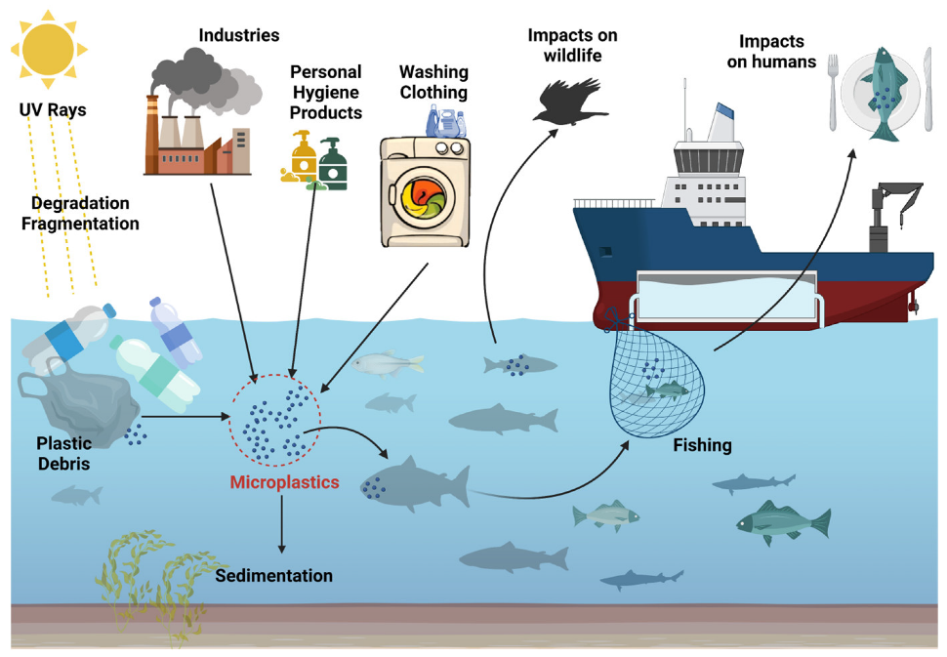
Figure 2- PE Microplastics in the food chain (Ziani, 2023)

Regulatory Frameworks
The first set of regulations that must be carried out for a manufacturing plant is incorporated by the Industrial Emissions Directive (IED) 2010 (THE EUROPEAN PARLIAMENT AND OF THE COUNCIL, 2010). IED advocates Best Available Techniques (BAT) for sulphuric acid plants, including efficient scrubbers and absorption towers to reduce SO₂ emissions. The BAT-Associated Emission Level (BAT-AEL) is 50-150mg/Nm³ for producing sulphuric acid. Furthermore, plants which produce ammonia are required to use a BAT measure to limit emissions and recommends a BAT-AEL of 5-30mg/Nm³ for gaseous ammonia released into the atmosphere. Additionally, polyethylene must be reduced to decrease particulate matter emitted to a BAT-AEL of 30-50mg/Nm³ (THE EUROPEAN PARLIAMENT AND OF THE COUNCIL, 2010).
Another set of regulations to be followed by the ChemCo manufacturing plant are laid out by the water environment (water framework directive) (England and Wales) 2017 (Legislation.gov.uk, 2017). This framework highlights that the discharge to water of sulphuric acid must be within a PH range of 6-9 to prevent water acidification. Additionally, ammonia emissions into water bodies must be limited to avoid aquatic life toxicity and that the permitted levels of ammonia release are 0.3mg/L for freshwater. However, for polyethylene there is no distinct amount that is not permitted but the levels emitted must be monitored and businesses should minimise emissions through an appropriate waste treatment process (Legislation.gov.uk, 2017).

Pollution Control Strategies

Sulphuric Acid
To mitigate sulphuric acid pollution, using a hybrid membrane technology, along with diffusion dialysis and electrodialysis, could be implemented to recover and recycle the sulphuric acid produced by the manufacturing plant (Loza et al., 2022). Sulfuric acid is separated from a solution via diffusion dialysis using anion-exchange membranes, as illustrated in figure 3. The mixed solution of acid and salts flows on one side of the membrane, while water flows on the other. This creates a concentration gradient, driving dissolved electrolytes to diffuse through the membrane into the water. The membranes positively charged fixed groups repel cations due to electrostatic forces, limiting their passage. Cations with lower charge and higher mobility, such as hydrogen ions, diffuse first, determining the transfer rate. Consequently, the dialysis module efficiently separates sulfuric acid, which diffuses through the membrane, from copper and ferrous sulphates, which remain in the original solution. This process effectively isolates sulfuric acid while leaving salts behind (Loza et al., 2022). The sulphuric acid separated can then be recycled for use or can potentially be sold to other industries for other purposes, instead of being emitted by the plant.
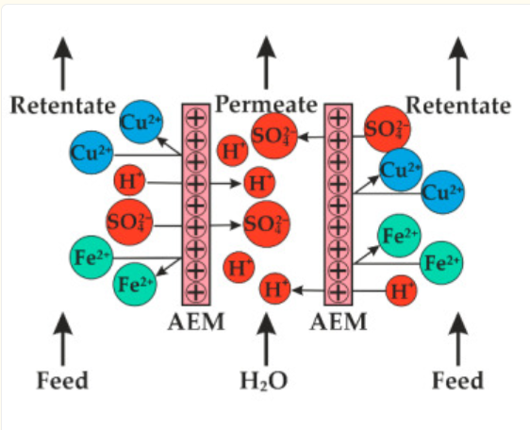
Figure 3- Image showing diffusion dialysis in hybrid membrane technology (Loza et al., 2022)

The ChemCo manufacturing plant already neutralise the acidic waste. One method to neutralise Sulphuric acid, is to add it to calcium hydroxide which will form calcium sulphate and gypsum. However, this causes a change in the solubility of the effluent and metal impurities present will react to form metal hydroxides once neutralised (DKL Engineering Inc., 2018). For initial pretreatment of the wastewater, a process of oxidation can be carried out. The addition of a chemical oxidant will enhance the removal of heavy metal present in the solution, especially those which are in their highest oxidation state. An effective additive is hydrogen peroxide (DKL Engineering Inc., 2018). To further pretreat the water, the manufacturing plant could use processes such as aeration, biodegradation using microbes and the administration of active carbon can be used to remove any present organic matter (Zhu and Tamburic, 2018). This ensures the water is suitable for the next stage of primary treatment within the local municipal water treatment plant.

Ammonia and Nitrogen Oxides
One control method for combatting the pollution of NOx produced from ammonia is by using low NOx burners. By burning fuel under lower thermal conditions, low-NOx burners keep fuel mixes from reaching the critical temperatures where NOx can originate. Additionally, these low NOx burners can be retrofitted into existing power plants to lower emission levels (Integrated Flow Solutions, 2020). An additional method is by flue gas treatment. An SCR system already used by the manufacturing plant can be used by introducing urea or NH3 into a flue gas zone that is channelled over a catalytic bed. When the catalyst is present, the NOx gases will easily react with oxygen to produce N2 and H2. (Integrated Flow Solutions, 2020). However, in the manufacturing plant the system is outdated as measurement are taken manually, so an automated process can be implemented to improve the design. This process could be an NOx sensor at the outlet or an analyser to measure the amount of pollution occurring in real time and to ensure the system’s function is correct by monitoring its state (AECC, n.d.). Additionally, the use of an NOx sensor allows a closed loop control mechanism of the monitoring system, which makes sure a feedback loop is present to regulate the control system to determine any errors between the actual and desired output (AECC, n.d.).
To mitigate the emissions of ammonia, a biofilter can be implemented into the manufacturing plant. This utilises a biofiltration system by collecting contaminants on the surface of a media that contains a variety of microorganisms. The microorganisms that are used to eliminate ammonia gases are autotrophs, which are photosynthesising bacteria which use sunlight energy and carbon dioxide in the air to produce their own food source to carry out respiration for cell growth. A biofilter works by utilising three parts: a porous medium such as a soil bed to support the microorganisms, a biofilm to provide a pathway for the ammonia to diffuse onto the microorganisms and a microorganism such as ammonia oxidising autotrophic bacteria that can use the contaminant for metabolic use. The dissolved organic chemicals are metabolised by microorganisms after being absorbed into the thin water layers surrounding the porous medium, which in turn reduces the ammonia emissions produced by the manufacturing plant when a biofilter is utilised. However, the rate of degradation of the organic compound is determined by the temperature and pH levels present in the system.

Polyethylene
Polyethylene is a polymer like every other form of plastic. Therefore, the control strategies for this can be carried out similarly to other forms of plastic pollution. One preventative method is a reduction in packing used for manufactured products. Instead of using traditional plastic containers, using metal containers or gallon drums is a suitable alternative for product packaging. Additionally, using containers that are the same size and shape as your products can minimise movement during transit. This eliminates the need for filler, simplifying the packaging process (Manufacturing.net, 2023). Another preventative method is by taking advantage of waste management equipment. These are essential for successfully managing plastic waste and preventing it from damaging the environment (Manufacturing.net, 2023). Plastic waste can be efficiently processed using technologically advanced equipment such as shredders, balers, garbage compactors, and rubbish bins. This facilitates proper waste processing and waste disposal by encouraging the recycling and reuse of plastic materials, such as polyethylene (Manufacturing.net, 2023).

Costs Associated with a Biofilter
The costs for the ChemCo plant to utilise a biofilter are both initial capital costs and operational costs. These costs can be varied depending on the type of biofilter used and the type of industry they are implemented onto (The Beef Site, 2024). The initial investment for a new biofilter on a mechanically ventilated building is approximately between £115 and £200 per 1,000cfm. Whereas vertical biofilters can be approximately 1.5 times more expensive than horizontal ones. Additionally, the operational cost for a biofilter, including media replacement every 5 years, is approximately between £4 to £8 per 1,000cfm (The Beef Site, 2024).
However, non-compliance with environmental standards, such as failing to install a biofilter to limit ammonia emissions at a manufacturing facility, can have serious financial and legal consequences. Businesses can face an unlimited fine by the environmental agency if they pollute the environment enough to exceed regulations (Department for Environment, Food and Rural Affairs, 2023). The Environment Agency will be authorised to impose unlimited Variable Monetary Penalties (VMPs) on polluting industries commencing December 11, 2023. This modification removed the prior £250,000 cap, allowing for larger fines based on the severity of the violation. (Department for Environment, Food and Rural Affairs, 2023). Furthermore, according to the Sentencing Council's guidelines, large organisations that commit intentional environmental breaches may face fines of up to £3 million. Whereas a small organisation committing a deliberate environmental breach with negligible environmental harm may receive fines starting from only £3,000. (Howard and Vallance, 2022). However, the actual value is determined by variables such as the company's income, the severity of the offence, and the harm inflicted (Howard and Vallance, 2022).

Conclusion
This report has highlighted the significant environmental and health impacts of pollutants released by the ChemCo manufacturing plant, including sulphuric acid, ammonia, and polyethylene. These pollutants contribute to soil and water acidification, biodiversity loss, aquatic ecosystem disruption, and human health risks. By integrating pollution control strategies, such as hybrid membrane technologies, biofilters, low-NOx burners, and improved waste management, the ChemCo manufacturing plant can reduce its environmental footprint while aligning with regulatory frameworks. Utilising these strategies not only reduces pollution but also minimises the legal and financial risks of non-compliance. Ultimately, implementing sustainable practices ensures environmental protection and long-term operational viability for the plant.

Reference List
- Mukherjee, S. (2020). Acid Rain: Definition, Causes, Effects, and Solutions. [online] Science Facts. Available at: https://www.sciencefacts.net/acid-rain.html [Accessed 21 Nov. 2024].
- Times of India (2021). Why ammonia is the leading cause of water pollution. The Times of India. [online] 10 Nov. Available at: https://timesofindia.indiatimes.com/life-style/health-fitness/health-news/toxic-ammonia-polluting-water-and-air-how-does-it-damage-your-health/photostory/87625828.cms?picid=87625950 [Accessed 21 Nov. 2024].
- Natural Resources Wales (2024). Natural Resources Wales / Marine algal blooms. [online] Cyfoethnaturiol.cymru. Available at: https://publish.cyfoethnaturiol.cymru/guidance-and-advice/environmental-topics/water-management-and-quality/water-quality/marine-algal-blooms/?lang=en [Accessed 26 Nov. 2024].
- Erisman, J.W. (2021). How ammonia feeds and pollutes the world. Science, 374(6568), pp.685–686. doi:https://doi.org/10.1126/science.abm3492. [Accessed 26 Nov. 2024].
- RAND Europe (2018). Agricultural ammonia emissions carry steep costs. [online] www.rand.org. Available at: https://www.rand.org/randeurope/research/projects/2018/impact-of-ammonia-emissions-on-biodiversity.html [Accessed 28 Nov. 2024].
- Yoezer, N., Gurung, D.B. and Wangchuk, K. (2023). Environmental Toxicity, Human Hazards and Bacterial Degradation of Polyethylene. Nature Environment and Pollution Technology, [online] 22(3), pp.1155–1167. doi:https://doi.org/10.46488/nept.2023.v22i03.006. [Accessed 30 Nov. 2024].
- IUCN (2024). Plastic Pollution. [online] iucn.org. Available at: https://iucn.org/resources/issues-brief/plastic-pollution [Accessed 2 Dec. 2024].
- Choi, D., Hwang, J., Bang, J., Han, S., Kim, T., Oh, Y., Hwang, Y., Choi, J. and Hong, J. 2021. In vitro toxicity from a physical perspective of polyethylene microplastics based on statistical curvature change analysis. Sci. Total Environ., 752: 142242. https://doi.org/10.1016/j. scitotenv.2020.142242. [Accessed 2 Dec. 2024].
- Zarus, G.M., Muianga, C., Hunter, C.M. and Pappas, R.S. 2021. A review of data for quantifying human exposures to micro and nanoplastics and potential health risks. Sci. Total Environ., 756: 144010. https:// doi.org/10.1016/j.scitotenv.2020.144010. [Accessed 2 Dec. 2024].
- Windheim, J., Colombo, L., Battajni, N.C., Russo, L., Cagnotto, A., Diomede, L., Bigini, P., Vismara, E., Fiumara, F., Gabbrielli, S., Gautieri, A., Mazzuoli-Weber, G., Salmona, M. and Colnaghi, L. 2022. Micro- and nanoplastics’ effects on protein folding and amyloidosis. Int. J. Mol. Sci., 23(18): 10329. https://doi.org/10.3390/ ijms231810329. [Accessed 2 Dec. 2024].
- Sigler, M. (2014). The Effects of Plastic Pollution on Aquatic Wildlife: Current Situations and Future Solutions. Water, Air, & Soil Pollution, 225(11). doi:https://doi.org/10.1007/s11270-014-2184-6. [Accessed 8 Dec. 2024]
- Integrated Flow Solutions (2020). Effective NOX Pollution Control and Removal Techniques | IFS. [online] Integrated Flow Solutions. Available at: https://ifsolutions.com/effective-nox-pollution-control-and-removal-techniques/ [Accessed 16 Dec. 2024].
- AECC (n.d.). SELECTIVE CATALYTIC REDUCTION FOR HEAVY-DUTY AND LIGHT-DUTY VEHICLES. [online] Available at: https://www.aecc.eu/wp-content/uploads/2020/08/AECC-summary-on-SCR-Nov-07.pdf [Accessed 16 Dec. 2024].
- DKL Engineering Inc. (2018). Effluent Treatment. [online] Sulphuric-acid.com. Available at: http://www.sulphuric-acid.com/TechManual/Effluent/effluent.htm [Accessed 17 Dec. 2024].
- Zhu, J. and Tamburic, B. (2018). Management of biogenic taste and odour: From source water, through treatment processes and distribution systems, to consumers. [online] Sciencedirect.com. Available at: https://www.sciencedirect.com/topics/engineering/pretreatment#:~:text=Pretreatment%20refers%20to%20the%20first%20set%20of%20operational,biodegradation%2C%20and%20dosing%20with%20powdered%20activated%20carbon%20%28PAC%29. [Accessed 17 Dec. 2024].
- Loza, S., Loza, N., Korzhov, A., Romanyuk, N., Kovalchuk, N. and Melnikov, S. (2022). Hybrid Membrane Technology for Acid Recovery from Wastewater in Coated Steel Wire Production: A Pilot Scale Study. Membranes, [online] 12(12), p.1196. doi:https://doi.org/10.3390/membranes12121196. [Accessed 17 Dec. 2024].
- Manufacturing.net (2023). 6 Proven Plastic Waste Reduction Strategies. [online] Manufacturing.net. Available at: https://www.manufacturing.net/operations/blog/22863237/6-proven-plastic-waste-reduction-strategies [Accessed 18 Dec. 2024].
- THE EUROPEAN PARLIAMENT AND OF THE COUNCIL (2010). EUR-Lex - 32010L0075 - EN - EUR-Lex. [online] Europa.eu. Available at: https://eur-lex.europa.eu/legal-content/EN/TXT/?uri=CELEX:32010L0075 [Accessed 18 Dec. 2024].
- Legislation.gov.uk (2017). The Water Environment (Water Framework Directive) (England and Wales) Regulations 2017. [online] Legislation.gov.uk. Available at: https://www.legislation.gov.uk/uksi/2017/407/contents [Accessed 19 Dec. 2024].
- The Beef Site (2024). Biofilters for Odour and Air Pollution Mitigation. [online] Thebeefsite.com. Available at: https://www.thebeefsite.com/articles/3305/biofilters-for-odour-and-air-pollution-mitigation-2? [Accessed 19 Dec. 2024].
- Department for Environment, Food and Rural Affairs (2023). Unlimited penalties introduced for those who pollute environment. [online] GOV.UK. Available at: https://www.gov.uk/government/news/unlimited-penalties-introduced-for-those-who-pollute-environment? [Accessed 19 Dec. 2024].
- Howard, H. and Vallance, M. (2022). Environmental sentencing: Trends for very large organisations in environment prosecutions. [online] Shoosmiths.com. Available at: https://www.shoosmiths.com/insights/articles/environmental-sentencing-trends-large-organisations-environment-prosecutions? [Accessed 19 Dec. 2024].
- Ziani, K. (2023). Microplastics: A Real Global Threat for Environment and Food Safety: A State of the Art Review. Nutrients, [online] 15(3), p.617. doi:https://doi.org/10.3390/nu15030617. [Accessed 19 Dec. 2024].

