Component 1 Portfolio

NAME: REHANA BEGUM PARVIN

STUDENT ID: 2435923

MODULE NAME: LCSH4003

LECTURERS NAME: AZIDA ZAINUL

Task 1: Poster (900 words equivalent)
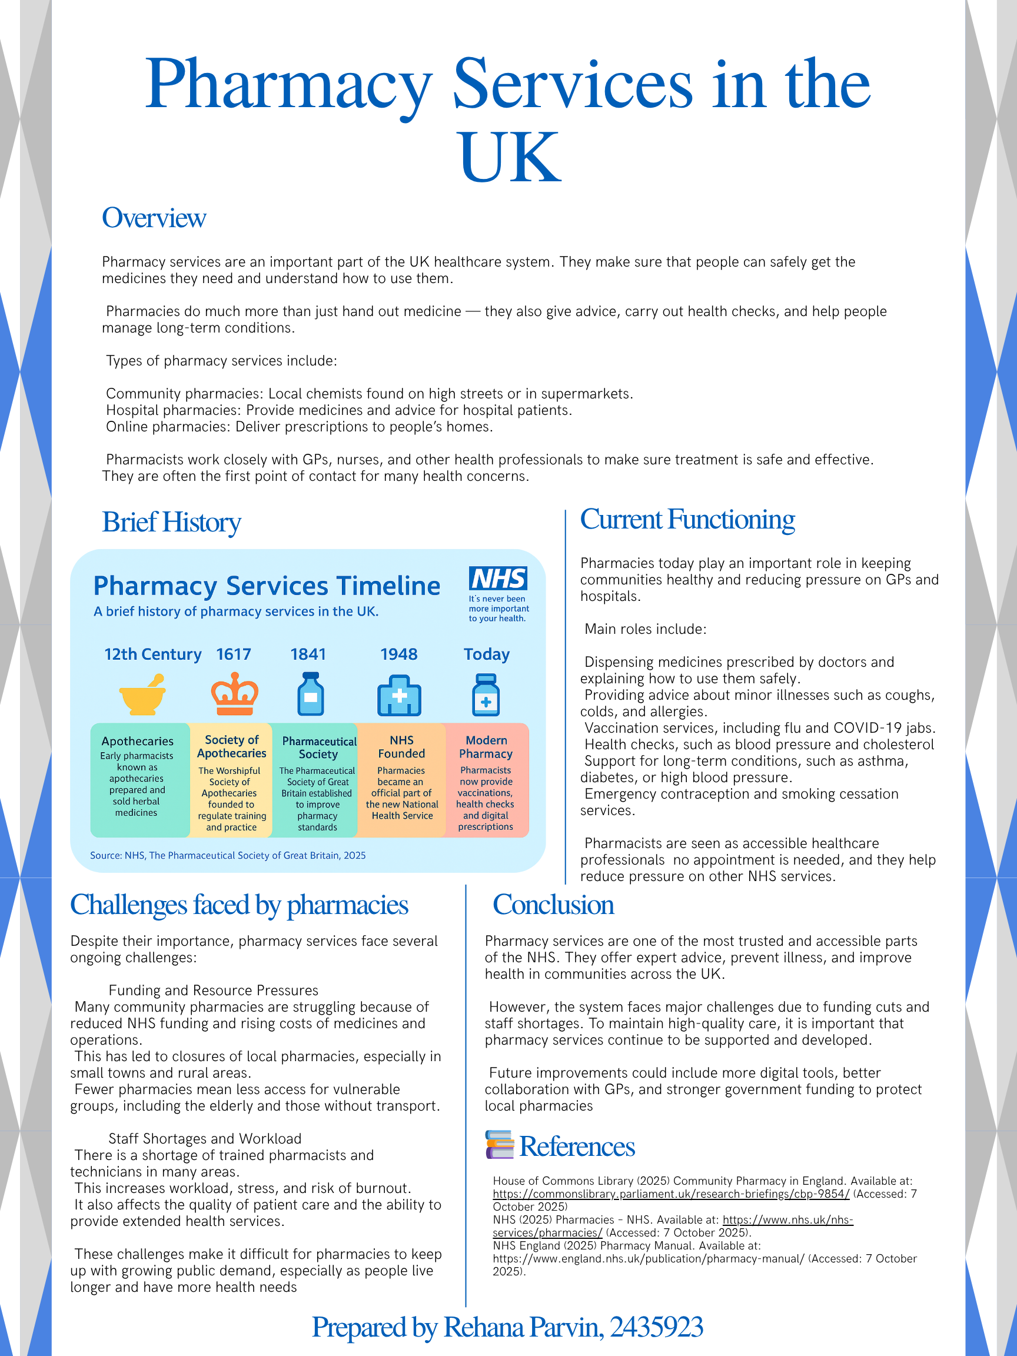

Assignment Title: Task 2 - NHS Essay

The National Health Service (NHS): Origins, Structure, and Key Principles
The National Health Service (NHS) was established in 1948 and is one of the most significant developments in the history of public health in the United Kingdom. Its creation came after World War II, during a time when the government wanted to rebuild the country and provide better welfare for its citizens. The Beveridge Report of 1942 played an important role in shaping the NHS. It identified five “giant evils” that needed to be overcome: disease, ignorance, squalor, idleness, and want. The report’s recommendations led to the introduction of the NHS, which aimed to make healthcare available to everyone, regardless of their financial situation.
The main principles of the NHS were that healthcare should be universal, free at the point of delivery, and based on clinical need rather than the ability to pay. Aneurin Bevan, the Minister of Health at the time, was the key figure behind its creation. He believed that medical treatment should not depend on wealth, and that everyone should have access to good healthcare. The NHS was funded through general taxation, allowing all UK residents to use its services without direct payment. This marked a major change from the pre-war system, where most people relied on private care or charity hospitals.
Over time, the NHS has grown and developed, but it still follows its founding principles. Today, it is made up of four separate systems: NHS England, NHS Scotland, NHS Wales, and Health and Social Care in Northern Ireland. Each system operates independently but works towards the same goal of providing accessible healthcare. NHS England is the largest and is responsible for most healthcare services in the country. It is divided into local Integrated Care Systems (ICS), which aim to coordinate services across hospitals, GPs, and community care.
However, the NHS faces many challenges in the modern era. One of the biggest issues is funding. Demand for healthcare continues to rise due to an ageing population and advances in medical technology. This puts pressure on NHS budgets and staff. According to The King’s Fund (2023), long waiting times, staff shortages, and underfunding are ongoing problems that affect patient care. Another issue is workforce burnout, especially after the COVID-19 pandemic, which increased pressure on hospitals and staff.
Despite these problems, the NHS remains highly valued by the public. It continues to provide essential services such as emergency care, maternity services, vaccinations, and mental health support. In recent years, there have been efforts to modernise the system, including the introduction of digital health services and online GP consultations. These changes aim to improve efficiency and accessibility, though some critics argue that technology cannot replace face-to-face care.
In conclusion, the NHS was founded on principles of fairness and equality, ensuring that everyone can access healthcare regardless of income. While it has faced many challenges over the decades, it remains a vital part of British society. The NHS continues to adapt and evolve, but its core mission – to provide free, high-quality care to all – remains unchanged.

References
Bevan, A. (1952) In Place of Fear. London: Heinemann.
House of Commons Library (2025) Community Pharmacy in England. Available at: https://commonslibrary.parliament.uk/research-briefings/cbp-9854/ (Accessed: 7 October 2025).
National Archives (1942) The Beveridge Report. Available at: https://www.nationalarchives.gov.uk/cabinetpapers/themes/beveridge-report.htm (Accessed: 18 October 2025).
NHS (2025) Pharmacies – NHS. Available at: https://www.nhs.uk/nhs-services/pharmacies/ (Accessed: 7 October 2025).
NHS England (2024) What we do. Available at: https://www.england.nhs.uk/about/what-we-do/ (Accessed: 18 October 2025).
NHS England (2025) Pharmacy Manual. Available at: https://www.england.nhs.uk/publication/pharmacy-manual/ (Accessed: 7 October 2025).
The King’s Fund (2023) How is the NHS structured? Available at: https://www.kingsfund.org.uk/publications/how-nhs-structured (Accessed: 18 October 2025).

