Module Handbook Autumn Term 2023

BMIH6004

Hotel Placement – Managing Hotel Administration

LUCIAN MATACHE
Table of Contents
Introduction 4
Kolb’s Experiential Learning Cycle 5
Concrete Experience 7
Observation 7
Critical Reflection 7
Planning 8
The issues and problems related to Guest Service at The Harlow Hotel by Accor 9
Conclusion 10
Reference List 11

List of Figures
Figure 1: The Harlow Hotel 4
Figure 2: Kolb's Reflective Learning Cycle 5

Introduction
The following report is a reflective report on the placement at The Harlow Hotel by Accor. The report will address the reflection by implementing Kolb’s experiential learning cycle. This learning cycle comprises steps or phases that are Concrete Experience, Reflective observation, critical reflection, and lastly Active Experimentation (Kingkaew et al., 2023). The reflection will address the placement thoughts as well as the overall experience of one of the administrative fields of work which is Reception, while focusing on the vocational, academic, and self-development in the process.
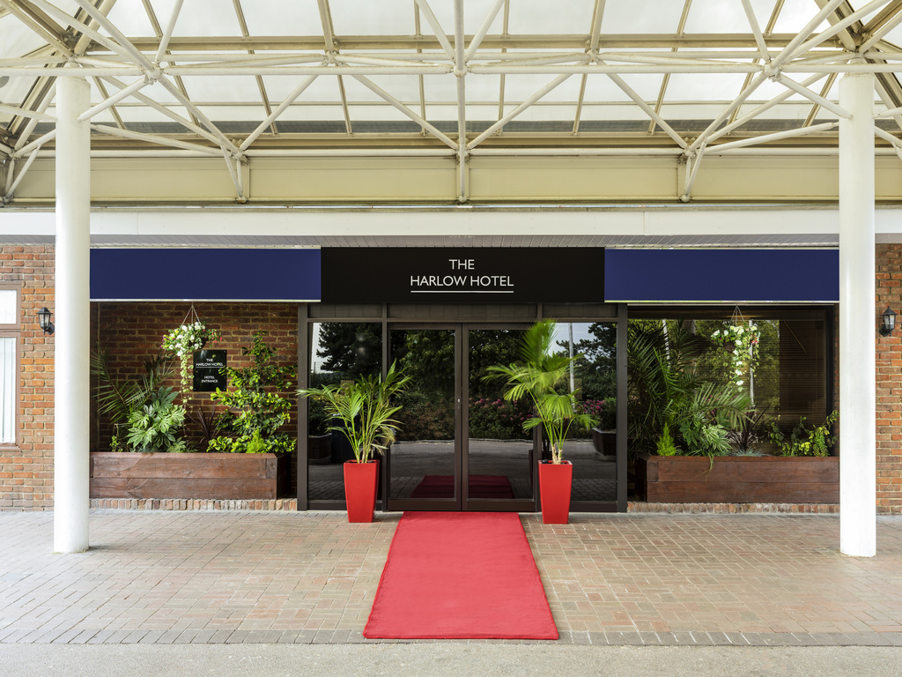
Figure 1: The Harlow Hotel
(Source: all.accor.com, 2023)

Kolb’s Experiential Learning Cycle
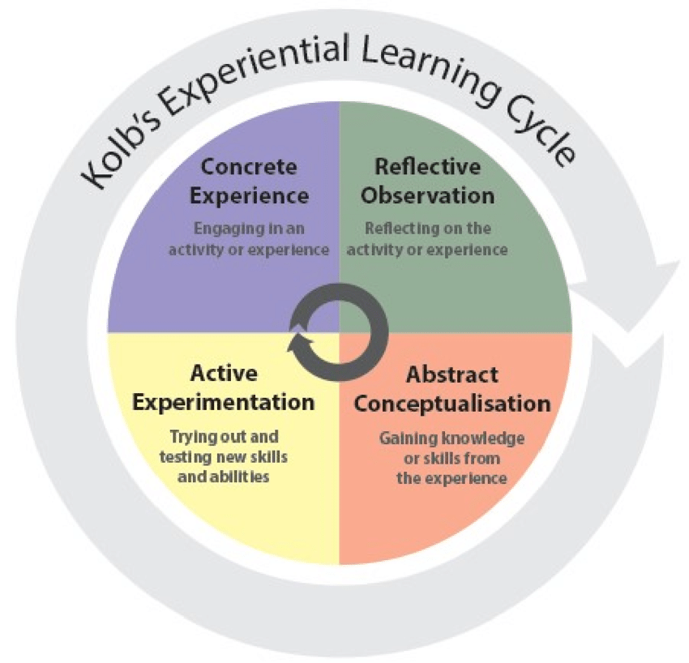
Figure 2: Kolb's Reflective Learning Cycle
(Source: researchgate.net, 2019)
Developed by David Kolb, this reflective learning cycle demonstrated the progress stages of the reflection through the cycle (Cheng et al., 2021). The salient feature of the cycle is that the individual can re-enter the cycle at any phase as the cycle addresses the reflection in two phases. One of the phases is the four main stages of the learning cycle and the other four distinct learning styles. This model of reflection facilitates perceived information and understanding of the person’s views and processes of information.
Kolb’s reflective learning cycle in this scenario, will address the cycle by focusing on the vocational development, academic development, and self-development that occurred during the experience. The concrete experience involves undertaking an action or activity that generates information to reflect upon later in the process. Later, the reflective observation includes thinking about the experience and reflecting upon it. Thirdly, the abstract conceptualisation or the critical reflection is reflected upon with analysis and the outcome of the situation and the experience. Lastly, the outcome and analysis of the experience need to be put into practice in plans for further learning experiences.

Concrete Experience
The placement at The Harlow Hotel by Accor is a great opportunity for me to enhance my overall skills related to the administration and management of the hotel. Working as a receptionist will help me understand human behaviour and preferences so that I can help the managers with administrative decisions. I gained an experience in hotel administration management at the Hotel. A hands-on experience in hotel administration directly impacted my academic development and helped me learn and understand concepts taught in the module, by involving actual and practical experience. This experience provided an opportunity to apply theoretical knowledge learned in the classroom to real-world situations. The experience greatly helped in my personal development and time management to complete all my daily tasks and duties.

Observation
The job placement will greatly help me in analysing the real-life implications of all the academic knowledge. The second stage of the reflective cycle helps me in reflecting on what I experienced in the job placement. the main outcome I can reflect from the observation in the reflection of the job placement is the improvement and enhancement of my vocational and self-development. The vocational skills I learned and developed in the placement were the skills of persuasion and convincing the guests. Apart from that, I also understood the importance of Task management which implies maintaining smoothness at work by scheduling tasks likewise. I personally this skill has been developed the most, as various types of guests visit the hotel and every guest needs to be handled uniquely.

Critical Reflection
The critical reflection can also be termed as abstract conceptualisation meaning the application of the theories to the experience of doing the job placement. My experience at the job placement at such a company will be essential for my self-development. Critical reflection refers to the correlation between the experience with academic and preparatory learning, expectations, and the outcome of the experiences. This interrelation helps me to evaluate the knowledge I learned in the lectures into a learning activity by accessing personal experience. Also, I would have taken the initiative at the workplace to undertake responsibilities and tasks but the management and the work culture obstructed the same which was logically correct as I was new to the place. However, I increased and enhanced my communication skills and got help from my seniors regarding the same.

Planning
The planning stage or the active experimentation stage of the cycle can be correlated with the Action plan stage of Gibb’s reflective cycle which emphasises the implementation of the further actions that I can undertake depending on the learning outcomes and experience of the situation. The planning stage also involves the application of knowledge in real-life situations such as the unexpected occurrence of a conflict between two guests. In this case, I will consider applying theory and reflection to guide planning for subsequent experiences. As an example, I can use insights gained from working as a receptionist and managing administration. This can help me collectively improve my vocational, academic, as well as self-development. The development of these skills and knowledge can drastically help me in my career options as well as future development.

The issues and problems related to Guest Service at The Harlow Hotel by Accor
During the duty of my job placement at the Harlow Hotel, I concluded that the hotel could consider revising or revisiting the guest service methods and techniques used by the company. Also, the physical evidence of the online reviews observed at the official site of the parent company shows that the Harlow Hotel has a lot of room to improve its guest service. I believe that administrative reception helped me investigate and understand the inside operations of the hotel. The operation of guest service is one of the most crucial aspects of the hospitality business. Hence, the issues and problems related to guest services in the industry can hamper the overall business. However, there are various methods and techniques that I believe the Harlow Hotels can implement to improve the overall guest experience. The official website of Accor depicts a review of the hotel that is given as 3.9/5, which is less considering the scale of the business and the company size (all.accor.com, 2023).
Considering the reviews, the business can consider rejuvenating the location into a more favourable and customer-friendly hotel to facilitate the accommodation experience of the guests. Other than this, the changing of the working environment seems to be necessary. However, any sort of change in the operations will affect the adaptability and acceptance of the employees. However, I believe that the dissatisfaction of the guests can be the result of the overall work culture that is reflected in the daily work of the employees. A healthy working environment can result in improved health and productivity of the employees (Leitão et al., 2019).
Lastly, I believe that the renovation of the hotel as well as revising the working culture can impact the overall profitability and productivity of the business. While improving the working culture, the business can also consider implementing motivation methods for the employees. As far as I have learnt and understood, the motivation techniques and theories help the organisation in overall operations and functions. Thus, my recommendation would be to improve the infrastructure of the hotel and revise the work culture by applying motivation theories.

Conclusion
The report above was a reflective write-up that addressed the learner’s experience after the placement at The Harlow Hotel by Accor. The placement at the hotel and its reflection were addressed by utilising Kolb’s reflective learning cycle which includes the steps; concrete experience, reflective observation, critical reflection, and active experimentation. The report also included the issue or problem relating to guest service and codes of conduct of the employees.

Reference List
all.accor.com, (2023) The Harlow Hotel by Accor [Online] Available at: https://all.accor.com/hotel/B542/index.en.shtml [Accessed on 31 October 2023]
Cheng, M.M., Lacaste, A.V., Saranza, C. and Chuang, H.H., (2021). Culturally responsive teaching in technology-supported learning environments in marine education for sustainable development. Sustainability, 13(24), p.13922.
Kingkaew, C., Theeramunkong, T., Supnithi, T., Chatpreecha, P., Morita, K., Tanaka, K. and Ikeda, M., (2023). A Learning Environment to Promote Awareness of the Experiential Learning Processes with Reflective Writing Support. Education Sciences, 13(1), p.64.
Leitão, J., Pereira, D. and Gonçalves, Â., (2019). Quality of work life and organizational performance: Workers’ feelings of contributing, or not, to the organization’s productivity. International journal of environmental research and public health, 16(20), p.3803.
researchgate.net, (2019) Developing and Testing ERE Cycle in Teaching Communication Courses Using Kolb’s Experiential Learning Theory [Online] Available at: https://www.researchgate.net/figure/Kolb-1984-Experiential-Learning-Cycle_fig2_343099188 [Accessed on 31 October 2023]

