Research Methods and Data Analysis
Jordan Phillips
MSc Computer Networks and Cybersecurity
University of Wales, Trinity Saint David
jphillips.147607@student.uwtsd.ac.uk
Abstract – This work analysed two groups of data which represented university satisfaction levels of Mature and Young Students with the aim of assessing whether there was a significant difference between the two groups. It was hypothesised that Mature Students were more satisfied with their university experience compared with Young Students and statistical tests were conducted to assess the validity of this hypothesis. Initial assessment determined the frequency distribution of both groups and mature student data was symmetrical with a single outlier, while young student data was more asymmetric with little discernible patterns. Subsequently, measures of central tendency summary statistics were calculated i.e. mean, mode and median, followed by determination of percentiles, standard deviation and variance of both groups. These enabled a Z Test and t Test to be performed to determine whether there was a significant difference between both groups. While the Z Test supported the hypothesis without any significant results, the t Test fully supported the hypothesis and the mature student group was significantly more satisfied with their university experience compared with young student group (p = 0.1, 0.01 and 0.02). Outliers were also assessed, and evaluations showed they had no significant impact on the results. To further validate findings, it was suggested that more data was needed for more accuracy.
Keywords – Data Analysis, Frequency Distributions, Measurements of Central Tendency, Z Test, t Test, Data Outliers
1 Introduction
A research study was conducted to determine university experience satisfaction. This study would examine reported experience levels of both Younger and Mature students. Data acquired could be used to determine which age groups are more satisfied with their university experience, or if age is irrelevant and all students, both young and mature, are equally satisfied or dissatisfied with the overall university experience. However, a trial study was conducted to examine this hypothesis before a full survey is conducted. A sample pool of ten mature students, aged 45 to 62, and ten young students, aged 17 to 20, were given this university experience satisfaction test, and their findings were documented for this trial study. The scores used within this experience satisfaction test range from 0 to 60, with higher scores indicating high university experience satisfaction, while lower scores indicated low university experience satisfaction. Findings can be viewed in Table 1 below.
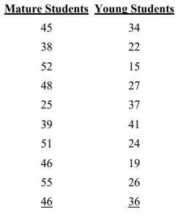
Table 1: University Experience Satisfaction Test Results
This paper will examine the results found in Table 1 and determine if there is a significant difference between the younger and mature students in terms of university satisfaction. The paper will put forth a hypothesis in relation to the data in Table 1 which will lead to several tests in order to determine whether there is a large difference between age groups. Any outliers found within the data will also be examined while also noting other factors that have impacted the results of the data.
2 Hypothesis
A hypothesis is a testable statement about the relationship between two or more variables or an explanation for an observed phenomenon [1]. Their importance lies in their ability to bring focus, direction and specificity to a research study [1].
The data acquired from the survey suggests that overall university satisfaction is higher among mature students when compared to younger students.
Several tests will be run to determine the validity of this claim, i.e. that mature students do have better experiences in university, or if overall satisfaction is much closer than it appears.
3 Frequency Distributions
Once data has been gathered, it is typically collected in an unorganised format. Therefore, arranging the data into a more organised form will be required to better analyse the data presented. This will also lead to patterns in the data which can lead to predictions of the final research study. There are several methods in terms of frequency distribution, such as locating the lowest and highest value within the recorded data and tallying up the number of times that each score occurs [2] [3]. This method scales poorly with a large data set without the use of various software’s. However, the sample size given for the trial study consists of 10 mature and 10 young students. This method provides more information than raw data and can assist in finding patterns within the data, such as identifying where most data is located [2] [3].
However, due to the variance in scores and limited sample sizes within each group of students, a grouped frequency distribution method was done in order to analyse the data with greater accuracy. This method involves grouping scores to better distribute the data into an organised format [2] [3]. Typically, the method of grouping data is to subtract the lowest value from the highest to find a range, which is then used to determine the width of each class interval, resulting between ten to twenty groups [2] [3]. However, due to the small number of students used within each group (10 for both mature and young students) and the high variance in data (ranging from 0 to 60), 6 groups were used to group data for both mature and young student groups. Final method which will be utilised in this report is to display the data as a graph [1] [2] [4]. Frequency polygons and bar charts, or histograms, are common methods of displaying data, with frequency polygons being the most used variant [1] [2] [4]. Graphs can make analysed data easier to understand and allow for the data to be easily presented in a manner that clearly shows how the data is distributed [1] [4].
3.1 Mature Student Frequency Distribution
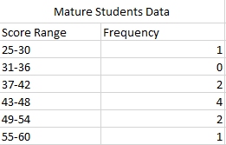
Table 2: Mature Student Frequency Distribution Table
As previously mentioned, 6 groups were chosen in order to group data acquired, which increase in an increment of 6, shown in Table 2. Table 2 shows the scores allocated by the 10 mature students for the trial study. As shown in Table 2, most mature students satisfaction falls into the 43-48 grouping, which gives a rough idea of the overall satisfactory levels.

Figure 1: Mature Student Frequency Distribution Graph
Figure 1 depicts the frequency a score occurred within each range. Like the observation found in Table 2, Figure 1 shows that most scores fall within the 43-48 category. Figure 1 shows almost a perfect symmetry within recorded data, with a single exception being within the 25-30 range. From this, it can be estimated that should a full research study be conducted based on the findings of the trial study, that most mature students would have an above average satisfactory level regarding the scoring system (0 to 60).
3.2 Young Student Frequency Distribution
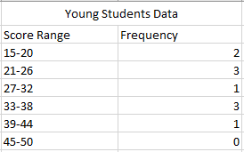
Table 3: Young Student Frequency Distribution Table
Like the mature student table seen in Table 2, data acquired from young students was also placed within a table for easier analysis, as seen in Table 3. Table 3 shows a more widespread scattering of data compared to Table 2, which had more concentrated allocation of data.

Figure 2: Young Student Frequency Distribution Graph
Figure 2 confirms the observation found in Table 3, in that younger students have a more widespread view of university experience in comparison to mature students. Figure 1 shows data in a symmetrical fashion, with a singular outlier within the data, whilst Figure 2 shows a more asymmetric spread of data with little discernible pattern. Due to this it is more difficult to anticipate the result of a full research study. However, comparing both tables and graphs does support the hypothesis that mature students are overall more satisfied with their overall university experience compared to younger students. Still, several factors could be cause of this, such as sample size used, which could lead to an unrealistic representation of how a final research study would look utilising a larger group of students of both categories.
4 Measures of Central Tendency
A measurement of central tendency is a summary statistic which represents a central point within a dataset [2] [5]. These measurements indicate where most values in a distribution fall [2] [5]. They are also known as the central location of a distribution [5]. The three most common measures of central tendency are the mean, median and mode [6] [7].
- The mean relates to the average of the data, and is the sum of the data set divided by the number of data entries [4] [6] [7] [8]
- The median is the middle value once the data is arranged in numerical order [4] [6] [7].
- The mode refers to the value that appears the most within a given data set [7]. It is possible for data sets to have either no mode or many modes [6] [7]. The effectiveness of the mode in data comparison can be compromised if there are multiple modes present within a given data set [6] [7].
Therefore, mature student’s data shows a mean of 44.5, a median of 46 and a mode of 46 while young students data shows a mean of 28.1, a median of 26.5 and there are no modes available.
Other methods of discovering information in relation to these groups are percentiles and quartiles [4] [2]. Percentiles are a measurement used to indicate where a certain percentage of given data is found, i.e. the 50th percentile is the value below which 50% of all given data is found [4]. Quartiles are connected to percentiles but operate on quarters of the dataset, i.e. 1st quartile is the 25th percentile, 2nd quartile is the 50th percentile and 3rd quartile is the 75th percentile [2] [4].
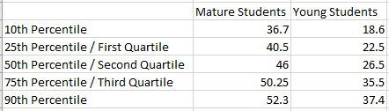
Table 4: Percentile and Quartiles of both datasets
Table 4 shows the percentiles and quartiles of both sets of data. This shows that for mature students, 75% of all data recorded is below 50.25, while for young students, 75% of all data falls below 35.5. as a result, Table 4 shows once again that mature student university satisfaction is higher in comparison to young student’s experience.
However, this data shows only the central point within a single data set, i.e. central point of either the mature students rankings or young students rankings. This means that further information is required in order to compare the two data sets. The standard deviation and variance must be discovered before a t Test can be conducted. Standard deviation is a number used to state how measurements for a group are spread out from the mean or expected value [2] [4] [6] [8]. A low standard deviation indicates that most numbers are very close to the average (mean), while a high standard deviation indicates that the numbers are spread out [2] [6] [8]. Variance is the measurement that shows how far a data set is spread out [4] [6] [9]. A variance of 0 would indicate that there is no variability, meaning that all numbers within the data set are the same [4] [6] [9].
In order to calculate the standard deviation, the following formula is required:
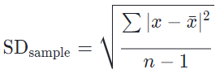
Equation 1: Standard Deviation Formula [8] [10]
Equation 1 shows the formula used for standard deviation when dealing with sample data sets [10], where X is a value within the dataset, $\overline{X}$ is the mean of the data set and N is the number of data points [2] [8] [10]. 1 is subtracted from N in order to artificially increase the standard deviation [8]. Rationale of this is to be conservative in case of mistakes, leaning on the side of overestimation of what the standard deviation is [8]. Variance is calculated using the following formula: ${SD}^{2}= \frac{\sum{{\left(X-\overline{X}\right)}^{2}}}{N-1}$. This effectively means that variance is the standard deviance value squared.
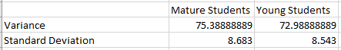
Table 5: Variance and Standard Deviations
Table 5 shows the variance and standard deviations of both mature and young students using Microsoft Excel. Regarding expected data sets, typically 68% of data is located within one standard deviation of the mean [4] [11], i.e. 68% of data is within +/- 1 standard deviation of the data average. Furthermore, it is expected that 95% of data is within 2 standard deviations of the mean and 99.7% of data is within 3 standard deviations of the mean [4] [11]. This is depicted in Figure 3 below.
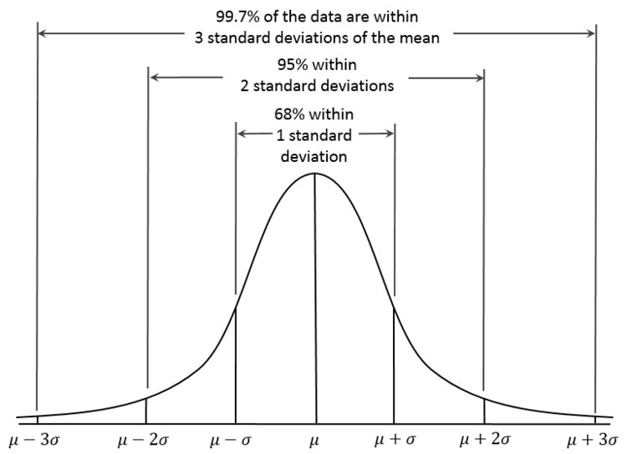
Figure 3: Standard Deviations within a normal curve [11]
It is possible to calculate how far each value is from the mean of the dataset group using a Z test [4] formula:
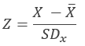
Equation 2: Z Test formula
Using the above formula in Equation 2, where X is the tested data value, $\overline{X}$ is the mean and SDx is the standard deviation, it is possible to calculate how far scores are from the mean in standard deviation units [2] [4]. A positive result would indicate that the score is higher than the mean while a negative score indicates that the score is below the mean [2] [4]. However, as we are examining the relationship between the means of two groups, rather than a singular group, a t Test will be more appropriate for this study [8].
5 t Test
Now that the standard deviation and the mean has been calculated for both Mature and Young Student groups, it is possible to perform a t Test in order to determine whether the hypothesis is correct or if there is no significant difference within the data sets. The t Test is a commonly used statistical test and is used to find out if the means of two samples differ to a statistically significant degree [2] [8]. A t Test can be used when there are independent means used, as well as for paired samples [8]. As the data sets presented are two independent groups, the independent t Test will be used in order to determine if there are significant differences at or beyond three different levels. In this case the t Test will be tested against the 0.1, 0.01 and 0.02 levels. The equation for independent samples is as follows:
$$t_{obt}=\frac{{\overline{X}}_{1}-{\overline{X}}_{2}}{\sqrt{\left[\frac{\left(n_{1}-1\right){SD}_{1}^{2}+(n_{2}-1){SD}_{2}^{2}}{n_{1}+n_{2}-2}\right]\left(\frac{1}{n_{1}}+\frac{1}{n_{2}}\right)}}$$
Equation 3: t Test formula for independent samples
Equation 3 shows the formula used for t Test independent samples, where x̄₁ is the mean of group 1, x̄₂ is the mean of group 2, n₁ is the number of participants in group 1, n₂ is the number of participants in group 2, ${SD}_{1}^{2}$ is the variance of group 1 and ${SD}_{2}^{2}$ is the variance of group 2.
Using Microsoft Excel, the following t Tests were run:
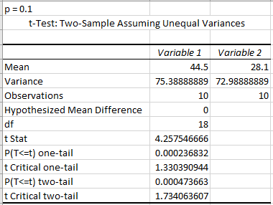
Table 6: t Test with Significance level of 0.1
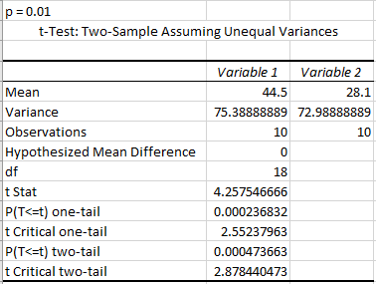
Table 7: t Test with Significance level of 0.01
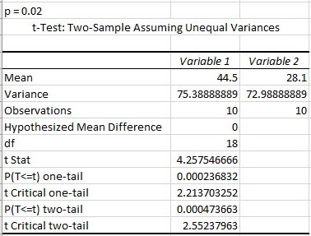
Table 8: t Test with Significance level of 0.02
Tables 6, 7 and 8 show the three t Tests run with the Significance levels of 0.1, 0.01 and 0.02, respectively.
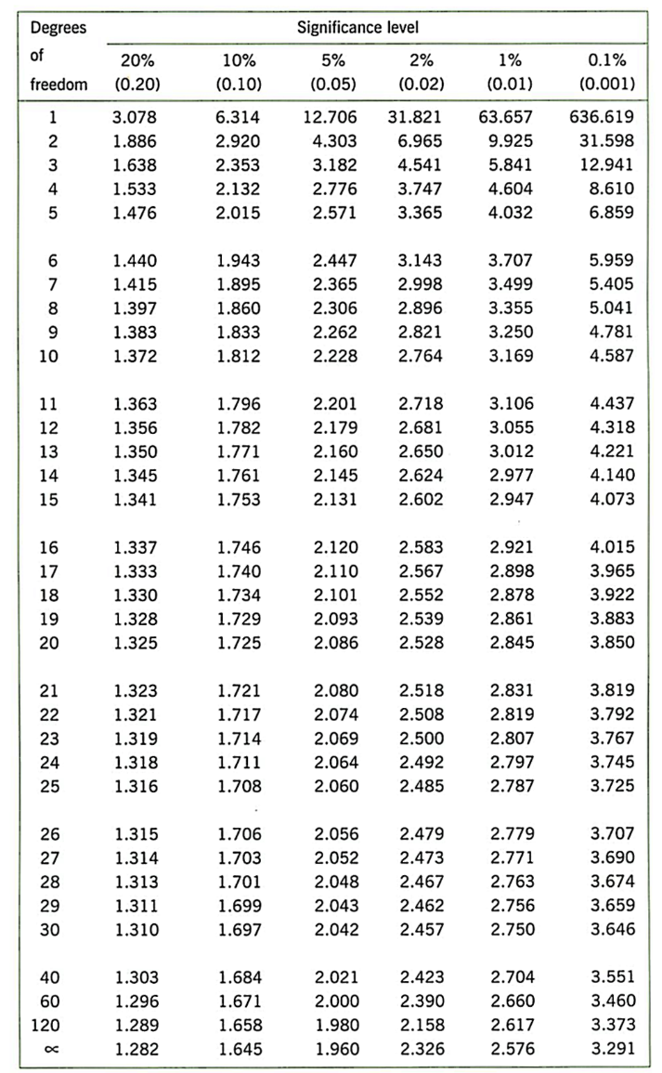
Table 9: Significance levels for t Test [12]
The results of the t Tests run shown in Tables 6, 7 and 8 display a critical a value of 1.734, 2.878 and 2.552 for significance levels 0.1, 0.01 and 0.02 respectively. This is discovered using a degree of freedom of 18, acquired by using the formula (N₁ + N₂) – 2, where N₁ is the number of participants in group 1 and N₂ is the number of participants in group 2. Using the table seen in Table 9, and using 18 as the degree of freedom, the critical values can be isolated. This demonstrates that there is a statistically significant difference in both one-tail and two-tail tests, which supports the hypothesis that mature students are more satisfied with their university experience compared to younger students.
During the investigation of the data, certain outliers presented themselves. Under specific conditions it is possible to exclude these outliers should they have no significant impact on the overall data [6]. Most disciplines have methods to decide if something is an outlier, and if they should be excluded or not [6]. Scatter grams are one method which can be employed to detect outliers [6]. In this scenario, an outlier was detected using the Grubbs test [13], which is a test that can detect outliers within the data and determine whether they have an impact on the result. For mature students’ dataset, the score of 25 was considered an outlier, while the score of 15 is an outlier for younger students’ dataset. However, the Grubbs test showed these outliers had no impact on the results, meaning these outliers did not need to be excluded from the final test. Other factors that could impact the results could include a larger sample size, which has the potential to alter the end results.
Conclusion
In conclusion, this paper put forth the hypothesis that mature students are more satisfied with their overall university experience in comparison to younger students, based on an observation of scores recorded from the trial study. Therefore, to prove or disprove this, several steps were taken which concluded in a final t Test. Firstly it became necessary to analyse the frequency distribution of the data, which involved grouping data as the sample given was both spread in terms of scoring, while also being a rather small sample size, for both sets of data. The resulting graphs would ultimately support the papers hypothesis. The end graphs also displayed anomalies within the data, namely young students displayed a wider range of satisfaction compared to mature students, which was led to a more fluctuating graph.
Following these observations, a look into the percentiles, quartiles, mean, mode and median of the two sets of data was conducted. These steps were necessary in order to perform other tests on the data, namely the t test and Z test. Percentiles and quartiles allowed for quick observations as to where data falls within each group, while discovering the mean and median enabled the discovery of the standard deviation and variance of the data, which would ultimately lead to the t test process. Using the gathered information, this paper conducted a t test using Microsoft Excel, explaining each step of the process. The t test ultimately supported the hypothesis put forth within this paper, as it was discovered that there was in fact a statistically significant difference in both one-tail and two-tail tests, using significance levels of 0.1, 0.01 and 0.02, giving a significance level of 1.734, 2.878 and 2.552, respectively.
Certain outliers were also identified within both groups, namely the 25 score for Mature Student dataset and 15 for Young Student dataset. It was concluded that, while these are considered outliers, they had no significant impact on the results of the t Test.
References
[1] R. Kumar, “Research Methodology A Step-by-Step Guide for Beginners, Fourth Edition”, London, SAGE Publications Ltd, 2014, pp. 1-399.
[2] J. H. Kranzler, “Statistics for the Terrified, Fifth Edition”, Pearson, 2010, pp. 1-192.
[3] Frequency Distributions, https://www150.statcan.gc.ca/n1/edu/power-pouvoir/ch8/5214814-eng.htm, Date Accessed Jan. 2, 2019.
[4] M. Baron, “Probability and Statistics for Computer Scientists”, Boca Raton, Chapman and Hall/CRC, 2006, pp. 1-413
[5] Measures of Central Tendency, http://statisticsbyjim.com/basics/measures-central-tendency-mean-median-mode/, Date Accessed Jan 2, 2019.
[6] G. Rugg, “Using Statistics A Gentle Introduction”, Maidenhead, Open University Press, 2007, pp. 1-137.
[7] Mean, Mode, Median, https://research-methodology.net/research-methods/quantitative-research/mean-mode-and-median/, Date Accessed Jan. 2, 2019.
[8] N. J. Salkind, “Statistics for People Who (Think They) Hate Statistics, Fifth Edition”, London, SAGE Publications Ltd, 2014, pp. 1-483
[9] Variance Explanation, https://www.statisticshowto.datasciencecentral.com/probability-and-statistics/variance/, Date Accessed Jan. 2, 2019.
[10] Standard Deviation and Formula, https://www.khanacademy.org/math/probability/data-distributions-a1/summarizing-spread-distributions/a/calculating-standard-deviation-step-by-step, Date Accessed Jan. 2, 2019.
[11] Standard Deviation, https://www.businessinsider.com/standard-deviation-2014-12?r=UK&IR=T, Date Accessed Jan. 2, 2019.
[12] Table of Significant Difference, https://jimgrange.wordpress.com/2015/12/05/statistics-tables-where-do-the-numbers-come-from/, Date Accessed Jan. 3, 2019.
[13] Grubbs Test, https://www.graphpad.com/quickcalcs/grubbs2/, Date Accessed Jan. 4, 2019.

