Module. Digital technologies
Lecturer. Munyaradzi N Murira
Student. Taiba Rashid 2229734
Task 3.
Evidence for completing course brainstorm ideas in a group.

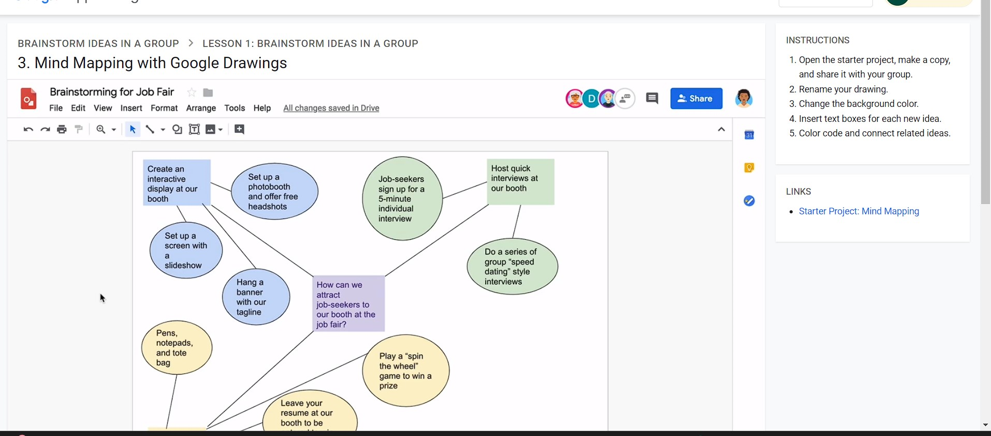
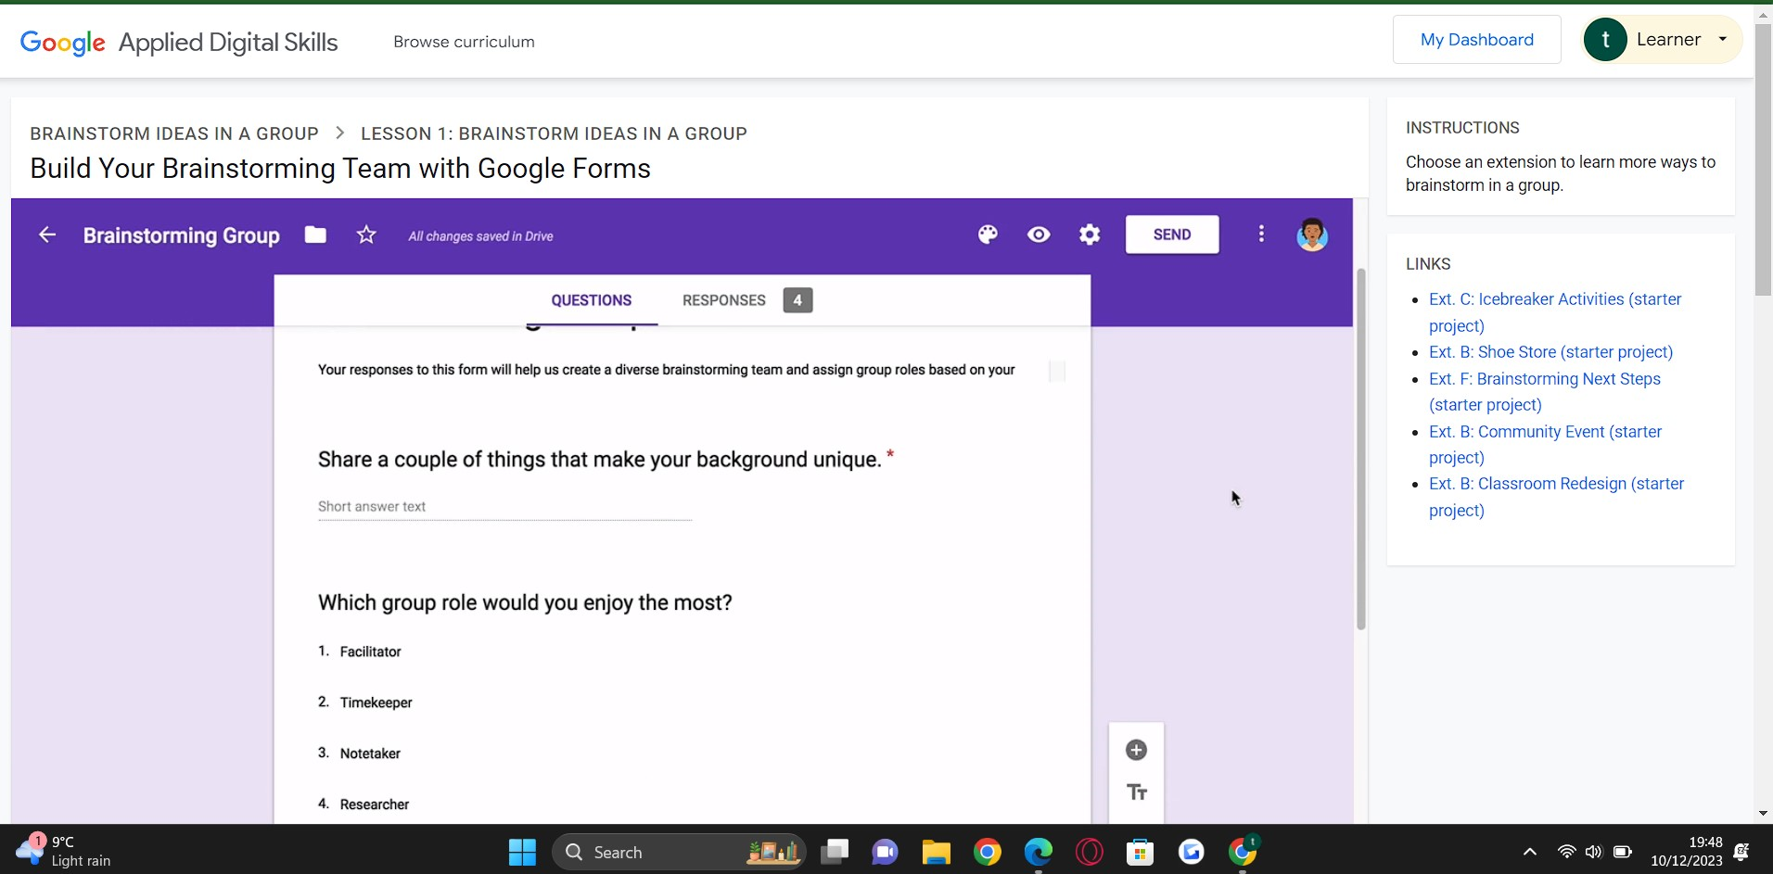
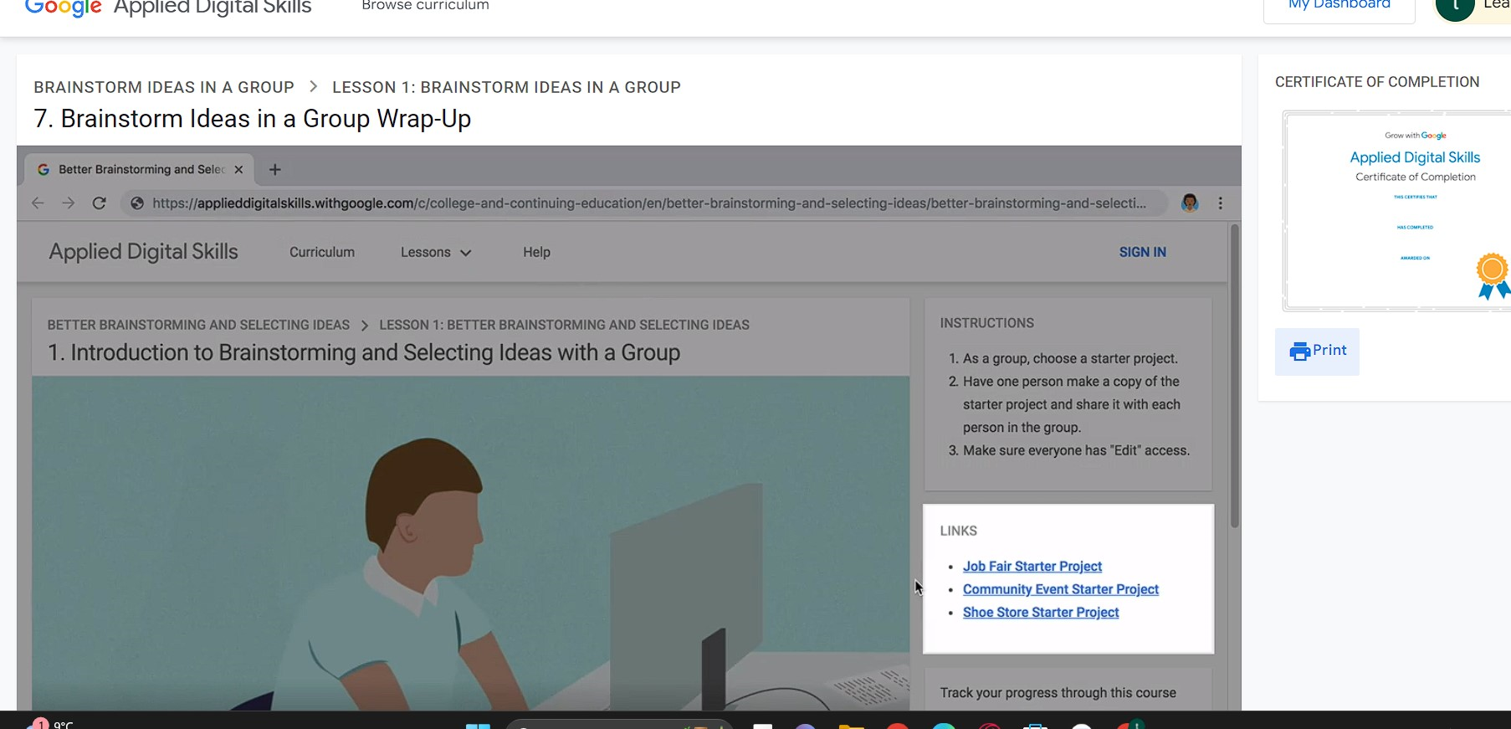

What have I learnt from this course?
From this course I have learnt how to do brainstorming with ideas, how to add ideas to any project and how this is beneficial as a group. Any input one has to a group sharing ideas is a technique for generating creative ideas and solutions to problems.

