
)(Robinson & Garton, 2007)

DIGITAL SKILLS AND RESEARCH METHODS.

MODULE LECTURER´S NAME: SUNETH FERNANDO
STUDENT NAME: ALEJANDRA ISABEL JARIT BONILLO
STUDENT IDENTITY NUMBER: 1915305

Table of Contents
1.0 INTRODUCTION 2
2.0 BACKGROUND 2
3.0 AIMS AND OBJECTIVES 4
4.0 METHODS 4
5.0 RESULTS 5
6.0 DISCUSSION 6
7.0 CONCLUSION 7
APENDIX 7
References 10

1.0 INTRODUCTION
The concept of virtual learning involves the use of computer software and/or the internet for teachers to deliver lessons to students and for students to participate in these lessons in a dynamic and interactive manner. The virtual learning setting reduces or eliminates the requirement for physical classroom-based learning. (Kanimozhi, 2018)
The concept of virtual learning was introduced in the late 1990’s shortly after the emergence of the internet. (Gerhard & Mayr, 2002) This technology is mainly used by students at university level or school level.
As society changes, the style in which individuals learn is also changing. According to Kanimozhi, 50% of learning will take place through an online setting and the rest in a physical class setting. Additionally, companies will increasingly value individuals who have the skills to learn online. (Kanimozhi, 2018)
I will conduct an experimental survey that will focus on how a virtual learning environment interacts with students in a learning and teaching environment and how popular virtual learning is among students, lecturers, and education institutions.

2.0 BACKGROUND
Virtual learning environments provides a vast array of services and benefits for the student learning experience. The importance of online learning was further demonstrated during the ongoing COVID-19 pandemic. According to Shea, almost all schools, including primary and graduate schools in the United States have moved lessons taught in physical classrooms to online learning. (Shea, 2020)
This is further justified when a national survey conducted on 641 institutions showed that 90% of these institutions had moved some or all in class teaching to a distance format. (Johnson, Veletsianos, & Seaman, 2020)
Virtual learning can be divided into various forms. Some of these forms are computer based, internet based, remote teacher online, blended learning, facilitated virtual learning, online learning, and full time online. (Kanimozhi, 2018)
Computer based learning is where an individual learns through a computer software and not through instruction by a teacher. The difference between computer based and internet-based learning is that in internet-based learning, students learn through a software on the internet. Remote teacher online, is where the teacher provides lessons to students through the internet rather than in class lessons. Blended learning is a combination of in class face to face instruction, with a computer based, internet based or remote teacher online teaching style. Online learning and full-time online learning is teaching that takes place through the use of the internet. The difference is that full time online learning does not include face to face interaction between students and teachers therefore blended learning is excluded from full time online learning. Online learning includes internet based, remote teacher online, blended learning and facilitated virtual learning types of instructions. (Kanimozhi, 2018)
Various types of technologies are used in the virtual learning environment. (Annemieke, Coldwell-Neilson, Goold, & Beekhuyzen, 2012)
Some examples of virtual learning environments include Moodle and Blackboard. These technologies are divided into general categories. They are lecture capture, webinars, and interactive web conferencing technologies.
Lecture capture systems use hardware and software tools to record a lesson conducted by a teacher. This will include the video of the teacher explaining the lesson, the power point slides used in the lesson and any annotations on these slides or annotations on a white board that are made by the teacher. These recordings are then modified to produce rich presentations for student viewing. Students can view these lectures at a convenient time to them. (Kanimozhi, 2018)
Webinars are presentations that take place over the internet in real time. Once it takes place in real time it is then recorded, and the students can view it later. Webinars involve presentation using power point slides. Teachers can use Voice over Internet Protocol technology to deliver the audio for the webinar. (Kanimozhi, 2018)
Virtual learning environments have several benefits for students and teachers to enhance the learning experience. Students can benefit by increased levels of interaction with their peers in class, with the teacher and with the course material. This increased level of interaction can be during the teaching session and outside the teaching session through modes of communication such as forums, discussion threads, polls, and surveys. The student receives a dynamic response to their comments and opinions in these channels. (Kanimozhi, 2018)
In addition to this, the online learning facilities enable efficient submission of assignments so that students do not have to physically locate their teachers to submit work. The teacher is also able to monitor the time of submission so that they can track whether the student submitted the assignment on time or not. (Kanimozhi, 2018)
Teachers can provide an abundance of supplementary resources to students on the online learning platform because of the large amounts of online storage space. These resources such as presentations, research articles and work sheets can be used by the students to improve their knowledge of the topics covered in class. Links to sources outside of the in class learning material can also be provided to students, in an online learning platform. The teacher can also use relevant information such as newspapers (e.g. BBC) as embedded content in the online learning platform so that students obtain additional information. (Kanimozhi, 2018)
Even though the virtual learning environment can present several advantages to teaching, it also presents some risks and threats, especially in the e-learning environment (learning using the internet). (Barik & Karforma, 2012)
Some of the threats faced when using an online learning platform is that an unauthorised person can obtain access to the content that is present in the e leaning platform. This person can also tamper with this content, which can negatively impact the efficient use of the e-learning platform. (Barik & Karforma, 2012)
An individual can illegitimately use the access privileges of a legitimate user. For example, a hacker can obtain the access rights of a teacher and change the timings of deadline submissions. This can provide misleading information to students and disrupt the online learning experience. The hacker can also use a malicious program that may have a negative impact on the online learning program and thereby prevent the proper functioning of the e- learning system. (Barik & Karforma, 2012)
Due to these threats the participants of the e-learning system can face various risks. For example, teachers face the risk that the discussions in online forums that are stored on a server, may be accessed by an illegitimate person. This will infringe on the privacy of students and teachers. (Barik & Karforma, 2012)
Additionally, teachers face the risk that examinations may be altered before they reach the student, examinations may be accessed before the appropriate time and answers to examination questions provided by students may be altered while in storage. (Barik & Karforma, 2012)
Students also face various risks from the use of e-learning systems. They may face the risk of important documents that they are provided with, been altered, or tampered with, by hackers or illegitimate users. This can create problems with students when they must revise before exam participation. Attackers can also use phishing techniques, where a fake website has an identical appearance to the e-learning website. This phishing website may draw students to submit confidential information. (Barik & Karforma, 2012)

3.0 AIMS AND OBJECTIVES
With my work and with this specific topic I have wanted to find out more about the impact on people's lives using VLE, ​​the objective of this work and also my questionnaire is to understand certain points such as:
• How effective the VLE is and therefore how people feel about it.
• Try to get feedback in order to improve for a new term at university.
• Try to understand if people consider it an advantage or a disadvantage and how it has affected their grades.

4.0 METHODS
I will be conducting a survey that investigates student’s opinions regarding the virtual learning environment used in the University Trinity Saint David certificate in Skills for the workplace. As a first step, I thought about which questions would best suit this type of survey. Some of these questions were direct and required a scaled answer regarding a student’s opinion. I wrote most of the questions in close answers and just two with open answer and always clarify For example, how they feel about accessibility of material on Moodle. A survey participant can select a result from strongly agree to strongly disagree.
Some other questions were description based and required the survey participant to provide a short description of opinion on a specific topic. For example, do you think it is an advantage or a disadvantage to study online and why.
In general, the questions that I explored in my survey were to understand how easy it is to use the virtual learning environment, whether it provided the facilities to effectively learn and also whether students felt satisfied and happy in terms of the user friendliness of the virtual learning system and its functionalities. Using the questions, I also attempted to understand whether students preferred online learning over in class learning.
I targeted the student population within the University of Trinity Saint David that studied the course as me in London. All the students were based in London and all of them had to heavily engage with the virtual learning environment, as all classes were conducted online since the beginning of the pandemic.
I selected 12 students within the course, as I felt this was a large enough sample to obtain an effective survey result. There were 15 students in our study group, that engaged with the virtual environment with me and I selected 12.

5.0 RESULTS
QUESTIONS | YES | NO | SOMETIMES
Q1 | 7 | 0 | 5
Q7 | 2 | 1 | 9

QUESTIONS | ALWAYS | SOMETIMES | NEVER | OFTEN | RARELY
Q2 | 1 | 10 | 1 | 0 | 0
Q4 | 2 | 4 | 0 | 6 | 0

QUESTIONS | Very interesting | Fairly interesting | Somewhat interesting | Hardly interesting | Not interesting
Q3 | 0 | 5 | 6 | 0 | 1

QUESTIONS (FROM A LITTLE TO A LOT) | 1(A LITTLE) | 2 | 3 | 4 | 5(A LOT)
Q5 | 1 | 1 | 8 | 2 | 0
Q8 | 3 | 3 | 2 | 1 | 2

ANSWERS Q10 | 1 | 2 | 3 | 4 | 5 | 6 | 7 | 8 | 9 | 10 | 11
ADVANTAGE | X | X | X |  | X | X |  | X | X | X
DISADVANTAGE |  |  |  | X |  |  | X |  |  |  | X

6.0 DISCUSSION
In discussing my work I have worked using different types of closed and open answer questions, I have also been able to analyze how normally respondents do not usually respond with extreme answers if they have the possibility of answering with an intermediate term, I have been able to verify how people enjoy using VLE, as you can see in the graphs clearly, the students see studying at home as an advantage, I think there is still a lot to improve but it is a good tool and it helps us to better manage time. In the questions I have been able to see that the students also have similar answers when the questions are yes or no, or there are fewer options. Undoubtedly asking about VLE is a good topic, the students have found it interesting, only 11% of 100% believe that it is boring so that gives very good prospects for the future, perhaps the advising to the students should be a little more focused as Sometimes students feel lost and believe that it is not the same as if it were face to face, thus losing a source of focus, since from home it is easy to have other external agents such as the internet, coexistence that can make something difficult to feel concentrated That's why the students responded that it is not always easy to focus at home.

7.0 CONCLUSION
I found the VLE topic very interesting and I hope to continue learning much more although there is still much to improve

APENDIX
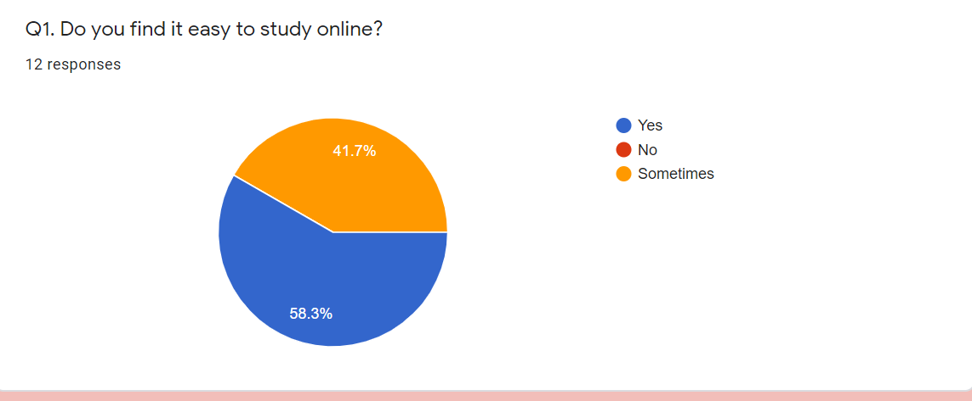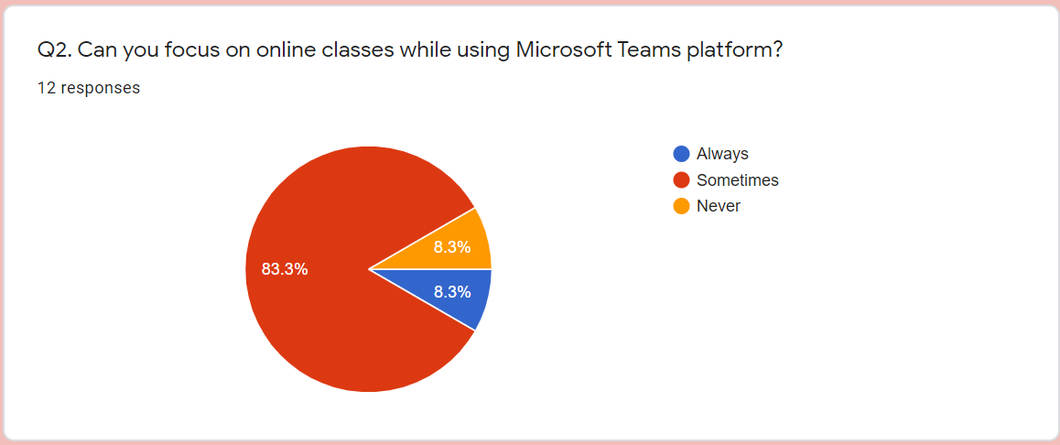
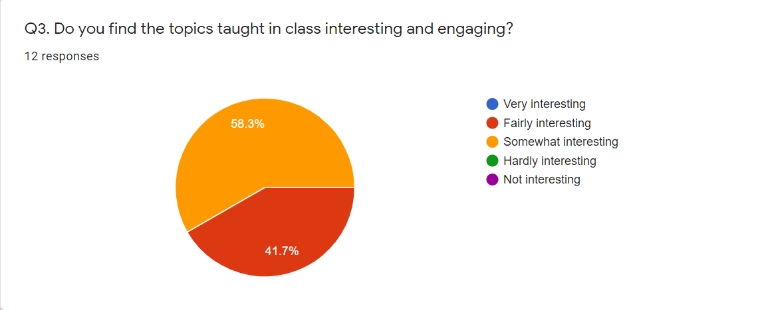
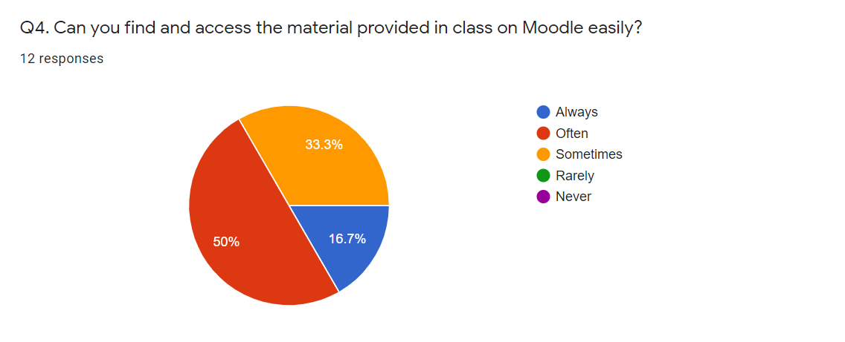
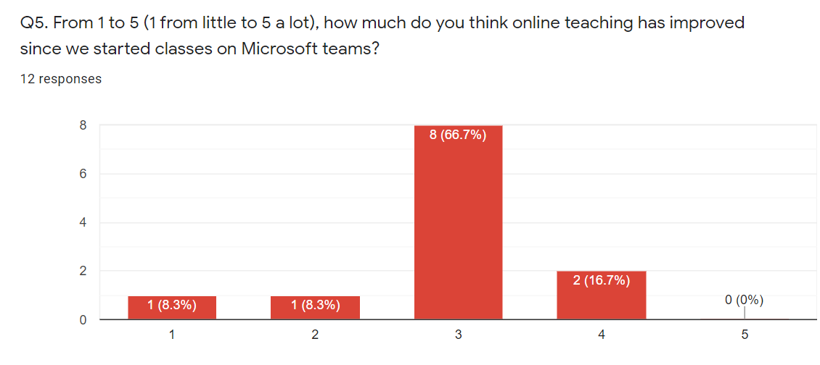
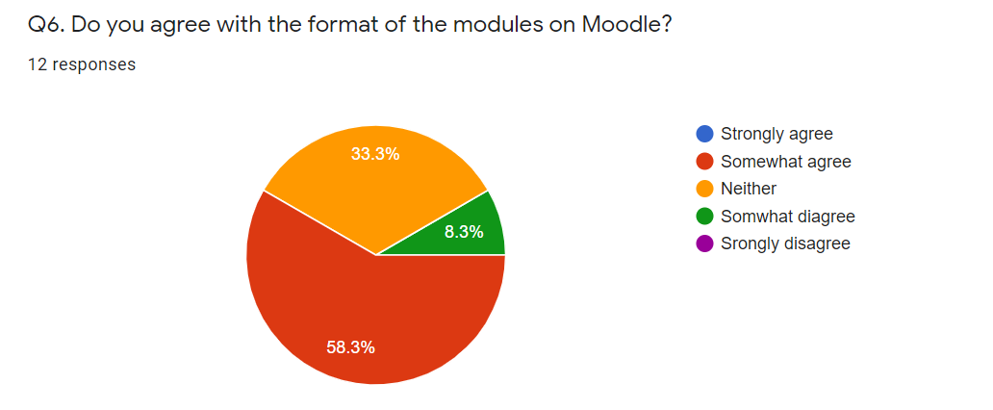
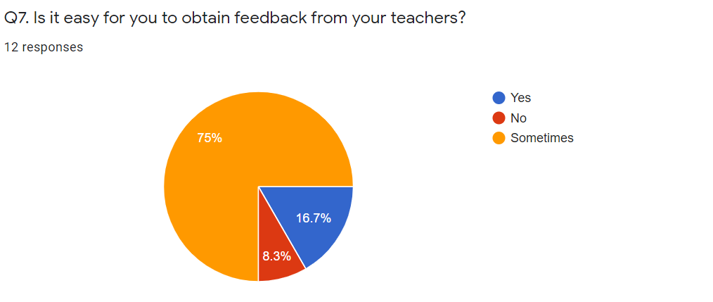
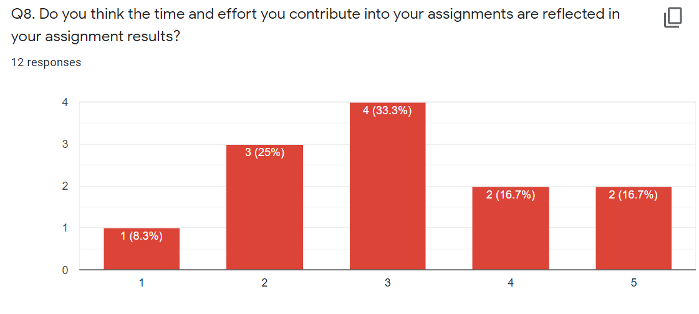
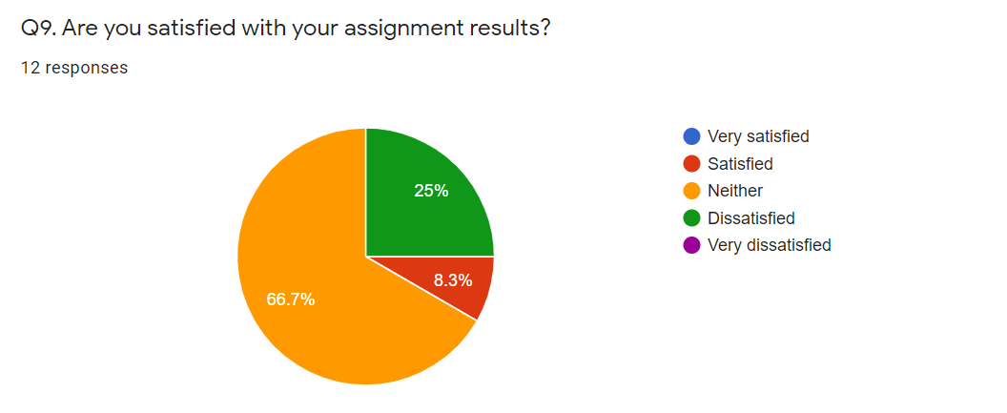
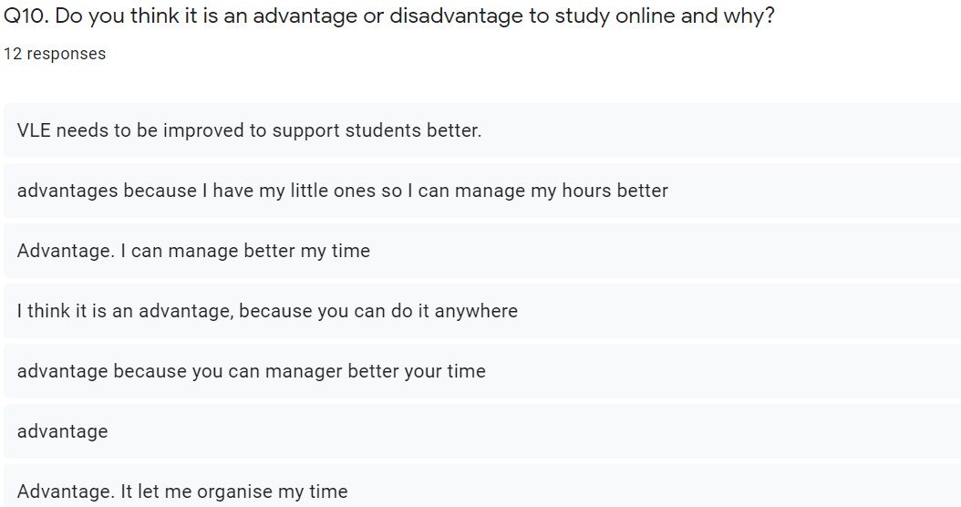
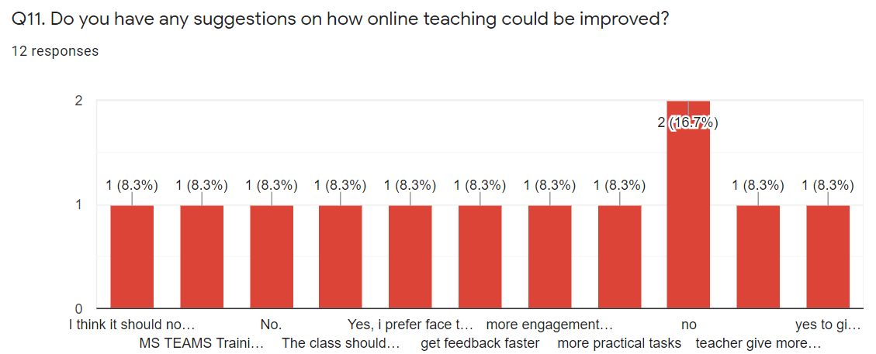

References
Annemieke, C., Coldwell-Neilson, J., Goold, A., & Beekhuyzen, J. (2012). A review of e-learning technologies - opportunities for teaching and learning. 4th International Conference on Computer Supported Education, (pp. 29-41). Porto, Portugal.
Barik, N., & Karforma, D. S. (2012). Risks and remedies in E-learning system. International Journal of Network Security & Its Applications, 4(1).
Gerhard, J., & Mayr, P. (2002). Competing in the E-Learning Environment - Strategies for Universities. Proceedings of the 35th Hawaii International Conference on System Sciences. Hawaii: IEEE Computer Society.
Johnson, N., Veletsianos, G., & Seaman, J. (2020). U.S. faculty and adminstrators' experiences and approaches in the early weeks of the COVID-19 pandemic. Online Learning, 24(2).
Kanimozhi, M. (2018). Virtual Learning Environment. International Journal of Advanced Research in Computer Science, 9(1).
Shea, P. (2020). Introduction to Online Learning. Online Learning, 24(2).

