A 6-week Velocity-Based Strength Training Programme for a Male Football Player.

Introduction
There are concerns that the physical demands of football suggest that higher levels of performance require a well-developed physical conditioning programme (Rodriguez-Rosell et al., 2016). Even though the predominant activity patterns being naturally, but highly strength and power are important in crucial situations in a game. Studies (Bogdanis et al., 2009; Rodriguez-Rosell et al., 2017) showed that football players involving high loads and repetitions ending at or close to failure have increased upon their muscular strength. Resistance training is utilised worldwide for its effective methods for improving athletic performance due to the well-known adaptations in muscular hypertrophy, maximal strength, power output and rate of force developed (Dorrell et al., 2019). Specific adaptive responses from resistance training has been shown to be directly influenced by the configuration of several acute training variables. These variables include loading magnitude, number of repetitions and sets, rest durations, and exercise type (Pareja-Blanco et al., 2017). Therefore, resistance training can be difficult to quantify due to its numerous training variabilities. Determining training methods is especially useful for coaches and athletes to allow for an effective periodisation programme to maximise specificity of appropriate attributes, optimise adaptations and allow for efficient recovery (Baechle and Earle, 2008).
Banyard et al., (2018) explains that traditional methods to determine training loads such as percentage-based training can prescribe relative submaximal loads from one-repetition maximum (1RM). Despite 1RMs being valid, reliable and require no further monitoring equipment, this method can be time consuming and increases the risk of injury. Also, Padulo et al., (2012) suggests that maximal strength and daily readiness can fluctuate daily due to fatigue and could significantly increase within a few weeks due to training adaptations. Therefore, training when fatigued or continued training based on an outdated 1RM would not optimise the neuromuscular stimuli that is required for maximising adaptations (Banyard et al., 2018). Performing to repetitions to failure have shown to impair neuromuscular performance, even in trained athletes due to the high degree of fatigue it produces (Gorostiaga et al., 2012). Therefore, a coach is able to use a velocity-based strength training approach which uses instantaneous repetition feedback to accurately prescribe training loads which optimises adaptations and avoid training to failure (Dolezal et al., 2016). Scott et al., (2016) acknowledges that a sudden increase in training load can cause a decrease in performance and lead to an increased risk in an injury. Furthermore, Scott et al (2016) suggests that monitoring the training process is therefore important to identify periods where the athlete can train at heavier or high loads and limit decreases in performance. This study will analyse a 6-week velocity-based strength training programme on a male football player, in order to increase strength, power and hypertrophy adaptations around the athlete’s busy football schedule.

Athlete Profile
A male football player (22-years old) is wanting to improve upon their leg strength, power, and hypertrophy around their weekly routine. Currently it is mid-season and the athlete is unable to rest for long periods of time due to a busy schedule as a footballer. Therefore, it makes it difficult to improve specific characteristics additional to a normal football schedule. Football is a game which combines and requires several fitness components: including agility, speed, strength, power, endurance, flexibility, and skills. In order to cover these fitness components, the athletes would need a specific and planned out training programme. This individual has been resistance training for a year, however he states that he has been inconsistent with training, for example, resistance training once or twice one week and then four times the next, and some weeks he never undertook a session. The individual wants to improve upon their footballing ability in order to get picked for the first team. However, undertaking additional resistance training sessions could interfere with the athlete’s performance upon a game day. Therefore, this wouldn’t look ideal for the coaches as he is fatiguing quicker due to these sessions. This is where velocity-based training becomes a key factor to implement during resistance training leg sessions in order to reduce delayed onset muscle soreness (DOMS) and fatigue (Dolezal et al., 2016). Table 1 is a timetabled programme in order to improve upon the athlete’s fitness components and goals in a time period of 6-weeks. Following the velocity-based training method explained below this 6-week timetable / program will be followed in order to achieve this by limiting fatigue.
Table 1: Weekly routine for the next 6-weeks for this individual.

Time of day | Monday | Tuesday | Wednesday | Thursday | Friday | Saturday | Sunday
Morning | LEGS | PUSH | PULL | LEGS | Upper body | GAME  DAY | REST
Evening |  | Football training | Stretching / mobility | Football training |  |  | Stretching / mobility

Velocity Profile
To establish the load/velocity profile for the athlete, repetitions at a number of pre-determined relative or absolute loads need to be performed (Jovanovic and Flanagan., 2014). Further, Jovanovic and Flanagan (2014) recommends that measuring mean concentric velocity over at least 4-6 increasing intensities of load, with increased range from 30% to 85% of estimated 1RM. Also, the athlete should be provided with approximately 3 minutes of passive recovery between sets. A large percentage of 1RM load should be used to ensure a decrease in velocity of 0.5m/s between the lightest and heaviest loads (Jidovtseff et al., 2011). Sanchez-Medina et al., (2010) states that the athlete should perform 3 reps at lighter loads (velocity > 1.0m/s), 2 reps at moderate loads (0.65 – 1.0m/s) and single reps at heavy loads (>0.65m/s). Then the highest velocity recorded at each load should be input in the analysis of the velocity profile. Table 2 below is an example of this athlete’s velocity profile based on his predicted 170kg 1RM. This allows a coach the dictate what weight is necessary for particular training methods for the back-squat exercise.

Table 2: An example of this specific athlete’s velocity profiles based on a predicted 170kg 1RM.
Velocity profile | Velocity (m/s)
3 reps @ 35% 1RM | 1.2m/s @ 60kg
3reps @ 45% 1RM | 0.86m/s @ 76kg
2 reps @ 65% 1RM | 0.78m/s @ 110kg
2reps @ 75% 1RM | 0.62m/s @ 128kg
1rep @ 85% 1RM | 0.53m/s @ 145kg

Velocity-Based Training using a PUSH band
Recent literature (González-Badillo et al., 2014; Pérez-Castilla et al., 2017) has explored the use of immediate feedback utilising velocity-based training (VBT) methods to accurately manipulate resistance training loads. Balsalbore-Fernandez et al., (2015) discusses a force-velocity relationship, which is recognised as the higher loads are moved at a slower velocity, whereas lighter loads move at a faster velocity. Also, the barbell velocity during the back squat is shown to be very highly correlated with training intensity in terms of 1RM%, with the utilisation of a wide range of loads (Bazuelo-Ruiz et al., 2015). Velocity-based training methods can allow 1RMs and each associated relative percentage to be predicted without conducting an actual 1RM test, by measuring barbell velocity. Accelerometers such as the PUSH band is a smartphone-based wearable device which measures movement velocity in resistance exercises by integrating the acceleration data with respect to time (Casartelli et al., 2010). This approach has been demonstrated to be very similar to barbell velocity in previous research (Casartelli et al., 2010) and does not need PC software to work. Velocity-based training combines the strength and power phase of a movement, and stated by Dolezal et al., (2016) that it is implemented into the athletes strength regiments as a way to maintain strength and increase power, also whilst preventing muscular fatigue for upcoming training sessions or games. Bazuelo-Ruiz et al., (2015) stated that no studies had analysed a smartphone-based wearable device to track movement velocity during the back squat, therefore they utilised this method to analyse the validity and reliability. Furthermore, overall findings of Bazuelo-Ruiz et al., (2015) were that the PUSH band demonstrated a high validity and reliability for measuring movement velocity during a back squat. Therefore, this study will utilise the smartphone-based wearable PUSH band device to measure movement velocity during a back squat, in order to increase the athlete’s strength and hypertrophic adaptations through a 6-week velocity-based training programme.
Minimal velocity threshold (MVT) is where the maximal load (1RM) attempts are associated with a specific velocity (Jovanovic and Flanagan., 2014). The MVT is measured as the mean concentric velocity produced on the last successful repetition of a set to failure performed with maximal lifting effort. Reports from Gonzalez-Badillo and Sanchez-Medina (2010) and Izquierdo et al., (2006) of MVT being specific to each exercise with approximately mean concentric velocities of 0.30m/s for back squat and 0.15m/s for bench press. Also (Turner, 2017) implemented a minimal velocity stop of 0.35m/s for a box squat, even though that velocity stop wasn’t evidence based, but rather a logical and rational assumption that the athlete would still have at least two reps ‘left in the tank’. Due to these findings this study will set a velocity stop of 0.35m/s for the individual during the back squat. This is so the athlete stops before failure and therefore reducing fatigue symptoms whilst continuing to optimise performance and training adaptations. Depending on the athlete’s daily readiness in a session, the weight would be adjusted to ensure the athlete performs movement velocity above 0.35m/s but ensuring that their repetitions are at maximal effort to ensure velocity losses until the last repetition. An estimated weight of 100kg was trailed to identify a suitable weight to ensure the last repetition was just above the velocity stop of 0.35m/s. The 100kg estimate showed to be an appropriate weight to begin the athlete for the first week of the velocity-based training programme. As the athlete wants to improve upon strength, power, and hypertrophy a back-squat programme with 4 sets of 10 repetitions will be implemented to target hypertrophy (Scott et al., 2016). These sets will be utilised with the velocity stop (0.35m/s) to reduce fatigue whilst ensuring maximal adaptations.

Results
Over the 6-week period the results were manually imported from the PUSH band application from the smartphone onto an excel document. Unfortunately, the data couldn’t be automatically transported, therefore data had to be manually imported in order to organise the data into appropriate tables or figures. Data allowed both the coach and athlete to identify progress or fatigued sessions.
Figure 1: A comparison of velocity of week 1 and week 6, second set.

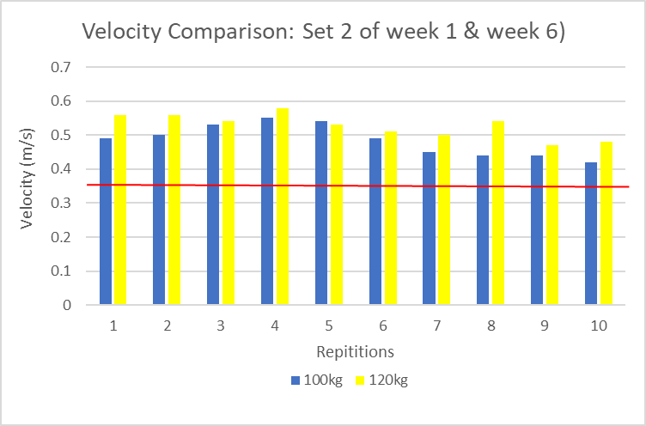

Figure 1 shows a comparison on velocity (m/s) during their second set of weeks 1 and 6. The athlete was back-squatting 100kg in week one for 10 repetitions and by week 6 he was able to back-squat 120kg with visible velocity improvements. The red line at a velocity of 0.35m/s indicates the velocity stop where ideally the athlete is trying to avoid going under the 0.35m/s to avoid fatigue. The slowest the athlete moves at m/s is 0.41m/s and the quickest is at 0.58m/s.

Figure 2: A comparison of velocity of week 2 and week 5, second set.

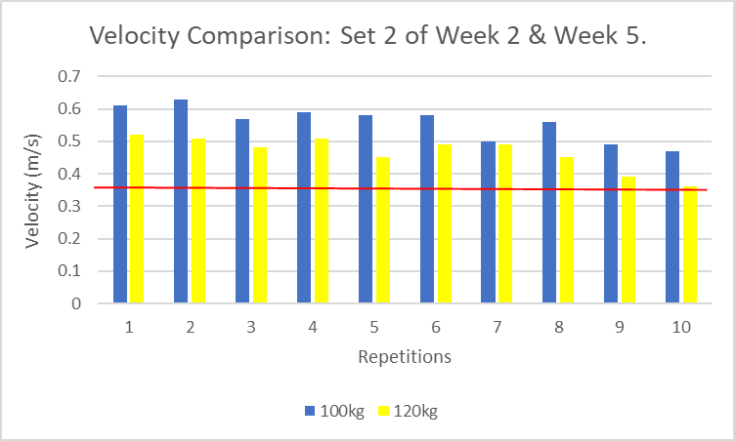

Figure 2 suggests that during week 2 at 100kg the athlete had no fatigue and was able to accomplish the 10 repetitions at a good velocity. However, week 5 at 120kg the athlete shows fatigue due to the slow movement velocity he produced in comparison. Week 2 identifies that there was a possibility that the athlete was fatigue in week 1 due to the velocity differences seen in figure 1. Whereas week 5 showed that the athlete was slightly fatigued and only just stayed within the velocity stop of 0.35m/s, indicated by the red line. Also, the velocity speeds are difference between week 5 and week 6, as figure 1 and 2 shows that week 5 was slower in velocity than week 6 at 120kg.

Figure 3: Pre and Post 6-week intervention 1RM prediction test.
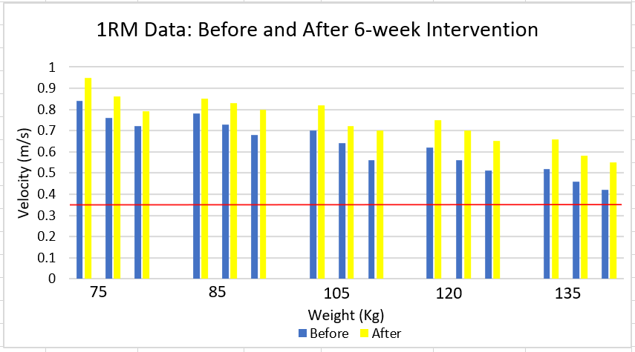

Figure 3 identifies the difference in velocity movement before and after the 6-week intervention. Clearly, figure 3 establishes that after the intervention the athlete’s velocity has improved. Before the intervention the athlete back squatted 135kg at a velocity of 0.41m/s and after the intervention the athlete was able to move the same weight at 0.55m/s. The athlete was also able to move at a speed of 0.76m/s with 120kg, whereas identified in both figure 1 and 2 he couldn’t reach these movement speeds with this weight. The velocity PUSH device calculated the pre-intervention 1RM to be 170kg and the post-intervention was calculated to be 181kg, an improvement.

Discussion
The purpose of this study was to investigate the effectiveness of a 6-week velocity-based strength training programme for an intermediate football player. Utilisation of a PUSH band was proved to be reliable and valid by Bazuelo-Ruiz et al., (2015), therefore this device and application was confidently and effectively used throughout the 6-weeks.
Strength training is a critical exercise stimulus for inducing changes in muscular strength, size and power (Crewther et al., 2005). Even though the velocity-based strength programme was specifically set to repetitions of 10 for hypertrophy adaptations, it is clear from the results that both strength and power adaptations were developed. The velocity PUSH band device was able to calculate the predicted 1RM from 170kg prior to the 6-week programme and 181kg post the programme. Therefore, identifying an improvement in back-squat strength through the hypertrophy velocity-based specific programme. The results also identify power adaptations as the athlete was able the move high loads at faster speeds. Comments from the athlete identified that the velocity-based training was working in the sense of reducing in fatigue for his football training sessions and matches. As identified in figure 2, the gradual decrease in repetitions velocity loss during the lifting of 120kg can be interpreted as evidence of impaired neuromuscular fatigue (Sanchez-Madina, and Gonzalez-Badillo, 2011). This velocity loss allowed identification on daily readiness and the extent of current fatigue, and therefore ability to control further fatigue. The velocity stop method which was implemented was suggested by Jovanovic and Flanagan (2014) and they state that velocity stops are highly correlated with how much exertion that athlete is experiencing and the proximity to failure. Further, Jovanovic and Flanagan (2014) suggested to use the velocity stop in periods of ‘peaking’, such as in-season, when an athlete wishes to enhance strength and power adaptations to occur as frequently and effectively as possible whilst minimising the fatigue effect of training. This method was evidently effective throughout the programme as the athlete felt less fatigued and was able to perform to high standards. Also, it was clear that adaptations were increasing in the athlete’s strength and power abilities, in which the weight was slowly increased throughout the 6-week period. Based on these results and supported by Guerriero et al., (2018), it appears that resistance training and velocity monitoring of a periodisation of >4 weeks can be very effective in enhancing sport specific performance, as well as strength and power adaptations during an in-season football period.

To conclude, velocity-based training for a 6-week period showed to be a useful method to specify sessions to ensure the effectiveness of adaptations and to ensure reduced fatigue effects by using velocity stops. The athlete was able to perform in both competition and training to a high standard due to the lack of fatigue, and further improve upon strength and power gains. Limitations are that the device may not be available to all athlete’s due to the expense (Bazuelo-Ruiz et al., 2015).

Wordcount: 2531/2500

Reference list
Baechle, T., and Earle, R. (2008) Essentials of strength training and conditioning. Champaign, IL: Human kinetics.

Banyard, H., Tufano, J., Delgado, J., Thompson, S., and Nosaka, K. (2018) Comparison of velocity-based training methods and traditional 1RM-recent-based training prescription of acute kinetic and kinematic variables. International Journal od Sports Physiology and Performance.

Bazuelo-Ruiz, B., Padial, P., Garcıa-Ramos, A., Morales-Artacho, A., Miranda, M., and Feriche, B. (2015) Predicting maximal dynamic strength from the load-velocity relationship in squat exercise. Journal of Strength Conditioning Research. Vol. 29., pp. 1999–2005.

Bogdanis, C., Papaspyrou, A., Souglis, A., Theos, A., Sotiropoulos, A., and Maridaki, M. (2009) Effects of hypertrophy and a maximal strength training programme on speed, force and power of soccer players, in Sciecne and Football VI. The proceeding of the sixth world congress on science and football. Ed. Reilly, T., Korkusux, F. New York, Routledge, 2009. Pp 290-295.

Casartelli, N., Muller, R., and Mafﬁuletti, N. (2010) Validity and reliability of the myo-test accelerometric system for the assessment of vertical jump height. Journal of Strength Conditioning Research. Vol. 24., pp. 3186–3193.

Crewther, B., Cronin, J., and Keogh, J. (2005) Possible stimuli for strength and power adaptations: Acute Mechanical Responses. Sports Medicine. Vol. 35., pp. 967-989.

Dorrell, H., Smith, M., and Gee, T. (2019) Comparison of velocity-based and traditional percentage-based loading methods on maximal strength and power adaptation. Journal of Strength and Conditioning Research. Vol, 34., Iss. 1., pp. 46-53.

González-Badillo, J., Rodriguez-Rosell, D., Sanchez-Medina, L., Gorostiaga. E., and Pareja-
Blanco, F. (2014) Maximal intended velocity training induces greater gains in bench press performance than deliberately slower half-velocity training. European Journal of Sport Science. Vol. 14., Iss. 8., pp. 772-781

González-Badillo, J.., Sánchez-Medina, L. (2010) Movement velocity as a measure of loading intensity in resistance training. International Journal of Sports Medicine. Vol. 31., pp. 347 – 352.

Gorostiaga, E., Navarro-Amezqueta, I., Calbet, J., Hellsten, Y., Cusso, R., Guerrero, M., and Izquierdo, M. (2012) Energy metabolism during repeated sets of leg press exercise leading to failure or not. PLoS One. Vol. 7.

Guerriero, A., Varalda, C., and Francesca, P. (2018) The role of velocity-based training in the strength periodisation for modern athletes. Journal of Functional Morphology and Kinesiology. Vol. 3., Iss. 55., pp. 1-13.

Izquierdo, M., Gonzalez-Badillo, J., Häkkinen, K., Ibañez, J., Kraemer, W., Altadill, A., Eslava, J., and Gorostiaga, E. (2006) Effect of loading on unintentional lifting velocity declines during single sets of repetitions to failure during upper and lower extremity muscle actions. International Journal of Sports Medicine. Vol. 27., Pp. 718–724.

Jidovtseff, B., Harris, N., Crielaard, J., and Cronin, J. (2011) Using the load-velocity relationship for 1RM prediction. Journal of Strength and Conditioning Research. Vol. 25., pp. 267-270.

Jovanovic, M., and Flanagan, E. (2014) Researched applications of velocity-based strength training. Journal of Australian Strength and Conditioning. Vol. 22., Iss. 2., pp. 58 – 69.

Padulo, J., Mignogna, P., Mignardi, S., Tonni, F., and D'Ottavio, S. (2012) Effect of different pushing speeds on bench press. International Journal of Sports Medicine. Vol. 33., pp. 376-380.

Pareja-Blanco, F., Rodrıguez-Rosell, D., Sanchez-Medina, L., SanchisMoysi, J., Dorado, C, Mora-Custodio, R., Yanez-Garcia, J., Morales-Alamo, D., Perez-Suarez, I., Calbet, J., and Gonzalez-Badillo, J. (2017) Effects of velocity loss during resistance training on athletic performance, strength gains and muscle adaptations. Scandinavian Journal of Medicine and Science in Sports. Vol. 27., Iss. 7., pp. 724–735.

Pérez-Castilla, A., García-Ramos, A., Padial, P., Morales-Artacho, A., and Feriche, B. (2017) Effect of different velocity loss thresholds during a power-oriented resistance training program on the mechanical capacities of lower-body muscles. Journal of Sports Science. Vol. 36., Iss. 6., Pp. 1-9

Rodriguez-Rosell, D., Torres-Torrelo, J., Frabco-Marquez, F., Gonzalez-Suarez, J., and Gonzalez-Badillo, J. (2017) Effects of light-load maximal lifting velocity weight training vs. combined weight training and plyometrics on sprint, vertical jump, and strength performance in adult soccer players. Journal of Science and Medicine in Sport. Vol. 20., pp. 695-699.

Sanchez-Medina, L., and González-Badillo, J. (2011) Velocity loss as an indicator of neuromuscular fatigue during resistance training. Medicine and Science in Sports and Exercise. Vol. 43., pp. 1725–1734.

Sanchez-Medina, L., Perez, C., and Gonzalez-Badillo, J. (2010) Importance of the propulsive phase in strength assessment. International Journal of Sports Medicine. Vo. 31., pp. 123 – 129.

Scott, B., Duthie, G., Thornton, H., and Dascombe, B. (2016) Training monitoring for resistance exercise: Theory and Applications. Sports Medicine. Vol. 46., Iss. 5., pp. 687-698.
Turner, T. (2017) Velocity based training for maximal strength. Strength of Science.

