International Meetings Management for the Hotel Industry

Lavinia Lenuta Siminiuc
2208461
Kathryn Flynn

Festive Family Fun Run Event
Report

Lavinia Lenuta



I acknowledge the use of Grammarly App (https://www.grammarly.com/) and Microsoft Editor on 8th November 2024
I confirm that I have not presented any Al generated text as my own work. I confirm I have copies of my drafts, notes, and other resources I used before, and after the use of Al tools which I may be asked to provide in evidence.

Executive Summary
This report examines the Festive Family Fun Run through the Event Cycle of the EMBOK framework, detailing each phase of event management from Initiation to Closure. The report focuses on conceptual design, marketing, budget distribution, and risk management strategies to improve attendee experience and reach financial sustainability. The primary objectives are to increase charitable donations by 20%, register 10,000 participants, and obtain sponsorships that account for a minimum of 40% of the budget. The report also examines best crowd management practices, accessibility, and industry trends such as digital engagement and sustainable event operations. Incorporating these elements will guarantee a successful and memorable event that will benefit the community and facilitate future events. Recommendations include improving customer comfort and accessibility through multilingual signs and carefully chosen rest areas.

Table of Contents
- Introduction
- The Event Cycle
- Event Concept
- Aim and Objectives
  - SMART Goals for Festive Family Fun Run
- Event Management
  - Operational Requirements
  - Marketing Strategy and Framework
  - Risk Management
  - Competitor Analysis and Best Practices
- Event Budget
  - Expenditure Breakdown
  - Revenue Sources
  - Financial Viability
- Industry Trends, Issues, and Impacts
- Situational and Cultural Considerations
- Conclusion
- Recommendations
- Reference List

Introduction
Event management is a multifaceted domain requiring a systematic methodology to guarantee that every component of an event corresponds with operational objectives and attendee expectations. The Event Cycle in the EMBOK framework offers a detailed model for event management, divided into five consecutive phases: Initiation, Planning, Implementation, Event, and Closure. This framework allows event organisers to address each stage carefully, providing adequate preparation, practical implementation, and reflective post-event evaluation. This report analyses the Festive Family Fun Run as a case study of the Event Cycle, explaining how each phase—from initial planning to post-event assessment—facilitates the event's goals. The report examines event-specific elements, including concept design, budgeting, and industry trends, focussing on different strategies for efficient crowd management, community involvement, and financial sustainability.
- The Event Cycle
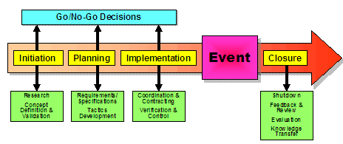
The Event Cycle in the EMBOK framework—comprising Initiation, Planning, Implementation, Event, and Closure—provides a systematic method for event management. This cycle ensures that each phase logically progresses from the preceding one, promoting a more unified and purposeful planning process (Robson, 2008). Every phase plays a role to the event's success, as research shows the significance of phase-specific objectives and resource allocation for successfully handling complications (Bowdin, 2011; Stokes, 2008).
During the Initiation phase, significant choices are made to guarantee alignment with the community's requirements and the event's financial goals. At this stage, knowing the distinctive characteristics of a family-centered event permits organisers to personalise their approaches for an inclusive and community-oriented atmosphere, as demonstrated in successful charity events (Bowdin, 2011; Filo et al., 2009).
In the planning phase, logistics including obtaining the rental of Hyde Park, putting together the marketing strategy, and the organisation of sponsorships have been finished. An efficiently planned logistics strategy guarantees an uninterrupted operation of aspects such as Santa’s Workshop and vendor arrangements. Research shows the importance of careful preparation in managing large-scale events, and it helps minimise risks related to crowd control and scheduling (Li, 2017).
The Implementation phase focuses on the practical arrangement related to setting up festive installations and facilitating easy registration. Real-time adjustments and resource optimisation are essential, permitting adaptability to challenges during setup (Shen and Liu, 2023).
On Event Day, a systematic timeline directs the activities, from the arrival of guests to the rotation of events. The focus on operational efficiency guarantees a positive participant experience, a priority confirmed by research on event-day management practices throughout various contexts (Theodorakis et al., 2015).
In the Closure phase, cleanup, financial reconciliation, and post-event evaluation provide insights for future growth. The systematic post-event evaluation corresponds with EMBOK’s standards for ongoing improvement, completing the cycle while creating a basis for bettering future events (Dwyer et al., 2016).
Following the Event Cycle, the Festive Family Fun Run can strategically utilise each phase to improve its social and financial outcomes, ensuring a significant experience and an efficient event operation.

- Event Concept
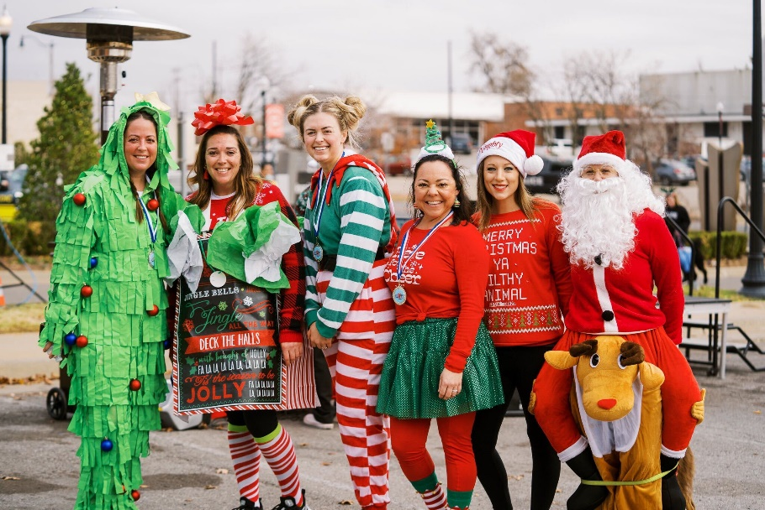
The Festive Family Fun Run offers a carefully crafted itinerary, starting with an exciting, themed run through Hyde Park, allowing participants of all ages to participate in a festive, community-oriented experience. The fun run, surrounded by a wintry landscape, offers families a distinctive combination of fitness and festive cheer. Activities like Santa’s Workshop, which provides seasonal crafts and gift-making stations, contribute to the experience by increasing active participation for children and families. A food village displaying the local vendors products, provides festive delicacies that strengthens the experience and accentuates the importance of supporting local businesses, an important aspect of community-oriented design for events (Stokes, 2008; Mayfield and Crompton, 1995).
The engagement strategy for this event has been created to have a lasting impact. Each component—fun runs, workshops, and festive treats—is meticulously designed to cultivate repeat attendance and community devotion. Such events grow by creating memorable experiences, helping participants to leave with a stronger sense of community and collective memories. This method corresponds to the principles outlined by Pegg and Patterson (2010) as essential for encouraging visitor satisfaction, as it aligns with their motivations and social requirements, growing the overall experience quality.
The event's family-oriented nature is fundamental to its design, aiming at local families, tourists, and community organisations seeking enjoyable, affordable activities during the holiday season. The Festive Family Fun Run integrates recreational activities with social components, celebrating seasonal joy while cultivating an inclusive environment that promotes communal values and traditions, that helps building local connections and boosting tourism (Stokes, 2008).

- Aim and Objectives
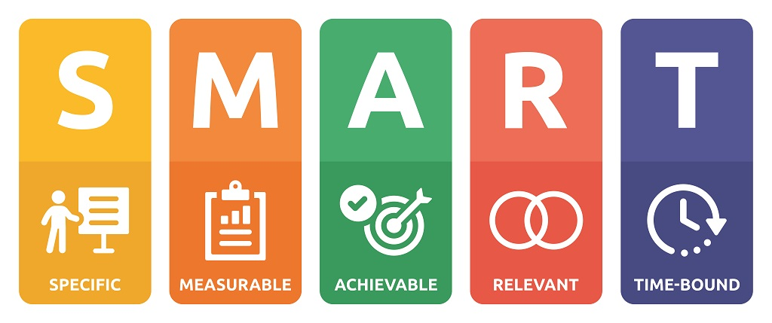
The principal objective of the Festive Family Fun Run is to organise a revenue generating event that significantly benefits community welfare and produces significant donations for local charities. This objective corresponds with community-oriented event planning, which highlights the mutual advantages of integrating philanthropic aims with public involvement (Fechner et al., 2022).
SMART Goals for Festive Family Fun Run
- Increase charitable funds by 20% through strategic sponsorships and an open registration framework, which improves donor involvement (Filo et al., 2009).
- Engage 10,000 participants through family-oriented marketing, promoting inclusivity and community engagement (Rhonda, 1999).
- Obtain sponsorships that cover a minimum of 40% of the event budget, which improves financial sustainability and positive community perception (Fasczewski et al., 2021).

- Event Management
A successful event management for the Festive Family Fun Run requires precise operational planning, community-oriented marketing, and careful risk management, all essential to maintaining a successful and safe experience.
Operational Requirements
Successful operations depend on detailed logistical planning, especially for a high-traffic location such as Hyde Park.
Reliable logistics facilitate seamless movement across event spaces, with staff concentrated on skilled volunteers to improve attendee experience. Contingency planning anticipates potential challenges, including overcrowding and medical emergencies. Real-time crowd density monitoring could prevent blockages and facilitate safe navigation through areas of congestion (Sharma et al., 2018). Additionally, assigning more staff at entry points and overseeing vendor locations could reduce risks while improving attendee comfort (Rahmat et al., 2011). SWOT analysis clarifies operational strengths, such as easy event layouts, while facing weaknesses, including insufficient parking. These strategies correspond with the 7Ps framework to make sure that the event is secure, effective, and pleasurable.
Space allocation and crowd flow must be optimised to facilitate the various activities—Santa’s Workshop, food stalls, and the race route—while ensuring clear and safe passageways. Research indicates that pre-event evaluations, including identifying potential blockages and placing controlled entry points, considerably lower risks (Bladen et al., 2012). Furthermore, the utilisation of obvious security measures and properly labelled facilities (e.g., portable restrooms, first-aid stations) promotes crowd safety and attendee comfort, which is recognised to improve the overall event experience (Rahmat et al., 2011).
Marketing Strategy and Framework
The event's community-focused marketing utilises digital platforms to engage families and local communities through channels such as Mumsnet and Netmums. This focused strategy increases event visibility within essential demographics, increasing participation and attendance (Laurell and Björner, 2018). Social media strategies, strengthened by influencer collaborations, widen the reach beyond typical audiences, permitting the attraction of both local families and international tourists seeking distinctive cultural experiences. The concentration on digital advertising aligns with recent changes in the promotion of events, where active participation by attendees through online communities promotes inclusivity (Wrathall and Steriopoulos, 2022).
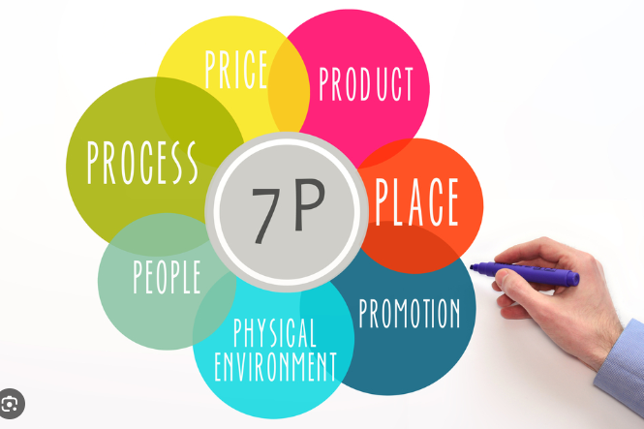
The marketing strategy for the Festive Family Fun Run use the 7Ps of marketing: Product, Price, Place, Promotion, People, Process, and Physical Evidence (Kotler, 2017):
- Product: A festive, family-centered event with a fun run, Santa’s Workshop, and a local food village.
- Price: Accessible pricing includes affordable admission, VIP tickets, and run registration fees (Andersson and Lundberg, 2013).
- Place: Hyde Park offers easy accesses for both locals and tourists (Smith, 2017).
- Promotion: Digital ads and influencer partnerships on family platforms like Mumsnet boost visibility (Laurell and Björner, 2018).
- People: Trained staff and volunteers increase family-friendly experiences (Rahmat et al., 2011).
- Process: Simplified ticketing and crowd flow reduce wait times (Sharma et al., 2018).
- Physical Evidence: Festive decorations and branded zones create an attractive, memorable setting (Bladen et al., 2012).
Additionally, by incorporating Maslow’s hierarchy facilitates the customisation of messages to meet participant needs, which include building a secure, family-oriented atmosphere (safety needs) in encouraging a sense of community and belonging (social needs) (Pegg and Patterson, 2010). This strategy creates participant satisfaction and increases the event's attractiveness.

Risk Management
The approach to risk management for the Fun Run adopts a stratified methodology, integrating preventive safety protocols with immediate risk mitigation strategies. Preparatory measures, such as fire safety compliance and crowd control training, are essential for reducing risks (Robson, 2008). Furthermore, technological innovations in crowd density monitoring provide effective solutions for managing high-traffic areas. Surveillance systems can identify crowd accumulation, facilitating prompt intervention to prevent escalated situations, as examined by Sharma et al. (2018) in similar event scenarios.
These components merge to build a resilient management framework, confirming that the Festive Family Fun Run is pleasurable and safe, while expanding community confidence through reliable safety measures and exciting marketing initiatives.
Competitor Analysis and Best Practices
Famous competitors such as the Race for Life and Hyde Park’s Winter Wonderland prioritise excellent crowd management, thematic experiences, and solid community connections. Using best practices such as crowd density tracking and tiered sponsorships, the Festive Family Fun Run can improve operations, increase engagement, and conform to industry standards (Bowdin, 2011; Sharma et al., 2018).

- Event Budget
A detailed budget plan is necessary for the Festive Family Fun Run, incorporating revenue and expenses to guarantee financial sustainability. By specifying precise costs and revenue streams, we can pinpoint areas for efficient allocation of resources and obtain the necessary funding for a successful event.
Expenditure Breakdown
- Venue Rental and Permits: Estimated at £50,000, Hyde Park’s rental includes seasonal demand fees and necessary licenses, ensuring accessibility and compliance with city regulations (Smith, 2017).
- Staffing and Security: Approximately £20,000, covering wages for event staff, security and volunteers.
- Workshops and Setup: Santa’s Workshop and crafts area setup costs are estimated at £25,000, including tent rentals, decorations, and activity materials (Smith, 2017).
- Marketing and Advertising: Digital and local advertising, projected at £12,000, relying on family-oriented online platforms.
- Miscellaneous Costs: £10,000 for insurance, utilities, and unforeseen expenses.
Revenue Sources
- Sponsorship: Through a tiered sponsorship approach, the aim is to raise £80,000 by offering businesses exclusive visibility and branded activity zones (Andersson et al., 2013).
- Ticket Sales:
  - VIP Tickets: 500 tickets at £150 each, projected to generate £75,000.
  - General Admission: 7,000 tickets at £20, estimated at £140,000.
  - Fun Run Registration: 3,500 runners at £25, totaling £87,500.
- Vendor Fees: 50 food and merchandise stalls at £600 each, totaling £30,000 (Smith, 2017).
Financial Viability
Implementing strategic cost-saving measures, including negotiating early deals with suppliers and obtaining local grants, reduces financial risks. Utilising volunteer staff for specific positions increases budget efficiency while building community involvement (Wrathall and Steriopoulos, 2022). The event is expected to be profitable, supporting both operational requirements and charitable donations through meticulous planning.
Break Even
The break-even analysis indicates that an average ticket revenue of £27.50 necessitates the sale of approximately 4,255 tickets to make up the total fixed costs of £117,000. Presented here is the table:
Category/Metric | Calculation/Amount | Result
Fixed Costs: Venue Rental and Permits | £50,000
Fixed Costs: Staffing and Security | £20,000
Fixed Costs: Workshops and Setup | £25,000
Fixed Costs: Marketing and Advertising | £12,000
Fixed Costs: Miscellaneous Costs | £10,000
Total Fixed Costs | £117,000 | £117,000
Revenue: Sponsorship | £80,000
Revenue: VIP Tickets (500 tickets at £150 each) | £75,000
Revenue: General Admission (7,000 tickets at £20 each) | £140,000
Revenue: Fun Run Registration (3,500 runners at £25 each) | £87,500
Revenue: Vendor Fees (50 stalls at £600 each) | £30,000
Total Revenue | £412,500 | £412,500
Break-even: Average Revenue per Ticket | £302,500 / 11,000 tickets | £27.50
Break-even: Break-even Point (in tickets) | £117,000 / £27.50 | 4,255 tickets
Profit Calculation: Total Revenue | £412,500 | £412,500
Profit Calculation: Total Costs | £135,000 | £135,000
Profit Calculation: Profit | £277,500 | £277,500

- Industry Trends, Issues, and Impacts
In the event industry, rapid technological advancements, sustainability, and inclusivity are transforming the design and experience of events. Mobile applications, data management systems, and online ticketing are becoming essential to event operations, facilitating easy information access and quick registration processes. Research indicates that applications boost attendee engagement by providing real-time updates, interactive maps, and event schedules, which leads to user satisfaction and fosters post-event loyalty (Sangkaew, 2019). Moreover, digital ticketing systems reduce paper consumption, complying with sustainable practices while lowering fraud risks through biometric identification and blockchain technology (Albshaier et al., 2024).
The recent development of hybrid events, combining in-person and virtual participation, signifies a crucial industry trend. Hybrid models facilitate event accessibility, allowing participation from individuals unable to attend physically, encouraging inclusivity. Studies demonstrate that hybrid and virtual elements lessen environmental impact by lowering travel-related emissions, an essential factor for sustainable event management (Kourkouridis et al., 2022).
Sustainability considers the utilisation of environmentally friendly materials and the implementation of inclusive practices. Research indicates that integrating accessible elements such as ADA-compliant pathways and alternative sensory experiences for individuals with disabilities promotes a more inclusive atmosphere (Bossey, 2020). Furthermore, the inclination towards sustainable materials, especially recyclable decorations and energy-efficient lighting, fits public expectations and builds community cooperation (Qiu et al., 2021).
When adopting these trends, events strengthen operational efficiency and engagement as they align with essential societal values of sustainability and accessibility, which are vital for future industry resilience and relevance.

- Situational and Cultural Considerations
To anticipate external factors, the Festive Family Fun Run needs an advanced approach to situational and cultural considerations, evaluated through a PESTEL analysis.
Political factors are crucial, as compliance with regulations and obtaining licenses from local authorities are required for organising an event in Hyde Park. Compliance guarantees compliance with environmental, safety, and accessibility regulations, conforming to London’s standards for public event management (Kara, 2018). These measures protect attendees while improving public perception of the event's organisational integrity.
The event's timing during a holiday season improves local businesses by contributing to tourism-related revenue. A study by Torre and Scarborough (2017) underlines that festivals revive local economies, particularly by improving the occupancy of hotels, restaurants, and shops and alleviating some financial difficulties families face during holidays.
Social factors, such as familial involvement and community pride, are essential to the event's success. Such events cultivate an overwhelming feeling of social connection and belonging by facilitating interactions between diverse community groups. Rivera et al. (2008) claim that culturally sensitive programming, honouring local values and traditions, can improve social inclusion and participation and fortify community bonds.
The event's design integrates inclusive elements that welcome attendees from diverse backgrounds. Providing bilingual signage, accessible services, and culturally respectful activities encourages diverse groups to feel appreciated. This methodology has been supported by research indicating that culturally inclusive events generate community pride and promote repeat attendance, making these design decisions essential for sustained success (Walters and Insch, 2018).
The Festive Family Fun Run merges community values with regulatory and economic considerations, building a culturally sensitive and contextually aware event strategy that satisfies diverse stakeholder expectations.
Conclusion
In summary, the Event Cycle within the EMBOK framework provides essential recommendations for managing large-scale events such as the Festive Family Fun Run. By implementing a tiered strategy, event organisers can anticipate difficulties, allocate resources efficiently, and synchronise each phase with broader goals, including ensuring safety, improving community engagement, and achieving financial sustainability. This report reveals how each phase—from initial logistics planning and budgeting to post-event evaluation—contributes to the event's overall success. Furthermore, embracing industry trends in sustainability, inclusivity, and digital engagement allows the event to fulfil modern expectations and cultivate a memorable experience. The Festive Family Fun Run, through strategic planning and execution, provides an enjoyable event, reinforces community values, and fulfils its charitable objectives, establishing a solid basis for future editions.
Recommendations
To improve attendees' comfort and accessibility, the visibility and accessibility of wayfinding should be increased through multilingual signage and strategically positioned facilities, including restrooms and water stations (Bossey, 2020). Adding rest areas can offer relaxation for families with children, elderly individuals, and people with mobility impairments. These changes are going to reduce attendee confusion, encourage inclusivity, and build a welcoming atmosphere for all guests.

Reference List
- Albshaier, L., Almarri, S. and Hafizur Rahman, M.M., 2024. A review of blockchain’s role in E-Commerce transactions: Open challenges, and future research directions. Computers, 13(1), p.27. https://doi.org/10.3390/computers13010027
- Andersson, T., and Lundberg, E., 2013. Commensurability and sustainability: Triple impact assessments of a tourism event. Tourism Management, 37, pp. 99-109. https://doi.org/10.1016/J.TOURMAN.2012.12.015.
- Bladen, C., Kennell, K., Abson, M., and Wilde N., 2012. Events Management: An Introduction. https://librarysearch.uwtsd.ac.uk/permalink/44WHELF_UWTSD/upgrip/alma99100147659902421
- BOSSEY, A., 2020. Accessibility in all areas? UK live music industry perceptions of current practice and Information and Communication Technology improvements to accessibility for music festival attendees who are deaf or disabled. International Journal of Event and Festival Management, 11(1), pp. 6-25. https://www.proquest.com/scholarly-journals/accessibility-all-areas-uk-live-music-industry/docview/2499002592/se-2?accountid=130472
- Bowdin, G. A. J. (2011). Events management (3rd ed.). Elsevier Butterworth-Heinemann. https://librarysearch.uwtsd.ac.uk/permalink/44WHELF_UWTSD/tj3s4p/alma99100158759802421
- Dwyer, L., Jago, L. and Forsyth, P. (2015) 'Economic evaluation of special events: Reconciling economic impact and cost-benefit analysis', Scandinavian Journal of Hospitality and Tourism, 16(2), pp. 115–129 https://www-tandfonline-com.ezproxy.uwtsd.ac.uk/doi/full/10.1080/15022250.2015.1116404#d1e205
- Fasczewski, K., Bramblett, P., Powell, S., Thornton-Brooks, J., and Stevens, N., 2021. Understanding Motivation for Physical Activity Charity Event Participation. American Journal of Health Behavior, 45 4, pp. 723-734 . https://doi.org/10.5993/AJHB.45.4.11.
- Fechner, D., Filo, K., Reid, S., and Cameron, R., 2022. Charity Sport Event Sponsorship as Value Creation Strategy: An Event Participant Perspective. https://doi.org/10.1123/jsm.2020-0139
- Filo, K., Funk, D., and O’Brien, D., 2009. The Meaning Behind Attachment: Exploring Camaraderie, Cause, and Competency at a Charity Sport Event. https://librarysearch.uwtsd.ac.uk/permalink/44WHELF_UWTSD/igoone/cdi_proquest_miscellaneous_20616086.
- Kara, E., 2018. A Contemporary Approach For Strategic Management in Tourism Sector: PESTEL Analysis on The City Muğla, Turkey. Journal of Business Research - Turk. https://doi.org/10.20491/ISARDER.2018.446.
- Kotler, P. (2017) Marketing Management. 15th edn. Harlow: Pearson Education.
- Kourkouridis, D., Frangopoulos, I. and Salepaki, A., 2024. POST-PANDEMIC TRADE FAIR DYNAMICS: A LONGITUDINAL STUDY OF EXHIBITORS'VIEWS ON DIGITAL AND HYBRID TRADE FAIRS. Geo Journal of Tourism and Geosites, 55(3), pp.1174-1185. https://www.researchgate.net/profile/Dimitris-Kourkouridis/publication/383101339_POST-PANDEMIC_TRADE_FAIR_DYNAMICS_A_LONGITUDINAL_STUDY_OF_EXHIBITORS'_VIEWS_ON_DIGITAL_AND_HYBRID_TRADE_FAIRS/links/66bcb003311cbb094938ca16/POST-PANDEMIC-TRADE-FAIR-DYNAMICS-A-LONGITUDINAL-STUDY-OF-EXHIBITORS-VIEWS-ON-DIGITAL-AND-HYBRID-TRADE-FAIRS.pdf
- Laurell, C. and Björner, E., 2018. Digital festival engagement: On the interplay between festivals, place brands, and social media. Event Management, 22(4), pp.527-540. https://doi.org/10.3727/152599518X15300559276930
- Li, L., 2017. Design on Logistics Information Management System for Large Sports Events. . https://webofproceedings.org/proceedings_series/ESSP/ICEMET%202017/ICEMET_1112036.pdf
- Mayfield, T., and Crompton, J., 1995. The Status of the Marketing Concept Among Festival Organizers. Journal of Travel Research, 33, pp. 14 - 22. https://doi.org/10.1177/004728759503300403.
- Pegg, S., and Patterson, I., 2010. Rethinking Music Festivals as a Staged Event: Gaining Insights from Understanding Visitor Motivations and the Experiences They Seek. Journal of Convention & Event Tourism, 11, pp. 85 - 99. https://doi.org/10.1080/15470141003758035.
- Qiu, Y., Wang, H., & Zhang, Q., 2021. Energy-efficient and Sustainable Construction Technologies and Simulation Optimisation Methods. 2021 International Conference on E-Commerce and E-Management (ICECEM), pp. 341-351. https://ieeexplore.ieee.org/document/9637031
- Rahmat, N., Jusoff, K., Ngali, N., Ramli, N., Md Zaini, Z.M., Samsudin, A., Abd Ghani, F. and Hamid, M., 2011. Crowd management strategies and safety performance among sports tourism event venue organizers in Kuala Lumpur and Selangor. World Applied Sciences Journal, 12(12), pp.47-52. https://www.academia.edu/download/81236961/8.pdf
- RHONDA, W.M., 1999. Event sponsorship: An exploratory study of small business objectives, practices, and perceptions. Journal of Small Business Management, 37(3), pp. 25-30. https://www.proquest.com/scholarly-journals/event-sponsorship-exploratory-study-small/docview/220957144/se-2?accountid=130472
- Rivera, M., Hara, T., and Kock, G., 2008. Economic Impact of Cultural Events: The Case of the Zora! Festival. Journal of Heritage Tourism, 3, pp. 121 - 137. https://doi.org/10.1080/17438730802138139.
- Robson, L.M., 2008. Risk Management for Meetings and Events, Julia Rutherford Silvers. Butterworth-Heinemann. https://doi.org/10.1016/j.tourman.2008.03.006
- Sangkaew, P., 2019. An investigation of how the adoption of event mobile applications influences satisfaction and post event behaviours of business event attendees. . https://doi.org/10.15126/THESIS.00852071.
- Sharma, D., Bhondekar, A., Shukla, A., & Ghanshyam, C., 2018. A review on technological advancements in crowd management. Journal of Ambient Intelligence and Humanized Computing, 9, pp. 485-495. https://link.springer.com/article/10.1007/s12652-016-0432-x
- Shen, Y., & Liu, J., 2023. Research on Logistics Resources Optimization Allocation Under Emergency Events. 2023 International Seminar on Computer Science and Engineering Technology (SCSET), pp. 485-489. https://ieeexplore.ieee.org/document/10266462
- Smith, A., 2017. Animation or denigration? Using urban public spaces as event venues. Event Management. https://www.researchgate.net/publication/321076882_Animation_or_Denigration_Using_Urban_Public_Spaces_as_Event_Venues
- Stokes, R., 2008. Tourism strategy making: Insights to the events tourism domain. Tourism Management, 29, pp. 252-262. https://doi.org/10.1016/J.TOURMAN.2007.03.014.
- Stokes, R., 2008. Tourism strategy making: Insights to the events tourism domain. Tourism Management, 29, pp. 252-262. https://doi.org/10.1016/J.TOURMAN.2007.03.014.
- Theodorakis, N., Kaplanidou, K., & Karabaxoglou, I., 2015. Effect of Event Service Quality and Satisfaction on Happiness Among Runners of a Recurring Sport Event. Leisure Sciences, 37, pp. 107 - 87. https://www.tandfonline.com/doi/full/10.1080/01490400.2014.938846#d1e201
- Torre, A., and Scarborough, H., 2017. Reconsidering the estimation of the economic impact of cultural tourism. Tourism Management, 59, pp. 621-629. https://doi.org/10.1016/J.TOURMAN.2016.09.018.
- WALTERS, T. and INSCH, A., 2018. How community event narratives contribute to place branding. Journal of Place Management and Development, 11(1), pp. 130-144. https://www.proquest.com/scholarly-journals/how-community-event-narratives-contribute-place/docview/2010846007/se-2?accountid=130472
- Wrathall, J., and Steriopoulos, E., 2022. Event marketing and strategy. Reimagining and Reshaping Events. https://doi.org/10.23912/9781911635871-4965.

