Researching and Analysing Data
Student Name: Rabia Miah
Student Number: 1605763
Module Code: EMPL4012
Module Lecturer’s Name: Isaiah Oino

Contents
Researching and Analysing Data 0
Question: Is online shopping better than visiting a store and are the advancements in online shopping having a positive outcome on our society? 2
Additional articles that demonstrate online shopping is better than visiting the store and that technological advancements have a positive outcome on society: 4
Additional articles that demonstrate online shopping is better than visiting the store and that technological advancements have had a positive outcome on society 5

Question: Is online shopping better than visiting a store and are the advancements in online shopping having a positive outcome on our society?

Whether you want to buy food, clothing or electronics, it can all be done at the touch of a finger nowadays. Online shopping is becoming extremely common and most companies would not be as successful as they are without it. In 2016, approximately 87% of the UK population had purchased at least one item via an online shopping service. On the other hand, in 2010, roughly only 38% of the UK population had used online shopping before. This comparison clearly reveals that the audience for e-commerce is increasing rapidly and this may be due to technological advancements, like the iPad Air and 2-in-1 convertible touchscreen laptops, since going online is very easy to access because these devices are portable and fast. According to ReadyCloud 2017, mobile shopping is worth over £2.4 billion pounds now whereas 4 years ago it was around £1.2 billion pounds meaning that in just the past 4 years, the value of mobile shopping has completely doubled revealing that e-commerce is growing expeditiously.
An article published on the Guardian by Sarah Butler on the 21st of February 2013 reveals that one of the leading department stores, John Lewis, had decided to go ahead and join the empire of Collect+, which is a service that allows the customer at home to go and collect their goods from a local store. This arrangement appeals to a lot of people since many people are impatient and would rather receive their items quickly from a nearby store instead of travelling to the closest John Lewis, which may be miles away. This scheme works for click and collect orders, but the customer could just as easily get the goods delivered to their home, which means they do not even have to step foot out of their house. However, some purchases will have a delivery charge which usually ranges from £1-£10 and this is dependant on how quick the customer wants the delivery to arrive as well as how much the customer has spent in store. Sometimes, if the customer spends over a certain value, they will get free standard delivery or even next day delivery if there is a promotion. The click and collect option is always free from the John Lewis stores or the Waitrose stores since they are partnered companies, but nevertheless the Collect+ scheme may have an additional charge.
Online shopping does have a positive outcome on society because a lot of websites online offer a discounted price from what that item may sell for in store. Customers saving money from shopping means they can save for other things like holidays which can lighten their mood and bring them joy. Additionally, doing online shopping from home saves the cost of petrol for the customer and helps the environment since less fuel will be used up because less people are travelling to shops. When shopping in store, the customer may not be aware of how much they are spending simply because it is not common to carry a calculator around and add up the price of every item. When it comes to online shopping however, there is a basket which includes a subtotal and therefore the customer is informed of how much the items in the basket add up to, so they know if they want to spend any more money. A unique feature on some online websites is that you can customise your item to how you would like it, whether that be with certain colours or words or initials. This service is not really offered in stores and therefore inclines the customer to go online and customise their item.
Despite this, Online shopping can also have a negative outcome on society because it allows a customer to purchase goods without leaving their house and therefore they are less active and social. There is a potential risk that in severe cases this could lead to obesity, anxiety or depression. Furthermore, there have been many reported cases of online shopping addictions where people have had to undergo serious treatment and rehab sessions because they have become so hooked on and addicted to online shopping. The worst aspect of online shopping is the fact that there is a possibility of online fraud where a customer gets scammed. It is quite easy to stay away from dodgy websites but not everybody understands how to tell whether a website looks like it is legitimate or not. The best course of action would be to shop from mainstream retailers that are common and have shops around the world. Moreover, it can be a pain when it comes to returns since it is so simple when it comes to just going back to the store and either getting a refund or swapping items. The online method of refunds is to send back the item that is unwanted to the warehouse that it was despatched from and then when the company receives the item they will issue the refund, or an exchange for different items if wanted.

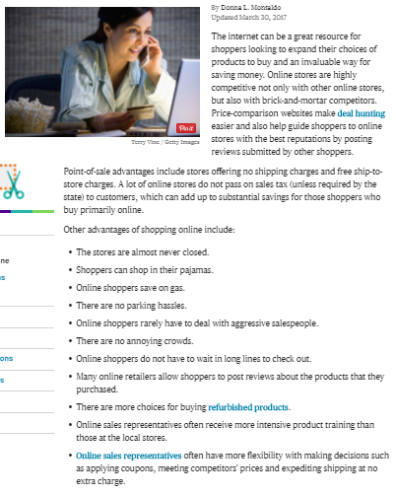
Additional articles that demonstrate online shopping is better than visiting the store and that technological advancements have a positive outcome on society:

Donna Montaldo, The Balance, March 30th 2017,
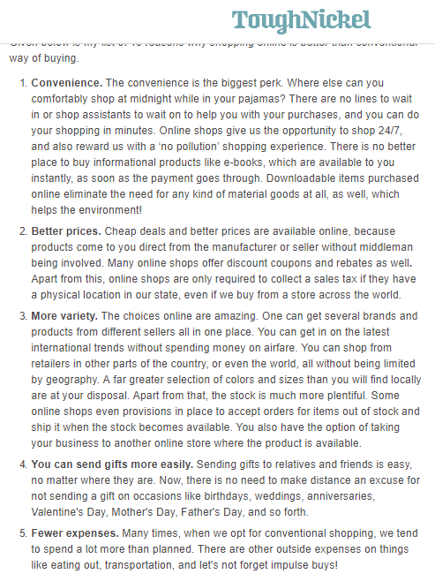
https://www.thebalance.com/the-pros-and-cons-of-online-shopping-939775

Anamika Jain, ToughNickel, June 12th 2017,
https://toughnickel.com/frugal-living/Online-shopping-sites-benefits
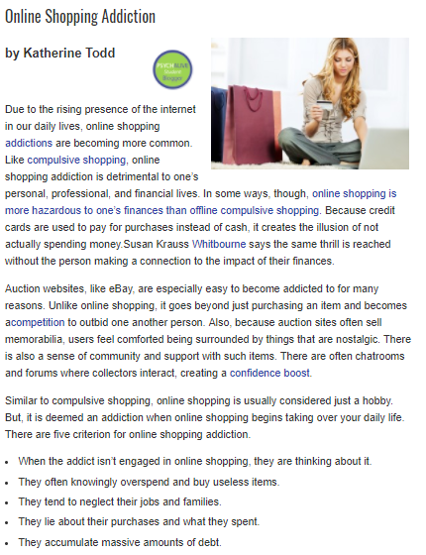
Additional articles that demonstrate online shopping is better than visiting the store and that technological advancements have had a positive outcome on society:

Katherine Todd, Psychalive, April 11th 2013,
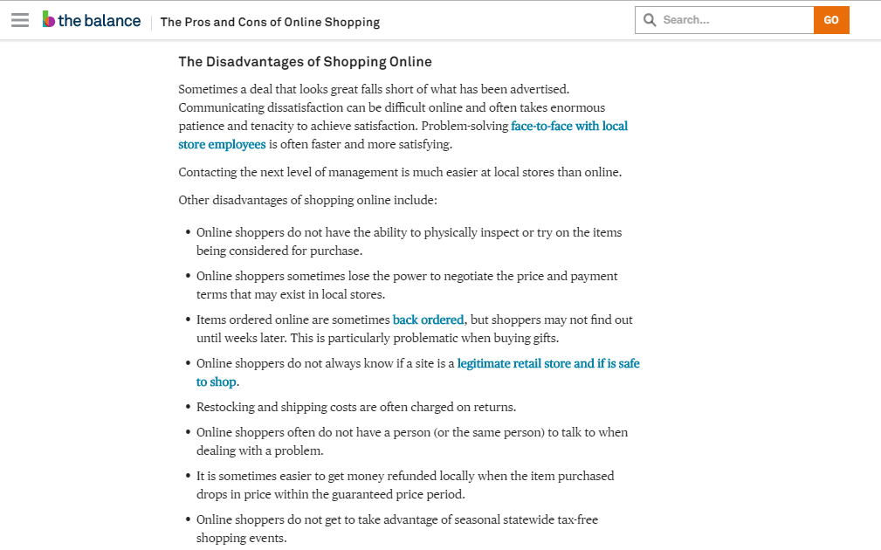
https://www.psychalive.org/online-shopping-addiction/
Donna Montaldo, The Balance, March 30th 2017,
https://www.thebalance.com/the-pros-and-cons-of-online-shopping-939775

