I chooses to do this test in a spesifc order so I can get the maximum out of my client. I started with her hight, weight and blood pressure as she doesn’t have to do anything that will caluse fatigue or use much energy. Then I made my client do the grip strength as shes just standing still and squeezing as hard as she can. Next was the sit and reach test as it it thr same as the others not as much energy she is putting in. the second to last test was the the sit up as she will needed to use more energy to be able to test as she had to use more energyand muscular strength to keep doing in for a longer period of time. Finally, was the step up test I done this last as it is a cardiovascular test that will be more tyiering but I csn see how she will do with this test being last and that she hasn’t done much before it.

Body Mass Index (BMI) has been the go-to metric for assessing weight status for over 150 years. But for athletes and muscular individuals, BMI often tells a misleading story. This comprehensive guide explains why BMI fails athletes, what metrics work better, and how to accurately assess your body composition. BMI Calculator (2026) BMI for Athletes: Why Standard BMI Fails Muscular People. Available at: BMI for Athletes: Why Standard BMI Fails Muscular People | BMI Calculator ( Accessed 26 March 2026).

Blood pressure (BP) dynamics during graded exercise testing provide important insights into cardiovascular health, particularly in athletes.
Exercise blood pressure (BP) monitoring has become a new era in cardiovascular diagnostics, particularly for athletes. It offers a broader perspective than traditional resting BP measurements, capturing the unique physiological adaptations that athletes undergo during intense physical exertion
(Pesova P et.al 2023)
The grip strength was next. The handgrip strength (HGS) is a simple and reliable measurement of maximum voluntary muscle strength. It is an important tool for diagnosing sarcopenia and is widely used as a single indicator to represent overall muscle strength . HGS it can also predict not only muscle mass and physical activity. The grip test also sees how strong you are when keeping the arms by the side and keeping to there to get the correct score. This has also been proven to see if there is any chronic diseases, nutritional status, quality of life, independence of daily life, length of hospital stay, and even mortality to a induvial .
Hand grip strength (abbreviated as HG or HGS in the scientific literature) is one of the simplest and most frequent methods of measuring muscle strength in clinical conditions. For this reason, it has been the focus of interest of many scientists all over the world for a long time.
The hand grip strength test serves the purpose of a diagnostic indicator, providing information, for instance, on the patient’s nutritional condition, or the purpose of a predictive factor, for example, of post-operative complications, injuries development of diabetes, mineral density of bones, dementia , and sarcopenia, as well as general health prognosis, i.e., mortality rate and a prophylactic means in the screening tests .
The second to last test was the sit ups Sit-ups are classic abdominal exercises done by lying on your back and lifting your torso. They use your body weight to strengthen and tone the core-stabilizing abdominal muscles. This Is a muscular strength test that will see how many you can do in a minute.
Sit-ups work the rectus abdominis, transverse abdominis, and obliques in addition to your hip flexors, chest, and neck. They promote good posture by working your lower back and gluteal muscles.
With a larger range of motion, setups target more muscles than crunches and static core exercises however you will need to get the correct form to make sure it is hitting all of these muscle.
Sit ups are the repeated muscular action and will help to improve and it so one of the most important components of physical activity as it will help in a day to day lifestyle. ( terry J. housh etal laboratory manual pg.202 30 march)

And finally ended it with the step ups test. When most people think of leg training, they picture squats or lunges. But one of the most underrated and effective lower-body exercises is the step-up. It’s simple, accessible, and incredibly functional — meaning it carries directly over into how you move every day such as walking running moving up and down stairs or even basic gym moves, stepping out of your car. By you performing a version of the step-up. Training it deliberately helps you move better, stay strong, and reduce your risk of injury.
Builds Real-World Strength and Balance
The step-up is a single-leg movement that develops strength, stability, and coordination at the same time. Because you’re working one leg at a time, it exposes and corrects imbalances between sides — something that’s common in nearly everyone. This will teach you basic movement that most people will use.
By doing this with each rep teaches your brain and body how to control movement through your hips and knees, building strength that actually transfers into everyday actions like lifting, carrying, or walking up stairs with ease. Instead of not knowing what to do or being stiff
By doing this the they are using primary movers in the step up such as your glutes hamstring and quad but it also is to help stabilise muscle and everything else round your hip knee and ankle as they are working just as hard as the other muscle.
This makes the step-up one of the best exercises for developing lower-body control and resilience, especially if you spend a lot of time sitting or have experienced hip or knee discomfort.

Sit and reach test is a test that shows the flexibility of an individual and also the range of movement behind a specific joint. The sit and reach test is where you see the movement of how flexible the hip joint is. ( terry J. housh etal laboratory manual pg.202 30 march)

I wrote down the score and data that my client done. When I was taking my client hight I asked them to take off their shoes and to stand up tall so I can take the accurate hight. After that I told them to stand on the scale so I can take her weight. Once I done that I was then able to calculate my clients BMI. By doing this I need to square the hight by itself and then divide it by the clients weight by your clients hight. When doing blood pressure I made my client sit down and not to talk or move for a few minutes. Once that is done I put the cuff of the blood pressure on and take her client blood pressure.
When carrying out the step up test I made sure that I followed the queen college step up test. I made sure that sure that I had the step on the right hight of 41.3 cm. however when doing the strength test I made sure that my client hand was in the right place and her hands where by her side and squeezed to get the her score. I done this 3 times then calculated the mean. The sit up test is when I have my client lay on there back with there feet 18 inches apart. When doing out the test I set a timer for a minute and they have to bring the elbow to the opposite knee and repeat this till the timer is completed. I
However in the in the sit up test I can see that my client struggled with this one more as she was in the very poor section as even though she was doing the setup she was also struggling on the form and how they should be done when brining her elbow to her knee. She was also struggling to keep her feet wide apart even though when I was holding he feet down.
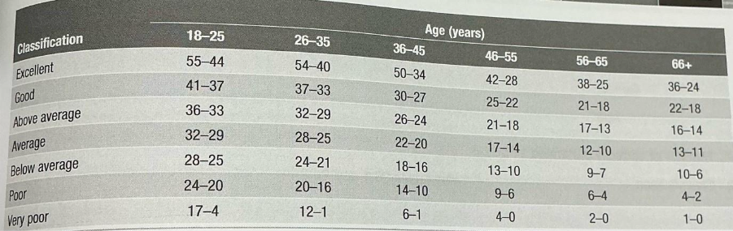

When doing the step ups test I placed I made sure that my client shoes where off and place there feet on the box with there legs straight. Once they done this I made sure that their finger tips where touching and will be able to reach to the furthest place they can reach. Once I my client has done all of the test I look for the normative data and see how well my client has done in their test.
We can see that my client in the queen college step test she was in the in the fair section as she was in the 29.0-32.9 in the ages 20-29. This is when women n have to do 22 steps per minute which will have the beat of 88 beats per minute on the metronome. When I done this I took her heart beet after 5 seconds she done this test to be able to see what category she will be in.

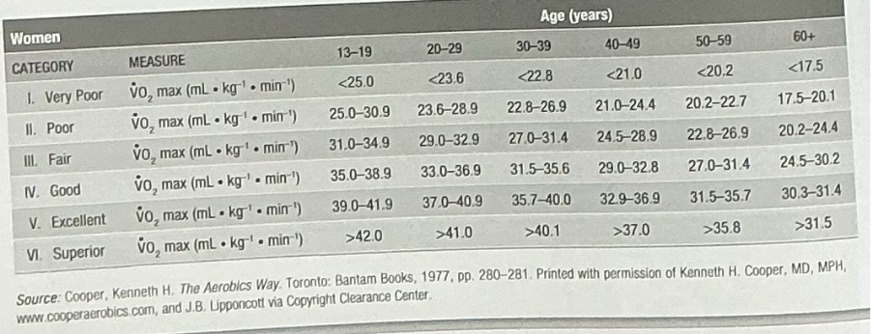

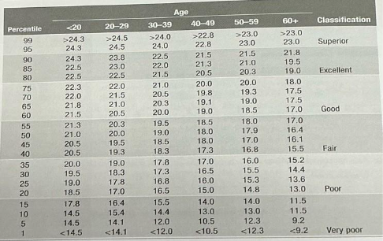My client done well in the sit and reach test as all of her score she git was in the superior as all of her score was above 24.5 with her highest score was 32 and her other two was in the high 20. This shows that my client has good flexibility as she can reach in the 30.

The normative data fort my client bmi was class as obese due to her weight being 84.4 and that she is only was only 167.5 cm tall. By her hight and weight being this her body mass index is just in the category of being obest with it being 30.1. however her blood pressure she is clast as having high blood pressure or also known as hypertension as a normal blood pressure is 120/80. I can see that my client has high blood pressure as when I done it her blood pressure was 134/93.
Using the normative data I can see that my client systolic blood pressure was in the prehypertension as it is in-between 120/139 however with her diastolic he in in the stage 1 hypertension as she is between 90-99.
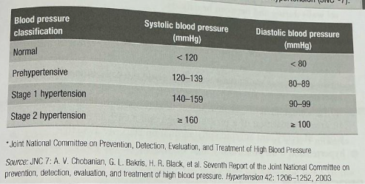

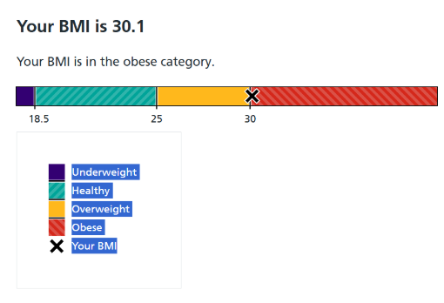
This figure shows from the nhs heath of my clients BMI.
The drip strength my client was in the 20% of her average mean was in the 38. This is where I took the test 3 time on the same hand and then added all of her scored up and dived it by 3 to get her average score from all 3 test.
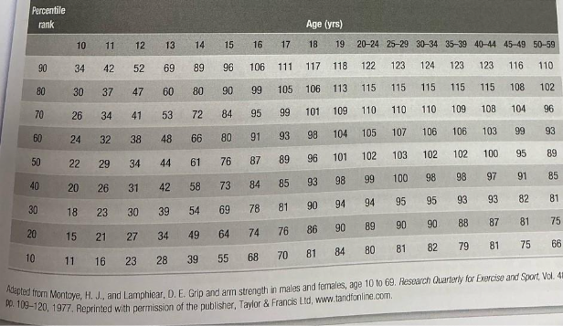
For my client she should do more stretching to help with my clients flexibility. She should also should do walking up and down stairs to improver her heart rate to help her get better with her queen college step test. this will help my client in everyday lifestyle activity such as running lifting housework job and may more.

BMI Calculator (2026) BMI for Athletes: Why Standard BMI Fails Muscular People. Available at: BMI for Athletes: Why Standard BMI Fails Muscular People | BMI Calculator ( Accessed 26 March 2026).
Congleton, E., (2023) 9 Benefits of Sit-Ups and How to Do Them. Available at: Sit-Ups Benefits: Exercises, Variations, and More ( Accessed: 26 March 2026)
GHOSH, V., 2024. ASSESSING ATHLETES NEEDS ANALYSIS, PAR-Q QUESTIONNAIRE, AND DETERMINING ENERGY NEEDS FOR PHYSICAL ACTIVITY.
Jarvis S., (2025) Why Step-Ups Are a Cornerstone of Functional Strength Training. Available at: Why Step-Ups Are the Ultimate Functional Strength Exercise — Simon M Jarvis (Accessed 26 March 2026).
Lee SY. (2021) Handgrip Strength: An Irreplaceable Indicator of Muscle Function. Ann Rehabil Med. Jun;45(3):167-169. Available at: doi: 10.5535/arm.21106
Pesova P, Jiravska Godula B, Jiravsky O, Jelinek L, Sovova M, Moravcova K, Ozana J, Gajdusek L, Miklik R, Sknouril L, Neuwirth R, Sovova E. (2023) Exercise-Induced Blood Pressure Dynamics: Insights from the General Population and the Athletic Cohort. J Cardiovasc Dev Dis. Nov 29;10(12):480. Available at: doi: 10.3390/jcdd10120480 .
Szaflik, P., Zadoń, H., Michnik, R., & Nowakowska-Lipiec, K. (2025) Handgrip Strength as an Indicator of Overall Strength and Functional Performance—Systematic Review. Applied Sciences, 15(4), 1847. Available at: https://doi.org/10.3390/app15041847
Terry J. housh, Joel T. Caramer, Joseph P.weir, Travis W. Beck, Glen O Johnson laboratory manual for exercise and physiology exercise testing and physical fitness

