2020
Andrei Agopian (1905498)

Developing Workplace Critical Thinking
BMSW5101

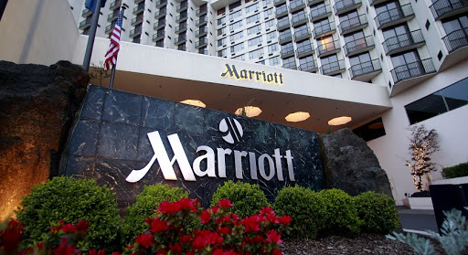
Lecturer: Gregory Cowan
COVID19 in The Workplace Context and The Path to Resilience

Table of Contents
Executive Summary 2
Introduction 3
Marriott International Hotel Group 3
Key Management Theories 4
Workplace Behaviour 7
Beliefs 7
Attitudes 7
Values 8
Analysis 8
The Workspace in the Post-COVID-19 Mindset 10
Marriott Workplace – The Family 10
The Future 11
Creating a Resilient Business 13
Critical Evaluation 14
Long-term side-effects 14
Increased Competition 14
Conclusion 15
References 16
Appendix 18

Executive Summary

In the final days of December 2019, news from the World Health Organization officially acknowledged the emergence of a new virus with the capability of rapidly infecting humans, in the Wuhan Province, China. Similar in structure with the Middle Eastern respiratory syndrome virus, which was contained to the region, the world was taken by surprise by an entire year of rapid changes.
With this analysis our objective is to determine what makes up the workplace within Marriott Hotels International and how that workplace will withstand in the current socio-economic tableau, drastically influenced by the background of the SARS-COV-2, known also as Covid, Covid19 or the Corona virus. To achieve this purpose, we look at management theories and what type of job setting they each provide, what style the hotel group adopts and what type of employees it attracts. Furthermore, we will examine an employee’s mindset in depth, looking at beliefs, attitudes and value systems and see how each of these elements fit in with Marriott and how will they align in the future (Zhao et al, 2020).
The final part will contain a series of recommendations, from updating standard operating procedures to a shift in organizational management, which will help pave the way to a resilient business model.
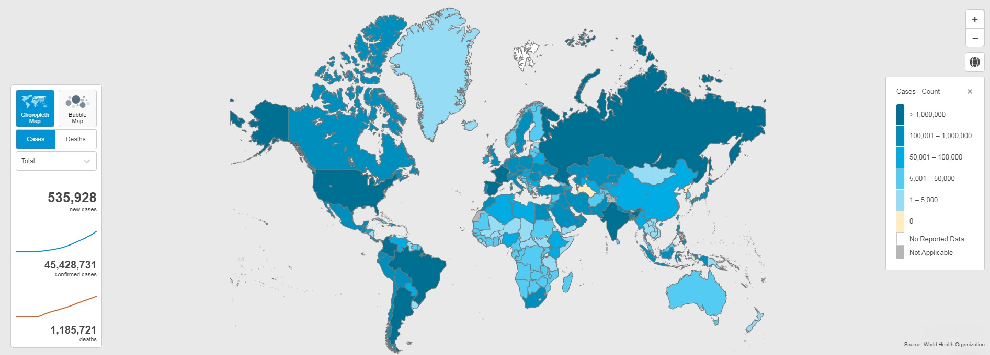
Figure 1 showing case numbers across the world in October 2020, source WHO (“https://www.who.int/”)

Introduction

Marriott International Hotel Group

From the early days of the Hot Shoppe to the current conglomerate, Marriott has continued to expand and extend its business potential. So much so that in the span of 5 years the figure describing total assets the company holds increased by 2 billion dollars per year. The exception being the contrast between 2015 and 2016, where the assets increased 4 folds, from 6 billion total to 24 (Wall Street Journal, 2020).
Such a growth was possible due to multiple management strategies the company employs at different levels. Most predominantly, Marriott is highly able at differentiating its products and appealing to customers from different backgrounds. Their fluidity in adapting to the ever-changing customer demands has proven efficient and allowed Marriott to remain competitive at all levels, be that when it comes to budget hotels, as well as luxury brands. Cost reduction, uniqueness of experience, customer data management and profile creation, alongside global presence, makes Marriott a shareholders’ preferred growth stock.
In implementing the market differentiation strategy, the decision-makers were quick to understand that they needed to apply it on all operational levels. This is reflected from the diversity of brands offered, one of the most recent ones being Edition, a cooperation between Marriott and Ian Schrager. The partnership between them giving birth to an iconic experience based on ground-breaking concepts and adding an upper layer to the word “luxurious” (Hui et al, 2013).
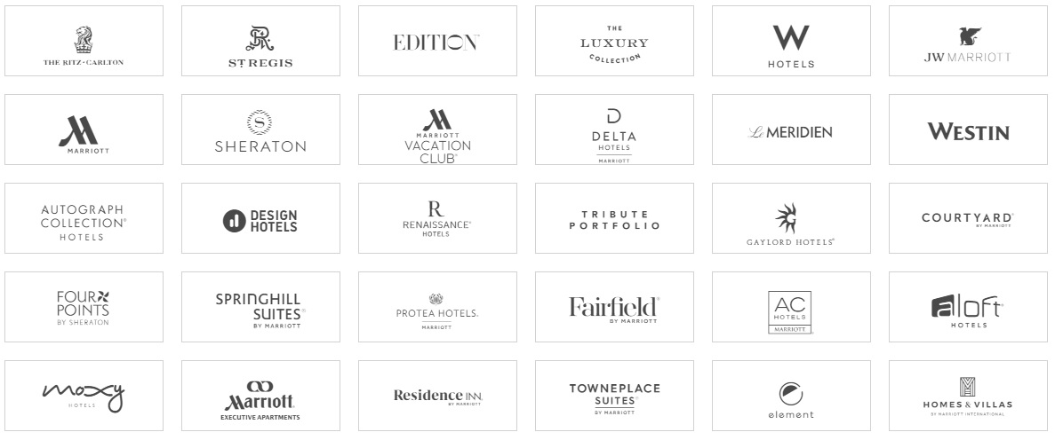
Figure 2 Marriott Brands, taken from Marriot.com

Key Management Theories

From the earliest moments of human civilization, the need for organisation manifested itself, without it, humans being exposed to a wide array of threats. Moving from Ancient Greece or Sun Tzu’s China, we come to more current times, where these theories have been refined and diversified. To better dissect a company the size of Marriott, we need to firstly look at the tools at our disposal.
In the book written in 1960 by Douglas McGregor – “The Human Side of Enterprise”, the author, an American social psychologist, proposes the X-Y theory. The basis of which stands on two types of managers, X – the authoritarian and Y – the participant. The literary work’s main idea is that under an authoritarian style of management the results are scarce, whereas in a participative and idea-sharing-oriented culture, they are bountiful. By an X style manager, we refer to someone who is results-driven at the expense of people’s morale, a person that directs from a far, issuing an order and expecting it to be executed as per his or her instructions. On the other side of the spectrum, we have the Y camp which encourages input from employees and where the tasks are not seen as being burdens. While the former is suitable for a military operation and perhaps in a situation where the manager cannot fully rely on the intellect of the individual, the latter is appropriate for the business environment and promotes a problem-solving environment. In 1981, William Ouchi wrote “Theory Z: How American business can Meet the Japanese Challenge” in which he suggests that the best approach would be the combination of both, alongside a few elements of Japanese work mentality: loyalty, discipline, dedication to the greater good (Render, 2006).
Going beyond the normal operating routine of a business, and strongly based on Taylor’s scientific management theory and Weber’s bureaucracy model, we have the contingency theory. This method expands from leadership models and aims at ensuring that organizations are adaptable and resilient in the face of unforeseen events. The most encountered applications for this theory are when a company must adapt to changes in technology, external pressure from groups, new legislation, employee demands, customer management and more importantly in dealing with supply and demand imbalance. There are here two schools of thought, one belonging to Fred Fiedler and the other to Gareth Morgan. Both of them are proponents of the idea that organizations are evolving entities and thus there is no single leadership style that suits them, but a various number, hence success is guaranteed by the ability to critically assess a situation and apply the most adequate method to it. Where Morgan was focused on organizational structure, Fiedler outlines the main characteristics of a great leader and focuses on change there. He asks himself what the level is of the influence the leader has within the organization, what type of interactions exist within the group, and what is the design of the ongoing assignment (Clegg and Bailey, 2008).
Another concept in management is the human relations theory. Born as a counter to Taylor’s view of an organization who advocates that human feelings and well-being are of little to no importance to the business success, the human relations theory focuses on three key aspects. At its core is the value of the individual, taking the stance that an employee is more than another part in the machine, suggesting that in order to maximise production, a manager must ensure that individual characteristics of the employee are respected. The other layer of this theory looks at the informal groupings in the work environment: what matters to an employee is not necessarily the company’s structure, but his interactions with his fellows. Thirdly, the human relations theory encourages input from the co-workers, claiming that the path to employee happiness is their participation in decision-making.
On the opposing spectrum of management theories, we have the bureaucratic method. From early proponents such as Max Weber to the American president Woodrow Wilson, this theory lives on in our day to day lives. It revolves around a strict and clear repartition of tasks within an organization, a well-defined management structure and specific rules of conduct. It is one of the theories that suggests uniforms – a task-oriented attire – and an environment that limits fraternization, all the while, ensuring any promotions are granted based on individual achievements (Weber, 1957).
Henri Fayol was the creator of one of the most encompassing theories of management, as well as the human relations theory, his administrative management one exists in contrast to Taylor’s scientific approach. Starting off as an engineer in a mining company and then working his way up to the position of managing director, Fayol outlines his theory in 14 principles: division of labour, authority with responsibility, discipline, reduction of conflicting instructions by appointing a single direct supervisor for a team, unity within a project (when two or more teams work on the same task they should be led by a single manager), coming together for the greater good, fair pay, clear vision for the employee on where they stand when it comes to decision making, the importance of transparency within the hierarchy, cleanliness and health and safety at work, managers must conduct themselves in a fair manner, allow initiative on employee’s side, and lastly “Esprit de Corps”, a focus on team spirit.
The final tool in our arsenal needed to dissect Marriott International is Frederick Taylor’s scientific management theory. With a background in engineering, Taylor focused on optimizing production and efficiency within the workplace, with the ultimate goal of pushing an organization to its maximum potential.
Embracing the motto “a fair day’s pay for a fair day’s work”, this theory can be summed up in four principles. First, study the task at hand and define the optimal means of completing it, thus allowing no space for improvisation. Secondly, find the right person for the job and ensure that the employee’s abilities are enhanced by training. Thirdly, constant supervision and performance checks to enforce adherence to the methods prescribed. And lastly, a division of roles between manager and worker to ensure the former is focused on constant improvement (Wren and Bedeian, 2009).
After presenting the methods of analysis above in depth, a few things come to the foreground when it comes to Marriott. Due to the necessity of the business to be present worldwide and having to provide the same level of customer experience and employee training on a global scale, the widely embraced theory of management is the scientific method. The business constantly develops new procedures and training regimens for its employees, with the aim of becoming more cost-effective and ensure all processes are streamlined. To give a specific example, - after studying the training manuals the company provides a new employee - it emerges that there is only one method for handing a key to a guest. But if on a global scale the method applied is scientific, when it comes to division between its brands, Marriott acts on the contingency spectrum, more precisely on a Morganian view, where specific means of operating and interacting between business and customer are refined to best suit their designated environment. Furthermore, at an individual operating entity level, we discover that Marriott functions a lot on the X-Y spectrum, where in some hotels the focus may fall entirely on the rigid authoritarian approach, whilst in others, allowing for a strong bond between upper management and low-level employee (Dul and Ceylan. 2014).
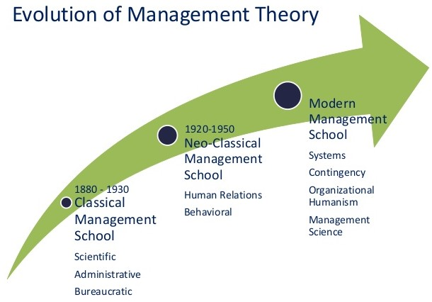
Figure 3 Showing the evolution of management through time, credit to “vskills.in”

Workplace Behaviour

The totality of actions, interactions, attitudes, beliefs and culture within an organization, which may impact on its level of performance, constitutes workplace behaviour. In the following lines we will look at these in depth and attempt to create an image of what that entails for Marriott and its associates and how COVID-19 impacted it.

Beliefs

When we talk about beliefs, we refer to a conclusion about the way things function in the world. It may or may not be accurate as it does not require evidence, other than our own previous experience. A manager might be of the belief that training his/her employees will yield better results, despite the fact that the monthly employee reports from the HR department suggested that everyone knows what they’re doing, however the company’s remuneration is not in line with what the employee expects. In our scenario, the manager will not get the results they want, however the concept exists outside the working environment, where one might avoid walking under a ladder because it brings bad luck. Another aspect that emerges is that they’re hard to challenge even in the face of uncompromising truth: the person in our second example wins the lottery the day they walked under a ladder but may think that they would have won more had they not chosen the wrong path (Behrendt, 2012).
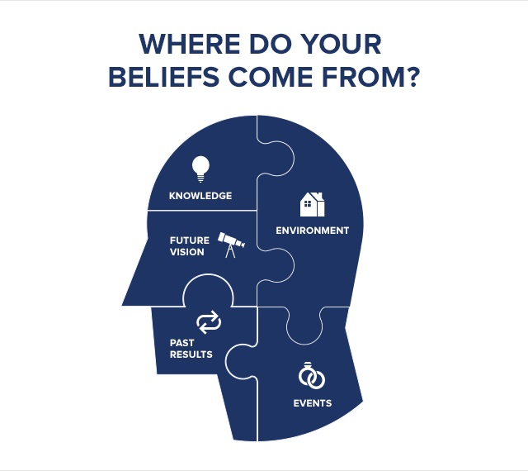
Figure 4 origin of beliefs from Tony Robbins (“tonyrobbins.com”)

Attitudes

Where beliefs are formed internally and generally exist within one person’s mind, an attitude is how we respond to things in our environment. In the job setting, an example would be a change of procedure without due consultation with the employees involved. They in turn will believe the change was incorrect and have a negative attitude towards it. From here stems the idea that in the workplace there are mainly two significant aspects to consider when it comes to attitude: job satisfaction and organizational commitment. The level of importance an organization attributes to these two factors is visible through the numerous surveys they conduct, to quote findings from Gallup, 90% of people interviewed were happy with their current job, whilst the Society for Human Resource Management noted that 40% were extremely happy with their current standing. As for the second attitude, organizational commitment, we look at the level of emotional attachment an employee has for his/her current company.

Values

A company’s values are determined by what it stands for, its ultimate goal and final destination. It can be cynically seen as the point where a company decides to take a hit in the profit margin with the scope or preserving its integrity. In most cases these are included in a mission statement and are most often than not written down. As a difference from the concepts highlighted above, values are always instilled top-down, being the responsibility of higher management.

Analysis

For clarity we will look at Marriott’s core values and how COVID-19 strengthened or weakened them. “We Put People First” is what the company promotes, and throughout the years they stayed true to it. It is perceived as one of the best employers when it comes to career progression, within each hotel there are various groups aimed at the well-being of an associate. It is one of Marriott’s top executives that coined the saying “look after your people and the people will look after your revenue”, however the global lockdown forced the company to let go of 30-40% employees and 15-20% of the corporate positions were made redundant, an approach that shows more concern for profit rather than people. More so, it highlights that by “people” in the aforementioned phrase refers to “our people” rather than the average employee. Marriott also advocates the pursuit of excellence, and this was clearly reflected in the trainings provided to staff, most people using the company as a steppingstone to a higher place, as seen by the high employee turnover that onto bigger projects. During COVID-19 however all but essential training has stopped – of course, alongside new hires – and standards have significantly dropped, as reported by people who used the facilities when regulations began to relax. Furthermore, Marriott claims it “embraces change”, a feature most visible when we look at the company’s history: from beverages to meals and finally to hotels and resorts. In contrast to that we see several times in the recent history of the company where it failed to do its due diligence and protect customer data by upgrading its systems. Expanding from this, the next core value the company is known for is “we act with integrity”, but according to a recent article in The Washington Post, they were deceiving customers about room prices and services offered. “We serve our world” is the last pillar of the Marriott philosophy, and as all large conglomerates, their CSR team is doing an amazing job at creating awareness about sensitive topics, supporting endangered species and getting involved in the community. On the negative side is the failed attempt of opening a hotel in Kabul and the company’s reputation of staining a green paradise with a grey block of cement. Putting it all together it becomes clear that by “we” in their mantra the company is referring to a handful of shareholders, completely disconnected from the original vision the founder had.
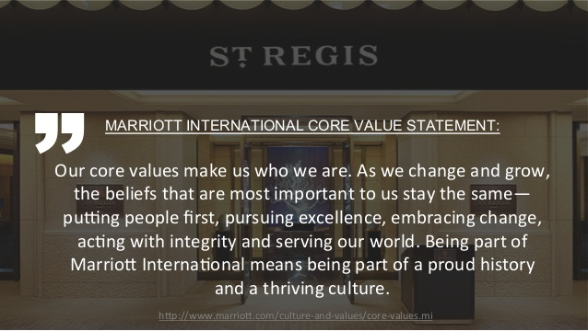
Figure 5 Marriott core value statement from the company’s website (“Marriott.com”)

The Workspace in the Post-COVID-19 Mindset

Marriott Workplace – The Family

As Marriott was opening its 4154th hotel in the Caribbean, in 2015, the Fortune magazine decided it is a noteworthy accomplishment and went to investigate the reasons why so many people want to work for this company. Before we report on their findings let us note that by workplace, we understand the location where the main activity of an employee takes place. It may vary in base of the type of activity one takes part in, but when it comes to hospitality, it is almost always the hotel. The company decided to establish a foothold in Haiti after the country had been devastated by the 2010 earthquake, taking this opportunity to give a glimmer of hope for many people that had lost everything during the natural disaster. By taking advantage of cheap land and labour, combined with unparalleled natural sights, Marriott, alongside Digicel and the Clinton Foundation, established a unique 175 room property, that from the outside looked as any regular hotel, but inside borrowed a lot from the local culture. By blending CSR policy into its business initiatives, the company creates a workplace that gives the employee a “home” feeling, hence the word “family” is a common occurrence when describing the job setting. As per J.W. Marriott:” Take care of the associates, the associates will take care of the guests, and the guests will come back again and again.”
A hotel business is based entirely on the ability to serve customers and meet their every need, but also on the ability to create a connection to ensure repeat business. It is for this very reason that an employee develops the same behaviour in interacting with his or her peers, and why management understands that meeting an associate’s demands is equivalent to more happy customers. Some of the benefits a Marriott employee has are food on shift, dry cleaning service for their uniform which is provided by the company, seminars, webinars, and online training free of charge, health care, gym, and up to 70-80% discount on other Marriott hotels (this includes relatives). Alongside all the above, the company has a reputation of promoting from within, and it is no surprise to find out that a GM started off a few years back as a bell boy (Mohammed et al, 2015).
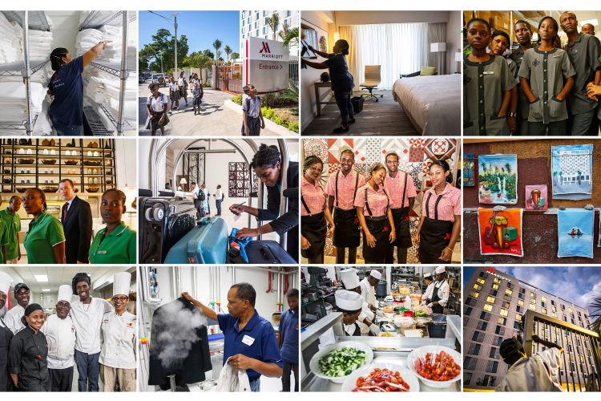
Figure 6 Marriott employees by Mark Peterson – Redux for Fortune (“https://fortune.com/2015/03/05/employees-loyalty-marriott/”)

The Future

Unfortunately, at around 95%, hospitality cannot function based on “work from home” premise so the future means adapting to a “new normal” and adopting some measures that will prevent a disease to spread. There were no people spared from the negative effects this pandemic has had, and as people begin travelling again, 79% of them have become more cautious, with 59% deciding to avoid certain hot spots altogether. This effect is greatly felt in countries that were hard hit by the virus, such as India (71%), China (67%), and South Korea (65%), whereas some European countries experience smaller numbers of cautious adventurers, with the Netherlands at 32%, Sweden at 47% and Germany at 49%. The people still willing to explore have new standards when it comes to cleaning and they want to be reassured that cleanliness and hygiene, sanitisation and social distancing measures are in place (Bennet, 2020).
From a Marriott associate perspective, this has had a tremendous impact on the psychological level, where the attempt to curb the virus spreading meant people cannot go on break at the same time, cannot interact with each other, they must perform their duties with a lot more care and impeded by a mask, to the point where Marriott has partnered with an external company to offer free wellbeing courses for its employees. Another detrimental factor is that in the initial phase of the lockdown, all new employees going through the onboarding process have been let go, creating a cognitive dissonance between the company’s mantra of “we look after people” and its cost-saving behaviour. Those that continued working, had to pick up the tasks and position that had remained unmanned, and, as per visitor’s reviews, it is not uncommon to find a security officer serving food in the restaurant or a receptionist mopping the floors. In parallel to these measures, the wage has stayed the same and the company’s slogan is “we all must do a little bit more and help each other to get through this situation”, which is English for “be happy you have a job because there are none out there”.
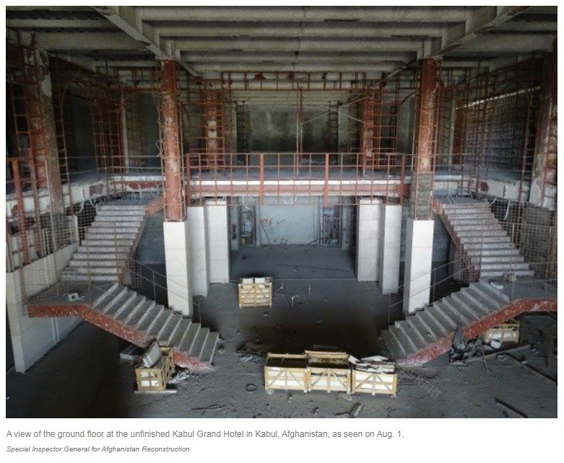
Figure 7 Marriott Kabul taken from “npr.org” (“https://www.npr.org/sections/thetwo-way/2016/11/17/502428985/how-85-million-failed-to-build-a-swanky-hotel-in-kabul”)

Creating a Resilient Business

There are two ways of creating a business that can weather a storm such as Covid19, one is to learn and adapt on the spot, using the knowledge you have available and changing from quarterly measurements to daily and weekly, and two learn from those that underwent this situation before you and survived – China.
For the first approach, a business might opt to follow the five steps model proposed by Daniel Sun, an analyst at Gartner, a company with a revenue of 4.2 billion dollars and a physical presence in 100 countries. The first stage is identification: know who the customers are, what you can offer them, who can help you achieve it and what is the profitability of your actions. After identifying what your company is, you need to get acquainted with the obstacles you may face and have a designated team that constantly assesses the situation. In the third phase, a resilient company unpacks the uncertainties discovered in phase two and works to address them. Stage four of building resiliency is dedicated to changing the physical aspect of the work environment, and leniency when it comes to feasibility: a company must understand that their profit margin will become very thin, but the goal here is to survive. The last stage of the process is implementation and a feedback loop: put the changes into practice, communicate efficiently and reassess the process, try and discover new threats and potential revenue streams that have been left untapped.
The second approach, or the Chinese model, is one of adaptation. The Chinese companies acted swiftly in reshaping their business to survive, by redesigning their work environment, streamlining their operations, partnering with other companies that were less affected by the pandemic, using technology to their advantage. From a department store that when faced with not being able to open its doors to the public partnered with an outside organization to conduct a livestream event to banks that streamlined their loan application process to become more appealing to the public, a country that was first hit with an unfavourable situation can teach tremendous lessons in resiliency. The spirit that emerges from these stories is embracing the unknown with a flexible mindset and desire to persevere in the face of adversity (Atalan, 2020).

Critical Evaluation

Long-term side-effects

Marriott is a behemoth in the hotel world and as such it has a global presence, therefore when the crisis that the company was hit with struck, it had exponentially larger detrimental effects. There is little to implement to prevent a massive shrinking of the revenue, and it will take time to rebuild an empire built over decades. At the start of the crisis, the company’s shares were trading around the 150-170 dollars mark, by contrast, at the time of writing this research, the price is struggling to maintain at 95, after a mild recovery that saw the lowest point at 68 dollars per share (from Yahoo Finance, data updated daily). Coupled with missing its targets for the first three quarters of the year – quite probable the fourth will be the same, unless a miracle happens – and the occupancy averaging 5%, in contrast to 98% last year, the Covid19 situation will have long-term implications. So far, the governments around the world provided relief packages for companies, however this will soon come to an end, and Marriott seriously lacks vision when it comes to the future. Their response was slow, and the measures implemented were based on the idea that in a short while things will go back to how they previously were (McKee and Stuckler,2020).

Increased Competition

An observation for Marriott is that, unlike SMEs who are struggling to survive due to lack of cashflow caused by a reduction in profitability, the brand conglomerate can afford to take a hit by undergoing a massive restructuration. The company that will emerge once the dust has settled and the storm has passed, will have to compete with new players, smaller hotel chains, who might have weathered the pandemic better. It will be a new environment for Marriott and one that raises a few challenges, from new approach to training, a better quality of customer relations management and stronger online presence.
After taking over Starwood in 2016, Marriott created the urgency for the European hoteliers to provide a response, another big firm that would exist in juxtaposition and drive competition. Since COVID-19 this idea starts to gain momentum in the shape of the merger between the British group IHG and the French from Accor. When the merger is finally complete, projected early 2021, Marriott will have to face a serious strong competitor, one that would be able to survive the pandemic with less financial stress thanks to a business model based on a light asset approach. It is known that Accor prefers to franchise or lease its properties rather than owning a physical location.

Conclusion

As we are dealing with a virus the most important aspect to consider – in respect of continuing operations – would be sanitation procedures. A hotel represents a high-volume movement of people, coupled with numerous shared contact surfaces, therefore cleanliness should be on every employee’s priority list. Not only the housekeeping department, but every individual has a responsibility towards their work area. From looking at Marriott’s procedures, we see that the measures imposed by the authorities have been implemented to a great extent, however, if a business is to survive and thrive, it needs to take things one step further. What is happening now will become a commonplace occurrence in the future as the world grows even more interconnected. This study recommends the creation of a dedicated department for the purpose of tackling issues such as COVID-19. Their main task would be of oversight and support, and the team members would have a higher degree of knowledge when it comes to cleanliness and diseases. It is of utmost importance that these employees have no other simultaneous duty in the hotel, as it minimises their effectiveness. It will surely be a costly measure; however, the rewards are boundless long-term. Continuing on the topic of health and safety, a hotel must take in account the materials it uses in decorations, fittings, and furniture, and strive to answer affirmatively to questions such as: is this hygienic, is it easy to sanitize, does it promote or prevent spread? Moreover, despite the virus not being airborne, it is known that it survives in water molecules in the air, so a rethink and assessment of the air conditioning system should take place. This matter is of greater importance in countries where humidity is high, and doors are kept open. A small step here would be the mandatory installation of air curtains above doors that are in constant, thus creating an invisible barrier between the external environment and hotel lobby. On the topic of improving the business whilst reducing costs, Marriott should investigate digitizing its processes, therefore reducing the volume of contact surfaces and guest-associate interactions. This is done by a strong emphasis on mobile keys and check-in, combined with the removal of TV remotes and providing an app for controlling the channels (Zhao et al, 2020).
A strong selling point for hotels is the idea that as a customer your every need is taken care of, thus suggestions regarding laundry, linen and turn down service drastically affect the business. For this reason, personal protective equipment should be enforced across the board in the housekeeping department, but taking it a step further, and opting for a full body disposable kit. In this area, innovation and research is required to ensure the most cost-effective measure it is implemented, and the environmental protection goals are met.

References

Atalan, A., 2020. Is the lockdown important to prevent the COVID-19 pandemic? Effects on psychology, environment and economy-perspective. Annals of Medicine and Surgery, 56, pp.38-42.
Baber, H., 2020. Spillover Effect of COVID-19 on the Global Economy. SSRN Electronic Journal,.
Bargiela-Chiappini, F., 2009. The Handbook of Business Discourse. Edinburgh: Edinburgh University Press.
Behrendt, R., 2012. The Evolved Structure of Human Social Behaviour and Personality. London: Karnac Books.
Brem, A., Tidd, J. and Daim, T., 2019. Managing Innovation. Singapore: World Scientific Publishing UK Limited.
Brokefield, S., 1987. Developing Critical Thinkers. San Francisco, CA: Jossey - Bass Publishers.
Brookfield, S., 2012. Teaching for Critical Thinking. San Francisco, Calif.: Jossey-Bass.
CELEBIOGLU, F., 2020. Spatial Spillover Effects of Mega-City Lockdown Due to Covid-19 Outbreak: Evidence from Turkey. Eurasian Journal of Business and Economics, 13(26), pp.93-108.
Clegg, S. and Bailey, J., 2008. International Encyclopaedia of Organization Studies. California: SAGE.
Dul, J. and Ceylan, C., 2014. The Impact of a Creativity-supporting Work Environment on a Firm's Product Innovation Performance. Journal of Product Innovation Management, 31(6), pp.1254-1267.
El-Meligi, A., 2012. Work, Management, and the Business of Living. Hackensack, N.J.: World Scientific.
Eräsaari, R., 1999. Why Recognition of Contigency is Not Surrendering to Contingency?. Redescriptions: Political Thought, Conceptual History and Feminist Theory, 3(1), p.132.
Frost, C., Wakeley, J. and Ruh, R., 1996. The Scanlon Plan for Organization Development. East Lansing: Michigan State University Press.
Gates, S. and Leuschner, K., 2007. In The Name Of Entrepreneurship?. Santa Monica, CA: RAND.
Harvey, F., 2018. Critical GIS: Distinguishing critical theory from critical thinking. The Canadian Geographer / Le Géographe canadien, 62(1), pp.35-39.
Harvey, F., 2018. Critical GIS: Distinguishing critical theory from critical thinking. The Canadian Geographer / Le Géographe canadien, 62(1), pp.35-39.
Heizer, J. and Render, B., 2006. Principles of Operations Management. Upper Saddle River, New Jersey: Pearson Prentice Hall.
Hilgard, E. and Richey, H., 1964. Theories of Learning and Instruction. Chicago, Ill.: NSSE.
Hui, B., Siu, A. and Ching, G., 2013. The Business Mindframe. Singapore: World Scientific Publishing Company.
Ishikawa, A. and Naka, I., 2007. Knowledge Management and Risk Strategies. Hackensack, NJ: World Scientific.
Lapierre, J. and Giroux, V., 2003. Creativity and Work Environment in a High-Tech Context. Creativity and Innovation Management, 12(1), pp.11-23.
Loasby, B., Dow, S. and Earl, P., 1999. Contingency, Complexity and The Theory of The Firm. Cheltenham, UK: Edward Elgar Pub.
McKee, M. and Stuckler, D., 2020. If the world fails to protect the economy, COVID-19 will damage health not just now but also in the future. Nature Medicine, 26(5), pp.640-642.
Mohammed, I., Denizci Guillet, B. and Law, R., 2015. The contributions of economics to hospitality literature: A content analysis of hospitality and tourism journals. International Journal of Hospitality Management, 44.
Mugano, G., 2020. The economy nexus of the COVID-19 pandemic. Socioloski pregled, 54(3), pp.737-760.
Munywoki, G., 2020. Economic Effects of Novel Coronavirus (COVID – 19) on the Global Economy. SSRN Electronic Journal.
Nayak, P., Mishra, V., Singh, M. and Tambuwala, M., 2020. Impacts and consequences of COVID-19 epidemic on global economy. Coronaviruses, 01.
Peterson, K., Gok, K. and Warren, V., 1995. Principals Skills and Knowledge for Shared Decision Making. [Washington, DC]: U.S. Dept. of Education, Office of Educational Research and Improvement, Educational Resources Information Center.
Philp, T., 1985. Improve Your Decision Making Skills. London, Angleterre: McGraw-Hill.
Steers, R., Nardon, L. and Sánchez-Runde, C., 2011. Management Across Cultures. Cambridge: Cambridge Univ. Press.
The Pharmaceutical Journal, 2020. Paul Bennett: 'Good governance is essential in any organisation'.
Walthall, W. and Wirth, M., 1987. Getting Into Business. New York: Harper & Row.
Weber, M., 1957. The Theory of Social and Economic Organization. Glencoe, Ill.: Free Press.
Work Study, 2003. Innovation: Harnessing Creativity for Business Growth. 52(4).
Wren, D., Bedeian, A. and Wren, D., 2009. The Evolution of Management Thought. Hoboken, N.J.: Wiley.
Zerbe, W., Ashkanasy, N. and Härtel, C., 2006. Individual and Organizational Perspectives on Emotion Management and Display. Amsterdam: Elsevier JAI.
Zhao, D., Yao, F., Wang, L., Zheng, L., Gao, Y., Ye, J., Guo, F., Zhao, H. and Gao, R., 2020. A Comparative Study on the Clinical Features of Coronavirus 2019 (COVID-19) Pneumonia with Other Pneumonias. Clinical Infectious Diseases, 71(15), pp.756-761.

Appendix
- Marriott International Report available at https://marriott.gcs-web.com/news-releases/news-release-details/marriott-international-reports-second-quarter-2020-results
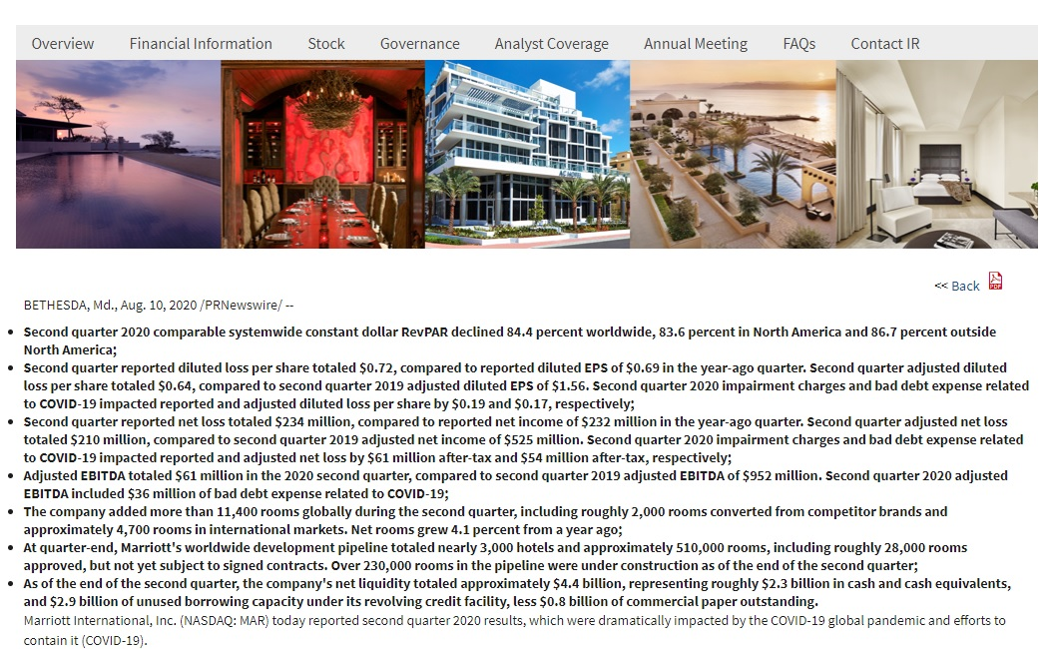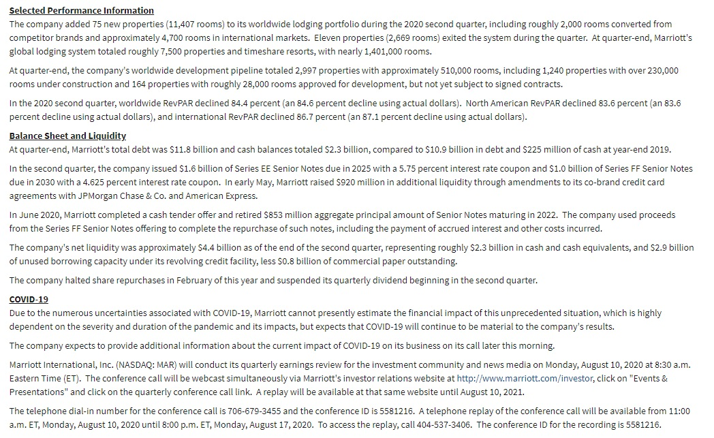

- Marriott International Annual Report 2019 available at https://marriott.gcs-web.com/static-files/178683c9-c9d9-47b0-b115-726588f43130
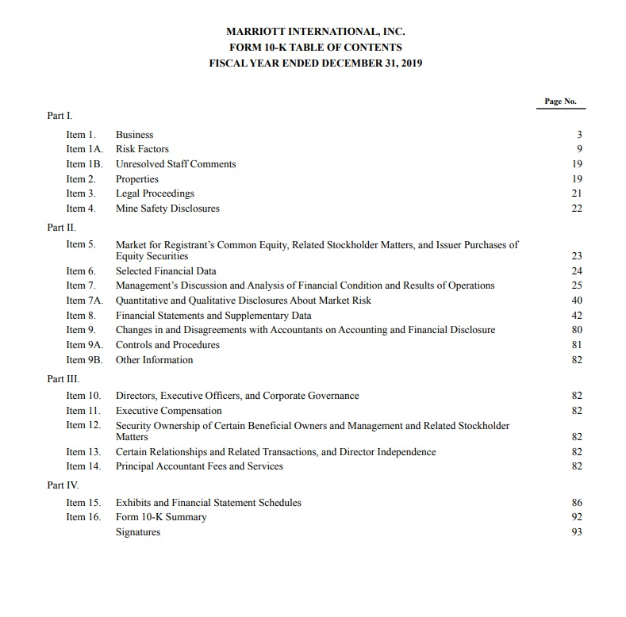
- Job satisfaction report from the Society for Human Resource Management available at https://www.shrm.org/hr-today/trends-and-forecasting/research-and-surveys/Documents/2016-Employee-Job-Satisfaction-and-Engagement-Report.pdf


