
APPENDIX GA36d

LEVEL 7 ASSESSMENT SPECIFICATION
Student name: | Rebecca Mountstephens | Student ID number: | 1800961
Programme: | Secondary PGCE
Module: | Curriculum Development and Enhancement
Module code: | ECSP7002 | Contribution to Overall Module Assessment (%): | 100%
Lecturer: | Helen Denny | Internal Verifier:
Assignment Title: | Research Study including Ethics Form | Word count (or equivalent): | 10.000 words in total including an Ethics form (to be given in on January 11th 2019)
Submission deadline: | May 13th 2019 | Return date of provisional marks & written feedback: | June 10th 2019

Curriculum Development and Enhancement: Examining the Impact of Peer Assessment on Pupil Progress in School X
Introduction
School X is a mixed, 11-18, English medium secondary school in South Wales (Estyn 2015). As of the 2018-19 academic year, there are 1,242 pupils on roll, and it achieved Excellent across all categories in its most recent inspection (My Local School, 2018; Estyn, 2015). At Key Stage 3, the teaching classes are streamed by ability. The research outlined in the following assignment was done in a year 7 top set class (known hereafter as Class A) as part of their history curriculum, using an end of unit assessment as the pre- and post-test for the research, with peer assessment during the assessment as an intervention to measure the impact it had on their progress. Class A consisted of 26 pupils (15 girls, 11 boys), and the research task and its purpose were made clear to the participants before they started the assessment.
The purpose of the research was to investigate whether peer assessment could have a positive impact on pupil progress in the classroom. It will be focusing on how effective peer assessment is as a method of formative assessment, as this type of assessment is being more frequently used by teachers to measure progress in the classroom, both in the United Kingdom and across the Western world (Noonan and Duncan, 2005). While there is evidence that peer assessment is a useful strategy in the classroom, there needs to be an investigation into how effective and successful it is in aiding pupil progress and showing improvement in their work (Noonan and Duncan, 2005). Therefore, this assignment will detail research undertaken in School X to examine the effectiveness of peer assessment in Class A.

Literature Review
Peer assessment started to gain popularity within the last 20 years and is most commonly used in primary and secondary classroom settings (Topping, 2018; Noonan and Duncan, 2005). Topping (2018) defines peer assessment as “an arrangement for learners to consider and specify the level […] of a product or performance of other equal-status learners, then learn further by giving elaborated feedback...” (Topping, 2018, p.1). It is a method of formative assessment through which pupils can aid each other’s progress by identifying strengths in their work and giving a target for improvement for their peer to identify the level their work is at (Topping, 2018). Peer assessment can also be identified in a number of forms; it can be both formative and summative (though it is more commonly formative) and can be used to create qualitative and quantitative data by either explicitly grading the assignment or simply giving verbal feedback on the strengths and weaknesses of the piece of work in question (Topping, 2018). The most significant characteristic to bear in mind, however, is ensuring that there is clarity on assessment criteria and pupils are aware of what is expected of them throughout the assessment and what peers will be looking for when they peer assess the work. This needs to be made clear from the start of the assessment, as one of the main limitations of this is that peers are often not involved in the development of the assessment criteria (Topping, 2018).
Topping (2018) also highlights some of the positive features of peer assessment, and why it seems to have grown in popularity. Peer assessment is usually associated with “products of learning” but can often also lead to benefits in other skills, such as social or learning behaviours which then lead to improvements in the products of learning such as classroom assessments (Topping, 2018, p. 16). Furthermore, peer assessment can also have a positive impact on learning and achievement, which in turn can help improve transferable skills such communication and collaborative work. When assessing learning, it can deepen the capability and knowledge of those being assessed, giving a broader understanding of a topic by providing feedback to their peers using success criteria provided (Topping, 2018). On the other hand, some of the limitations of peer assessment outlined by Topping (2018) suggest that it can be too much of a time-consuming process for teachers, especially if teachers and pupils are unsure of how to implement it. Although peer assessment can enhance the abilities of pupils, this can only be done once they are used to how this method of assessment works. This can be overcome, however, by ensuring classroom practitioners have a clear awareness of how to use peer assessment effectively and pupils are presented with explicit criteria on how to complete the peer assessment to a high enough standard (Topping, 2018). Another key limitation to consider is the reliability of pupils and how correct their assessment is compared to that of the teacher (Topping, 2018). For this reason, peer assessment must be implemented with caution, and teachers should not expect their pupils to be experts on peer assessment immediately. Despite this, peer assessment can be provided and accessed almost instantly, and there is less pressure on teachers to produce a large amount of assessment feedback in a short space of time (Topping, 2018). By using peer assessment in the classroom, a teacher can have an indication of what levels pupils are working at before formally marking work.
Despite the limitations outlined by Topping (2018), Noonan and Duncan (2005) recognise the importance of assessment in education and highlight the need for assessment reforms in order to maximise the improvement of pupil learning and progress. The most important factor to consider when referring to Noonan and Duncan is the clear difference between assessment for learning and formative assessment, two factors that they consider to be the key principles that have helped to facilitate assessment reforms (Noonan and Duncan, 2005). Assessment for learning is where pupils are directly involved in classroom assessment, whereas formative assessment relies on feedback from teachers to check the progress of pupils in the formation of learning (Noonan and Duncan, 2005; Guskey, 2003). While Noonan and Duncan (2005) define formative assessment as teacher-led feedback, however, Black and Harrison (2001) indicate that peer assessment is one of the most effective components of teacher feedback in formative assessments, as well as questioning, graded feedback, and summative tests (Noonan and Duncan, 2005). This therefore suggests that while teacher feedback is important in formative assessment and the measuring of pupil progress, peer assessment can have a significant impact on the progress of pupils in the classroom. Peer assessment is of increasing interest to educational researchers as it is more pupil-focused, as argued by Black and Harrison (2001), and makes the role of the teacher less central to the process of learning and feedback in the classroom (Noonan and Duncan, 2005). As a result of these factors, the assessment undertaken as part of the research for this assignment focused greatly on peer assessment in the formation of pupil feedback in order to assess the impact it had on their progress in their end of unit assessment.
Further to this, Sebba et al. (2008) published an investigation into the impact of self and peer assessment on pupil progress. Most of the research into pupil self and peer assessment is usually related to with comparing pupil assessment with teacher assessment research into student self and peer assessment, or the overall effect of self and peer assessment on pupils (Sebba et al., 2008). Sebba et al. (2008) focused primarily on the latter and examined the impact of peer assessment on pupil achievement in secondary schools. Their review examined a series of studies relating to secondary education in which peer assessment had been used across the curriculum and examined if there were any changes in the level of the work where peer assessment had been used in the feedback process (Sebba et al., 2008). The overall findings of their report noted an impact on pupil attainment, pupil self-esteem and pupil engagement in the classroom in the studies that had implemented peer assessment as a method of feedback (Sebba et al., 2008). Most of the studies in Sebba et al.’s (2008) report showed that, across a range of subjects, peer assessment had a positive impact on the attainment of pupils and pupils were more engaged with learning. Pupils also had more awareness of setting objectives and targets and were able to take responsibility for their own learning, gaining more confidence in the classroom (Sebba et al., 2008). This research links to the claims made by Noonan and Duncan (2005), and supports evidence that researchers are paying more attention to the impact of peer assessment. The research highlighted by Sebba at al. (2008) also suggests that peer assessment is an effective method of formative assessment and shows a positive impact on pupils’ learning in a secondary school environment. For this reason, the research undertaken in this assignment aimed to test the effectiveness of peer assessment based on the findings outlined by Sebba et al. (2008).
Liu and Carless (2006) also discuss the impact of peer assessment and focus their attention more on the learning element of this type of feedback. Their article looks at the reasoning for peer assessment and explore whether there is significant potential for peer assessment to enhance pupils’ learning (Liu and Carless, 2006). It is important to note the difference between peer feedback and peer assessment, as outlined by Liu and Carless (2006). Peer feedback is where there is direct communication between teachers and learners through which the learners are involved in discussions relating to their attainment and performance, whereas peer assessment means that pupils are giving definitive grades on the work of their classmates using specific assessment criteria provided by the teacher (Liu and Carless, 2006; Falchikov, 2001). Therefore, peer feedback is more about providing feedback comments without formally grading work, and peer assessment indicates specific grades (Liu and Carless, 2006). According to these definitions, the work that will be discussed in this essay relates more to what Liu and Carless (2006) define as peer feedback, as the premise of the task was for learners to provide feedback halfway through an assessment. Initially, Liu and Carless (2006) highlight the positive implications of peer assessment, arguing that it is a logical way of measuring progress and improving pupil learning and achievement. This is supported by Butler and Winne (1995) who argue that peer assessment can be described as self-regulated learning and enables learners to be actively in control of their own learning (Liu and Carless, 2006; Butler and Winne, 1995). Furthermore, Nicol and MacFarlane-Dick (2006) also support the claims that peer assessment can enhance pupil progress by arguing that it helps to encourage pupils to be more objective in their work, meaning that if pupils are aware and in control of their own learning, they have a strong understanding of the necessity of setting clear objectives in their work to improve their learning development (Liu and Carless, 2006; Nicol and MacFarlane-Dick, 2006). Another reason in favour of peer assessment cited by Liu and Carless (2006) is that it enables pupils to receive feedback quicker compared to when they are relying on academics and practitioners to provide comments and feedback (Gibbs, 1999). Therefore, peer feedback can “become a central part of the learning process” instead of just being occasionally used by classroom practitioners (Liu and Carless, 2006, p. 281). For these reasons, the research undertaken for this assignment focused on continuing to place peer feedback at the centre of learning in School X.
On the other hand, Liu and Carless (2006) also examine arguments that discuss some of the limitations of peer feedback and assessment. The first reason is that there must be a degree of reliability when marking and grading pupil work, and frequent peer assessment raises the issue of how reliable pupils are for this purpose (Liu and Carless, 2006). Teachers may be disinclined to use peer assessment because pupils have less knowledge and competence in a subject and would be less likely to provide a reliable assessment. There is more pressure on academics to demonstrate that pupils are reliable enough assessors for peer assessment and feedback to be effective (Liu and Carless, 2006). Secondly Liu and Carless (2006) discuss the issue of perceived expertise. This means that some pupils may be better suited than others to provide relevant feedback (Liu and Carless, 2006). There is still a blur, however, between perceived expertise and actual expertise, as some pupils “may be more perceptive that their classmates give them credit for” (Liu and Carless, 2006, p. 285). Therefore, while some students may be reluctant to receive feedback from their peers as they do not think they are qualified enough to provide feedback, some pupils may have more expertise than initially thought, and can be useful in providing feedback for certain tasks (Liu and Carless, 2006). Thirdly, there are arguments to suggest that peer assessment can negatively affect power relations in the classroom. This is supported by Brew (1999) who claims that the ability assess enables someone to have power over a person and giving the power of assessment to pupils shares the power of the teacher. Most obviously, some teachers dislike the idea of their power being shared to pupils, but one must also consider the fact that pupils may be reluctant to let their peers have power over them (Liu and Carless, 2006). This then leads to the issue of pupils being afraid to mark their friends too harshly, and changes to power relations can also result in an increase in “friendship marking” where pupils will over-mark their friends, and “decibel marking” where the most dominant pupils in a class receive higher grades (Brown and Knight, 1994; Liu and Carless, 2006, p. 286). The final reason presented by Liu and Carless (2006) is that peer assessment is often time-consuming (Falchikov, 2001; Liu and Carless, 2006). Timing issues with peer assessment can often dissuade teachers from using peer assessment as it is sometimes more complicated than when the work is only marked by the teacher, a claim supported by Langan et al. (2005). There is also often pressure for teachers to complete a scheme of work in a certain amount of time and may sometimes see peer assessment as an unnecessary extra activity which wastes time (Liu and Carless, 2006).
Sackstein (2017) further explains reasons for and against the use of peer feedback and assessment in the classroom. In terms of the rationale in favour of using peer feedback, Sackstein (2017) sees this method of assessment of allowing pupils to be given “agency in their own learning” which he argues has been limited and pupils have been deprived of this opportunity for some time (Sackstein, 2017, p. 11). This is similar to the view presented by Nicol and MacFarlane-Dick (2006) who argued that peer assessment allows pupils to be more in control of their learning and can enhance their progress. Peer feedback enables pupils to grow and develop as learners and enables them to gain confidence in the classroom and increase their expertise in a topic by being specific in what they want to achieve in the feedback (Sackstein, 2017). This means that peer feedback is an effective method of developing pupils’ potential in the classroom, by setting clear objectives and criteria for peer feedback and encouraging them to develop their writing skills based on the feedback from their peers (Sackstein, 2017). Therefore, the aim of the research outlined in this assignment is partly based on Sackstein’s ideas that peer assessment can enable pupils to become experts on a certain topic based on the criteria and feedback outlined by the teacher and the peer assessment (Sackstein, 2017). However, Sackstein (2017) does briefly acknowledge some of the drawbacks of peer feedback. He debates the reliability of peer feedback as a result of pupils feeling the pressure of the responsibility to provide meaningful feedback. Some pupils may find the responsibility of giving feedback to their peers challenging and their ability to provide a good level of feedback may be negatively affected (Sackstein, 2017). Despite this, Sackstein (2017) claims that challenges such as this can be beneficial to the improvement of pupils’ learning, teamwork skills and leadership. Teachers must be prepared to acknowledge these risks and challenges use peer feedback as a method of assessment in a calm, consistent and supportive classroom environment (Sackstein, 2017).
School Policy and Practice
School X has placed a significant focus on attainment and achievement of its pupils over the course of the academic year, according to its most recent development plan (Appendix 1). While there is very little direct reference to peer assessment in the whole-school development plan, some of School X’s plans for improving attainment link to some of the benefits of peer assessment outlined in the previous section. Teachers will ensure that a focus is placed on improving pupil performance across all departments and implement a range of departmental strategies in order to increase pupil attainment across all curriculum areas (Appendix 1). Scholars such as Sackstein (2017), Topping (2018), and Liu and Carless (2006) emphasise how beneficial peer assessment can be to the improvement of pupil attainment by allowing them to be in control of their own learning, therefore indicating that peer assessment would be beneficial to School X’s plan to focus on the improvement of pupil attainment levels throughout the academic year.
As a result of undertaking professional teaching experience in School X, there was found to be more evidence of peer assessment being implemented within each department. This piece of research focused on the History department and its use of peer assessment and feedback as part of the assessment process, particularly at Key Stage 3. The History departmental plan for the 2018-19 academic year highlights the department’s focus on improving assessment methods at Key Stage 3 and enhance pupil progress by adapting the assessment process (Appendix 2). School X is aiming to do this by having more frequent assessments that are shorter rather than extensive assessments at the end of each term, in order to gain a more accurate understanding of pupil levels. In terms of how School X’s History departmental plan links to academic discussions on peer assessment, there is an emphasis on the implementation of clear success criteria in all assessments. This links to the argument presented by Liu and Carless (2006) which indicates that having clear success and assessment criteria can have a positive effect on pupil attainment and the effectiveness of peer assessment.
Although the development plans make little clear reference to specific policies on peer assessment, undertaking professional teaching experience at School X provided an opportunity to see assessment policy and practice in action in the classroom. Key Stage 3 classes have several assessments throughout the year, usually at the end of a scheme of work on a topic. Each assessment relates to a specific skill linked to the study of history, such as knowledge and understanding or source analysis. Clear success criteria are always provided, and pupils are given an assessment feedback sheet at the start of the assessment which outlines the expectations required of them in order to achieve a certain grade (Appendix 3). The assessment feedback sheet also has a section for pupils to complete peer and self-assessment, where they will be given feedback and a target from one of their classmates, as well as a self-assessed target in acknowledgement of their peer assessment (Appendix 3). This gives pupils a clear outline of the expectations of the assessment, and the peer assessment, giving them a clear understanding of the benefits of the peer assessments, linking to the arguments given by Liu and Carless (2006) and Nicol and MacFarlane-Dick (2006).
Methodology and Ethics
When undertaking research in the classroom as outlined in this project, it is important to consider the best methods of research in order to ensure that it is conducted effectively, and ethical implications are taken into consideration. The most common method of research used by classroom practitioners and researchers is action research, which is where practitioners develop an enquiry and investigation that can be conducted within their own classroom settings and as part of normal school practice to identify key issues and test methods for improvement (Efron and Ravid, 2013). Efron and Ravid (2013) argue that action research is one of the most effective methods of educational research and present the view that it is one of the most applicable models for educators to understand, change, and improve the process of teaching and learning, and can significantly further improve the quality of their professional growth and development. Action research, therefore, provides teacher-researchers with a highly effective approach for being actively involved in school development (Efron and Ravid, 2013; Hopkins, 2008). The main reason for action research increasing in popularity in recent years is largely due to a response to the increased necessity for more practical, relevant knowledge within the social sciences, encompassing educational research and highlighting the need for more enquiry-based research in the classroom (Nolen and Vander Putten, 2007). Action research makes educational research easier because it closes the gap between academic research and daily application of normal classroom practice, and the process becomes more seamless and makes it more accessible for all teachers, enabling them to measure progress in teaching and learning while keeping to the normal routine of classroom practice (Nolen and Vander Putten, 2007). Action research was chosen for this research project based on these recommendations, as it would ensure that the researcher could play a direct role in the development of pupils’ learning and was able to control the assessment. It can be easily implemented into the classroom without causing any interruption to the scheme of work, allowing the researcher to gather data as part of normal classroom practice.
Despite the apparent success of action research, Gebhard (2005) identifies limitations that should be considered. Practitioners are in danger of focusing too much on negative aspects of teaching and learning, as action research tends to primarily look at the problems (Gebhard, 2005). This means that if teacher-researchers are too focused on a problem and trying to find a specific solution to that problem, they risk missing opportunities to develop ideas for teaching and learning beyond this problem by drawing upon positive features (Gebhard, 2005); Fanselow, 1987, 1988). Furthermore, the action research process usually involves finding the problem, investigating the problem, planning an intervention, putting this into practice and examining the results, with this process being repeated as is necessary (Gebhard, 2005). While there are benefits to this process, Gebhard (2005) describes it as a narrow, linear method and there is danger of missing out on potential solutions for improvement beyond this process. Therefore, action research can often limit solutions because of its tendency to be too narrow a process (Gebhard, 2005). Despite this, the benefits of action research outweigh the limitations, as argued by Efron and Ravid (2013), and action research appeared to be the best method of practical classroom research when considering how to approach this research project.
Another research method that can be taken into consideration in education research is the pre-test/post-test design model. This means that a measurement or data collection is undertaken both before and after the implementation of an intervention by a teacher researcher, enabling the researcher to see if an intervention influences the test results taken from the start of the research (Morris, 2007). The main advantage of the pre-test/post-test model is that it enables the researchers to control any differences amongst participants before the intervention and allow them to predict the effectiveness of the intervention on those involved before the research is undertaken (Morris, 2007). Kumar (2014) argues that the pre-test/post-test model is the most suitable method for researcher to measure the effectiveness of an intervention because it allows researchers to directly measure change in a situation based on a specific issue. Morris (2007) also highlights the advantage of pre-test/post-test design as it allows individual researchers to control each individual participant and how they will best benefit from the intervention, thus increasing the precision and success of action research undertaken in this way (Morris, 2007). However, Kumar (2014) presents some possible disadvantages for using the pre-test/post-test model. As there can be a significant amount of time between the pre-test and the post-test, there is a danger of there being some deterioration in the abilities of the participants depending on how much time passes between the intervention and the post-test. As this model is aiming to measure the total change in a group of participants, there is still a risk of other variables that are not directly related to the research that may impact the success of participants in the post-test (Kumar, 2014). This means that while the aim of the intervention is to improve results in the post-test, there can often be external circumstances and limitations which my impact the participants involved and be beyond the control of the researcher. Despite this, the research undertaken for this project supports the positive arguments presented by Morris (2007) and takes the success of the pre-test/post-test model into consideration during the research.
When undertaking any kind of research such as this, it is important to understand any ethical implications that may arise while the research is being carried out. Research should be carried out by skilled practitioners who are aware of any potential ethical implications, but when action research is being undertaken by teacher-researchers in normal classroom practice, it is imperative to understand at which point teaching becomes research and the researchers ensure that it is being conducted ethically (Nolen and Vander Putten, 2007). The British Educational Research Association (BERA) highlight the importance of ethics in research and make it clear that it is the responsibility of the teacher-researcher to ensure the impact of the research on those involved is taken into consideration and that participants are clearly informed about the research and what it means for them (BERA, 2018). Informed consent must be obtained from the participants before any research is carried out and they must have the option to withdraw if they wish to (BERA, 2018). This is significant for this particular project as the research involved schoolchildren, and the impact of the teacher taking on a dual role as a researcher on the pupils involved must be taken into consideration (BERA, 2018). Another factor that must be taken into consideration is how data is handled, especially as the participants for this project are children, and child and data protection rules must be adhered to (BERA, 2018). BERA (2018) states that the teacher-researchers must uphold their duty of care and ensure that all risks of danger or distress to the participants is minimal before data collection begins. Once the data has been collected, researchers should ensure that the anonymity of participants is upheld and that those involved are made aware of their confidentiality and anonymity rights before the research begins (BERA, 2018). This ensures that risks to the participants are minimised as their data is kept anonymous and confidential between them and the researcher, ensuring that there is no risk of distress arising as a result of the research being undertaken.
Evaluation
Having discussed the best methods of practice regarding research methodology and ethics, this section will now outline how the research for this project was carried out in the classroom and evaluate its effectiveness in one with the literature discussed previously. The aim of the series of lessons, which were used as the basis for the research, was to follow the pre-test and post-test format as described by Morris (2017) as the best method of measuring pupil improvement in the classroom. The initial plan for the research was to use a pre-existing set of assessment data as the pre-test example alongside the progress grades and global grades (a predicted progress grade given to each pupil at the start of the academic year) of the pupils in Class A, using this information as the basis for the research project. In School X, progress grades are used to measure how pupils are progressing in particular subjects, with progress reports throughout the year. Assessment results at the end of a scheme of work contribute to this grade, and this data is used to ensure that all pupils are working towards their predicted global grade throughout the academic year. Therefore, further to the peer assessment and pre-test and post-test models outlined previously, it was considered to be best practise to follow the assessment format in line with the policy at School X, using these methods collectively to measure the effectiveness of peer assessment on pupil progress.
To give some context to the series of lessons used as the basis of the research for this assignment, the assessment that Class A did for the purpose of the research was a source analysis task on the Black Death. The research was clearly explained to them at the start of the scheme of work on the Black Death, in line with the recommendations given by BERA (2018). At the start of the research, Class A consisted of 26 pupils, all of whom consented to being part of the research project and allowed their data to be used in the study. Class A was a high ability class, the top set in year 7, with all pupils averaging a global grade of a B (Appendix 4). Once the research was explained to the class and all pupils had consented to the research, the scheme of work was taught over a period of three weeks, covering several important aspects related to the Black Death, including causes, cures and consequences. The basis of the assessment was a series of sources each relating to either a cause, cure or consequence of the Black Death, and had to decide which sources would be more useful to an historian researching either of these topics. The assessment was completed over two lessons, with the first part of the assessment and the peer assessment taking place in one lesson and the work being completed in the second lesson once the pupils had acknowledged their peer target (Appendix 5). It would be peer assessed halfway through in order to determine if the peer assessment had any impact on improving their assessment and potentially improving their global and progress grades. Ensuring that the research and its purpose was explained to the participants at the start of the study, as recommended by BERA (2018), made sure that the research study was able to run smoothly and achieve its aims as pupils knew what the purpose of the project was and completed the assessment successfully in order for the intervention of peer assessment to be of utmost effectiveness.
In terms of evaluating the effectiveness of peer assessment with regards to the research, the use of success criteria was imperative to the scheme of work and the success of the assessment Class A were working towards. Based on the recommendations from Topping (2018) and Liu and Carless (2006), it was key that the assessment for the research project included explicit success criteria, not just in the assessment itself, but throughout the scheme of work in various lesson tasks, so that the pupils are aware of what the purpose of success criteria is. Topping (2018) also highlighted that giving success criteria enables learners to broaden their understanding of a topic, particularly when they are assessing the work of their peers, thus ensuring that the peer assessment is as effective as possible. In the scheme of work on the Black Death taught to Class A, part of the success criteria for the assessment was that they were required to analyse a range of sources using content, origin, purpose, usefulness and reliability (COPUR) as prompts to find the relevant information in the sources (Appendix 5). Presenting these criteria to Class A and working through a source as an example using the criteria made sure that all learners were aware of the requirements of the assessment and knew what factors to look for when they were assessing each other’s work during the task. Further to the success criteria outlined for the source analysis, Class A were also presented with success criteria to aid their progress in the overall assessment (Appendix 5). Pupils were required to structure their assessment to ensure that it included ​an explanation on why the content of each source was useful to their question, why the authorship of the source was useful, and an overall judgement on which source was more useful and why. This also enabled learners to improve their source analysis skills, using the peer assessment as a catalyst for progress.
Due to time constraints, it was difficult to gain access to a pre-existing set of assessment results to use as the pre-test for the research. However, as pre-tests and post-test have been supported by Morris (2007) and Kumar (2014), I felt that it was important to try and implement some form of pre-test before the peer assessment so that the intervention could be more effective. Based on recommendations from my subject mentor at School X, and after some further research into peer assessment methods, I decided to divide the assessment into two parts. Once the pupils in Class A had analysed their sources and chosen two sources to answer their question, they wrote an introduction to the assessment and the first paragraph which explained why their first source was useful in answering their question, using the COPUR method. This first paragraph was then peer assessed, to ensure that all pupils had included COPUR in their analysis. To ensure pupils were aware of which section was being marked, as well as the explicit success criteria, the assessment used the technique of yellow box marking (TeacherToolkit, 2018). Yellow box marking works by highlighting a section of work to be marked using a yellow highlighter (TeacherToolkit, 2018). It is then peer assessed using a purple pen to differentiate it from the main body of work. The TeacherToolkit (2018) website describes yellow box marking as a highly effective method of assessment, both when work is being marked by a teacher or being peer assessed. It ensures that pupils know which specific areas they need to work on and allows them to set clear, explicit targets based on the yellow boxed section, and their progress is supported by enabling them to identify necessary improvements as they work (Teacher Toolkit, 2018). For the assessment that Class A did for the purpose of the research, they used the yellow box marking method to mark the first paragraph of the assessment, using COPUR as the success criteria, and using the first paragraph of the assessment as the pre-test before they completed the remainder of the written task (Appendix 6). Pupils underlined where their peers had met the success criteria, ensuring that each component of the COPUR method had been included. I, as the researcher, marked on the work in red to confirm where each pupil had included COPUR in the first section of their assessment (Appendix 6). Having followed the recommendations of my mentor and guidelines from TeacherToolkit (2018), using the yellow box method to support the use of peer assessment in the research project proved to be an effective method of providing clear criteria and guidance to pupils when they are assessing and evaluating each other’s work, supporting the recommendations made by Liu and Carless (2006) on success criteria, and separating the pre- and post-tests as recommended by Morris (2007).
In line with the recommendations on pre- and post-testing by Morris (2007), the post-test for the research was for the pupils to complete the remainder of the assessment having had the first part of their writing peer assessed and had a target set. This part of the assessment involved the pupils writing up the analysis for the second source they had examined, linking it to their chosen question and how useful it is for historians studying the Black Death. The pupils then completed the assessment with a short conclusion, explaining which of their two sources was more useful to an historian and why. The aim was that the pupils would acknowledge the peer assessment of the first section of their work and take on board the target that had been set for them by their classmate. It was then predicted that the second part of their assessment would be an improvement on the first part and would consequently result in them achieving a higher grade for the overall assessment having taken the peer target and feedback into account. Using the pre-test/post-test model in this way ensured that all pupils were aware of explicit targets that were individual to them, and I, as the researcher, could clearly see how the intervention had worked for each individual pupil and whether it had been successful and effective (Morris, 2007).
The most effective method to measure how successful the intervention had impacted upon the pre-test and post-test is to examine the assessment results for the pupils in Class A (Appendix 7). At the end of the assessment, out of the 26 pupils in the class at the start, only 23 pupils were able to present data for use in the research. One pupil (Pupil X) had been absent for the duration of the assessment due to illness and would not be able to complete the assessment in the time frame given for the research. Two other pupils (Pupils Y and Z), while they had completed the assessment, voluntarily withheld their work meaning that I was unable to include their data in the final list of results (Appendix 7). Out of the 23 pupils that were able to present results, thirteen pupils achieved A grades, eight pupils achieved B grades, and two pupils achieved C grades, and all pupils measured had improved upon their global grade that had been set for them previously in the academic year, with a level 5 indicating an A, level 4 indicating a B and level 3 indicating a C in the list of results (Appendix 4). This therefore indicates that the pre-test and post-test had been positively impacted by the implementation of a peer assessment, and all pupils had improved their assessment in the second half based on the peer feedback and target that was set by them (Appendix 6). The examples of work shown in Appendix 6 clearly show that the pupils had a clearer understanding of the success criteria for the assessment after the peer assessment had been used as an intervention and included more of the components required for the COPUR source analysis (Appendix 6).

Conclusion
Overall, the research undertaken for this project confirms that peer assessment is an effective method of measuring pupil progress and it can have a positive impact on improving pupils’ work, as argued by several scholars including Liu and Carless (2006) and Sebba et al., (2008). Using peer assessment halfway through the assessment that Class A were completing was a quick and easy method for providing pupils with feedback on a piece of work in a short space of time, rather than waiting for the teacher to mark their work and making the process more time consuming. This supports that claim made by Gibbs (1999) that highlights peer assessment as an integral part of the process of learning and is increasing in popular use as it enables pupils to receive feedback and targets more quickly, and use this to improve upon their work in a shorter time period (Gibbs, 1990; Liu and Carless, 2006). Class A pupils peer assessed each other’s work after they had each written the first paragraph of their assessment and, as the work was being carried out over two lessons, it would allow pupils to receive their feedback as soon as possible once they had completed the COPUR source analysis for the first source they had chosen to write about in the assessment. Using this method of assessment meant that pupils had a clear awareness of their progress level in the first half of the assessment and could then effectively use this feedback to improve in the second part.
Another tool used in this research that shows the positive effect of peer assessment is the use of success criteria to help pupils understand the topic they are studying, the work they are doing and why the peer assessment will be useful to them. Providing clear success criteria for the assessment ensured that pupils knew what they needed to look for when marking the work of their peers and what recommendations to make when giving them a target for improvement. Recommendations from Topping (2018) make it clear that peer assessment is more effective when success criteria are provided, therefore it was imperative to this research that this tactic was used. This meant that pupils were aware of the purpose of using success criteria and enables them to further understand what they are being taught and allows them to peer assess each other’s work more accurately and give them a clear target to work on. Pupils in Class A were able to use the success criteria in their peer assessment and were able to clearly mark on their classmates’ work where they had met the success criteria provided, and understanding how peers had met each criterion enabled the pupils to understand how to clearly set a target for their classmate to improve their work when they continued the assessment. This therefore supports the claims made by Topping (2018) that the use of success criteria is a recommended method of improving the usefulness of peer assessment in the classroom.
In terms of methodology, the most effective way of determining how much of an impact peer assessment has on pupil performance and achievement was to use the pre-test and post-test method. This method, when applied to the research undertaken for this project, was clearly beneficial to the peer assessment process and enabled pupils to clearly understand the purpose of dividing the assessment into two parts for the peer assessment and seeing the results of the intervention for themselves in their final grades. Pre- and post-testing, paired with the use of success criteria, had a clear impact on the efficacy of the peer assessment, as pupils could use the success criteria to accurately provide feedback for their peers and see the impact of peer assessing each other on completion of the assessment. As recommended by Morris (2007), pre- and post-testing allows researchers to effectively measure the impact of an intervention on a set of test results or a piece of work created before the intervention. The assessment results and the examples of work by pupils from Class A clearly show that there was marked improvement in the second half of the assessment, after they had acknowledged the target set for them by their class partner, and the majority of pupils were able to improve on their COPUR analysis for the second source in the assessment. This made certain that the pupils were able to set targets for each other and clearly acknowledge them in the second half of the assessment, and the research showed how the intervention had impacted each pupil, showing the effectiveness of pre- and post-testing as recommended by Morris (2007) when used correctly.
The results of the assessment itself show how effective peer assessment can be and confirm the recommendations that it is a popular assessment tool for teachers to use (Topping, 2018). Although three pupils were unable to contribute data to the final collection of results for the research, the data clearly shows improvement on the global grades that they were given at the start of the year, highlighting the successful impact of peer assessment since it has been implemented in their lessons (Appendix 4). The majority of Class A gained A and B grades in the assessment and showed significant improvement in the quality of their written work once the peer assessment had been completed and acknowledged by the pupils (Appendix 4; Appendix 6). Examples of work by the pupils included in the research clearly prove that the pupils had used the peer assessment effectively to improve the quality of their assessment and achieve more of the success criteria in comparison to the first section of the assessment that was yellow box marked and peer assessed, thus reinforcing the idea that peer assessment does have a significant impact on pupil progress. This also links to the recommendations of including success criteria because the pupils were using specific criteria to peer assess each other and set targets, meaning that pupils could then use feedback from their classmates to reinforce their understanding of the success criteria and improve their assessment grade, as recommended by Topping (2018).
Based on this research, it is clear to see why more teachers are implementing peer assessment in their lessons, as it broadens pupils’ understanding of a topic, particularly when combined with success criteria and a pre-test (Topping, 2018; Morris, 2007). There is significant evidence in the assessment data to support the use of peer assessment and the positive outcome of pupil work when they have had the opportunity to set targets and use them to improve their work. School X’s policies on peer assessment is something that will continue throughout my teaching practice as I have seen first hand the impact it can have on pupil learning and development, and enables them to have a clearer understanding of what is expected of them in an assessment, and setting targets for themselves or their peers can help them understand how to improve in future assessments (Sebba et al. 2008). Peer assessment develops a range of skills which can influence significant improvements in products of learning such as classroom assessments (Topping, 2018). To ensure success for future practice, peer assessment must be implemented with care, acknowledging some of the limitations outlined in this research, such as being too time consuming or pupils being unsure of how to peer assess (Topping, 2018). Therefore, the key recommendations for using peer assessment in the future are to include clear success criteria both for the assessment and the peer feedback to ensure pupils fully understand its purpose and it is as effective as possible.
Limitations and Future Development
While the results of the research project undertaken showed how effective peer assessment can be, it is necessary to acknowledge some of the limitations encountered during the research and how these will influence recommendations for future development if I were to undertake the research again. The first, and perhaps most important limitation to acknowledge, was timing and the limited time scale that was available for completing the research, meaning that the overall impact of the pre- and post-testing may not have been maximised. This limitation was noted by Topping (2018) who highlighted that peer assessment can be time-consuming and difficult to implement in a short time period, such as the one that was available at School X. The initial plan for the research on Class A’s work was to use a pre-existing set of data as the pre-test and then mark the whole assessment, incorporating the peer assessment, in order to determine the effect of this style of marking and feedback. Due to the time constraints, the pre- and post-testing had to be altered accordingly as there were only four lessons over the three-week period where Class A were being taught. Despite this, I was still able to complete the research and gather enough data from Class A’s assessment results, enabling me to clearly see the impact peer assessment had on their achievement levels. However, if I were to undertake this type of action research again, I would ensure that there was more time for me to plan and carry out the pre- and post-testing to increase the accuracy and success of the intervention.
Linking to the previous limitation, another factor that was evident during the classroom research was that there were a number of pupils who were absent for all or part of the scheme of work or assessment lessons, and the limited time available made it difficult to ensure these pupils caught up and completed the assessment before the placement period at School X came to an end. Although all pupils initially consented to having their data included in the research, three pupils missed lessons during the research, meaning there was some limitation in how much data would be collected. Pupil X was absent for the entire assessment on medical grounds and was unable to complete the assessment over the research period (Appendix 7). Due to a trip that some pupils were involved in on the day one of the assessment lessons, pupils Y and Z missed the second half of the assessment once and were limited in the time they had to peer assess and complete their assessments (Appendix 7). This meant that their assessments had to be marked separately and were therefore withheld from the final collection of data that was used for the research. This limitation again links to the problem of timing and contributes to the often-time-consuming nature of peer assessment (Topping, 2018). With regards to future development based on this limitation, in a future piece of research I would ensure that there was sufficient time for all pupils to complete the assessment and for me to mark all pieces of work if there was a delay in some of the pupils’ assessments. Notwithstanding this limitation, I was still able to use results from 23 pupils’ assessments and there was significant improvement in all of their work once the peer assessment had been carried out, meaning that I was able to confirm that peer assessment could have a significantly positive impact on pupil progress.
Despite encountering some limitations during the research, the intervention was successful in its impact on the pupils’ attainment in the assessment, and the research has significantly influenced future development and practice in my teaching. Action research has been shown to be an effective method of carrying out research in the classroom as I can see the direct impact of various teaching and learning strategies on the progress of pupils without significantly interrupting the natural flow of lessons. If it is undertaken properly and ethically, action research is one of the most effective methods of measuring the impact of interventions in the classroom and using pupil data to evaluate the impact of strategies such as pre- and post-testing (Efron and Ravid, 2013). Educational research can be highly beneficial to teachers’ professional development and allows them to continuously develop methods of teaching practice (Campbell et al., 2004). Finally, in terms of how the use of peer assessment will impact future practice, seeing it used effectively in School X and the impact it had on the assessment data for the research has confirmed that it is an effective strategy of measuring and improving pupil achievement levels and will remain an integral part of how I measure the progress of my pupils throughout my teaching practice. It will be imperative for me to carry out further research on this, to ensure that I can find the best methods of practice and use peer assessment to its utmost effectiveness to ensure my pupils thrive.

Appendices
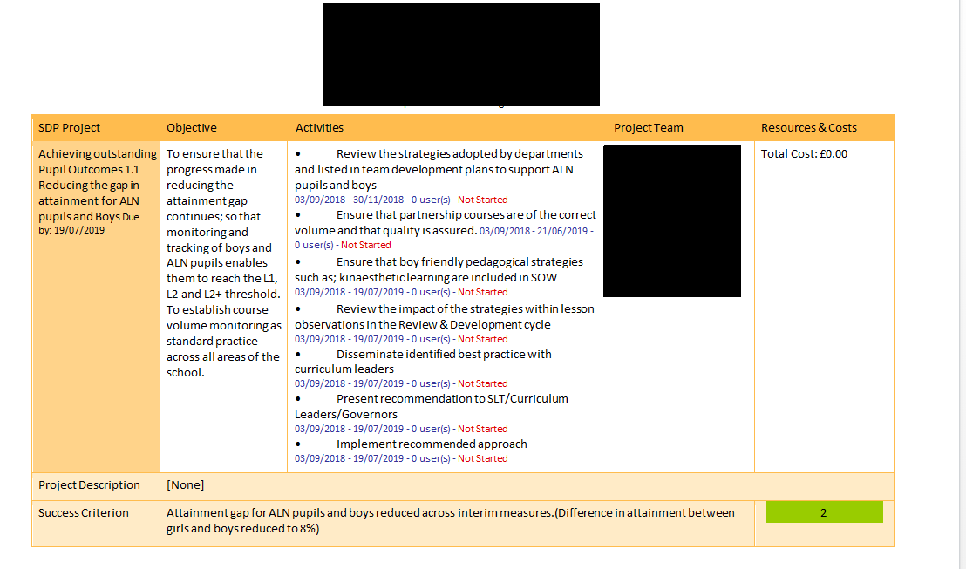
Appendix 1: Extract from Whole School Development Plan for School X

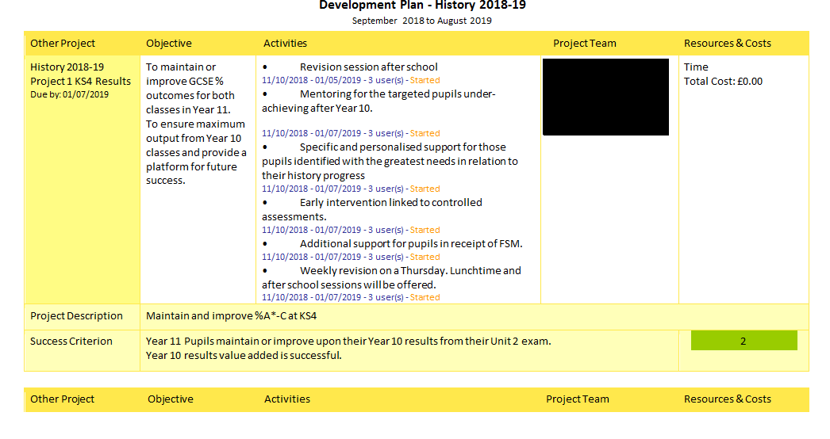
Appendix 2: Extract from School X’s History Department’s Development Plan
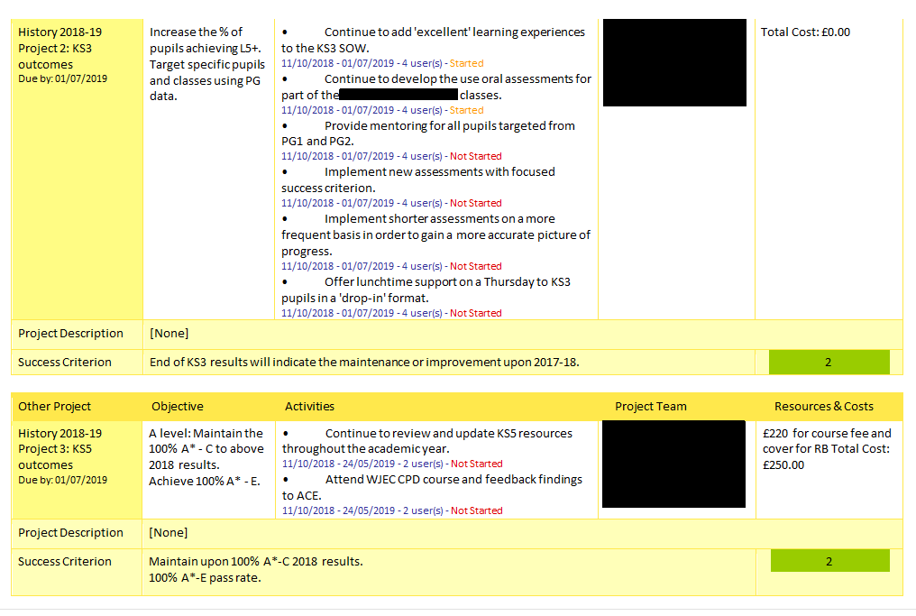

Appendix 3: School X History Department Assessment Feedback Sheet


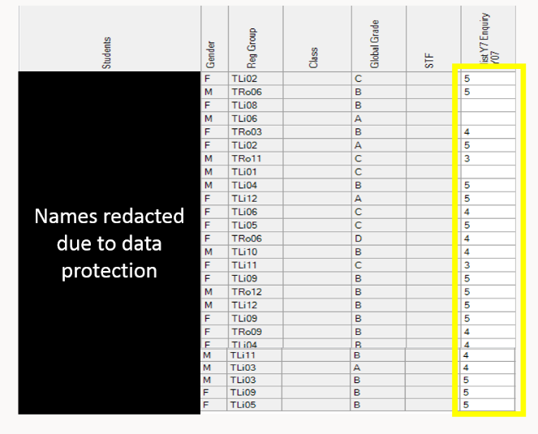
Appendix 4: Table showing Global Grades and Assessment Result Levels for Class A (5=A Grade, 4=B Grad, 3=C Grade)

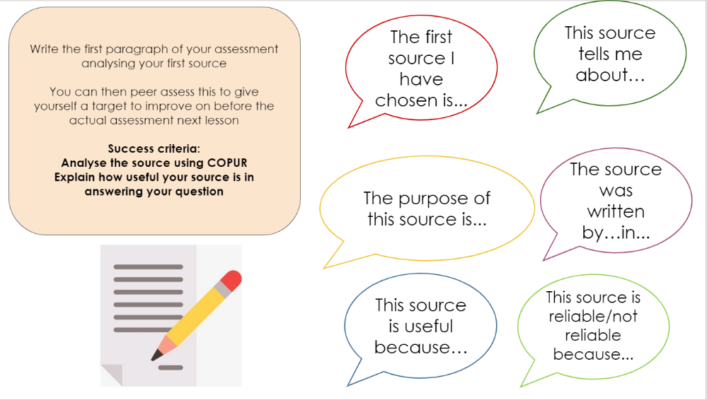
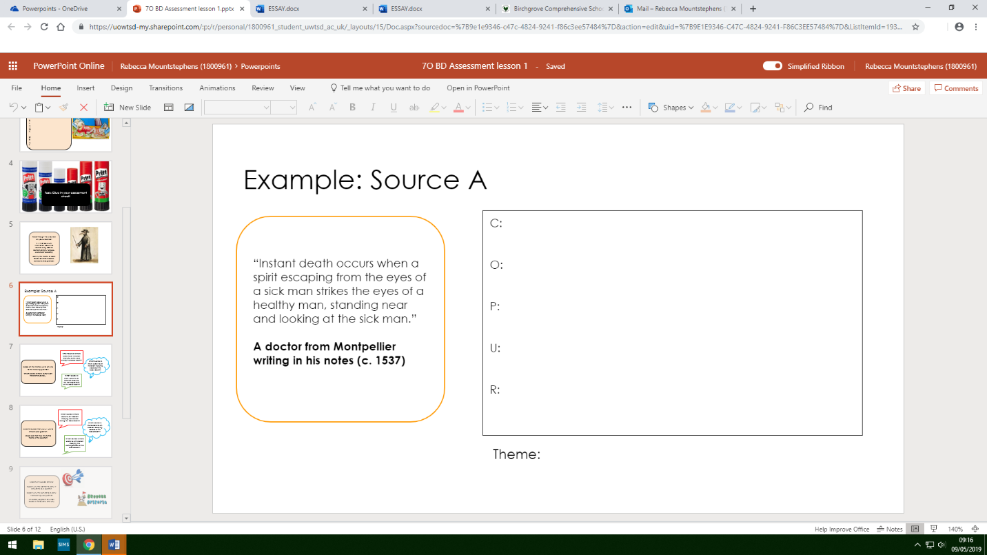
Appendix 5: Slides from Assessment Lesson PowerPoint explaining structure of assessment and peer assessment criteria

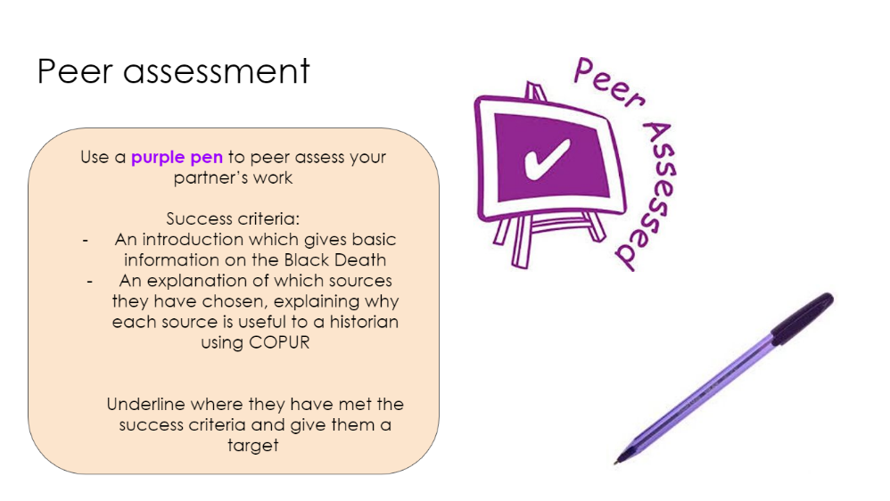

Appendix 6: Examples of Pupil Work





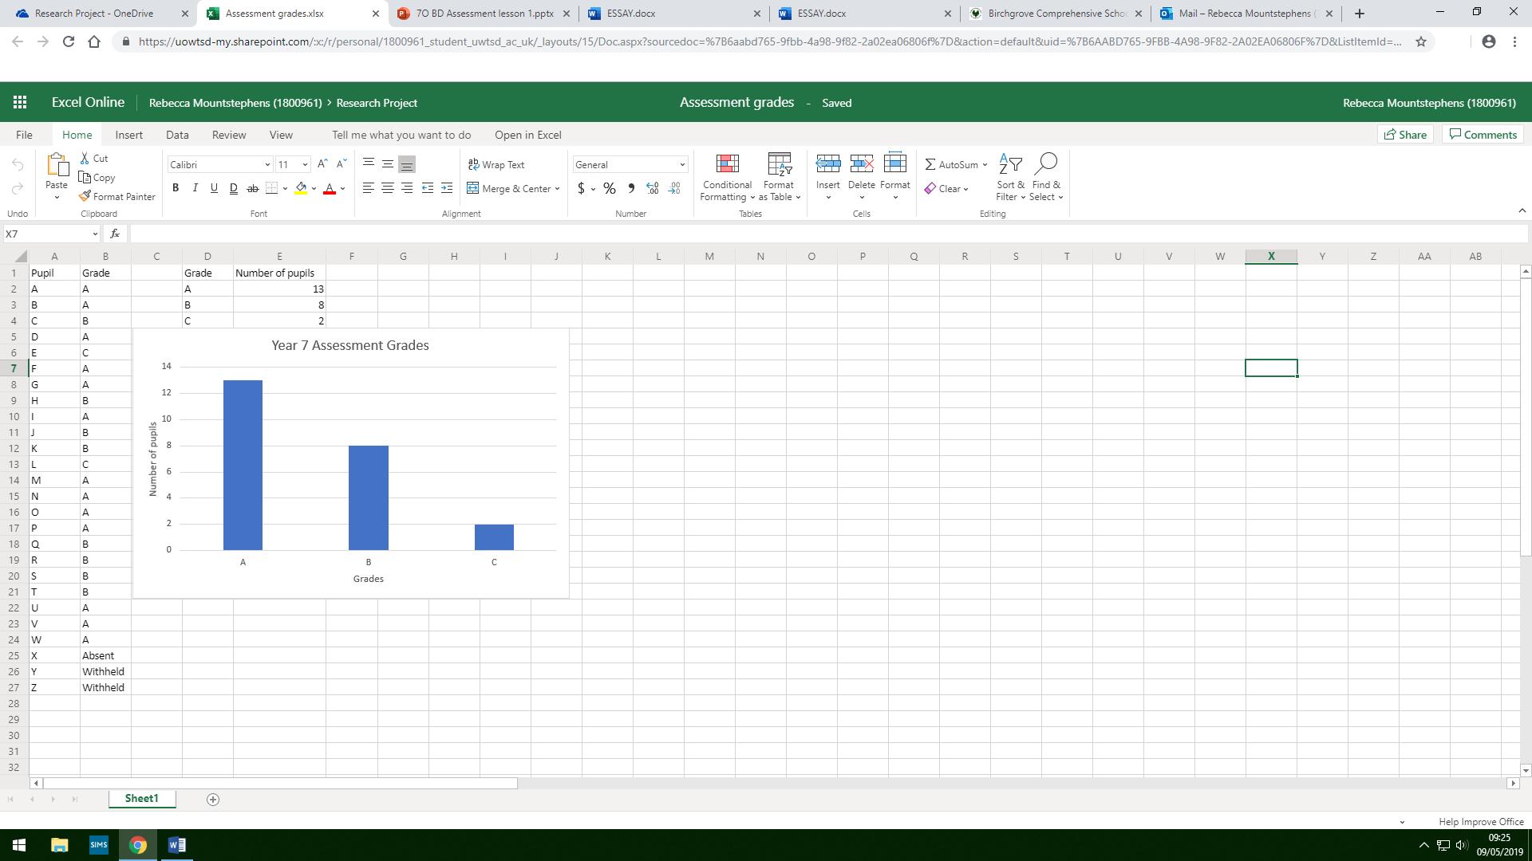
Appendix 7: Assessment Results Table and Graph
Reference List
Black, P., and Harrison, C. (2001) ‘Self- and peer-assessment and taking responsibility: The science student’s role in formative assessment’ School Science Review, 83(302), pp. 43-49
Brew, A. (1999) ‘Towards autonomous assessment: using self-assessment and peer assessment’ in Brown, S. and Glasner, A. (ed.) Assessment Matters in Higher Education. Buckingham: Open University Press
British Educational Research Association (BERA) (2018) Ethical guidelines for educational research. Available at: https://www.bera.ac.uk/wp-content/uploads/2018/BERA-Ethical-Guidelines-for-Educational-Research_4thEdn_2018.pdf?noredirect=1 (accessed 10/04/2019)
Brown, S. and Knight, P. (1994) Assessing learners in higher education. London: Kogan Page
Butler, D. and Winne, P. (1995) ‘Feedback and self-regulated learning; a theoretical synthesis’, Review of Educational Research, 65(3), pp. 245-281
Campbell, A. et al. (2004) Practitioner Research and Professional Development in Education. London: SAGE
Efron, S. and Ravid, R. (2013) Action Research in Education. New York: The Guildford Press
Estyn (2015) Inspection Report for School X.
Falchikov, N. (2001) Learning Together: Peer Tutoring in Higher Education. London: Routledge Falmer
Fanselow, J.F. (1987) Breaking Rules: Generating and Exploring Alternatives in Language Teaching. New York: Longman
Fanselow, J.F. (1988) ‘“Let’s See: Contrasting conversations about teaching’, TESOL Quarterly, 11(1), pp. 17-41
Gebhard, J. (2005) ‘Awareness of Teaching through Action Research: Examples, Benefits, Limitations’, Japan Association for Language Teaching Journal, 27(1) pp. 53-70
Gibbs, G. (1999) ‘Using assessment strategically to change the way students learn’ in Brown, S. and Glasner, A. (ed.) Assessment Matters in Higher Education. Buckingham: Open University Press
Guskey, T.R. (2003) ‘Peer assessments in physical education’ Journal of Physical Education, Research and Dance, 75(8), pp. 269-288
Hopkins, D. (2008) A Teacher’s Guide to Classroom Research. Maidenhead: Open University Press
Kumar, K. (2014) Research Methodology: A Step-By-Step Guide for Beginners. London: SAGE
Langan, M. et al. (2005) ‘Peer assessment of oral presentations: effects of student gender, university affiliation and participation in the development of assessment criteria’, Assessment and Evaluation in Higher Education, 1, pp.3-31
Liu, N. and Carless, D. (2006) ‘Peer feedback: the learning element of peer assessment’ Teaching in Higher Education 11(3), pp.279-290, available at https://www.tandfonline.com/doi/abs/10.1080/13562510600680582 (accessed 10/03/2019)
Morris, S. B. (2007) ‘Estimating Effect Sizes From Pretest-Posttest-Control Group Designs’, Organizational Research Methods, 11(2), pp. 364–386. doi: 10.1177/1094428106291059.
My Local School (2018) School X Information
Nicol, D. and MacFarlane-Dick, D. (2006) ‘Formative assessment and self-regulated learning: a model and seven principles of good feedback practice’, Studies in Higher Education, 31(2), pp. 190-218
Nolen, A. and Vander Putten, J. (2007) ‘Action Research in Education: Addressing Gaps in Ethical Principles and Practices’, Educational Researcher, 36(7) pp. 401-407, available at https://doi.org.10.3102/0013189x07309629 (accessed 20/03/2019)
Noonan, B. and Duncan C. (2005) ‘Peer and Self-Assessment in High Schools’Practical Assessment, Research & Evaluation, 10(17), pp. 1-8, available at https://www.pareonline.net/pdf/v10n17.pdf (accessed 08/03/2019)
Sackstein, S. (2017) Peer Feedback in the Classroom: Empowering Students to be the Experts. Virginia: ASCD
Sebba, J. et al. (2008) Systematic review of research evidence of the impact on students in secondary schools of self and peer assessment. EPPI-Centre Social Science Research Unit, University of London
TeacherToolkit (2018) Yellow Box Methodology. Available at: https://www.teachertoolkit.co.uk/2018/05/19/yellow-box-methodology (accessed 18/04/2019)
Topping, K. (2018) Using Peer Assessment to Inspire Reflection and Learning. Abingdon: Routledge

