Community Engagement

(LCBB4011)

Student ID:2130698
Student name: Andreea Alina Tudorache
Lecturer name: Ibrahim Rufai

Table of Contents
Introduction 3
Main Body 4
Youth Mentorship Program: Empowering Future Leaders 4
Linking Community Engagement Principles to the Youth Mentorship Program 6
Meeting Standards and Impact of the Youth Mentorship Program 9
Leveraging Individual Skills to Facilitate the Youth Mentorship Program 11
Links to personal skills 14
Conclusion 16
References 17
Appendix 19

Table of Figures
Figure 1: Mentorship in Youth Development 6
Figure 2: Community Engagement 8
Figure 3: The Role of Mentorship in Your Personal & Professional Development 11
Figure 4: 5 Key Skills to be a Successful Mentor 13
Figure 5: Improving Soft Skills Through Mentorship 15

Introduction
This report explores the improvement and implementation of a Youth mentoring programme that aims to empower teens by way of providing them probabilities for each non-public and expert development in addition to recommendations and help. By encouraging a sense of community and duty among members, the programme seeks to shut the space between training and work preparedness.
We shall observe several aspects of the programme within the elements that observe, starting with an intensive explanation of its important dreams and organisational framework. We'll observe how the programme is installed to adhere to moral ideas, satisfy instructional criteria, and meet the highest expectations for network involvement, mentorship, and schooling.
The examination may also pass into how the Youth Mentorship Programme affects every individual, the network, and society as an entire. We will emphasise this system's lengthy-term social advantages, consisting of reducing socioeconomic inequities and developing destiny leaders, in addition to the individuals' improved non-public development, fulfilment of their research and careers, and more desirable community links.
We will also observe the program's compliance with network participation principles, emphasising empowerment, inclusion, and teamwork. The planning and design method can be examined, with a focal point on how network resources, strategies for ongoing improvement, and sustainability tasks are integrated.
This report will observe how my unique skills—persuasive negotiation, enterprise improvement, organisational control, leadership, tactical advertising, and cultural sensitivity—will help the Youth Mentorship Programme be carried out and run correctly. The programme hopes to make an awesome, lengthy-lasting difference in the lives of younger people with the aid of utilising these skills. Cultivating a community that is energetic and supportive. The purpose of this report is to present a clear knowledge of the Youth Mentorship Programme, including its goals, methods of execution, and the tremendous benefits it affords to both participants and the larger community.

Main Body

Youth Mentorship Program: Empowering Future Leaders
The Youth Mentorship Programme seeks to empower youth by way of offering routes, encouragement, and probabilities for each professional and personal improvement. The major intention is to close the information hole between training and vocational preparedness while encouraging an experience of belonging and accountability amongst individuals. Through organising connections between younger human beings and pro mentors from different industries, the program hopes to develop a brand-new breed of in-position, self-confident, and community-engagement leaders.
Working on the Project
Program Structure and Development:
- Identifying the Target Group: The programme is aimed toward young people from 14 to 21 years vintage from a whole lot of backgrounds, which include impoverished neighbourhoods. All individuals could be assured inclusion and identical opportunities as a result.
- Recruitment of Mentors: Experts and experts from quite several disciplines, along with commercial enterprises, eras, the arts, and sciences, are sought to function as mentors. Their skills to encourage and mentor younger minds, in conjunction with their preference to serve, are carefully considered when choosing them (Johnson et al, 2021).
- Training and Orientation: Extensive education and orientation classes are furnished to each mentor and mentee. Mentors get schooling in best practices for mentoring, cultural sensitivity, and powerful communication. A review of this system's goals and expectations is given to mentees (Blanchard and Thacker, 2023).
Mentorship Matching Process:
- Evaluation and Profiling: In-depth profiles are manufactured by mentors and mentees, encompassing their passions, objectives, and specialisations. Making informed and suitable pairings is aided using this.
- Personalised Matching: Mentors and mentees who've similar hobbies and professional goals are matched primarily based on their profiles. The importance and effect of the mentorship connection are assured using this customised matching.
Program Activities and Engagement:
- Regular Meetings: To discuss goals, advancement, and difficulties, mentors and mentees meet collectively regularly, both individually or remotely. The mentor-mentee connection can emerge evidently in those scheduled yet adaptable interactions.
- Workshops and Seminars: A style of topics, which includes profession-making plans, management capabilities, emotional intelligence, and networking, are protected within the software's workshops and seminars. These conferences are meant to supplement one-on-one mentoring and provide more giant academic opportunities.
- Community Service Projects: Participants participate in community-provider projects to foster a sense of civic duty. These tasks now not only improve the network but also the management and collaboration abilities of the contributors.
Support and Resources:
Access to Resources: A style of sources is available to mentees, which includes instructional materials, equipment for professional advising, and internship possibilities. They are better capable of making selections regarding their destiny way to this help.
Ongoing Support: The programme gives persistent help to mentors and mentees through scheduled take-a-look at-ins, remarks meetings, and a committed guide workforce. This guarantees that any problems are resolved speedily and the mentoring programme keeps achieving success.
Evaluation and Impact Assessment:
- Regular feedback: To compare this system's efficacy, mentors, mentees, and their guardians provide ongoing entry. This feedback aids in the vital modifications and advancements.
- Impact Assessment: A variety of criteria, along with the mentees' academic achievement, non-public growth, and activity development, are used to evaluate the program's effectiveness. Testimonials and fulfilment stories are recorded to focus on the useful effects of the programme (Goff 2018).
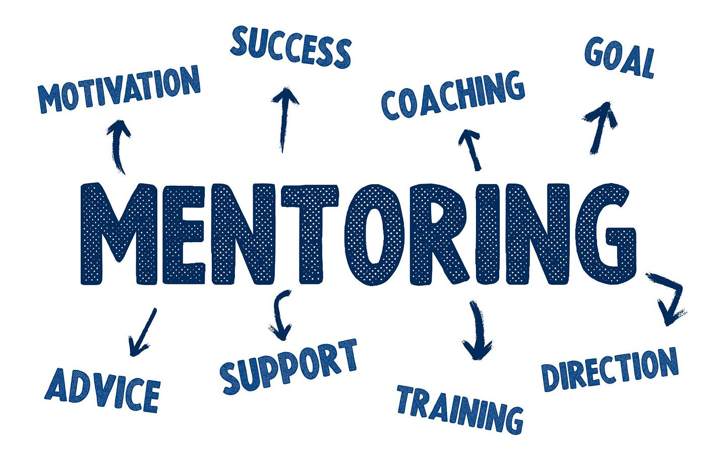
Figure 1: Mentorship in Youth Development
(Source: Medium)

Linking Community Engagement Principles to the Youth Mentorship Program
Community engagement idea is the core of the Youth Mentorship Programme. Fundamentally, the programme prioritises inclusion by way of making sure equitable right of entry to mentorship possibilities for teens from a variety of backgrounds, especially those from impoverished neighbourhoods. This inclusiveness concept promotes equality of opportunity and a feeling of network. The programme also exemplifies teamwork using bringing together quite several stakeholders, together with schools, local companies, community corporations, mentors, and mentees. This cooperative attempt guarantees that the programme isn't always just community-driven but additionally makes use of sources and abilities from many sectors to perform shared targets (Medina, Cosby, and Grim, 2020).
Empowerment is also another critical concept. The software intends to empower mentors and mentees with the aid of giving them the gadgets, materials, and assistance wished to accomplish their career and private goals. While mentors take pride in helping the next era of leaders and giving a return to their community, mentees gather knowledge, self-belief, and skills. Mutual empowerment promotes energetic engagement and participation whilst fortifying ties in the community.
Planning and Design
The Youth Mentorship Programme is carefully planned and designed to supplement a hit network involvement procedure. To pinpoint the specific possibilities and problems facing the target group, a complete wishes evaluation is performed in the first phase. Surveys, recognition agencies, and conferences with businesses and network leaders are all part of this assessment procedure to make sure the programme is customised to the unique necessities of the younger humans it's far intended to help (Treasure et al, 2022).
After needs are determined, dependent and bendy factors are incorporated into the programme layout to satisfy members' numerous demands and schedules. For instance, the matching system for mentoring may be very individualised and makes certain that each mentee reveals a mentor who stocks their desires and interests. This tailor-made method not only increases the efficacy of the mentorship but additionally encourages mentors and mentees to expand a greater profound, meaningful relationship.
Integrating Community Resources
To enhance its effect, the programme carefully consists of community sources. Collaborations with neighbourhood companies, non-income, and schools provide essential resources and assistance, which includes access to instructional materials, workshop areas, and chances for activity exploration. These collaborations are essential to building a complete aid gadget for mentees that goes past the mentor-mentee dynamic (Davies and Challis, 2018).
An essential part of the programme is workshops and seminars, which are created alongside specialists and community experts. To give mentees a comprehensive learning experience, those conferences consist of a huge variety of topics, together with career planning, management skills, emotional intelligence, and network service. Through network participants' participation in the periods' delivery, the programme ensures that the material is suitable, sensible, and pertinent to the neighbourhood setting.
Continuous Improvement and Sustainability
The program's layout adheres to the best practices for a hit community participation with the aid of incorporating mechanisms for sustainability and ongoing development. To pinpoint areas that want development, player and stakeholder entry is mechanically accrued and tested. With the help of this feedback loop, the programme is guaranteed to be adaptable to the changing needs of the network and capable of making the required modifications to improve its efficacy (Blackburn, Chambers, and Gaventa, 2018).
Additionally, via enhancing local potential, the programme highlights sustainability. It is usually recommended for mentors to coach and assist new mentors to set up a self-maintaining mentoring cycle inside the network. To make certain of its continuous operation and growth, the program additionally looks for lengthy-time period financing and aid through offers, contributions, and collaborations.
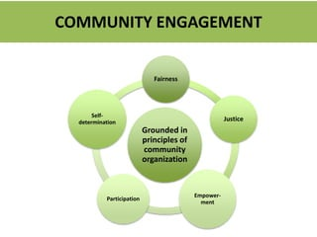
Figure 2: Community Engagement
(Source: SlideShare)

Meeting Standards and Impact of the Youth Mentorship Program
Standards
The Youth Mentorship Programme is made to satisfy the most stringent necessities for community involvement, schooling, and mentoring. To assure adherence to these standards, the programme integrates many crucial additives:
- Adherence to Ethical Guidelines: The programme adheres closely to the moral requirements set up by reputable mentoring institutions, which includes the National Mentoring Partnership. These regulations make making sure that connections between mentors and mentees are stable, civil, and inspiring. A code of behaviour, confidentiality agreements, and background exams on mentors are essential additives to the programme (Zey, 2020).
- Organised Guidance and Assistance: Comprehensive education is supplied to each mentor and mentee to be able to put together them for his or her duties. Mentors get schooling on quality practices in mentoring, cultural sensitivity, and powerful conversation. Orientation is provided to mentees on the goals, expectations, and ways to optimise the benefits of the programme of the mentorship. Throughout the programme, all facets get hold of ongoing help and sources.
- Alignment to Educational Standards: Through partnerships with nearby educational institutions and faculties, the programme is consistent with educational requirements. This alignment makes sure that the mentorship sports help the mentees' general educational growth and supplement the instructional curriculum. Workshops and seminars desire to enhance personal growth, expert preparedness, and academic skill ability (Care et al, 2018).
- Frequent statement and evaluation: A complete tool for monitoring and evaluating the programme is put in the region to keep its results and improvement. The achievement of the mentorship relationships and the overall effect of the programme are measured via regular critiques, remarks classes, and performance signs. This ongoing evaluation aids in upholding excessive requirements and making the required improvements.

Impact
The Youth Mentorship Program's effects are glaring on numerous levels, along with the social, community, and individual degrees:
Individual Impact:
- Personal Development: As a result of the programme, mentees go through substantial private improvement. They accumulate vital life abilities which include emotional intelligence, problem-solving, and communique. One-on-one mentorship gives mentees customised advice and helps in overcome limitations and realise their objectives (Abbott, 2021).
- Academic and Professional Achievement: The direction improves both career preparedness and educational fulfilment. In addition to accessing possibilities like internships and work shadowing, mentees receive assistance with college and professional instruction and accumulate insights into a variety of expert pathways. Their prospects of fulfilment in postsecondary education and the labour market are more desirable via this help, which permits students to make well-knowledgeable decisions about their future.
Community Impact:
- Strengthened community bonds: Participants' feelings of belonging and network are fostered by the programme. Through the programme, community ties are bolstered and a collaborative and mutually supportive way of life is fostered through pairing young humans with local mentors and getting them worried in-network provider tasks.
- Building Capacity: By encouraging mentors and mentees to get involved in their groups, the programme will increase neighbourhood potential. Mentees are recommended to offer again to their network through management and voluntary paintings, and mentors take on roles as function models and position models. As a result of this ability building, more network members are encouraged to take part in sports of a comparable nature.
Societal Impact:
- Reduction in Social inequality: The programme contributes to the reduction of social disparities using providing mentorship possibilities to young human beings from numerous and disadvantaged backgrounds. It guarantees that all young people have access to the aid and equipment they want to acquire, regardless of their financial state of affairs.
- Long-Term Societal Advantages: By developing a brand new era of responsible, successful, and community-targeted leaders, the programme facilitates to fostering of long-term societal benefits. Probably, those upcoming leaders will positively impact society and propel both social and financial development.
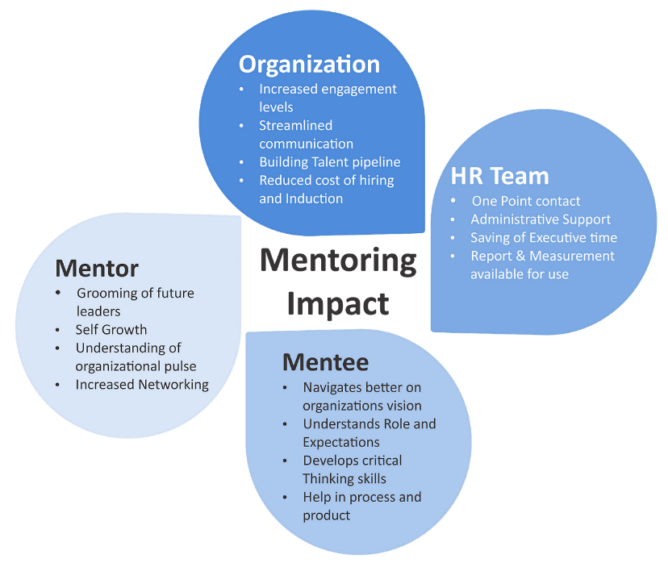
Figure 3: The Role of Mentorship in Your Personal & professionally Development
(Source: Medium)

Leveraging Individual Skills to Facilitate the Youth Mentorship Program
Effective communication
Effective conversation is one of my most powerful fits and is critical to going for walks in a successful mentoring programme. Building stable connections between mentors and mentees calls for a clear and specific communique. To help mentors provide steering, grievance, and assistance to their mentees in a clear and motivating manner, I can provide training workshops on effective verbal exchange strategies. Furthermore, via actively listening, I can understand the desires and concerns of each mentor and mentee, fostering a supportive environment in which all people are made to experience stated and liked (Buluş, Atan, and Sarıkaya, 2017).
Organisation skills
My potential to be organised might be very helpful in the improvement and implementation of the Youth Mentorship Programme. Overseeing a programme at this length calls for overseeing several factors, along with recruiting mentors, linking mentees with mentors, putting in common meetings, and planning lectures and workshops. The program will function easily and correctly way to my interest in elements and multitasking skills. To ensure that every part of the programme is well-coordinated, I will make thorough challenge plans, preserve deadlines, and utilise venture management equipment (Curran and Wexler, 2017).
Adaptive Leadership and Leadership
Having worked in each management and adaptive management, I am qualified to mentor and assist each mentee and mentor at some stage in the programme. With the usage of my leadership talents, I may be capable of encouraging and uplifting individuals, encouraging a proactive and upbeat method of mentoring. In precise, adaptive leadership is crucial as it enables me to negotiate the complexity and uncertainty that emerge at some stage in the programme. I can regulate moving conditions, deal with obstacles quickly, and position innovative ideas into exercise to make certain the programme is a hit.
Persuasive Negotiation: My capacity to steer others will come in very reachable while seeking to get partnerships and investment for the programme. Whether I'm negotiating sponsorship with nearby corporations, finding a place for a workshop, or operating with academic establishments, my ability to make sturdy instances and training sessions in high-quality conditions will assist me with the sources and aid I want. This will assure the program's improvement and sustainability similarly to improving its offers.
Business Development: My history in business development can help the Youth Mentorship Programme attain a much wider target market and have an extra impact. I can see areas for development, formulate plans to attract extra members and convey collaborations with corporations who proportion our goal. I can make certain that the programme continues changing and adapting to the demands of the community by utilising my commercial enterprise development capabilities, as a way to ultimately have a bigger effect on the lives of young people (Ogamba, 2019)
Tactical Marketing: Promoting the Youth Mentorship Programme will help recruit mentors and mentees through using tactical marketing strategies. I can spread the word about the program and its blessings using making use of social media, launching focused marketing efforts, and interacting with neighbourhood firms. Good advertising will not handiest increase involvement but also assist the programme in establishing a strong recognition inside the community, which will entice extra people to take part (Labin, 2017).
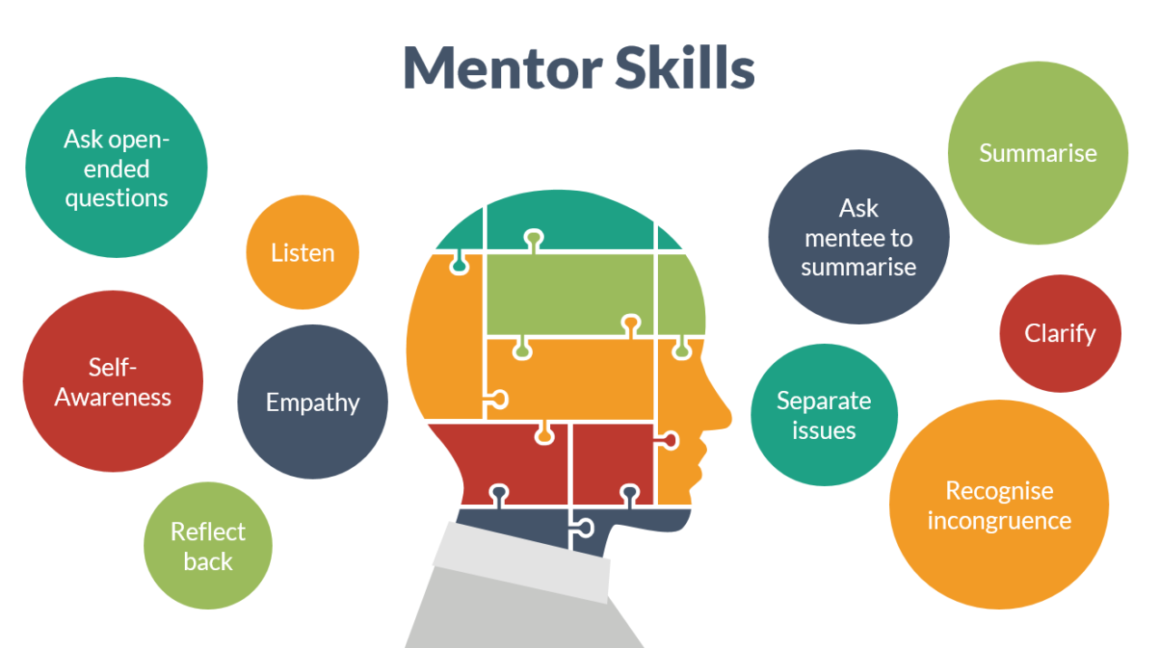
Figure 4: 5 Key Skills to be a Successful Mentor
(Source: LinkedIn)

Links to personal skills
Effective Prioritisation and Time Management
Effective time management and prioritisation are the most essential skills I acquired at some stage in the Community Engagement reflection log, which ran from April to June of 2024. We mentioned the Eisenhower field on January twenty second, which aids with task prioritisation in step with precedence and urgency. By the usage of this approach on my assignments, I became capable of perceiving which ones needed to be executed well away and which ones could wait until later. This capacity is crucial for overseeing the Youth Mentorship Programme as it calls for handling several duties, which include putting in place seminars, arranging mentor-mentee conferences, and making sure members acquire ongoing assistance. I can make sure that essential components of the programme get the attention they require by way of placing priorities wisely if want to grow this system's usual efficacy and efficiency.
Skills in Organisation
Applying the Eisenhower box to my paintings was a notable workout that helped me emerge as a great deal greater organised. I've become greater skilled at managing challenging assignments using studying to organise my paintings and focus on important matters. These organisational competencies will assist me in manipulating the Youth Mentorship Program's many elements, along with mentee matching, mentor recruiting, and event instruction. To make certain that the whole thing is well-coordinated and not anything gets overlooked, I will draft thorough undertaking plans and uphold an organised timetable. This established technique will assist me steer the program easily, making sure all stakeholders are aligned and targets are met.
Adaptive Leadership and Leadership
My capability for management and adaptability can be a critical asset in running the Youth Mentorship Programme. I developed these talents in the course of the mirrored image time by taking components in sports that are known as main groups and adjusting to transferring conditions. To create a proactive and happy place of business for both mentors and mentees, effective leadership is essential. Specifically, adaptive leadership allows me to overcome limitations that may come up at some point in the programme with the aid of navigating uncertainty and setting innovative solutions in the area. I can make sure the programme remains dynamic and sensitive to the necessities of participants with the aid of workout flexibility and resilience as a leader.
Communication and Persuasive Negotiation:
Another essential ability I have acquired is effective communication, which is important for the Youth Mentorship programme to achieve success. Strong connections may be constructed between mentors and mentees as well as with different stakeholders while there is clear communication. Furthermore, my potential to influence others will be available very on hand when trying to get partnerships and funding for the program. Whether I'm running with instructional institutions or local businesses to get sponsorships, my ability to make strong cases and steady beneficial situations can be vital in securing the funding and sources needed to improve the program's services.
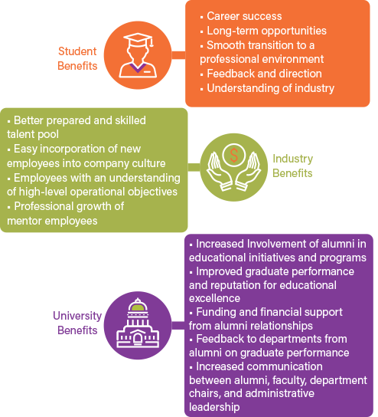
Figure 5: Improving Soft Skills Through Mentorship
(Source: AIChE)

Conclusion
In conclusion, I am well-equipped to oversee the Youth Mentorship Programme way to the combination of sturdy organisational skills, compelling negotiating skills, competent leadership, clean conversation, and effective prioritisation that I even have evolved via my Community Engagement reflection journal. With these abilities, I might be able to control boundaries, plan numerous programme elements, and create a welcoming environment for both mentors and mentees. My purpose is to guarantee the program's effectiveness and long-lasting useful effect on the network and its participants through implementing non-stop development and upholding a proactive attitude.

References
Abbott, T., (2021). Social and personality development. Routledge.
Blackburn, J., Chambers, R. and Gaventa, J., (2018). Mainstreaming participation in development. In Making development work (pp. 61-82). Routledge.
Blanchard, P.N. and Thacker, J.W., 2023. Effective training: Systems, strategies, and practices. SAGE Publications.
Buluş, M., Atan, A. and Sarıkaya, H.E., (2017). Effective Communication Skills: A New Conceptual Framework and Scale Development Study. International Online Journal of Educational Sciences, 9(2).
Care, E., Kim, H., Vista, A. and Anderson, K., (2018). Education System Alignment for 21st Century Skills: Focus on Assessment. Center for Universal Education at The Brookings Institution.
Curran, T. and Wexler, L., (2017). School‐based positive youth development: A systematic review of the literature. Journal of School Health, 87(1), pp.71-80.
Davies, B. and Challis, D., (2018). Matching resources to needs in community care: An evaluated demonstration of a long-term care model. Routledge.
Goff, L.M., (2018). A quantitative non-experimental study of school funding and academic achievement in Mississippi public school districts (Doctoral dissertation, Northcentral University).
Johnson, M.O., Fuchs, J.D., Sterling, L., Sauceda, J.A., Saag, M.S., Fernandez, A., Evans, C.H. and Gandhi, M., (2021). A mentor training workshop focused on fostering diversity engenders lasting impact on mentoring techniques: results of a long-term evaluation. Journal of Clinical and Translational Science, 5(1), p.e116.
Labin, J., (2017). Mentoring programs that work. Association for Talent Development.
Medina, M.A., Cosby, G. and Grim, J., (2020). Community engagement through partnerships: Lessons learned from a decade of full-service community school implementation. In Reviewing the Success of Full-Service Community Schools in the US (pp. 128-146). Routledge.
Ogamba, I.K., (2019). Millennials empowerment: youth entrepreneurship for sustainable development. World Journal of Entrepreneurship, Management and Sustainable Development, 15(3), pp.267-278.
Treasure, A.M., Hall, S.M., Lesko, I., Moore, D., Sharan, M., van Zaanen, M., Yehudi, Y. and van der Walt, A., (2022). Ten simple rules for establishing a mentorship programme. PLoS computational biology, 18(5), p.e101- 015.
Zey, M.G., (2020). The mentor connection: Strategic alliances within corporate life. Routledge.

Appendix
CPD Record
Name: Andreea Alina Tudorache | LCBB4011 – Community Engagement Reflection log | Covering the period from:  To: May 2024 to July 2024

Date of Lesson | What Did You Do in the Lesson? | What Did You Learn from This? | How Will You Use This in Future? | Actions Outside of the Lesson
18May | Discussed the Eisenhower box (Important/Not – Urgent/Not) to prioritize different tasks. Applied this to my example. | Learned that not all tasks have the same priority and thought about what I usually do first. Helps organize tasks in priority-urgency order. | Move tasks on my calendar to ensure that tasks with priority get the first pick. This skill can help me be more organized in future projects. | Watch 3 more YouTube videos on time management. Keep a record of my actions until the next lesson to see if I did them in priority order.
25May | Participated in a group discussion about time management techniques, including the Pomodoro Technique. Applied it during a study session. | Learned the effectiveness of breaking work into intervals and taking short breaks to maintain focus and productivity. | Use the Pomodoro Technique to improve productivity during study sessions and work projects. | Implement the Pomodoro Technique in daily tasks. Track productivity to see improvement over time.
1Jun | Attended a workshop on effective communication skills, including active listening and clear articulation. Practiced these skills in role-playing scenarios. | Understood the importance of active listening and clear communication in personal and professional interactions. | Apply active listening and clear articulation in future communications, ensuring better understanding and collaboration. | Practice active listening in daily conversations. Seek feedback from peers on communication effectiveness.
8Jun | Engaged in a seminar on conflict resolution strategies, including mediation and negotiation techniques. Applied these strategies in group activities. | Learned various conflict resolution strategies and their application in resolving disputes amicably. | Use conflict resolution strategies in future group projects and professional settings to manage and resolve conflicts effectively. | Read more articles on conflict resolution. Practice mediation and negotiation techniques in role-playing scenarios with peers.
15Jun | Participated in a leadership development session focused on adaptive leadership and situational analysis. Conducted a case study analysis. | Learned the principles of adaptive leadership and how to apply situational analysis to adapt leadership styles based on the context. | Implement adaptive leadership principles in future leadership roles, adapting style to meet the needs of the situation and team members. | Study case studies on adaptive leadership. Apply learned principles in group activities and seek feedback on leadership effectiveness.
22Jun | Attended a presentation on strategic planning and goal setting. Created a personal strategic plan with short-term and long-term goals. | Learned the importance of strategic planning and how to set realistic and achievable goals to guide personal and professional growth. | Use strategic planning techniques to set and achieve personal and professional goals, ensuring continuous growth and development. | Review and update the personal strategic plan regularly. Set measurable milestones and track progress towards achieving goals.
29Jun | Participated in a workshop on teamwork and collaboration, including activities to build trust and enhance team cohesion. | Learned the value of trust and effective collaboration in team settings. | Foster trust and collaboration in future teamwork scenarios, enhancing overall team performance and cohesion. | Engage in more team-based activities. Reflect on teamwork experiences and identify areas for improvement in collaboration and trust-building.
6Jul | Attended a seminar on cultural sensitivity and awareness. Engaged in discussions about different cultural perspectives and practices. | Gained insights into the importance of cultural sensitivity in diverse environments. | Apply cultural sensitivity in interactions with people from diverse backgrounds, promoting inclusivity and respect. | Learn more about different cultures through reading and interactions. Participate in cultural events to gain practical experience in cultural sensitivity.
13Jul | Participated in a session on stress management techniques, including mindfulness and relaxation exercises. | Learned various stress management techniques and their benefits in maintaining mental well-being. | Apply stress management techniques in daily life to maintain mental well-being and productivity. | Practice mindfulness and relaxation exercises regularly. Monitor stress levels and adjust techniques as needed for optimal mental health.
20Jul | Attended a workshop on public speaking and presentation skills. Delivered a short presentation and received feedback. | Learned effective public speaking techniques and areas for improvement in presentation delivery. | Use public speaking techniques to improve future presentations, ensuring clear and engaging communication. | Practice public speaking regularly. Record presentations to self-assess and seek feedback from peers for continuous improvement.

