Student No: 2514137

Portfolio 2
Katie Evans - July 2026
Total Words: 3,915

Community Profile on Young people Living in Ceredigion who are not in Education, Employment or Training (NEET)

Aims
The aim of this paper is to explore a community of young people, it will look into young people who have been identified as being not in education, employment or training (NEET), it will examine the provisions and opportunities available for these young people residing within Ceredigion. It will also include young people’s perspectives and experiences, along with the frameworks and policies that are in place seeking to support young people back into education, employment or training while ensuring the provisions available are inclusive and educative, highlighting the different agencies that are working with these young people. It will also look into different research relating to NEETs, exploring the links between risk factors that can determine a young person’s pre-detriment to becoming NEET upon turning 16. It will also explore the Welsh government NEET framework and Ceredigion youth services policies for working with NEET young people along with voluntary agencies and Council agencies which also seek to provide opportunities to the NEET young people who reside in Ceredigion.
All young people’s experiences and perspectives included within this paper will be anonymised and verbal consent has been obtained from the young people to include their perspectives and experiences within this paper.
Geographical context
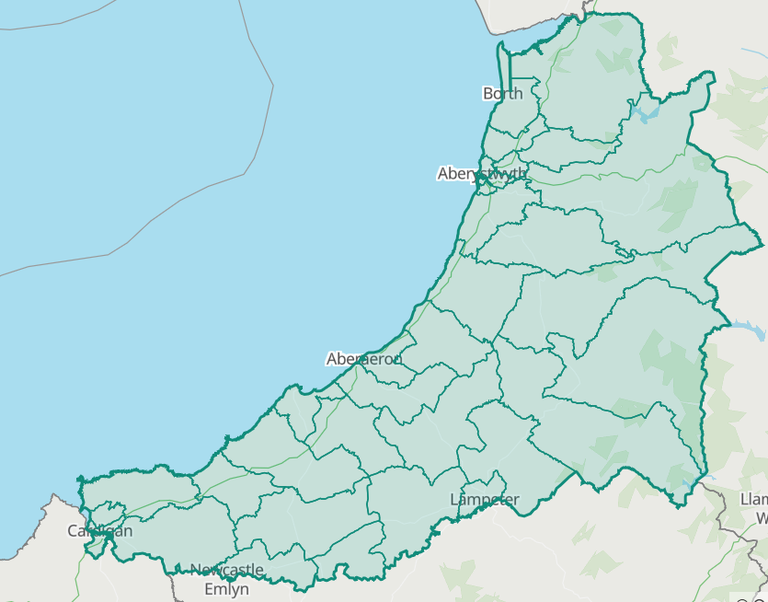 (Office for National Statistics)
Ceredigion is a rural county in mid Wales spanning over 1,785 square kilometres, which had a population of 72,599 in 2024 (Office for National statistics). Based on information obtained from the 2021 Census there was 9,300 to 10,000 young people aged between 16-25 residing within Ceredigion during this period (Population and migration report: August 2024), it is difficult to obtain statistical data as to how many of those young people would have be identified as NEET. Welsh Government Statistical document shows that at the end of December 2025, 17% of 16–25 year olds residing in Wales were identified as being NEET, the graph below shows that North Wales had the highest rates of NEET young people, with Mid and South West Wales having the second highest and South East Wales having the lowest levels of young people identified as being NEET within Wales.
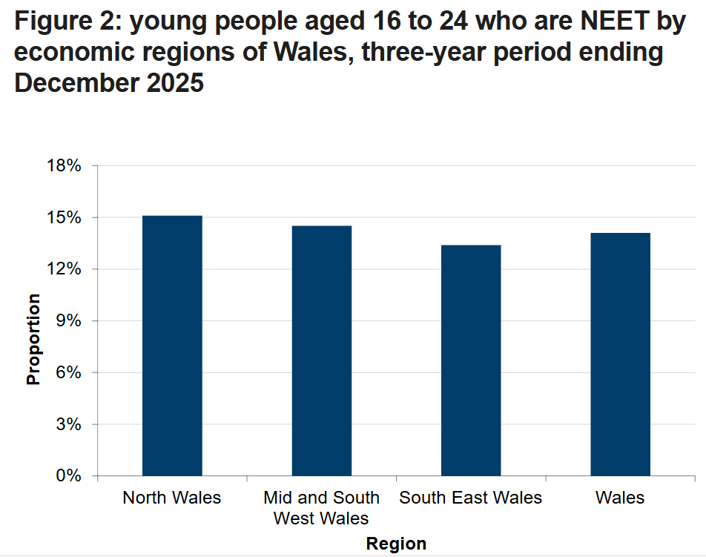 (Gov.Wales)
Young person observations
While working with the local authority and specifically with young people who had been identified as NEET, they were able to provide insight as to what had led them to fall within this category. These conversations provided invaluable first had lived experiences as to what is working well within Ceredigion, but also what could be implemented to establish earlier identification and support mechanisms to ensure young people are provided with preventative transitional support and not just opportunities and provisions once they had become NEET.
Provisions available for NEET young people that are facilitated by Ceredigion youth service include one-to-one support, group-based support and predominantly a group called Inspire. The Inspire Group is tailored to enhancing 16–25-year old’s confidence, employability skills and providing opportunities for them to obtain qualifications such as food hygiene, first aid, Agored Cymru’s and so on (Ceredigion youth service). Young people highlighted that there was a need for further targeted NEET provisions focusing on mental health and an LGBTQ+ group that youth workers supported and were able to facilitate for the young people.
A young person accessing the inspire provision said they find it really helpful and staff are very knowledgeable and supportive, they attend weekly, with the hope of building their confidence to then progress into work. They said they have been provided with opportunities to do volunteering in different places as part of this group, and it has helped them to see what their interests are and areas they would like to seek employment in the future.
Many young people who attend the provision spoke about how it has supported them to leave the house, make friends and socialise again after covid 19, and through this provision they now feel hopeful for their future and excitement towards the opportunities available to them.
One young person spoke about how they would have liked to have been able to meet with a post 16 youth worker before they became NEET and left school. The confidence they now have after doing targeted work with a youth worker and the support they have been offered would have made so much difference when they were not sure what they wanted to do after completing their GCSEs.
Agencies and Multi-Agency working
Within Ceredigion there are multiple agencies working with young people that are identified as NEET, these agencies collaboratively work together to meet the needs of each individual. It is written within the Youth Work Wales: principles and purpose document that youth work begins at the point where young people are within their lives, regardless of their circumstances, supporting them to reach their full potential (Youth Work Wales: Principles and purpose, 2018). By agencies working together and meeting the needs of the individuals, it has proven to be successful in supporting young people back into education, employment or training, allowing services to signpost individuals to the different agencies that best meet their needs showing a collaborative working style.
These agencies include Careers Wales which work with the young people from year 10 in secondary school, PRU’s and also go out to the homes of EHE (elected home educated) young people. Careers works with the youth service by providing them with Teir 1 and Teir 2 data ensuring that no young people are missed and not offered provision/support. There are monthly meetings with partnership agencies including Careers Wales, Collage, HCT training provider, housing support and post 16 outreach youth workers. These meetings seek to track down and offer support to those NEET young people that have been identified by Careers Wales but are no longer engaging with Careers Wales. This method of multi-agency working ensures that all the young people that have been identified as NEET that reside in Ceredigion, have access to support, seeking to help them find a destination once leaving school or are offered youth service provision if they are not ready to engage in education, employment or training at present.
There is also the employability team within Ceredigion County Council who work alongside the Welsh government to deliver Communities for work+ project, this project seeks to work with anyone aged 16 plus to support them into employment. They are able to facilitate support with young people in gaining work experience (work trials), qualifications needed for employment, reducing the barriers to obtaining the qualification (by funding the qualification, study skills), they also have the means to purchase equipment and clothing needed to obtain work for young people (Ceredigion County Council). This agency allows the youth service along with may other agencies to refer young people onto their programme and works collaboratively with the allocated youth worker for each young person to ensure the young person is able to succeed.
There are two Job Centres within Ceredigion, one in the North in Aberystwyth and one in the South in Cardigan, which both have a youth worker from the youth service that works out of the centres one day a week to meet with young people. This allows job centre work coaches that are working with 16-25 year olds, to refer those young people who are claiming universal credit but are not quite ready to engage with work, onto the youth service to access their provisions and youth workers to support young people with the transition into employment.
Policies and Framework
There is a vast amount of research being conducted into NEETS across the county with the Youth engagement and progression framework (YEPF) being implemented into Ceredigion youth service’s five-year plan. The YEPF noted six core components to working with NEET young people these are: early identification, targeted one-to-one support, provision, employability and accountability towards agencies in ensuring these are met.
Youth work in Wales principles and purpose, this sees that youth work starts at whatever point the young person is at in their life, regardless of their circumstances and it recognises their potential (Youth Work Wales: Principles and purpose, 2018). By embedding this into practice it ensures provisions available to those NEET young people of Ceredigion are given targeted provisions tailored to the individual ensuring equality and inclusion.
National Occupational Standards (NOS) also ensure that young people are listened too, that they have a voice, that they are safeguarded and much more. These are principles that youth workers must follow and implement into their daily practices ensuring provisions are inclusive, educative, expressive, empowering and participative (youth work strategy for Wales, 2024).
The wellbeing of future generations act notes that working collaboratively with different agencies to ensure young people prosper and thrive creating a more equal Wales and cohesive communities (Wellbeing of future generations act, 2015).
Alternative Education
Alternative education provisions are designed to increase employability and functional skills of young people, by providing those young people aged 14 -16 who do not conform to formal schooling with an opportunity to learn hands on trades and life skills and obtain an accreditation upon completion. Yet the opportunity to attend alternative education is not open access and young people must meet a certain criteria to be eligible to be offered this opportunity, post 16 NEET youth workers try and facilitate this sort of provision and opportunities to those young people aged 16-25 through similar means.
Once young people have reached 16 years of age the provisions offered through Ceredigion youth service are open access, the opportunities available to these young people are seeking to engage them back into education, employment or training. They offer a wide range of different activities linking accreditations to activates, below is a picture of Ceredigion youth service’s post 16 Inspire group receiving their outdoor first aid certificates after completing a 6 week programme incorporating water activities and an outdoor first aid accreditation.
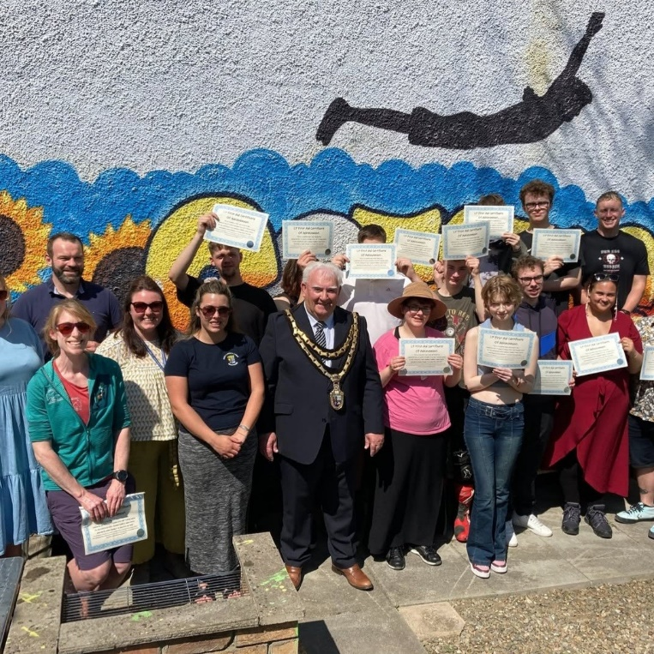
(Ceredigionifanc, 2025)
Activities like these provide NEET young people with the skills and qualifications to progress onto further education, employment or training, while helping them build resilience, confidence and supporting their mental health.
Some of the young people who attend inspire voiced that had they been able to access provisions such as this while still in education, as many did not meet the criteria to attend alternative curriculum while in school, it may have supported them and enhanced their confidence sooner to progress straight into further education after finishing school.
Risk-Factors
There is much research into young people being identified as NEET and having some form of mental health, provisions such as those offered by the youth service within Ceredigion help young people and do not push them to conform and transition into NEET within a time frame.
It was highlighted in a study conducted by Liverpool University which identified the links that can contribute to young people being identified as NEET. They noted that experiencing poor physical health and/or poor mental health in childhood are seen as ‘risk factors’ that can contribute to inequalities leading to adolescence NEET status (Creese, Taylor-Robinson and Hargreaves, 2023).
By investing in youth mental health early this can be seen as a way of improving life chances, another study shows the link between health conditions in early adolescence can lead to poor subsequent education and employment outcomes. This study concluded that by the information obtained within their research, it would provide insight to inform intervention strategies and areas of earlier identification of ‘at risk’ young people (Hale and Viner, 2018).
These two studies both conclude that young people experiencing poor mental health and/or physical health can be an early indicator and ‘risk factor’ to that young person becoming NEET in later adolescence. Providing a measurement method towards early identification and the need for intervention and preventative measures from agencies to go into support young people earlier.
Suggestions
Earlier identification of young people who are deemed at risk of becoming NEET is needed and for those young people disengaging with education or presenting with ‘risk factors’. There is a need for targeted interventions and for them to have the opportunity to work with a post 16 trained youth worker to support their re-engagement into education and encourage their future aspirations. This has been noted within the youth engagement and progression framework, where one of their core components is early identification. With Ceredigion implementing this into their new 5-year plan commencing in September 2026 this should enable them to identify early on who is ‘at risk’ and presenting with ‘risk factors’ enabling them to work collaboratively within their North, Mid and South of the county ‘bubbles’ to ensure those early interventions are implemented.
Conclusion
The is a number of young people identified as being NEET within Ceredigion, with tailored provisions being offered to support them back into education, employment or training. The multi-agency working throughout Ceredigion is very strong, with all agencies involved with working with young people identified as being NEET, putting the young people at the centre of their practice and liaising with each other to best meet the needs of the individuals. It was apparent through discussions and consultations with young people that they feel supported and heard within the youth service and that due to this support many were progressing towards re-engagement with education, employment or training.
With research providing insights into how they could identify and implement early identification through ‘risk factors’ and Ceredigion youth service highlighting the need for early identification along with the YEP framework, hopefully NEET numbers will decrease within the area due to targeted work being conducted earlier on with young people.
Words 2263
Reference List
Office for National Statistics, Government web page, 2024. Ceredigion (W06000008) - ONS (Accessed 7/2026)
Welsh Government, Young people not in education, Employment or training (NEET) Published April 2026. Young people not in education, employment or training (NEET): 2025 [HTML] | GOV.WALES (Accessed 7/2026)
Research and performance team, Ceredigion County Council. Census 2021: Population and Migration Report August 2024. Population and Migration Topic Paper - Census 2021 (Accessed 7/2026)
Gwasanaeth Ieuenctid Ceredigion Youth Service website. Ceredigion Youth Service – Supporting Young People | Youth Club (Accessed 7/2026)
Ceredigion County Council website. Communities for Work + - Ceredigion County Council (Accessed 7/2026)
Youth Engagement and Progression Framework handbook: Guidance on early identification. Youth Engagement and Progression Framework: guidance on early identification [HTML] | GOV.WALES (Accessed 7/2026)
Youth Work in Wales: Principles and purpose. Published Youth Work in Wales Review Group, October 2018. BOOKLET (Accessed 7/2026)
Youth work National Occupational Standards, 2019. Youth Work National Occupational Standards 2019 Introduction (Accessed 7/2026)
Wellbeing of Future Generations act 2015, Welsh Government, updated January 2025. Well-being of Future Generations (Wales) Act 2015: the essentials [HTML] | GOV.WALES (Accessed 7/2026)
Youth Work Strategy for Wales, Welsh Government, Education Wales, 2024. The Youth Work Strategy for Wales english (Accessed 7/2026)
Creese, H., Taylor-Robinson, D. and Hargreaves, D. (2023) “Do child mental & physical health explain inequalities in adolescent NEET status? A UK Cohort Study,” European journal of public health, 33(Supplement_2). Available at: https://doi.org/10.1093/eurpub/ckad160.751 (Accessed 7/2026)
Hale, D.R. and Viner, R.M. (2018) “How adolescent health influences education and employment: investigating longitudinal associations and mechanisms,” Journal of epidemiology and community health (1979), 72(6), pp. 465–470. Available at: https://doi.org/10.1136/jech-2017-209605. (Accessed 7/2026)

In Depth Analysis of own practice
Analysis of own practice: relating to post 16 provision, LGBTQ+ group and Miles for the Mind.
Within my second placement, work was carried out with young people aged 16-25 that had been identified as being NEET. After youth consultations were held with young people within a group and one to one basis it was noted that there was a need for targeted groups as well as the already pre-established Inspire group. The Inspire group predominantly focuses on confidence building, obtaining accreditations, volunteering experiences and supporting young people back into education, employment or training. Once we were able to establish there was a need for further provisions, we were then able to speak with management and highlight areas in need of further provisions and following these discussions, two groups were then established.
The Miles for the mind group which runs weekly, that focuses on mental health and fitness this is a group that consists of walking in different areas around Ceredigion and is open to all young people aged 16-25 who are Neet that may suffer with their mental health and/or physical health. We then created an LGBTQ+ group that runs fortnightly, for young people who are part of the LGBTQ+ community as a safe space for them to explore and express themselves freely.
As a youth worker that has supported the creation of these two additional groups due to young people expressing their needs, I do feel proud that we were able to facilitate what young people have asked for and empowered them to speak up and feel heard, drawing connections to the National Occupational Standards (NOS). Young people feel comfortable expressing their needs and activities that they would like to do and by implementing their ideas into practice, it empowered them and allowed them to see that their voice is heard within the service, and that Staff do take their ideas forward and follow through with them.
Early evaluations of these groups have been positive with numbers growing each week, with growing emphasis on the need for groups supporting mental health, LGBTQ+ along with ALN being incorporated into the youth services 5 yr plan, which shows we are heading in the right direction and meeting the needs of the young people residing within Ceredigion.
There were some threats identified, with funding and staff capacity being amongst the two main ones that we encountered. Funding and grant cuts meant that sessions needed to be facilitated in house utilising staff expertise and knowledge to deliver relevant, empowering and educative sessions to young people. The rurality of Ceredigion also proved problematic as staff residing and working within each area of Ceredigion (North, Mid and South) needed to facilitate lifts for young people to be able to attend these additional provisions utilising the service minibuses. This has put further strain onto staff and occupied another day a week to facilitate these groups due to grants ending and funding cuts staff are having to work multiple session a week on top of doing one-to-one visits, tier visits, meetings, case note logs and so on.
When reading through the youth work in Wales principles and purposes document, it highlighted the good work Ceredigion youth service has done at implementing the principles of youth work into our daily practices and in conjunction with the youth engagement and progression framework ensures that staff provide relevant, engaging and inclusive provision and opportunities for Neet young people.
Words 574

Reference List
Youth work National Occupational Standards, 2019. Youth Work National Occupational Standards 2019 Introduction (Accessed 7/2026)
Youth Work in Wales: Principles and purpose. Published Youth Work in Wales Review Group, October 2018. BOOKLET (Accessed 7/2026)
Youth Engagement and Progression Framework handbook: Guidance on early identification. Youth Engagement and Progression Framework: guidance on early identification [HTML] | GOV.WALES (Accessed 7/2026)

Summery of professional Learning and development
 | 1. Work with Young People in accordance with the 5 pillars of Principles and Purposes of Youth Work in Wales (YWWRG, 2018) (Educative, Expressive, Participative, Inclusive, Empowering). | 2. Facilitate learning and development of young people through planning and implementing learning activities in youth work | 3. Actively demonstrate commitment to inclusion, equity and young people’s interests and health and wellbeing. | 4. Plan and implement strategy and youth work activities for young people | 5. Develop, lead and manage self and others | 6. Work with communities. Encouraging Young People to actively engage in their communities and work to promote the voice and needs of young people.
What do you need to learn? | By working with young people who are NEET and planning provisions that are young person lead, meet the needs of the individuals as well as aligning with policy and youth Engagement and progression framework. Ensuring I have prior knowledge of the youth work in Wales: principles into practice document and be able to draw on links between the theory and practice. NOS: YW10, YW11, YW12 | By providing young people with the knowledge and tools they need to progress in their future, supporting their needs and impowering them. By looking at Welsh Gov framework relating to NEETs and ensure that the provisions available to those young people in Ceredigion align. | Equality, Diversity and inclusion. Theory to support this and articles that highlight the inclusion of all young people who experience being NEET. Articles relating to factors that could cause young people to become NEET. | Target groups to support the wellbeing of young people encouraging their positive mental health, support them to build their confidence and enable them to be ready to engage in EET. | Celebrate one’s successes, it was highlighted from my first placement this was one of my weaknesses where as I was very confident is showing support to my colleagues and highlighting their areas of successes. | How Ceredigion actively seek to engage young people in aspects of their planning, enabling them to be inclusive, educative, empowering, expressive and ensuring sessions/activities are participative.
Activities you will learn from (how will you learn, what will you learn from) | Youth consultations are held termly with Neet young people to incorporate their voice into our planning. Creation of 2 new provisions LGBTQ+ group and Miles for the mind. Inspire group works on upskilling young people and providing them with the tools and knowledge ready to engage back with EET | Group provision and one-one targeted work focusing on EET opportunities with young people, ensuring they are ready for EET and not being set up to fail, sessions tailored to the individual with interventions plans for each young person. | Group provisions and how they meet the needs of all young people, how groups are inclusive. Discussions with young people to hear their experiences and what they feel could have been done differently to support them and what has worked well. | Planning sessions, activities, intervention plans for young people, with information obtained through group discussions, one-to-one and youth consultations. Being able to facilitate provisions that engage, educate, advocate and empowering young people. | Team meetings, supervision and staff discussions focusing on reflective practice. Looking at signs of safety supervision model along with different models to ensure professional and personal learning development. | Group discussions, Team planning days and activity days. Ensuring young people who are NEET have different volunteering opportunities within their communities.

Student | 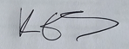
Supervisor
Date | 19/6/2026

By focusing on a community of need within this placement, specifically young people who have been identified as being Neet and tailoring my supervision sessions around this I found them extremally insightful. My supervisions were conducted using Brown and Bourne 1996’s model where young people are the beneficiaries within the agency context, ensuring that I used my supervision as a method of reflection to ensure high standards of provision and practices were on offered to the young people (Brown & Bourne, 2002). We also followed the signs of safety model focusing on what is working well? What are we worried about? What needs to happen? This encouraged me to see areas within my role that were positive and helped me to highlight my good practice, this was also used to explore group provisions and one to one session’s. Due to this we were able to see there was a need for further targeted provisions and by conducting consultations with young people it provided me with their recommendations that I was able to take into these meetings and voice to my supervisor.
By exploring the different frameworks and research around Neets in the UK and Wales, I was able to see that mental health was a key aspect into young people becoming and remaining NEET. With early identification being one of the key components of the youth engagement and progression framework we had multiple discussions around early identification and how this works within Ceredigion.
There was a need for those young people within Ceredigion who are currently NEET to have targeted provisions supporting their mental health and wellbeing and by creating the provision called ‘Miles for the mind’ it incorporated mental health and physical health through walking and talking sessions, the group has proven successful with young people and numbers are growing weekly. This then led onto us discussing the youth services five-year plan and how a section in the plan focuses on mental health provisions for young people and the importance of targeted provisions, this highlighted that we were identifying where there was need for further provisions before we had been informed my management.
Discussions were had around effective communication with young people ensuring sessions were inclusive and references were made to the National Occupation Standards (NOS) with links to the five pillars of youth work and the youth work strategy Wales. We explored how we could ensure groups were targeted and all young people were offered group-based provision that met their individual needs supporting with young people’s confidence building while being educative and engaging for them.
In my second placement it was slightly easier to identify positive areas of my work and areas I had learnt from as there was notable provisions and activities that I had taken lead on and groups I had implemented. This provided me with talking points and through conducting youth consultations and doing research around how young people become NEET and ‘risk factors’ it enabled me to go forward with an evidence-based suggestion around trialling new provisions.
Words 1078

Reference List
Brown, A.G. and Bourne, I. (2002) The social work supervisor : supervision in community, day care, and residential settings. Buckingham ; Open University Press.
Youth work National Occupational Standards, 2019. Youth Work National Occupational Standards 2019 Introduction (Accessed 7/2026)
Youth Work Strategy for Wales, Welsh Government, Education Wales, 2024. The Youth Work Strategy for Wales english (Accessed 7/2026)

Appendix

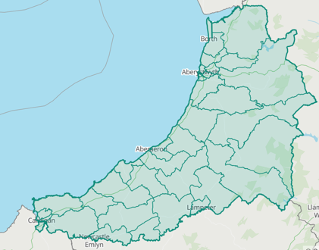
Image 1- Office for National Statistics
Image 2- Welsh Government (Gov.Wales)
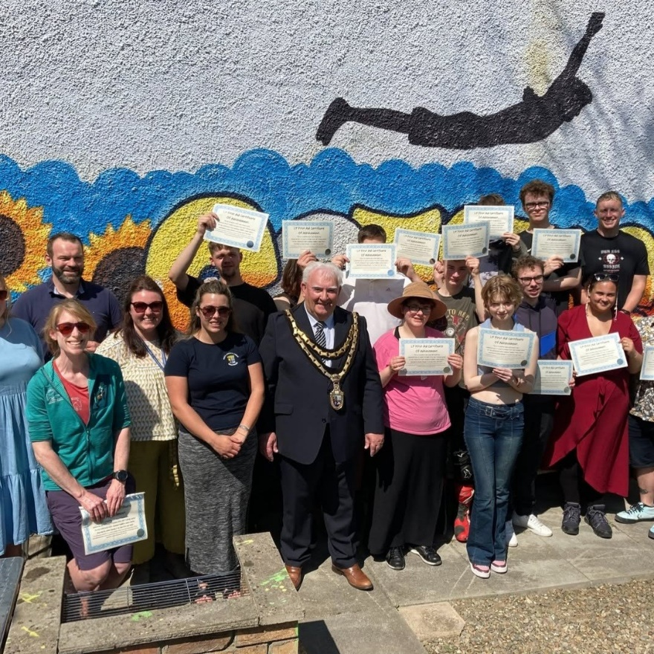
Image 3– Gwasanaeth Ieuenctid Ceredigion Youth Service, Instagram Post 2025

SUPERVISION RECORDING FORMAT 1
SUPERVISION RECORDING
DATE: 16/6/26
TIME: 9.30-11am
PEOPLE PRESENT: GJ and KE
DURATION OF THE MEETING: 1H 30
AGENDA/ DISCUSSION POINTS
1. Youth work Statutory – Youth work Wales 5 yr plan Ceredigion
2. Case Load
3.
NOTES/ ACTION OF EACH ITEM
1. How this will look, what the pilot will look like and how it will affect my current role.
2. High case load went through individual YP needs and work being completed with them (interventions/ distance travelled ect)
3.
PROBLEMS ENCOUNTERED
Staff capacity in the North of the county, with only 1 post 16 staff whereas Mid and South have 2 each.

REFLECTION ANALYSIS AND LEARNING Links between theory and practice can be made here and referenced in the usual way. Also reflection on effectiveness of supervision.
By Looking at it through the signs of safety model and exploring what’s working well, what could be improved and what I can do to differently or improve, we were able to highlight good practice and see areas of weakness.
The youth work strategy and the youth engagement and progression framework were discussed.

QUESTIONS ARISING
Implementation of Ceredigion’s new 5 yr plan

DATE OF NEXT MEETING: 23/6/26
SIGNED:
STUDENT: 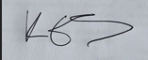
SUPERVISOR:

SUPERVISION RECORDING FORMAT 2
SUPERVISION RECORDING
DATE: 23/6/26
TIME: 9.30-11am
PEOPLE PRESENT: GJ and KE
DURATION OF THE MEETING: 1H 30
AGENDA/ DISCUSSION POINTS
1. NOS- Effective Communication and youth led provisions
2. Young persons voice
3. Staff Capacity
NOTES/ ACTION OF EACH ITEM
1. Meeting the NOS standards and how we implement these into already established group sessions ensuring they are still being followed.
2.
3.
PROBLEMS ENCOUNTERED
Effective communication between staff and clear methods of ensuring young people contacts and communication so staff are aware who’s been contacted and so on for provisions.

REFLECTION ANALYSIS AND LEARNING Links between theory and practice can be made here and referenced in the usual way. Also reflection on effectiveness of supervision.
Effective communication and young peoples voice is a key component of youth work.
The National Occupational Standards highlights this and ensuring that provisions is inclusive for all young people.
Signs and safety model followed and explored how we can ensure provision is offered to all young people who are 16-25

QUESTIONS ARISING
Staff capacity and transportation of young people

DATE OF NEXT MEETING: 2/7/26
SIGNED:
STUDENT:
SUPERVISOR

SUPERVISION RECORDING FORMAT 3
SUPERVISION RECORDING
DATE: 2/7/26
TIME: 1pm-2pm
PEOPLE PRESENT: GJ and KE
DURATION OF THE MEETING: 1H
AGENDA/ DISCUSSION POINTS
1. Youth engagement and progression framework
2. Early identification tracking
3. Youth work 5 yr plan and implementation as a service wide approach
4. Neet opportunities within Ceredigion

NOTES/ ACTION OF EACH ITEM
1. 6 core components- early identification, targeted support, provision, employability, accountability.
2. VAP (vulnerability assessment profile. Red, green, amber traffic light system. TAPPAS- team around the pupil-parent and school meetings Ceredigion piloted but schools not invested.
3.Support and pathways team- initial port of contact
Post 16 target 1-1 support
Inspire
4.
PROBLEMS ENCOUNTERED
No specific Legislation for Neet
Youth Engagement and progression Framework up to 18 only

REFLECTION ANALYSIS AND LEARNING Links between theory and practice can be made here and referenced in the usual way. Also reflection on effectiveness of supervision.
Youth Cymru evaluation (on Ceredigion)
Economic impact in Ceredigion

QUESTIONS ARISING
DATE OF NEXT MEETING:
SIGNED: 17/7/26
STUDENT: 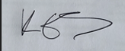

SUPERVISOR

